ASSIGNMENT - 2

Govardhan M G

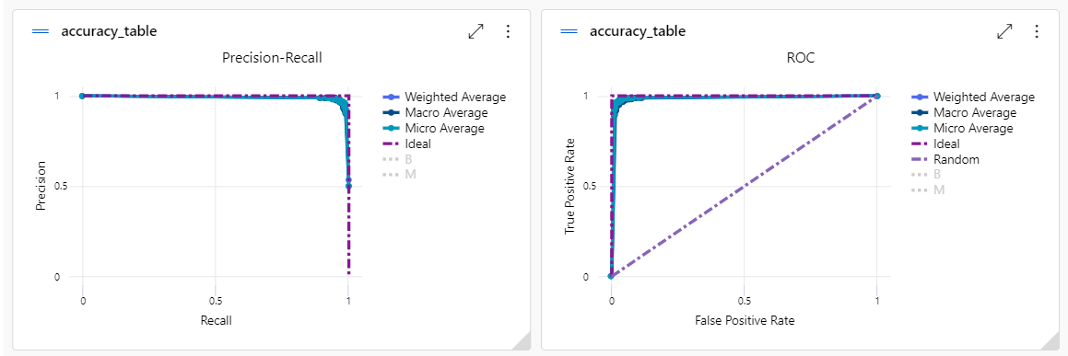

Deployment successfully  
