PHASE 3: PROJECT DESIGN
PROJECT DOCUMENTATION
ANSWERBOT – AI-POWERED FAQ AND CUSTOMER SUPPORT AUTOMATION
Project Details
Project Title | AnswerBot – AI-Powered FAQ and Customer Support Automation
Team Leader | GANESH.M
Mail ID | ganeshmurugam1411@gmail.com
Team Members
Name | Mail ID
GOKUL.K | Silambamgokul17@gmail.com
GOVARSHUN.R | govarshunr@gmail.com
HAARISH.B | haarish.b46@gmail.com

Introduction
The AnswerBot design defines how the major parts of the system work together to deliver secure FAQ and customer-support functionality. The design connects the API gateway, authentication middleware, application services, MongoDB database, and Google Gemini integration into a structured backend architecture. The following design elements provide the technical blueprint used for development.

System Architecture
AnswerBot uses a layered server architecture. Incoming API requests first reach the Express server gateway, where HTTP methods, JSON payloads, and CORS-related processing are handled. Authentication middleware then checks protected requests before the request reaches granular services and application logic.
The database interface layer uses Mongoose to translate application operations into MongoDB queries. The AI service integration connects the controller or service layer to Google Gemini for question answering and automated topic generation.

System Architecture Diagram
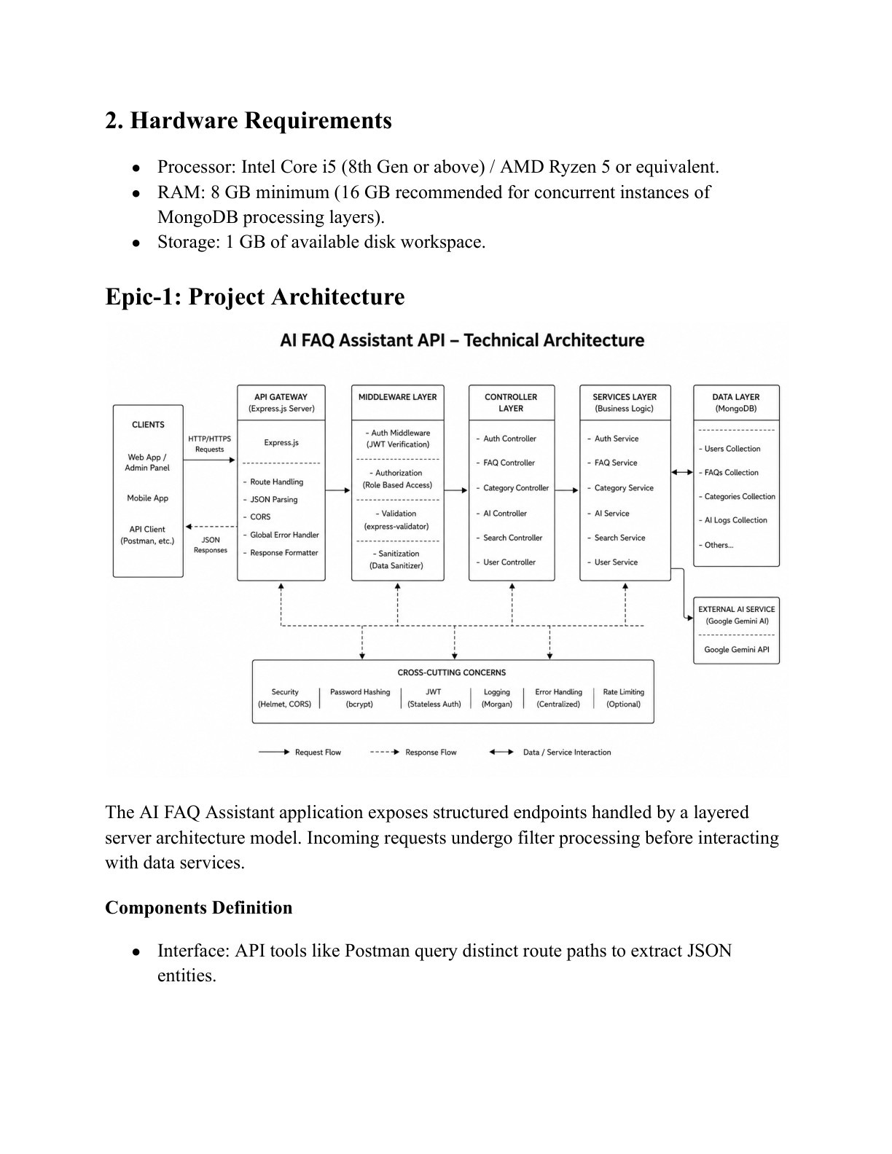

Figure: 3. System Architecture
The diagram is reproduced from the 20-page AnswerBot Demo documentation and shows the layered flow from API clients through the Express gateway, authentication, services, database layer, and AI integration.

Database and ER Design
The database contains logical entities for User, FAQ, AI Generation, and Category. User records contain identity and authentication information. FAQ records contain questions, answers, category information, creator references, and timestamps. AI Generation represents content generated dynamically through Google Gemini. Category organizes FAQ information.

ER Diagram
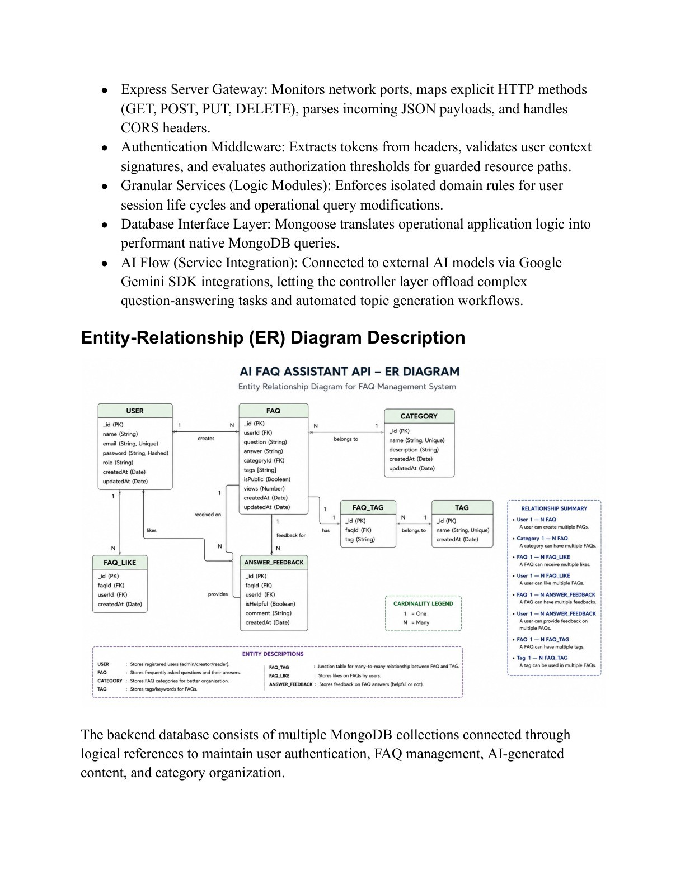

Figure: 5. ER
The diagram is reproduced from the AnswerBot Demo documentation and represents the logical relationships among users, FAQs, AI-generated content, and categories.

Entity Relationships
A registered user can create and manage multiple FAQ records. Each category can contain multiple FAQ documents. A user can generate multiple AI-assisted FAQs, which may later be saved into the FAQ collection. Search operations retrieve matching FAQ documents using keyword and semantic matching.

User Roles and Use Cases
- Admin: manages registered users, FAQs, categories, and AI-generated content.
- Content Creator: creates, edits, deletes, organizes, and generates FAQ content using AI.
- Authenticated User: views and searches FAQs and can use AI-assisted answers.
- Public User: views and searches published FAQs but cannot access protected API operations.

User Flow / Flowchart
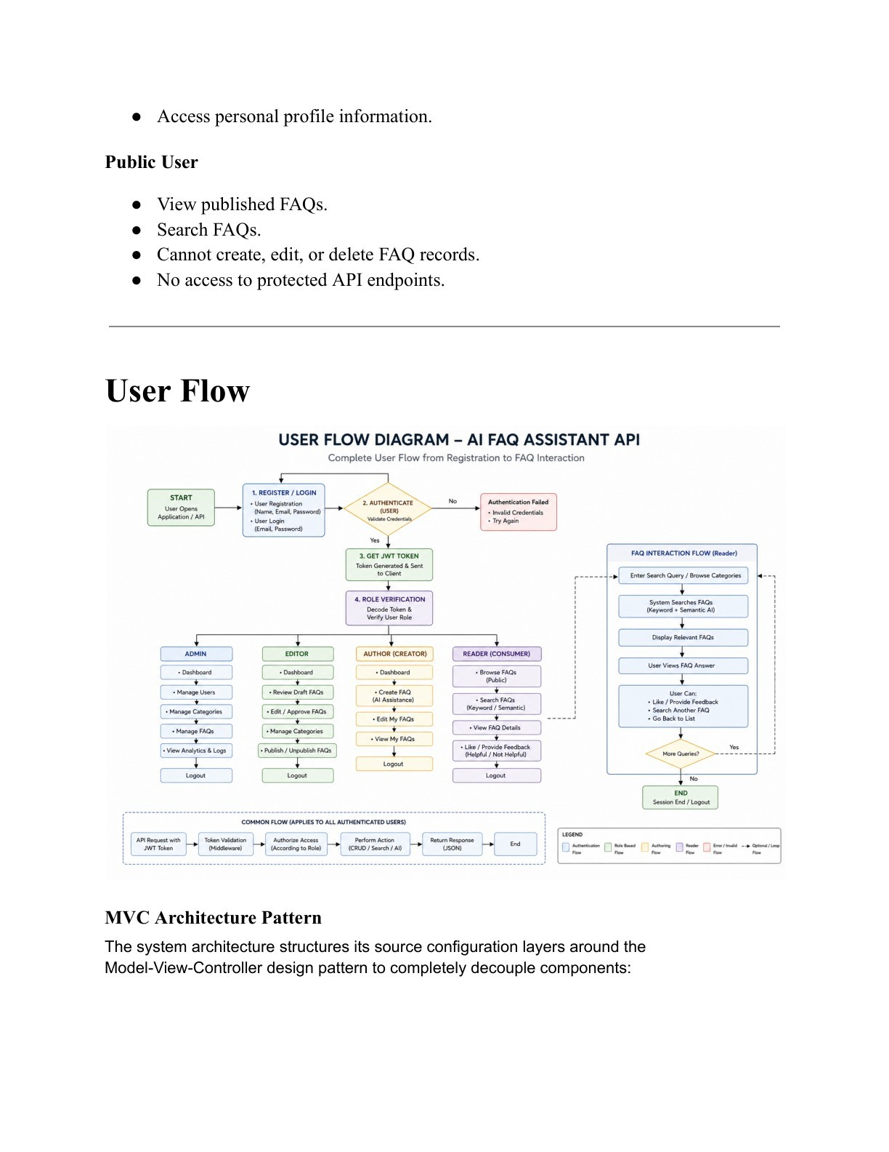

Figure: 8. User Flow / Flowchart
The flowchart is reproduced from the AnswerBot Demo documentation and is included as part of the project design reference.

MVC Architecture
The demo describes an MVC-based separation of responsibilities. The Model layer defines Mongoose schemas and database field rules. The Controller layer receives requests, validates request structures, delegates processing to models or services, and returns standardized JSON responses. In the headless backend, the View role is represented by the API routing layer rather than HTML templates.

MVC Architecture Diagram
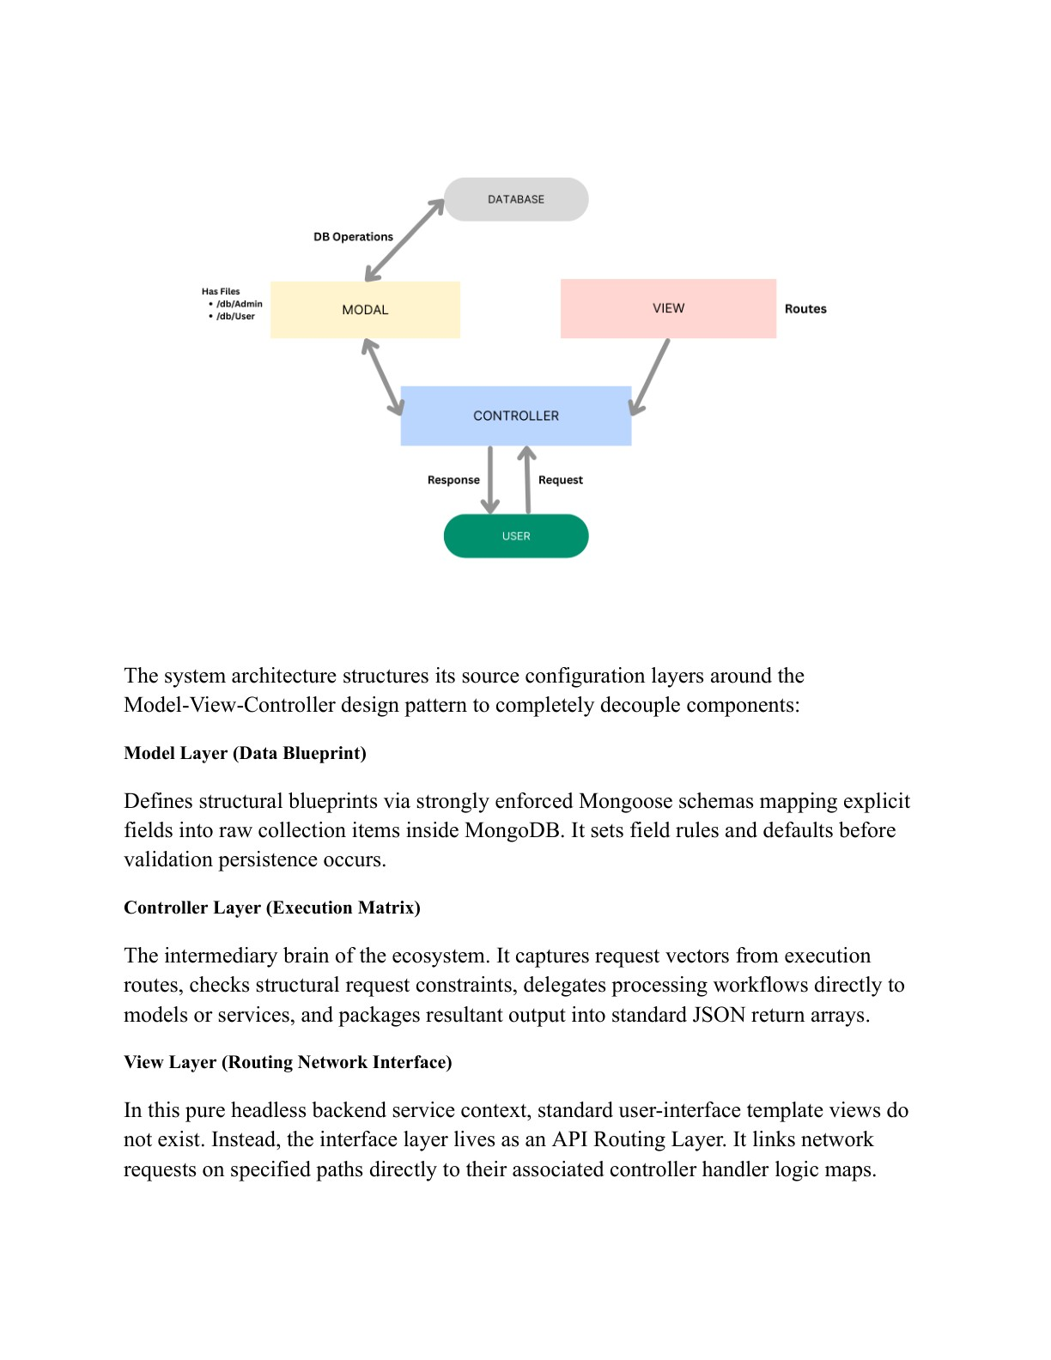

Figure: 10. MVC Architecture
The MVC diagram is reproduced from the AnswerBot Demo documentation and illustrates the separation between model, controller, and API routing responsibilities.

Project Folder Structure
The demo organizes the project around configuration, controllers, middleware, models, routes, services, and the server entry point. This separation allows database definitions, authentication middleware, routing, and specialized AI logic to remain independently maintainable.

Folder Structure Visual
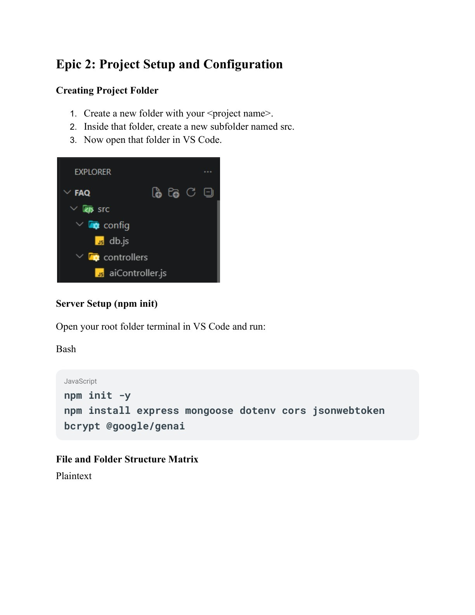

Figure: 12. Folder Structure
The folder-structure visual is reproduced from the AnswerBot Demo documentation and is included to show the documented source organization.

