PHASE 5: PROJECT DEVELOPMENT
PROJECT DOCUMENTATION
ANSWERBOT – AI-POWERED FAQ AND CUSTOMER SUPPORT AUTOMATION
Project Details
Project Title | AnswerBot – AI-Powered FAQ and Customer Support Automation
Team Leader | GANESH.M
Mail ID | ganeshmurugam1411@gmail.com
Team Members
Name | Mail ID
GOKUL.K | Silambamgokul17@gmail.com
GOVARSHUN.R | govarshunr@gmail.com
HAARISH.B | haarish.b46@gmail.com

Introduction
The development phase turns the AnswerBot design into a working backend service. The implementation brings together the Node.js and Express.js server, MongoDB and Mongoose data layer, JWT authentication, bcrypt password protection, FAQ routes, search functions, category organization, and Google Gemini AI integration. The sections that follow describe the documented implementation structure and API workflow.

Project Setup and Configuration
The demo begins with creating a project folder, creating a src directory, opening the project in Visual Studio Code, and initializing the Node.js package configuration using npm init -y.
The documented dependencies include Express, Mongoose, dotenv, cors, jsonwebtoken, bcrypt, and @google/genai. Environment configuration is used to keep runtime settings separate from application code.

Backend Development
The main server entry point loads environment configuration, establishes databaserelated startup behavior, and binds the application to its network port. Express is configured to receive and process HTTP requests.
Authentication middleware intercepts protected requests, extracts authorization information from headers, and validates token identity and access context. Centralized error handling is used to provide controlled API error responses.

Database Development
The User model enforces identity field criteria and includes password hashing behavior before persistence. The FAQ model defines question, answer, category, and creator reference fields and maintains the logical connection to the source user.
MongoDB is the primary document store and Mongoose is used as the objectdocument modeling layer. Schema validation helps prevent structurally invalid data from being persisted.

API Route Development
Public authentication operations include POST /api/auth/register and POST /api/auth/login. Protected FAQ operations include POST /api/faqs and related FAQ management routes. Search is provided through GET /api/faqs/search?q=configure. AI automation is exposed through POST /api/ai/generate-faq.

AI FAQ Workflow
The AI workflow accepts a topic from an authenticated request, passes the topic to the Google Gemini integration, and uses the returned content to produce an FAQ-oriented response. The demo identifies generated question, generated answer, and generated category as logical AI-generated information.

Development Structure Visual
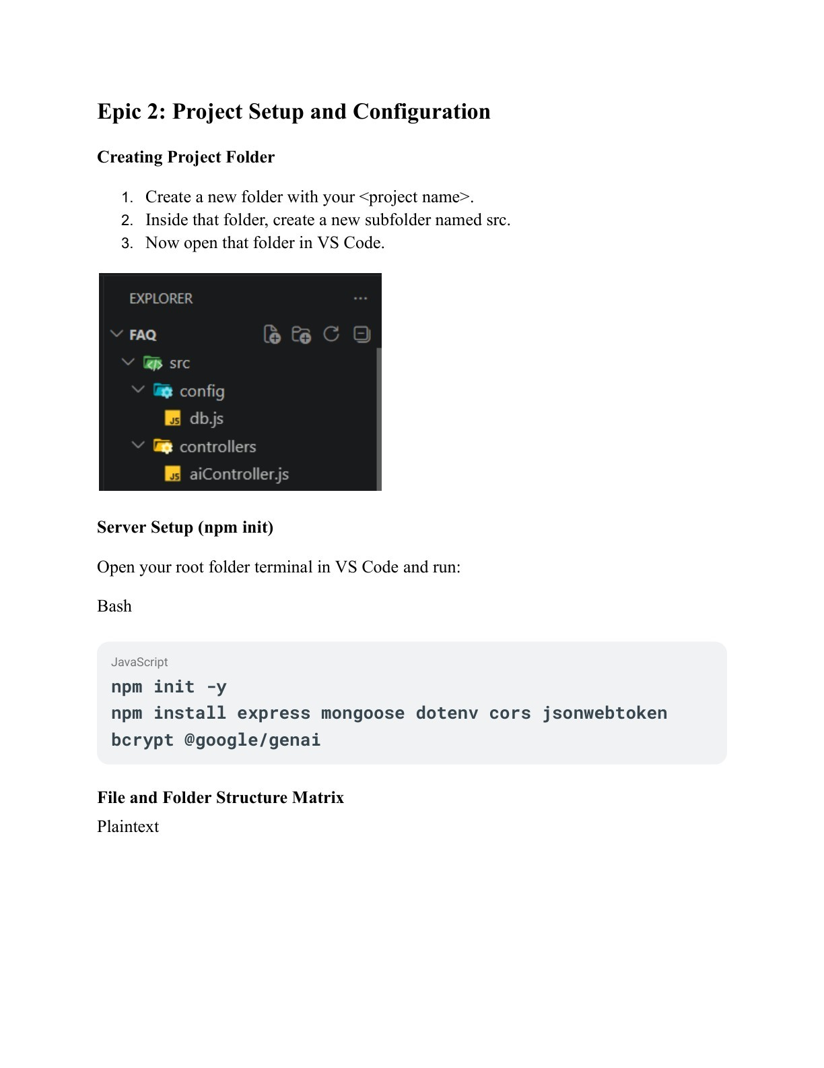
Figure: 7. Development Structure

Development Outcome
The development phase brings together the server gateway, authentication, database models, API routes, search, FAQ management, and AI automation into one backend service. The resulting architecture is modular enough to support future client interfaces and additional customer-support functionality.

