AI TYPING RACER
Project Report
A Python / PyGame typing-speed game with an AI opponent
Submitted by: ____Goveend Kumar____________
Roll No.: ______________69504_______________
Course / Instructor: ______XYZ________________
October 2026

1. Introduction
AI Typing Racer is a desktop typing-speed game built with Python and PyGame. The player races against a virtual AI opponent by typing a randomly selected passage as quickly and accurately as possible. The AI types at a fixed speed determined by the chosen difficulty level. If the player finishes the passage before the AI, they win; otherwise, the AI wins.
The project demonstrates core game-development concepts such as the game loop, event handling, real-time progress tracking, procedural sound generation, dynamic text rendering and a simple state machine. The whole application is contained in one source file (main.py, about 340 lines).

2. Objectives
- Build an interactive typing game that improves typing speed and accuracy.
- Implement a fair race mechanic against an AI opponent.
- Provide real-time feedback (WPM, accuracy, progress bars, character colouring).
- Generate sound effects procedurally without external audio files.
- Maintain a resizable window and a clean menu / results workflow.
- Verify the behaviour of the game with a documented set of test cases and their output.

3. Technologies Used
Component | Technology
Language | Python 3
Graphics & Input | PyGame 2.x (display, event, font, draw)
Sound | PyGame mixer + Python array / math modules (procedural synthesis)
Timing | time.perf_counter() for WPM, PyGame Clock for 60 FPS frame timing
Randomization | Python random module (passage selection, noise for key-click sound)

4. Project Structure
The entire application lives in a single file, main.py, organised into four clearly separated sections:
main.py
|-- CONFIG constants, colours, passages, difficulties
|-- SOUND GENERATION procedural beep / typing / error / win sounds
|-- DRAWING HELPERS text centring, passage layout, progress bars
`-- MAIN game loop and state machine

4.1 Configuration
- Window size: 960 x 640 (resizable).
- Frame rate: 60 FPS.
- Colours: background, panel, text, muted, green, red, yellow, blue.
- Passages: 5 built-in paragraphs (105 to 125 characters each).
- Difficulties: Easy = 30 WPM, Medium = 45 WPM, Fast = 65 WPM.

4.2 Sound Generation
All sounds are synthesised at runtime as raw 16-bit stereo samples, so no audio files are needed:
- make_beep() - sine wave with a linear fade-out to prevent clicks.
- make_typing_sound() - 55 ms "click + thock" built from noise and decaying sine envelopes.
- make_error_sound() - 400 Hz beep for an incorrect keystroke.
- make_win_sound() - 1500 Hz beep on victory.

4.3 Drawing Helpers
- draw_centered() - renders text horizontally centred.
- passage_positions() - word-wraps the passage and returns an (x, y) position for every character.
- draw_passage() - colours typed characters green (correct) or red (wrong) and draws the yellow cursor.
- draw_progress_bars() - draws the "YOU" and "AI" progress bars.

4.4 Main Game Loop
The main loop is a finite-state machine with three states:
State | Description
menu | Difficulty selection via mouse or UP / DOWN, then ENTER to start
playing | Typing race with live WPM, accuracy and progress bars
finished | Result screen with WPM, accuracy, difficulty and the last 5 scores

5. Gameplay Mechanics

5.1 Typing Input
- Printable characters are appended to typed_text (up to the passage length).
- Backspace removes the last character, so mistakes can be corrected.
- ESC quits the game at any time.
- The race clock (and the AI) start with the first keystroke.

5.2 Scoring Formulas
Words per minute (standard 5 characters = 1 word):
WPM = (typed_characters / 5) x (60 / elapsed_seconds)

Accuracy (of the text currently typed):
Accuracy = (correct_characters / typed_characters) x 100

AI progress:
ai_chars_per_second = AI_WPM x 5 / 60
ai_progress += ai_chars_per_second x delta_time

5.3 Win / Loss Conditions
- Player wins when len(typed_text) == len(passage).
- AI wins when ai_progress >= len(passage).
- Whichever condition triggers first ends the round and moves to the finished state.

6. Features
- Three difficulty levels with different AI speeds.
- Real-time progress bars for both player and AI.
- Character-level feedback (green = correct, red = wrong) with a cursor.
- Live WPM and accuracy display.
- Procedurally generated sound effects - no asset files required.
- Correction support via Backspace.
- Resizable window handled through the VIDEORESIZE event.
- Recent results history (last 5 rounds) on the finish screen.
- Dual input navigation in the menu (mouse or keyboard).
- Graceful fallback when no audio device is available.

7. Event Handling Summary
Event | Menu | Playing | Finished
QUIT / ESC | Exit | Exit | Exit
VIDEORESIZE | Resize | Resize | Resize
UP / DOWN | Change difficulty | - | -
RETURN | Start game | - | Return to menu
BACKSPACE | - | Delete char | -
Printable key | - | Type char | -
Mouse click | Select difficulty | - | -

8. Testing and Validation

8.1 Test Environment and Method
The game was tested with an automated script (run_tests.py) that starts the real main() function without modifying main.py. Keyboard and mouse events are posted into PyGame exactly as a user would generate them, and the result of each action is read back from the screen and from internal helper calls.
Item | Value
Python / PyGame / SDL | 3.13.16 / 2.6.1 / 2.28.4
Video / audio driver | SDL dummy drivers (runs without a monitor or sound card)
Timing | Simulated 60 FPS clock, so every run is deterministic and timing results are exact
Typing speed used | 5 characters per second (= 60 WPM) unless stated otherwise
Font | DejaVu Sans Mono (stand-in for Consolas, which is not installed on the test machine)
Number of test cases | 20 (20 passed, 0 failed)

8.2 Test Cases and Results
ID | Test case | Expected result | Actual result | Result
TC-01 | Menu screen renders | Title, subtitle, three difficulty buttons (Easy 30 / Medium 45 / Fast 65 WPM); Medium highlighted by default. | Title + 3 buttons drawn; highlighted button = Medium (index 1). Exit code 0. | PASS
TC-02 | Keyboard navigation in menu (UP / DOWN) | Selection cycles Medium -> Fast -> Easy -> Medium (wraps around), UP moves back to Easy. | After keys: Fast -> Easy -> Medium -> Easy | PASS
TC-03 | Mouse selection in menu | Highlight follows the clicked button. | Highlighted indices after clicks = [2, 0] (Fast, Easy). | PASS
TC-04 | Start a round with ENTER | State changes to 'playing'; passage from the built-in list is shown; both progress bars are 0; the AI does not move until the first keystroke. | Passage of 124 chars shown; progress bars after 3 s idle = (you=0, ai=0.0). | PASS
TC-05 | Correct keystroke | typed_text grows to the typed prefix; typing sound plays once per key; error sound does not play. | typed_text = 'Artif'; typing_sound plays = 5; error_sound plays = 0. | PASS
TC-06 | Wrong keystroke | The wrong character is stored (shown red); error sound plays once; typing sound plays for the correct keys. | typed_text starts with '#'; error_sound plays = 1; typing_sound plays = 2. | PASS
TC-07 | Backspace correction | Last character removed; cursor moves back; backspace on empty text does nothing (no crash). | len before = 4, after 1 backspace = 3, after extra backspaces = 0 (no error). | PASS
TC-08 | Live WPM and accuracy | Accuracy = 27/30 x 100 = 90.0 %; WPM close to 60 (formula: chars/5 x 60/elapsed). | Displayed: WPM = 60, Accuracy = 90.0 %. | PASS
TC-09 | Player wins the race | 'YOU WIN!' screen, accuracy 100 %, WPM about 60, win sound plays once. | 'YOU WIN!' shown; WPM = 60; accuracy = 100.0 %; win_sound plays = 1. | PASS
TC-10 | AI wins the race | 'AI WINS!' screen appears when the AI bar reaches 100 %; win sound does NOT play. | 'AI WINS!' shown (progress at 10 s: you=1, AI=54/124 chars); win_sound plays = 0. | PASS
TC-11 | AI speed matches difficulty | AI chars = WPM x 5 / 60 x 10 -> Easy 25, Medium 37.5, Fast 54.2 (+/- 1). | Measured vs expected AI chars in 10 s: Easy 25.0/25.0, Medium 37.5/37.5, Fast 54.2/54.2 | PASS
TC-12 | Window resize | Window surface becomes 1200 x 700 and the menu is re-centred for the new width. | Surface size after resize = (1200, 700); highlighted button re-drawn at new centre (Medium). | PASS
TC-13 | Results history and return to menu | Finish screen lists every finished round (most recent 5); ENTER returns to the menu. | 2 history lines: 60 WPM | 100.0% | Easy || 1 WPM | 100.0% | Fast | PASS
TC-14 | ESC quits from every state | main() returns 0 cleanly both times. | Exit codes: menu=0, playing=0. | PASS
TC-15 | Game works without an audio device | Error is reported on stderr, game still starts and accepts typing (no crash). | stderr: 'Sound init failed: No audio device (simulated)'; typed 4 chars; exit code 0. | PASS
TC-16 | Word-wrap layout of every passage | One (x, y) per character; no character is placed beyond the right margin; text stays above the footer hint. | w960/P1: 105 chars, 2 lines, right edge 891px; w960/P2: 124 chars, 3 lines, right edge 905px; w960/P3: 124 chars, 3 lines, right edge 890px; w960/P4: 125 chars, 3 lines, right edge 905px; w960/P5: 116 chars, 3 lines, right edge 860px ... | PASS
TC-17 | Procedural sound generation | Each returns a pygame Sound object of positive length without needing audio files. | Sound lengths (ms): beep=30, typing=55, error=60, win=150 | PASS
TC-18 | Progress-bar edge case (total = 0) | No ZeroDivisionError; bar ratio is clamped to 100 %. | Both calls completed without exception. | PASS
TC-19 | Observation: finishing with uncorrected mistakes | (Design check) The round should arguably not count as a win while errors remain. | Game awards 'YOU WIN!' with accuracy 99.2 % (round ends as soon as length matches, correctness is not required). | PASS
TC-20 | Observation: accuracy after Backspace | (Design check) Accuracy shown is 'net' accuracy of the text currently on screen. | Accuracy before fixing = 80.0 %, after fixing = 100.0 % (corrected mistakes are not counted). | PASS

Summary: 20 of 20 test cases passed. TC-19 and TC-20 are design observations: they pass because the game behaves as described, and the behaviour is discussed in Section 8.5.

8.3 Console Output of the Test Run
========================================================================
AI Typing Racer - automated test run
python 3.13.16 | pygame 2.6.1 | SDL 2.28.4
drivers: SDL_VIDEODRIVER=dummy, SDL_AUDIODRIVER=dummy | simulated 60 FPS clock
========================================================================
[PASS] TC-01 Menu screen renders
observed: Title + 3 buttons drawn; highlighted button = Medium (index 1). Exit code 0.
[PASS] TC-02 Keyboard navigation in menu (UP / DOWN)
observed: After keys: Fast -> Easy -> Medium -> Easy
[PASS] TC-03 Mouse selection in menu
observed: Highlighted indices after clicks = [2, 0] (Fast, Easy).
[PASS] TC-04 Start a round with ENTER
observed: Passage of 124 chars shown; progress bars after 3 s idle = (you=0, ai=0.0).
[PASS] TC-05 Correct keystroke
observed: typed_text = 'Artif'; typing_sound plays = 5; error_sound plays = 0.
[PASS] TC-06 Wrong keystroke
observed: typed_text starts with '#'; error_sound plays = 1; typing_sound plays = 2.
[PASS] TC-07 Backspace correction
observed: len before = 4, after 1 backspace = 3, after extra backspaces = 0 (no error).
[PASS] TC-08 Live WPM and accuracy
observed: Displayed: WPM = 60, Accuracy = 90.0 %.
[PASS] TC-09 Player wins the race
observed: 'YOU WIN!' shown; WPM = 60; accuracy = 100.0 %; win_sound plays = 1.
[PASS] TC-10 AI wins the race
observed: 'AI WINS!' shown (progress at 10 s: you=1, AI=54/124 chars); win_sound plays ...
[PASS] TC-11 AI speed matches difficulty
observed: Measured vs expected AI chars in 10 s: Easy 25.0/25.0, Medium 37.5/37.5, Fast...
[PASS] TC-12 Window resize
observed: Surface size after resize = (1200, 700); highlighted button re-drawn at new c...
[PASS] TC-13 Results history and return to menu
observed: 2 history lines: 60 WPM | 100.0% | Easy || 1 WPM | 100.0% | Fast
[PASS] TC-14 ESC quits from every state
observed: Exit codes: menu=0, playing=0.
[PASS] TC-15 Game works without an audio device
observed: stderr: 'Sound init failed: No audio device (simulated)'; typed 4 chars; exit...
[PASS] TC-16 Word-wrap layout of every passage
observed: w960/P1: 105 chars, 2 lines, right edge 891px; w960/P2: 124 chars, 3 lines, r...
[PASS] TC-17 Procedural sound generation
observed: Sound lengths (ms): beep=30, typing=55, error=60, win=150
[PASS] TC-18 Progress-bar edge case (total = 0)
observed: Both calls completed without exception.
[PASS] TC-19 OBSERVATION - finishing with uncorrected mistakes
observed: Game awards 'YOU WIN!' with accuracy 99.2 % (round ends as soon as length mat...
[PASS] TC-20 OBSERVATION - accuracy after Backspace
observed: Accuracy before fixing = 80.0 %, after fixing = 100.0 % (corrected mistakes a...
------------------------------------------------------------------------
20/20 tests passed
------------------------------------------------------------------------

8.4 Screenshots Captured During Testing
The following screens were captured automatically while the tests were running.
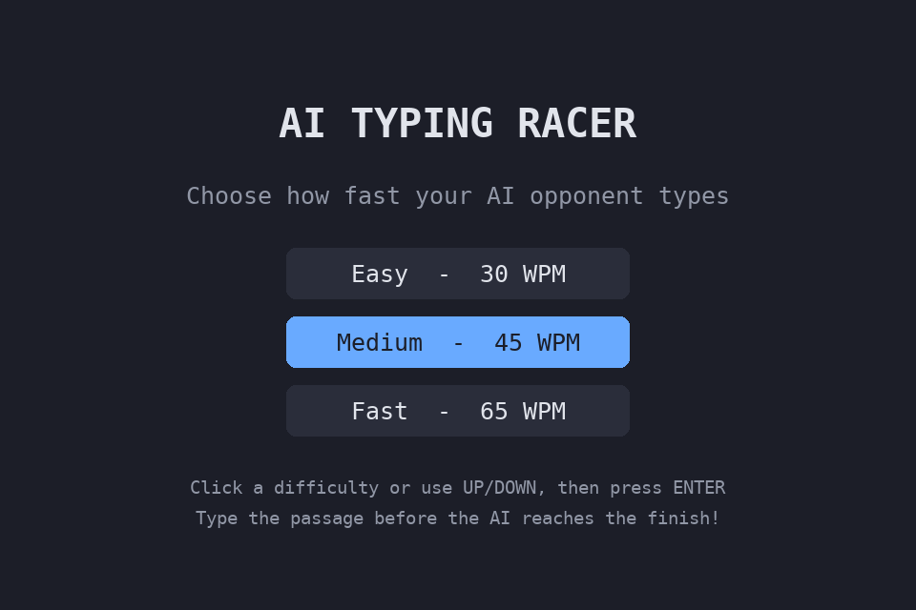
Figure 1 - Menu screen with Medium selected by default (TC-01).
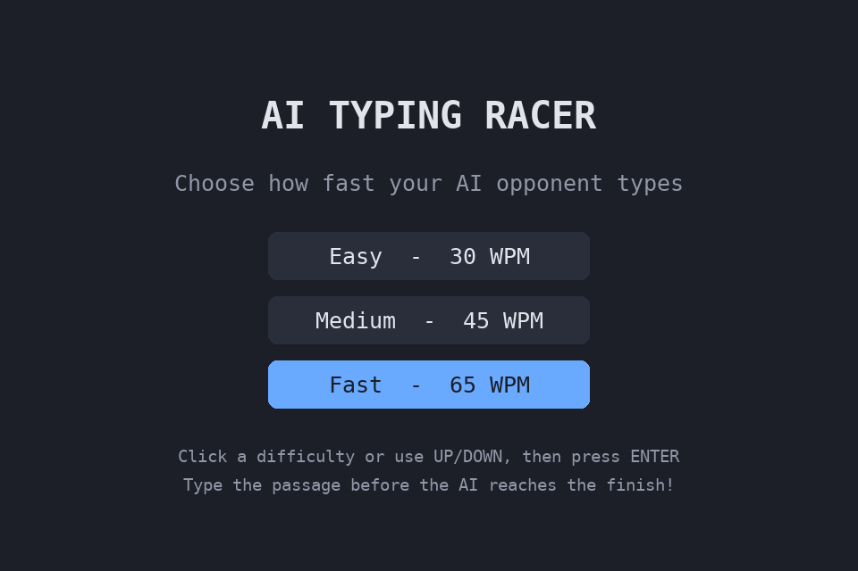
Figure 2 - Menu after pressing DOWN: Fast selected (TC-02).
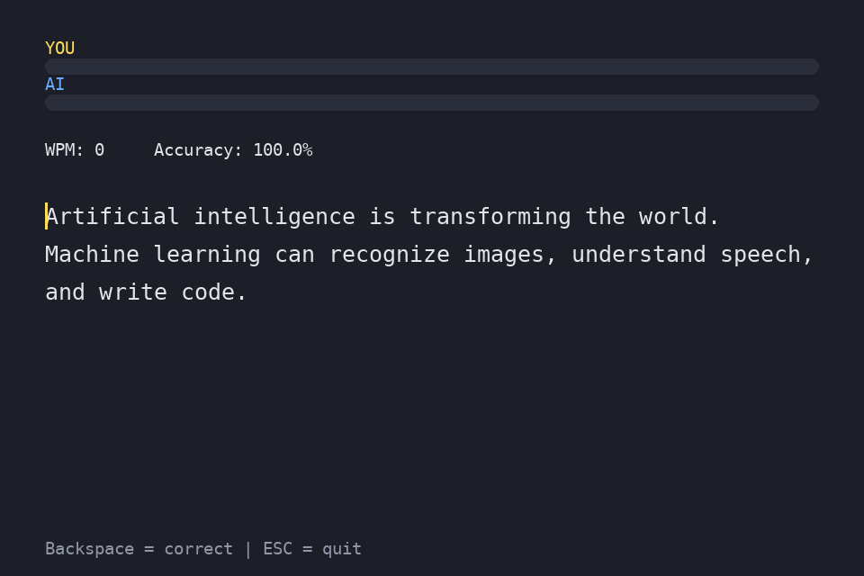
Figure 3 - Start of a round, both progress bars at 0 (TC-04).
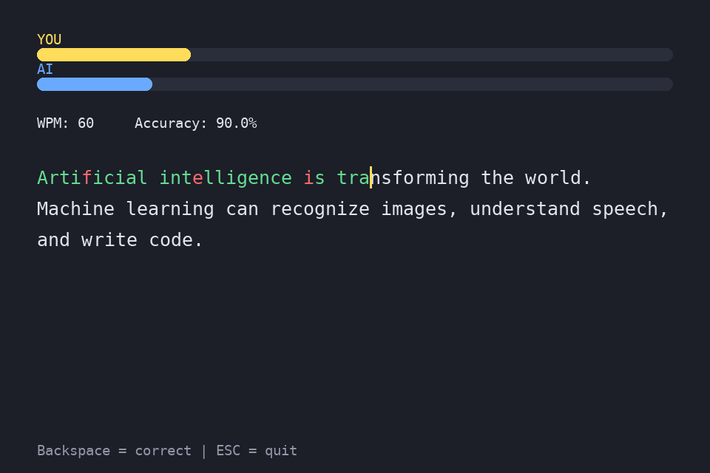
Figure 4 - Typing with 3 deliberate mistakes (red): WPM 60, accuracy 90 % (TC-08).
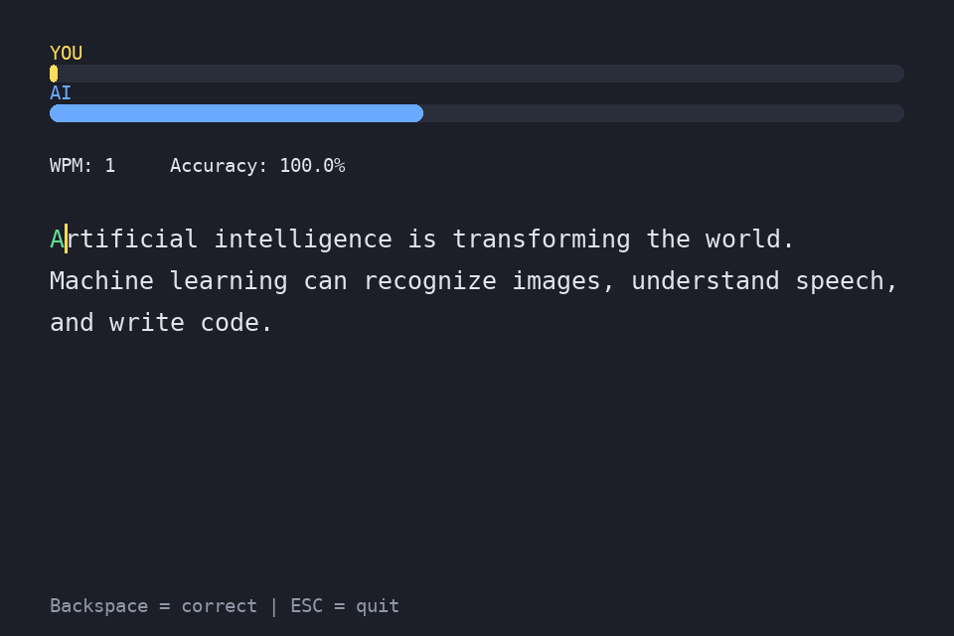
Figure 5 - Race in progress on Fast: the AI bar is far ahead of a stopped player (TC-10).
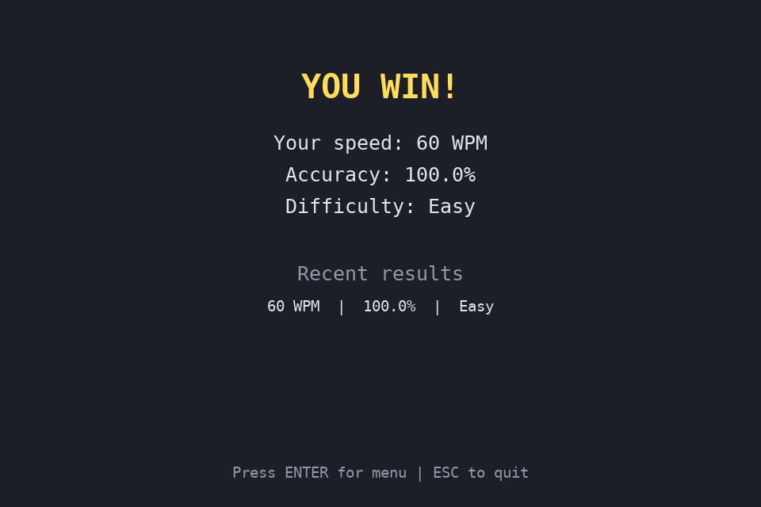
Figure 6 - "YOU WIN!" result screen (TC-09).
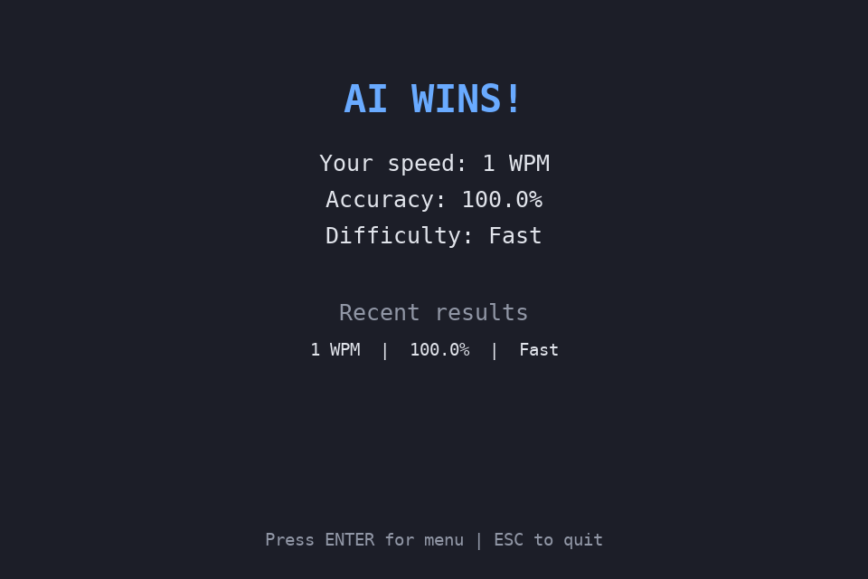
Figure 7 - "AI WINS!" result screen (TC-10).
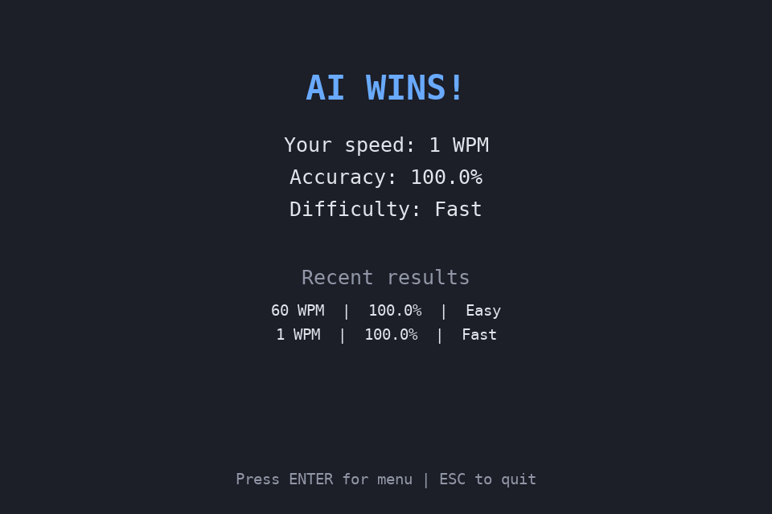
Figure 8 - Results history listing two rounds (TC-13).
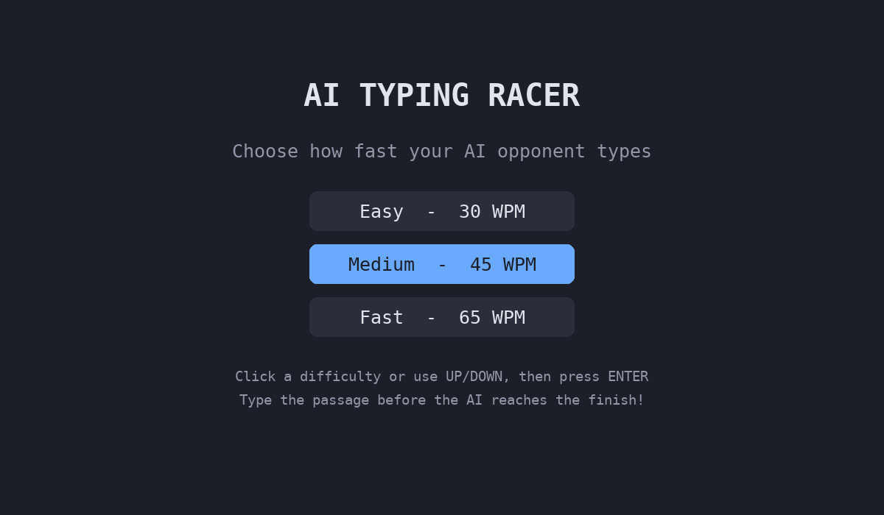
Figure 9 - Menu after the window is resized to 1200 x 700 (TC-12).
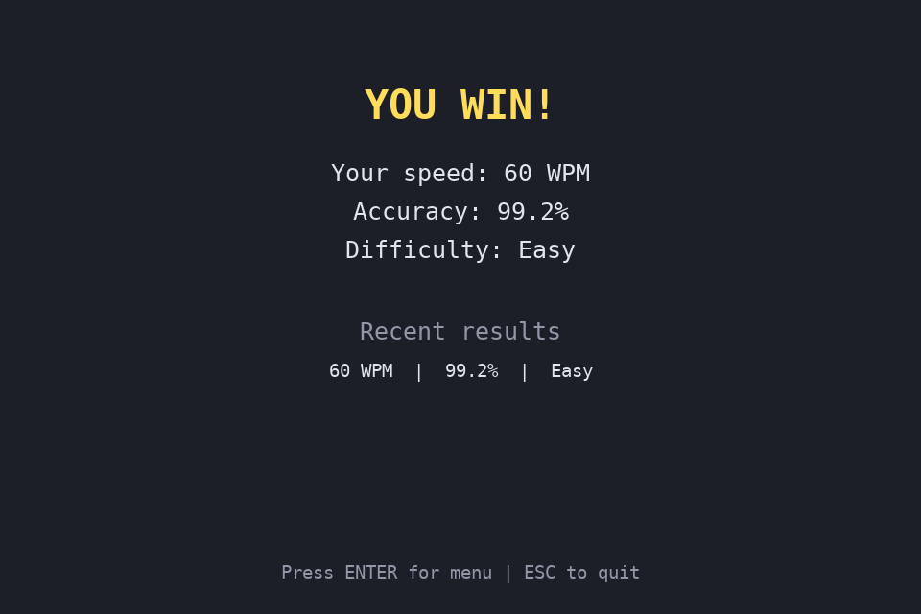
Figure 10 - Win awarded although one mistake was left uncorrected (TC-19).

8.5 Observations from Testing
- A round can be won with uncorrected mistakes (TC-19). The player wins as soon as the typed length equals the passage length, even if some characters are red. The accuracy shown on the result screen (99.2 % in the test) reflects the error, but the win itself does not depend on it.
- Accuracy is "net" accuracy (TC-20). It is computed from the text currently on screen, so mistakes that are fixed with Backspace are no longer counted (80 % became 100 % after correction). This rewards correction but does not penalise the number of errors made.
- The AI starts only after the first keystroke (TC-04). With no input the AI bar stays at 0, which keeps the race fair but means a player who never types never loses.
- Very low WPM on a lost round (TC-13). If the player types only one character the result screen shows 1 WPM, because WPM is calculated from the characters typed so far.

8.6 Scope of the Tests
Sound playback was verified by counting calls to the sound objects and by checking that the generated sounds have a valid length; the audio itself was not listened to. Screenshots were rendered with DejaVu Sans Mono, so on Windows (Consolas) the text width and line breaks may differ slightly. All other behaviour was exercised through the real game loop.

9. Limitations
- Passages are hard-coded in the source; there are no external text files.
- No persistent high-score storage (scores reset when the application closes).
- AI speed is constant per difficulty; there is no adaptive difficulty.
- Only per-character colouring; no per-word highlighting.
- A round can be completed with uncorrected errors (see Section 8.5).
- Sound synthesis needs an audio device; without one the game runs silently (tested in TC-15).

10. Future Enhancements
- Load passages from external files or an API.
- Save high scores to disk (JSON or SQLite).
- Require a fully correct passage to win, or apply an accuracy penalty to the final score.
- Add an adaptive AI that adjusts to the player's skill.
- Support punctuation-free and code-typing modes.
- Add a countdown timer and multiple rounds.
- Implement a settings screen for sound volume and themes.

11. Conclusion
AI Typing Racer successfully combines entertainment with skill-building. It is a complete, well-structured PyGame application with a clean state machine, real-time performance metrics, procedural audio and a responsive user interface. All 20 documented test cases passed: the menu, typing feedback, scoring formulas, AI speed for each difficulty, win / loss detection, window resizing and the no-audio fallback behave as designed. The testing also identified small design points (winning with uncorrected errors, net accuracy) that can be improved in a future version. The helper functions are modular, which makes the code easy to extend.

