Karachi House Price Analysis
Exploratory Data Analysis (EDA) Using Python
Project Type: Data Analysis Project
Tools: Python, Pandas, NumPy, Matplotlib, Seaborn
Dataset: Karachi.csv (Zameen.com property listings)
Prepared by: Goveend Kumar
Project Status: Completed Exploratory Data Analysis

1. Executive Summary
This project explores 8,414 property listings from Karachi, Pakistan, to understand asking prices, property sizes, bedroom counts and differences between locations. Python (Pandas, NumPy, Matplotlib and Seaborn) was used to load, clean, analyze and visualize the data.
After cleaning, 8,413 valid listings remained. The median asking price is PKR 25.0 million, while the mean is PKR 55.6 million, showing a strongly right-skewed distribution. DHA Defence has the most listings (3,943) and the highest median price (PKR 73.0 million) among the three main locations. Property area has the strongest relationship with price (correlation 0.85), followed by bedrooms (0.56) and bathrooms (0.54).
The final deliverables are a cleaned CSV dataset, five charts and the statistical summaries presented in this report.

2. Introduction
Karachi is a major commercial and residential city in Pakistan. Its property market includes houses and flats of different sizes, prices and locations. Analyzing property listings can reveal patterns in asking prices and differences between residential areas, although prices also depend on construction quality, amenities and market conditions.
This project applies Exploratory Data Analysis (EDA) techniques to a Karachi property dataset. EDA helps organize and understand data before performing advanced statistical analysis or building predictive models.

3. Problem Statement
Property listings may contain inconsistent price formats, missing values and differences in property characteristics, which makes accurate price comparison difficult. The project addresses the following question:
How can Python-based data analysis help identify patterns and relationships in Karachi house prices using available property listing data?

4. Project Objectives
- Load and explore the Karachi property dataset.
- Understand the dataset's rows, columns and data types.
- Identify missing values and duplicate records.
- Standardize column names and clean relevant numerical fields.
- Convert lakh and crore price formats into Pakistani rupees.
- Calculate average, median, minimum and maximum prices.
- Identify locations with the highest number of listings.
- Compare median property prices across locations.
- Investigate relationships between price, bedrooms and property area.
- Create visualizations to communicate findings.
- Export the cleaned dataset for future analysis.

5. Tools and Technologies
Tool | Purpose
Python | Main programming language
Pandas | Data loading, cleaning, grouping and analysis
NumPy | Numerical operations and data handling
Matplotlib | Creating charts and graphs
Seaborn | Statistical visualizations
Regular Expressions (re) | Extracting numbers and units from text
pathlib | Managing file and folder paths
CSV | Storing the original and cleaned datasets

6. Dataset Description
The project uses a CSV file named Karachi.csv containing 8,414 rows and 12 columns. The listings come from Zameen.com (the source appears in the url column).
Column | Description | Type
title | Listing title | Text
price | Asking price (e.g. "11.5 Crore") | Text
date added | Relative listing age (e.g. "14 hours ago") | Text
type | House, Flat, Penthouse, etc. | Text
bedrooms | Number of bedrooms | Integer
bathrooms | Number of bathrooms | Integer
area | Property size in Sq. Yd. | Text
location | Main location (DHA Defence, Bahria Town, Clifton) | Text
complete location | Detailed sub-area | Text
description | Listing description | Text
keywords | Listing features | Text
url | Listing link | Text

Missing values in the raw data: date added (367), location (367), area (1,092), keywords (863), and one missing value each in price, type, complete location and description. The area column is expressed entirely in square yards (Sq. Yd.).

7. Methodology

7.1 Data Loading
The dataset was loaded into a Pandas DataFrame using pd.read_csv(), after checking that the file exists in the expected project directory.

7.2 Initial Data Exploration
- df.head() to inspect the first five records.
- df.shape to determine the number of rows and columns (8,414 x 12).
- df.columns to inspect column names.
- df.info() to examine data types and non-null values.
- df.describe(include="all") to generate descriptive statistics.

7.3 Data Cleaning
Column names were converted to lowercase, trimmed and spaces replaced with underscores. Missing values and duplicates were counted; no duplicate rows were found. Prices written in "Crore" and "Lakh" were converted into rupees (1 Crore = 10,000,000; 1 Lakh = 100,000). One row with a missing price was removed, leaving 8,413 listings. Bedroom values were converted to numeric data and the numeric part of the area field was extracted (unit: Sq. Yd.).

7.4 Descriptive Statistical Analysis
Mean, median, minimum and maximum prices were calculated to summarize the typical range of listings.

7.5 Location Analysis
Listings were counted by location, and mean, median and listing count were calculated for each location. Groups with fewer than five listings were excluded from the median-price ranking.

7.6 to 7.9 Visual and Correlation Analysis
A histogram with KDE curve, a boxplot of price by bedrooms, a scatterplot of area against price and a correlation heatmap were produced. Correlation describes linear association only and does not establish causation.

7.10 Exporting Cleaned Data
The cleaned dataset was saved as data/karachi_house_prices_cleaned.csv for future analysis, dashboards or machine learning experiments.

8. Key Analysis Questions
- What are the average and median asking prices?
- What are the minimum and maximum recorded prices?
- Which locations have the highest number of listings?
- Which locations have the highest median listing prices?
- Do properties with more bedrooms generally have higher prices?
- Is property area positively associated with price?
- Does the price distribution contain extreme values or skewness?
- Which numerical variables have the strongest correlations?
The answers are given in Section 10.

9. Visualizations (Program Output)
The following figures are the output of the analysis code run on the cleaned dataset.
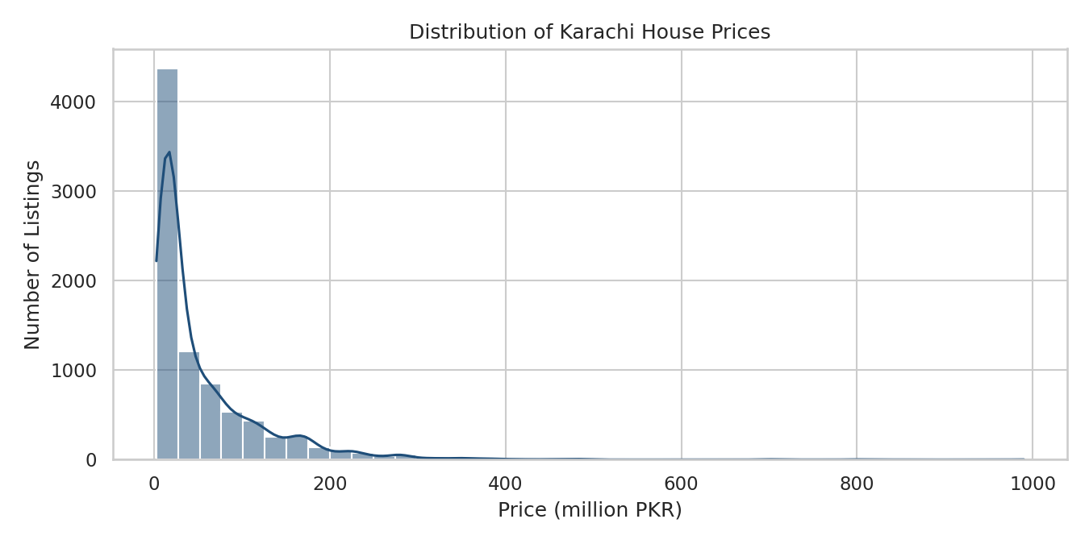
Figure 1: Karachi House Price Distribution
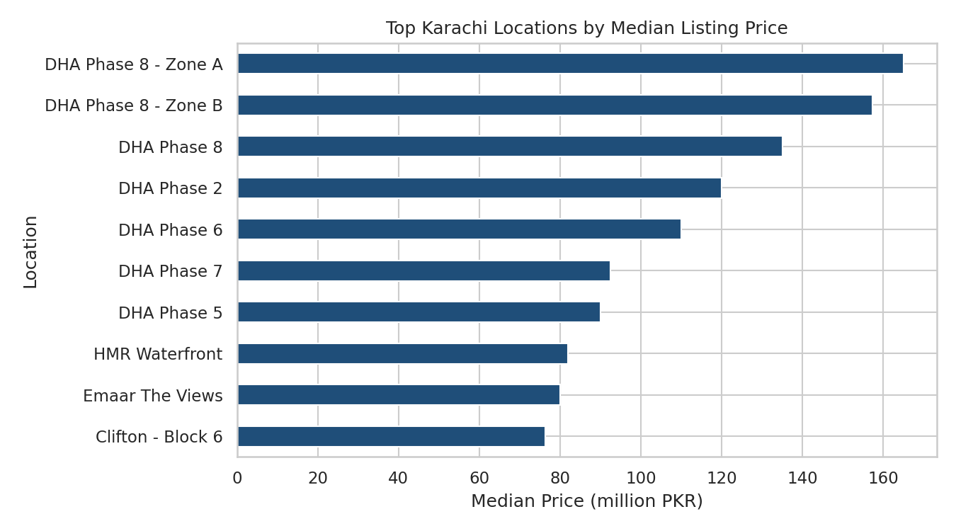
Figure 2: Top Locations by Median Listing Price (sub-areas with 5+ listings)
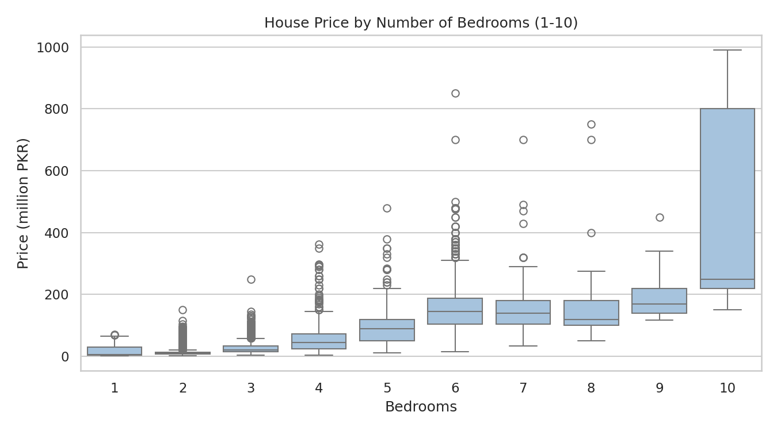
Figure 3: House Price by Number of Bedrooms
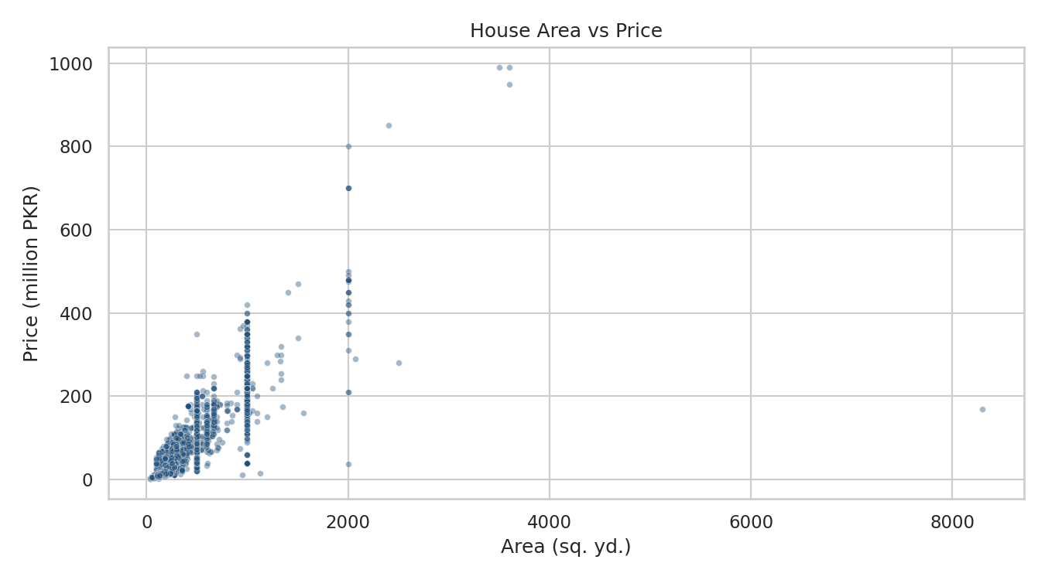
Figure 4: House Area vs Price
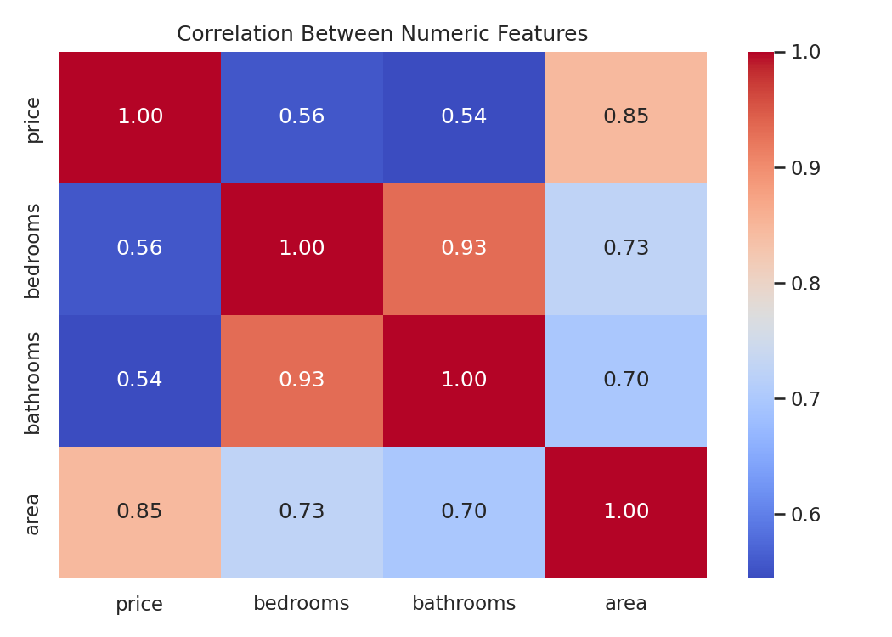
Figure 5: Correlation Heatmap

10. Results and Findings

10.1 Summary Metrics
Metric | Actual result
Original dataset rows | 8,414
Original dataset columns | 12
Duplicate rows removed | 0
Valid listings after cleaning | 8,413
Mean house price | PKR 55,556,884 (about 55.6 million)
Median house price | PKR 25,000,000 (25.0 million)
Minimum house price | PKR 2,500,000 (2.5 million)
Maximum house price | PKR 990,000,000 (990 million)
25th / 75th percentile | PKR 14.3 million / 72.8 million
Highest median-price location (main) | DHA Defence (PKR 73.0 million)
Highest median-price sub-area (5+ listings) | DHA Phase 8 - Zone A (PKR 165.0 million)
Most frequently listed location | DHA Defence (3,943 listings)
Most frequently listed sub-area | DHA Phase 6 (873 listings)

10.2 Price Distribution
The mean (55.6 million) is more than double the median (25.0 million), and the skewness is about 3.6. A small number of very expensive properties pull the average upward, so the median is the better measure of a typical listing (Figure 1).

10.3 Locations
Location | Listings | Mean (M PKR) | Median (M PKR)
DHA Defence | 3,943 | 92.4 | 73.0
Clifton | 633 | 48.7 | 36.0
Bahria Town Karachi | 3,471 | 18.1 | 16.3

DHA Defence is the most expensive location, with a median about 4.5 times that of Bahria Town. Among sub-areas, DHA Phase 8 zones lead (Zone A 165.0M, Zone B 157.3M, Phase 8 overall 135.0M), followed by DHA Phase 2 (120.0M) and DHA Phase 6 (110.0M) (Figure 2).

10.4 Bedrooms and Price
Median price rises steadily with bedroom count, from about 5.5 million (1 bedroom) to 20 million (3 bedrooms), 45 million (4), 90 million (5) and 144.5 million (6 bedrooms). Listings with 7 or more bedrooms are few, so those groups are less reliable (Figure 3). A total of 983 listings show 0 bedrooms.

10.5 Area and Price
Area is positively associated with price: larger properties generally cost more (Figure 4). The median price per square yard is about PKR 215,000 in DHA Defence, 165,700 in Clifton and 90,200 in Bahria Town.

10.6 Correlations
Pair | Correlation
Price and area | 0.85
Bedrooms and bathrooms | 0.93
Bedrooms and area | 0.73
Bathrooms and area | 0.70
Price and bedrooms | 0.56
Price and bathrooms | 0.54

Area has the strongest correlation with price. Bedrooms and bathrooms are highly correlated with each other (Figure 5). Correlation does not prove causation.

10.7 Property Types
Type | Listings | Median price (M PKR)
House | 4,587 | 47.5
Flat | 3,768 | 14.5
Penthouse | 48 | 125.0
Farm House | 4 | 140.0
Lower / Upper Portion | 6 | 35.0

11. Business Value and Practical Applications
- Property buyers: compare asking prices across locations and sizes.
- Property sellers: review comparable listings before setting an asking price.
- Real estate analysts: explore price differences across residential areas.
- Students and researchers: practice data cleaning, statistics and visualization.
- Future developers: use the cleaned dataset for a price-prediction project.
These applications are exploratory. The results represent listing data and should not be treated as verified market valuations.

12. Limitations
- Findings depend on the accuracy and completeness of the dataset.
- Asking prices may differ from actual transaction prices.
- Area is missing for 1,091 listings, so area-based results use 7,322 listings.
- 983 listings show 0 bedrooms, which may be plots or missing data.
- Ten listings have "For Rent" in the title but sale-style prices; these may be errors and should be reviewed.
- The "location" column contains only three main areas, so results do not represent all of Karachi.
- Some sub-areas have few listings, making comparisons less reliable.
- The "date added" field is relative (e.g. "14 hours ago"), so time trends cannot be analyzed.
- Correlation does not prove a causal relationship.

13. Future Improvements
- Validate rent versus sale listings and remove incorrect rows.
- Handle missing values and 0-bedroom records appropriately.
- Identify and investigate outliers and suspicious records.
- Analyze price per square yard systematically.
- Compare price patterns across property types and sub-areas.
- Build an interactive dashboard using Power BI or Plotly.
- Develop a machine learning model to estimate prices and evaluate it with MAE, RMSE and R2.
- Add dataset source details and setup instructions to a GitHub README.

14. Conclusion
This project shows how Python can be used to explore real estate listing data through data cleaning, descriptive statistics, grouping and visualization. Location and property area emerge as the main drivers of asking prices in the Karachi dataset: DHA Defence listings have a median of PKR 73.0 million compared with 16.3 million in Bahria Town, and area correlates strongly with price (0.85). The price distribution is heavily right-skewed, so the median (25.0 million) describes a typical listing better than the mean (55.6 million).
The cleaned dataset and this workflow provide a foundation for further analysis and for building a price-prediction model.

15. Project Deliverables
- Original dataset: Karachi.csv
- Python analysis notebook: house_price_analysis.ipynb
- Cleaned dataset: karachi_house_prices_cleaned.csv
- Generated visualizations (Figures 1 to 5)
- Final report with actual findings (this document)
- GitHub README with overview, setup instructions, methods and results
Project Outcome: A reproducible exploratory data analysis workflow for investigating Karachi residential property listings using Python.

