USCDI+ Maternal Health Postpartum TOC FHIR IG

Project Scope Statement (PSS) Draft 1.0

1a. Project Name
USCDI+ Maternal Health Postpartum Transitions of Care (TOC) FHIR IG

1b. Project ID
[Not assigned yet]

1c. Is Your Project an Investigative Project (aka PSS-Lite)?
No

1d. Is your Project Artifact being Reaffirmed or proceeding to Normative directly after being either Informative or STU?
No

1e. Today's Date
03/25/2026

1f. Name of standard being reaffirmed
N/A

1g. Project Artifact Information
The new product is a Fast Healthcare Interoperability Resources (FHIR) implementation guide (IG) that specifies data elements necessary for postpartum transitions of care to streamline data exchange and decrease maternal health morbidity and mortality. This FHIR IG is a FHIR representation of the USCDI+ Maternal Health postpartum transitions of care use case developed by Clinovations Government + Health (Clinovations) with funding from the Office of the Assistant Secretary for Planning and Evaluation (ASPE) and the Assistant Secretary for Technology Policy/Office of the National Coordinator for Health Information Technology (ASTP/ONC). This work expands upon prior dataset and standards development activities funded by the National Institutes for Health (NIH) and ASTP/ONC.

1h. ISO/IEC Standard to Adopt
Although not an ISO, IEC, or an ISO/IEC standard, the FHIR IG uses the Internet Engineering Task Force (IETF) Request for Comments (RFC) 5646 Language Tags standard. IETF collaborates with International Organization for Standardization (ISO) and International Electrotechnical Commission (IEC).

1i. Does the standard include excerpted text from one or more ISO, IEC or ISO/IEC standards, but is not an identical or modified adoption?
No

1j. Unit of Measure
Both US and Metric are supported, since the FHIR IG supports the Unified Code for Units of Measure (UCUM) standard. However, since this FHIR IG is intended for the US realm, the project team expects units of measure to align with US standards.

2a. Primary/Sponsor WG
None

2b. Co-Sponsor WG
None

2c. Co-Sponsor Level of Involvement
N/A

2d. Project Facilitator
Anita Samarth

2e. Other Interested Parties (and roles)
Assistant Secretary for Technology Policy (ASTP) / Office of the National Coordinator for Health Information Technology (ONC) - Contributor
MedStar Health Research Institute - Contributor

2f. Modeling Facilitator
Justin Wang and Joseph Blumenthal

2g. Publishing Facilitator
Anita Samarth and Justin Wang

2h. Vocabulary Facilitator
Justin Wang

2i. Domain Expert Representative
Anita Samarth and Cait Cusack

2j. Business Requirements Analyst
Nicole Kemper and Meredith Wilson

2k. Conformance Facilitator
Joseph Blumenthal and Yan Heras

2l. Other Facilitators
N/A

2m. Implementers
MedStar Health Research Institute (Pilot)

3a. Project Scope
The scope of this project is to develop a FHIR IG to support the USCDI+ Maternal Health Postpartum Transitions of Care use case with funding from ASTP/ONC, ASPE, and NIH. During the development of the FHIR IG, the project team shaped the use case, and the data elements necessary to support the use case, based on feedback collected from a variety of sources, including but not limited to: 1) public discussion forums, federal and industry; 2) 1:1 discussions with subject matter experts; 3) 1:1 discussions with selected Federal agencies; 4) an environmental scan; and 5) initial pilot evaluation feedback and results. To better support postpartum care and improve maternal health outcomes, it is critical for the USCDI+ Maternal Health domain not only to develop new implementation guidance, but also to account for existing ontological standards, data formats, and exchange mechanisms. Doing so will advance timely and interoperable data sharing amongst postpartum and clinical providers in a HL7 FHIR ecosystem.
Key considerations for IG development include, but are not limited to:
- Interoperability between currently used data formats (e.g., Clinical Documentation Architecture (CDA), Admission, Discharge, and Transfer (ADT), US Standard Certificate of Birth, Interjurisdictional Exchange (IJE)) and data exchange (e.g., SFTP, fax, HL7v2, NAPHSIS) standards and HL7 FHIR;
- Health IT capacity at data exchange partners (e.g., health systems, federally qualified health centers (FQHCs), mental and behavioral health providers, lactation consultants, at-home providers) especially for data exchange partners with non-enterprise level EHRs;
- Clinical workflows and data captured at the time of pregnancy outcome events(e.g., delivery);
- Format and structure of documented data; and
- Custom and/or site-specific data dictionaries.
This IG presents an opportunity for the USCDI+ MH domain to develop HL7 FHIR implementation guidance for the Postpartum Transition of Care Use Case to support an additional data exchange modality, HL7 FHIR, for maternal health clinical care (see figure below).
Such guidance would specify the relevant postpartum data elements and value sets, enabling the capture and exchange of structured—and potentially codified—postpartum data. Lastly, this standardization will support emerging health IT use cases in postpartum care, including remote patient monitoring, clinical decision support, and third-party mobile applications, continuing the growing momentum for HL7 FHIR adoption within the US health IT ecosystem.
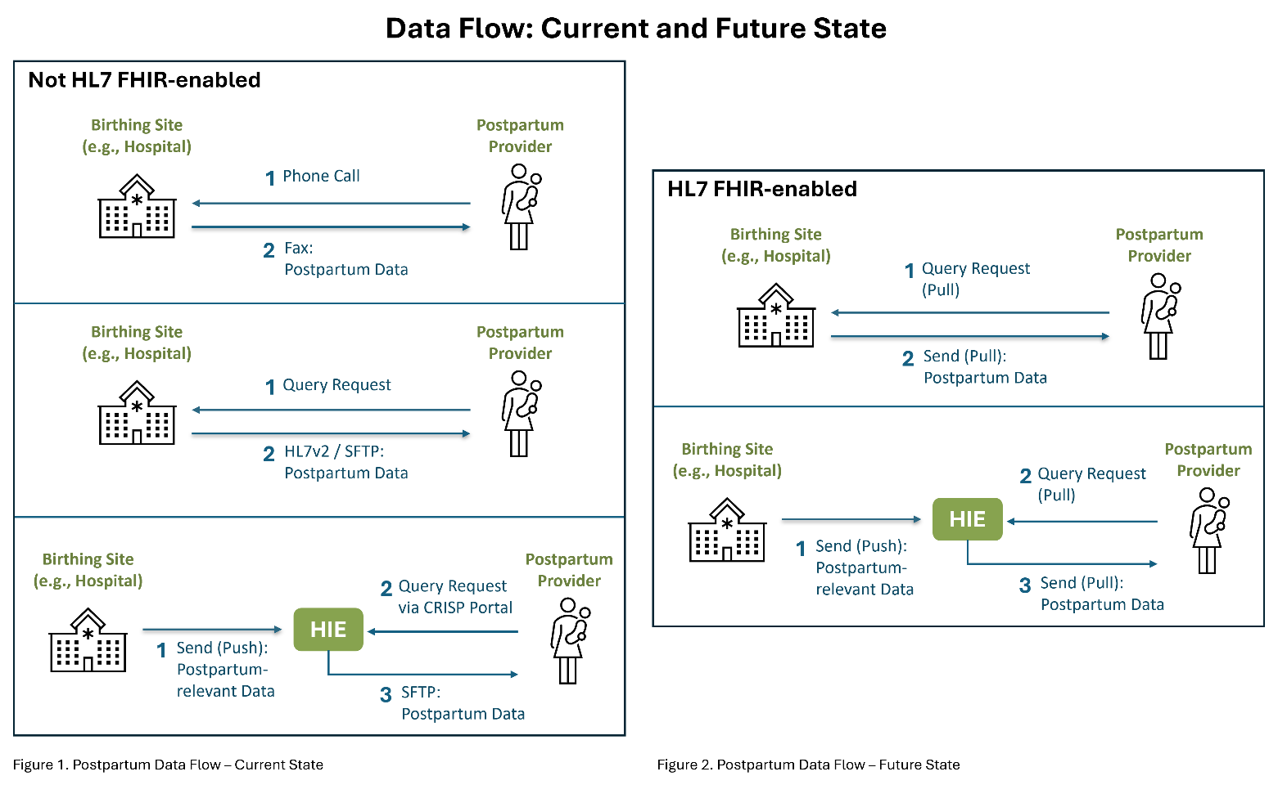

3b. Project Need
With increasing rates of maternal mortality for pregnant women and new mothers, it is paramount that providers, across care settings, have access to reliable and accurate health data to inform their treatment and interventions. However, current gaps in standardized, interoperable data to exchange across health care settings can limit providers’ ability to access necessary health data to effectively manage and deliver high-quality care.
A study of pregnancy-related deaths that occurred between 2017 and 2019 found that 12% occurred one to six days after delivery, 23% occurred between 7 to 42 days after delivery, and 30% occurred between 43 and 365 days after delivery. In 2022, the maternal mortality rate in the United States was 22.3 deaths per 100,000 live births, significantly higher than rates in other high-income countries. This elevated rate underscores the ongoing challenges in maternal health within the U.S. healthcare system.
In the United States, maternity care involves transitions across multiple healthcare settings, each with distinct providers and systems. Prenatal care typically occurs in outpatient clinics, where obstetricians, midwives, or family physicians monitor the pregnancy through regular visits. When labor begins, care shifts to a hospital or birthing center, where a different team manages the delivery. After childbirth, the mother returns to outpatient care for postpartum follow-up.
This fragmented system can hinder the seamless sharing of clinical information. For instance, outpatient providers may lack immediate access to detailed records from the hospital stay, such as delivery complications or interventions. The American College of Obstetricians and Gynecologists (ACOG) emphasizes the importance of coordinated care, advocating for a continuous individualized process rather than a single encounter. ACOG recommends that all women have contact with their obstetric care providers within the first three weeks postpartum, followed by a comprehensive visit no later than 12 weeks after birth. However, researchers have found that the number of women who have postpartum care visits ranges significantly, depending on their insurance coverage and other demographic factors. Effective communication and data sharing across these settings are crucial to address ongoing health needs, manage chronic conditions, and support the mother's transition to primary care.
This approach addresses the critical need for coordinated clinical information across care settings. Timely follow-up enables healthcare providers to manage chronic conditions, assess mental health, and support infant care and feeding. Moreover, it facilitates the transition from obstetric to primary care, ensuring continuity and comprehensiveness in a woman's health journey.
Given the concentration of deaths that occur in the postpartum period, it is critical to support providers who care for patients in this stage by equipping them with the necessary information from antepartum (before birth) and intrapartum (during birth) period. However, gaps in standardized and interoperable data exchange between health IT systems prevent care providers from access to the most up to date and accurate care information necessary to provide effective and safe postpartum care.

3c. Security Risk
No known security risks. Since the FHIR IG leverages US Core 6.1.0, this FHIR IG’s security risks should align with US Core 6.1.0. Additionally, the project team operates using standards that support appropriate security protocols and will update the FHIR IG as directed based upon new findings related to validated privacy and security concerns.
Newly developed profiles did not introduce any new known security risks.

3d. External Drivers
This FHIR IG is a result of a publicly-funded project led by the Assistant Secretary for Technology Policy/Office of the National Coordinator for Health Information Technology (ASTP/ONC).

3e. Objectives/Deliverables and Target Dates
Submission via the HL7 FHIR Foundation FHIR Community Process for the April HL7 FHIR Foundation Coordination Committee meeting review.

3f. Common Names / Keywords / Aliases
USCDI+ Maternal Health; USCDI+ Maternal Health Postpartum Transitions of Care; USCDI+ Maternal Health PTOC; USCDI+

3g. Lineage
N/A

3h. Project Dependencies
This project must be aligned with USCDI+ Maternal Health and USCDI+ more broadly. This FHIR IG will be dependent on ASTP/ONC and USCDI+ revision/update cycles.

3i. HL7-Managed Project Document Repository URL
Link to the FHIR IG repository: GitHub Link

3j. Backwards Compatibility
Since the FHIR IG leverages US Core 6.1.0, this FHIR IG’s backwards compatibility should align with US Core 6.1.0. Newly developed profiles leverage existing HL7 FHIR R4 resources, primarily resources that are contained with US Core, when possible, but with newly specified values/codes (e.g., ICD-10-CM, SNOMED, or LOINC). To view the changelog (to determine backward compatibility with prior US Core versions), please view the US Core Changelog.

3k. Additional Backwards Compatibility Information (if applicable)
Since the FHIR IG leverages US Core 6.1.0, the backwards compatibility of the FHIR IG should align with backwards compatibility guidance specified by US Core 6.1.0. The project team did not conduct additional backwards compatibility analysis to determine backwards compatibility of newly developed profiles. However, the project team suspects that newly developed profiles should also align with the backwards compatibility guidance specified by US Core 6.1.0.
Since the submitted FHIR IG is version 1, there was no backwards compatibility guidance developed relative to prior versions of the submitted FHIR IG.

3l. Using Current V3 Data Types?
No, the FHIR IG does not currently leverage HL7 V3 data types. However, since the FHIR IG leverages HL7 FHIR R4 and US Core 6.1.0, the FHIR IG should be compatible with HL7 V3 data types.

3m. Reason for not using current V3 data types?
Data elements could be represented in HL7 FHIR R4.

3n. External Vocabularies
Yes, this project includes/references external vocabularies – see 3O

3o. List of Vocabularies
- CDC Race and Ethnicity
- CDT
- CPT
- CVX
- ICD-10-CM
- IETF RFC 5646 Language Tags
- LOINC
- National Healthcare Safety Network (NHSN) Healthcare Facility Patient Care Location (HSLOC)
- NDC
- OMB Race and Ethnicity
- RxNorm
- SNOMED CT
- UCUM

3p. Earliest prior release and/or version to which the compatibility applies
N/A

4a. Products
FHIR Implementation Guide


4b. For FHIR IGs and FHIR Profiles, what product version(s) will the profiles apply to?
FHIR R4

4c. FHIR Profiles Version
FHIR R4

4d. Please define your New Product Definition
The new product is a FHIR implementation guide (IG) that specifies data elements necessary for postpartum transitions of care to streamline data exchange and decrease maternal health morbidity and mortality. This FHIR IG is also a FHIR representation of the USCDI+ Maternal Health postpartum transitions of care use case.

4e. Please define your New Product Family
While the new product family only consists of one FHIR IG currently, there is the potential for the FHIR IG to support additional USCDI+ Maternal Health use cases in addition to the USCDI+ Maternal Health postpartum transitions of care use case.

5a. Project Intent
The intent of the project is to develop an Implementation Guide (IG) to support the USCDI+ Maternal Health Postpartum Transitions of Care use case.

5b. White Paper Type
The project team developed multiple white papers to outline and describe the following: a) FHIR IG development and methodology; b) initial pilot implementation and activities methodology; c) findings and insights resulting from initial pilot implementation and activities; and d) USCDI+ Maternal Health Postpartum Transitions of Care dataset update. These white papers are not submitted with the FHIR IG and are pending review and public distribution by ASTP.

5c. Is the project adopting/endorsing an externally developed IG?
No, the project primarily adopts the US Core FHIR IG. Other FHIR IGs that were leveraged during the development of the USCDI+ Maternal Health Postpartum Transition of Care FHIR IG include: a) US Public Health Profiles Library FHIR IG; b) Birth and Fetal Death (BFDR) FHIR IG; c) Electronic Case Reporting (eCR) FHIR IG; and d) SDOH Clinical Care (SDOHCC) FHIR IG. These implementation guides are published by HL7 FHIR.

5d. Externally developed IG is to be (select one)
None

5e. Specify external organization
N/A

5f. Revising Current Standard Info
This PSS submission is for a net new FHIR IG; the project team is not revising an existing FHIR IG.

5g. Project Ballot Type
Comment (aka Comment-Only) – the project team is planning to publish the FHIR IG so that a) it is publicly available and b) available for comment and feedback. The project team does not plan to currently ballot the FHIR IG but may do so in the future.

5h. Additional Ballot Info
None

5i. Joint Copyright
No

5j. I understand I must submit a Joint Copyright Letter of Agreement to the TSC in order for the PSS to receive TSC approval (yes/no)
No

6a. External Project Collaboration
The project team that developed the FHIR IG includes collaborators from two organizations and one federal agency: 1) Clinovations Government + Health; 2) MedStar Health Research Institute; and 3) The Assistant Secretary for Technology Policy/Office of the National Coordinator for Health Information Technology (ASTP/ONC). The specific authors are:
Name | Role | Organization
Joseph Blumenthal | IG Author | Clinovations Government + Health
Nicole Kemper | Contributor | Clinovations Government + Health
Anita Samarth | Contributor (Project Lead) | Clinovations Government + Health
Meredith Wilson | Contributor | Clinovations Government + Health
Justin Wang | IG Author | Clinovations Government + Health
Yan Heras | IG Author | Clinovations Government + Health SME
Collin Campbell | Contributor | MedStar Health Research Institute
Rebecca Dills | Contributor | MedStar Health Research Institute
Aaron (Zach) Hettinger | Contributor | MedStar Health Research Institute
Shrey Mathur | Contributor | MedStar Health Research Institute
Mindi Messmer | Contributor | MedStar Health Research Institute
Loral Patchen | Contributor | MedStar Health Research Institute
Patricia Tanjutco | Contributor | MedStar Health Research Institute
Sara Armson | Contributor | ASTP/ONC
Andrew Hayden | Project Sponsor Contact | ASTP/ONC
Laverne Perlie | Contributor | ASTP/ONC
Liz Turi | Contributor | ASTP/ONC

6b. Content Already Developed
Yes

6c. Content externally developed? (yes/no)
No

6d. List Developers of Externally Developed Content
See 6A

6e. Is this a hosted (externally funded) project?
Yes – ASTP/ONC led the project with funding from NIH and ASPE.

6f. Stakeholders
Clinical and Public Health Laboratories; Quality Reporting Agencies; Regulatory Agency; Payors; Others

6g. Other Stakeholders
Clinicians; Health Systems; Accountable Care Organizations

6h. Vendors
EHR, PHR; Health Care IT; Clinical Decision Support Systems; Lab; Others

6i. Other Vendors
HIEs/QHINs/TEFCA; FHIR Server Vendors; Case Management Systems (e.g., National Vital Statistics System).

6j. Providers
Clinical and Public Health Laboratories; Emergency Services; Local and State Departments of Health; Medical Imaging Service; Healthcare Institutions (hospitals, long term care, home care, mental health); Others

6k. Other Providers
Ambulatory clinics, Birthing centers, home births (e.g., midwives), lactation and nutrition counselor

6l. Realm
The developed FHIR IG is intended for the US Realm.

6m. US Realm Approval Date
[For HL7 FHIR to complete]

7a. Management Group(s) to Review PSS
N/A

7b. Sponsoring WG Approval Date
[For HL7 FHIR to complete]

7c. Co-Sponsor Approval Date
[For HL7 FHIR to complete]

7d. CDA MG Approval Date
[For HL7 FHIR to complete]

7e. FMG Approval Date
[For HL7 FHIR to complete]

7f. V2 MG Approval Date
[For HL7 FHIR to complete]

7g. Architecture Review Board Approval Date
[For HL7 FHIR to complete]

7h. Steering Division Approval Date
[For HL7 FHIR to complete]

7i. TSC Approval Date
[For HL7 FHIR to complete]

https://www.commonwealthfund.org/sites/default/files/2024-05/PDF_Gunja_insights_us_maternal_mortality_crisis_international_comparison.pdf
https://www.acog.org/clinical/clinical-guidance/committee-opinion/articles/2018/05/optimizing-postpartum-care

