SCD_1
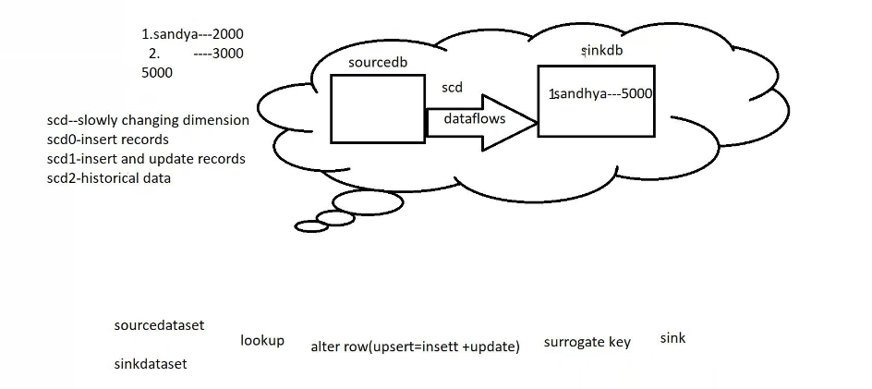
Create database source side : create table in this
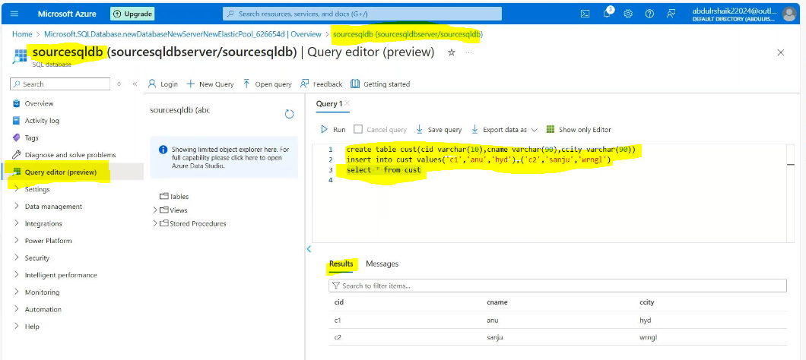
Create database for sink side: in this data base upload the schema like source side add 1 more key column for sink side for unique key purpose
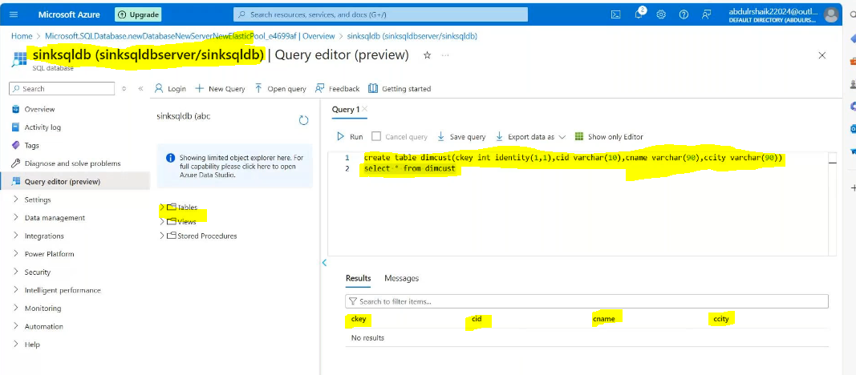
Create a datafactory:
Create a linked service for source side:
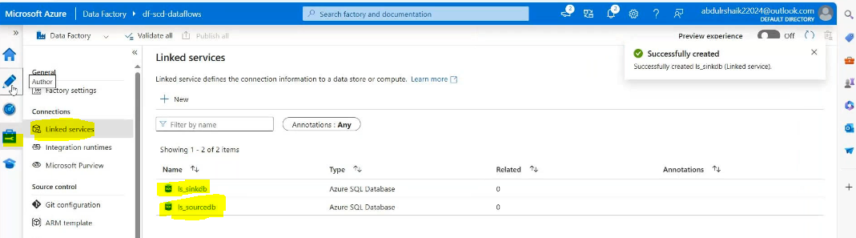
Create dataset for source side:
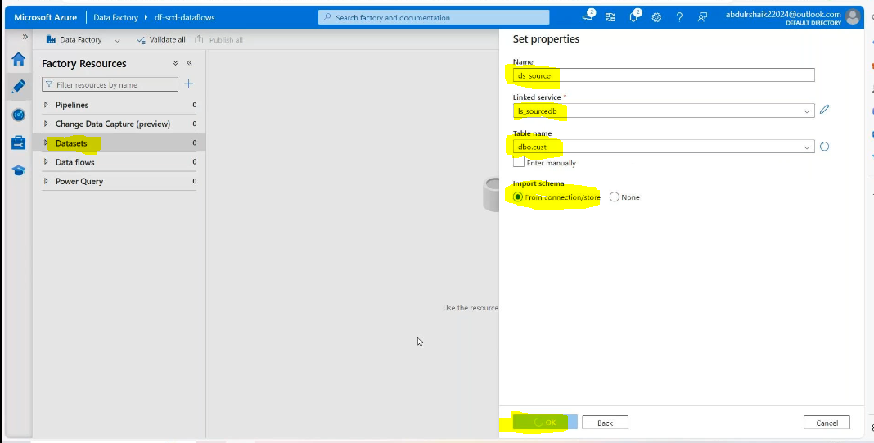
Create dataset for sink side:
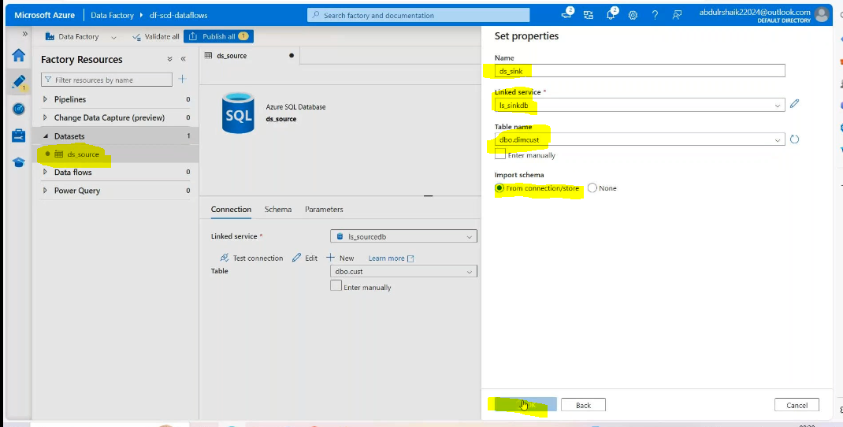
Create dataflow: Add source in that Add source side database
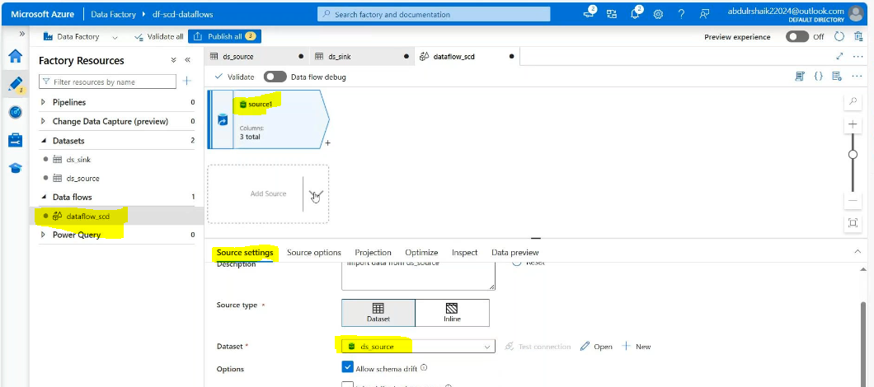
Add source in that Add sink side database
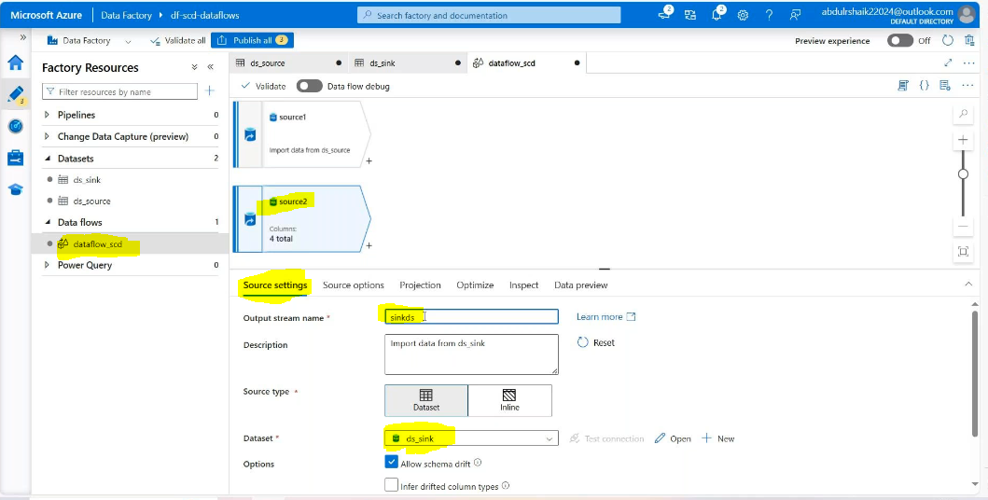
Enable the debug mode:
Data preview source side and sink side:
Then call look up activity:
Add source side and sink side

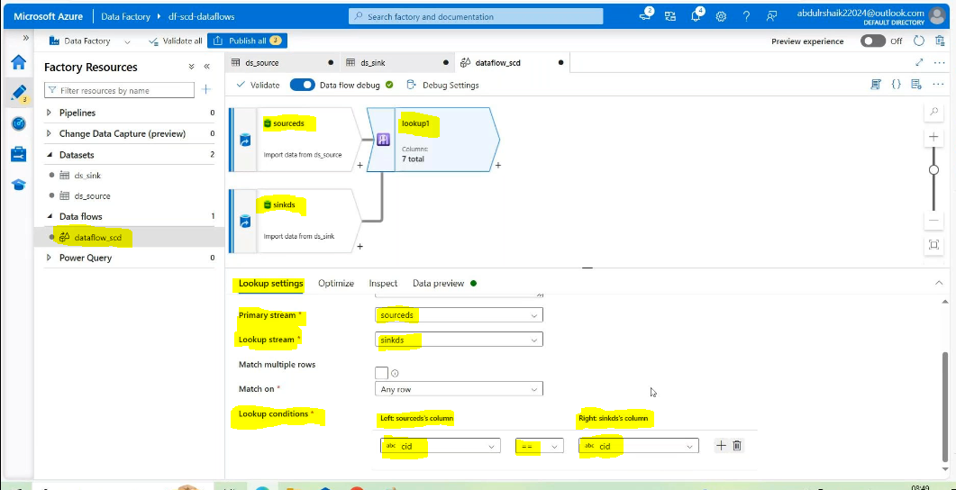
Data preview:
Then ADD ALTER ROW SOURCE IT WILL DO UPSERT (UPDATE THE RECORDS AND INSERT THE RECORDS)
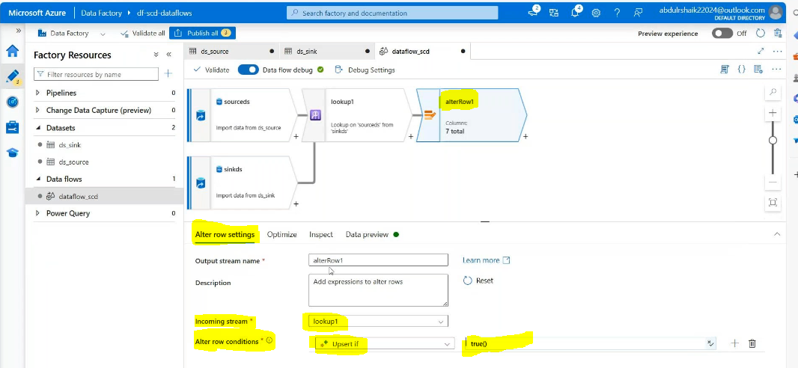
Datapreview:
Then Add select source here:
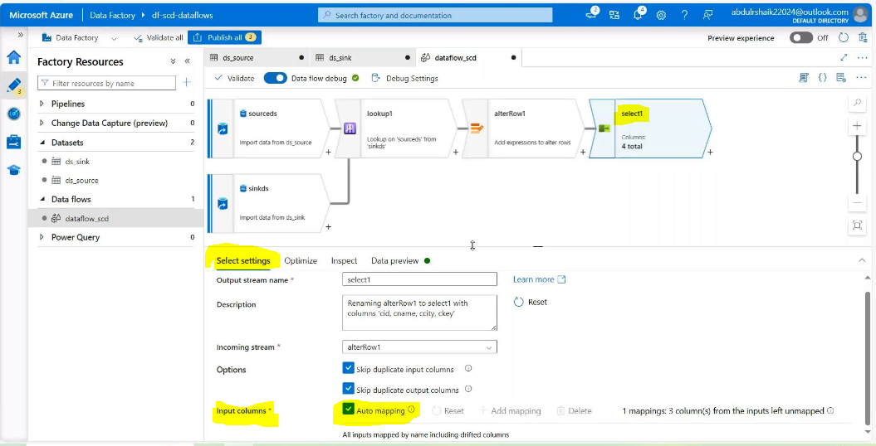 Datapreview:
Then Add sink source
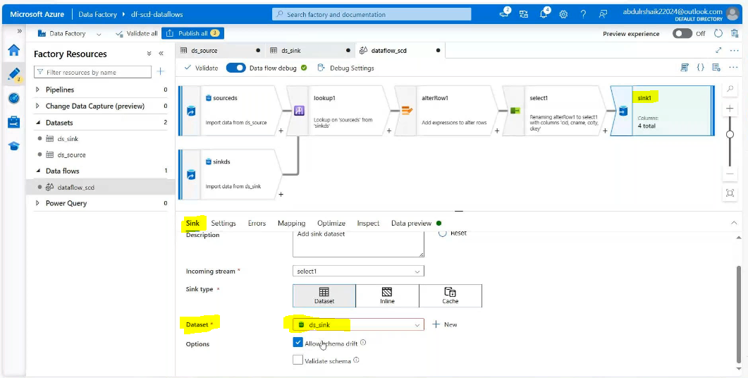
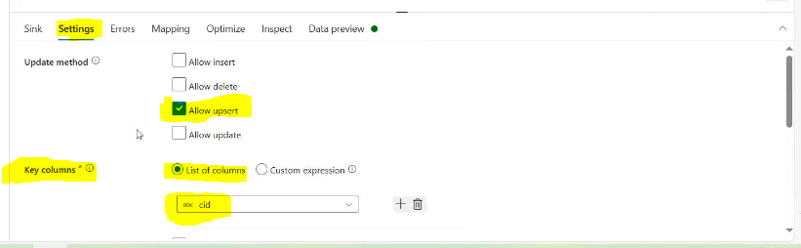
Inmapping level delete the ckey
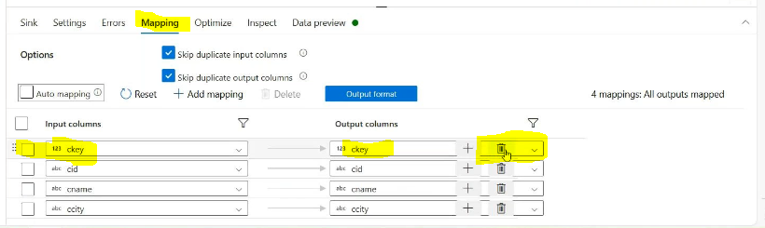
Data preview:
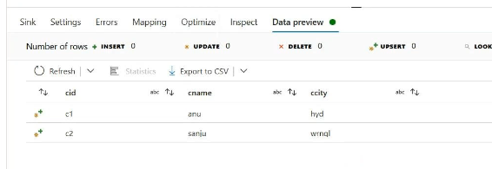
Create 1 pipeline :drag Dataflowsetingsadd dataflowvaldateDebug
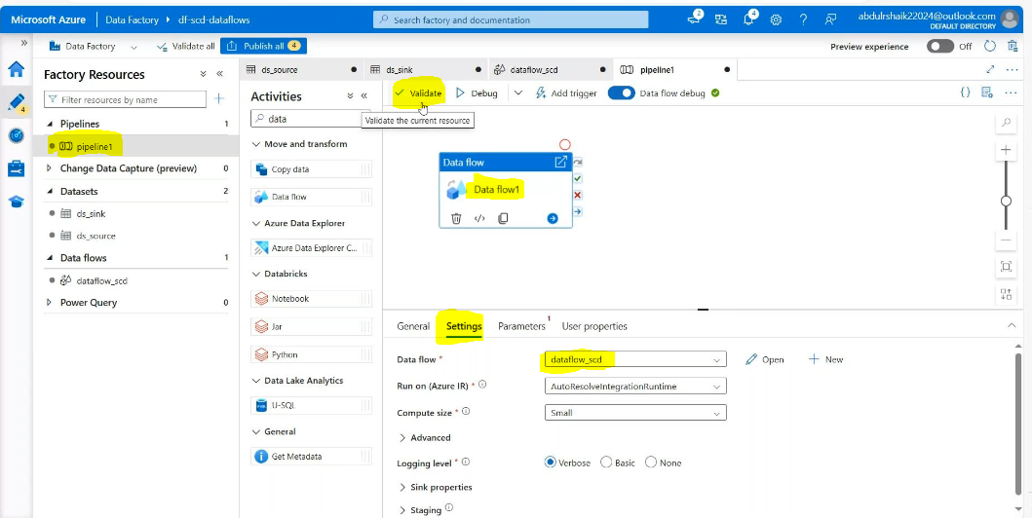

Validate and debug
Result:
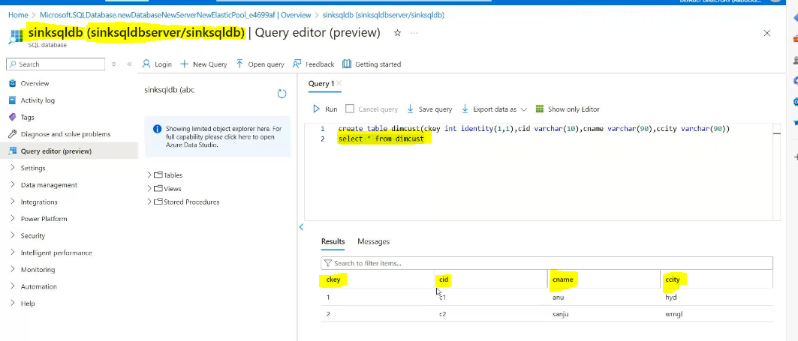

Then
Add some records one is duplicate record other one is new record
From source data base:
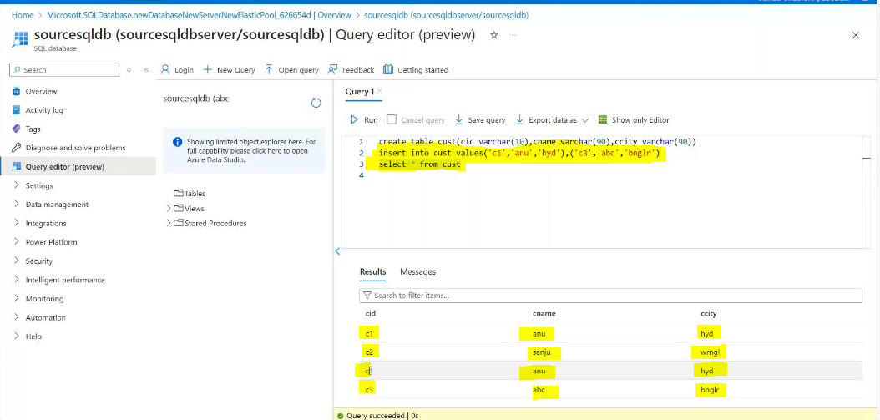
Then validate the pipeline and debug:
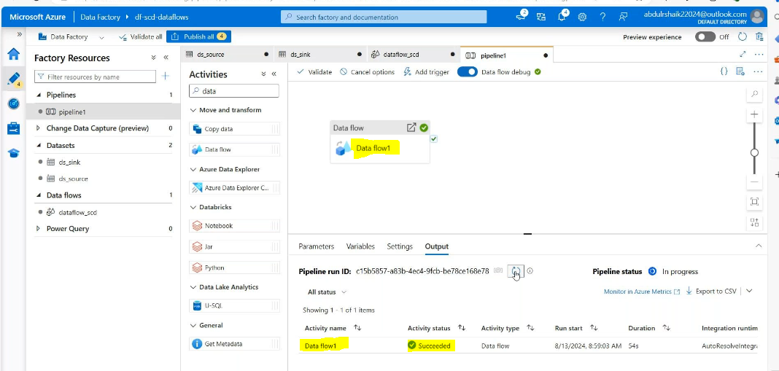
Result:
