NAME-GOVIND
ROLL-2501630016
COURSE-B.TECH CSE(AI & ROBOTICS)
DESCIPLINE-SOET
PROGRAM-PYTHON

REPORT ON PROJECT

• Programming Language: Python
• Concepts Used:
- Lists
- Loops (while)
- Conditional statements (if-elif-else)
- Input/Output
- Basic arithmetic operations

MAIN DISPLAY
Inside an infinite while True loop, a menu is shown with four options:
- Add Food Item
- Add Exercise
- View Summary
- Exit

Add Food Item
- The user enters the name of the food.
- Then they enter the calories.
- The calories are stored in the food_log list.
- A confirmation message is shown.

Add Exercise
- The user enters the exercise name.
- Then they enter calories burned.
- The value is saved in the exercise_log list.
- A message is displayed to confirm.

View Summary
The program calculates:
- Total Calories Consumed → sum of food_log
- Total Calories Burned → sum of exercise_log
- Net Calories → consumed − burned
It then displays the results with messages:
- If net calories > 0 → consumed more
- If net calories < 0 → burned more
- If net calories = 0 → perfect balance

Exit
- Shows a farewell message
- Breaks the loop and ends the program.

Invalid Option Handling
If the user enters any other number, the program prints:
❌ Invalid choice. Try again.

Conclusion
This program is a beginner-friendly Python project that demonstrates:
✔ User input handling
✔ Lists and loops
✔ Real-world calorie tracking
✔ Conditional logic for summaries
MY SOME OUTPUT FORM THIS PROJECT

OUTPUT

  - 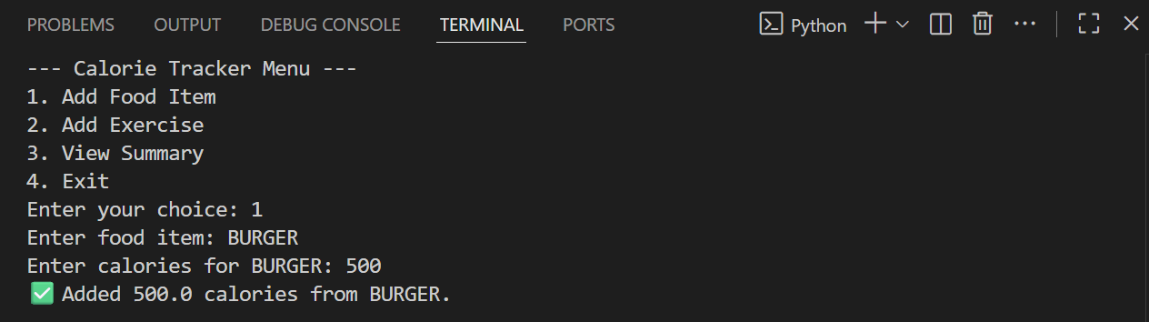

2.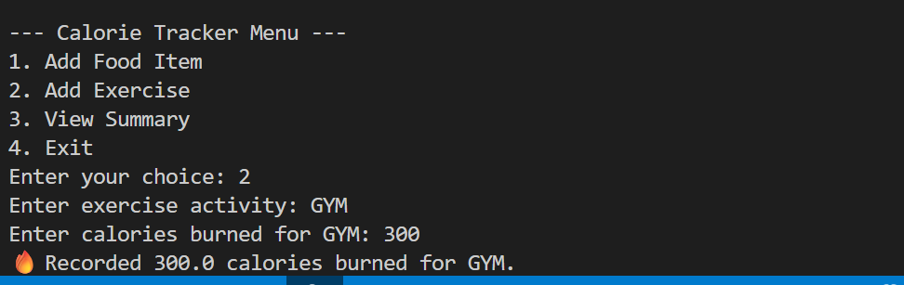

3.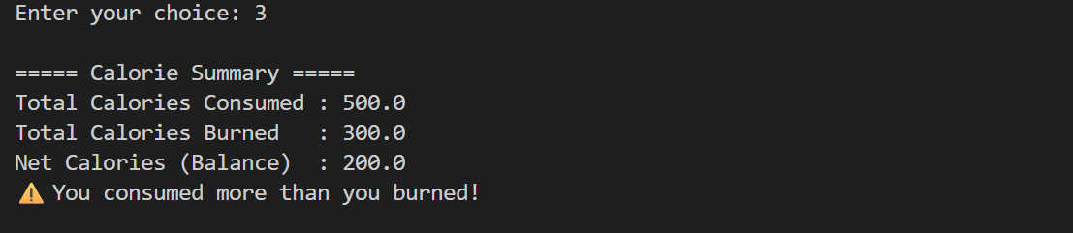

4.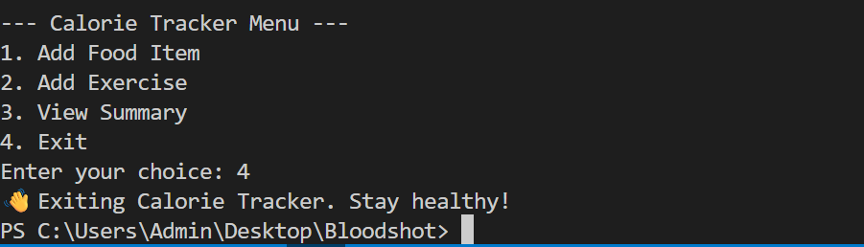

THANK YOU

