Data Structures (ETCCDS202)
Unit–2 Assignment: Linear Data Structures

Name: govind
Roll No.: 2501630016
Program -CSE Robotics and AI
Course Title: Data Structures
Submitted to: Aarti Sangwan
Submitted by: govind

Task 1: Dynamic Array Simulation (Like Python List)

Goal: To understand and simulate the resizing logic of a dynamic array, similar to how a Python list handles memory allocation.
Implementation Logic:
- Capacity Management: The array starts with a small initial capacity (e.g., 2).
- Resizing: When the number of elements matches the current capacity, a new internal array is created with double the previous capacity.
- Element Transfer: All existing elements are copied from the old array to the new, larger array before the new element is appended.
Amortized Time Complexity of append():
- Worst-Case: When the array is full, the append() operation triggers a resize, which requires copying n elements. This specific operation is O(n).
- Average Case: Most append() operations simply involve inserting an element into an empty slot, which is O(1).
- Conclusion: Because the doubling of capacity happens infrequently, the "expensive" O(n)operations are spread out over many O(1) operations. Therefore, the amortized time complexity for append() is O(1).
- 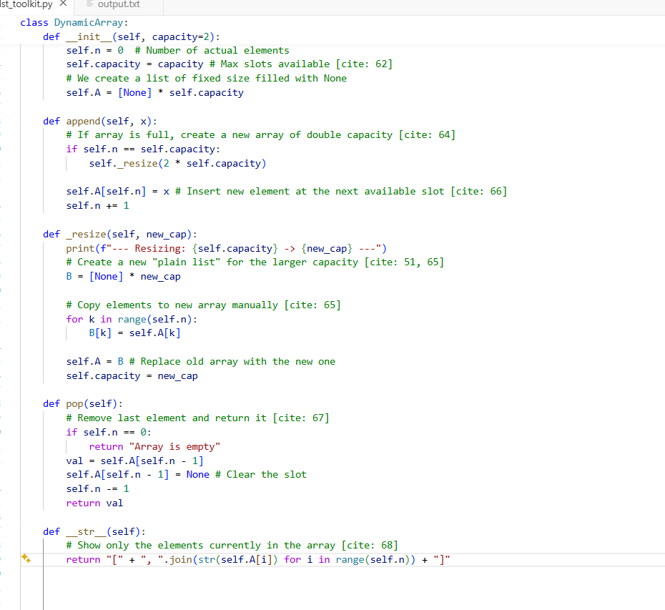

- 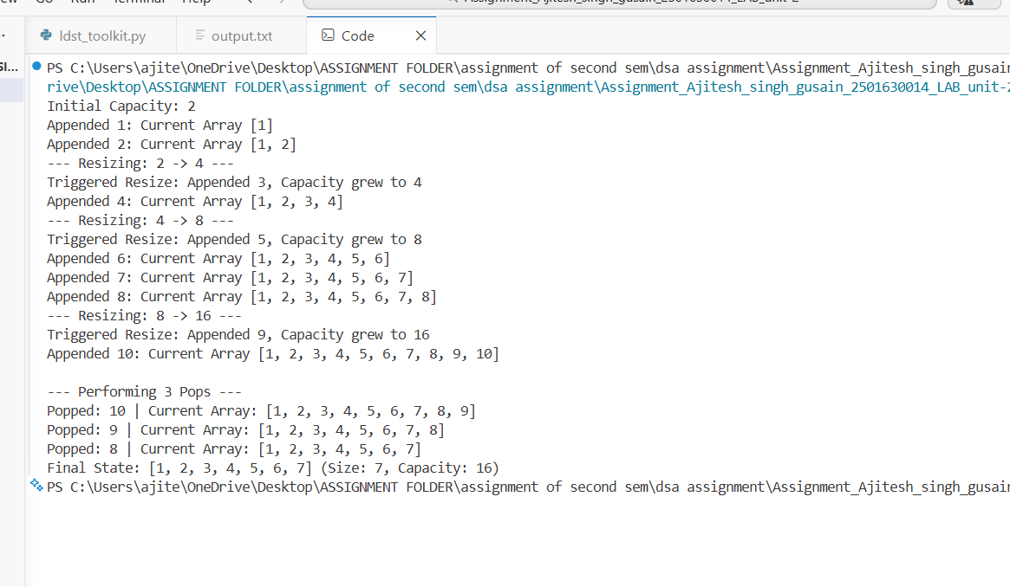

Task 2: Linked List Operations

Advantage: Unlike arrays, linked lists do not require shifting elements during insertion or deletion, making these operations O(1) if the pointer is already at the location.
Doubly vs Singly: The Doubly Linked List allows for bidirectional traversal and easier deletion of a node if you only have a reference to the node itself.

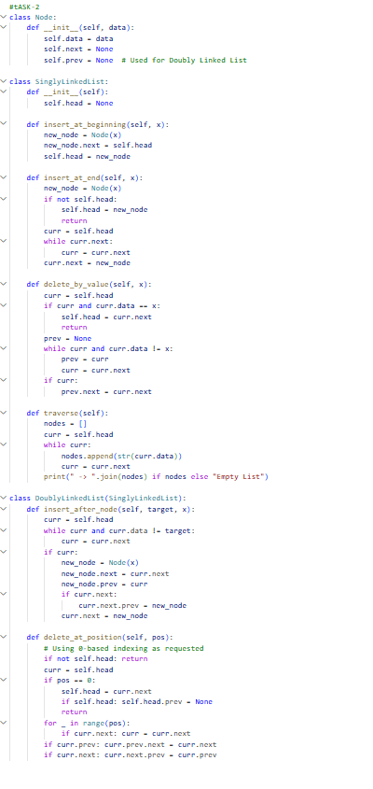

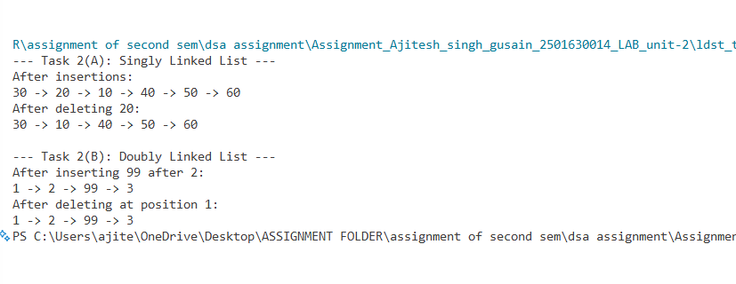
Task 3: Stack & Queue From Scratch (Using Singly Linked List)
To ensure O(1) efficiency for the Stack, we perform all operations at the head. For the Queue, we maintain a tail pointer so that adding to the back is also O(1).
Operation | Time Complexity | Explanation
Stack Push/Pop | O(1) | Performed at the head of the linked list; no traversal needed.
Queue Enqueue | O(1) | Achieved by maintaining a tail pointer to the end of the list.
Queue Dequeue | O(1) | Performed by moving the head pointer forward one step.
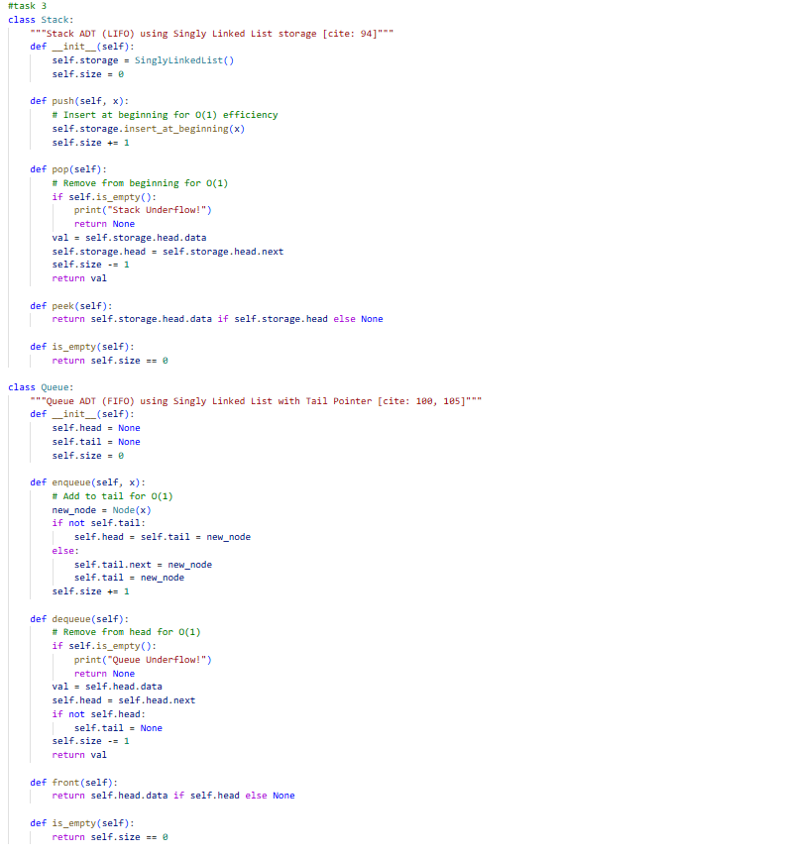
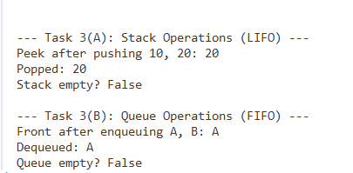

Task-4
Task 4: Application - Balanced Parentheses Checker
Goal: To apply the Stack Data Structure to solve a real-world expression validation problem.
1. Implementation Logic
- Algorithm: The function is_balanced(expr) iterates through each character of a string.
- Pushing: Whenever an opening bracket ((, {, [) is encountered, it is pushed onto the custom Stack.
- Popping: When a closing bracket (), }, ]) is encountered, the top element of the Stack is popped and compared.
- Validation: The expression is considered unbalanced if a closing bracket does not match the popped opening bracket, or if the Stack is empty when a closing bracket appears.
- Final Check: After processing the entire string, the Stack must be empty for the expression to be truly balanced.
2. Required Test Case Results
Input String | Expected Result | Logic Applied
"([])" | Balanced | [ and ( are pushed; then ) matches ( and ] matches [.
"([)]" | Not Balanced | [ and ( are pushed; ] is encountered but does not match the top (.
"(((" | Not Balanced | Three ( are pushed, but the stack remains non-empty at the end.
"" (empty) | Balanced | No brackets to process; stack starts and ends empty.

3. Complexity Analysis
- Time Complexity: O(n), where n is the length of the string, as we traverse the string exactly once.
- Space Complexity: O(n) in the worst case (e.g., a string of all opening brackets), as they are all stored in the Stack

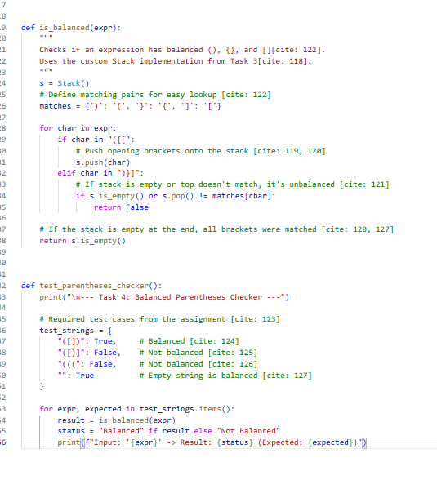
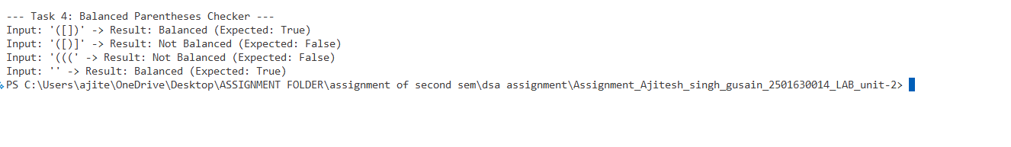

Github link - https://github.com/govind-ui2007/assignment-2---govind--2501630016/blob/main/ldst_toolkit.py

