Cold Chain Intelligence

Exploratory Data Analysis and Project Plan
Team SEC02_Contextual_Odyssey · Client: Contextual IO, for Harbor Table Foods · 5 November 2026
Companion files: EDA_dashboard.pptx (slide dashboard, one takeaway per slide) and EDA_infographic.pdf (one-page summary). All figures and numbers are reproducible with the scripts in 01_exploratory_analysis/eda_deliverable/.

1. From raw data to clean data
Question: what did cleaning change, add and remove, and how much of the data is usable? Data used: the original zip (511 controller .txt exports, 20 operations CSVs) and data/cleaned_v2/. Source: the team's raw-to-clean summary (00_raw_to_clean_summary.md), checked against data/cleaned_v2/.

1.1 Headline numbers
 | Raw | Clean
Controller files | 511 .txt reports | 12 CSVs (4 per plant)
Point-blocks (one point, one report, one day) | 30,284 | 29,810
Hourly values | 726,816 | 715,440
Usable hourly values (value_clean filled) | not separable | 635,787 (88.9%)
Operations files / rows | 20 / 26,440 | 12 / 26,440
Lines that could not be parsed |  | 0
Table 1. Raw versus clean data, all three plants, Apr–Sep 2026.
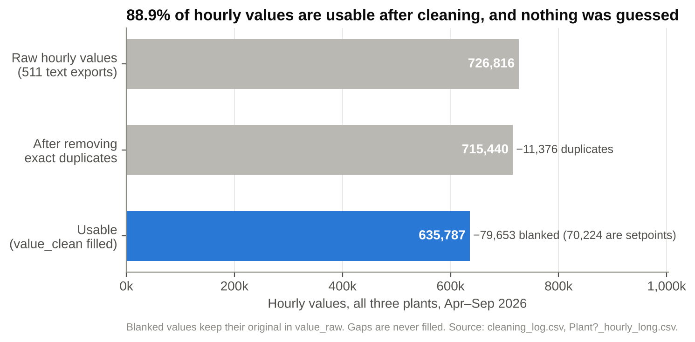
Figure 1. Hourly values at each cleaning step.
Takeaway: 88.9% of hourly values are usable. Most of the 11.1% that is blank is Plant B setpoints that were never exported (70,224 values), not lost sensor readings. Only 11,376 exact duplicates were removed; everything else is kept.
How to read it: Each bar is a count of hourly readings. The top bar is everything the controllers exported; each bar below shows what is left after one cleaning step.
In plain terms: The controllers exported about 727,000 hourly readings. About 11,000 were exact copies of other readings, so we removed them. Another 80,000 were kept but marked as unusable, and almost 9 in 10 of those are Plant B setpoints that were never exported at all. What remains, about 636,000 readings (89%), is good data.
Why it matters: Everyone can trust the numbers in the rest of the report: nothing was made up or filled in, every original value is still stored, and each unusable reading carries a label saying why. The low usable rate at Plant B is missing setpoints, not missing sensor readings.

1.2 What was removed
- 474 exact duplicate point-blocks (11,376 hourly values). Plant A: 314 (UC-3/4 Pre-Weigh and its setpoint exported twice). Plant B: 160 (V-2 Intercooler Pres. exported twice). Plant C: none.
- Nothing else was deleted. No operations rows were removed.

1.3 What was blanked (kept in value_raw, blank in value_clean)
Flag | Plant | Hourly values | Why
setpoint_unavailable | B | 70,224 | Setpoint channels read 0.0 because they were never exported (all months except 4 June days)
sensor_disconnected | B | 8,064 | Dead sensors reading 459.6 (UC-7 Boxing And Dock, UC-4 Filling Room)
export_truncated_zero_fill | A | 680 | 2026-09-15 hours 14–23: controller lost communication, export wrote zeros
implausible_value | C (372), A (1) | 373 | Back Dock sensor reading 130–283 °F; one negative vessel level
stuck_value | A | 312 | UC-25 flat for 7 days (2026-08-04 to 08-10)
Total |  | 79,653 (11.1%)
Table 2. Blanked values by flag. Readings lost to bad data, leaving out the setpoints that were never exported, are 9,429 (1.3% of all hourly values); this is the count used throughout the report. By plant: Plant A 993 blank (0.4%), Plant B 78,288 (20.4%, almost all setpoints), Plant C 372 (0.5%).

1.4 What was changed (standardized)
Change | Before | After
Distinct point names, Plant B | 121 | 85 (variable spacing collapsed)
Distinct unit strings | 10 | 7 standard units (degF, psig, psid, pct_level, pct_FLA, pct_open, cycles)
Point-blocks with an inconsistent unit fixed | 7,742 | 0
Hourly rows re-dated (file named 06-05, data from 06-04) | 816 | 0
Dock-door close times clipped at 23:59, recomputed | 9 | 0
'24:00' schedule end times converted | 106 | 0
'(not acknowledged)' alarm placeholders | 83 | 0 (boolean column)
Detector events with location 'various' | 18 | 0 (filled from asset register)
Monthly files merged (dock doors, weather) | 10 | 2
Table 3. Standardization changes.

1.5 What was added
- Controller: timestamp, hour, point_id, point_label, is_setpoint, measures_point (5,985 setpoint blocks linked to their measured point), compressor, value_clean, quality_flag, date_corrected, source_folder, source_file, plus cleaned and recomputed columns in the daily summaries.
- Coverage files listing every date and report group, and why missing ones are missing.
- Operations: 17 new columns across 8 tables (for example acknowledged, duration_min, start_ts, end_ts, temp_applicable, and plant on weather).

1.6 What was deliberately not changed
- 34 missing report groups on 15 days in Apr–May and Jul–Sep (Plant A 6 groups on 4 days, Plant B 22 on 5 days, Plant C 6 on 6 days) are not filled.
- 559 receipts with blank temperatures are dry goods and packaging, so they are marked not applicable, not missing.
- Back Dock drift below 130 °F, idle compressors, transfer counters, and the controller's own summary lines are kept as exported.

1.7 What it means for EDA and modeling
- Use value_clean and rows where quality_flag is blank.
- Plant B's high blank rate is setpoints, not lost measurements. Its learned normals need history, not setpoints.
- Before comparing periods, check *_coverage.csv; June is a sparse sample (8 days for A and B, 6 for C).

Summary
Guiding question (from our problem statement): How can Harbor Table Foods automatically turn its nightly controller reports into an accurate daily review and the right alerts, so that sudden and slow-building problems are caught early, explained, and sent to the right person, without flooding staff with false alarms?
Overall takeaway: the nightly reports already carry the warning signs. The hard part is separating them from broken data, weather and chronic noise. The EDA supports four design choices:
- Flag bad data before any rule runs. 9,429 hourly readings are dead sensors, a stuck sensor, outage zeros or an impossible 130–283 °F dock reading. Plant B's dead sensor alone produces 8,064 readings of 459.6 °F.
- Learn normal per point and hour, but keep the food-safety rule beside it. 3.5% of cold-room hours are above 41 °F, and three rooms hold 83% of them. A purely learned "normal" would absorb those chronic rooms.
- Read the 15-minute summary line for slow trends. The 02:45 freezer spike set the daily high on 150 of 159 days, and hourly values miss its peak by 3 °F on average.
- Explain readings with context. Engine-room temperature tracks the weather (r = 0.99), so the fan fault only shows as the engine-minus-outdoor gap. Today's controller alarms run at 26.6 a week, 70% from three chronic rooms, while 6 of 12 logged faults never alarmed on their own point.
Important caveat: June 2026 controller data is real (8 days for Plants A and B, 6 for Plant C). April–May and July–September are simulated, and the operations records (work orders, shift log, alarms, detectors, dock, receiving, schedule, weather, energy) cover only those simulated months. We use June as the realism check and the simulated months for scoring.

2. High-level project plan
Milestones run from the start of the semester project to the final presentation. Dates after today are estimates. The final demo is planned for early December 2026; we will confirm the exact date. Each milestone names the SMART goal it moves forward (G1 read every file, G2 reproduce the six reviews, G3 catch the June 9 events, the 02:45 trend by day two and at least 80% of test faults, G4 at most 2 false alerts per plant per week, G5 forecast 15% better than yesterday's values).
Week (2026) | Milestone | Key deliverables | SMART goal | Status
Oct (wk 1) | Ingest and inventory | Parser for both export layouts; 715k-row tidy table; point inventory; coverage calendar | G1 | Done
Oct (wk 2) | Data quality and review check | Quality flags (dead, stuck, outage, implausible); 309 review numbers traced; 26-event ground-truth map | G1, G2 | Done
Oct–Nov 3 | Plant A baseline | Hour-of-day normals, rules, drift and weather models; scored against known events | G3, G4 | Done (development result)
Nov 2–6 | EDA and project plan | This report, slide dashboard, infographic; analysis plan v1 | All | This week
Nov 9–13 | Client check-in 1; Plant B and C baselines | Answers on thresholds, setpoints and data feed; lead/lag and spiral-freezer regimes; Plant C step and trend detection | G3, G4 | Planned
Nov 16–20 | Detection and context | Event grouping, washdown/maintenance suppression, cause and severity; one scoring module for all plants | G3, G4 | Planned
Nov 23–27 | Reporting and alerts (short week) | Daily review generator in the five-part format with source links; alert levels and routing; forecast baseline | G2, G5 | Planned
Nov 30–Dec 4 | Validation and build on Contextual | Day-by-day replay of all months; scorecard against the success criteria; Object Types, Flows, Agents and a Site | All | Planned
Early Dec | Final presentation | Demo, scorecard, handover notes | All | Planned
Table 4. Project milestones. Status as of 5 November 2026.

3. Analysis plan (living table, version 1)
Each sub-question breaks down the guiding question. The last column says whether we have the data, need it from the client, or don't yet know where it lives. We will re-show this table in later updates whenever a row changes, with the change noted below it.
Sub-question | Analysis or method | What it produces | Tools | Data needed | Data status
SQ1. Data quality and report trust: can we read every file, separate broken sensors and gaps from real readings, and check the human reviews? | Parse both layouts into one table; rule-based quality flags; coverage calendar; compare each review number with the raw value | Clean tidy table with quality_flag; data-health list; review error log (2 found so far) | Python (pandas), regex parser | Have: controller exports (Apr–Sep), six reviews  Client: a live or hourly export to test ingest at production cadence | Have (core); client for the live feed
SQ2. Normal behavior: what does normal look like for each point, by hour of day, day type and operating regime? | Robust median and MAD by hour × weekday/weekend, trained on Apr–May; regime labels (Plant B compressor lead/lag, spiral freezers on/off); correlation of co-moving points | Normal band per point and hour; list of ~15 modeled points per plant; chronic-condition list | Python (pandas, numpy, scipy), matplotlib | Have: hourly values, production and sanitation schedule (simulated months)  Client: Plant B setpoint history and Plant C setpoints  Unknown: defrost schedule per evaporator | Have (values); client (setpoints); unknown (defrost)
SQ3. Sudden events: can we catch faults like June 9 the same day and rate their severity? | Persistence rules (cold room above 41 °F for 2+ h; receiver ≤1% for 2+ h during production); count of points deviating together; replay day by day | Alerts with priority and evidence; time-to-detect per known event | Python, rule engine; later Contextual Flows | Have: hourly values, ground-truth events  Client: final thresholds and escalation times; June detector data (272 ppm exists only in review text); sub-hourly or alarm feed | Have (data); client for thresholds and June ammonia
SQ4. Slow trends and forecasts: can we flag slow builds like the 02:45 spike by day two, and forecast next-day readings? | EWMA and Theil-Sen trend on daily summary highs and times; change-point detection (Plant C Queso chiller); same-hour-yesterday forecast baseline, then a model that beats it | Low-priority trend alerts; days-to-detect for E03, E04, E10, E25; forecast error vs baseline | Python (scipy, scikit-learn, statsmodels) | Have: daily summary lines (15-minute high/low/avg), Apr–Sep history  Unknown: whether longer real history (2025) exists and where it lives | Have; unknown for longer history
SQ5. Context and false alarms: which readings have a known cause, and how few alerts can we send while still catching real faults? | Join alerts to sanitation windows, dock-door events, work orders and weather; engine-room-minus-ambient regression; compare current alarm log with known events | Suppressed and explained alerts with reasons; false alerts per plant per week; routing table | Python, SQL joins; Contextual Agents for explanations | Have: schedule, dock, receiving, weather, work orders, shift log, alarms (simulated months)  Client: June operations records, on-call roster and channels  Unknown: which evaporators are switched off on purpose | Have (simulated months); client (June records, roster); unknown (evaporators off)
Table 5. Analysis plan v1, 5 November 2026. Change log: v1, first version.

4. Descriptive statistics
All statistics use value_clean (invalid readings blanked, gaps never filled) from data/cleaned_v2. They cover 1 April to 30 September 2026. June has only 8 sampled days for Plants A and B and 6 for Plant C.

4.1 Dataset overview
Plant | Hourly rows | Measured points | Setpoints | Days with data | Report groups | Groups present (full months) | Groups present (June sample) | Measured readings flagged
Plant A | 257,664 | 31 | 19 | 159 | 2 | 300/306 | 16/60 | 0.43%
Plant B | 384,336 | 66 | 19 | 160 | 6 | 896/918 | 39/180 | 2.58%
Plant C | 73,440 | 20 | 0 | 153 | 1 | 147/153 | 6/30 | 0.51%
Table 6. 715,440 hourly rows from 155 points (117 measured, 38 setpoints). Missing report groups in full months: Plant A 6, Plant B 22, Plant C 6.

4.2 Data quality
Issue | Plant | Hourly readings | What it looks like | Handling
Dead sensor | B | 8,064 | 459.6 °F every hour; summary says −459.67 (absolute zero) | Blank, flag sensor_disconnected
Outage zeros | A | 680 | Every point, including setpoint channels, 0.0 after 14:00 on 15 Sep | Blank, flag export_truncated_zero_fill
Failing sensor | C | 372 | Back Dock reads 130–283 °F | Blank above 130 °F, flag implausible_value
Stuck sensor | A | 312 | UC-25 flat for 7 days (4–10 Aug) | Blank, flag stuck_value
Negative level | A | 1 | V2 liquid level −18.8% | Blank, flag implausible_value
Setpoints not exported | B | 70,224 | All setpoints 0.0 except 10–30 June | Blank, flag setpoint_unavailable
Table 7. 9,429 invalid readings, plus 70,224 unavailable Plant B setpoint readings. The human reviews were checked: 309 numbers, 296 exact matches, 13 matches after rounding or hourly-vs-summary quoting, and 2 text errors in the 9 June review.

4.3 Key points
Plant | Point | Unit | n | Mean | SD | Min | P5 | Median | P95 | Max
A | UC-5 Ready To Eat | °F | 3,806 | 36 | 1.4 | 32.9 | 34.1 | 35.8 | 38.8 | 52.2
A | UC-6 Ready To Eat | °F | 3,806 | 40.6 | 1.5 | 37.4 | 38.8 | 40.3 | 43.9 | 52.8
A | UC-3/4 Pre-Weigh | °F | 3,806 | 41.6 | 4.4 | 35 | 38.1 | 40.3 | 53.8 | 56.3
A | UF-3 QFM | °F | 3,806 | 17.7 | 2 | 13.5 | 15.8 | 17.5 | 19.6 | 47.7
A | HPR V1 Level | % | 3,806 | 26.7 | 3.8 | 0 | 20 | 27.6 | 31.4 | 40.3
A | Discharge Pressure | psig | 3,806 | 150.2 | 8.7 | 77.1 | 135.1 | 150.6 | 163.8 | 173.2
A | UC-1 Engine Room | °F | 3,806 | 76.1 | 6.7 | 61.7 | 65.1 | 75.6 | 87.7 | 105.9
A | Ambient Temperature | °F | 3,806 | 74.1 | 8.9 | 53.5 | 58.6 | 74.2 | 89.8 | 98.3
B | UC-8 Fin. Goods Cooler | °F | 3,840 | 34.3 | 1 | 31.7 | 33.1 | 34.2 | 36.9 | 39.9
B | UF-1 Ingr. Freezer | °F | 3,840 | 15.4 | 8.9 | -5.9 | 7.8 | 12.2 | 33.8 | 69.5
B | SF-1 Spiral Freezer 1 | °F | 3,840 | -4.8 | 40.8 | -40.6 | -34.4 | -27 | 67.4 | 79.2
B | Discharge Pressure | psig | 3,840 | 151.9 | 7.8 | 116.1 | 139 | 152 | 164.8 | 177.4
B | Engine Room Temp. | °F | 3,792 | 76.9 | 5.6 | 62.4 | 67.7 | 76.6 | 86.3 | 103.7
B | Motor Load C01 | %FLA | 3,720 | 38.8 | 37.6 | 0 | 0 | 47.6 | 91.9 | 98.1
B | Motor Load C03 | %FLA | 3,696 | 86.9 | 9.3 | 0 | 78 | 87.8 | 95.8 | 105.5
C | Bulk Cooler 1 | °F | 3,672 | 37.6 | 1.5 | 31.6 | 35.1 | 37.6 | 40.1 | 42.6
C | Queso Cup Chiller | °F | 3,672 | 38.4 | 3.7 | 34.8 | 36.1 | 37 | 47.4 | 51.3
C | Protein Room Front | °F | 3,672 | 52.5 | 6.4 | 40.1 | 45.3 | 50.5 | 65.1 | 78.1
C | Freezer | °F | 3,672 | -3.2 | 2.9 | -10.6 | -7.1 | -3.7 | 1.8 | 18.2
C | Ambient Air | °F | 3,672 | 75.4 | 11.5 | 50.3 | 57.2 | 74 | 96 | 111.1
Table 8. Hourly values, Apr–Sep 2026. Wide spreads mark regimes, not faults: spiral freezer SF-1 sits warm when off (SD 40.8 °F), and C-01 load swings with the weekly lead/lag swap. Full table for every point: descriptive_stats_by_point.csv.

4.4 Cold rooms and the 41 °F limit
We define a cold room as a temperature point whose median is between 30 and 41 °F (24 rooms: 16 at Plant A, 4 at Plant B, 4 at Plant C). Across 90,642 valid room-hours, 3,174 (3.5%) are above 41 °F. 7 rooms never exceed it. The top three are UC-3/4 Pre-Weigh (Plant A, 30.48%), UC-6 Ready To Eat (Plant A, 24.65%), Queso Cup Chiller (Plant C, 14.73%).
Month | Plant A cold rooms | Plant B cold rooms | Plant C cold rooms | Outdoor A | Outdoor B | Outdoor C
2026-04 | 36.8 | 34.6 | 36.4 | 64.7 | 66.8 | 64.1
2026-05 | 37.1 | 34.6 | 36.6 | 71.9 | 74.2 | 69.8
2026-06 (real) | 37.4 | 34.6 | 36.7 | n/a | n/a | n/a
2026-07 | 37.5 | 34.6 | 38.2 | 80.2 | 81.5 | 79.2
2026-08 | 37.4 | 34.6 | 36.7 | 78.7 | 82.4 | 79
2026-09 | 37.1 | 34.6 | 36.6 | 73.7 | 76.9 | 72.1
Table 9. Mean temperature (°F) by month. Cold rooms hold within about 1 °F while outdoor temperature swings by 16 °F, so seasonality matters for the engine room and condensers, not the rooms. There are no weather records for June.

4.5 Operations records
Record | Rows | What stands out
Controller alarm history | 695 | 26.6 per week (A 15.9, B 4.4, C 6.4); 83 never acknowledged; median duration 60 min
Work orders (CMMS) | 671 | 496 preventive, 175 corrective; 19 not completed by 30 Sep
Operator shift log | 951 | Free text; timestamps unreliable to the hour, so use the text and the date
Dock door events | 4,882 | Median open 21.2 min, P95 37.9 min; Carrier K at door D4 went from 19.3 to 59.5 min after the seal tore (6 Jul)
Receiving log | 2,107 | 1,548 temperature-checked; 1 rejected
Ammonia detector events | 47 | All below the 25 ppm warning (max 17.5 ppm); GD-A-04 rising: 04: 2, 07: 1, 08: 5, 09: 18
Field rounds (handheld) | 4,912 | Twice-daily manual readings; independent check on controller values
Weather (hourly) | 11,016 | Mean outdoor temperature A 73.9 °F, B 76.4 °F, C 72.9 °F; peak 104.3 °F
Schedule, energy, assets | 592 / 459 / 92 | Production and washdown windows; daily kWh; equipment list linking doors to rooms
Table 10. Operations records, Apr–May and Jul–Sep 2026. The ground truth holds 26 known events, 15 of them real faults, slow builds or chronic conditions.

5. Preliminary findings
Each figure answers part of one sub-question. Headers state the point, gray marks are context, blue marks are the focus, and the dashed red line is the 41 °F limit.

SQ1 · Data quality
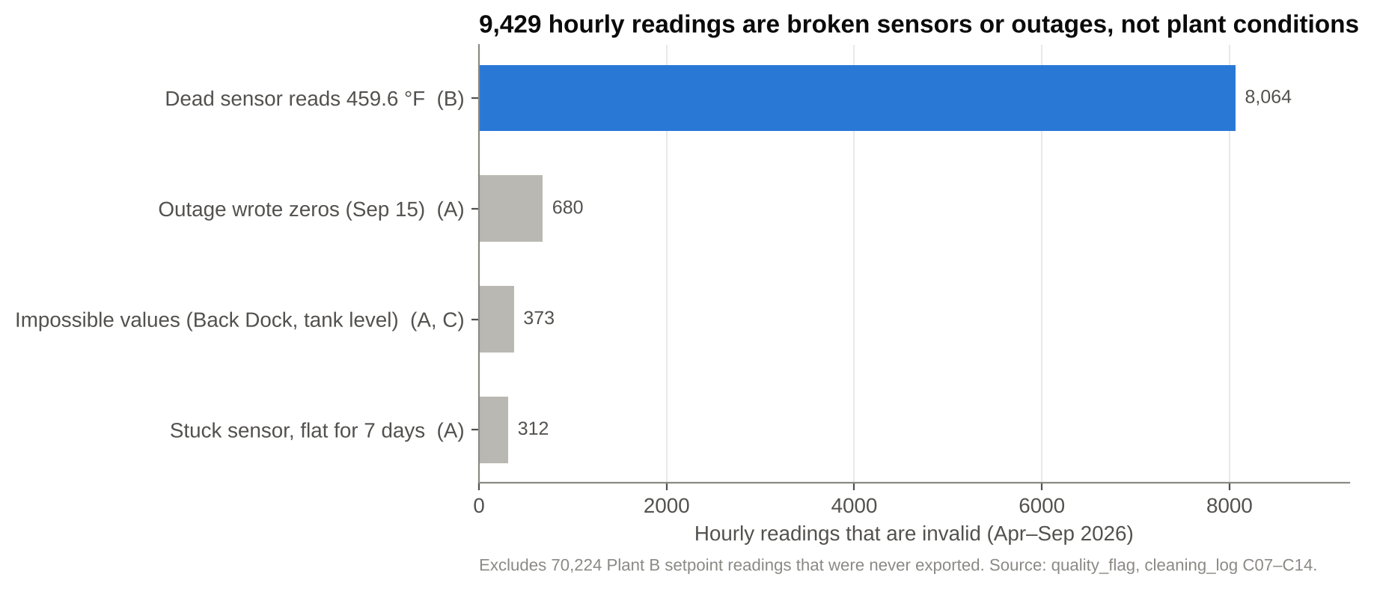
Figure 2. Invalid hourly readings by cause (excluding setpoints that were never exported).
Takeaway: Unflagged, Plant B's dead sensor alone would fire a 459.6 °F emergency every hour for months. Quality flags must run before any detection rule, and the 34 missing report groups must show as "no data", never as healthy.
How to read it: Each bar is one kind of bad data; its length is how many hourly readings it ruined.
In plain terms: Some sensors report nonsense. One disconnected sensor at Plant B says 459.6 °F every hour, which is impossible for a room. Another sensor got stuck on one number for a week, and on Sept 15 a controller lost connection and wrote zeros.
Why it matters: An alarm system that believed these would treat them as emergencies and page people for nothing. It has to recognize “this sensor is broken” before deciding “this room is in trouble.”

SQ3 · Sudden events
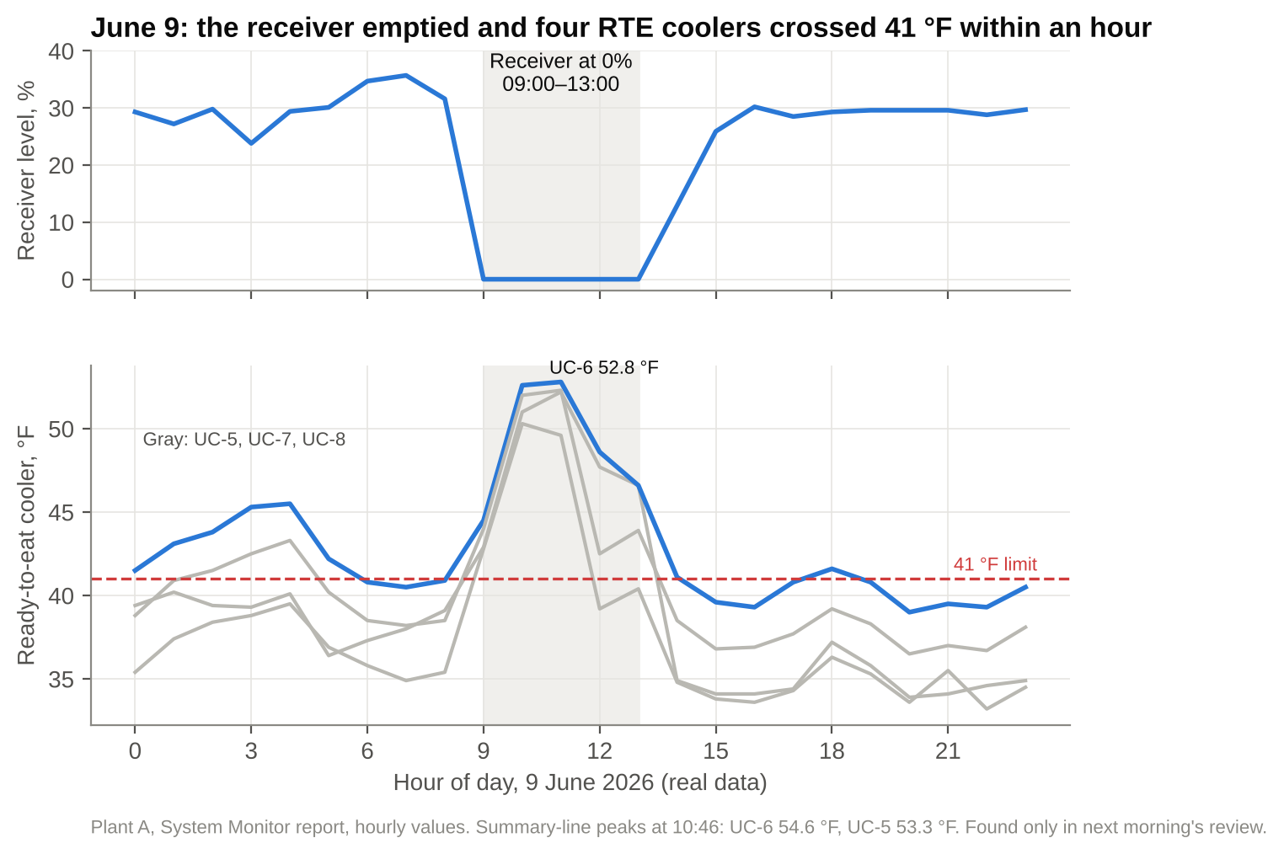
Figure 3. Plant A on 9 June 2026 (real data): receiver level and the four ready-to-eat coolers, hourly.
Takeaway: The receiver read 0% for 5 hours and discharge pressure fell from 154.1 to 77.1 psig. All four coolers were above 41 °F by 10:00. A same-day persistence rule fires at 09:00; today the event surfaces in the next morning's review.
How to read it: One day at Plant A, hour by hour. Top: the main ammonia supply tank (the receiver). Bottom: four coolers holding ready-to-eat food; the red dashed line is the 41 °F safe limit.
In plain terms: At 9 a.m. the tank ran empty and stayed empty until about 1 p.m. (shaded). Within an hour every cooler warmed past 41 °F, one to about 53 °F. When the tank refilled, the coolers cooled back down.
Why it matters: This was a real, serious problem, and nobody saw it until the next morning’s report. An automatic check would have raised it at 9 a.m.

SQ4 · Slow trends
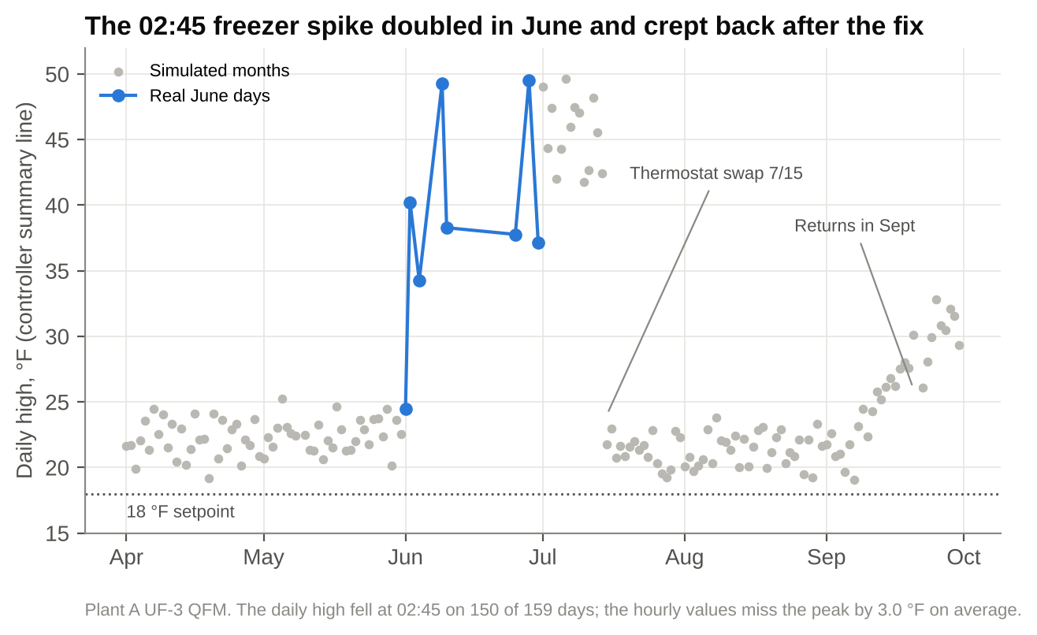
Figure 4. Plant A UF-3 QFM daily high from the controller summary line.
Takeaway: The daily high rose from about 22.3 °F to 40–49 °F in June, dropped after the 15 July fix, and crept back to about 31 °F by late September. Hourly values miss the 02:45 peak by 3 °F, so trend rules must read the summary line.
How to read it: Each dot is one day: the warmest the freezer got that day. Blue dots are real June data; gray dots are the simulated months.
In plain terms: Every night at 2:45 a.m. the freezer briefly warms. In spring the spike reached about 22 °F; in June it jumped to 40–49 °F. A part was replaced in mid-July and it went back to normal, then in September it started creeping up again.
Why it matters: No single night looks dramatic, so it is easy to miss. You only see it by watching the trend over several days, using the controller’s daily summary, because hourly readings mostly miss the short spike.

SQ5 · Context: weather
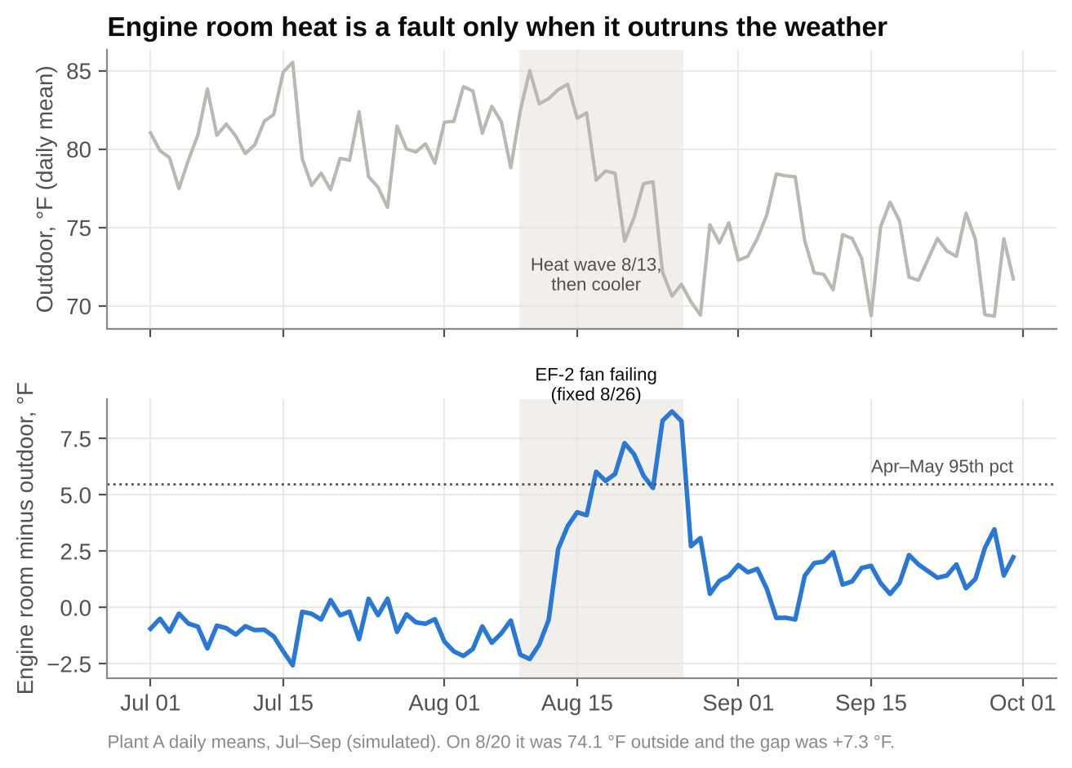
Figure 5. Plant A outdoor temperature (top) and engine room minus outdoor (bottom), daily means, Jul–Sep.
Takeaway: The hottest stretch (8/13, 83.8 °F) had a normal gap of +2.6 °F. The failing EF-2 fan showed as +7.3 °F on 8/20, when it was only 74.1 °F outside. Model the gap, not the raw temperature, or heat waves will page people and real faults will hide.
How to read it: Top: outdoor temperature. Bottom: how much hotter the engine room was than outside.
In plain terms: The engine room normally runs a little warmer than outside, so hot days are fine. In the mid-August heat wave the gap stayed normal. A week later it cooled off outside, but the engine room stayed hot and the gap shot up to 7–8 °F: a failing exhaust fan. After the fan was fixed on Aug 26 the gap went back to normal.
Why it matters: Watching raw temperature gives false alarms every heat wave and can miss a real fault on a mild day. The useful number is the gap: is the engine room hotter than the weather explains?

SQ5 · Context: false alarms
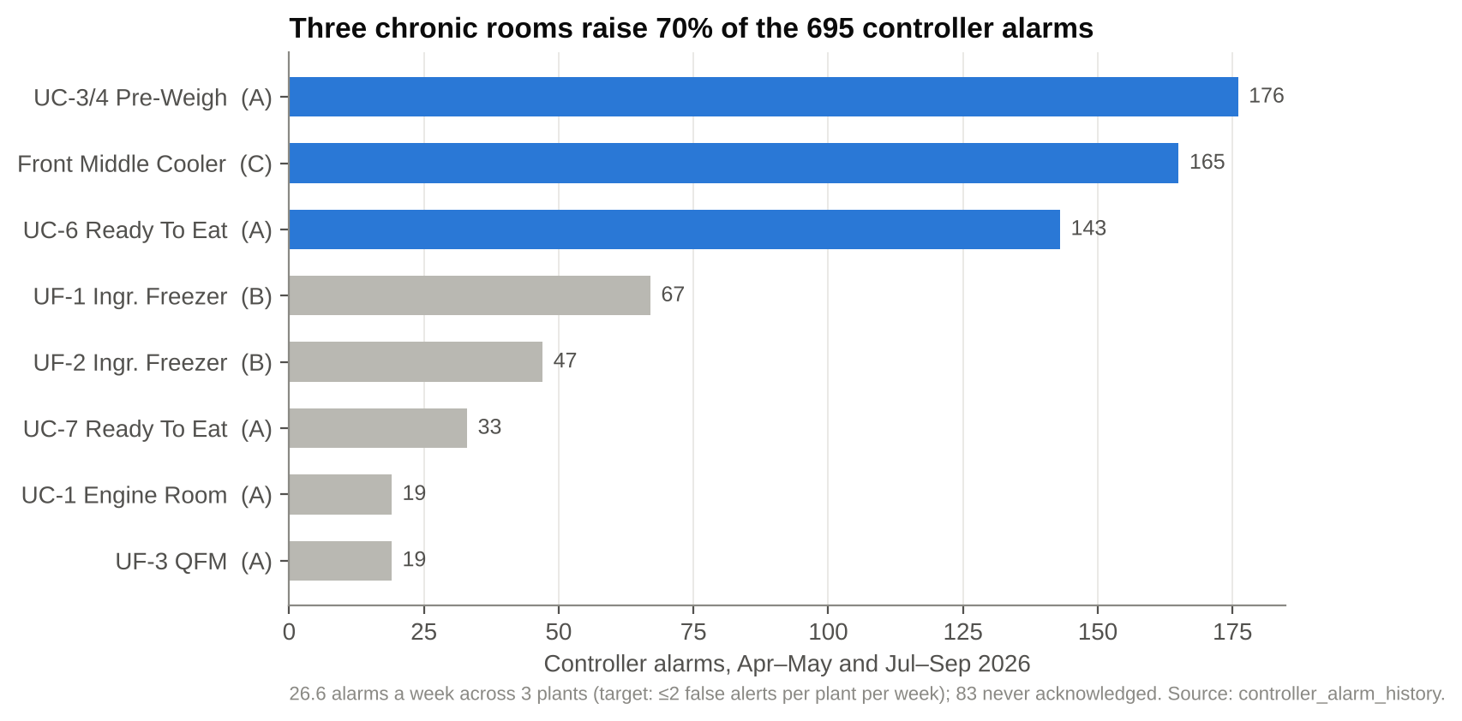
Figure 6. Controller alarms by point (top 8 of 12), Apr–May and Jul–Sep.
Takeaway: Three chronic rooms raise 70% of alarms and 83 were never acknowledged. At the same time, 6 of 12 logged faults (E10, E16, E17, E18, E24, E25) never alarmed on their own point, including E10, the possible refrigerant loss. More thresholds will not fix this; context and trends will.
How to read it: Each bar is one room or freezer; its length is how many alarms it set off over five months.
In plain terms: Today’s alarm system goes off about 27 times a week, mostly from three rooms that are always a bit warm and keep going off. Staff have stopped reacting: 83 alarms were never acknowledged.
Why it matters: It is the “boy who cried wolf” problem. Meanwhile half of the real problems we know about, including a possible ammonia leak, never set off an alarm on their own sensor. More alarms will not help; knowing what is normal, what explains a reading, and which slow trends matter will.

SQ2 · Normal behavior
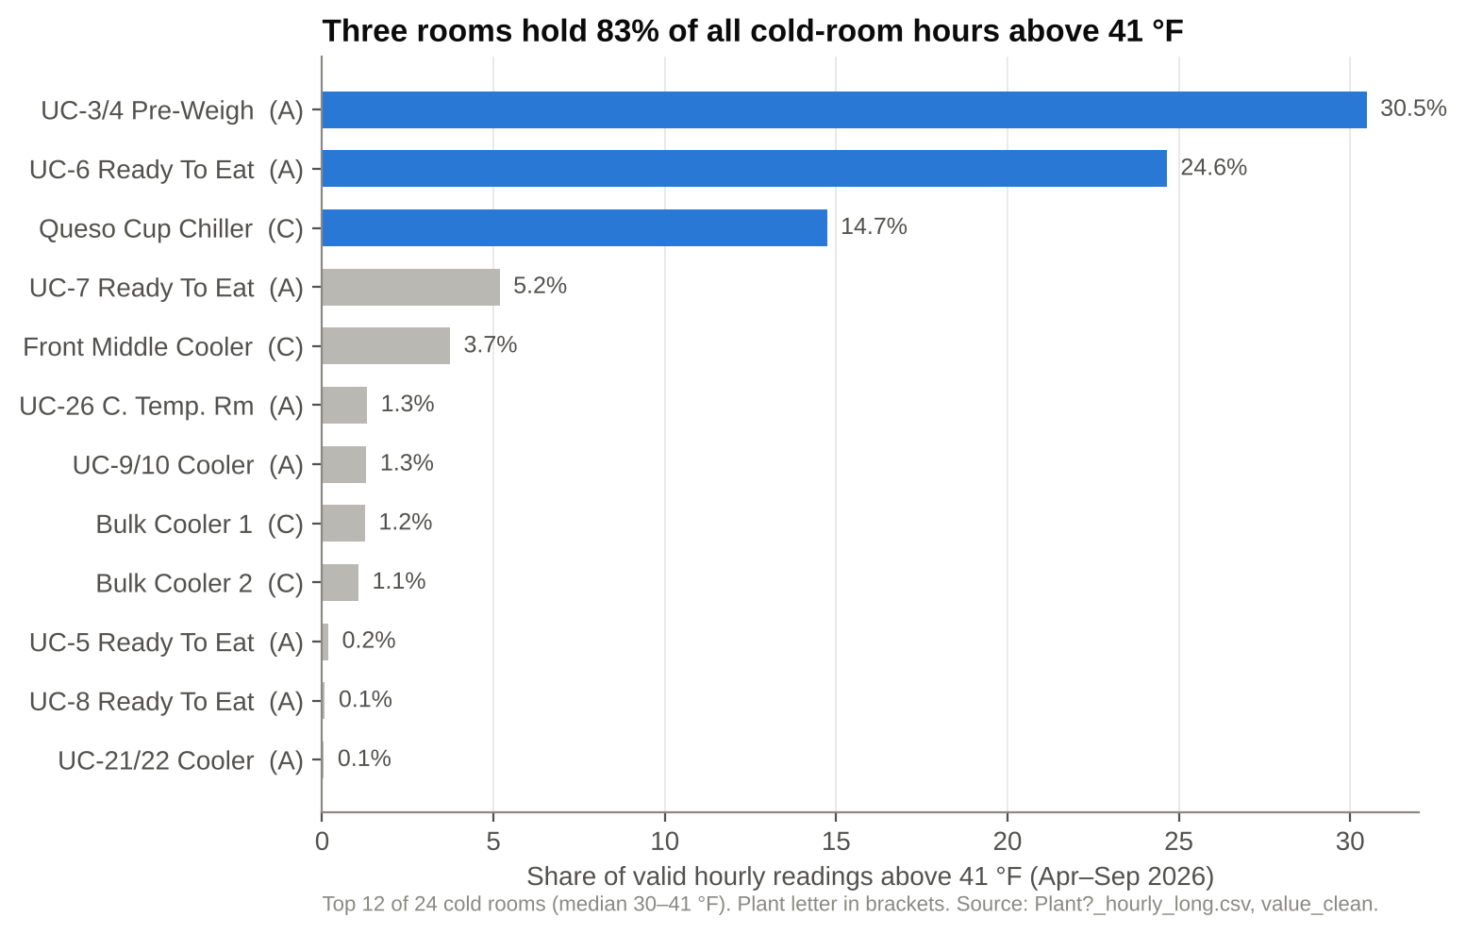
Figure 7. Share of valid hours above 41 °F, top 12 cold rooms.
Takeaway: Food-safety exposure is concentrated: three rooms hold 83% of out-of-limit hours. A "normal" learned from history would treat them as healthy, so the model keeps a fixed 41 °F rule and a standing alert for chronic rooms beside the learned bands.
How to read it: Each bar is a cold room; its length is the share of hours it spent above the 41 °F safe limit.
In plain terms: Most cold rooms almost never go above 41 °F. Three rooms account for most of the time over the limit; one pre-weigh room is over about 30% of the time.
Why it matters: The food-safety risk is concentrated in a few rooms. A system that learns “normal” from the past would decide these rooms are fine because they are always warm, so keep a fixed 41 °F rule and flag chronic rooms once as an ongoing issue, not as a daily alarm.

6. Overall takeaway and next steps
The sudden and slow faults we checked are visible in data the plants already export. A detector that flags bad data first, learns normal per point and hour, reads the 15-minute summary lines for slow trends, and explains readings with weather, schedules and work orders can beat today's status quo of 27 alarms a week, most of them chronic repeats.
- Build Plant B baselines conditioned on compressor lead/lag and spiral-freezer regimes, and Plant C baselines with step and trend detection.
- Add washdown suppression to Plant A. All 10 unexplained Plant A High alerts in Jul–Sep fall inside a scheduled UC-7 washdown.
- Score every plant with one module against the 26 known events, reporting detection rate, days to detect and false alerts per plant per week.

Questions for the client
- Is there a faster-than-nightly feed (hourly export or live alarms)? It decides whether a Critical alert can arrive in time.
- Are 41 °F for 30 minutes, the escalation times and the ammonia limits final?
- Can you share Plant B setpoint history, Plant C setpoints, and the defrost schedule per evaporator?
- Do June operations records exist (detector logs, work orders, shift log)? The 272 ppm reading appears only in the review text.
- Who is on call at each plant, and which channels (SMS, Slack, Teams) do they use?

Limitations
- Simulated months drive most findings except Figure 3 and the June points in Figure 4. Simulated patterns may be cleaner than reality; for example, Plant B cold-room monthly means do not move at all.
- Rules for Plant A were adjusted after a first run, so July–September is a development result, not a held-out test.
- Hourly data cannot resolve the 30-minute food-safety rule; we approximate it with two consecutive hours and use the summary line for short transients.

