CREATE TABLE sap_dept(did NUMBER PRIMARY KEY,dname VARCHAR2(45) NOT NULL);

DESC sap_dept;

INSERT INTO sap_dept VALUES(1,’HR’);

INSERT INTO sap_dept VALUES(2,’Finance’);

INSERT INTO sap_dept VALUES(3,’Production’);

INSERT INTO sap_dept VALUES(4,’IT’);

INSERT INTO sap_dept VALUES(5,’Testing’);

//COMMIT IN CASE COMMAND LINE

CREATE TABLE sap_empl(eid NUMBER PRIMARY KEY,ename VARCHAR2(45) NOT NULL,sal NUMBER CHECK sal>=5000, dept_id NUMBER,CONSTARINT emp_fk FOREIGN KEY(dept_id ) REFRENCES sap_dept(did));

DESC sap_;

INSERT INTO sap_empl VALUES(1001,’tom’, 5000, 1);

INSERT INTO sap_empl VALUES(1002,’ram’, 5000, 1);

……

SELECT CONSTRAINT_NAME, CONSTRAINT_TYPE FROM USER_CONSTRAINTS WHERE TABLE_NAME=’SAP_EMPL’;

SELECT CONSTRAINT_NAME, CONSTRAINT_TYPE FROM USER_CONSTRAINTS WHERE TABLE_NAME=’SAP_DEPT’;

SELECT OBJECT_NAME FROM USER_OBJECTS WHERE OBJECT_TYPE=’TABLE’;

//Query

SELECT * FROM sap_dept;

SELECT * FROM sap_empl;

Order By

SELECT * FROM sap_dept ORDER BY EID;

(ANS 17) SELECT * FROM sap_EMPL ORDER BY SAL DESC;

(ANS 18) SELECT * FROM sap_EMPL ORDER BY DEPT_ID, ENAME ;

(ANS 23) SELECT * FROM sap_EMPL ORDER BY SAL, ENAME ASC;

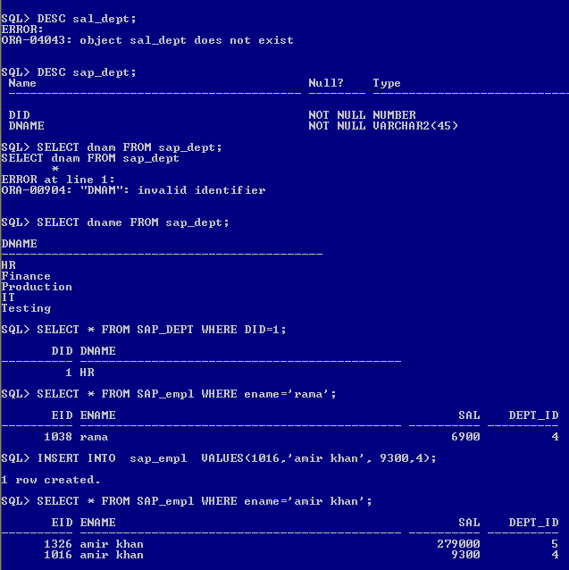

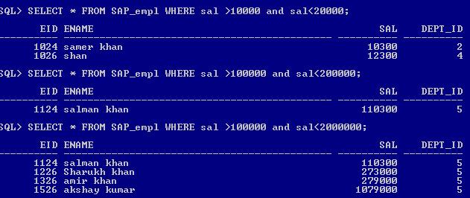

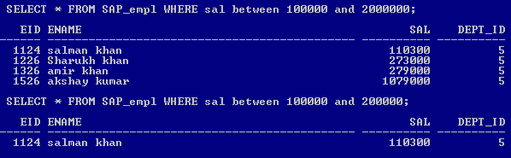

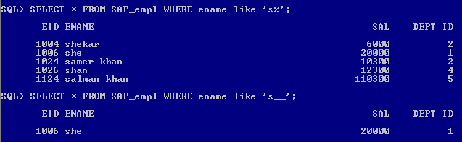

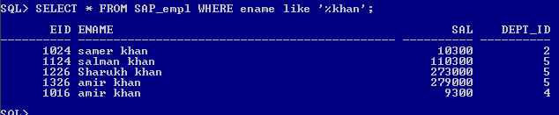

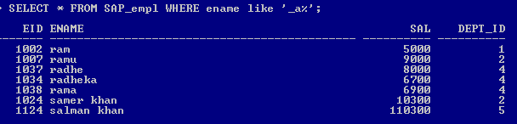

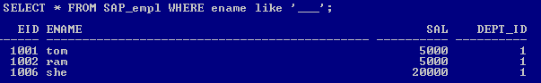

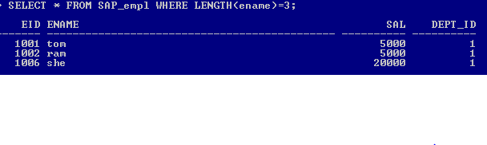

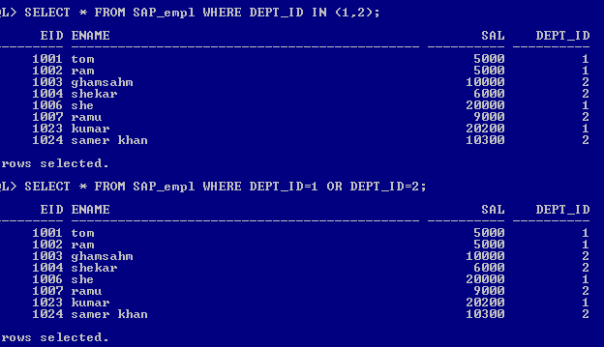

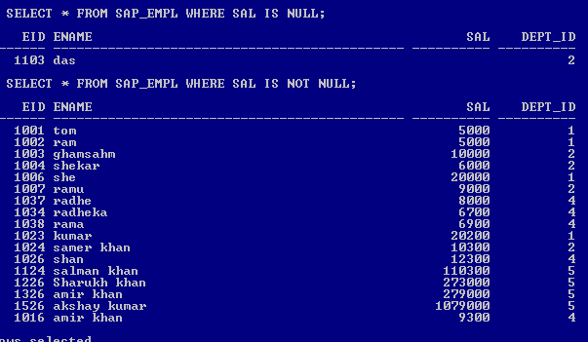

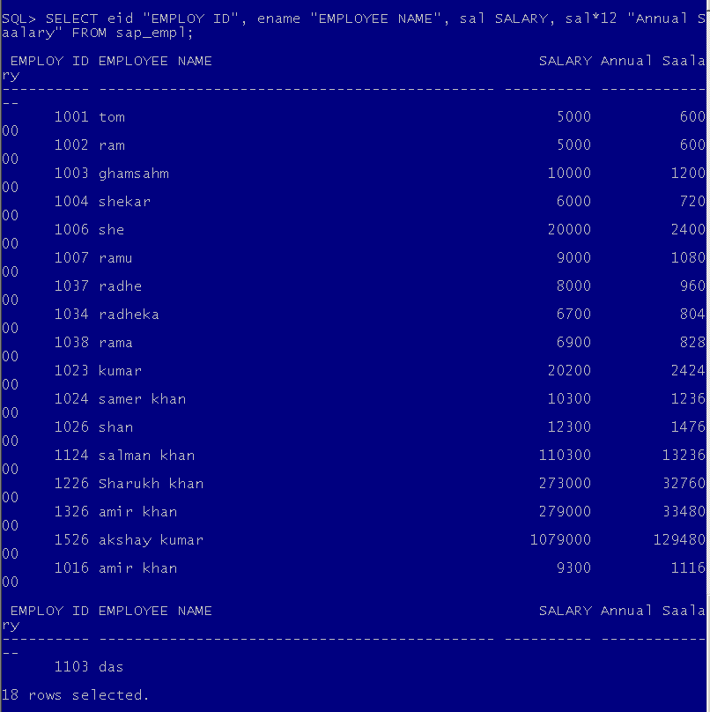

Session 2

SELECT did,UPPER(dname) FROM sap_dept

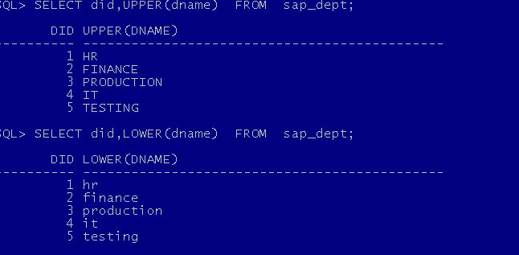

SELECT eid, INITCAP(ename) “Emp name” , LENGTH(ename) Lenght FROM sap_empl;

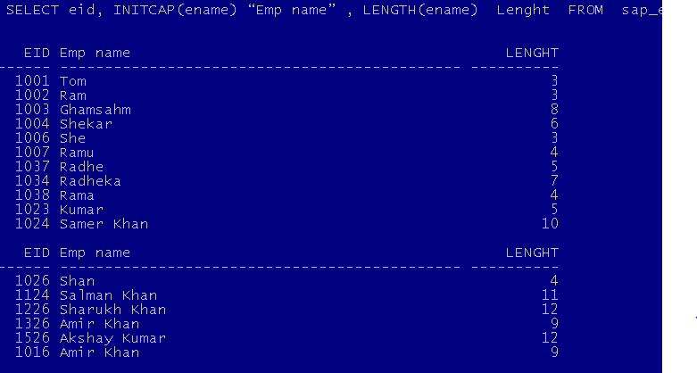

SELECT eid, SUBSTR(ename,1,4) “Emp name” FROM sap_empl;

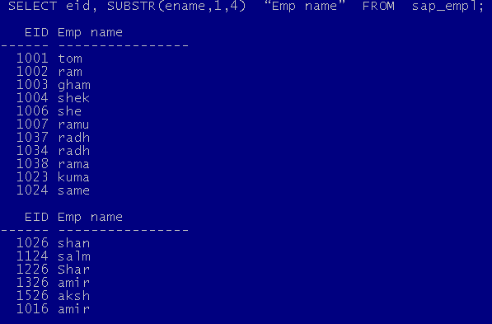

select trim(' ram ') from dual; // removes space both side to give ram

select LPAD(56781.32,20,'*') from dual; //************56781.32

select RPAD(56781.32,20,'*') from dual; /56781.32************

select concat('vikas','raj') from dual; /// vikasraj

select INSTR('sapient technologies','t') from dual;// 7 ‘t’ is 7th charater

select nvl(null, '-NA-') from dual;NVL(NULL,'-NA-')-NA-

select eid , ename,sal, nvl(to_char(sal),'NA') from sap_empl; // display NA in place of null

select power(3,3), mod(9,2), round(89.32323,2),ceil(34.4), floor(45.3), trunc(23.2344,2) from dual; 

select round(67.7),trunc(32.8) from dual;

 

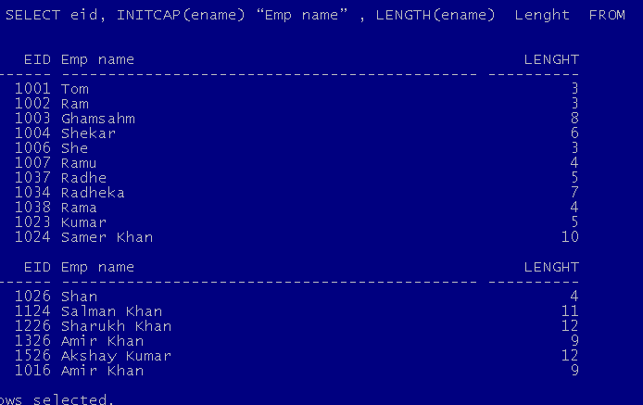

//Date

select TRUNC(MONTHS_BETWEEN('14-DEC-2011', '04-DEC-2010')) from dual; //12

select eid, ename, NULLIF(sal,5000) from sap_empl;

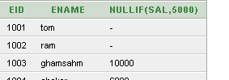

select count(eid), sum(sal),avg(sal), max(sal), min(sal), median(sal),stddev(sal) from sap_empl;



select avg(nvl(sal,0)) from sap_empl;// include null values

select dept_id,count(eid),sum(sal), max(sal) from sap_empl group by dept_id;

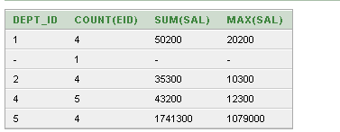

select dept_id, sum(sal), max(sal), count(eid) from sap_empl group by dept_id having count(eid)>4;



Table staff

CREATE TABLE staff(sid NUMBER PRIMARY KEY, sname VARCHAR2(20), doj DATE, sal NUMBER(10,2));

DESC staff;

ALTER TABLE staff MODIFY sal NUMBER(10,2);

select * from staff;

INSERT INTO staff values(1,'rama','02-aug-2012',15000);

INSERT INTO staff values(2,'trish','22-sep-2012',25000);

INSERT INTO staff values(3,'rav1','22-jan-2014',17000);

INSERT INTO staff values(4,'varun','09-feb-2016',27000);

INSERT INTO staff values(5,'tarun','09-mar-2015',19000);

INSERT INTO staff(sid,doj,sal,city) values(6,'06-mar-2017',29000,'pune');

ALTER TABLE staff ADD design varchar2(20);

ALTER TABLE staff ADD city varchar2(20) default 'delhi' NOT NULL ;

update staff set design='manager' where sal>=20000;

update staff set design='associate' where sal<20000;

ALTER TABLE staff MODIFY sname varchar2(20) default 'userx' NOT NULL ;

CREATE TABLE sap_dept(did NUMBER PRIMARY KEY,dname VARCHAR2(45) NOT NULL);

DESC sap_dept;

INSERT INTO sap_dept VALUES(1,'HR');

INSERT INTO sap_dept VALUES(2,'Finance');

INSERT INTO sap_dept VALUES(3,'Production');

INSERT INTO sap_dept VALUES(4,'IT');

INSERT INTO sap_dept VALUES(5,'Testing');

select * from sap_dept;

CREATE TABLE sap_emp(eid NUMBER PRIMARY KEY,

ename VARCHAR2(45) NOT NULL,

sal NUMBER(10,2) CHECK(SAL>=5000),

dept_id NUMBER,

CONSTRAINT emp_fk FOREIGN KEY(dept_id)

REFERENCES sap_dept(did));

DESC sap_emp;

INSERT INTO sap_emp VALUES(1001,'Ram', 5000, 1);

INSERT INTO sap_emp VALUES(1001,'Tom', 8000, 1); //Will give an error of primary key (unique)

INSERT INTO sap_emp VALUES(1002,'Tom', 3000, 1); //Will give an error for contraint check

INSERT INTO sap_emp VALUES(1002,'Tom', 8000, 5); //Will give an error -- parent key not found -- foreign key value must match the primary key in parent table

INSERT INTO sap_emp VALUES(1002,'Tom', 15000, 1);

INSERT INTO sap_emp VALUES(1003,'Sam', 23000, 1);

INSERT INTO sap_emp VALUES(1004,'Peter', 13000, 2);

INSERT INTO sap_emp VALUES(1005,'Shyam', 7000, 2);

INSERT INTO sap_emp VALUES(1006,'Ravi',27000, 2);

INSERT INTO sap_emp VALUES(1007,'Salman Khan', 37000, 3);

INSERT INTO sap_emp VALUES(1008,'Shahrukh Khan', 39000, 3);

INSERT INTO sap_emp VALUES(1009,'Rajesh', 18000, 3);

INSERT INTO sap_emp VALUES(1010,'Janit', 3418000, 3);

INSERT INTO sap_emp(eid, ename, dept_id) VALUES(1011, 'Tarun', 2);

SELECT CONSTRAINT_NAME, CONSTRAINT_TYPE FROM USER_CONSTRAINTS WHERE TABLE_NAME='SAP_DEPT';

SELECT CONSTRAINT_NAME, CONSTRAINT_TYPE FROM USER_CONSTRAINTS WHERE TABLE_NAME='SAP_EMP';

SELECT OBJECT_NAME FROM USER_OBJECTS WHERE OBJECT_TYPE='TABLE';

CREATE TABLE staff(sid NUMBER PRIMARY KEY, sname VARCHAR2(20), doj DATE, sal NUMBER(10,2));

ALTER TABLE staff MODIFY sal NUMBER(10,2);

select * from staff;

INSERT INTO staff values(1,'rama','02-aug-2012',15000);

INSERT INTO staff values(2,'trish','22-sep-2012',25000);

INSERT INTO staff values(3,'rav1','22-jan-2014',17000);

INSERT INTO staff values(4,'varun','09-feb-2016',27000);

INSERT INTO staff values(5,'tarun','09-mar-2015',19000);

INSERT INTO staff(sid,doj,sal,city) values(6,'06-mar-2017',29000,'pune');

ALTER TABLE staff ADD design varchar2(20);

ALTER TABLE staff ADD city varchar2(20) default 'delhi' NOT NULL ;

update staff set design='manager' where sal>=20000;

update staff set design='associate' where sal<20000;

ALTER TABLE staff MODIFY sname varchar2(20) default 'userx' NOT NULL ;

DELETE FROM staff WHERE sid=8;

UPDATE staff SET sal=(sal+sal*0.10);

DROP TABLE staff;

//RENAME COLUMN

ALTER TABLE staff RENAME COLUMN design TO job;

//drop column

ALTER TABLE staff DROP COLUMN city;

// add constraint

ALTER TABLE staff ADD CONSTRAINT staff_chk CHECK(sal>=2000);

// DROP constraint

ALTER TABLE staff DROP CONSTRAINT staff_chk;

// check for constraints FOR THE TABLENAME

SELECT * FROM USER_CONS_COLUMNS WHERE TABLE_NAME='STAFF';

SELECT CONSTRAINT_NAME,CONSTRAINT_TYPE FROM USER_CONSTRAINTS WHERE TABLE_NAME='STAFF';

// DROP USING PRIMARY KEY

ALTER TABLE staff DROP PRIMARY KEY;

// ADDING A PRIMARY KEY CONSTARINT

ALTER TABLE staff ADD CONSTRAINT S_PK PRIMARY KEY(sid);

//DEFAULT INDEX – PRIMARY KEY AND UNIQUE KEY

SELECT * FROM sap_emp;

// add new column to employee table

ALTER TABLE sap_emp ADD doj DATE;

// update doj

UPDATE sap_emp SET doj='03-jan-2012' where eid<=1003;

UPDATE sap_emp SET doj='07-Aug-2014' where eid<1006 and eid>1003;

UPDATE sap_emp SET doj='22-NoV-2016' where eid<=1009 and eid>=1007;

UPDATE sap_emp SET doj='13-jAn-2017' where eid>1009;

// ADD_MONTHS + 18 months

SELECT eid, ename, sal, doj, ADD_MONTHS(doj,18) "BOND PEROID" FROM sap_emp;

// format of date change dd, mm, mon, month, yy, yyyy, year

SELECT eid, ename, to_char(doj,'MM/dd/YYYY'),ADD_MONTHS(doj,18) "BOND PEROID" FROM sap_emp;

SELECT eid, ename, to_char(doj,'mon/dd/YEAR'),ADD_MONTHS(doj,18) "BOND PEROID" FROM sap_emp;

SELECT eid, ename, to_char(doj,'month/dd/yy'),ADD_MONTHS(doj,18) "BOND PEROID" FROM sap_emp;

// service

SELECT eid, ename, LPAD(sal,7,'*') as salary,to_char(doj,'month dd yyyy') as "JOINED ON",TRUNC(MONTHS_BETWEEN(sysdate,doj)/12) "SERVICE-YEAR", TRUNC(MONTHS_BETWEEN(sysdate,doj)) "MONTHS" , TRUNC(MONTHS_BETWEEN(sysdate,doj)*30) "DAYS"FROM sap_emp;

// current date

select sysdate from dual;

// SUB QUERIES

// max salary earned by emp

SELECT * FROM sap_emp WHERE sal=(SELECT MAX(sal) FROM sap_emp);

// MIN salary earned by emp

SELECT * FROM sap_emp WHERE sal=(SELECT MIN(sal) FROM sap_emp);

//BELOW Avg

SELECT * FROM sap_emp WHERE sal<=(SELECT AVG(NVL(sal,0)) FROM sap_emp);

//aboveAvg

SELECT * FROM sap_emp WHERE sal>=(SELECT AVG(NVL(sal,0)) FROM sap_emp);

// corelated max salary from each dept having full details

SELECT * FROM sap_emp el WHERE sal=(SELECT MAX(sal) FROM sap_emp WHERE dept_id=el.dept_id);

// corelated min salary from each dept having full details

SELECT * FROM sap_emp el WHERE sal=(SELECT MIN(sal) FROM sap_emp WHERE dept_id=el.dept_id);

// corelated below avg salary from each dept having full details

SELECT * FROM sap_emp el WHERE sal < (SELECT AVG(NVL(sal,0)) FROM sap_emp WHERE dept_id=el.dept_id) ORDER BY DEPT_ID;;

// corelated ABOVE avg salary from each dept having full details

SELECT * FROM sap_emp el WHERE sal > (SELECT AVG(NVL(sal,0)) FROM sap_emp WHERE dept_id=el.dept_id) ORDER BY DEPT_ID;

//JOINS

// INNER JOIN- only on relationship matching

SELECT e.eid,e.ename,e.sal,d.dname FROM sap_emp e INNER JOIN sap_dept d ON d.did=e.dept_id;

//left join

SELECT e.eid,e.ename,e.sal,d.dname FROM sap_emp e LEFT JOIN sap_dept d ON d.did=e.dept_id;

//right join

SELECT e.eid,e.ename,e.sal,d.dname FROM sap_emp e RIGHT JOIN sap_dept d ON d.did=e.dept_id;

//questions

SELECT e.eid,e.ename,e.sal,d.dname FROM sap_emp e INNER JOIN sap_dept d ON d.did=e.dept_id where e.dept_id=2;

SELECT e.eid,e.ename,e.sal,d.dname FROM sap_emp e INNER JOIN sap_dept d ON d.did=e.dept_id where d.dname='Finance';

SELECT max(e.sal) maxSal , count(e.eid) Total FROM sap_emp e INNER JOIN sap_dept d ON d.did=e.dept_id where d.dname='HR';

SELECT d.dname , max(e.sal) maxSal , count(e.eid) Total FROM sap_emp e INNER JOIN sap_dept d ON d.did=e.dept_id group by d.dname having d.dname='HR';

SELECT d.dname , max(e.sal) maxSal , count(e.eid) Total FROM sap_emp e INNER JOIN sap_dept d ON d.did=e.dept_id group by d.dname;

SELECT d.dname FROM sap_dept d LEFT JOIN sap_emp e ON d.did=e.dept_id where e.eid IS NULL;

SELECT d.dname FROM sap_dept d LEFT JOIN sap_emp e ON d.did=e.dept_id where e.eid IS NOT NULL group by d.dname;

//multiple and single subquery

// single

select * from sap_emp where sal=(select sal from sap_emp where eid=1001);

//multiple

select * from sap_emp where sal IN (select sal from sap_emp where dept_id=1);

select * from sap_emp where sal = ANY(select sal from sap_emp where dept_id=1);

select * from sap_emp where sal > ANY(select sal from sap_emp where dept_id=1);

select * from sap_emp where sal < ANY(select sal from sap_emp where dept_id=1);

select * from sap_emp where sal >= ALL(select sal from sap_emp where dept_id=3);

select * from sap_emp where sal <= ALL(select sal from sap_emp where dept_id=3);

select * from sap_emp where sal = ALL(select sal from sap_emp where dept_id=3);

// CREATE VIEW

CREATE OR REPLACE VIEW V1

AS

SELECT EID,ENAME, SAL,DEPT_ID FROM SAP_EMP;

//OPERATION ON VIEWS

SELECT * FROM V1;

INSERT INTO V1 VALUES(1012,'piku',22200,2);

// READ ONLY ON VIEWS

CREATE OR REPLACE VIEW V1

AS

SELECT EID,ENAME, SAL,DEPT_ID FROM SAP_EMP

WITH READ ONLY;

// READ ONLY virtual column not allowed here

INSERT INTO V1 VALUES(1012,'piku',22200,2);

CREATE OR REPLACE VIEW V2

AS

SELECT d.dname , max(e.sal) maxSal , count(e.eid) Total FROM sap_emp e INNER JOIN sap_dept d ON d.did=e.dept_id group by d.dname;

SELECT * FROM V2;

CREATE OR REPLACE VIEW V3

AS

SELECT e.eid, e.ename FROM sap_emp e;

INSERT INTO V3 VALUES(7,'ABC');

SELECT * FROM V3;

CREATE OR REPLACE VIEW V3 AS SELECT * FROM staff;

SELECT * FROM V3;

INSERT INTO V3 VALUES(7,'ABC','',1212,'d');

SELECT * FROM staff; // data is added here also

Drop table Staff;

//For seeing view object

SELECT OBJECT_NAME FROM USER_OBJECTS WHERE OBJECT_TYPE='VIEW';// view is present as it is definition only

//unique/primary keys in table referenced by foreign keys -> relationship present

Drop table sap_dept;