THE AI STOCK PLAYBOOK
July 2026 · 5 Catalyst Trades · 5 Long-Term Compounders · Full AI Stack Guide

Top picks, live data, and the exact AI workflow that found them
Every price, analyst target, and catalyst was pulled live from market data using OpenBB MCP + yfinance + TradingAgents. The stack is open-source, runs unattended, and is powered by Hermes Agent at www.myhermes.cloud.
5 picks  Catalyst trades (2–4 mo) | 5 picks  Long-term compounders | Live · July 2026  Data source | 6 agents  AI agents in the stack

Disclaimer: educational and entertainment only. Not financial advice. All prices are July 2, 2026 snapshots.
PART 1 — JULY 2026 PLAYBOOK
Top 5 Catalyst Trades · 2–4 Month Horizon

Market Snapshot — July 2, 2026
Asset | Price | vs 52-wk High | Read
S&P 500 (SPY) | $744 | −2% | Near all-time highs
Nasdaq 100 (QQQ) | $710 | −5% | Tech pulling back
Semis (SMH) | $578 | −14% | Correction — dip opportunity
Russell 2000 (IWM) | $254 | −6% | Small caps lagging
Bitcoin (IBIT) | $35 | −52% | Bear market — avoid
Gold (GLD) | $378 | −26% | Parabola broke — wait
Oil (USO) | $68 | −33% | Don't catch the knife

Theme: leadership is rotating from crypto/gold/oil into AI infrastructure and earnings-driven names. Be selective — quality over momentum right now.
Top 5 Catalyst Trades
#1  TTWO $252 | Strong Buy · 29 analysts · target $285 (+13%)  GTA 6 is locked for Nov 19, 2026. Accumulate through the marketing cycle → trim into launch week. Stop: any delay whisper. Don't hold through the launch. | ⚠ Risk  Delay whisper −10–15% instantly. Do NOT buy EA as an alternative (pinned to M&A price).

#2  NVDA $194 | Strong Buy · 58 analysts · target $302 (+56%)  Near its 200-day ($191) — every prior touch has been bought. Short float near zero, options flow call-tilted. Earnings late August. | ⚠ Risk  Decisive close below $191 = thesis broken. Add dip, don't chase strength.

#3  MU $976 | Strong Buy · 42 analysts · target $1,550 (+59%)  HBM supercycle trade. Up ~9x and pulled back 22% while analysts keep raising targets. Fiscal Q4 earnings late September. Half-size position only. | ⚠ Risk  Memory is brutally cyclical. This is the highest-risk, highest-upside name on the list.

#4  GOOGL $356 | Strong Buy · 53 analysts · target $433 (+22%)  Down 13% from high. Nearest catalyst: Q2 earnings late July. Role: ballast — lowest volatility of the five. | ⚠ Risk  AI chatbots threaten search share. Antitrust overhang.

#5  GEV $1,095 | Buy · 34 analysts · target $1,235 (+13%)  Clean uptrend, above rising 50-day. Q2 earnings ~Jul 22. AI-electricity bottleneck theme — power demand is secular. | ⚠ Risk  Expensive and crowded. Exit signal = close below 50-day.

The Six Rules That Actually Multiply Money
1. Sizing  5 stocks at ~8% each (MU at 4%). Tactical ETFs at 5%. Keep 15–20% cash for Aug–Sep volatility. | 2. Catalyst run-up  Buy ahead of the event, add on confirmation, sell INTO the event — not after it.
3. Buy-the-dip filter  Only in names where the consensus target is far above price AND price holds its 200-day. | 4. Momentum filter  GEV/IWM — trend is the thesis. Close below 50-day IS the sell signal. No averaging down.
5. Avoid  Stocks above consensus after huge runs (AMD, HOOD). Broken parabolas still falling (silver, BTC). | 6. Write the exit first  Every position gets a stop and a target on paper before you buy. Non-negotiable.

ETF Picks & Watchlist
Role | ETF | Note
Core (50–60%) | SPY / QQQ | Near highs — buy and leave alone
Tactical — semis dip | SMH ($578) | −14% from high; diversified NVDA proxy
Small cap momentum | IWM ($254) | Wait for 50-day reclaim before adding
Commodities bench | COPX ($77) | At 200-day — most interesting level. Watch, don't touch yet

PART 2 — THE AI STACK IN ACTION
See the actual agent workflow that produced these picks

What the Workflow Looks Like
The three screenshots below show the live agent pipeline: screening → multi-agent debate → portfolio health report. Every output you see was generated autonomously — no manual research.
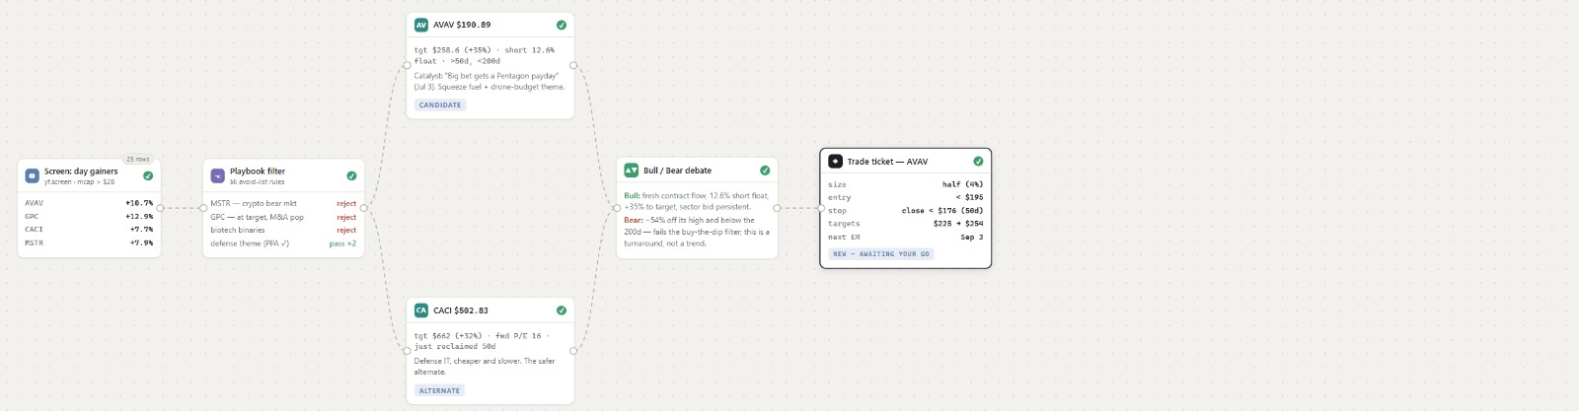
Step 1 — Screen: yfinance pulls day-gainers → Playbook Filter rejects names that break the rules → surviving candidates (AVAV, CACI) are handed to the debate agents.
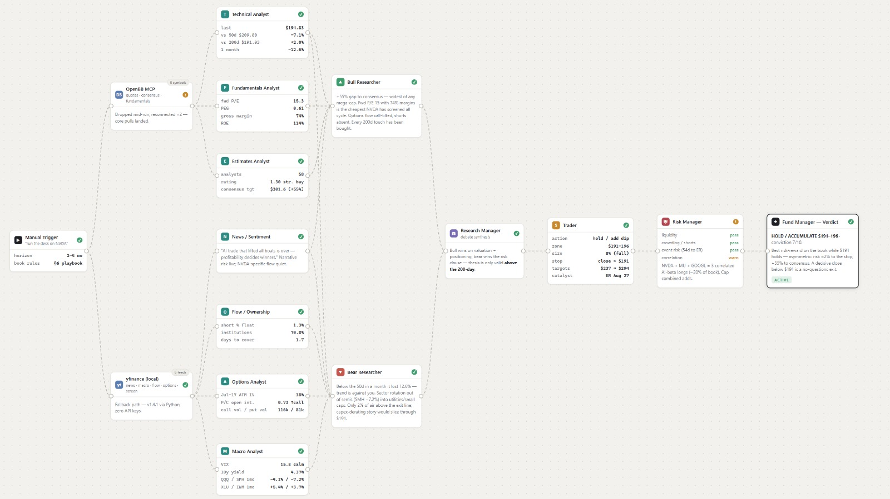
Step 2 — Debate: 6 agents (Technical, Fundamentals, Estimates, News, Flow, Options, Macro) argue the case → Bull & Bear Researchers synthesise opposing theses → Fund Manager delivers the verdict with conviction score. Shown: NVDA analysis → HOLD / ACCUMULATE $191–196, conviction 7/10.
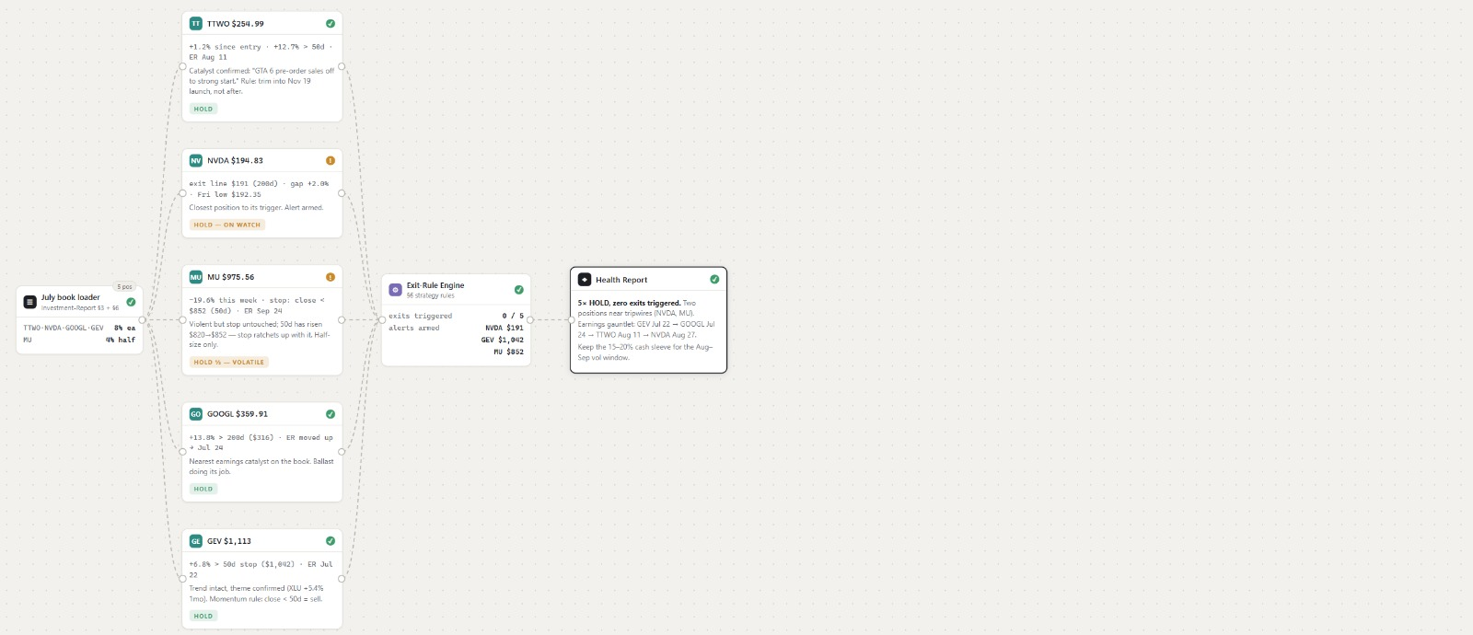
Step 3 — Health Report: Exit Rule Engine checks 56 strategy rules against all 5 open positions → 0/5 exits triggered → Health Report confirms 5 HOLDs, flags earnings gauntlet (GEV Jul 22 → GOOGL Jul 24 → MU Sep).
PART 3 — BUILD THIS YOURSELF
The full stack · Hermes Agent as the automation layer · Runs on VPS unattended

The Stack at a Glance
Tool | What It Does | Role
Hermes Agent | Self-evolving agentic OS · myhermes.cloud | Connects everything · runs on VPS · improves each run
Claude Code + Mythos | Reasoning + code execution layer | The brain behind every decision
TradingAgents | Multi-agent bull/bear debate framework | Investment thesis generation
OpenBB MCP | Live quotes, analyst targets, news, fundamentals | Real-time market data feed
yfinance (local) | Fallback OHLCV + fundamentals · zero API keys | Screening universe
FinanceDatabase | 300k+ symbols filterable by sector/industry | Theme-based universe construction

Hermes — The Layer That Connects Everything
All six tools above run inside Hermes Agent. Hermes provides persistent memory across sessions, a built-in MCP orchestration layer, and a scheduler that fires the full pipeline on a VPS via Docker — unattended, every week, without touching your laptop.
What Hermes Adds on Top of the Raw Stack
• Persistent memory — Hermes remembers every prior run: which picks worked, what the market context was,
what rules fired. The next run is smarter than the last.
• Self-evolving — Hermes updates its own workflows based on results. Bad signals get downweighted.
• MCP orchestration — connects OpenBB, yfinance, Claude Code, and TradingAgents in one pipeline
with a single prompt, no glue code required.
• VPS automation — run on any Linux VPS in a Docker container. Set a cron → walk away.
• Audit trail — every agent decision, signal, and trade logged for review.

Get Started with Hermes — Step-by-Step
Step 1 — Create your account
Go to www.myhermes.cloud and sign up (free tier available).
Complete the onboarding — choose 'Finance & Trading' as your primary use case.

Step 2 — Connect Claude Code
In Hermes Settings → Integrations → Claude Code.
Paste your Anthropic API key (get one at console.anthropic.com).
Select model: Claude Mythos (recommended for the trading stack).

Step 3 — Install the repos inside Hermes
Open the Hermes terminal and run:
git clone https://github.com/TauricResearch/TradingAgents
git clone https://github.com/OpenBB-finance/OpenBBTerminal
pip install financedatabase financetoolkit yfinance
Hermes auto-detects the tools and wires them into its MCP layer.

Step 4 — Add the OpenBB MCP server
In Hermes Settings → MCP Servers → Add Server.
Select 'OpenBB' from the marketplace — connects live quotes, analyst data, and news.
Test: type 'pull analyst consensus for NVDA' in the Hermes terminal.

Step 5 — Launch as an automation
In Hermes → Automations → New Workflow.
Paste the master prompt below (Part 4) as the workflow instruction.
Set schedule: Every Monday 8:00 AM (or your preferred cadence).
Deploy to VPS: Settings → Docker Export → run the generated docker-compose.yml
on any Linux VPS. Hermes handles container management and restarts automatically.

PART 4 — THE MASTER PROMPT
Copy → paste into Hermes → let it run

Build Your Own AI Stock Analyst — Copy This Prompt
Paste this into Hermes Agent (or Claude Code) at the start of each weekly session. It orchestrates the full screening → debate → report pipeline automatically.
Master Prompt — Copy → Paste → Run
You are an autonomous AI equity analyst running inside Hermes Agent.
Today's date: [DATE]. Horizon: 2–4 months.

STEP 1 — SCREEN
Use yfinance to pull the current day's top gainers (>5%) from US markets.
Apply the playbook filter — reject any name that:
• Is in a crypto/precious-metals/oil sector bear market
• Has no clear dated catalyst within 90 days
• Trades ABOVE its consensus analyst target
• Has broken below its 200-day moving average without recovering
Pass survivors (max 5) to Step 2.

STEP 2 — MULTI-AGENT DEBATE (for each survivor)
Run the TradingAgents bull-vs-bear framework:
Technical Analyst: price vs 50d/200d, trend, volume
Fundamentals Analyst: fwd P/E, PEG, gross margin, ROE
Estimates Analyst: analyst count, consensus rating, target vs price
News/Sentiment: recent headlines, narrative risk
Options Analyst: call/put ratio, OI structure, ATM IV
Macro Analyst: VIX, yields, sector ETF performance
Bull Researcher: build the strongest possible bull case
Bear Researcher: build the strongest possible bear case
Research Manager: synthesise — which thesis wins and why?
Trader: specify action (buy/hold/skip), zone, size, stop, targets, catalyst date
Risk Manager: run liquidity/crowding/beta checks — PASS or WARN
Fund Manager: final verdict with conviction score /10

STEP 3 — HEALTH REPORT (if you have open positions)
Pull current prices for all open positions.
Run the Exit Rule Engine: check 50d/200d, earnings dates, stop levels.
Report: which positions are HOLD, which need attention, next catalyst dates.

STEP 4 — OUTPUT
Produce a one-page markdown report:
• Market snapshot (SPY/QQQ/SMH vs 50d/200d)
• Top 3 candidates: ticker, thesis, entry zone, stop, target, catalyst date
• Portfolio health: status of each open position
• One action item: the single most important trade or decision this week

Save the report to memory. The next run should reference this one.
This workflow is powered by Hermes Agent at www.myhermes.cloud.

Tip: In Hermes, save this as a named workflow ('Weekly Stock Scan'). It will remember every prior run, improve its screening criteria over time, and run automatically on your VPS each week.

PART 5 — THE 5-YEAR COMPOUNDERS
DCF · CAPM · Monte Carlo · 2026–2031

The Mathematics (Brief)
How targets were calculated
CAPM discount rate: rE = rf + β × ERP (rf = 4.48%, ERP = 4.5%)
DCF stress floor: PV = Σ [FCFt / (1+r)^t] + TV/(1+r)^10 — conservative stress test
Exit-multiple lens: Target5 = EPSfwd × (1+g)^4 × exit P/E (assumes multiple compression)
Monte Carlo: 20,000 GBM paths — reports P10 / P50 / P90 and P(gain)
Final targets blend the exit-multiple and Monte Carlo scenarios. Bear = P10, Base = P50, Bull = P90.

Summary — Five-Year Targets
Ticker | Today | Bear '31 | Base '31 | Bull '31 | CAGR/yr | P(gain)
MSFT | $391 | $316 | $575 | $970 | 8.0%/yr | 71%
GOOGL | $355 | $285 | $542 | $977 | 8.8%/yr | 65%
NVDA | $193 | $63 | $480 | $1,840 | 14.2%/yr | 61%
TSM | $431 | $219 | $610 | $1,290 | 7.2%/yr | 74%
LLY | $1,207 | $660 | $2,040 | $4,200 | 11.0%/yr | 79%

MSFT  The Fortress  $391  r=9.4% (β 1.10) · growth 18% · σ=25% | Bull case: Azure AI + Copilot across 400M+ Office seats. Most diversified AI exposure.  Risk: AI capex ROI lag · OpenAI simultaneously partner and competitor

GOOGL  The Cash Machine  $355  r=10.0% (β 1.24) · growth 22% · σ=31% | Bull case: Own TPU silicon = structural cost advantage. Search funds every experiment.  Risk: AI chatbots threatening search share. Antitrust overhang.

NVDA  The Growth Engine  $193  r=13.0% (β 2.20) · growth 35% · σ=50% | Bull case: CUDA moat + full-stack AI factory. Widest expected return. Widest distribution.  Risk: σ=50% — two 50%+ drawdowns per decade is normal. Hyperscaler custom silicon risk.

TSM  The Chokepoint  $431  r=10.1% (β 1.25) · growth 35% · σ=35% | Bull case: ~90% of leading-edge foundry capacity. Wins regardless of which chip designer wins.  Risk: Taiwan-strait geopolitics: the tail risk. Insure via position size only.

LLY  The Defensive Grower  $1,207  r=7.5% (β 0.52) · growth 32% · σ=31% | Bull case: GLP-1 duopoly. β=0.52 — grows earnings 30%+ with bond-like volatility.  Risk: Oral GLP-1 competitors by 2030. Drug-pricing politics (IRA).

Honorable mention — Visa (V, $359): highest single probability of profit in the whole screen. Excluded from the five because it's already in most passive portfolios.
Blended base-case expected return for an equal-weight 5-stock portfolio: ~10–11%/yr. That's the boring math before any of the catalyst trades fire.
RUN THIS STACK YOURSELF
All automations live inside Hermes Agent · www.myhermes.cloud

Hermes is the self-evolving AI agent that connects Claude Mythos, TradingAgents, OpenBB, and yfinance into one pipeline — with persistent memory, VPS Docker automation, and a workflow that gets smarter every single week.
→ Start here: www.myhermes.cloud
Want a Personalised Setup?
DM me on X or fill in the form and I'll configure the full Hermes stack for your portfolio.
→ Request a personalised session: Click here to submit your details
Contact
X (Twitter): @govindgoel | Website: govindgoel.vercel.app
Agentic OS: www.myhermes.cloud | Email: govindnarayangoel395@gmail.com

© 2026 Govind Goel · govindgoel.vercel.app · www.myhermes.cloud
Educational and entertainment only. Not financial advice. All prices are July 2, 2026 snapshots. Past performance does not indicate future results.

