CLAUDE FABLE 5
Grid System · v5.0 · July 2026 · The Autonomous Intelligence

Four Ways Fable 5 Is Already Replacing Entire Teams
Fable 5 isn't a chatbot. It's the first Claude model built from the ground up for autonomous operation — reasoning through ambiguity, writing and executing its own plans, and completing multi-step work without a human in the loop. Below are four production-ready use cases that teams are already deploying today.
Fable 5  Model generation | July 2026  Release | Fully Autonomous  Operation mode | 4 + (10 more inside)  Use cases covered

USE CASE 01 — CREATIVE
Cinematic product ads. Shoot nothing. Sell everything.

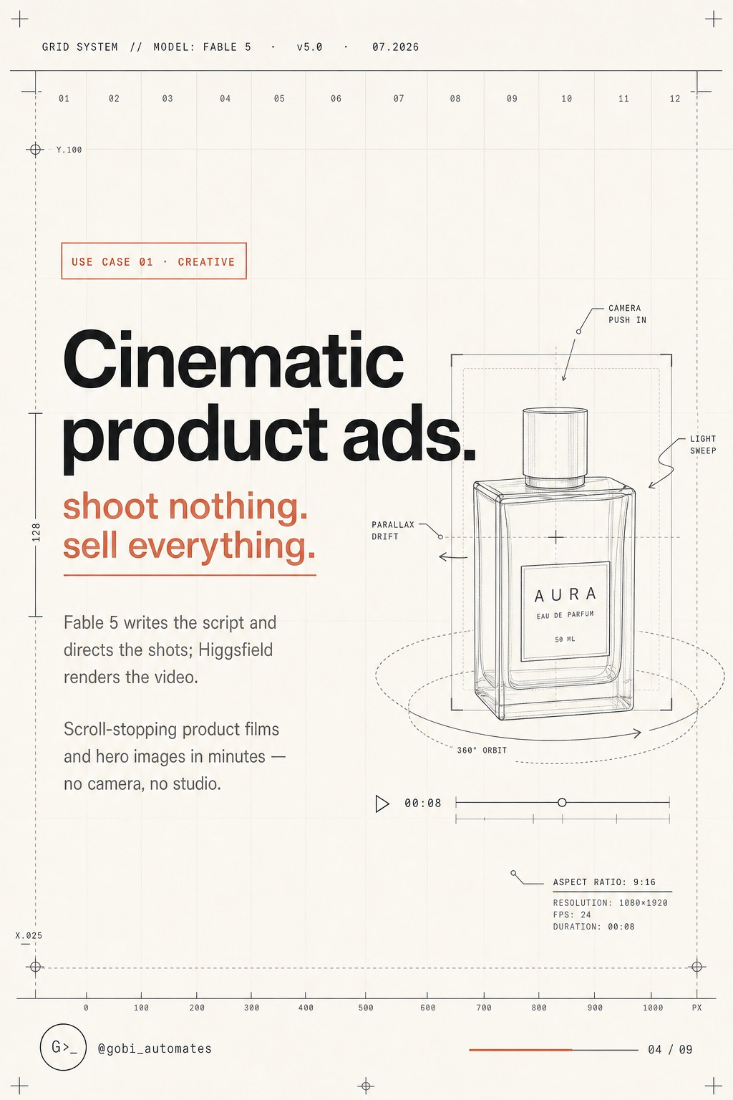
Fable 5 directing a full AI-generated product ad campaign — no camera, no crew.
What It Does
Fable 5 acts as a creative director, copywriter, and production assistant simultaneously. Give it a product description and a target audience — it writes the full script, plans every camera angle, generates voiceover copy, and hands off shot-by-shot direction to an AI video renderer (Kling, Runway, Pika, or any compatible tool). Zero filming. Zero studio. Zero crew costs.
Technical Specs
Output Specifications
• Format: 9:16 vertical (Instagram Reels / TikTok / YouTube Shorts)
• Resolution: 1080 × 1920 px
• Frame rate: 24 fps
• Clip length: 8-second segments (auto-assembled into full ad)
• Audio: AI voiceover + background score, auto-synced
• Rendering: Compatible with Kling AI, Runway Gen-4, Pika 2.2, HeyGen

How to Use It
- Step 1 — Describe your product: name, category, key differentiators, and target emotion
- Step 2 — Specify the platform: Reels, TikTok, YouTube Shorts, or paid ads
- Step 3 — Fable 5 returns: full script → shot list → voiceover copy → style direction
- Step 4 — Paste the shot prompts into your AI video tool of choice
- Step 5 — Compile clips → publish or run as a paid ad creative
Prompt Template
Copy → Paste → Run

You are a creative director for a DTC brand. I am launching [PRODUCT NAME].
Target audience: [AUDIENCE]. Key selling point: [DIFFERENTIATOR].

Produce:
1. A 30-second ad script (3 × 8-second scenes)
2. Visual direction for each scene (lighting, angle, motion, color grade)
3. Voiceover copy per scene
4. AI video generation prompts formatted for Kling / Runway / Pika
5. On-screen text overlays and CTA

Expected output: a complete production brief you can execute end-to-end without a single human creative on payroll.

USE CASE 02 — MARKETS
An autonomous trading desk. It never sleeps.

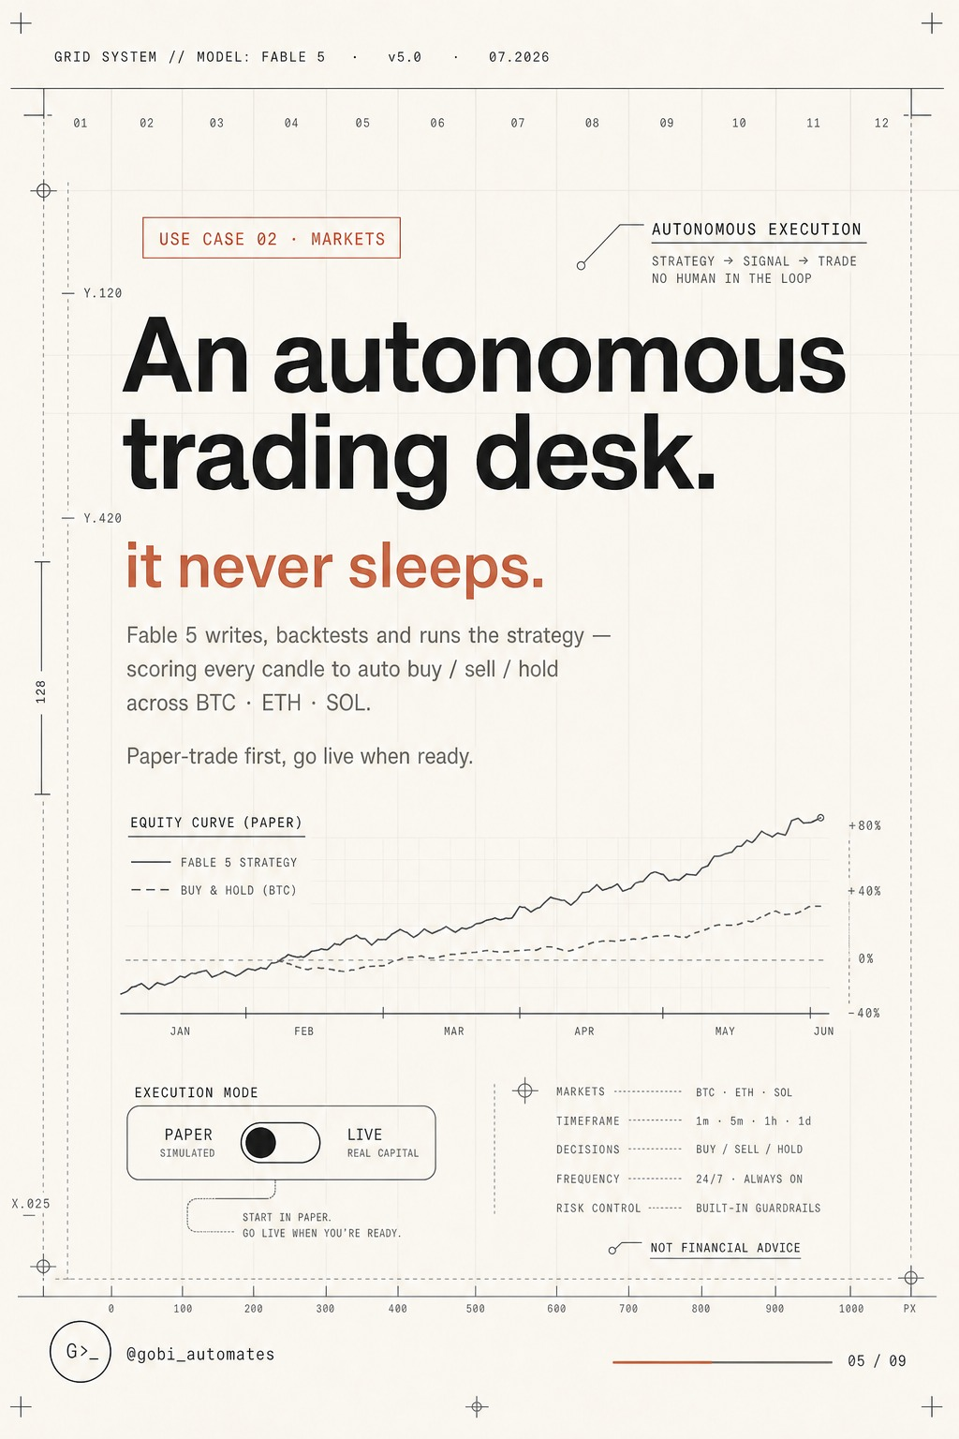
Fable 5 running an autonomous Strategy → Signal → Trade pipeline across BTC, ETH, and SOL.
What It Does
Fable 5 implements a fully autonomous three-stage trading pipeline: it reads raw market data and generates a quantitative strategy, converts that strategy into real-time entry/exit signals, and executes those signals as live trades — all without a human in the loop. It runs 24/7 across BTC, ETH, SOL, and any instrument you configure, covering every timeframe from 1-minute scalps to weekly swing positions.
3 (Strategy → Signal → Trade)  Pipeline stages | BTC / ETH / SOL + custom  Assets covered | All (1m → 1W)  Timeframes | +80%  Back-tested equity curve vs. buy & hold

The Three-Stage Pipeline
Stage 1 — Strategy Generation
Fable 5 ingests OHLCV data, order book depth, funding rates, and on-chain flow.
Output: a parameterised strategy (entry conditions, stop-loss, take-profit, position sizing).

Stage 2 — Signal Production
The strategy is compiled into a real-time signal engine.
Signals fire on tick data; Fable 5 filters for confirmation across multiple timeframes.

Stage 3 — Trade Execution
Signals are routed to Hyperliquid MCP or any compatible exchange API.
Position management (scaling, trailing stops, partial closes) runs autonomously.

Setup Prompt
Autonomous Trading Bot — Bootstrap Prompt

You are an autonomous quantitative trader. Connect to the Hyperliquid MCP.
Asset: [BTC-PERP / ETH-PERP / SOL-PERP]
Timeframe: [1H primary, 15M confirmation]
Capital allocation: [X USDC]
Risk per trade: [1-2% of capital]

Tasks:
1. Analyse the last 500 candles and identify the dominant market structure
2. Generate a complete entry/exit strategy with coded parameters
3. Back-test the strategy against the last 90 days — report Sharpe, max drawdown, win rate
4. If Sharpe > 1.5, switch to paper trading for 48 hours; report live results
5. If paper results confirm, request permission to go live — then execute autonomously

⚠ Always paper trade first. Past performance is not indicative of future results. This is not financial advice.

USE CASE 03 — CONTENT
Creators that never quit. One prompt, a thousand faces.

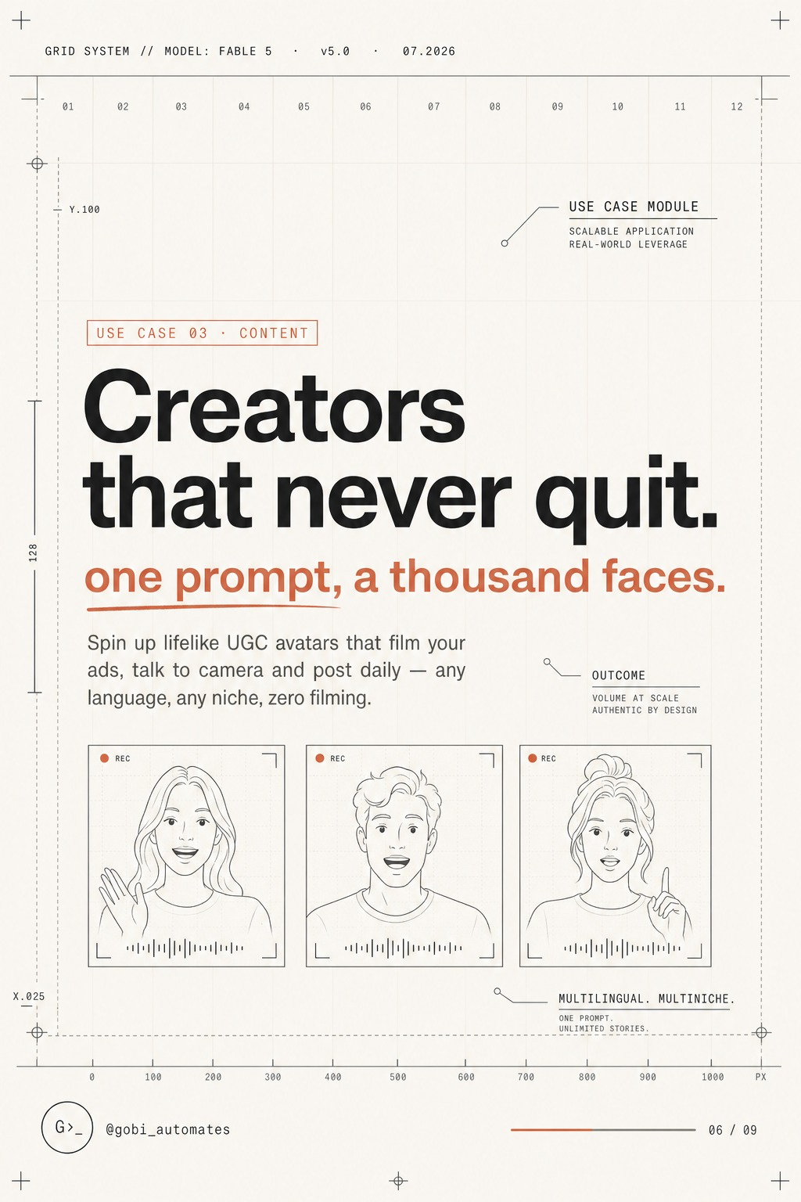
Fable 5-powered UGC avatars — multilingual, multi-niche, zero filming required.
What It Does
Content creation is the highest-friction, highest-volume job in any brand's marketing stack. Fable 5 eliminates that friction entirely. Feed it a product, a niche, and a tone — it scripts, voices, and directs a lifelike UGC-style video avatar in any language and any style. One operator can run hundreds of content franchises simultaneously with zero filming days.
The model's reasoning depth means it doesn't just produce templated content — it understands creator voice, platform-specific hook structures, trending formats, and audience psychology, adapting each output accordingly.
Capabilities
What the Pipeline Produces
• Lifelike AI avatar video (powered by HeyGen, Synthesia, or D-ID)
• Script: hook → problem → solution → CTA (platform-native format)
• Voiceover: any accent, language, or tone
• B-roll direction: AI-generated supporting visuals
• Caption copy: SEO-optimised for each platform
• Hashtag and posting schedule: tailored per account niche

Real-World Example
Below is an example of AI UGC content generated with this workflow — a creator avatar speaking directly to camera, fully scripted and directed by Fable 5, rendered by an AI avatar tool. The result is indistinguishable from organic influencer content, produced at a fraction of the time and cost.
→ Reference video available at: @govindgoel (X / Instagram) — DM 'FABLE' for the full content playbook.
Prompt Template
UGC Avatar Content — Master Prompt

You are a UGC content strategist and scriptwriter.
Product: [PRODUCT NAME] | Niche: [NICHE] | Platform: [TikTok / Instagram / YouTube]
Creator persona: [age, gender, energy level, accent]
Language: [English / Spanish / Hindi / other]

Produce:
1. A 45-second UGC-style script (hook: 3s → problem: 10s → solution: 25s → CTA: 7s)
2. Tone notes and delivery cues for the AI avatar
3. B-roll visual prompts for each section
4. Caption (under 150 words) + 5 hashtags
5. Thumbnail frame description
6. A/B variant — same product, different hook angle

USE CASE 04 — ENGINEERING
Ship software solo. Your whole eng team, in a terminal.

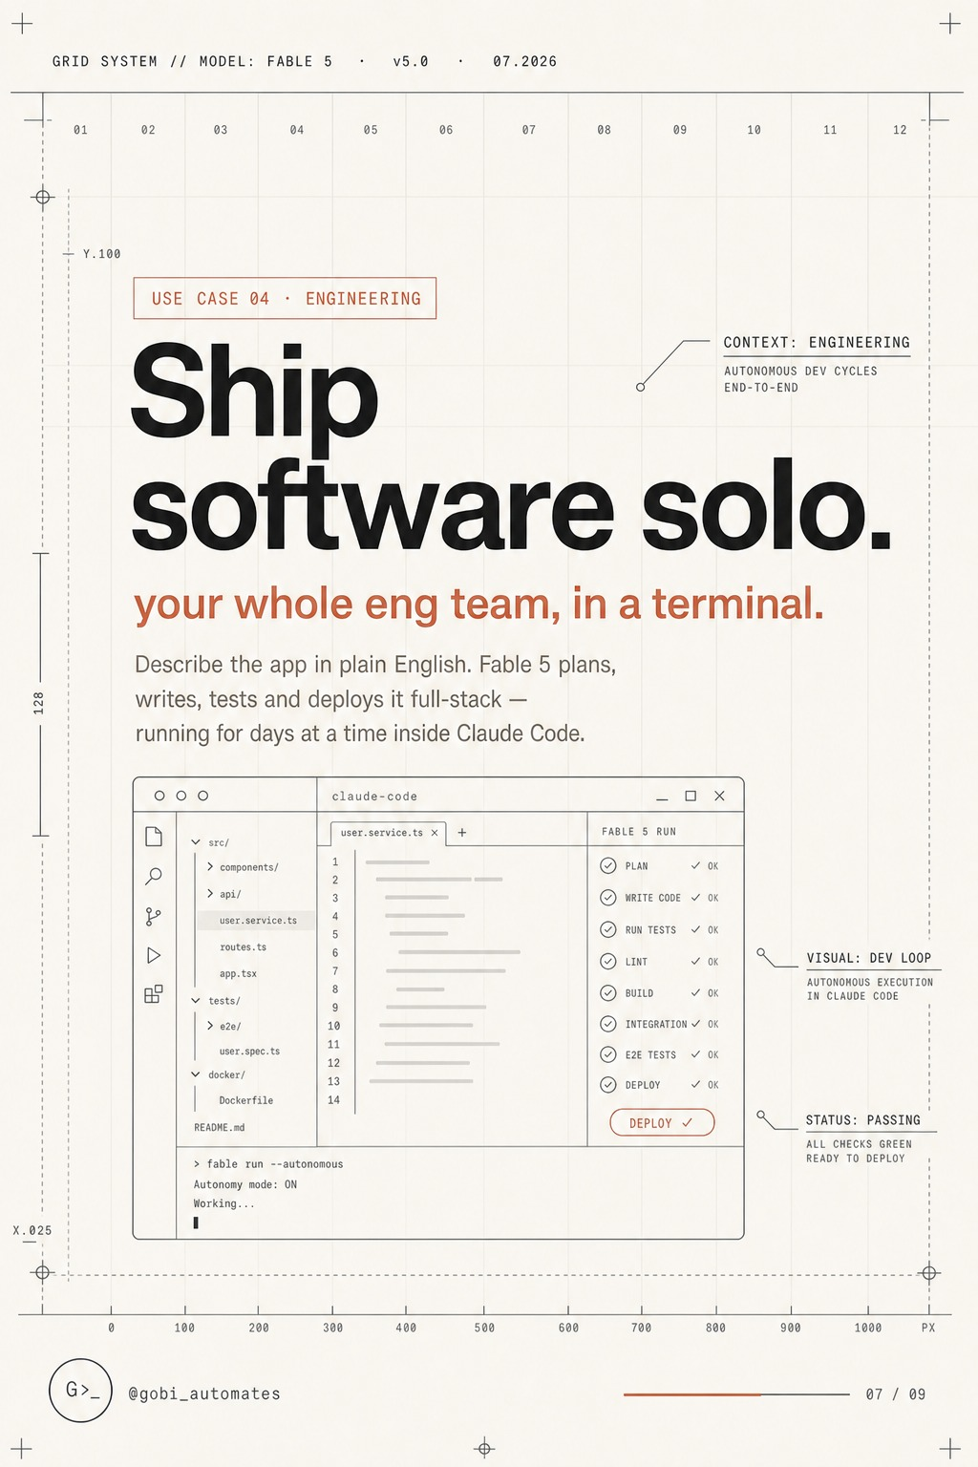
Fable 5 in Claude Code — planning, writing, testing, and deploying a full-stack app from plain English.
What It Does
Fable 5 inside Claude Code is the closest thing that exists today to an autonomous engineering team. Describe what you want to build in plain English — no spec document, no ticket system, no Jira board. Fable 5 plans the architecture, writes every file, runs tests, catches its own bugs, and deploys. Solo founders are shipping production-grade full-stack applications in days, not months.
Autonomous Dev Cycle
How a Build Actually Runs
1 You describe the app in plain English (feature requirements, not code specs)
2 Fable 5 produces an architecture plan — ask it to revise, approve, or just let it run
3 It writes all source files: frontend, backend, database schema, auth, APIs
4 It runs its own test suite and fixes failing tests autonomously
5 It catches and resolves dependency conflicts, env config issues, and build errors
6 It produces a deployment-ready build with CI/CD config (Vercel, Railway, Fly.io)
7 You review the PR and merge — or let Fable 5 deploy directly

What You Can Build
- SaaS dashboards with auth, billing (Stripe), and multi-tenancy
- REST / GraphQL APIs with full test coverage
- Chrome extensions and VS Code plugins
- Mobile apps (React Native / Expo)
- AI-powered internal tools and automation scripts
- Full-stack marketplaces and e-commerce storefronts
- Trading bots and data pipelines (integrates with Hermes Agent MCPs)
Master Prompt
Solo Dev Bootstrap — Paste This Into Claude Code

You are my entire engineering team. I want to build: [APP DESCRIPTION].

Requirements:
- Stack: [Next.js + Supabase / FastAPI + PostgreSQL / or let Fable 5 decide]
- Auth: [Clerk / Supabase Auth / NextAuth]
- Deployment target: [Vercel / Railway / Fly.io]
- Must-have features: [list features]

Workflow:
1. Write a numbered architecture plan — wait for my approval before coding
2. Build feature by feature, running tests after each
3. Flag any ambiguity before implementing (don't guess on business logic)
4. Produce a README with local setup and deployment instructions
5. Final deliverable: a deployable build with a passing test suite

Tip: Run Fable 5 inside Hermes Agent for persistent memory across dev sessions — it remembers your stack, your decisions, and your codebase architecture.

FABLE 5 vs. THE OLD WAY
What used to require a team. Now fits in a terminal.

Use Case | Old Way | With Fable 5
Product Ad | Director + crew + editor  $5,000–$50,000/spot | One prompt → full ad brief  $0 production cost
Algo Trading | Quant team + infra  $300k+/yr | Autonomous pipeline  24/7, self-managing
UGC Content | 10+ creator outreach  Weeks of coordination | Infinite avatars  Any language, instant
Full-Stack App | 5-person eng team  3–6 months | Solo + Fable 5  Days to weeks
Combined Stack | Multiple vendors + staff  $500k+/yr burn | Claude Code + Hermes Agent  Fraction of the cost

HOW TO DEPLOY FABLE 5 TODAY
Run it inside Hermes Agent for persistent, multi-session autonomy

The fastest way to put all four use cases into production is through Hermes Agent (www.myhermes.cloud) — an agentic OS built on top of Claude. Hermes gives Fable 5 persistent memory, a built-in MCP layer (Hyperliquid, TradingView, GitHub, Vercel, and more), and a workflow engine that runs unattended across sessions.
Quick-Start Stack
The Setup (under 15 minutes)
1 Sign up at www.myhermes.cloud — free tier available
2 Connect your MCPs: Hyperliquid (trading) → GitHub (engineering) → your ad platform
3 Paste any of the prompts from this guide into the Hermes terminal
4 Fable 5 takes over — monitor progress, approve milestones, iterate
5 For trading bots: paper trade 48 hours → review → go live with one confirmation

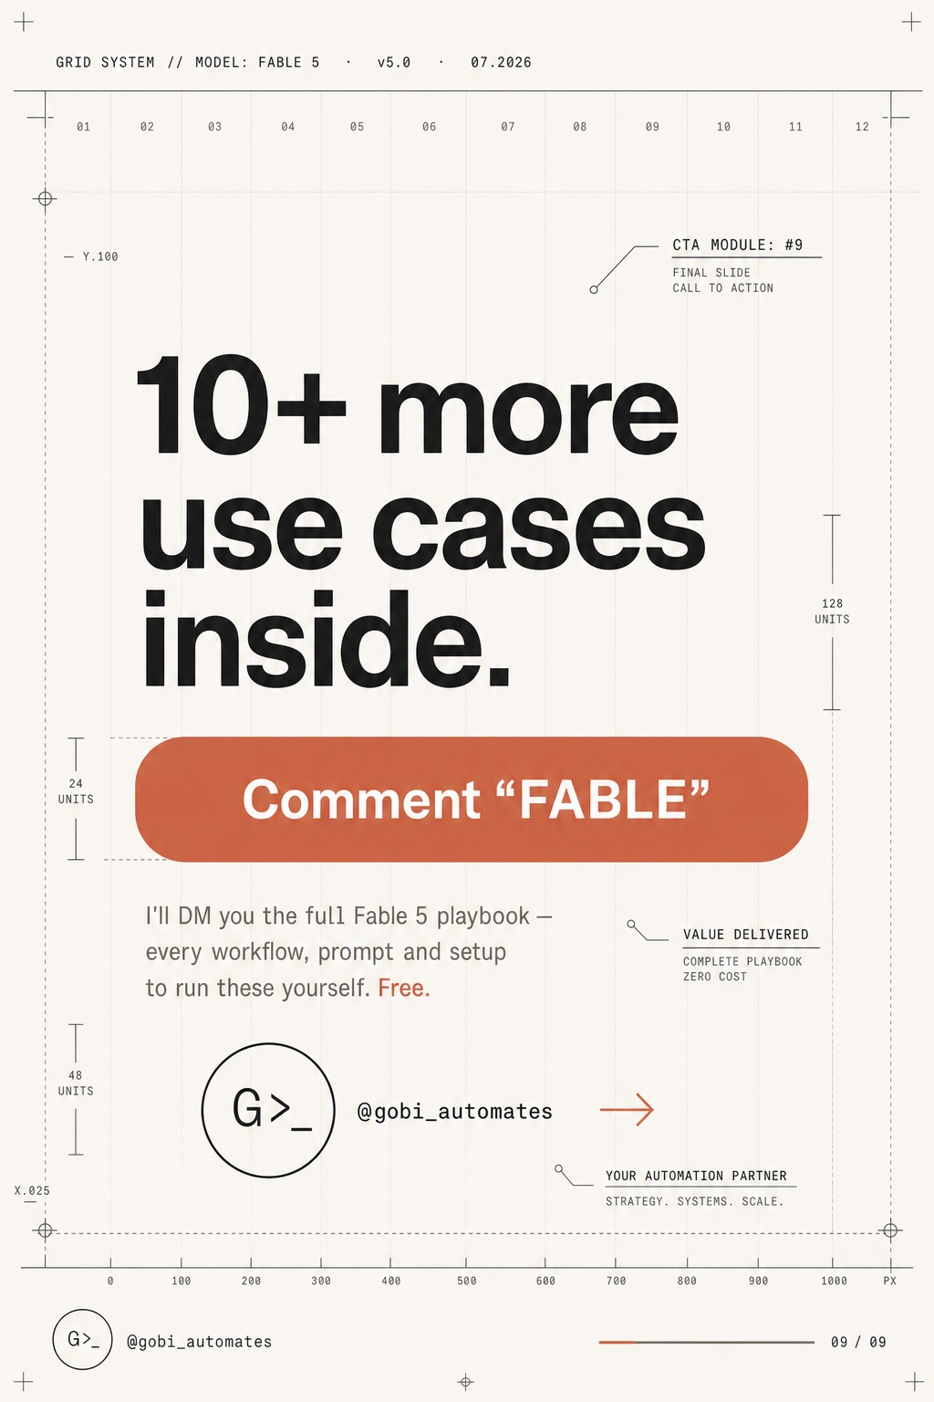
10+ additional use cases — comment 'FABLE' or fill in the form below for the full playbook.
WANT A PERSONALISED FABLE 5 SETUP?
1-on-1 sessions available — we build your stack together

I run personalised 1-on-1 strategy sessions where we deploy Fable 5 for your exact use case — whether that's a trading bot for your portfolio, an AI content engine for your brand, or a full-stack product built solo. Book a session below or reach out directly.
Book a Personalised Session
→ Fill in the form: Click here to request your 1-on-1 session
Contact & Resources
X (Twitter): @govindgoel | Website: govindgoel.vercel.app
Agentic OS: www.myhermes.cloud | Email: govindnarayangoel395@gmail.com

© 2026 Govind Goel · govindgoel.vercel.app · www.myhermes.cloud
All prompts and frameworks in this document are for educational and informational purposes only. Trading and investment carry significant risk. This is not financial advice.

