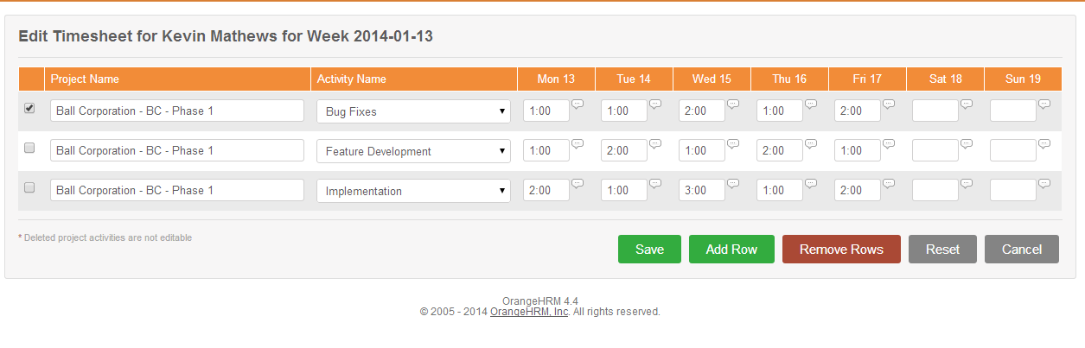

Edit timesheet

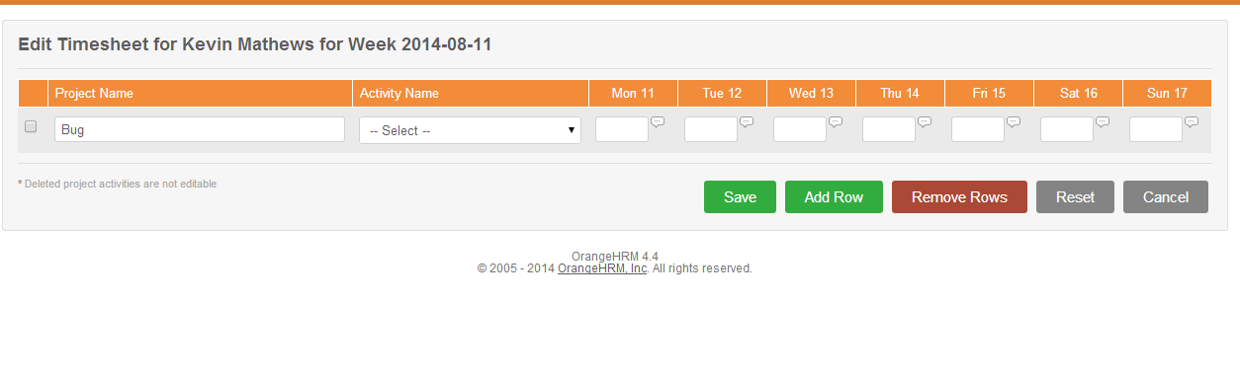

New TimeSheet