HRMS – Employee Module: User Manual

D:\Daikin Project data\Daikin UI 3.0\images1\Daikin_logo_.jpg

***User Guide***

**Distribution Date: Jan 6, 2014 Version: 1.0**

**Login:-**

***Navigate to the Login Home Page***

|  |  |  |
| --- | --- | --- |
| |  | | --- | | Go to  hrms.earthsoft.in/hrms/  web site: | |  |
| |  | | --- | | Login using the correct User name (employee code) and correct Password.  **Note:** This system is only For authorized users. If you are not the one please logout. | |  |
| |  | | --- | | After successful login,  You are now at the HRMS Home Page.  The instructions outlined in this User Guide will always  Be in this column to the left side of the screen | | Admin Panel |
| |  | | --- | | When you click on the Admin Panel, this type of web page display.  For Employee Module click Employee Profile | |  |

**Employee Module:-**

This module allows you to create, edit and view the employee.

|  |  |  |
| --- | --- | --- |
| |  | | --- | | Click **Employee Master** from the Home Page. | |  |
| |  | | --- | | These are the fields in Employee Master module.  **Create Employee** option is used to create the new employee.  **View / Edit Employee** option is used to view and edit the existing employees.  **View Employee who Resigned** option is used to view the resigned employees. | |  |

➢ **Create Employee**

|  |  |  |
| --- | --- | --- |
| |  | | --- | | Click **Create Employee Form** from the “Employee master” tab on the Home Page. | |  |
| |  | | --- | | After clicking on the “**Create Employee” tab,** the form will be displayed.  The Form has 6 Major Tabs:  **Job Detail:** fill the employee job details here.  **Professional:** Fill the educational, professional and experience detail of employee here.  **Personal Detail:** Fill the personal detail of employee in this tab.  **Contact Detail:** Fill the Contact detail of employee in this tab.  **Salary Detail:** Fill the salary details of employee in this tab.  **Document Detail:** Attach the documents of employee in this tab. | |  |
| In **Professional Tab**, Fill the educational, professional and experience detail of employee here. |  |
| In **Personal Detail,** Fill the personal detail of employee in this tab. |  |
| In **Contact Detail,** Fill the Contact detail of employee in this tab. |  |
| In **Salary Detail,** Fill the salary details of employee in this tab. |  |
| In **Document Detail**, Attach the documents of employee in this tab. |  |

**Description of Job Detail Tab:-**

**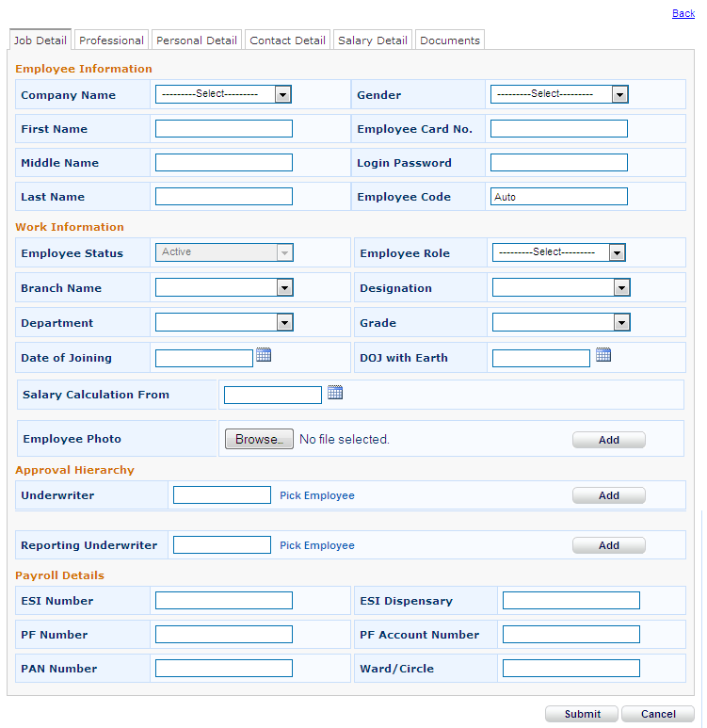**

**1. Company Name*:-***

Select any Company in the given dropdown list. At a time only one Company name is selected.

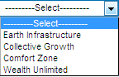

This is compulsory field and when you left this field empty then error message displayed.

**2. Gender:-**

Select gender in the given dropdown list. At a time only one gender is selected.

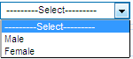

This is compulsory field and when you left this field empty then error message displayed.

**3. First Name:-**

This is a text box in which we write the first name. In this field you can able to use characters, numeric, special character.

This is mandatory field and when you left this field empty then error message displayed.

**4. Middle Name:-**

This is a text box in which we write the middle name. In this field you can able to use characters, numeric, special character.

**5. Last Name:-**

This is a text box in which we write the last name. In this field you can able to use characters, numeric, special character.

**6. Employee Card No.:-**

This is a text box in which we write the employee card no. In this field you can able to use characters, numeric, special character.

This is mandatory field and when you left this field empty then error message displayed.

**7. Password:-**

This is a text box in which we write the password. In this field you can able to use characters, numeric, special character.

This is mandatory field and when you left this field empty then error message displayed.

**8. Employee Code:-**

This field is Auto generated.

**9. Employee Status*:-***

This field is Auto generated.

**10. Role:-**

Select role in the given dropdown list. At a time only one role is selected.

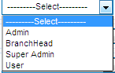

This is compulsory field and when you left this field empty then error message displayed.

**11. Branch Name:-**

Select any Branch name in the given dropdown list. At a time only one Branch name is selected.

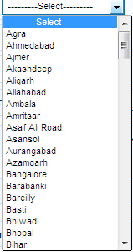

This is compulsory field and when you left this field empty then error message displayed.

**12. Designation Name:-**

Select any designation name in the given dropdown list. At a time only one designation name is selected. When you select any designation then automatically grade will updated.

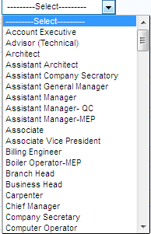

This is compulsory field and when you left this field empty then error message displayed.

**13. Department Name:-**

Select any department name in the given dropdown list. At a time only one department name is selected.

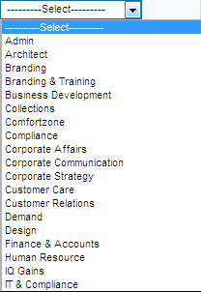

This is compulsory field and when you left this field empty then error message displayed.

**14. Date of joining:-**

In this field you enter the date of joining of the employee.



**15. DOJ with earth:-**

In this field you enter the DOJ with earth of the employee.

**16. Salary Calculation from:-**

In this field you enter the date of salary calculation of the employee.

**17. Photo:-**

In this field you can upload photo of the employee. To upload the photo click the browse button.



**18. Underwriter:-**

In this field you select the employee using the **“Pick employee”** for Approval hierarchy**.**

**19. Reporting Underwriter:-**

In this field you select the employee using the **“Pick employee”** for Approval hierarchy**.**

**20. ESI Number:-**

In this field you enter the ESI No. of the employee for payroll.

**21. PF Number:-**

In this field you enter the PF No. of the employee for payroll.

**22. PAN Number:-**

In this field you enter the PAN No. of the employee for payroll.

**23. ESI Dispensary:-**

In this field you enter the ESI dispensary of the employee for payroll.

**24. PF Account Number:-**

In this field you enter the PF account number of the employee for payroll.

**25. Ward/Circle:-**

In this field you enter the ward/circle of the employee for payroll.

**Description of Professional Detail Tab:-**

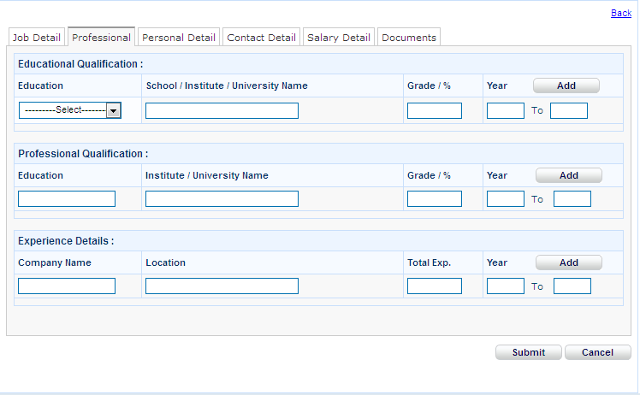

**In Educational Qualification:**

1. **Education:**

Select any education name in the given dropdown list. At a time only one education name is selected.

**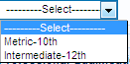**

This is compulsory field and when you left this field empty and try to add the education then error message displayed.

1. **School/Institute/ University Name :**

In this field you enter the school/ institute/ university name of the employee.

This is compulsory field and when you left this field empty and try to add the education then error message displayed.

1. **Grade / %:**

In this field you enter the percentage in two digit maximum.

1. **Year:**

In this field you enter from and to year of education.

**In Professional Qualification:**

1. **Education:**

In this field you enter the professional education name of the employee

This is compulsory field and when you left this field empty and try to add the education then error message displayed.

1. **Institute/ University Name :**

In this field you enter the institute/ university name of the employee.

This is compulsory field and when you left this field empty and try to add the education then error message displayed.

1. **Grade / %:**

In this field you enter the percentage in two digit maximum.

1. **Year:**

In this field you enter from and to year of education.

**In Experience Detail:**

1. **Company Name:**

In this field you enter the Company name of the employee

This is compulsory field and when you left this field empty and try to add the experience name then error message displayed.

1. **Location :**

In this field you enter the Location of the employee previous company.

This is compulsory field and when you left this field empty and try to add the experience then error message displayed.

1. **Total Exp:**

In this field you enter the experience in two digit maximum.

1. **Year:**

In this field you enter from and to year of experience.

**Description of Personal Detail Tab:-**

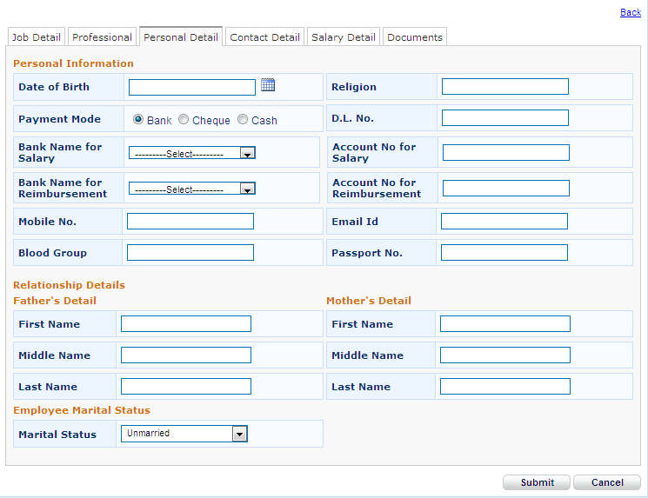

**1. Date of Birth:-**

In this field you enter the date of birth of the employee.

**2. Religion:-**

In this field you enter the religion of the employee.

**3. Payment Mode:-**

There are three ways of payment mode

➢ **Bank**

➢ **Cheque**

➢ **Cash**

By Default Bank is selected.

If you select the” **Bank”** payment mode then also enter the Bank Name and account Number.

**4. Mobile No.:-**

In this field you enter the mobile number of the employee.

**5. Email ID.:-**

In this field you enter the email id of the employee.

**6. Blood Group:-**

In this field you enter the blood group of the employee.

**7. Passport No.:-**

In this field you enter the passport number of the employee.

**8. Father’s First Name:-**

This is a text box in which we write the first name. In this field you can able to use characters, numeric, special character.

**9. Father’s Middle Name:-**

This is a text box in which we write the middle name. In this field you can able to use characters, numeric, special character.

**10. Father’s Last Name:-**

This is a text box in which we write the last name. In this field you can able to use characters, numeric, special character.

**11. Mother’s First Name:-**

This is a text box in which we write the first name. In this field you can able to use characters, numeric, special character.

**12. Mother’s Middle Name:-**

This is a text box in which we write the middle name. In this field you can able to use characters, numeric, special character.

**13. Mother’s Last Name:-**

This is a text box in which we write the last name. In this field you can able to use characters, numeric, special character.

**14. Marital Status:-**

Select any marital status in the given dropdown list. At a time only one status is selected.

By default **Unmarried** selected.

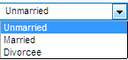

**Description of Contact Detail Tab:-**

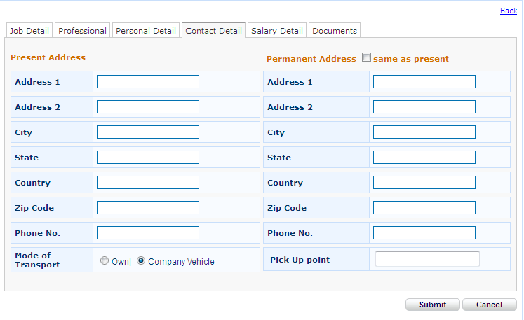

**In Present Address:**

**1. Address 1:-**

This is a text box in which we write the present Address of the employee. In this field you can able to use characters, numeric, special character.

**2. Address 2:-**

This is a text box in which we write the Address of the employee. In this field you can able to use characters, numeric, special character.

**3. City:-**

This is a text box in which we write the city of the employee. In this field you can able to use characters, numeric, special character.

**4. State:-**

This is a text box in which we write the state of the employee. In this field you can able to use characters, numeric, special character.

**5. Country:-**

This is a text box in which we write the country of the employee. In this field you can able to use characters, numeric, special character.

**6. Zip Code:-**

This is a text box in which we write the zip code of the employee. In this field you can able to use numeric only.

**7. Phone No.:-**

This is a text box in which we write the phone number of the employee. In this field you can able to use numeric only.

**8. Mode of Transport:-**

There are two ways of transport

➢ **Own**

➢ **Company Name**

By Default **own** is selected.

**In Permanent Address:**

**1. Address 1:-**

This is a text box in which we write the permanent Address of the employee. In this field you can able to use characters, numeric, special character.

**2. Address 2:-**

This is a text box in which we write the Address of the employee. In this field you can able to use characters, numeric, special character.

**3. City:-**

This is a text box in which we write the city of the employee. In this field you can able to use characters, numeric, special character.

**4. State:-**

This is a text box in which we write the state of the employee. In this field you can able to use characters, numeric, special character.

**5. Country:-**

This is a text box in which we write the country of the employee. In this field you can able to use characters, numeric, special character.

**6. Zip Code:-**

This is a text box in which we write the zip code of the employee. In this field you can able to use numeric only.

**7. Phone No.:-**

This is a text box in which we write the phone number of the employee. In this field you can able to use numeric only.

**Description of Salary Detail Tab:-**

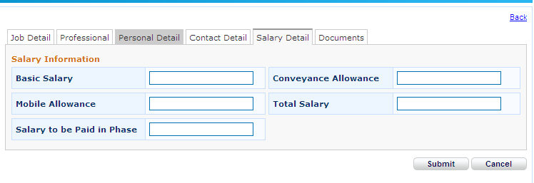

**1. Basic Salary:-**

This is a text box in which we write the basic salary of the employee. In this field you can able to use numeric only.

**2. Conveyance Allowance:-**

This is a text box in which we write the conveyance allowance of the employee. In this field you can able to use numeric only.

**3. Mobile Allowance:-**

This is a text box in which we write the mobile allowance of the employee. In this field you can able to use numeric only.

**4. Total Salary:-**

This is a text box in which we write the total salary of the employee. In this field you can able to use numeric only.

**5. Salary to be paid in phase:-**

This is a text box in which we write the salary to be paid in which phase of the employee. In this field you can able to use numeric only.

**Description of Documents Tab:-**

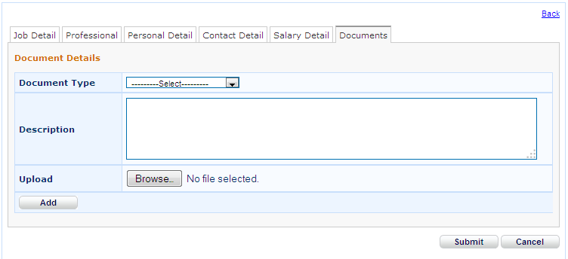

**1. Document Type:-**

Select any document type in the given dropdown list. At a time only one document type is selected.

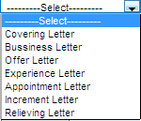

**2. Description:-**

This is a text box in which we write the description of the document.

**3. Upload:**

In this field you can upload the documents of the employee. To upload the documents click the browse button.

When you click on Browse button then this type of box opened.

