There will be a list of Customers and provision to add new customer:



Each customer can be assigned one or many projects:

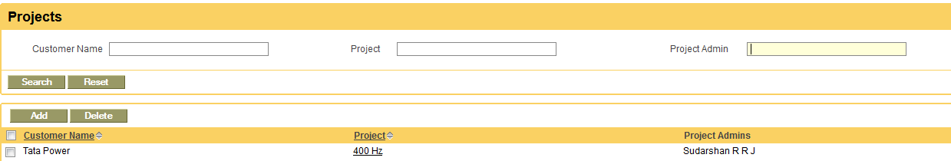

Each Project will have many Activity: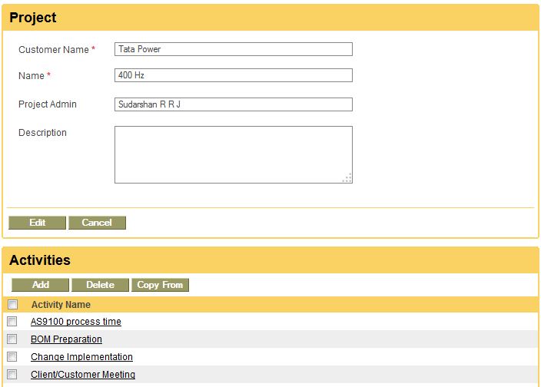

**A project can have more than 1 Project Admin:**

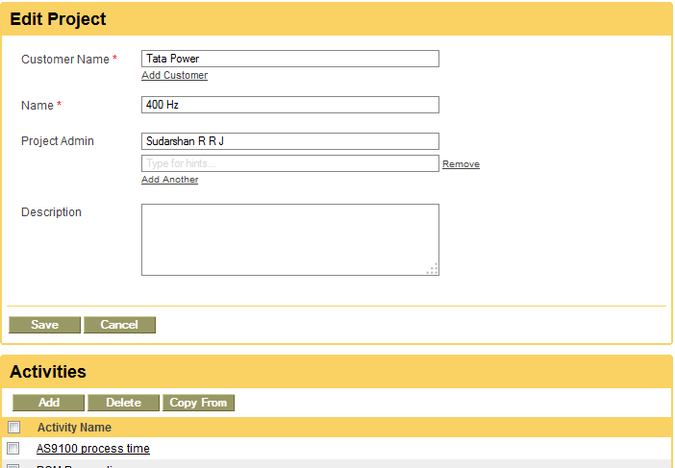

**Time sheet: ESS and Managers self service**

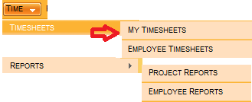

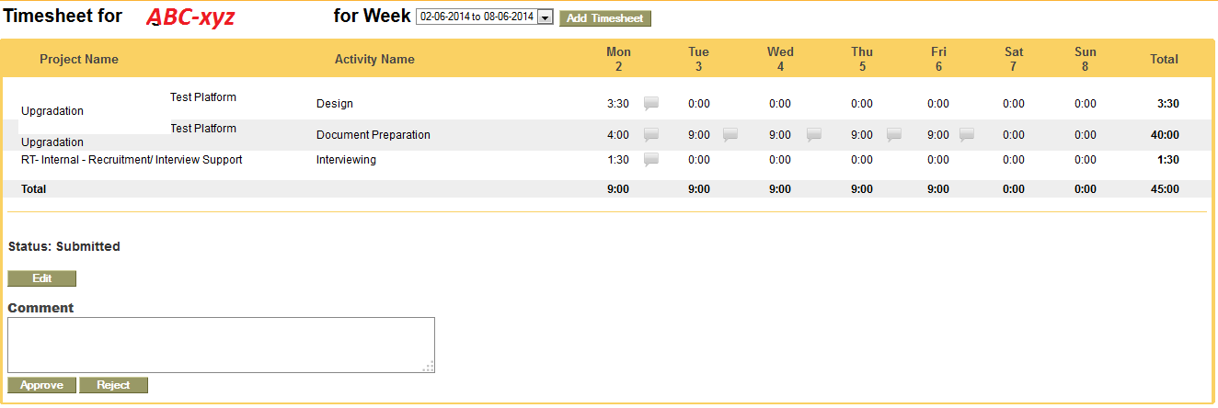

Reports:

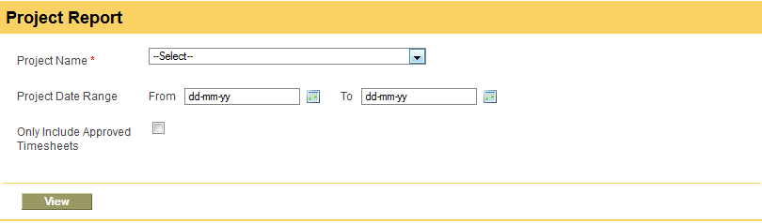

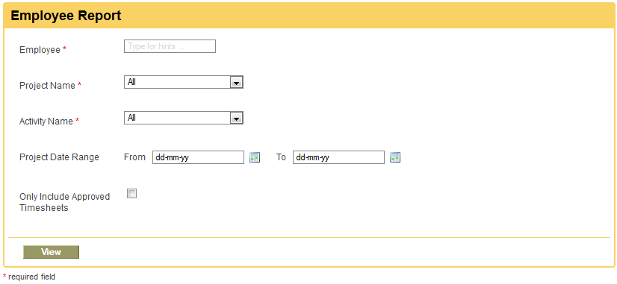

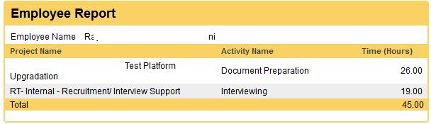

**Summary Report – Project wise for a duration (Between two dates):**

|  |  |  |  |  |  |
| --- | --- | --- | --- | --- | --- |
| EmpName/Project | PR1 | PR2 | PR3 | PR4 | Total Hrs |
| Emp1 |  |  |  |  |  |
| Emp2 |  |  |  |  |  |
| EMP3 |  |  |  |  |  |
| Total Hrs |  |  |  |  |  |

**Summary Report – Activity wise for a duration (Between two dates):**

|  |  |  |  |  |  |
| --- | --- | --- | --- | --- | --- |
| EmpName/ Activity | Activity1 | Activity2 | Activity 3 | Activity 4 | Total Hrs |
| Emp1 |  |  |  |  |  |
| Emp2 |  |  |  |  |  |
| EMP3 |  |  |  |  |  |
| Total Hrs |  |  |  |  |  |