**97 seats up for grabs in the second phase of polling**

**It is a battle royale in Udhampur as the grandson of last Dogra ruler takes on Jitendra Singh**

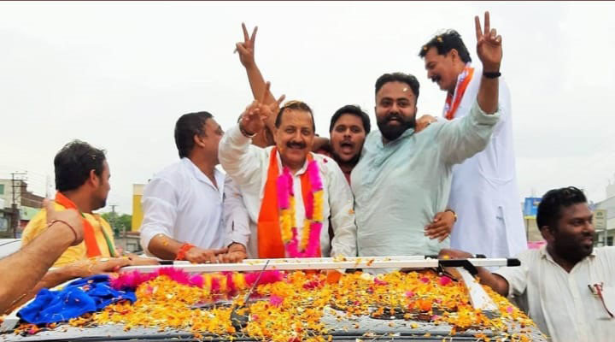

**Dr. Jitendra Singh**

**By SANJAY BHAT**

JAMMU: AS ninety-seven seats are up for grabs in the second phase of polling to be held across different states on Thursday, the election for two seats—Udhampur and Srinagar in Jammu and Kashmir state will decide the fate of two high-profile candidates.

Out of six Parliamentary seats in Jammu and Kashmir, the election for two seats—Jammu and Baramulla were held in the first phase. The second phase of polling to witness a tough fight among the candidates fielded by the two national and regional parties.

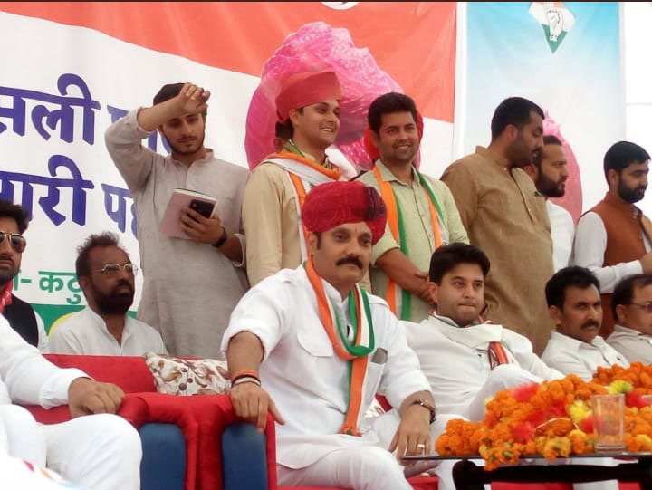

Vikramadatiya **Singh**

Whereas Bharatiya Janata Party (BJP) fielded its two sitting candidates Dr. Jitendra Singh, Union minister of state in Prime Minister’s office from Udhampur-Kathua constituency, and Jugal Kishore from Jammu-Poonch seat, Congress fielded Vikramadatiya Singh, son of Dr. Karan Singh, the first Sadar-e-Riyasat of Jammu and Kashmir and Raman Bhalla from Jammu.

The Polling for Jammu and Baramulla Parliamentary seats took place in the first phase on April 11 peacefully, two days ahead of the first phase when suspected terrorists killed Rashtriya Swayamsewak Sangh( RSS) leader Chanderkant Sharma and his bodyguard in Kishtwar township of district Doda forcing the authorities to impose curfew for a few days.

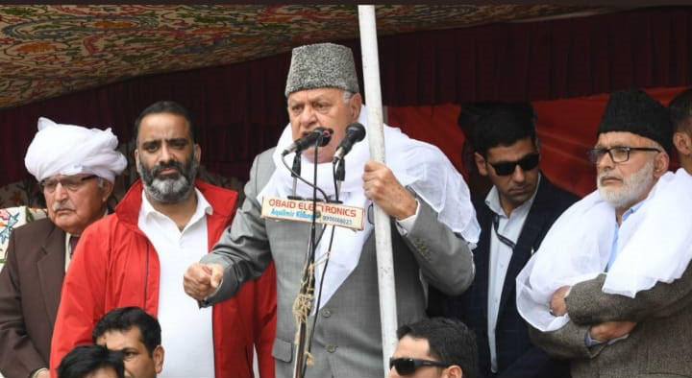

**Dr. Farooq Abdullah**

During 2014 Parliamentary polls, Congress had fielded Madan Lal from Jammu-Poonch seat as Ghulam Nabi Azad, former Jammu and Kashmir Chief Minister from Udhampur-Kathua seat. However, both the two lost to Modi wave. Madan Lal’s brother Shyam Lal, who served as a cabinet minister in Congress –NC rule joined BJP a few days ago.

People’s Democratic Party (PDP) and National Conference have not fielded any candidate from both these two seats to avoid division of “secular” votes.

National Conference has repeated candidature of Dr. Farooq Abdullah from Srinagar constituency and PDP’s Mehbooba Mufti is contesting from Anantnag constituency. National Conference has fielded Mohd Akbar Lone, a former speaker from Baramulla and former High Court Judge Justice (Retd) Hasnain Masoodi from Anantnag.

BJP has fielded its candidates from all the three seats of Kashmir division. Sofi Yusuf is contesting from Anantnag, Ghulam Mohammad War from Baramulla( election held) and Khalid Jehanger from Srinagar. However, with BJP rebel and Chairman of Dogra Swabhiman Sangthan(DSS) Chaudhary Lal Singh, contesting from Udhampur seat, the going seems tough for Dr. Jitendra Singh. Lal Singh also contested from Jammu seat.

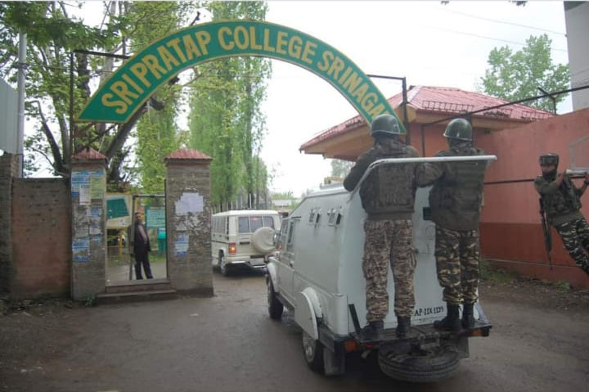

**Tight security arrangements at one of the polling stations in Srinagar**

This time Peoples Conference also fielded former cop Raja Aijaz Ali from Baramulla and Panthers Party chief Prof Bhim Singh also jumped into the fray from Jammu seat. The polls for Udhampur and Srinagar to take place on April 18. Prime Minister Narendra Modi addressed a rally in Akhnoor on March 28 followed by another rally in Kathua a few days ago. Similarly, BJP Chief Amit Shah also campaigned in both the two constituencies of Jammu division, but till now did not campaign for any of the candidates in the fray in Kashmir division.

Former Sadar-e- Riyasat Dr. Karan Singh, Ghulam Nabi Azad, Jyotiraditya Scindia and few cabinet ministers of Punjab government were among those who campaigned for Vikramadatiya Singh in the nook and corner of Kathua-Doda constituency. Dr. Karan Singh also released a Dogri song sung by him to re-connect to the traditional Dogra voters. Both Dr. Jitendra Singh and Vikramadatiya Singh tried to connect with voters through social media.

Udhampur, however, awaits a battle of ballots among four Rajputs. The going seems slightly tough for Jitendra Singh, union minister in PMO as three other candidates from his community are in the fray with all the three holding sway in their areas. The Congress candidate is likely to garner Muslim votes also given the fact, Ghulam Nabi Azad who holds considerable sway in his native Doda district campaigned in his favor also.

However, the going seems easy for National Conference President and former Chief Minister Dr. Farooq Abdullah who is contesting from Srinagar. Congress has fielded its state president Ghulam Ahmed Mir from Anantnag.

The battle for a total of 543 seats had started with elections in 91 constituencies across 20 states on April 11. The final vote count will be done May 23 and seal the fate of Indian politics when it will be finally decided if the incumbent BJP and Prime Minister Narendra Modi secure another term in the office or the anti-incumbency factor swings the tide.

Voting for Phase two Lok Sabha Election will take place on April 18, Thursday. 12 states and one union territory will vote to elect representatives on 97 seats. Phase 2 Lok Sabha Election states are Assam, Bihar, Jammu and Kashmir, Karnataka, Maharashtra, Manipur, Odisha, Tamil Nadu, Tripura, Uttar Pradesh, Bengal, Chhattisgarh, and Union Territory Puducherry. The voting time for Phase 2 elections will be from 7 AM to 6 PM. The first phase of Lok Sabha saw a voter turnout of 69.43 percent.

Some high profile seats going for the poll in phase two from UP are Fatehpur Sikri, Agra, Mathura, Aligarh, etc.