In this exercise we will implement a Library web application

The Library will connect to a DB, either Mongo or SqlExpress.

**Ans: I have used Microsoft SQL Server 2019 (RTM) - 15.0.2000.5 (X64)**

The database should be called Library.

* Books will have an Id, a Title, an Author name and a Genre. (no need for type or count of books)

**Yes, I have added fields as you mentioned and few required field to mange data**

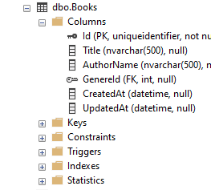

* Subscribers will have an Id, a First name, a Last name and a list of all Books under loan – either the book id, or an entire Book object. A subscriber can loan up to 3 books.

**Yes, I have added fields as you mentioned and few required field to mange data and a dbo.BooksLoans table to mange** *list of all Books under loan for the subscriber.*

* 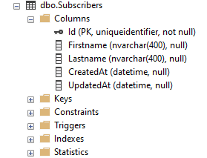
* 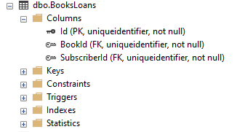

Display Information of Subscriber with list of all books he had.

* 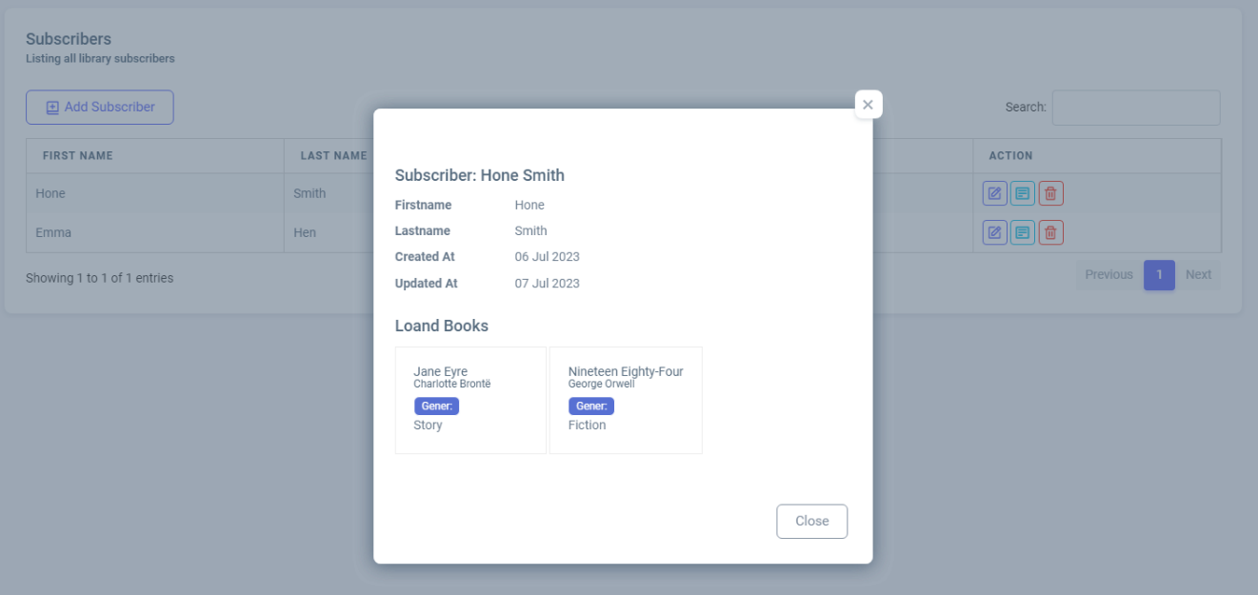
* The same book can be loaned as many times as we want.

**Yes, We can loaned as many thimes as we want**

* If using Mongo, create two collections under the Library database.

**No used Mongo**

* If using SqlExpress, create two tables in the Library database.

**Yes, I have made two main table called** *dbo.Books* **and** *dbo.Subscribers* **instend of those we have added two table** *dbo.Geners* **and** *dbo.BooksLoans* **that was required to manage loand books and Geners**

The application should include at least 4 razor pages:

1. Home- will contain links or button to the other 3 pages  
**Yes, I have added main 3 pages and Home page linkes**   
  
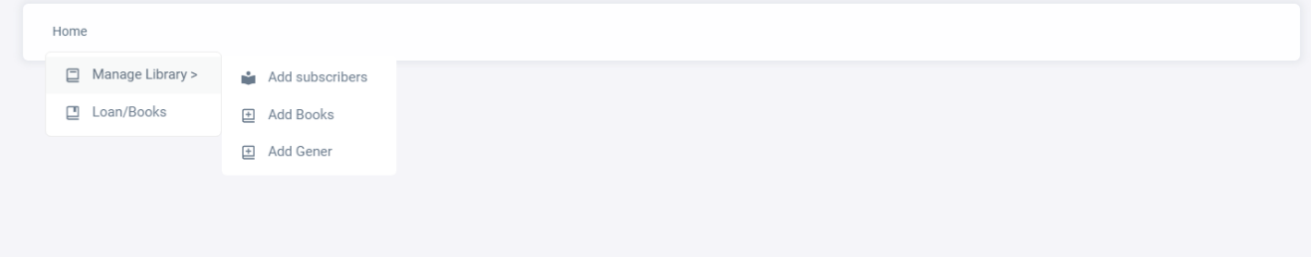

2. Manage Library- Add subscribers, Add Books  
**Yes, I have made section called Subscribers and Books with Add, Edit, Delete, View and Fiter featured.**  
SUBSCRIBER  
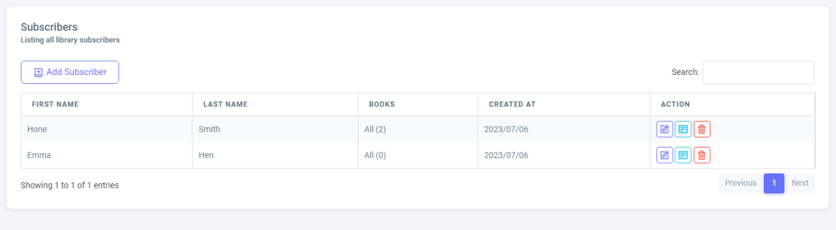  
  
ADD SUBSCRIBER   
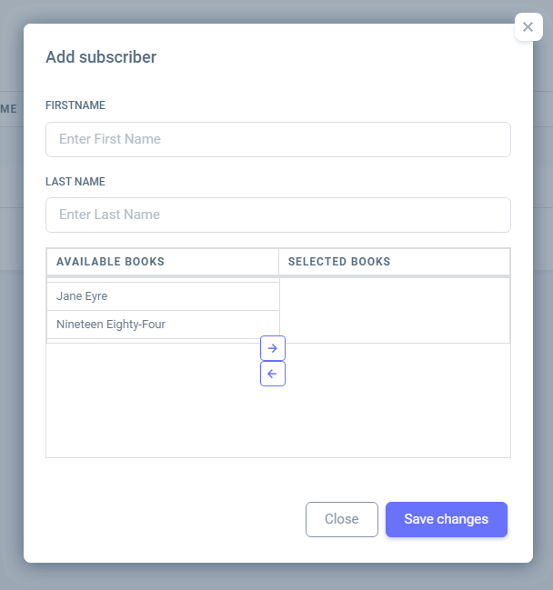

BOOKS  
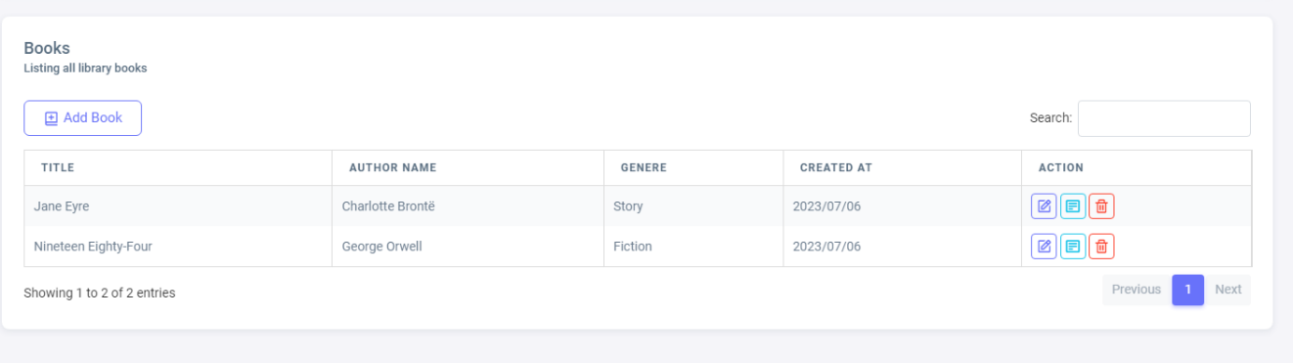  
  
ADD BOOK

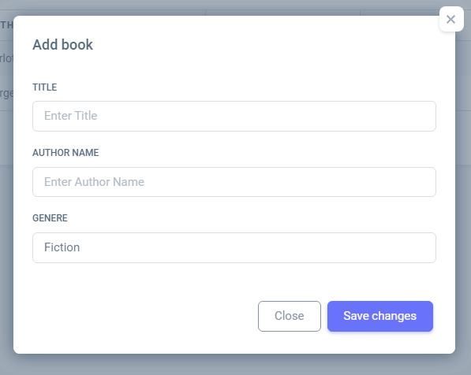

3. Loan/Return Books- by Id

**Yes, I have added the feature to display Loan information by Books Id, there we can get loan book by id,author name and book name**.

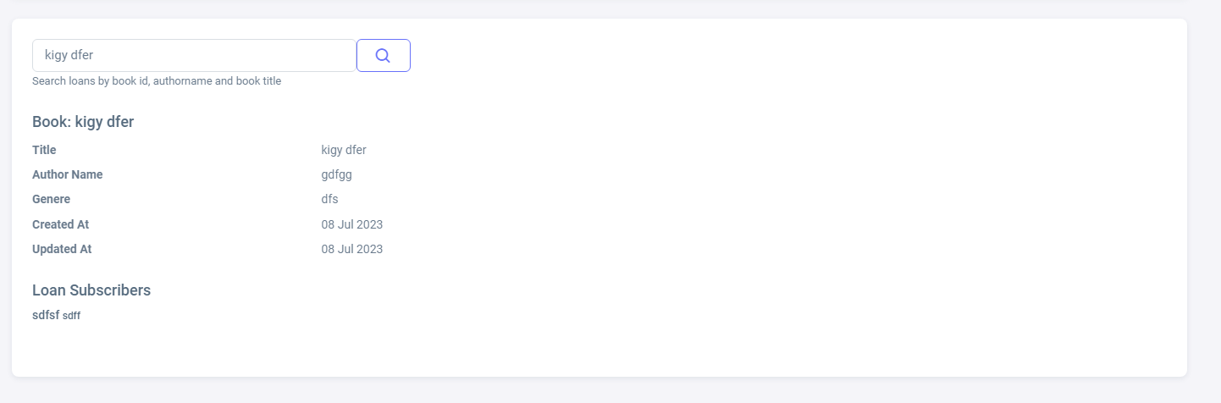

4. Display Information – about a subscriber, about a book, about a genre

**Yes, I have added the feature to display information with about a subscriber As you mentiond** *"Each subscriber can have at least 3 books, his list of all books he had will shown on the* ***display information page*"**.

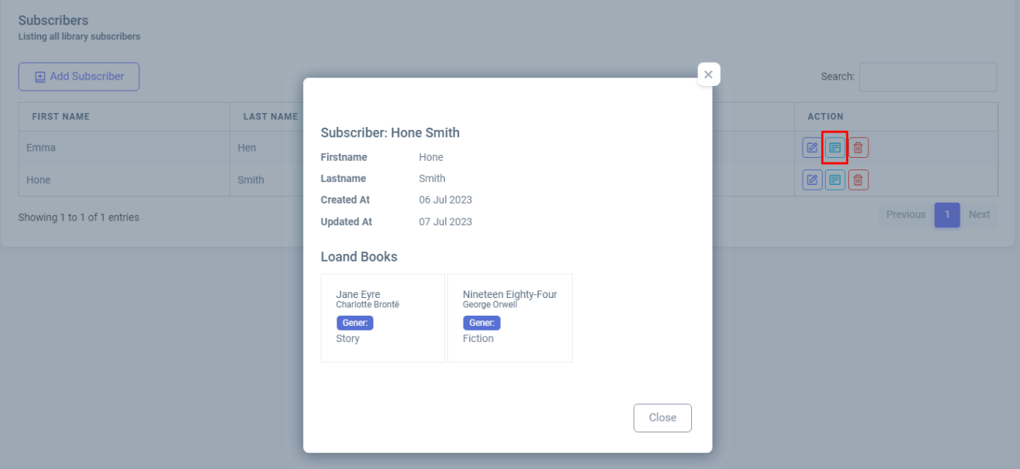

Use Forms for supplying the data.

**Yes, I have used the Form to subblying data.**

Use Tag handlers, Binding and routing where it is appropriate.

**Yes, I have used required handlers, Binding and routing**

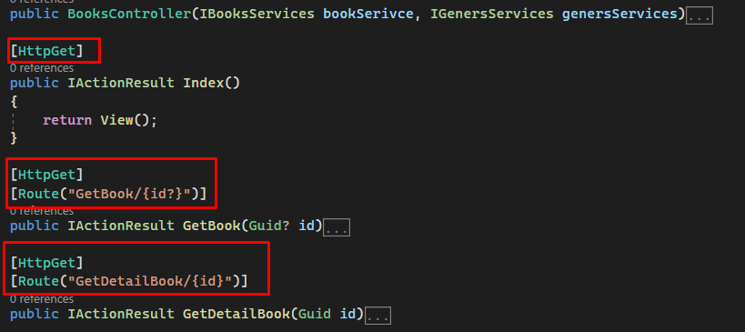

The DB should be registered as a service and its configuration should also be registered.

**Yes, I have configured DB as Serivce**

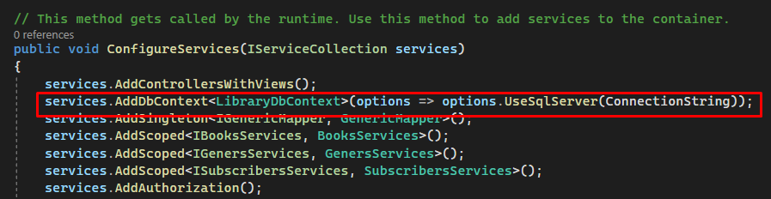

You don’t have to use asynchronous programming, but it is recommended.

**Yes, As you mentions we didn't used asynchronous programing**

Feel free to add behavior if you wish – delete book (but only if it is not on loan), delete subscriber, loan book by name..

**I have added those feture as well**

Use CSS and html/js as much as you can

**I have used CSS and HTML/JS as per requirenment**