VeriDoc
A Citation-Grounded Q&A Assistant for Institutional Documents

Final Year Project Report
B.Tech — Computer Science & Engineering / Information Technology
Live app: https://veridoc-9td5zj9kteg5cly2vnaz6b.streamlit.app

Submitted by: ____________________
Roll No.: ____________________
Under the guidance of: ____________________
Department & College: ____________________
Academic Year: 2026-27

1. Abstract
VeriDoc is a domain-specific question-answering system that answers questions about an institution using only its official documents. Every answer is backed by a citation to the exact source passage, and the system honestly refuses when the information is not present, instead of hallucinating. It is built using Retrieval-Augmented Generation (RAG) with an added relevance gate and strict grounding prompt. Evaluated on a benchmark of 61 real questions, VeriDoc answered 50 of 53 answerable questions correctly (94%) with a citation on every answer, and correctly refused all 8 unanswerable questions (100%). In contrast, both a keyword-search baseline and a plain chatbot refused 0% of the unanswerable questions and provided no citations — demonstrating that VeriDoc is substantially more trustworthy.

2. Introduction
Essential institutional information — fees, examination rules, scholarship eligibility, the academic calendar and hostel regulations — is scattered across many PDFs and web pages. Students waste time searching for answers or get inconsistent responses from staff, sometimes leading to missed deadlines. This project builds a trustworthy assistant that answers such questions directly from official documents, with verifiable citations.

2.1 Problem Statement
There is no reliable, fast way for students to get correct, source-backed answers to everyday questions about their college. Existing options are slow, inconsistent, or untrustworthy.

2.2 Objectives
- Ground every answer: produce answers only from official documents.
- Cite the source: attach the exact document and passage to each answer.
- Refuse honestly: say "not found" when the answer is absent.
- Prove the improvement: benchmark against keyword search and a vanilla chatbot.

3. Literature Review / Existing Solutions
Current approaches to this problem and why they fall short:
Approach | Limitation
Asking staff / office | Slow, inconsistent, often unavailable.
Keyword search on portal | Misses meaning; no direct answer.
Reading PDFs manually | Time-consuming; info is buried.
Generic AI chatbots | Hallucinate; no citation; not trustworthy.
[ FILL IN: optionally cite 2-3 papers on RAG you read ]

4. System Design & Architecture
VeriDoc uses a Retrieval-Augmented Generation pipeline with two paths: an offline indexing pipeline that stores document chunks in a vector store, and an online query pipeline that retrieves passages, applies a relevance gate, and generates a cited answer or refuses.
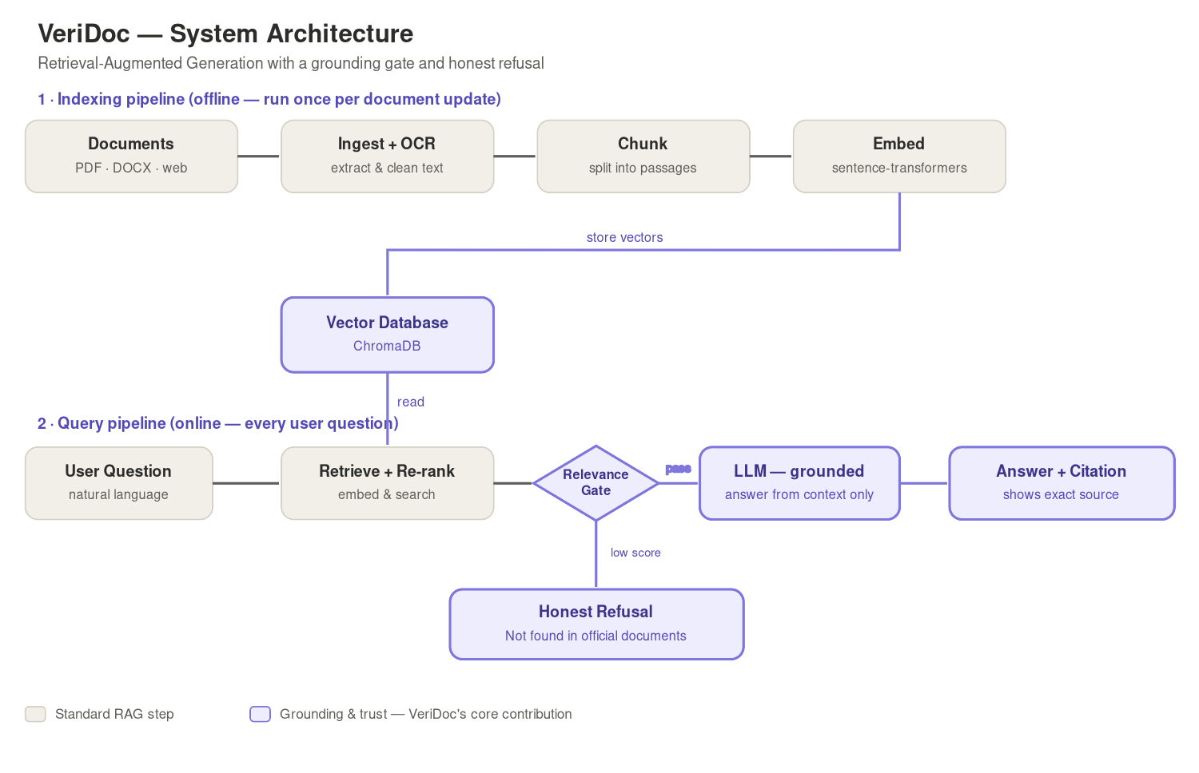
Figure 1: VeriDoc system architecture.

4.1 Modules
- Document Ingestion: loads and cleans PDFs/DOCX/web pages, with OCR.
- Indexing: chunks text, creates embeddings, stores them in a NumPy vector index.
- Retrieval & Re-ranking: finds and orders the most relevant passages.
- Grounded Answering: answers from context only, with citation and honest refusal.
- User Interface: Streamlit chat with a verifiable source panel.
- Evaluation: benchmark and three-way comparison.

5. Implementation
The system is implemented in Python. Key technologies used:
Component | Technology
Language | Python
UI | Streamlit
Document extraction | PyMuPDF, python-docx, BeautifulSoup, Tesseract (OCR)
Embeddings | sentence-transformers (all-MiniLM-L6-v2)
Vector search | NumPy (in-memory cosine similarity)
Re-ranking | cross-encoder (ms-marco-MiniLM)
LLM | Llama 3 via Ollama (local) / Google Gemini (cloud)
Deployment | Streamlit Community Cloud
Version control | Git + GitHub
The two-layer honest-refusal mechanism is the core contribution: (1) a relevance gate refuses before calling the LLM when no passage is relevant enough, and (2) a strict prompt instructs the model to refuse if the answer is not in the provided context.
[ FILL IN: optionally add a screenshot of the live app here ]

6. Experimental Setup & Dataset
Dataset: five representative institutional documents (student handbook, fee circular, scholarship policy, academic calendar, and admission form), producing 23 indexed text passages. Benchmark: 61 questions — 53 answerable from the documents and 8 intentionally unanswerable, used to test honest refusal. Three systems were compared: VeriDoc, a keyword-search baseline, and a vanilla chatbot (LLM with no document context).

7. Results
The measured results across the three systems:
Metric | VeriDoc | Keyword Search | Vanilla Chatbot
Answer accuracy (answerable) | 94% (50/53) | see note | see note
Provides citations | Yes (every answer) | No | No
Correct refusals on unanswerable | 100% (8/8) | 0% (0/8) | 0% (0/8)
Wrong answers on unanswerable | 0 | 8 | 8

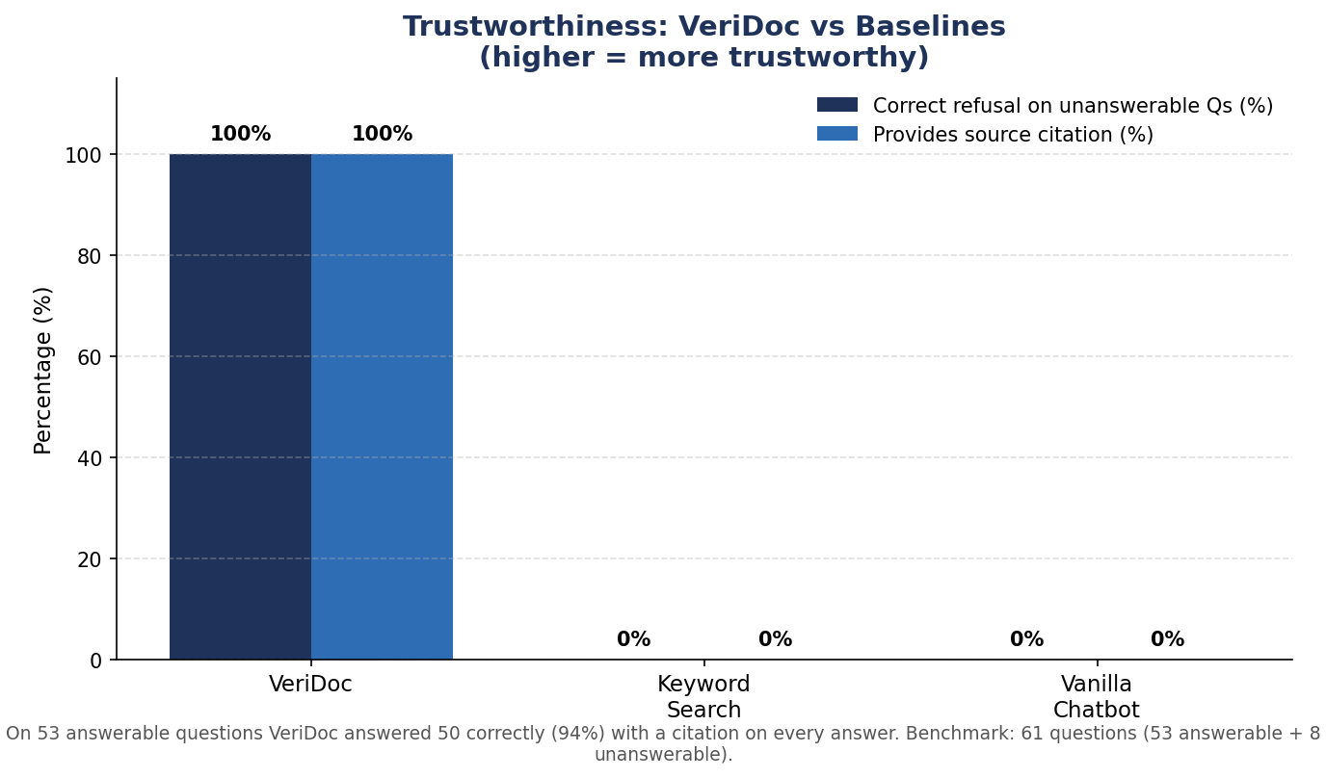
Figure 2: Trustworthiness comparison.
Note: the keyword and chatbot baselines always return an answer, so their "accuracy" on answerable questions is not directly comparable — the key differentiator is that they never refuse and never cite, whereas VeriDoc does both.

7.1 Discussion
VeriDoc correctly refused all 8 unanswerable questions, while both baselines answered every one of them — fabricating information a user could not verify. VeriDoc also provided a citation for every answer, which neither baseline can do. On answerable questions VeriDoc answered 50 of 53 correctly; the 3 it declined were a deliberate, safe trade-off from its relevance gate, which prioritises never giving a wrong answer over answering every question. This confirms the central claim: grounding plus honest refusal makes the system trustworthy where plain retrieval or a generic chatbot is not.

8. Conclusion & Future Work
VeriDoc demonstrates that a citation-grounded, refusal-capable RAG system can answer institutional questions reliably and verifiably, clearly outperforming keyword search and a plain chatbot on trustworthiness. The system is deployed live and usable from any browser.

8.1 Future Work
- Support for regional / code-mixed (Hinglish) questions.
- Handling conflicting documents by preferring the most recent by date.
- A live admin interface for continuous document updates.
- Scaling the vector store (e.g. to ChromaDB / pgvector) for larger document sets.

9. References
[ FILL IN: list the papers, libraries and documentation you referred to, in your college citation format ]

