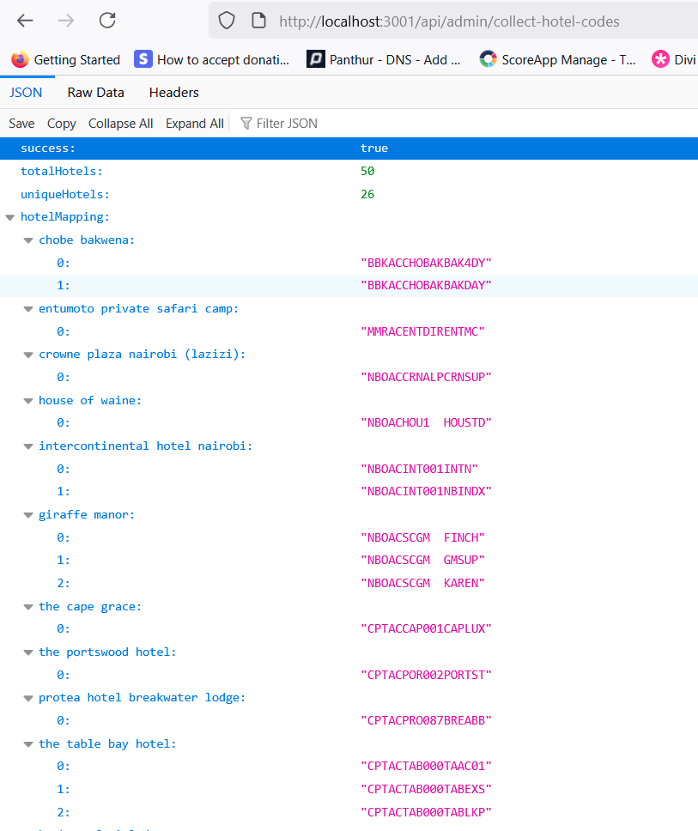

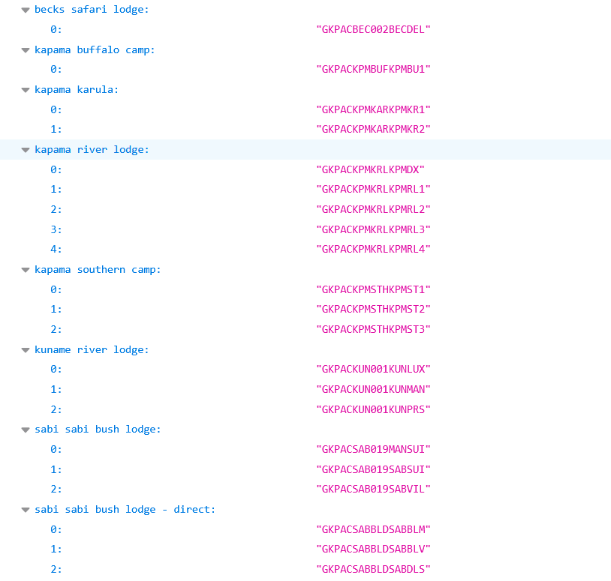

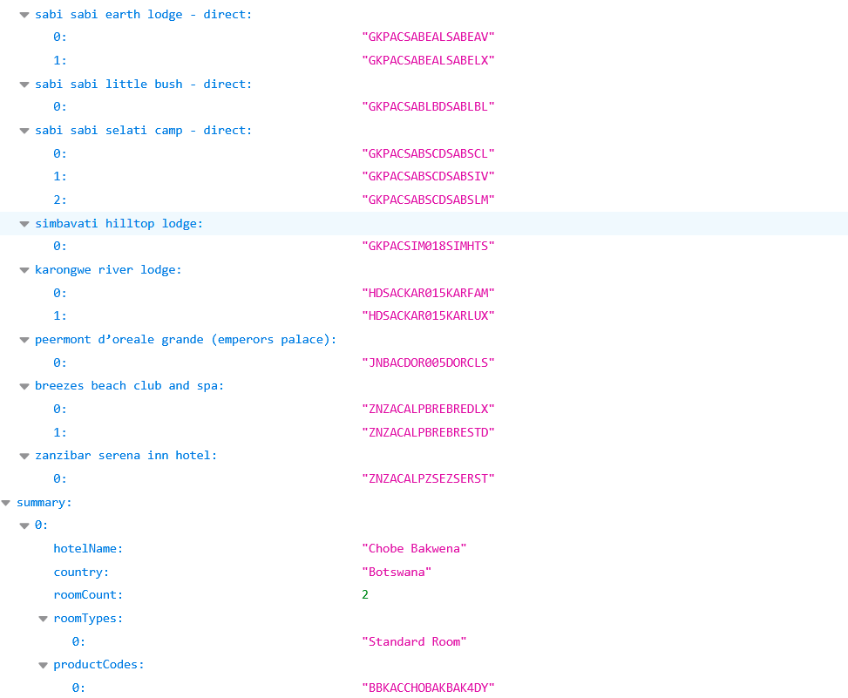

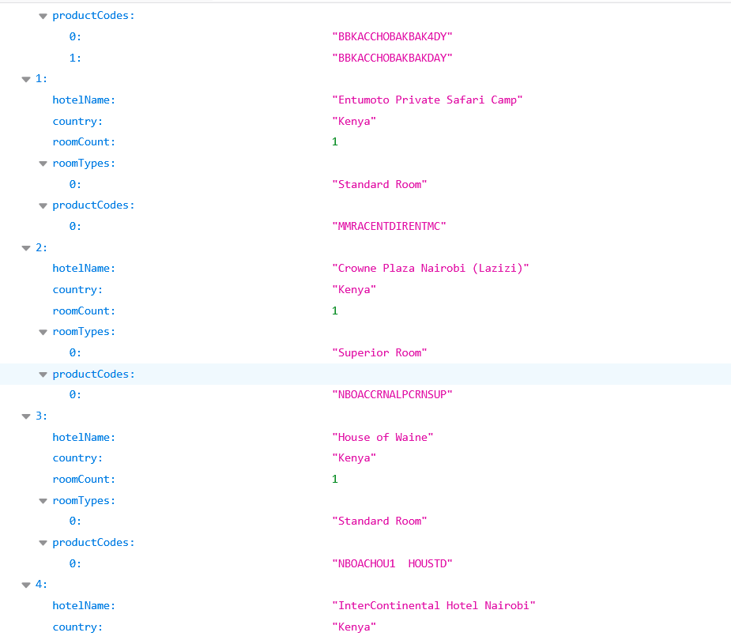

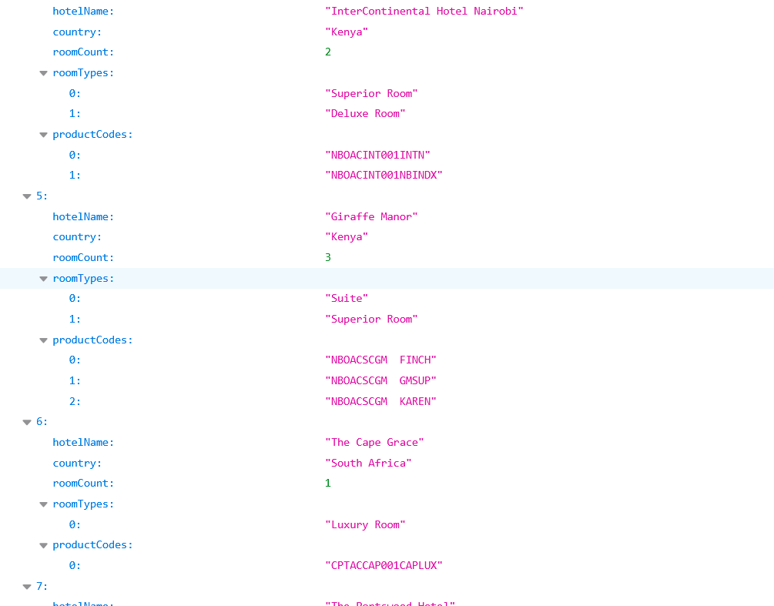

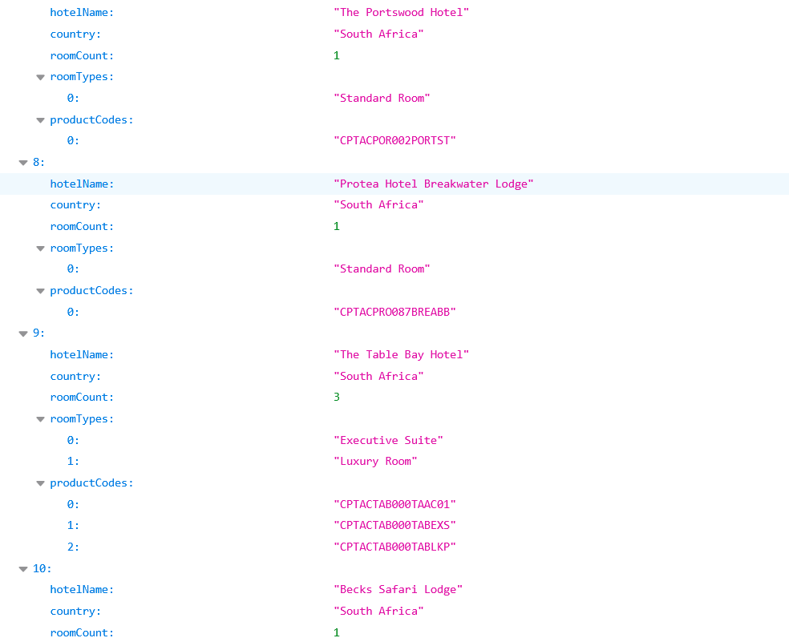

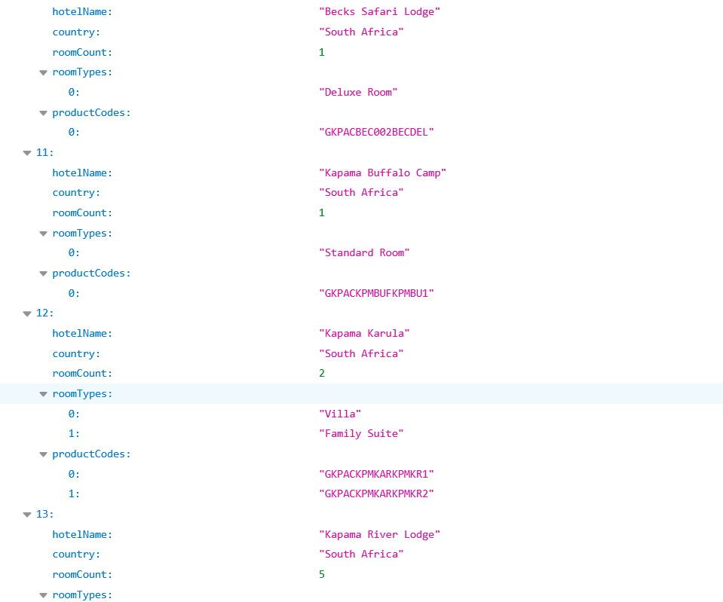

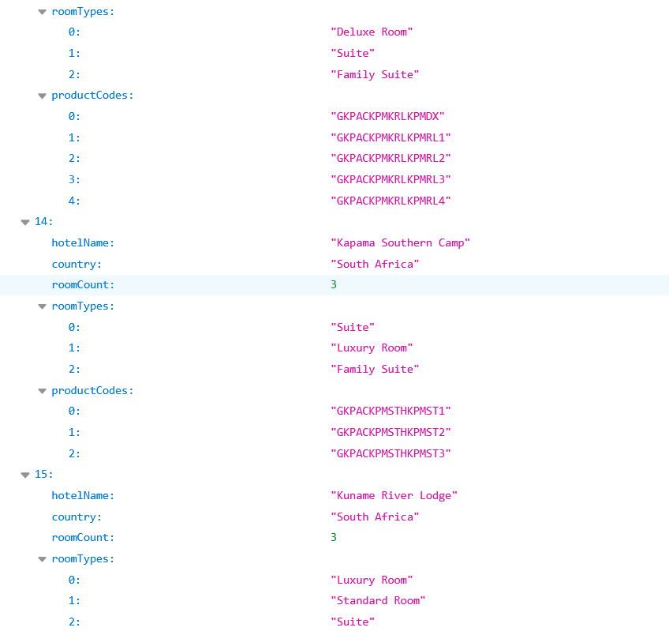

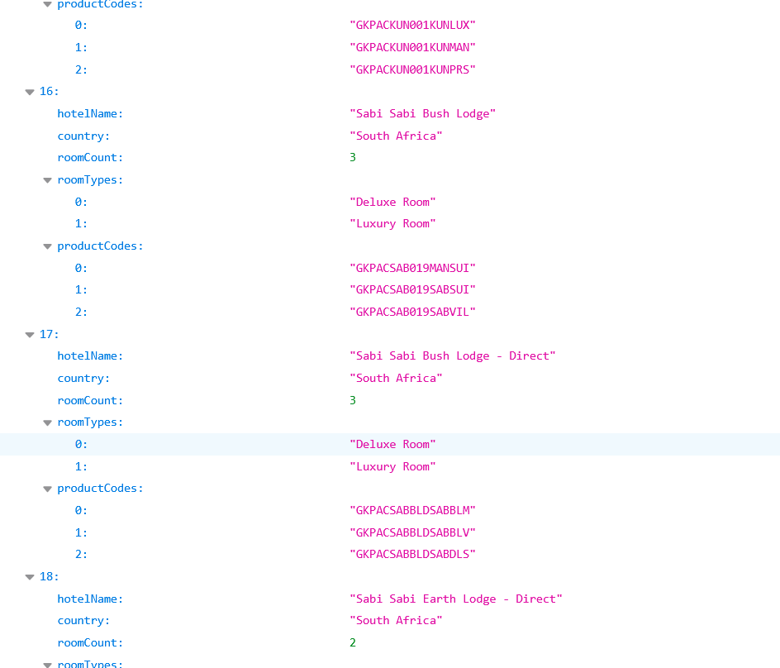

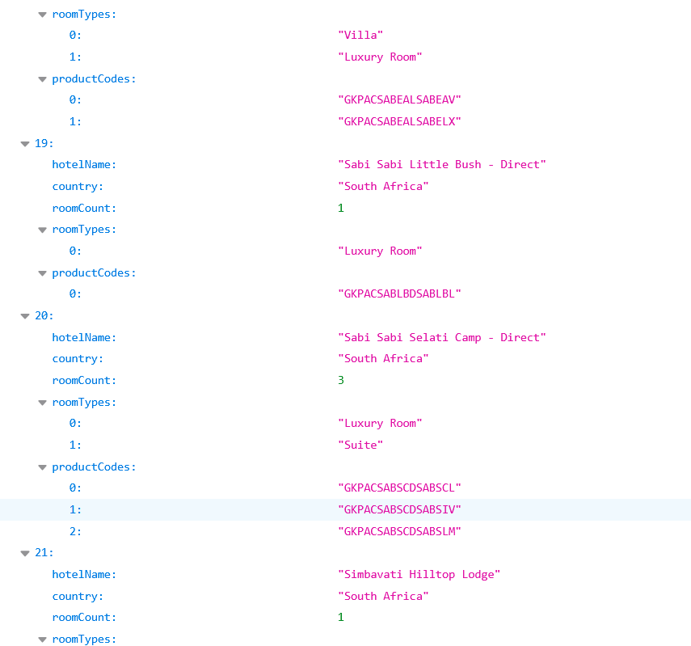

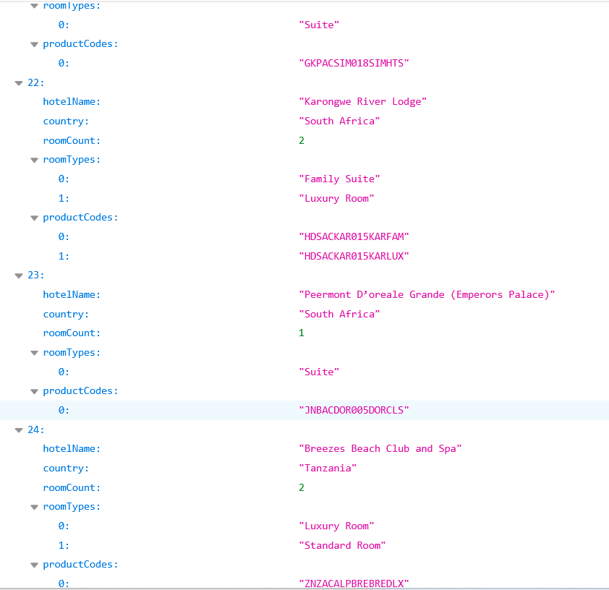

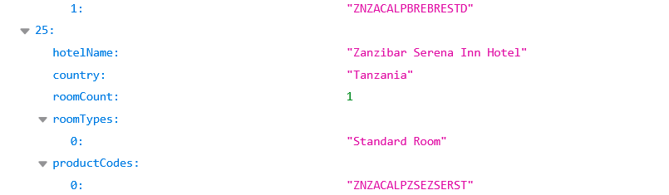

Json data from API:

{

"success": true,

"totalHotels": 50,

"uniqueHotels": 26,

"hotelMapping": {

"chobe bakwena": [

"BBKACCHOBAKBAK4DY",

"BBKACCHOBAKBAKDAY"

],

"entumoto private safari camp": [

"MMRACENTDIRENTMC"

],

"crowne plaza nairobi (lazizi)": [

"NBOACCRNALPCRNSUP"

],

"house of waine": [

"NBOACHOU1 HOUSTD"

],

"intercontinental hotel nairobi": [

"NBOACINT001INTN",

"NBOACINT001NBINDX"

],

"giraffe manor": [

"NBOACSCGM FINCH",

"NBOACSCGM GMSUP",

"NBOACSCGM KAREN"

],

"the cape grace": [

"CPTACCAP001CAPLUX"

],

"the portswood hotel": [

"CPTACPOR002PORTST"

],

"protea hotel breakwater lodge": [

"CPTACPRO087BREABB"

],

"the table bay hotel": [

"CPTACTAB000TAAC01",

"CPTACTAB000TABEXS",

"CPTACTAB000TABLKP"

],

"becks safari lodge": [

"GKPACBEC002BECDEL"

],

"kapama buffalo camp": [

"GKPACKPMBUFKPMBU1"

],

"kapama karula": [

"GKPACKPMKARKPMKR1",

"GKPACKPMKARKPMKR2"

],

"kapama river lodge": [

"GKPACKPMKRLKPMDX",

"GKPACKPMKRLKPMRL1",

"GKPACKPMKRLKPMRL2",

"GKPACKPMKRLKPMRL3",

"GKPACKPMKRLKPMRL4"

],

"kapama southern camp": [

"GKPACKPMSTHKPMST1",

"GKPACKPMSTHKPMST2",

"GKPACKPMSTHKPMST3"

],

"kuname river lodge": [

"GKPACKUN001KUNLUX",

"GKPACKUN001KUNMAN",

"GKPACKUN001KUNPRS"

],

"sabi sabi bush lodge": [

"GKPACSAB019MANSUI",

"GKPACSAB019SABSUI",

"GKPACSAB019SABVIL"

],

"sabi sabi bush lodge - direct": [

"GKPACSABBLDSABBLM",

"GKPACSABBLDSABBLV",

"GKPACSABBLDSABDLS"

],

"sabi sabi earth lodge - direct": [

"GKPACSABEALSABEAV",

"GKPACSABEALSABELX"

],

"sabi sabi little bush - direct": [

"GKPACSABLBDSABLBL"

],

"sabi sabi selati camp - direct": [

"GKPACSABSCDSABSCL",

"GKPACSABSCDSABSIV",

"GKPACSABSCDSABSLM"

],

"simbavati hilltop lodge": [

"GKPACSIM018SIMHTS"

],

"karongwe river lodge": [

"HDSACKAR015KARFAM",

"HDSACKAR015KARLUX"

],

"peermont d’oreale grande (emperors palace)": [

"JNBACDOR005DORCLS"

],

"breezes beach club and spa": [

"ZNZACALPBREBREDLX",

"ZNZACALPBREBRESTD"

],

"zanzibar serena inn hotel": [

"ZNZACALPZSEZSERST"

]

},

"summary": [

{

"hotelName": "Chobe Bakwena",

"country": "Botswana",

"roomCount": 2,

"roomTypes": [

"Standard Room"

],

"productCodes": [

"BBKACCHOBAKBAK4DY",

"BBKACCHOBAKBAKDAY"

]

},

{

"hotelName": "Entumoto Private Safari Camp",

"country": "Kenya",

"roomCount": 1,

"roomTypes": [

"Standard Room"

],

"productCodes": [

"MMRACENTDIRENTMC"

]

},

{

"hotelName": "Crowne Plaza Nairobi (Lazizi)",

"country": "Kenya",

"roomCount": 1,

"roomTypes": [

"Superior Room"

],

"productCodes": [

"NBOACCRNALPCRNSUP"

]

},

{

"hotelName": "House of Waine",

"country": "Kenya",

"roomCount": 1,

"roomTypes": [

"Standard Room"

],

"productCodes": [

"NBOACHOU1 HOUSTD"

]

},

{

"hotelName": "InterContinental Hotel Nairobi",

"country": "Kenya",

"roomCount": 2,

"roomTypes": [

"Superior Room",

"Deluxe Room"

],

"productCodes": [

"NBOACINT001INTN",

"NBOACINT001NBINDX"

]

},

{

"hotelName": "Giraffe Manor",

"country": "Kenya",

"roomCount": 3,

"roomTypes": [

"Suite",

"Superior Room"

],

"productCodes": [

"NBOACSCGM FINCH",

"NBOACSCGM GMSUP",

"NBOACSCGM KAREN"

]

},

{

"hotelName": "The Cape Grace",

"country": "South Africa",

"roomCount": 1,

"roomTypes": [

"Luxury Room"

],

"productCodes": [

"CPTACCAP001CAPLUX"

]

},

{

"hotelName": "The Portswood Hotel",

"country": "South Africa",

"roomCount": 1,

"roomTypes": [

"Standard Room"

],

"productCodes": [

"CPTACPOR002PORTST"

]

},

{

"hotelName": "Protea Hotel Breakwater Lodge",

"country": "South Africa",

"roomCount": 1,

"roomTypes": [

"Standard Room"

],

"productCodes": [

"CPTACPRO087BREABB"

]

},

{

"hotelName": "The Table Bay Hotel",

"country": "South Africa",

"roomCount": 3,

"roomTypes": [

"Executive Suite",

"Luxury Room"

],

"productCodes": [

"CPTACTAB000TAAC01",

"CPTACTAB000TABEXS",

"CPTACTAB000TABLKP"

]

},

{

"hotelName": "Becks Safari Lodge",

"country": "South Africa",

"roomCount": 1,

"roomTypes": [

"Deluxe Room"

],

"productCodes": [

"GKPACBEC002BECDEL"

]

},

{

"hotelName": "Kapama Buffalo Camp",

"country": "South Africa",

"roomCount": 1,

"roomTypes": [

"Standard Room"

],

"productCodes": [

"GKPACKPMBUFKPMBU1"

]

},

{

"hotelName": "Kapama Karula",

"country": "South Africa",

"roomCount": 2,

"roomTypes": [

"Villa",

"Family Suite"

],

"productCodes": [

"GKPACKPMKARKPMKR1",

"GKPACKPMKARKPMKR2"

]

},

{

"hotelName": "Kapama River Lodge",

"country": "South Africa",

"roomCount": 5,

"roomTypes": [

"Deluxe Room",

"Suite",

"Family Suite"

],

"productCodes": [

"GKPACKPMKRLKPMDX",

"GKPACKPMKRLKPMRL1",

"GKPACKPMKRLKPMRL2",

"GKPACKPMKRLKPMRL3",

"GKPACKPMKRLKPMRL4"

]

},

{

"hotelName": "Kapama Southern Camp",

"country": "South Africa",

"roomCount": 3,

"roomTypes": [

"Suite",

"Luxury Room",

"Family Suite"

],

"productCodes": [

"GKPACKPMSTHKPMST1",

"GKPACKPMSTHKPMST2",

"GKPACKPMSTHKPMST3"

]

},

{

"hotelName": "Kuname River Lodge",

"country": "South Africa",

"roomCount": 3,

"roomTypes": [

"Luxury Room",

"Standard Room",

"Suite"

],

"productCodes": [

"GKPACKUN001KUNLUX",

"GKPACKUN001KUNMAN",

"GKPACKUN001KUNPRS"

]

},

{

"hotelName": "Sabi Sabi Bush Lodge",

"country": "South Africa",

"roomCount": 3,

"roomTypes": [

"Deluxe Room",

"Luxury Room"

],

"productCodes": [

"GKPACSAB019MANSUI",

"GKPACSAB019SABSUI",

"GKPACSAB019SABVIL"

]

},

{

"hotelName": "Sabi Sabi Bush Lodge - Direct",

"country": "South Africa",

"roomCount": 3,

"roomTypes": [

"Deluxe Room",

"Luxury Room"

],

"productCodes": [

"GKPACSABBLDSABBLM",

"GKPACSABBLDSABBLV",

"GKPACSABBLDSABDLS"

]

},

{

"hotelName": "Sabi Sabi Earth Lodge - Direct",

"country": "South Africa",

"roomCount": 2,

"roomTypes": [

"Villa",

"Luxury Room"

],

"productCodes": [

"GKPACSABEALSABEAV",

"GKPACSABEALSABELX"

]

},

{

"hotelName": "Sabi Sabi Little Bush - Direct",

"country": "South Africa",

"roomCount": 1,

"roomTypes": [

"Luxury Room"

],

"productCodes": [

"GKPACSABLBDSABLBL"

]

},

{

"hotelName": "Sabi Sabi Selati Camp - Direct",

"country": "South Africa",

"roomCount": 3,

"roomTypes": [

"Luxury Room",

"Suite"

],

"productCodes": [

"GKPACSABSCDSABSCL",

"GKPACSABSCDSABSIV",

"GKPACSABSCDSABSLM"

]

},

{

"hotelName": "Simbavati Hilltop Lodge",

"country": "South Africa",

"roomCount": 1,

"roomTypes": [

"Suite"

],

"productCodes": [

"GKPACSIM018SIMHTS"

]

},

{

"hotelName": "Karongwe River Lodge",

"country": "South Africa",

"roomCount": 2,

"roomTypes": [

"Family Suite",

"Luxury Room"

],

"productCodes": [

"HDSACKAR015KARFAM",

"HDSACKAR015KARLUX"

]

},

{

"hotelName": "Peermont D’oreale Grande (Emperors Palace)",

"country": "South Africa",

"roomCount": 1,

"roomTypes": [

"Suite"

],

"productCodes": [

"JNBACDOR005DORCLS"

]

},

{

"hotelName": "Breezes Beach Club and Spa",

"country": "Tanzania",

"roomCount": 2,

"roomTypes": [

"Luxury Room",

"Standard Room"

],

"productCodes": [

"ZNZACALPBREBREDLX",

"ZNZACALPBREBRESTD"

]

},

{

"hotelName": "Zanzibar Serena Inn Hotel",

"country": "Tanzania",

"roomCount": 1,

"roomTypes": [

"Standard Room"

],

"productCodes": [

"ZNZACALPZSEZSERST"

]

}

]

}