A Case Study of Multi-Period Renewable Energy and Battery Scheduling

Team members: Mikhail Zvyagintsev, Natalia Aksamentova, Eriah Dwi Pamessangi Putri
A power operator runs a small power system for “tomorrow", which is split into several time periods (for example, every hour). Thus the operator plans over a horizon of T time periods (t = 1; 2; : : : ; T ) covering tomorrow. The power operator has
• a wind farm (free energy but varies a lot), and
• a battery (stores energy and recharges).
Tomorrow’s demand for electricity and the amount of wind available are uncertain. That is represented by the uncertainty with three possibilities (scenarios): low, medium, or high need of electricity.
The power operator’s job is to make a plan today and then adjust it tomorrow once operator knows which scenario actually happens.
Before knowing future (today, same for all scenarios): For each time period t,operator decides a base amount of energy to provide: x_{t} (MWh). Think of this as “day-ahead plan".
After knowing what happens (tomorrow, can differ by scenario and time):
• How much to charge the battery (in case excess energy left then save excess energy in the battery): q_{s;t} (MWh)
• How much to discharge the battery (to supply electricity for fulfilling the demand): r_{s;t} (MWh)
• How much wind power is unused (called curtailment): u_{s;t} (MWh).
• How much extra energy to buy from the market (to complete the demand): m_{s;t} (MWh).
• What is the battery power level at the end of the period (state of charge): S_{s;t} (MW).
• Unmet power demand in every scenario s and time t: l_{s;t} (MWh).
(In every notation, subscript s means in every scenario: low/medium/high, and subscript t means in every time period).
Goal: Minimize the total expected cost, divided into:
• a cost of day-ahead planed energy.
• a price for any market purchases, if needed
• a penalty, if operator curtail wind energy instead of using it.
• a penalty, if any amount of electricity demand is unserved.
• a cost of charging and discharging battery.
Because operator does not know which scenario will happen, he/she minimizes the average cost across the three scenarios (weighted by their probabilities).
Rules must be followed:
• Battery cannot be charged or discharged faster than its limit.
• The battery level (state of charge) must always stay between 0 and its maximum size.
• Battery power level carries over time.
• Meet demand in every period.
• Finish the day reasonably. That means
1. Operator must end the last period with the battery neither empty nor unrealistically full (stay within a reasonable final range).
2. This prevents “cheating" by using the whole battery at the last minute and leaving it empty for the next day.
Data/Known Parameters
• T = 24: Tomorrow’s 24 hour planning horizon.
• Scenario set s = {1; 2; 3} with probabilities π₁ = 0,3; π₂ = 0,4; π₃ = 0,3.
• Day-ahead base schedule cost per MWh energy: c_{t} for each period t is given in ‘table1_ct.csv’.
• A big penalty for unserved energy demand: P_{unmet} = 100000 (NOK/MWh).
• For each period t and scenario s:
1. Net load D_{s;t} (MWh) is given in ‘table2_D.csv’.
2. Available wind energy W_{s;t} (MWh) is given in ‘table3_W.csv’.
3. Real-time market purchase price p_{s;t} (NOK/MWh) is given in ‘table4_p.csv’
4. Wind energy curtailment penalty k_{s;t} = 320 (NOK/MWh) in every scenario and hour.
• Hourly maximum market purchase capacity M_{cap;t} (MWh) is given in ‘table5_MCap.csv’.
• Battery limits: energy capacity E_{max} = 120 (MWh), charge and discharge power limits P_{max-charge} = 45 (MW), P_{max-discharge} = 55 (MW), respectively, efficiencies of charging and discharging η_{charge} = 0,95 and η_{discharge} = 0,95.
• Initial state of charge of battery S₀ = 60 (MWh), desired minimum and maximum limit of state of charge of battery are S_{min} = 55 (MWh); S_{max} = 85 (MWh), respectively.
• Optional battery throughput cost β = 12 (NOK/MWh) applied to (q_{s;t} + r_{s;t}) (charging/discharging battery).
Task 1.1. Define the types of all the decision variables, such as continuous variable (fractional values), integer variable, in the two-stage stochastic optimization model (1)
Task 1.2. Write clearly two-stage framing for decision variables. For example, which decision variable belongs to first-stage and which belongs to second-stage?
Solution for task 1.1, 1.2:
First-stage (here-and-now) decision variables – must be chosen before the uncertainty is revealed.
Variable | Meaning | Type
x_{t} | Day-ahead scheduled energy for hour t, MWh | Continuous, non-negative (x_{t} ≥ 0)*
*can be modelled as integer if discrete energy blocks are required; in this assignment we treat x_{t} as continuous.
x_{t} is linking the scenarios and will be the complicating variable in the decomposition context.
Second-stage (recourse) decision variables – to be defined after the scenario s becomes known.
Variable | Meaning | Type
m_{s,t} | Energy purchased from real-time market, MWh | Continuous, m_{s,t} ≥ 0
q_{s,t} | Battery charging power, MW | Continuous, q_{s,t} ≥ 0
r_{s,t} | Battery discharging power, MW | Continuous, r_{s,t} ≥ 0
u_{s,t} | Wind energy curtailed, MWh | Continuous, u_{s,t} ≥ 0
l_{s,t} | Unserved demand, MWh | Continuous, l_{s,t} ≥ 0
S_{s,t} | Battery state at end of hour t, MWh | Continuous, bounded: 0 ≤ S_{s,t} ≤ E^{max}

So, no integer or binary variables are required for this model. Therefore, the model is a continuous two-stage stochastic linear problem.
Task 2. Write the Master problem for the two-stage stochastic optimization model (1)
Solution:
The Master Problem contains only first-stage (here-and-now) decisions and an auxiliary variable that lower-bounds the expected second-stage cost.
The Master problem:
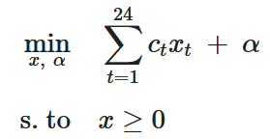
α_{down} ≤ α
α – master (first-stage) auxiliary variable, serving as a lower bound of the expected recourse (second-stage) cost
Task 3. Write the sub-problem(s) (per scenario s) for the two-stage stochastic optimization model (1). Solution:
Given a fixed day-ahead schedule ${\hat{x}}_{t}$from the master problem, the subproblem for each scenario $s∈S$ determines the optimal real-time operating decisions.
For each scenario $s$, the subproblem is:
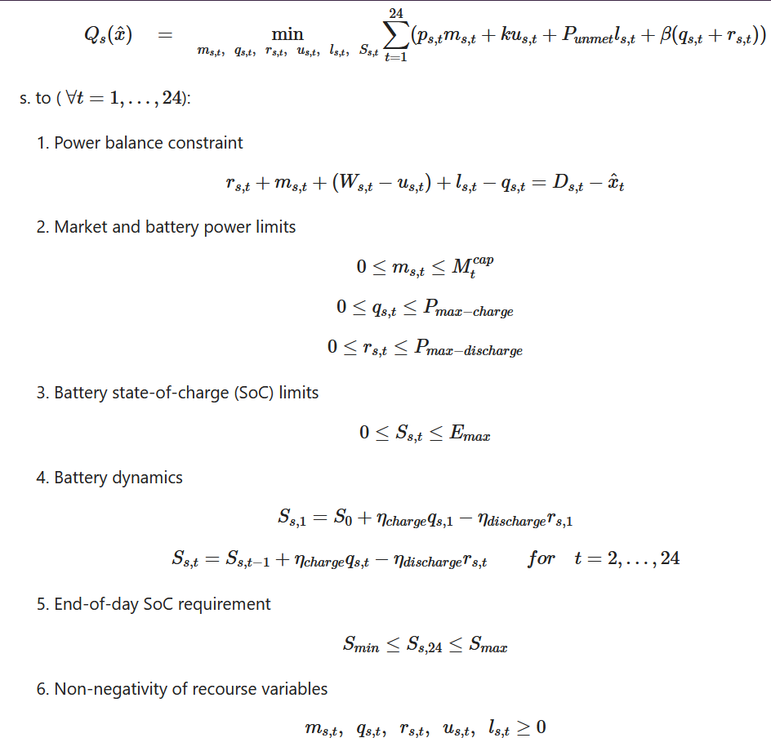
So, for each scenario $s$, the subproblem is a linear program that minimizes the real-time operating cost given the first-stage schedule ${\hat{x}}_{t}$, while satisfying:
- power balance,
- market & battery limits,
- battery dynamics & SoC bounds.
Task 4. Write the Benders cut for the two-stage stochastic optimization model (1), and clearly mention the dual variable.
Solution:
After solving the subproblem for each scenario $s$ at iteration $k$, we obtain the dual variables associated with the power balance constraints.
Let:
$λ_{s,t}^{(k)}$ - dual variable of the power balance constraint in scenario $s$, hour $t$ at iteration $k$ - measures how the second-stage cost changes if the first-stage decision $x_{t}$increases by 1 unit.
${\hat{x}}_{t}^{(k)}$— the first-stage solution from the master problem at iteration $k$
$Q_{s}({\hat{x}}^{(k)})$— optimal value of subproblem $s$ at iteration $k$
Probability-weighted second-stage cost:
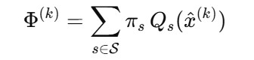
Aggregated (scenario-weighted) dual multipliers:
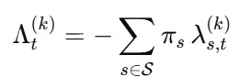
Benders optimality cut (added to the Master problem):
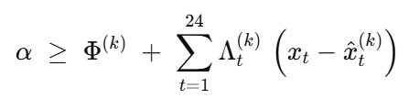
Explanation: The dual variable $λ_{s,t}^{(k)}$ measures how the second-stage cost changes if the first-stage decision $x_{t}$increases by 1 unit.
By combining duals across all scenarios, Benders cut provides a linear underestimate of the expected recourse cost, forcing the master problem to update $x_{t}$ toward an optimal solution.
Task 5 Write the Step 1 and Step 2 of Benders decomposition algorithm for the two-stage stochastic optimization model (1).
Solution:
Step 1: Master problem
- Initialize the algorithm with no Benders cuts.
- Solve the master problem:
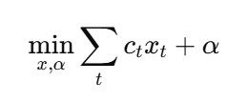
subject to:
- $x_{t}≥0$(first-stage constraints)
- $α≥α_{down}$
- Existing Benders cuts: none in the first iteration
- Obtain the first-stage solution ${\hat{x}}_{t}^{(k)}$and the current value of $α^{(k)}$.
In the first iteration both will be zero, since this provides the absolute minimum total cost.
Step 2: Subproblem (second-stage):
For each scenario $s$:
- Fix $x_{t}={\hat{x}}_{t}^{(k)}$from Step 1.
- Solve the subproblem SP_{s}:
- Minimize real-time operating cost under scenario $s$
- Obtain optimal value $Q_{s}\left({\hat{x}}^{\left(k\right)}\right)$
- Extract the dual variables $λ_{s,t}^{(k)}$of the power balance constraints
- Compute the expected second-stage cost:
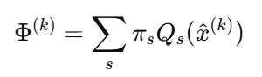
- Compute the aggregated dual multipliers:
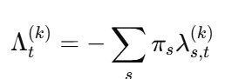
Task 6 Write the Step 3 and Step 4 of Benders decomposition algorithm for the two-stage stochastic optimization model (1).
Solution:
Step 3: Checking convergence
We are still at interation k. Using the values from Step 2 -
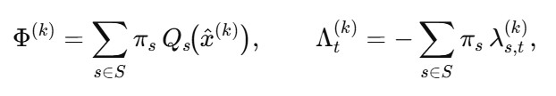
, we construct the Benders optimality cut:
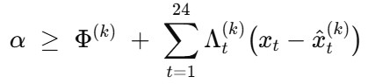
Then we check the gap between master problem solution (optimal objective function value) and original problem solution, as they are at this iteration.
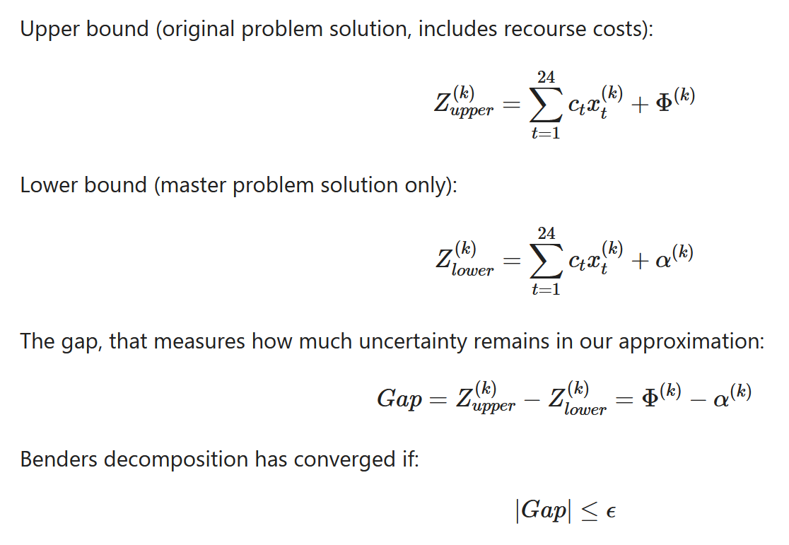
In our case the tolerance ε = 10⁻⁴, so we iterate until the gap does not exceed it longer.
Step 4: Update of the master problem and new iteration
We set iteration to $k+ 1$ and solve the updated master problem with all cuts $j=1,…,k$:
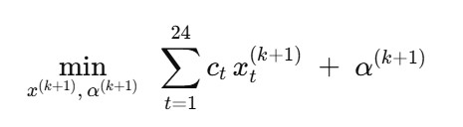
subject to
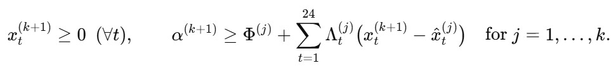
From here we obtain a new solution {x^{(k+1)}; α^{(k+1)}} and update master problem with it.
Now, we proceed from Step 2 (solve subproblems at $x^{(k+1)}$) until convergence.
Task 7 Implement the Benders decomposition algorithm for solving the two-stage stochastic optimization model (1) in Python using Pyomo library and GLPK solver
Our code of Benders implementation for Energy problem and CSV files of all the optimal decision variables are attached.
Conclusion:
We have implemented Benders decomposition in Pyomo with GLPK. The algorithm iteratively solves a master problem and scenario subproblems, imports the duals of the balance constraints, and adds Benders optimality cuts until the UB–LB gap ≤ tolerance. The results are reported for a baseline model and for a 30% minimum day-ahead commitment.
The optimal day-ahead purchase $x_{t}=0$for all hours is not caused by a coding constraint, but is the true economic optimum of the model. Since real-time energy, wind generation, and battery flexibility allow the operator to satisfy demand at a lower expected cost than committing energy in the day-ahead market, the model rationally chooses not to lock-in any day-ahead volume. Therefore, purchasing zero energy in the day-ahead market minimizes total expected system cost under the given assumptions.
Task 8 Plot the convergence graph of Benders decomposition algorithm for solving the two-stage stochastic optimization model (1).
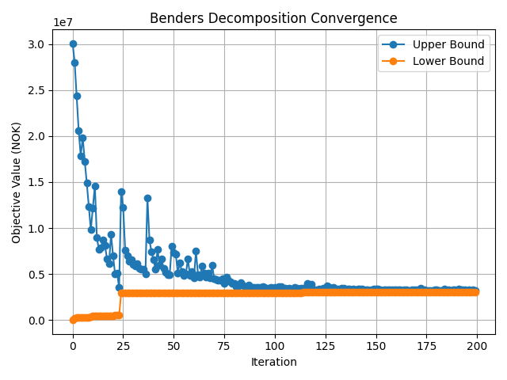
The plot shows how the Benders algorithm improves the solution over the iterations.
The Upper Bound (UB), driven by iterative solution of subproblem, starts high and goes down, while the Lower Bound (LB) driven by iterative solution of master problem, starts low and goes up.
As the two lines get closer, the model converges to the optimal solution.
This means that each iteration adds useful information (cuts out infeasible regions), and the algorithm keeps improving the decision $x_{t}$ until the optimal cost is reached.

