**Implement Ocelot API Gateway**

**AIM**:

In this article, we will see how to route to different microservices through ocelot gateway. Ocelot is open source and designed for .Net. Even Microsoft uses ocelot, you can see the implementations in their articles.

Through ocelot:-

* We can create a unified end point for our microservice and avoid exposing our actual endpoints. For this we will route to different end points from our ocelot gateway.

Other features include:-

* API composition (to call multiple requests in a single request)
* Caching
* Logging
* Authentication
* Authorization
* Load balancing
* Service discovery

In this article, we will discuss on routing and ocelot implementation in your project. I have created a POC for this and we will use .NET CORE 3.1 framework in this implementation. A few words on the POC, it is based on a Hospital system. We have a the following modules in it:-

* HospitalAPI: - It will help to create and manage Hospital details for the system.
* **APIGateway**: - We have used ocelot to build this gateway, it routes the incoming requests to corresponding API’s in the system.

In this POC, our point of interest is APIGateway. Let’s see how to implement ocelot gateway.

**High Level Steps**:

Steps to implement ocelot gateway in your project:-

1. Create ASP.NET Core Web Application.
2. Download NuGet package “Ocelot”
3. Add a JSON file to the project (Ocelot.json). We will mention our routing details in this file.
4. In the program.cs, we will add the “Ocelot.json” file
5. In startup, we will configure the middleware and you are done ☺

**Steps**:

Let’s see the steps in detail:-

1. Open visual studio, add a new project and select ASP.NET Core Web Application. As shown below:-

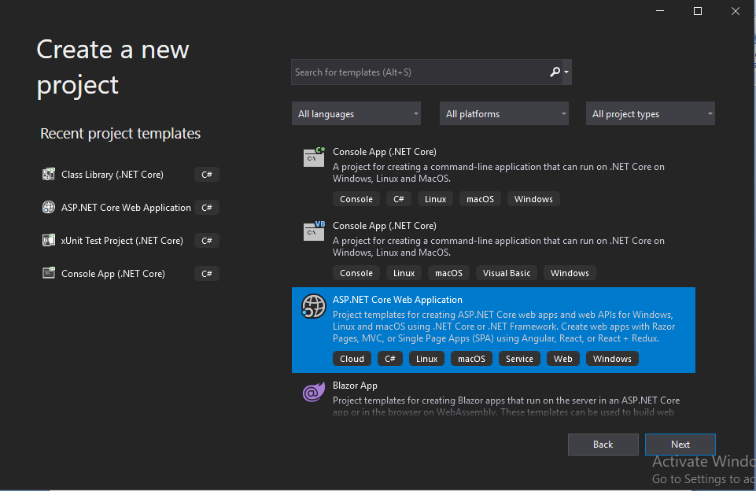

1. Create an empty project and name as APIGateway. In the next screen make sure you select ASP.NET Core 3.1 framework.

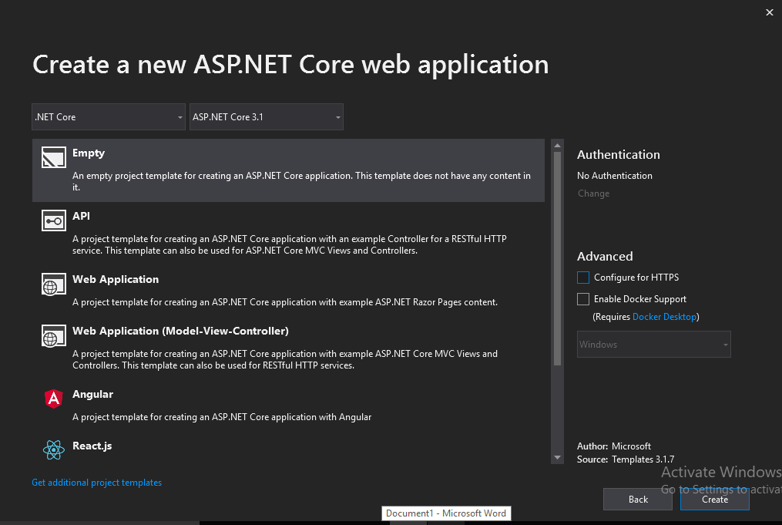

1. Right click on the APIGateway project -> Dependencies and then select “Manage NuGet Packages”. In the browser tab, type ocelot and click install, you will see a screen as shown below.

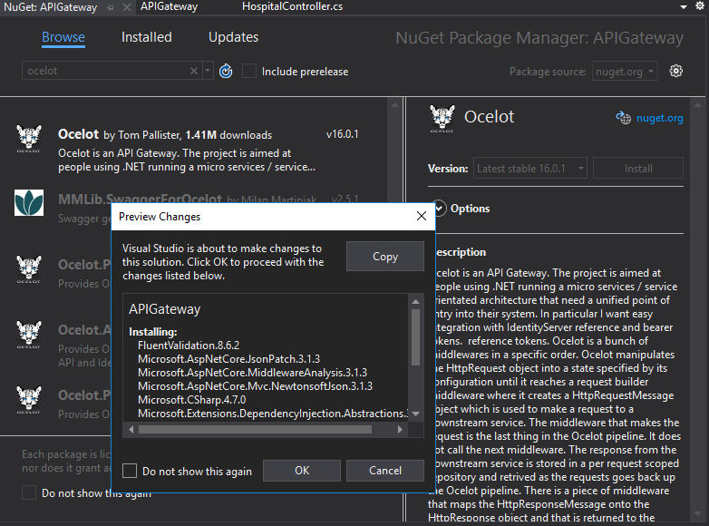

Click “Ok” button and click “I Accept” button in License Acceptance screen.

1. Right click on “APIGateway” project, and add a new item. Search for JSON file and name the JSON file as “ocelot.json” (you can change the name if you want).

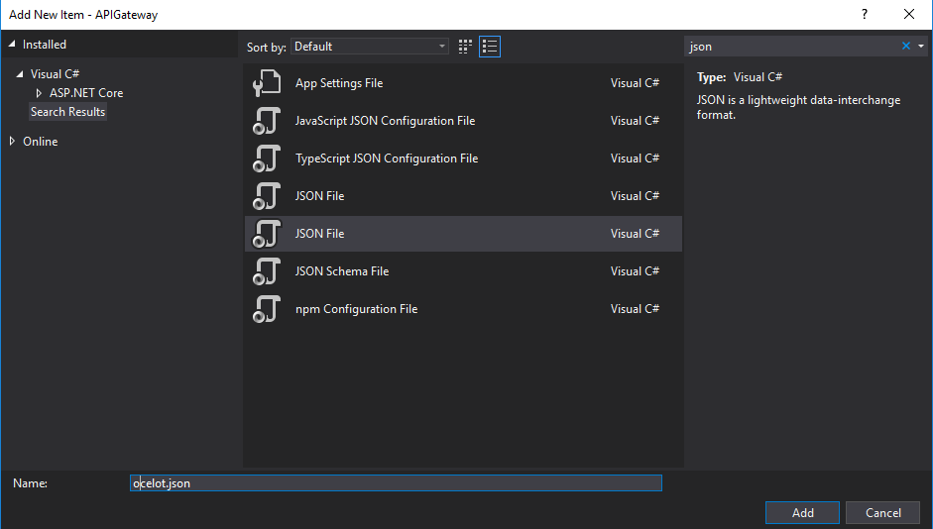

1. Now we need to add our routing information in “ocelot.json” file. So to mention routing information we need to create routes by adding "Routes":[ *we can mention any number of routing information here*] and inside routes we need to mention 5 informations:-
2. DownstreamHostAndPorts :- where you can mention the host name or url and port number as shown below:-

"DownstreamHostAndPorts": [

{

"Host": "localhost",

"Port": "50204"

}

]

Inside the square brackets, you can mention multiple host and port numbers set separated by curly brackets and comma ({},).

1. DownstreamPathTemplate:- Mention the downstream path that is the API path you want to call. For example, in this case, if you want to call Hospital API, we should mention “/api/hospital” (where hospital will be the controller name)

c) DownstreamScheme: Here you mention your project support http or https.

d) UpstreamHttpMethod: - Select the HTTP verbs you support in your controller. If you miss to mention the respective verb, your API call will not work.

e) UpstreamPathTemplate: - here you mention the path as how it should look while you call the API

Below is the routing code which we have used in our ocelot.json file:-

"Routes": [

{

"DownstreamHostAndPorts": [

{

"Host": "localhost",

"Port": "50204"

}

],

"DownstreamPathTemplate": "/api/hospital",

"DownstreamScheme": "http",

"UpstreamHttpMethod": [ "POST", "PUT", "GET", "DELETE" ],

"UpstreamPathTemplate": "/hospital"

}

Like this, we can add multiple route information with curly brackets and comma ({},). For example, suppose we want to have an action with a different API URL. In this case you can mention the action name in the upstream and downstream paths. Or if you want to support multiple action names with different API URL’s, then add “{everything}” in the upstream and downstream paths as below:-

{

"DownstreamHostAndPorts": [

{

"Host": "localhost",

"Port": "50204"

}

],

"DownstreamPathTemplate": "/api/hospital/{everything}",

"DownstreamScheme": "http",

"UpstreamHttpMethod": [ "POST", "PUT", "GET", "DELETE" ],

"UpstreamPathTemplate": "/hospital/{everything}"

}

So finally, your ocelot.json file will look like below:-

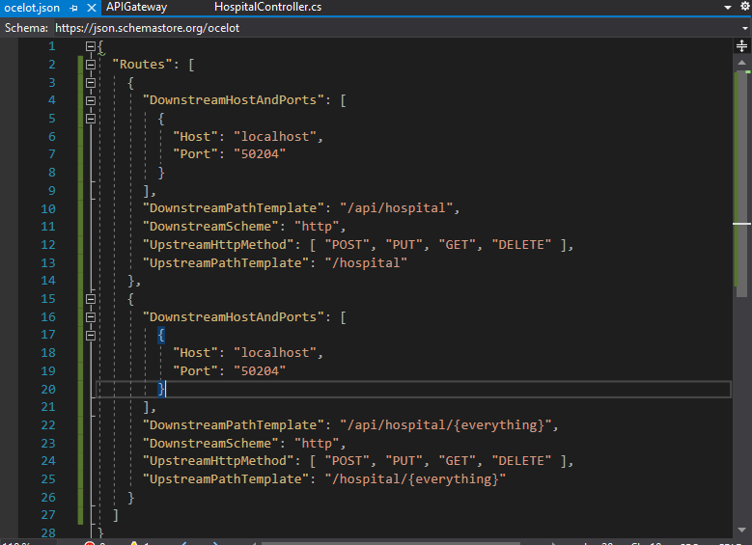

Save the file.

1. Now let’s add the “ocelot.json” file in program.cs. Inside the static method “CreateHostBuilder”, add the below code to add the JSON file.

.ConfigureAppConfiguration((hostingContext,config)=>

{

config.AddJsonFile("ocelot.json");

});

So your program.cs will look like below:-

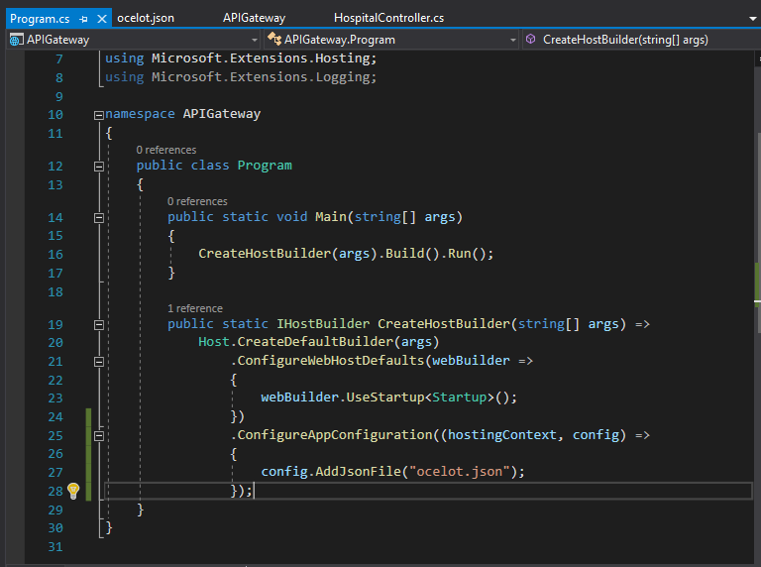

1. And in Startup.cs, add the middleware.
2. For this add “services.AddOcelot();” in ConfigureServices method and add the using “using Ocelot.DependencyInjection;”.
3. Also to add middleware, add “app.UseOcelot();” in Configure method. Since this is an async call, add wait and make the method async. Also you will have to add using “using Ocelot.Middleware;”

If you are having multiple projects or API’s in your solution, you will have to select multiple startup projects, so that your gateway and API will run at the same time. If your API is not started and only your gateway is working, we will not be able to call the API and vice versa. To enable multiple startup projects, right click solution and select properties. Then select “Multiple startup projects” and start individual projects (as shown below) and apply.

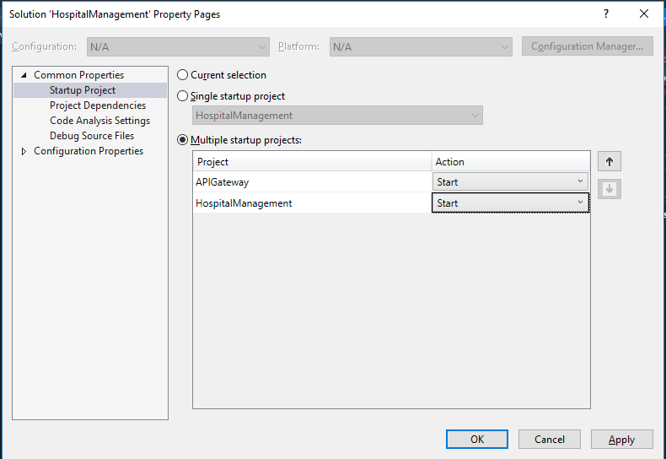

Now run your project and you have implemented ocelot gateway in your project. Congratulations!!

**Attachment to the Article** (if necessary):

POC of the implementation.