Type of wait group

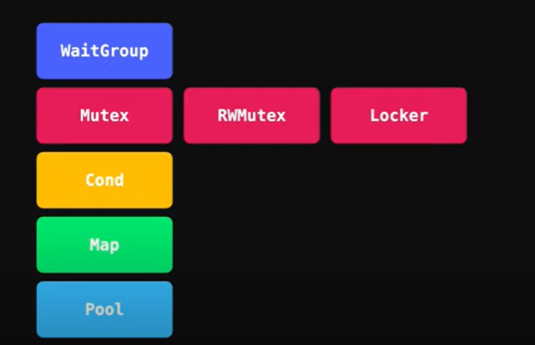

**Concurrency Primitives**

All of Go's Concurrency Primitives are stored inside the sync package, which stands for **Synchronization**, because most of the times that's what we as developers do with the **executing concurrent code**.

These are all the available types under the sync package:

* WaitGroup
* Mutex
* RWMutex
* Locker
* Cond
* Map
* Pool



