Kapture Finance — Maya Collections Voicebot
High-Level Design (HLD) | AI Delivery Intern Take-Home Assignment
Version: 1.0 | Date: August 2026 | Demo / Mock Implementation

1. Executive Summary
Maya is an outbound collections voice agent for Kapture Finance. The agent conducts polite, compliant conversations with customers who may have an overdue EMI. The design prioritizes identity verification before disclosure of sensitive account information, clear payment-intent handling, deterministic tool calls, safe edge-case handling, and an auditable call outcome.

2. Scenario and Assumptions
- Demo customer: Rahul Sharma.
- Product: Personal Loan.
- Demo overdue EMI: ₹8,499.
- Demo days past due: 12.
- The account and tool responses are mock data for the assignment.
- The production system would connect the same orchestration layer to authenticated account, payment, CRM, and messaging APIs.

3. Architecture & Pipeline
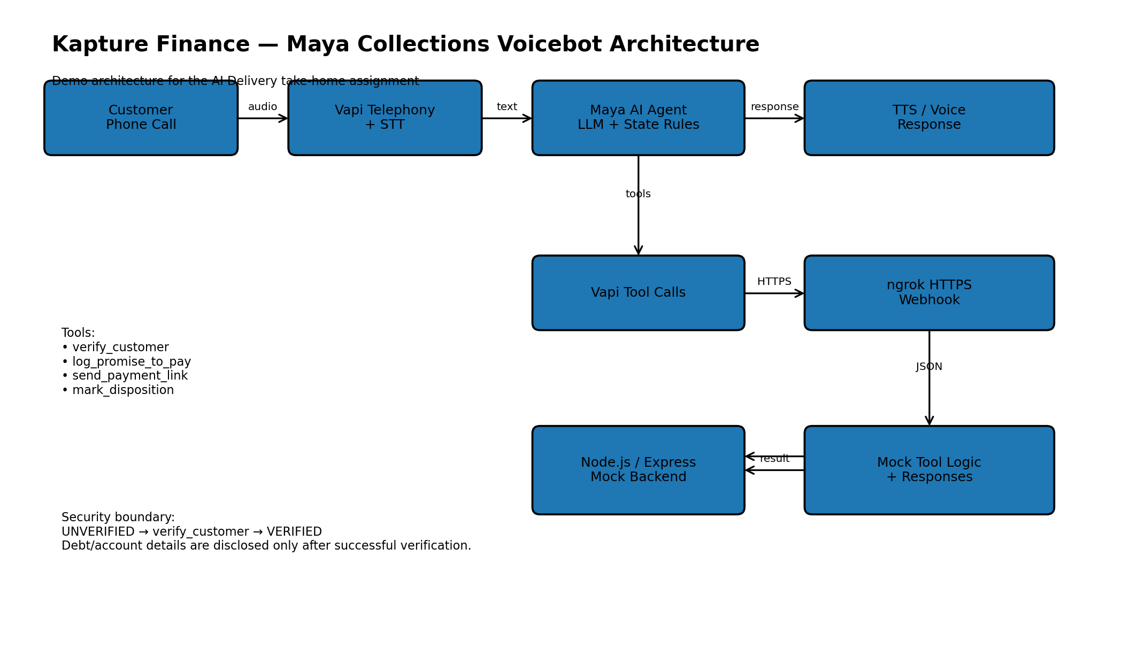
Figure 1. End-to-end architecture and security boundary.
Pipeline: customer audio → Vapi telephony/transcription → Maya orchestration/LLM → tool calls when required → Node.js/Express webhook → mock tool response → Maya → TTS/voice response.

4. Latency Budget
Hop | Target Budget | Notes
Telephony / audio transport | ≤ 150 ms | Network/audio transport target.
STT partial/final transcription | ≤ 500 ms | Use streaming transcription where available.
LLM/orchestrator decision | ≤ 800 ms | Keep prompts/tools concise.
Tool/API round trip | ≤ 700 ms | Mock endpoint is local; production APIs should be low-latency.
TTS first audio | ≤ 500 ms | Streaming voice output preferred.
Target conversational turn | ≈ 2.5 s | End-to-end target; real performance depends on provider/network.

5. Conversation State Machine
State | Entry / Lock
UNVERIFIED | Initial state. No debt, EMI, balance, or account details may be disclosed.
VERIFYING | Customer provides verification code; call verify_customer immediately.
VERIFIED | Only after verified:true. Account/payment discussion becomes permitted.
PAYMENT_INTENT | Classify will-pay, already-paid, dispute, hardship, payment-link request, callback, etc.
PTP_CONFIRMATION | For will-pay, confirm exact amount and date before tool execution.
PTP_RECORDED | Call log_promise_to_pay only after explicit customer confirmation and success response.
ALREADY_PAID | Call mark_disposition(status=already_paid); do not create a PTP.
ESCALATE / CALLBACK / DNC | Use the appropriate safe disposition/escalation path when available.
CLOSING | Confirm next step, avoid unsupported claims, thank customer, end politely.
Critical security invariant: the assistant cannot move from UNVERIFIED to account/payment disclosure merely because the model believes the caller is the customer. The VERIFIED state is entered only from an actual successful verify_customer tool result.

6. Intents & Entities
Intent | Key Entities | Expected Action
Will pay | amount, date | Confirm both; call log_promise_to_pay only after explicit confirmation.
Already paid | payment date, reference if offered | Do not ask customer to pay again; call mark_disposition(already_paid).
Dispute | dispute reason | Do not argue; route for review/escalation.
Hardship / cannot pay | reason, requested help | Empathize; do not invent options; escalate/review.
Payment link | channel | After verification, call send_payment_link when requested.
Wrong person | none | Do not disclose purpose/debt; politely end or request approved contact.
Callback | preferred time if supported | Do not disclose before verification; record disposition when available.
Human agent | none | Acknowledge and arrange follow-up; do not claim a live transfer unless confirmed.
Do not call | none | Respect request and route for processing; end politely.
Hostile / abusive | none | Remain calm, avoid escalation, offer appropriate exit/escalation.

7. Tools / API Contracts
Tool | Input | Success Output | When Used
verify_customer | verification_code: string | verified: boolean, message | Immediately when code is provided.
log_promise_to_pay | amount: number, ptp_date: string | success, ptp_id, confirmed_date, amount | Only after verified + explicit amount/date confirmation.
send_payment_link | channel: string | success, message | Only after verified + customer requests link.
mark_disposition | status: string | success, disposition_logged, timestamp | Required for already-paid; also supports final outcome logging.

8. Authentication & Data Safety
- The call starts UNVERIFIED.
- The bot must not reveal loan, EMI, overdue, balance, DPD, debt, or account information before successful verification.
- When a verification code is spoken, verify_customer is called immediately with the exact code.
- The assistant waits for the actual tool result; it never assumes verification succeeded.
- If verified:false, the customer is asked for another verification code without requesting unnecessary additional identity data.
- If a wrong person answers, no debt information or reason for the call is disclosed.
- Passwords, PINs, OTPs, and unnecessary payment credentials are never requested.
- Production deployment should add authenticated webhook credentials, encrypted transport, access control, audit logging, and least-privilege API permissions.

9. Compliance & Guardrails
- Identify the company/agent and purpose appropriately before protected account information is discussed.
- Use permitted calling hours and respect applicable local collection rules and customer opt-outs.
- No threats, harassment, shaming, coercion, or fabricated consequences.
- No hallucinated account facts or unsupported payment status.
- Never claim a tool action completed unless the tool returns success:true.
- Do-not-call requests are respected and routed for processing.
- Disputes are treated neutrally and routed for review rather than argued.
- Hardship cases are handled empathetically without inventing payment programs.
- The assistant stays on-topic and safely ends when continued collection discussion is inappropriate.

10. Edge Cases
- Already paid: mark_disposition(status=already_paid); never call log_promise_to_pay.
- Disputes amount/debt: acknowledge and route for review; do not decide validity.
- Do-not-call: acknowledge, pass the request for processing, and end politely.
- Wrong person: disclose nothing sensitive and end/request approved contact.
- No input / voicemail: do not reveal debt information; end or follow the approved voicemail policy.
- Abusive caller: remain professional; offer to end/escalate without threats.
- Callback request: obtain a suitable time only when supported; do not disclose before verification.
- Human-agent request: arrange follow-up without falsely claiming a live transfer.
- English/Hindi switch: maintain the same security and tool rules while changing language where supported.

11. Escalation & Disposition
Routine calls are intended to be self-served by Maya. Human follow-up is appropriate for disputes, hardship requiring case review, explicit human-agent requests, unsupported account issues, or other situations where the automated agent cannot safely complete the requested action. Every completed path should end with a disposition in a production system.

12. Observability
- Containment / self-service rate
- Promise-to-Pay rate
- PTP confirmation rate
- Payment-link request and success rate
- Already-paid/dispute/hardship rates
- Average end-to-end latency and tool latency
- Tool error / timeout / 4xx / 5xx rate
- Call drop and no-input rate
- Escalation rate
- Verification success/failure rate
Logs should include call/session identifier, state transitions, tool name, sanitized inputs/outputs, latency, error status, and final disposition. Sensitive data should be minimized or redacted.

13. Implementation Notes
The demo implementation uses Vapi for the voice agent and a local Node.js/Express webhook exposed through ngrok. The webhook returns deterministic mock responses for the four configured tools. This keeps the demo reproducible while matching the assignment's allowance for mocked endpoints.

14. Testing Evidence
Test | Scenario | Status
Successful verification | Code 1234 → verify_customer → verified:true | Passed
Failed verification | Invalid code → verify_customer → verified:false | Passed
Promise-to-Pay | ₹8,499 + Friday + explicit confirmation → log_promise_to_pay | Passed
Already paid | Customer says already paid → mark_disposition(already_paid) | Passed
Payment link | Verified customer requests link → send_payment_link(SMS) | Passed

15. Known Limitations / Production Improvements
- Mock verification and payment responses should be replaced by authenticated production APIs.
- Persistent state should be stored server-side rather than relying only on prompt context.
- Production webhook authentication and authorization should be enabled.
- A real CRM/disposition system, payment provider, and messaging provider should be integrated.
- A human transfer/escalation mechanism should be added.
- Automated regression tests and conversation evaluations should cover every major intent and safety boundary.
- Production compliance rules should be configurable by jurisdiction and reviewed by the appropriate legal/compliance team.

16. Conclusion
The HLD defines a secure, state-aware collections voicebot architecture that aligns with the working Vapi demo. The core implementation demonstrates verification-before-disclosure, Promise-to-Pay handling, payment-link delivery, already-paid dispositioning, and safe conversational guardrails. The design can be extended to production integrations without changing the core security boundary or conversation-state model.

