**2.INTERNSHIP SUMMARY**

During my 4-week internship, spanning a total of 20 days, I delved into the exciting realm of UI/UX and web technology. This immersive experience provided a comprehensive understanding of key technologies, including HTML, CSS, and a foundational introduction to JavaScript. The internship also covered essential aspects of web hosting, enriching my skill set and offering practical insights into the dynamic field of web development.

My internship commenced with an in-depth exploration of HTML, the backbone of web content. Through hands-on exercises and guided tutorials, I gained proficiency in structuring web documents. This included understanding HTML elements, attributes, and their role in creating a well-organized and semantically meaningful web page.

Building on the foundation laid by HTML, I delved into the art of styling web pages using CSS. This involved mastering selectors, properties, and values to control the layout and appearance of various elements. The internship provided practical scenarios to apply responsive design principles, ensuring a seamless user experience across different devices.

A significant portion of the internship focused on introducing JavaScript and its role in enhancing interactivity on the web. I gained insights into variables, data types, control structures, and functions. While the coverage was introductory, it laid a crucial foundation for future explorations into more advanced JavaScript concepts.

The internship also delved into the vital aspect of web hosting, emphasizing the process of making a website accessible to the public. I gained practical knowledge of domain registration, server setup, and the deployment of web applications. Understanding the nuances of web hosting provided a holistic view of the entire web development lifecycle.

Throughout the internship, collaboration was encouraged, fostering a dynamic and engaging learning environment. Regular interactions with mentors and fellow interns provided valuable insights and diversified perspectives, enhancing the overall learning experience.

In conclusion, this internship has been instrumental in equipping me with foundational skills in UI/UX and web development. The exposure to HTML, CSS, JavaScript, and web hosting, coupled with hands-on projects, has laid a robust groundwork for my future endeavors in this dynamic and ever-evolving field.

**3.** **DAILY LOG SUMMARY**

Day 1, we received a foundational introduction to web technologies, covering HTML for structuring content, CSS for styling, and JavaScript for basic interactivity.

Day 2 focused on the basics of HTML, emphasizing the construction of HTML documents and introducing fundamental tags.

Day 3 covered HTML anchor tags, attributes, link creation, and image embedding. The focus was on practical application, offering a hands-on understanding of incorporating these elements into web content.

Day 4 concentrated on HTML elements, distinguishing between block and inline elements. The session further explored semantic and structural elements, offering insights into their distinct roles in web page organization.

Day 5, focus was on CSS, exploring inline, internal, and external styling methods. The session provided insights into applying styles directly within HTML, internally within a document, and externally through separate style sheets.

Day 6 introduced Scalable Vector Graphics (SVG) and covered the process of embedding SVG in webpages. The session aimed at providing a basic understanding of SVG elements and their integration for enhancing visual content on websites.

Day 7 focused on HTML forms, exploring various form tags and their associated attributes. The session provided practical insights into creating interactive and user-friendly web forms, covering essential elements and attributes for effective form design.

Day 8, the fundamentals of Cascading Style Sheets (CSS) were introduced. The session covered basic CSS concepts, setting the groundwork for styling web elements, including selectors, properties, and values.

Day 9 focused on linking CSS styles to HTML elements using IDs and classes. The session explored various CSS properties, providing insights into their application for effective styling and layout customization on webpages.

Day 10 delved into text effects in CSS. The session explored various CSS properties and techniques for manipulating text, covering aspects like font styles, sizes, colors, and other text-related effects to enhance the visual appeal of web content.

Day 11 expanded on CSS with a focus on positioning and display properties. The session covered key aspects of layout design, exploring properties like position, display, and others to enable precise control over the placement and appearance of elements on webpages.

Day 12 introduced CSS animations and keyframes, offering a simple exploration of how to bring elements to life on a webpage. The session covered the basics of creating smooth transitions and dynamic effects using straightforward CSS animation properties and keyframes.

Day 13 was dedicated to hands-on experience, allowing practical application of the acquired knowledge.

Day 14, the focus shifted to CSS Grid properties. The session explored the fundamentals of grid-based layout design, covering properties that enable the creation of responsive and organized structures on webpages.

Day 15, Participants engaged in hands-on coding, applying CSS Grid properties for practical layout design, enhancing their proficiency in web development.

Day 16 continued the hands-on experience, focusing on practical coding exercises to reinforce understanding and application of advanced web development concepts.

Day 17 introduced JavaScript, focusing on fundamental concepts like methods and operators. The session provided insights into their practical use in scripting and their role in coding logic.

Day 18 provided participants with hands-on experience in applying various web development concepts. Practical exercises focused on reinforcing skills in HTML and CSS.

Day 19 continued the hands-on experience, emphasizing practical application of web development skills.

On Day 20, the focus was on prototyping in web development ,translating design concepts into interactive web elements.

**4.WEEKLY REPORT SUMMARY**

Week 1,The first week provided a foundational introduction to web technologies, covering HTML, CSS, and JavaScript. The focus extended to HTML basics, including document structure and fundamental tags. Emphasis was placed on practical application, incorporating HTML anchor tags, attributes, and image embedding. Exploration of HTML elements distinguished block and inline elements, delving into semantic and structural elements. The week concluded with a focus on CSS, exploring inline, internal, and external styling methods to solidify web development understanding.

Week 2,Introduction to Scalable Vector Graphics (SVG) enhanced visual content integration on webpages. Subsequently, exploration of HTML forms provided practical insights into creating interactive and user-friendly design. The fundamentals of Cascading Style Sheets (CSS) were introduced, covering selectors, properties, and values. The session on linking CSS styles using IDs and classes delved into various properties, offering insights into effective styling and layout customization. Lastly, text effects in CSS were explored, incorporating properties for font styles, sizes, colors, and overall visual enhancement of web content.

Week 3,the sessions progressed with an exploration of CSS, focusing on positioning and display properties to gain precise control over webpage layout. Subsequently, CSS animations and keyframes were introduced, providing a simple understanding of creating dynamic effects. A dedicated hands-on experience on Day 13 allowed practical application of acquired knowledge. The focus then shifted to CSS Grid properties, delving into the fundamentals of grid-based layout design for responsive and organized structures on webpages. The week concluded with participants actively engaging in hands-on coding, applying CSS Grid properties to enhance their proficiency in web development.

Week 4,continuing with practical coding exercises to reinforce advanced web development concepts, the internship introduced JavaScript, emphasizing fundamental methods and operators. Participants gained hands-on experience applying various web development concepts, reinforcing skills in HTML and CSS. The practical application of web development skills persisted, culminating in a focus on prototyping in web development to translate design concepts into interactive elements.

**5.HTML & CSS MINI PROJECTS**

1. **Food Website (HTML)**

The "Food Website" project tasked us with translating a given design into HTML. This exercise focused attention to detail and accuracy, providing practical application in web development. Participants honed their HTML skills by replicating design elements, contributing to a deeper understanding of coding practices. The project's focus on practical application aimed to bridge theoretical knowledge with real-world web development challenges. Through replication, I gained valuable insights into the HTML coding for effective design implementation. This project helped in strengthening foundational skills and promoting a keen eye for precision in web development.

1. **NUUK Web page (CSS)**

We were assigned to mimic the "NUUK" website using CSS, aiming to practice styling skills. This hands-on project emphasized getting the visual details right, providing practical experience in applying CSS styles to recreate the website's look. The task helped bridge what we learned about CSS theory with actual design work, improving our ability to style and layout elements for real-world web development scenarios. It was a straightforward opportunity to apply CSS knowledge and enhance our skills in creating visually appealing websites.

**6. MAIN PROJECT – WhereNext(Travel website)**

**Aim:**

WhereNext stands as a functional platform, providing users with efficient tools to explore, plan, and book budget-friendly trips. The inclusion of Sign In and Login buttons in the header enhances user convenience, allowing seamless access to personalized accounts for a more personalized travel experience.

**Theme:**

The theme of the "whereNext" website is centered on "Affordable Travel Exploration." It aims to provide users with an accessible platform for budget-friendly trip planning, offering straightforward navigation, personalized features, and transparent pricing. The focus is on making travel planning seamless, enjoyable, and cost-effective.

**Advantages:**

* **Budget-Friendly Adventures:** Access destinations fitting your budget, ensuring cost-effective and enjoyable travel experiences.
* **Effortless Exploration:** User-friendly navigation to explore destinations, seamlessly plan your journey, and optimize your travel opportunities.
* **Wishlist Management:** Curate your dream destinations with a click - our wishlist feature enables easy list creation and management.
* **Transparent Pricing:** Obtain clear and comprehensive pricing details, empowering informed decision-making aligned with your budget and preferences.

**Sections:**

**1. Header:**

* Destination Page: Navigational link leading to a comprehensive list of tourist destinations.
* About Us: Detailed insights into the background, mission, and values of whereNext.
* Contact Us: Dedicated section for inquiries or assistance.
* Sign In & Login Buttons: Seamless access to user accounts and personalized profiles.

**2. Home Page:**

* Explore Section: Visual representation of available destinations, facilitating quick exploration.
* About Us Section: In-depth information about the mission, values.
* Contact Us Section: Direct communication channel for personalized assistance.

**3. Destination Page:**

* Destination Cards: Display of destinations with images, concise descriptions, and pricing details.
* Wishlist Icon: User-friendly functionality to add preferred destinations to a personalized wishlist.
* Explore Button: Direct access to detailed information for booking purposes.

**4. Booking Page:**

* Detailed Information: In-depth details about the selected destination.
* Quantity and Duration Customization: Flexible options to adjust trip parameters, such as quantity and duration.
* Secure Booking System: Streamlined and secure booking process, ensuring a seamless travel experience.

**5.Footer:**

* Quick Links: Easy access to essential links, including Home, Destinations, About Us, Contact Us, and Sign In.
* Social Media Icons: Links to whereNext’s account in various platforms

**7.WhereNext website preview:**

**Header:**



**Home Page:**

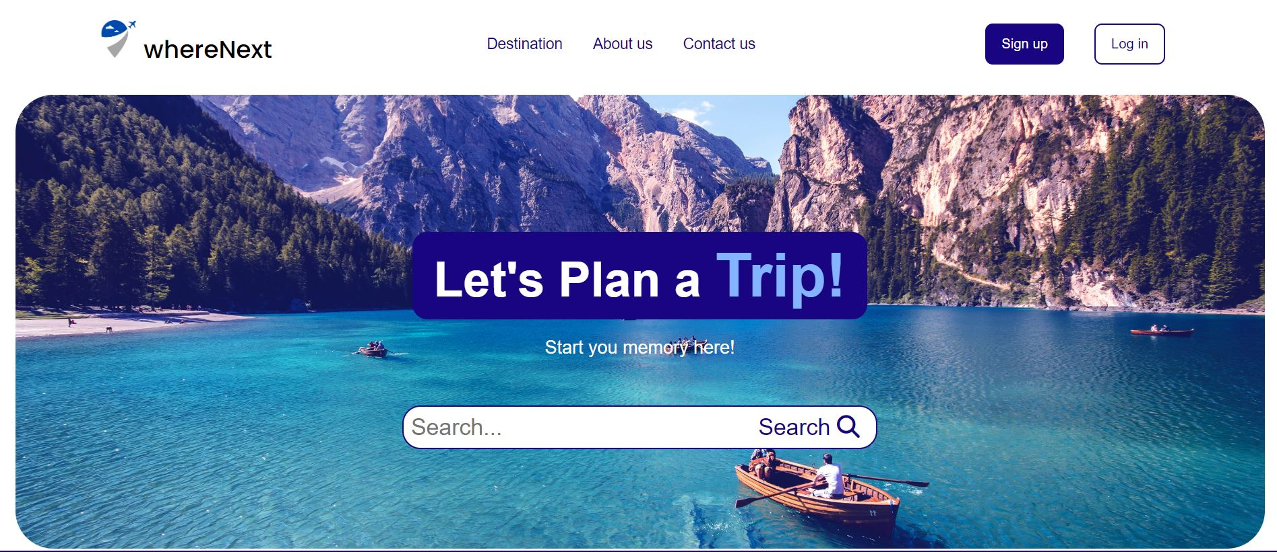

**Explore Section :**

**About Us Section:**

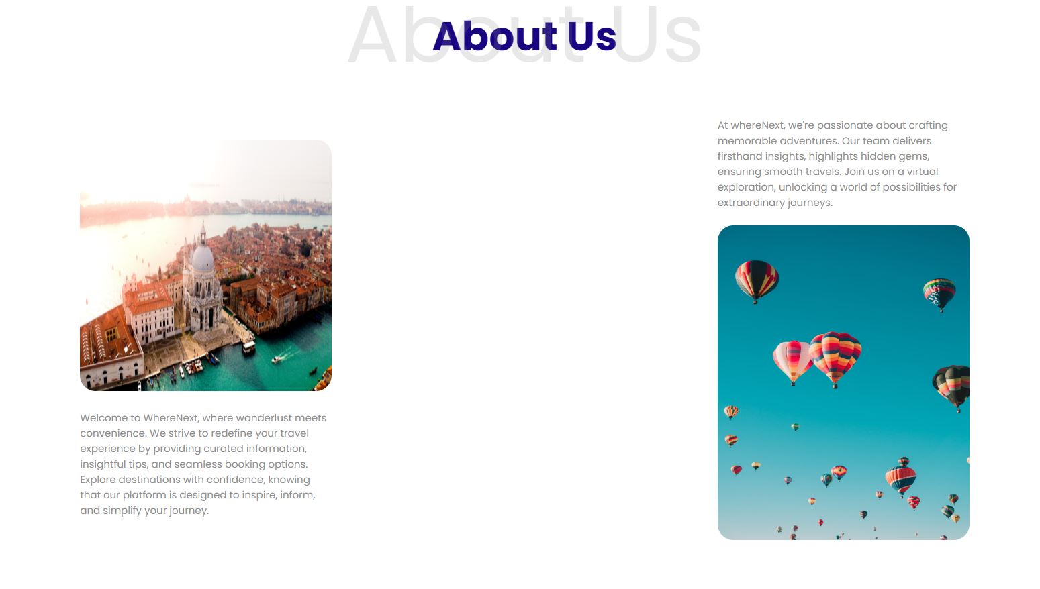

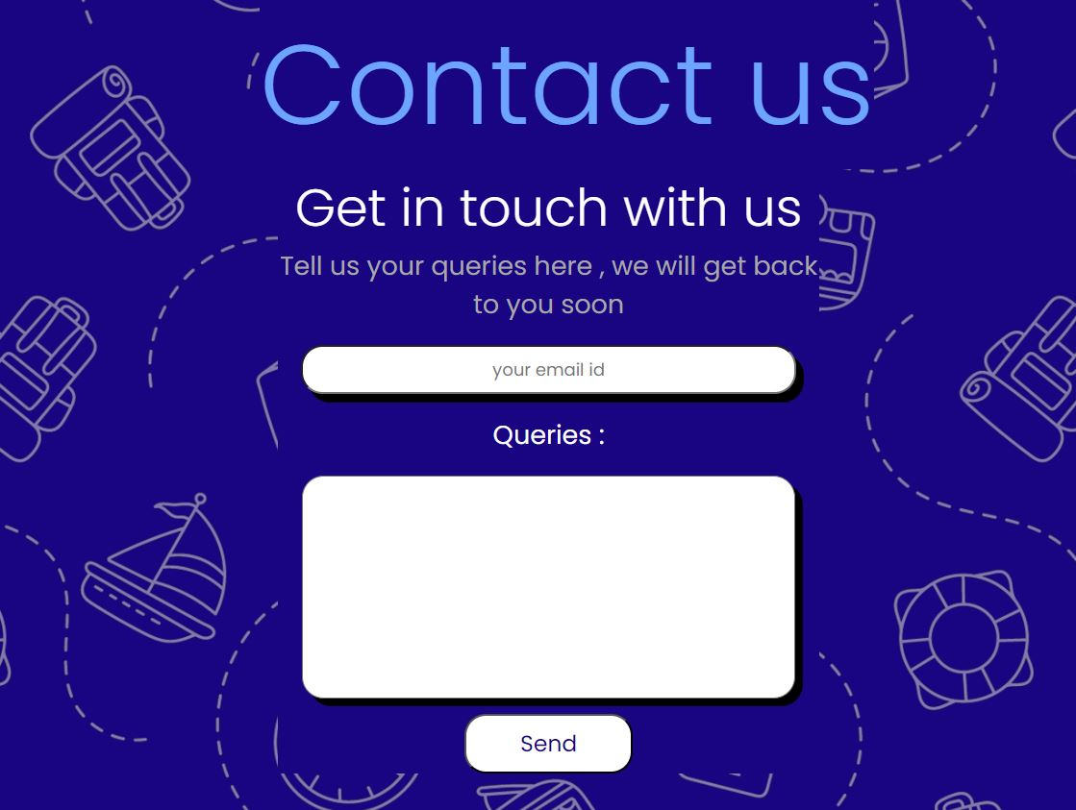 **Contact Us Section:**

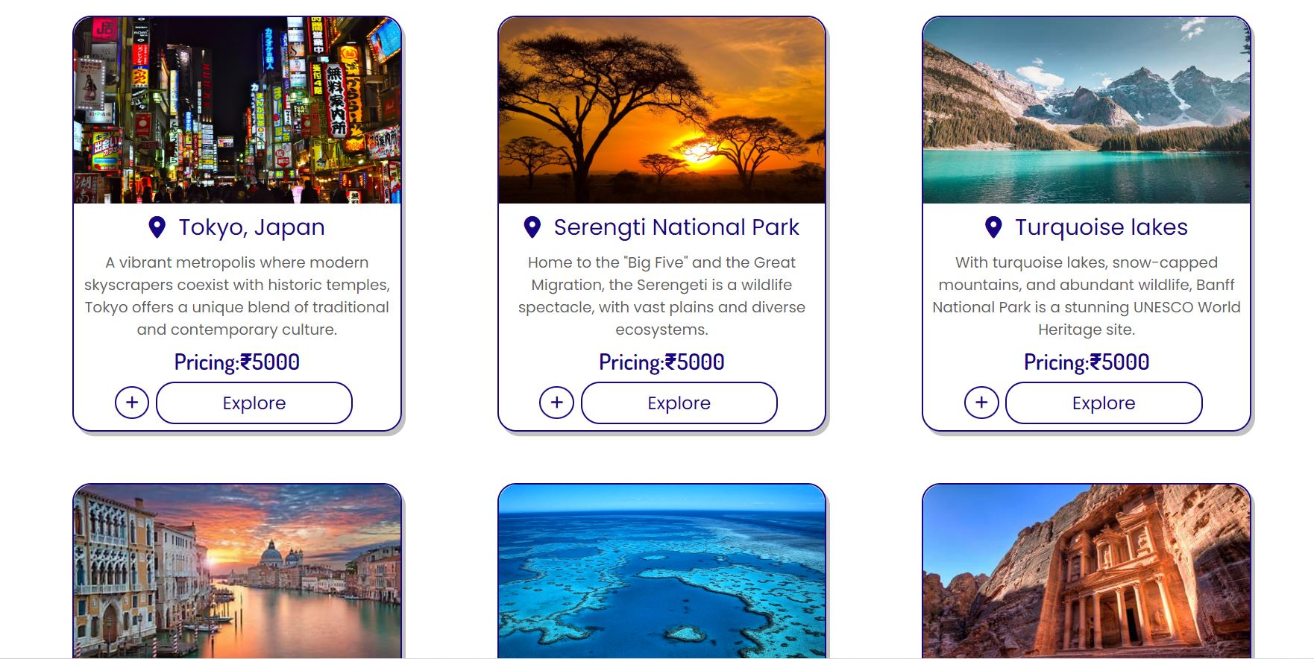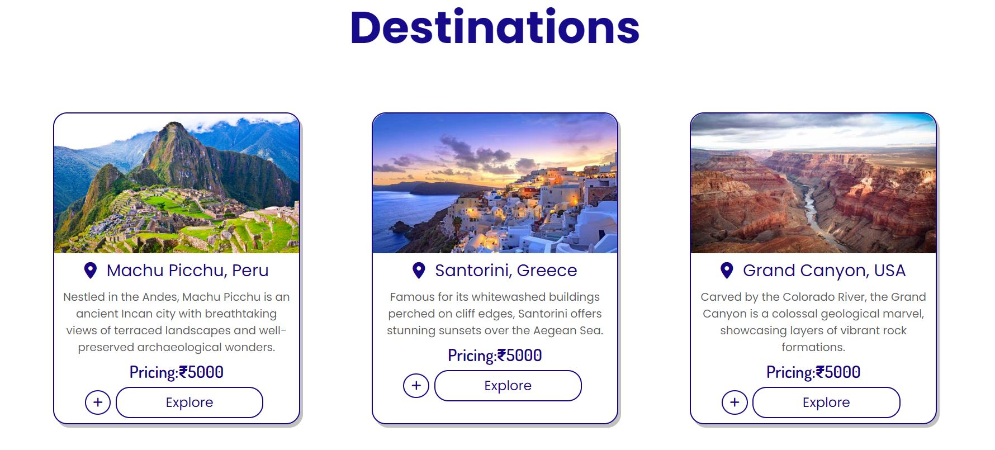 **Destination Page:**

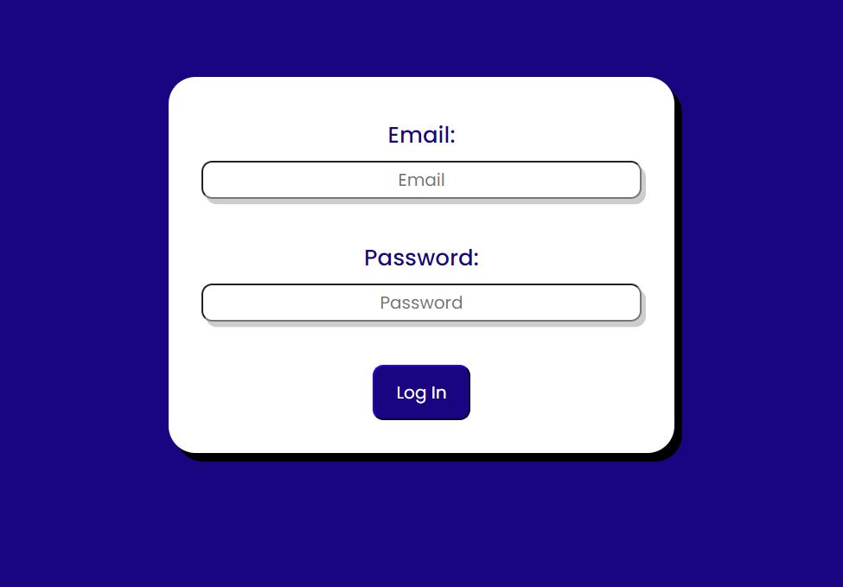**Log-in Page:**

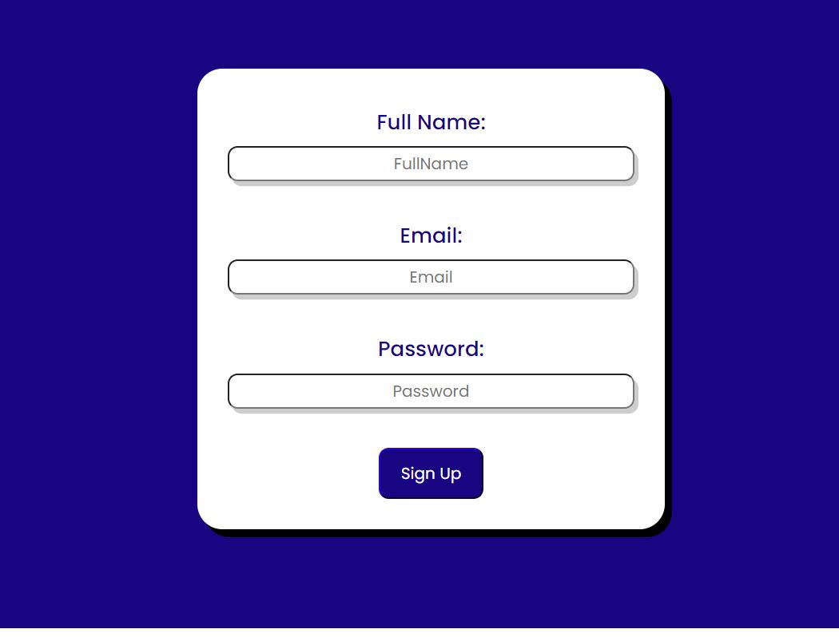 **Sign-in page:**

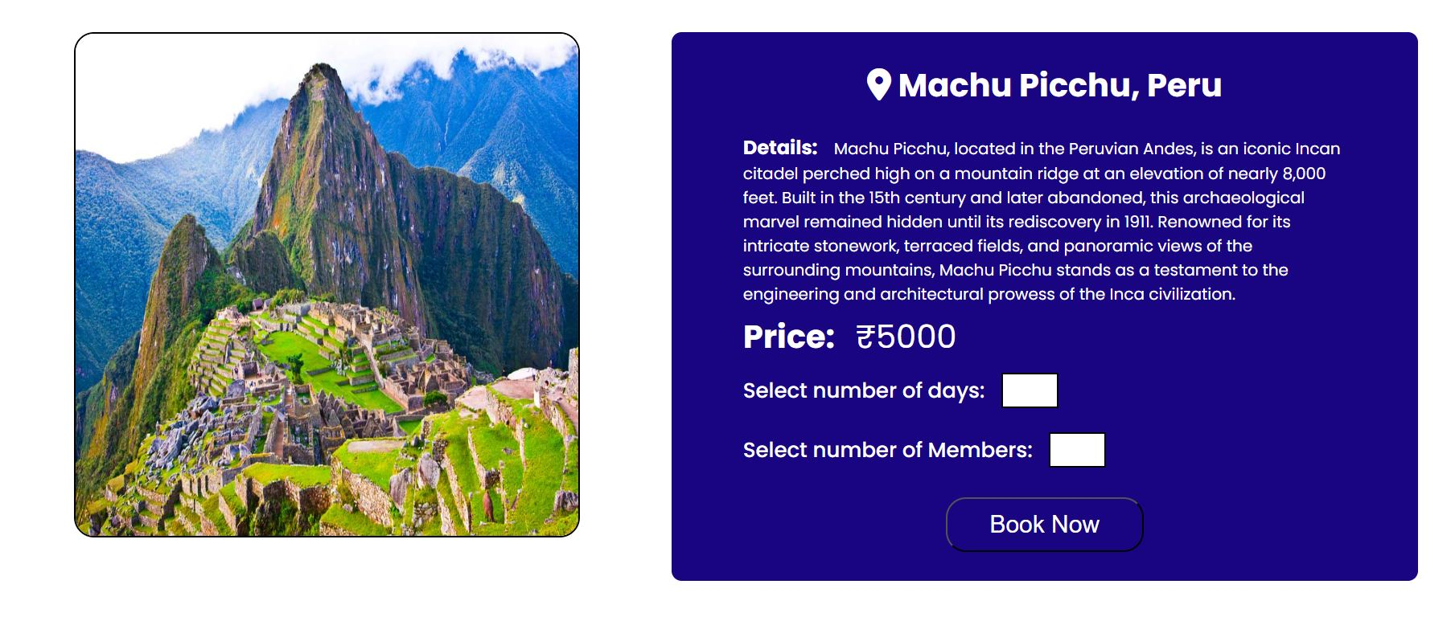 **Booking page:**

** Footer**

**8.Conclusion**

In conclusion, the internship provided a practical and insightful introduction to web development, covering HTML, CSS, JavaScript, and various design concepts. Through hands-on exercises and real-world projects, I gained a solid understanding of the fundamentals, enabling me to create functional and visually appealing websites. The structured approach of the program, from basic concepts to advanced techniques, facilitated a gradual and effective learning process. The inclusion of practical projects, like replicating websites and building one from scratch, significantly enhanced my skills and confidence in web development.

The specific project, whereNext, further reinforced the practical application of HTML and CSS in creating a user-friendly travel planning platform. By replicating existing designs and building new features, such as wishlists and customizable bookings, I honed my ability to translate concepts into functional web elements. The addition of Sign In and Login buttons in the header, along with a well-organized footer, contributed to the overall user experience. The internship, including the whereNext project, equipped me with valuable skills, bridging theoretical knowledge with hands-on application in the dynamic field of web development.