# Main Features

* IC control circuit and LED point light source share one power supply*。*
* *The control circuit and RGB chip are integrated in a 5mm diameter round head four-pin in-line packaged lamp bead, forming a complete external control pixel point。*
* *Built-in signal shaping circuit, any pixel receives the signal after waveform shaping and then outputs it to ensure that the line waveform distortion will not accumulate。*
* *Built-in power-on reset and power-down reset circuit。*
* *The three primary colors of each pixel can realize 256-level brightness display and complete the full true color display of 16777216 colors。*
* *Scanning frequency 2kHz/s。*
* *Serial cascading interface, which can receive and decode data through one signal line.*
* *When the transmission distance of any two-point transmission does not exceed 2 meters, there is no need to add any circuit.*
* *When the refresh rate is 30 frames/second, the number of cascades is not less than 2048 points.*
* *The data transmission speed can reach 800Kbps.*
* *The color of the light is highly consistent, and the cost performance is high.*

# Main application areas

● LED full-color light-emitting character light string, LED full-color module, LED full-color flexible light strip and hard light strip, LED guardrail tube.

● LED point light source, LED pixel screen, LED special-shaped screen, various electronic products, electrical equipment marquee.

# Product Description

* WS2812D-F5-15MA-C1 is an intelligent externally controlled LED light source that integrates control circuit and lighting circuit. Its appearance is the same as an F5 LED lamp bead, and each element is a pixel. The interior of the pixel includes an intelligent digital interface data latch signal shaping and amplifying drive circuit, as well as a high-precision internal oscillator and constant current control part, which effectively ensures that the color of the pixel light is highly consistent.
* The data protocol adopts the single-line return-to-zero code communication method. After the pixel is powered on and reset, the DIN terminal accepts the data transmitted from the controller. The 24bit data sent first is extracted by the first pixel and sent to the interior of the pixel. The remaining data is shaped and amplified by the internal shaping processing circuit and then forwarded and output to the next cascaded pixel through the DO port. After the transmission of one pixel, the signal is reduced by 24 bits. The pixel adopts automatic shaping and forwarding technology, so that the cascade number of the pixel is not limited by the signal transmission, but only limited by the signal transmission speed requirement.
* LED has the advantages of low voltage drive, environmental protection and energy saving, high brightness, large scattering angle, good consistency, ultra-low power, ultra-long life and so on. By integrating the control circuit on the LED, the circuit becomes simpler, the volume is smaller, and the installation is easier.

**Mechanical dimension and pin diagram (unit mm)**

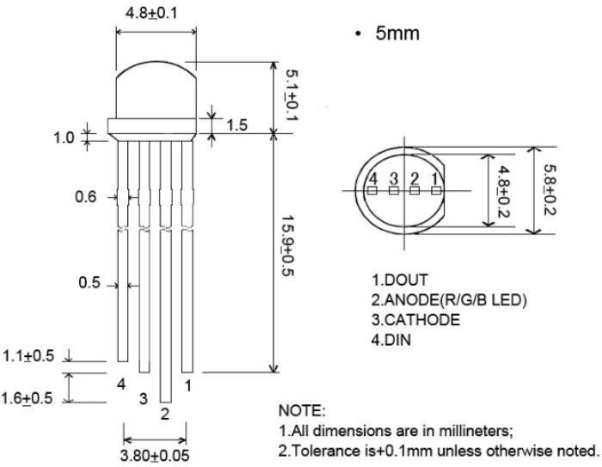

# Pin Function

|  |  |  |  |
| --- | --- | --- | --- |
| **Pin** | **Symbol** | **Name** | **Function** |
| 1 | Dout | *Data Output* | *Control data signal output* |
| 2 | VDD | *Power Supply* | *Power supply pins* |
| 3 | GND | *Ground* | *Signal ground and power ground* |
| 4 | Din | *Data Input* | *Control data signal input* |

**Maximum rating (unless otherwise specified,**TA=25℃*，*VSS=0V)

|  |  |  |  |
| --- | --- | --- | --- |
| **Parameter** | **Symbol** | **Scope** | **Unit** |
| *voltage* | VDD | +3.7~+5.3 | V |
| *Logic input voltage* | VI | VDD-0.5*～*VDD+0.5 | V |
| *Operating temperature* | Topt | -25*～*+80 | ℃ |
| *Storage temperature* | Tstg | -55~+150 | ℃ |

**Electrical parameters (if no special instructions,**TA=-20*～*+70℃*，*VDD=4.5*～*5.5V*，*VSS=0V)

|  |  |  |  |  |  |  |
| --- | --- | --- | --- | --- | --- | --- |
| **Parameter** | **Symbol** | **Min** | **Typical** | **Max** | **Unit** | **Test Cond.** |
| *Low Level Output Current* | Idout | 14.5 | 15 | 15.5 | mA | Vo=0.4V, Dout |
| *Input Current* | II | —— | —— | ±1 | µA | VI=VDD/VSS |
| *High Level Input* | VIH | 0.7VDD | —— | —— | V | DIN, SET |
| *Low Level Input* | VIL | —— | —— | 0.3 VDD | V | DIN, SET |
| *Hysteresis Voltage* | VH | —— | 0.35 | —— | V | DIN, SET |

**Switching characteristics (unless otherwise specified,**TA=-20*～*+70℃*，*VDD=4.5*～*5.5V*，*VSS=0V)

|  |  |  |  |  |  |  |
| --- | --- | --- | --- | --- | --- | --- |
| **Parameter** | **Symbol** | **Min** | **Typical** | **Max** | **Unit** | **Test Cond.** |
| *Oscillation Freq* | *Fosc* | —— | 800 | —— | KHz | —— |
| *Transmission Delay* | tPLZ | —— | —— | 300 | ns | CL=15pF, DIN→DOUT, RL=10KΩ |
| *Fall Time* | tTHZ | —— | —— | 120 | µs | CL=300pF, OUTR/OUTG/OUTB |
| *Input Capacitance* | CI | —— | —— | 15 | pF | —— |

# Lamp bead light-emitting chip parameters

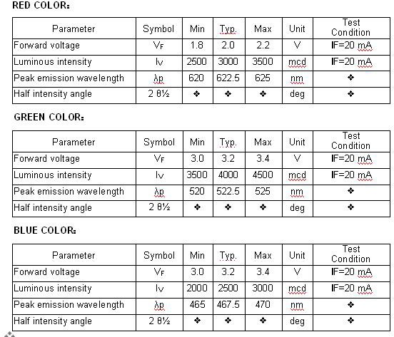

**Timing Waveform**

**Input Pattern: Connection Method：**

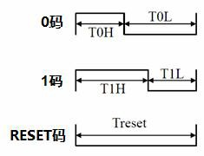D1 D2 D3 D4

DIN DO

PIX3

DIN DO

PIX2

DIN DO

PIX1

# Data Transfer Time（TH+TL=1.25us±150ns）：

|  |  |  |
| --- | --- | --- |
| T0H | 0 *code, high time* | 220ns~380ns |
| T1H | 1 *code, high time* | 750ns~1us |
| T0L | 0 *code, low time* | 750ns~1us |
| T1L | 1 *code, low time* | 220ns~380ns |
| RES | *Low time* | 280us *above* |

**Data Transfer Method**

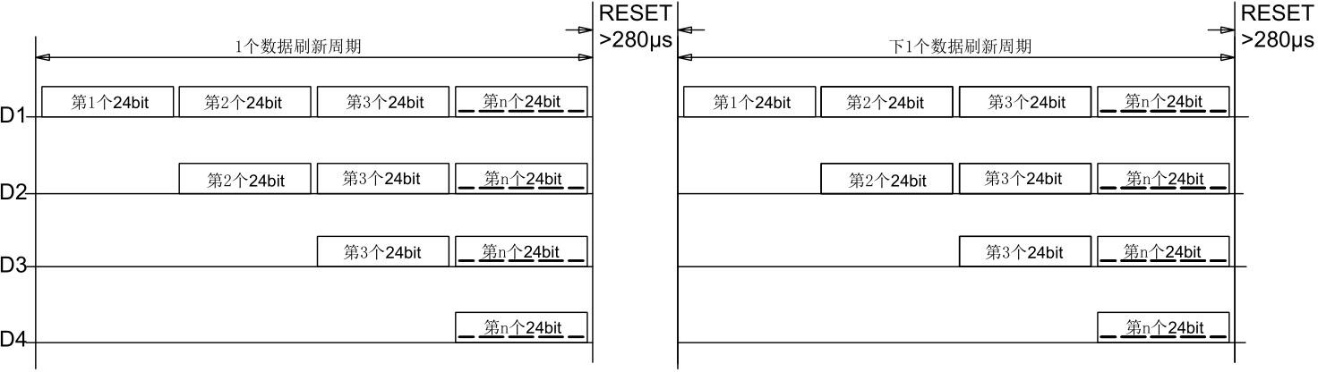

# *Note: D1 is the data sent by the MCU, D2, D3, D4 are the data automatically shaped and forwarded by the cascade circuit.*

# 24bit data structure

|  |  |  |  |  |  |  |  |  |  |  |  |  |  |  |  |  |  |  |  |  |  |  |  |
| --- | --- | --- | --- | --- | --- | --- | --- | --- | --- | --- | --- | --- | --- | --- | --- | --- | --- | --- | --- | --- | --- | --- | --- |
| R7 | R6 | R5 | R4 | R3 | R2 | R1 | R0 | G7 | G6 | G5 | G4 | G3 | G2 | G1 | G0 | B7 | B6 | B5 | B4 | B3 | B2 | B1 | B0 |

*Note: High-order bits are sent first, and data is sent in the order of RGB.*

# Typical Application Circuit

75R

L1

C1

4

3

104

1

5V

Din GND VDD

Dout

WS2812D

75R

L2

C2 4

104

1

5V

Din GND VDD

Dout

2

3

2

WS2812D

75R

Ln

Cn

4

3

104

1

5V

Din GND VDD

Dout

WS2812D

2

# File Change Log

|  |  |  |  |  |  |
| --- | --- | --- | --- | --- | --- |
| **版本号** | **状态** | **修改内容概要** | **修订日期** | **修订人** | **批准人** |
| V1.0 | N | *新建* | 20170523 | *沈金国* | *尹华平* |
| V1.1 | M | *最大额定值、数据传输方法* | 20171009 | *沈金国* | *尹华平* |
|  |  |  |  |  |  |
|  |  |  |  |  |  |
|  |  |  |  |  |  |
|  |  |  |  |  |  |

*注：初始版本号*V1.0*；每次修订批准后，版本号顺序加*“0.1”*；状态包括：*N--*新建，*A--*增加，*M--*修改，*D--*删除。*