Table of Contents

**1.0 Introduction2**

1.1 Background2

1.2 Objectives2

**2.0 Requirement Definition3**

2.1 Functional Requirements3

2.2 Non- Functional Requirements4

**3.0 Requirements Specification5**

3.1 Use Case Diagram & Use Case5

3.2 Expanded Use Cases5

3.3 Analysis Class Diagram12

**4.0 Documentation13**

4.1 Updated Gantt Chart13

1. **Introduction**
   1. **Background**

Many people are actually interested with investment but they do not have the knowledge about it, and this make them afraid of making investment. This issue has inspired us to develop this application. In fact, there are many virtual investment applications in the market nowadays, but people who do not have the knowledge on making investment will feel these applications are very complicated and confusing. This application could help them to learn the basic concept of making stock investment.

* 1. **Objectives**
     1. To produce a novice friendly game UI with instructions stated clearly.
     2. To develop a stock game based on fictitious stock that helps to improve decision making skill of user.
     3. To help user in learning essential life skills which include critical thinking and independent research.
     4. To let user experiences the real-time stock market circumstance through analysing the virtual stock market and make investment in a proper way.

**2.0 Requirements Definition**

**2.1 Functional Requirement**

|  |  |
| --- | --- |
| Use Case | Login |
| Actor(s) | FundFair App User |
| Description | FundFair App User key in the userID and password to log in as a user to the FundFair application. |

|  |  |
| --- | --- |
| Use Case | Register |
| Actor(s) | FundFair App User |
| Description | FundFair App User want to create an account to access to the FundFair application |

|  |  |
| --- | --- |
| Use Case | View Company and Stock Details |
| Actor(s) | FundFair App User |
| Description | FundFair App User can view a list of stock and descriptions for each stock and company to make decision and analysis based on the details given. |

|  |  |
| --- | --- |
| Use Case | Buy Stock |
| Actor(s) | FundFair App User |
| Description | After viewing the stock, FundFair App User can buy any stock based on their decision. |

|  |  |
| --- | --- |
| Use Case | View Portfolio |
| Actor(s) | FundFair App User |
| Description | FundFair App User can view their profit and loss every time they end a round. |

|  |  |
| --- | --- |
| Use Case | Sell Stock |
| Actor(s) | FundFair App User |
| Description | FundFair App User wants to sell stock that bought. |

**2.2 Non-functional Requirement**

**Performance Constraints**

* The response time for stock information to appear to a user should be made available in a maximum of 3 seconds.
* The system should be available 24 hours for 7 days in a week.
* The system should be able to hold a 50000 user records initially.
* The system should be able to add 5000 records.
* A record should be fully available on the system for at least 5 years.

**Development Constraints**

* Time - The first prototype should be delivered on 13th March 2017 and the second prototype should be delivered on 10th April 2017.
* Resource – Throughout the development of this system, the only place that need money is publishing the application to the google play store, which will cost around RM 150. The amount of money costs is not the key resource for developing an application, however, the amount of time is the key resource. To develop this system prototype will need around 3-month time and there is only 2 development staff will be involving.
* Quality - The development methods of this system is RAD. The reason we use RAD because we need to produce the prototype as soon as possible and get feedback from the end user to improve our system, which will take few iterations until the final prototype done.

**3.0 Requirement Specification**

**3.1 Use Case Diagram**

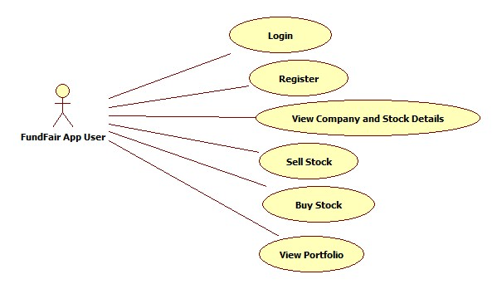

Figure 1 Use Case Diagram

**3.2 Expanded Use Case**

Expanded Use Case – Login Account

|  |  |  |
| --- | --- | --- |
| Use Case 1 | Login | |
| Goal in Context | To allow app users to login FundFair application with their accounts | |
| Primary Actor  Secondary Actor | FundFair App User  (none) | |
| Trigger | When the FundFair App User wants to login to the FundFair application. | |
| Related Use Cases | |  |
| Typical Course of Events  Actor Action | | System Response |
| 1. This use case begins when FundFair App User has an account and is not logged in to the application. | | 2. The system prompts the user to enter a username and password for login and display another button for register a new account. |
| 3. The FundFair App User enters the username, password. | | 4. The system will validate the username and password entered and making sure that the entered username is a valid username, and also required password is entered for the entered username. |
|  | | 5. User is signed in and returned to home screen and a message will be pop out, showing “Login Successful”. $100,000 of virtual money will be allocated to the user immediately after the login. |
| Alternative Course of Events  Line 4a. If username is not found or it is found but does not match with the password, the reasons why the user failed the authentication will be shown and repeat step 2 where prompts user to enter the username and password.  Line 4b. If the system found the entered information is matched with an existing user account, the user data of that particular account will be loaded. | | |

Expanded Use Case – Register

|  |  |
| --- | --- |
| **Use Case 2** | Register |
| **Goal in Context** | To allow a non-app user to create for an account to access to FundFair application. |
| **Primary Actor**  **Secondary Actor** | FundFair App User  (none) |
| **Trigger** | When the FundFair App User wants to login but they do not have a FundFair account. |
| **Related Use Cases** |  |
| **Typical Course of Events**  **Actor Action** | **System Response** |
| 1.      This use case begins when the user is not logged in to the application and goes to the login page. | 2. The system prompts the user to enter a username and password for login and display a button to register new account. |
| 3.      The user selects registration option by tapping on the “Sign up” button. | 4. The system will prompt user to enter username and password. |
| 5. The user enters the username and password. | 6. The system will verify username and password entered by user and creates account. A registration successful message will be displayed. |
| Alternative Course of Events       Line 4a. If user tap on “Cancel” button, cancel the use case.  Line 6a. If the username and password entered by user is not verified by the system  Line 3b. If the system found the entered information is matched with an existing user account, the user data of that particular account will be loaded. | |

Expanded Use Case – View Company and Stock Details

|  |  |
| --- | --- |
| Use Case 3 | View Company and Stock Details |
| Goal in Context | To allow users to view a list of stock with details, the price and the background of the company. |
| Primary Actor  Secondary Actor | FundFair App User    (none) |
| Trigger | When the FundFair App User wants to view stocks available and tap on the “Trading Centre” button. |
| Related Use Cases |  |
| Typical Course of Events  Actor Action | System Response |
| 1. This use case begins when FundFair App User wants to view stock details, price and company background. |  |
| 2. The FundFair App User tap on “Trading Stock Center”. | 3. The system will display stocks that available. |
| 4. FundFair App User selects a stock from “Trading Stock Center”. | 5. Company information will be displayed, for example, currentPricePerShare, dailyPeak, weeklyPeak, amountOfShare, companyBackgroundInfo, totalLotAvailable and marketCapital. |
| Alternative Course of Events | |

Expanded Use Case – Buy Stock

|  |  |
| --- | --- |
| Use Case 4 | Buy Stock |
| Goal in Context | Allow FundFair App User to buy stock. |
| Primary Actor  Secondary Actor | FundFair App User    (none) |
| Trigger | When the FundFair App User wants to buy stock after viewing the stock details and tap on the “Place Buy Order” button. |
| Related Use Cases | View Company and Stock Details |
| Typical Course of Events  Actor Action | System Response |
| 1. This use case begins when FundFair App User wants to buy stock. |  |
| 2. The FundFair App User tap on “Place Buy Order” button. | 3. The system will prompt the user to select a number of lot they want to buy. |
| 4. FundFair App User selects a number of Lot they want to buy and proceed. | 5. A confirmation message box will be popped out to get user confirmation. |
| 6. FundFair App user tap on “Yes”. | 7. The system will calculate the totalPrice and a message “Successful” will be shown after the system finish processing the request. The buy history will be updated in the portfolio. |
| Alternative Course of Events  Line 4a. If number of lot entered by user exceeds the total lot available, prompts user to re-enter a valid amount.  Line 6a. If app user tap on “No”, cancel the use case.  Line 7a. If the totalPrice exceeds the balance of virtual money owned by the user, prompts user to re-enter a valid amount. | |

Expanded Use Case – View Portfolio

|  |  |  |
| --- | --- | --- |
| Use Case 5 | View Portfolio | |
| Goal in Context | To display stocks details that user bought and sold. | |
| Primary Actor  Secondary Actor | FundFair App User    (none) | |
| Trigger | When the FundFair App User wants to view their portfolio. | |
| Related Use Cases |  | |
| Typical Course of Events  Actor Action | System Response | |
| 1. This use case begins when FundFair App User wants to view or track the stock they bought/sold. | |  |
| 2. The FundFair App User tap on “My Portfolio” button. | | 3. A history showing the current status of each stock  will be displayed. |
| Alternative Course of Events | | |
|  |  |  |

Expanded Use Case – Sell Stock

|  |  |
| --- | --- |
| Use Case 6 | Sell Stock |
| Goal in Context | Allow the user to sell stock. |
| Primary Actor  Secondary Actor | FundFair App User    (none) |
| Trigger | When the FundFair App User wants to sell the stocks they bought. |
| Related Use Cases | View Portfolio |
| Typical Course of Events  Actor Action | System Response |
| 1. This use case begins when FundFair App User wants to sell the stock they bought. |  |
| 2. The FundFair App User tap on “Place Sell Order” button. | 3. The system will prompt the user to select number of lot they want to sell. |
| 4. FundFair App User selects number of Lot they want to sell and proceed. | 5. A confirmation message box will be popped out to get user confirmation. |
| 6. FundFair App User tap on “Yes”. | 7. Message “Sold Successful” will be shown after the system finish processing the request. The sold stock will be removed from the portfolio. Total amount of virtual money will be updated. |
| Alternative Course of Events  Line 4a. If the number of lot entered exceeds the number of lot that owned by the user, prompts user to re-enter a valid amount.  Line 6a. If app user tap on “No”, cancel the use case. | |
|  | |

**3.3 Analysis Class Diagram**

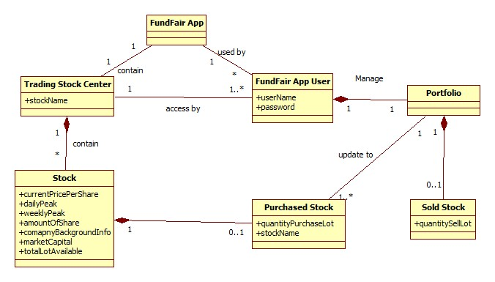

Figure 2 Analysis Class Diagram

**4.0 Documentation**

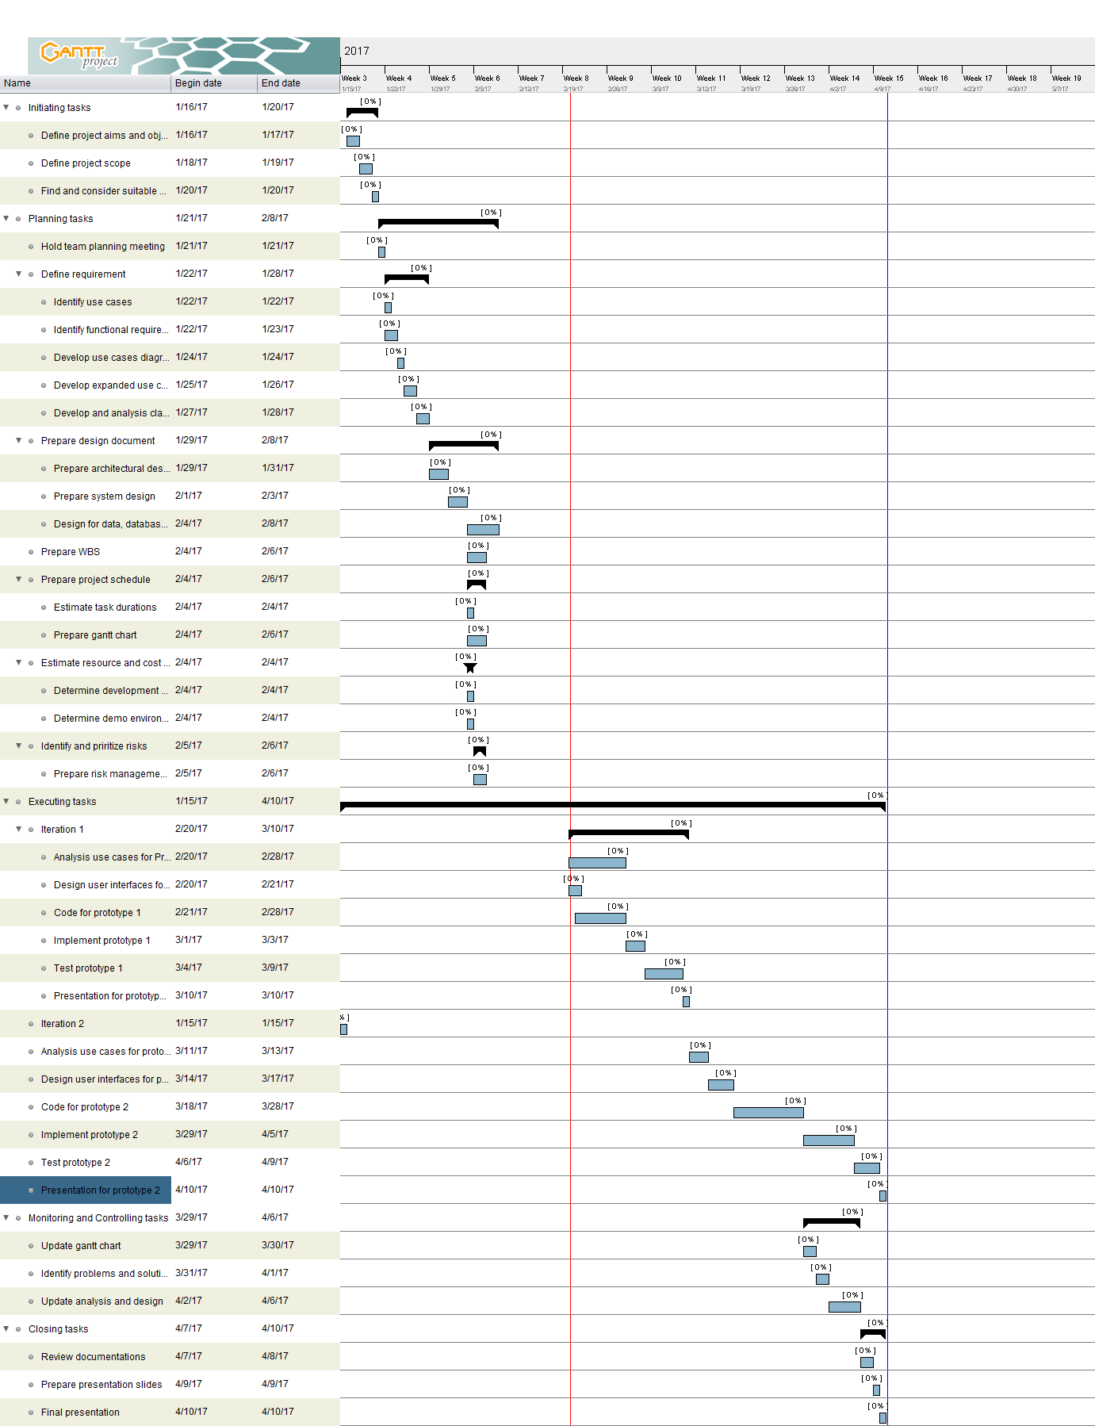**4.1 Updated Gantt Chart**