Step 1:Download Bitstream to USB Board and Audio Board

Step 2:Connect IIS Signals between USB Board and Audio Board

Audio Board:

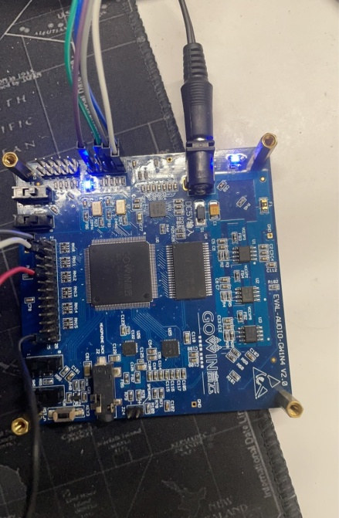

USB Board:

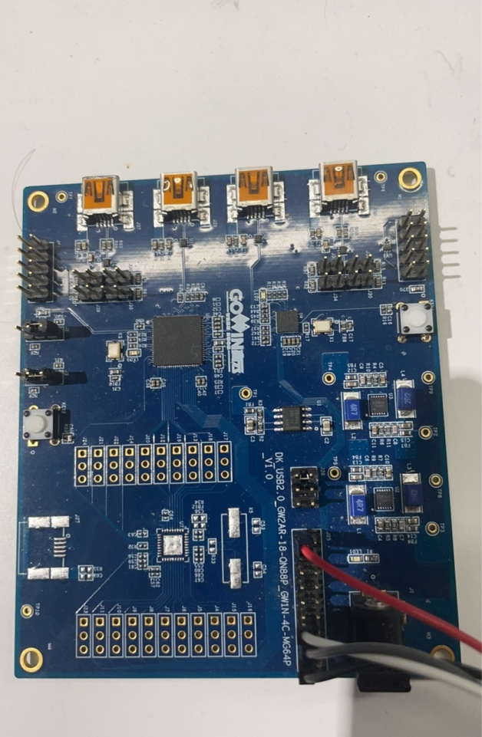

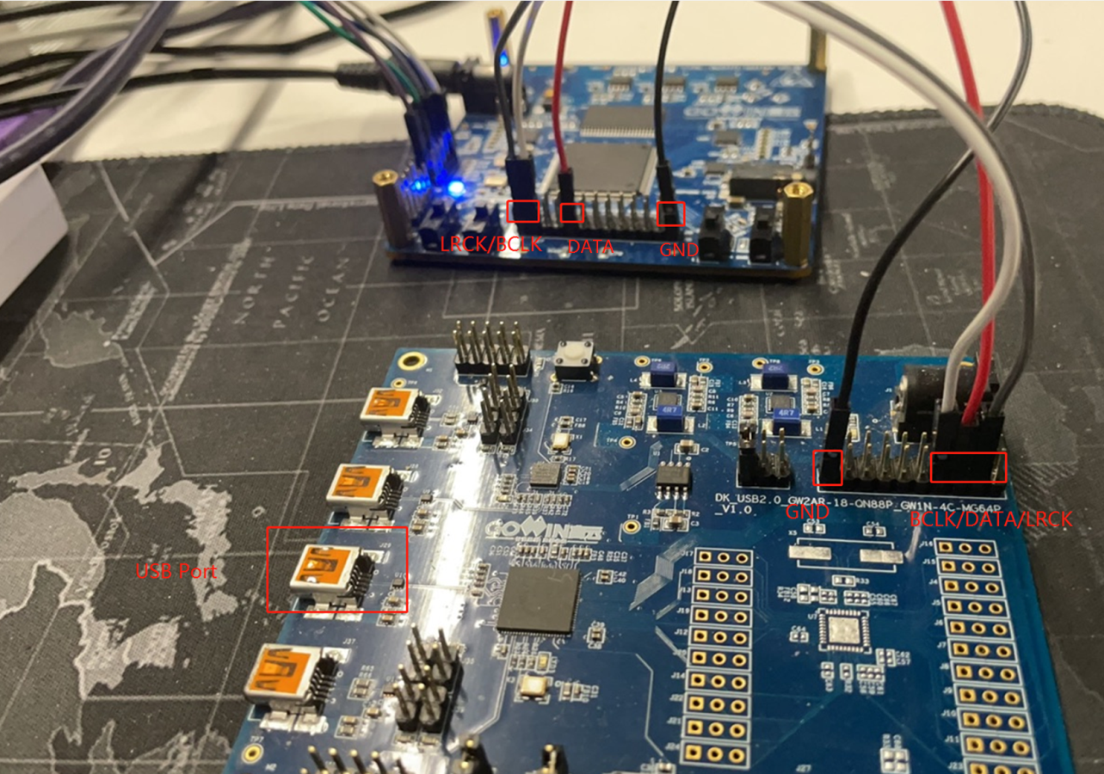

Connection between USB Board and Audio Board

Setp 3.Select Gowin Audio Device in Win10 Sound Configuration

Step 4 Config Gowin Audio Device Sample Frequency(like 384KHz) in Sound advanced setting

Step 5 Connect Headphone to Audio Board then Play Music