**EX:No.1 221501032**

**21/01/25**

**PROGRAM TO IMPLEMENT TIME SERIES DATA FOR IMPORT LIBRARY, LOAD DATA, PREPROCESSING AND VISUALISING**

**AIM:**

To write Program to implement time series data for import library, load data, Preprocessing and visualising.

**PROCESS:**

**#Importing libraries**

import pandas as pd

**# Load the stock data**

file_path = r'AAPL_short_volume.csv'

data = pd.read_csv(file_path)

close_prices_AAPL = data['Close']

**# Reverse the order of the data**

close_prices_AAPL_reverse = close_prices_AAPL.iloc[::-1]

**# Reset index to maintain the correct time series order in the plot**

close_prices_AAPL_reverse.reset_index(drop=True, inplace=True)

**# 1. Handling Missing Values:**

**# Check for missing values in each column**

print(data.isnull().sum())

**# Drop rows with missing values (if not too many)**

data.dropna(inplace=True)

**# Fill missing values in 'Close' with the mean - Moved before outlier handling**

data['Close'].fillna(data['Close'].mean(), inplace=True) # Fill NaNs in 'Close' column

**# 2. Handling Outliers:**

**# (a) Visualization: Create box plots or scatter plots to visually identify outliers.**

**# (b) Using IQR (Interquartile Range):**

**# Calculate IQR for relevant numerical columns, e.g., 'Close'**

Q1 = data['Close'].quantile(0.25)

Q3 = data['Close'].quantile(0.75)

IQR = Q3 - Q1

lower_bound = Q1 - 1.5 * IQR

upper_bound = Q3 + 1.5 * IQR

**# Filter data to remove outliers**

data = data[(data['Close'] >= lower_bound) & (data['Close'] <= upper_bound)]

**# Data preprocessing**

import numpy as np

data = close_prices_AAPL_reverse.values.reshape(-1, 1)  # Reshape the data

data_normalized = data / np.max(data)  # Normalize the data

# Split the data into training and testing sets

train_size = int(len(data_normalized) * 0.8)

train_data = data_normalized[:train_size]

test_data = data_normalized[train_size:]

**# Plot the line chart**

import matplotlib.pyplot as plt

plt.figure(figsize=(10, 6))

plt.plot(close_prices_AAPL_reverse)

plt.xlabel('Time')

plt.ylabel('Close Prices')

plt.title('AAPL Stock Close Prices')

plt.grid(True)

plt.show()

**OUTPUT:**

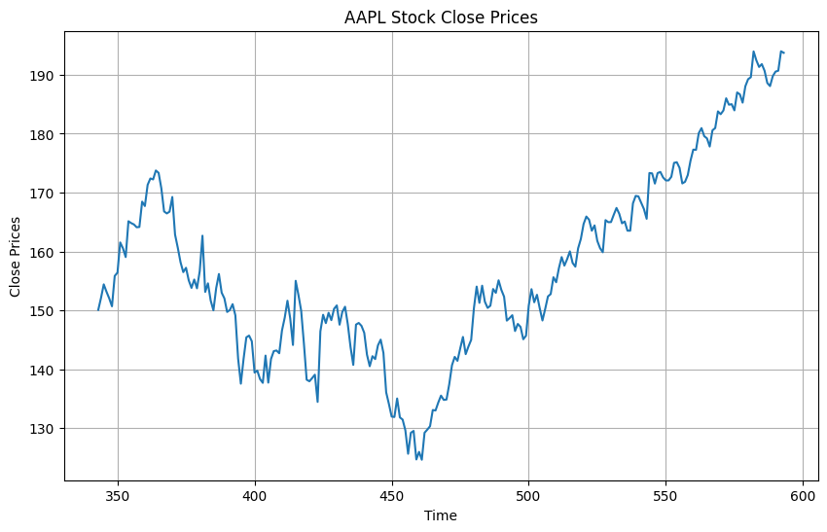

**\**

**RESULT:**

The program To write Program to implement time series data for import library, load data, Preprocessing and visualising is created and executed successfully.