REG NO.

MAKE YOUR FUTURE WITH ALC CORPORATION LTD

















LEGALITIES

PLAN

1. **PCV INCOME 500 PAIR, CAPING 75000, CLOSSING 15 DAYS.**
2. **EVERY INTRODUSER SPIL INCOME 100/- EXTRA**
3. **SALARY**
4. **REWARDS**
5. **REPURCHAGE INCOME**
6. **RETAIL PROFIT UP TO 20% MRP – DP = RETAIL PROFIT**
7. **EXECUTIVE CLUB INSENTIVE 30% 8th LEVEL**
8. **LEVEL INCOME 30%**
9. **MONTHLY BONUS 20%**
10. **DEVELOPMENT FUND 6%**
11. **SEMINAR ALOUNCE 10%**
12. **ULTIMATE INCOME 5000 PAIR PCV* 5% OF COMPANY VOLUM IN ALL ACHIVBER**

PRODUCT

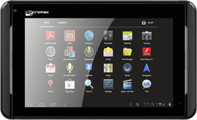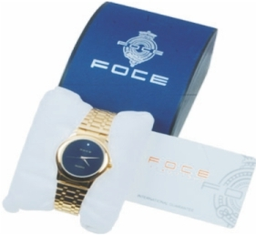

PRODUCT MRP PV

FOCE WATCH 3100 100 BIO PRODUCT 3100 100

TAB 6100 150 Madiclaim POLICY 5000 100

Life POLICY 10000 150

REDARD

PAIR REWARD

10 **DIGITAL CAMERA**  

NEXT25 **MOBILE **

NEXT 50 **PC**  

NEXT 100 **BIKE**  

NEXT 300 **CAR**  

NEXT 500 **GOLD**  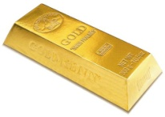

NEXT 1500 **PLOT**

NEXT 2500 **CAR**  

NEXT 5000 **HOME**  

NEXT 10000 **CAR+BANGLO**

NEXT 20000 **1 CR + CAR**  

NEXT 30000 **1.8 CR +CAR**  

**BANK DETAIL :**

ALC CORPORATION LTD

WWW.ALCL.BIZ