Hands on assessment on ml studio

1. CREATING ML STUDIO

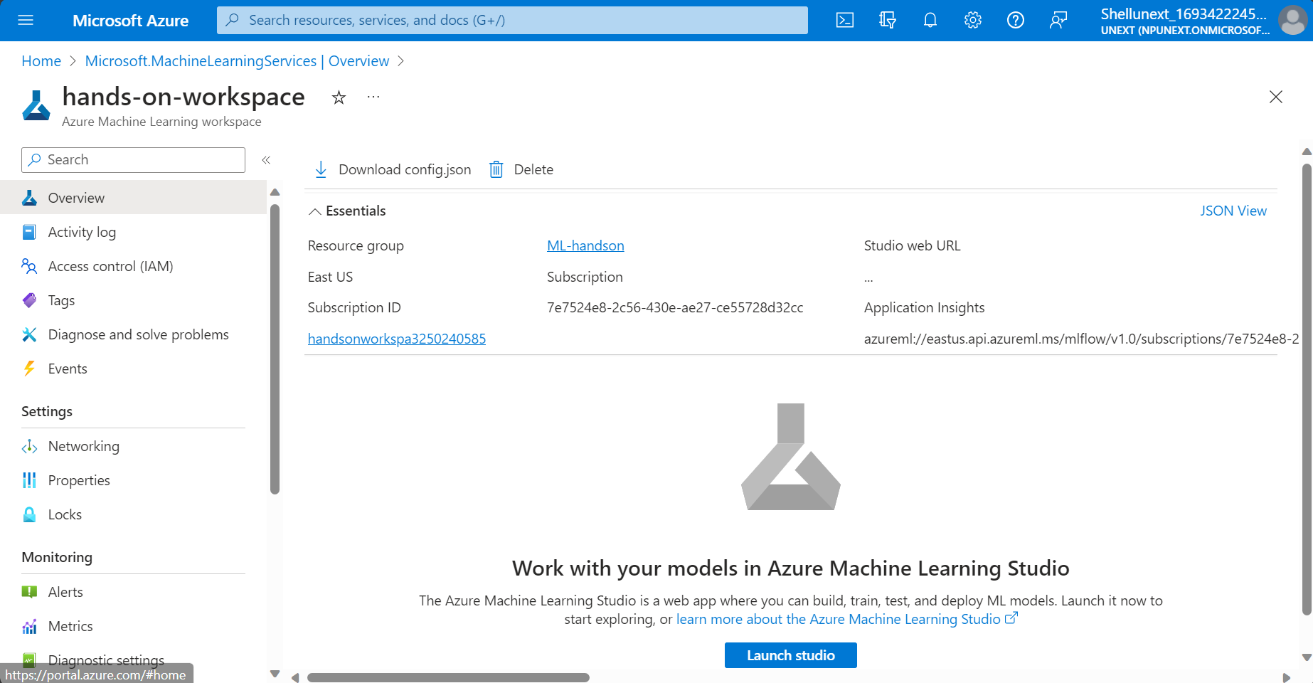

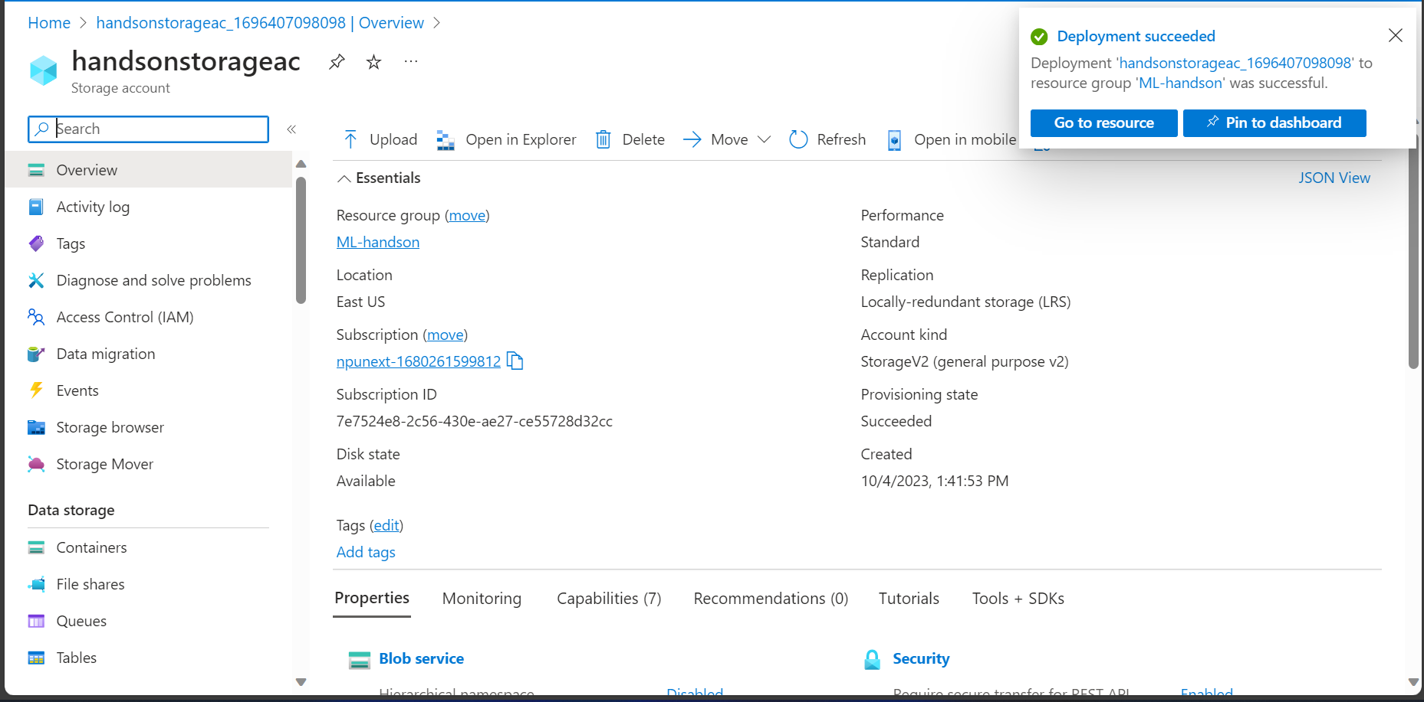

1. ML STUDIO WORKSPACE

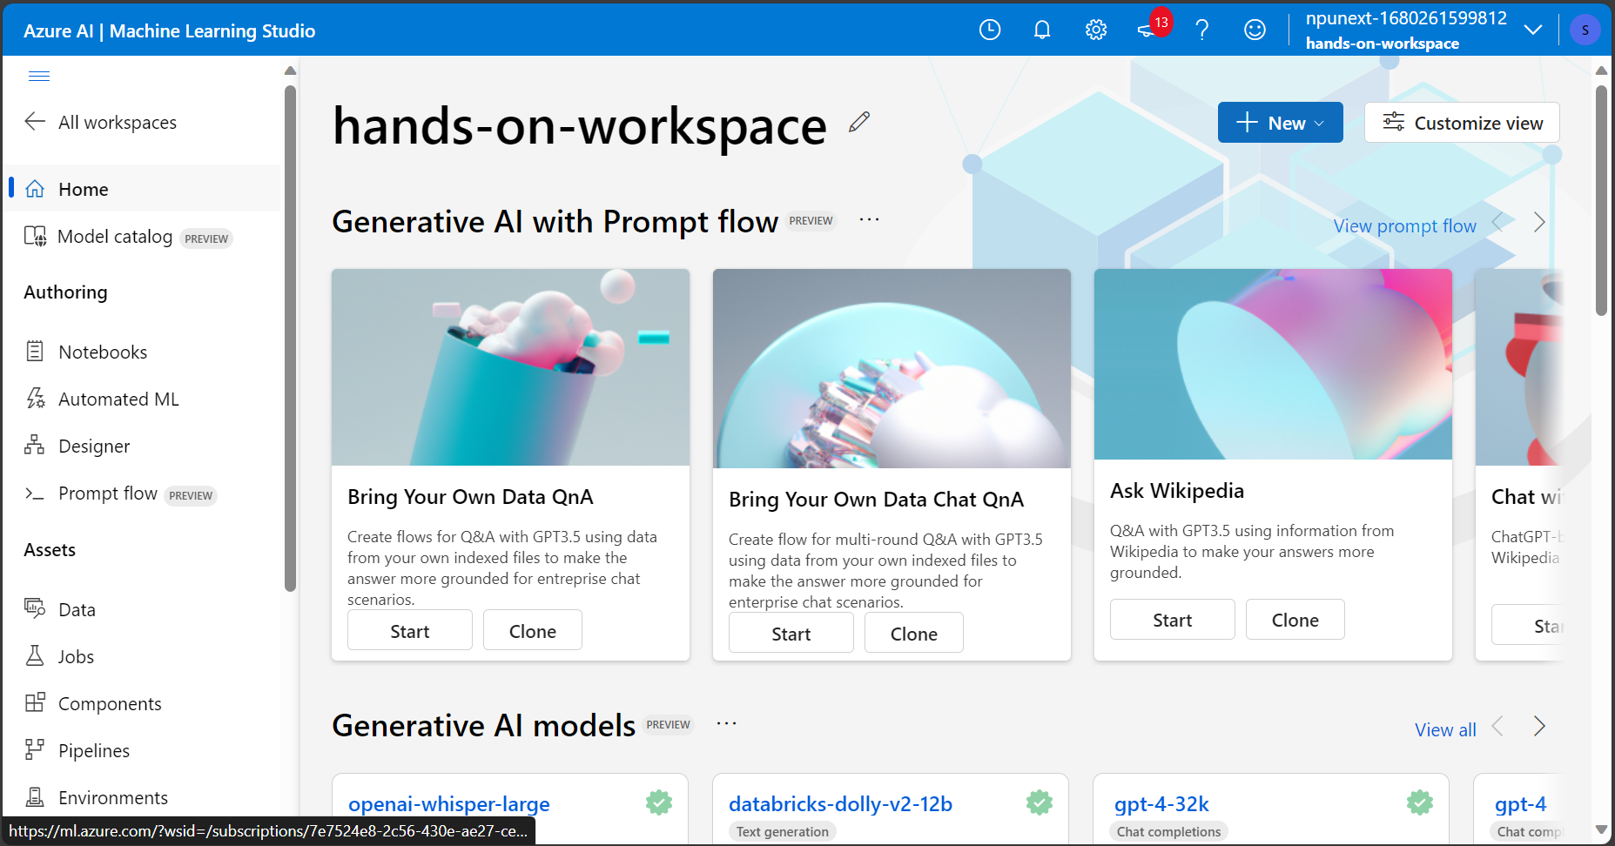

1. ML DESIGNER FOR PIPELINES

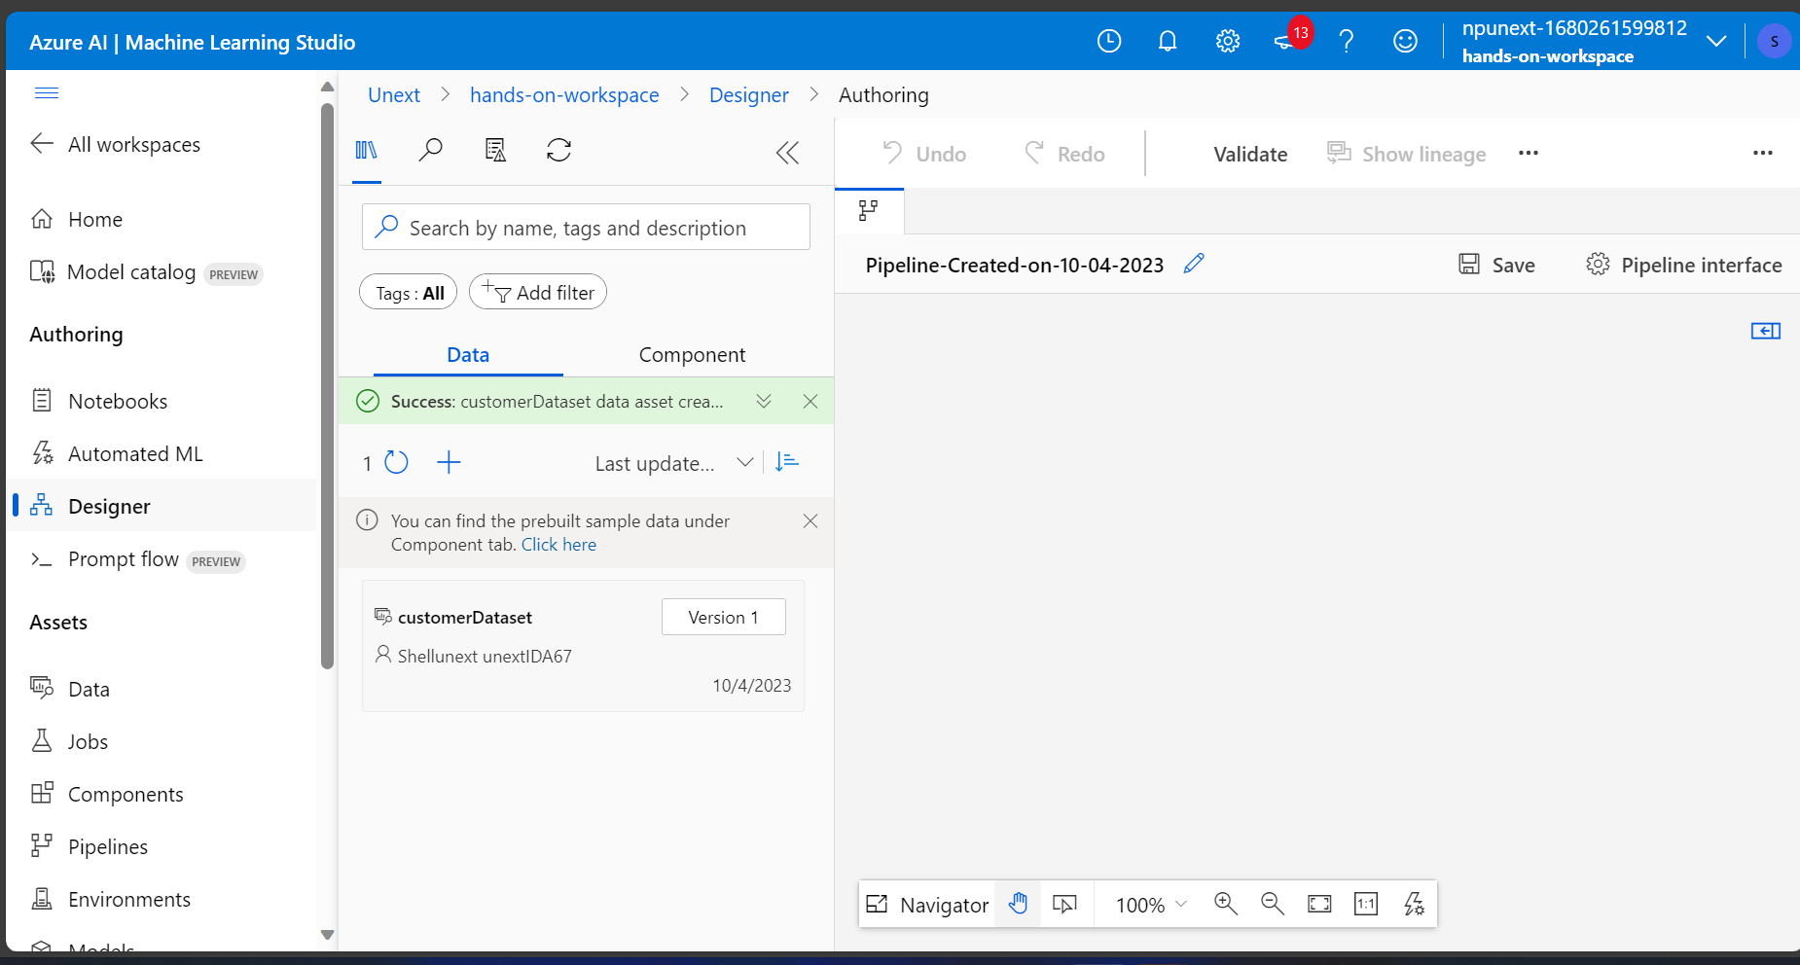

1. LOADING DATASET

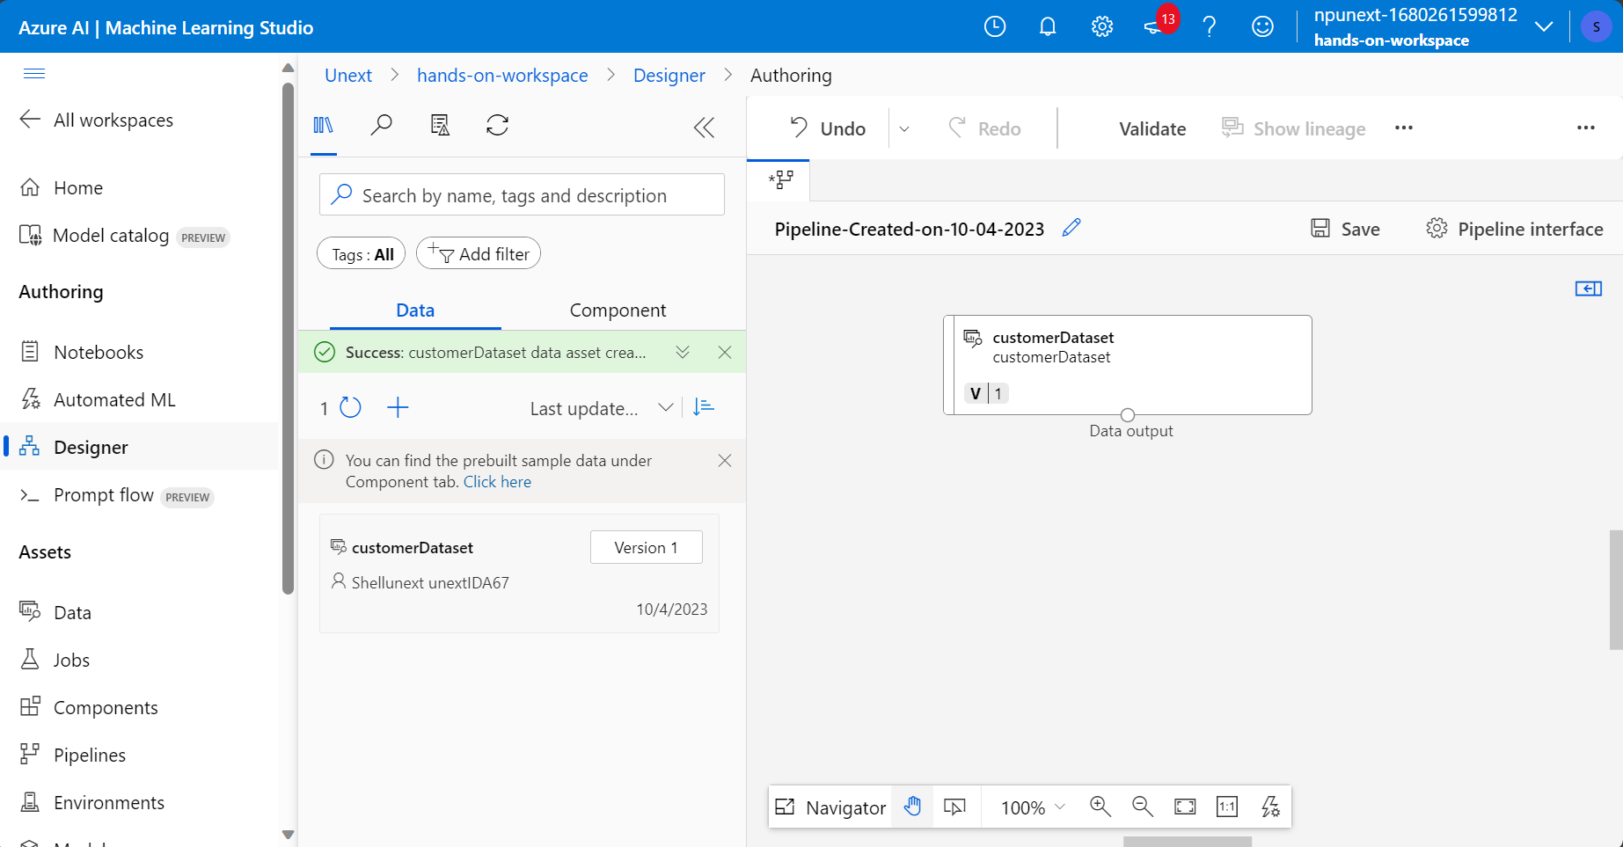

1. CLEANING DATASET

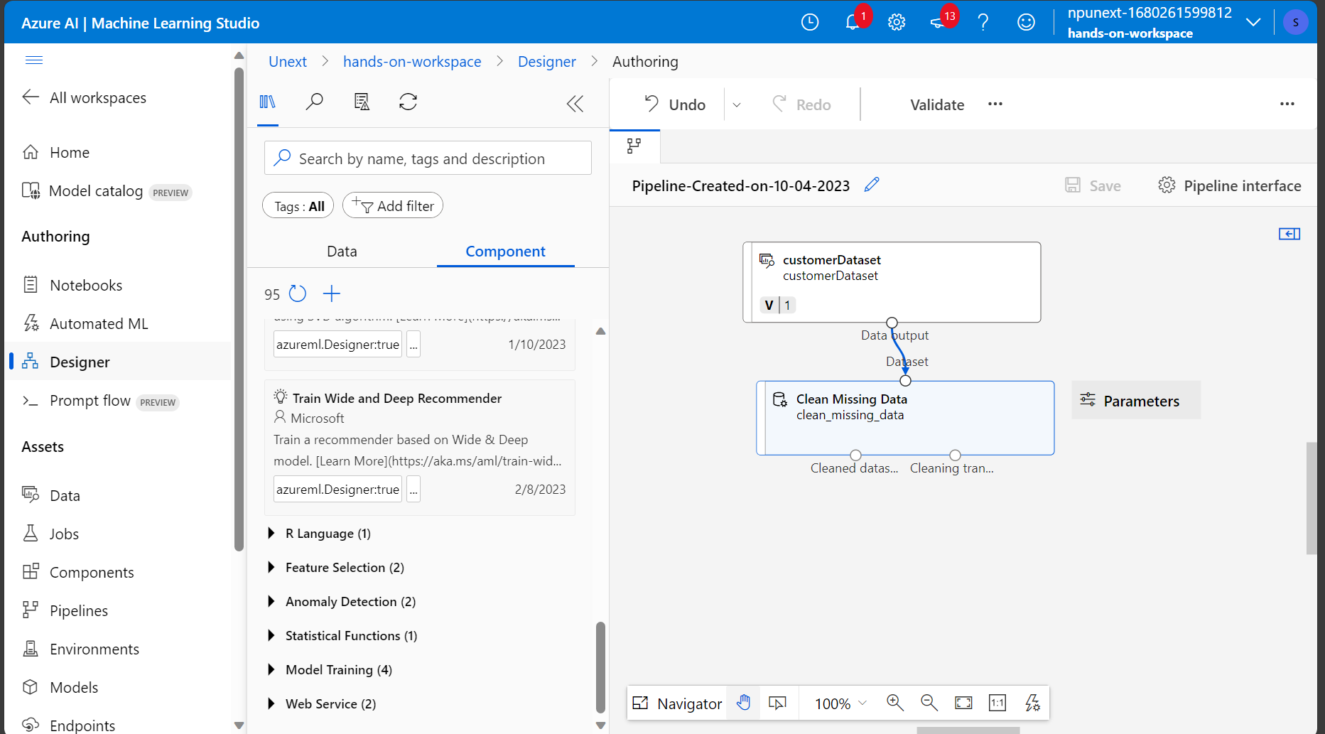

1. CLEANING MISSING DATA

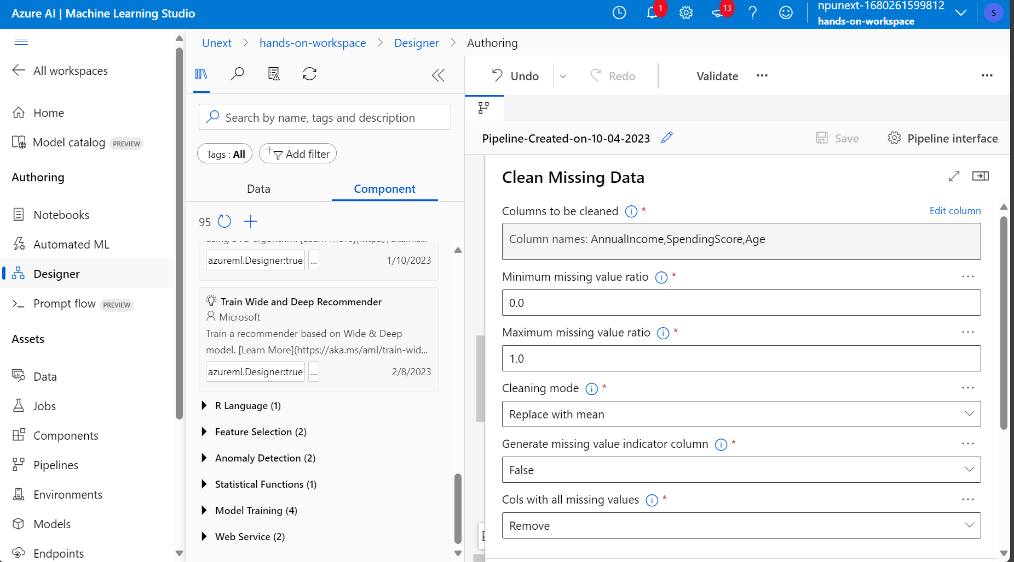

7)FILTERING FEATURES

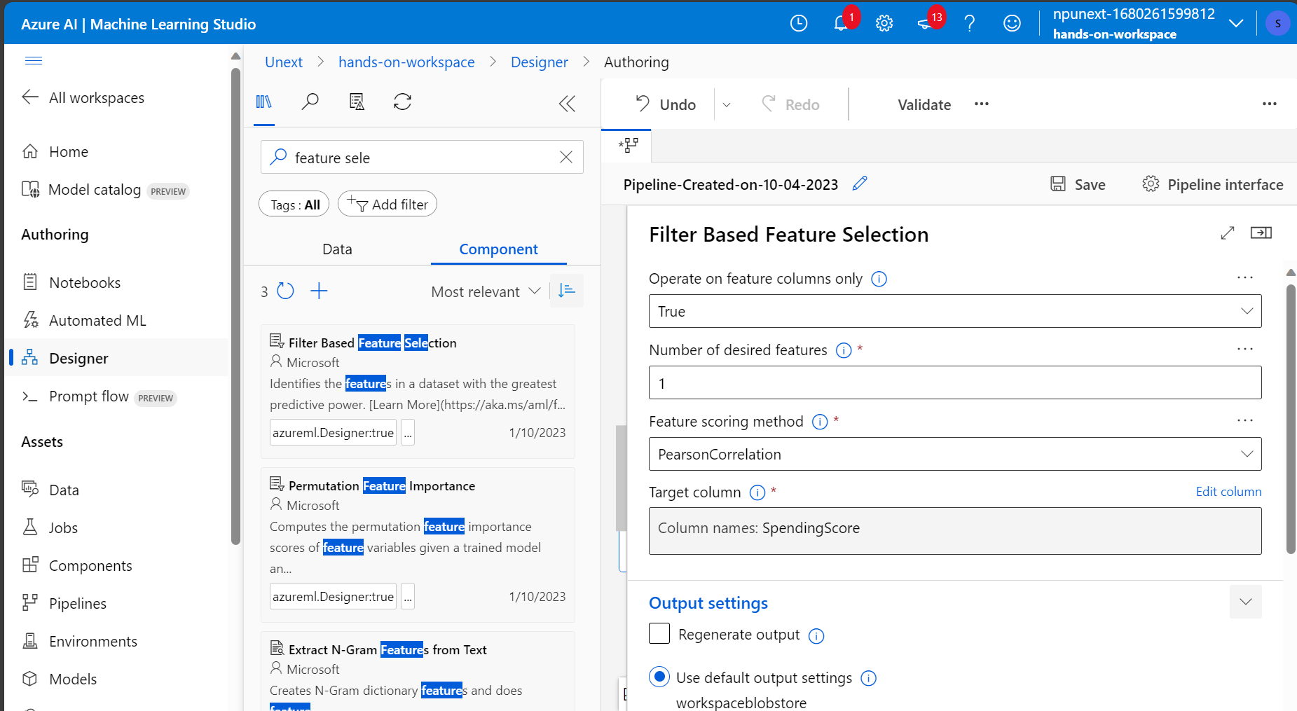

1. SPLIT DATA

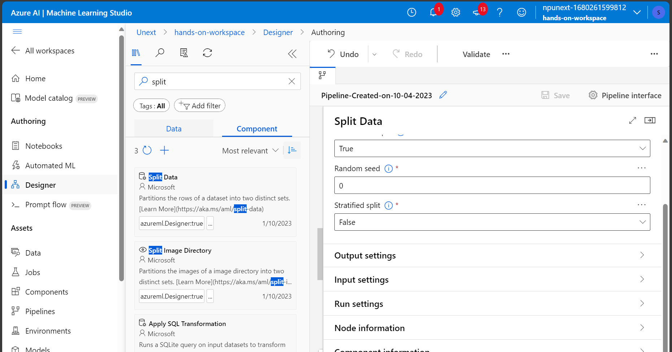

8)TRAINING ML MODEL

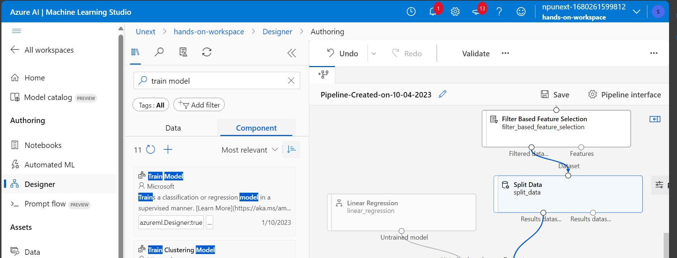

1. SCORE MODEL AND EVALUATE MODEL

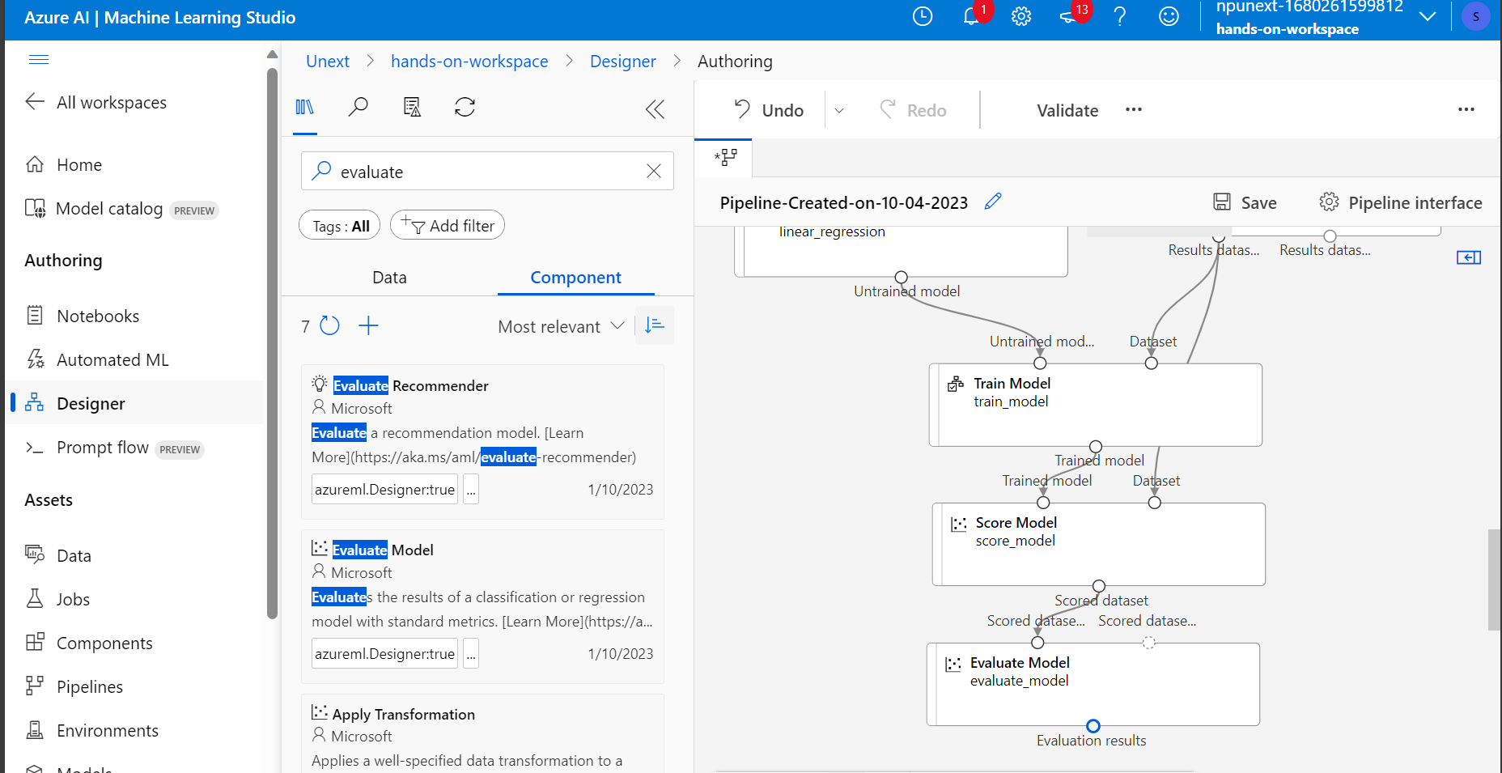

VALIDATION SUCCESS

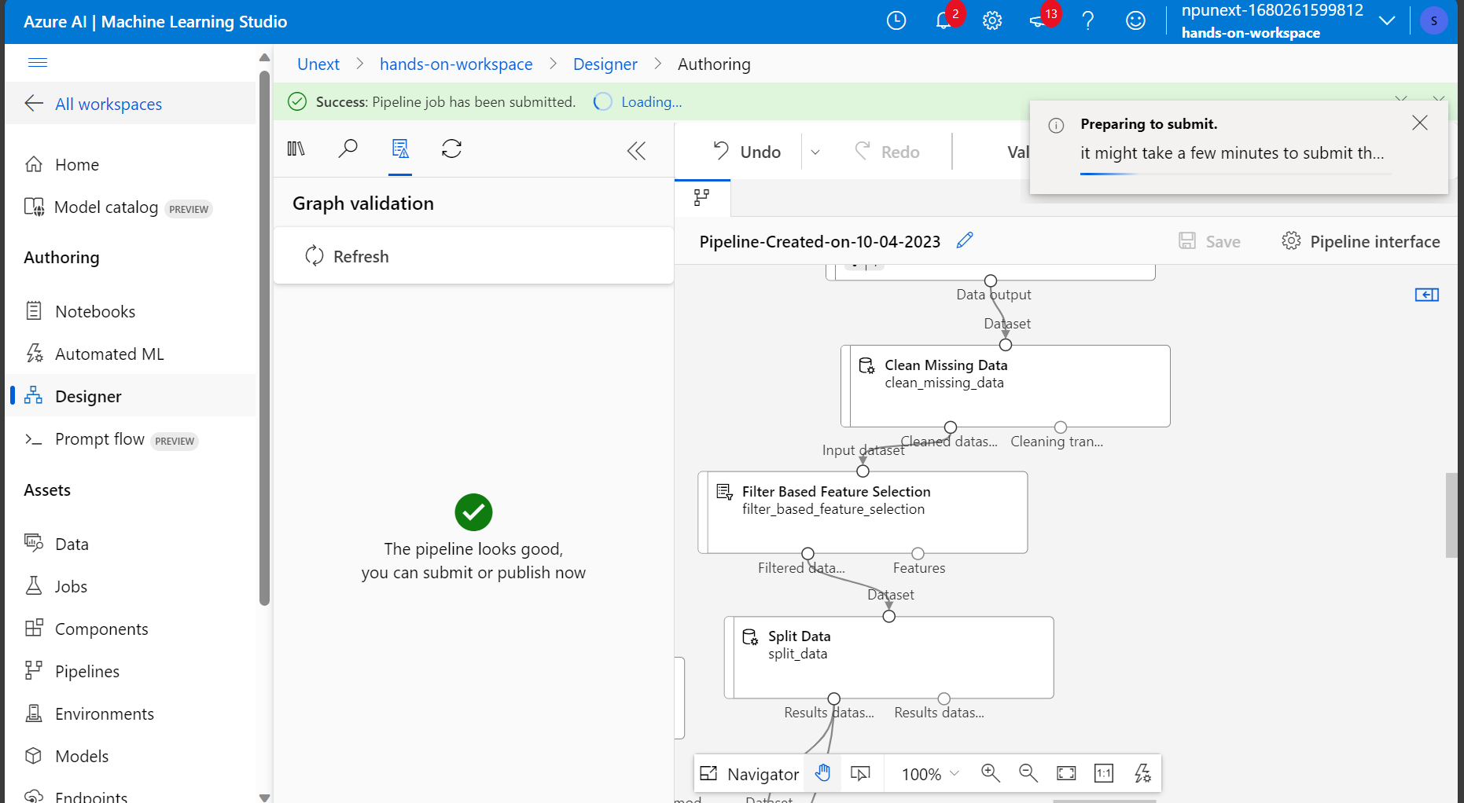

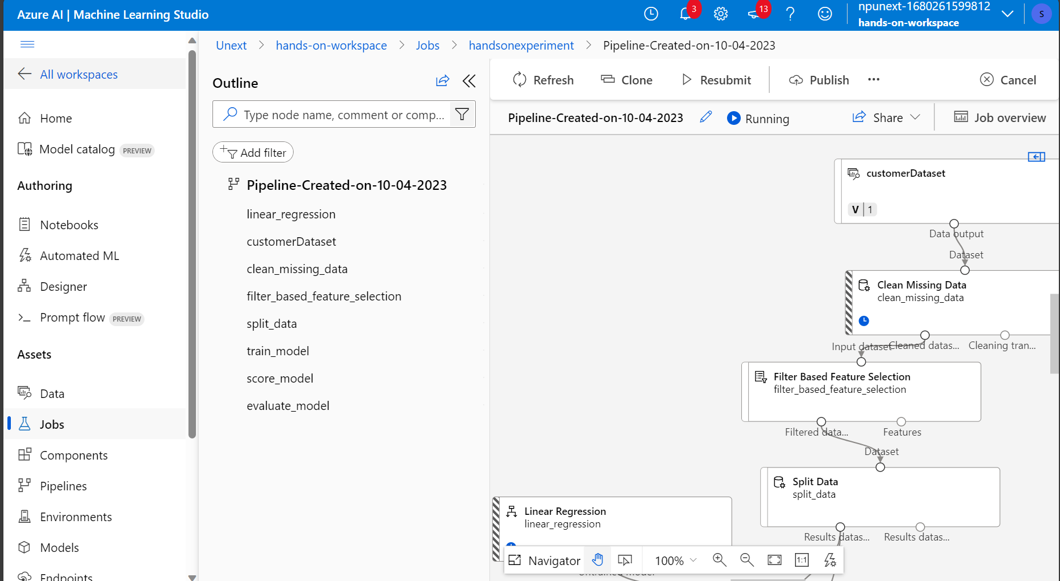

EVALUTION RESULTS

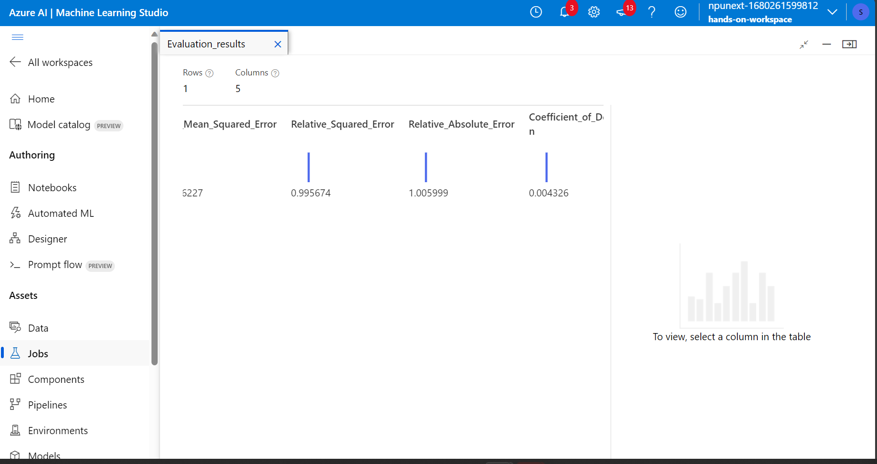

Question and answers

1. Preparing a dataset in Azure Machine Learning involves steps like data collection, exploration, cleaning, transformation, splitting, labeling (if supervised), preprocessing, versioning, and pipeline creation.
2. Splitting a dataset into training and testing sets is vital for machine learning model development as it allows for model evaluation. This separation helps gauge how well the model generalizes to new, unseen data, ensuring its reliability and effectiveness.
3. For predicting customer purchasing behavior, a suitable algorithm is LINEAR REGRESSION
4. What is hyperparameter tuning, and why is it important in machine learning? Explain a technique used for hyperparameter tuning and its benefits.