ASSIGNMENT 7

we have tested the following techniques to check whether it improves our model.

- Binarization
- Kmeans++

Observations:

- Word embedding improve the model when taken as features.
- Binarization even further improves the model.
- Kmeans with K =10 is where we get the best model while increasing it reduces the F1 score.
- The value of t was calculated as :
i) tpos = average of positive values
- ii) tneg = average of negative values
- Values less than tneg are tagged as “neg” and values greater than tpos are tagged as “pos” And values between tpos and tneg are tagged as “zero”
Words not in the vocabulary are tagged are “new”

- currentWord,previousWord,previousPosTag,previousNameTag,previousChunk,currentPosTag,currentCapital,currentWordConstant,nextCapital,nextWordConstant,nextPosTag,nextWord,currentNameTag. with binarization
This gave the highest F1 score. with Kmeans clustering

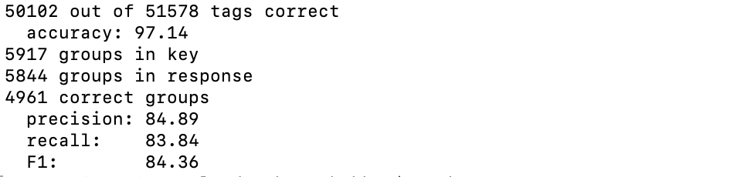

currentWord, previousWord,previousPosTag,previousNameTag,previousChunk,currentPosTag,currentCapital,currentWordConstant,nextCapital,nextWordConstant,nextPosTag,nextWord,currentNameTag. with binarization
This gave the highest F1 score. without kmeans clustering 85.49%

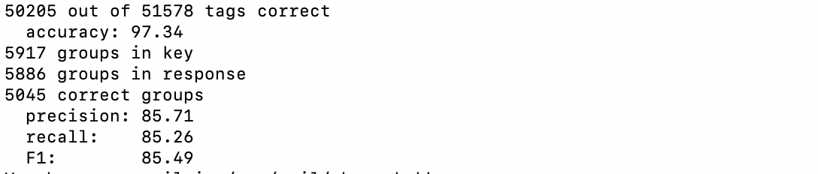

Reference:
https://www.aclweb.org/anthology/D14-1012

