# Enhanced Green Cover Index (GCI) Comprehensive Report

Generated by: Automated GCI Analyzer

This report contains historical GCI (NDVI) trends, model performance, and future predictions for the analysed plot.

## 1. Plot Analysis

|  |  |
| --- | --- |
| Latitude | Longitude |
| 12.982620 | 77.616139 |
| 12.987261 | 77.620130 |
| 12.987387 | 77.622062 |
| 12.981574 | 77.622534 |
| 12.977559 | 77.620002 |
| 12.981449 | 77.616397 |

Calculated area: 462943.46 m² (46.29 hectares)

Plot outside legal buffer. Closest lake details:

|  |  |
| --- | --- |
| Attribute | Value |
| Name_of_Th | Ulsoor Lake |
| UniqueID | 172 |
| Valley | V |
| Area | 36.82 |
| Latitude | 12.9786563762569 |
| Longitude | 77.6202468411846 |
| Ward_Numbe | 90 |
| Ward_Name | Halsoor |
| Ward_Couns | Smt. Mamatha Saravana |
| Ward_offic | #19, 1st Street, Halsoor, Bengaluru-560008 |
| Ward_Conta | 9844059238/9448459238 |
| Facebook | https://www.facebook.com/Ulsoor-Lake-Bengaluru-256872594397906   https://www.facebook.com/pages/category/Community/Save-Ulsoor-Lake-108271669203575/ |
| New_Custod | BBMP |
| Custodian | BBMP |
| Aream3 | 395761.792858798755333 |
| latitude | 12.9786563762569 |
| longitude | 77.6202468411846 |

## 2. Environmental Risk Assessment

Risk assessment summary based on historical GCI and environmental indicators.

|  |  |
| --- | --- |
| Risk Category | Risk Level |
| Vegetation Decline | Medium |
| Climate Vulnerability | Low |
| Water Stress | Low |
| Urbanization Pressure | Unknown |
| Air Quality | Medium |

## 3. Historical GCI Data & Trend

|  |  |
| --- | --- |
| Year | GCI |
| 2015 | 0.3753 |
| 2016 | 0.2785 |
| 2017 | 0.3311 |
| 2018 | 0.3340 |
| 2019 | 0.3495 |
| 2020 | 0.3468 |
| 2021 | 0.2902 |
| 2022 | 0.2835 |
| 2023 | 0.2847 |
| 2024 | 0.3029 |

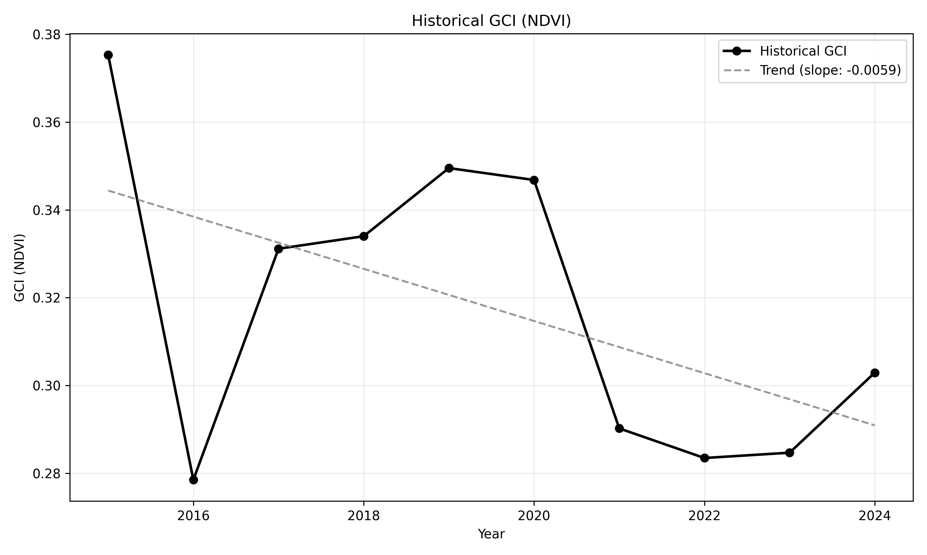

## 4. Model Performance

Model performance visualisation (R², MAE, RMSE).

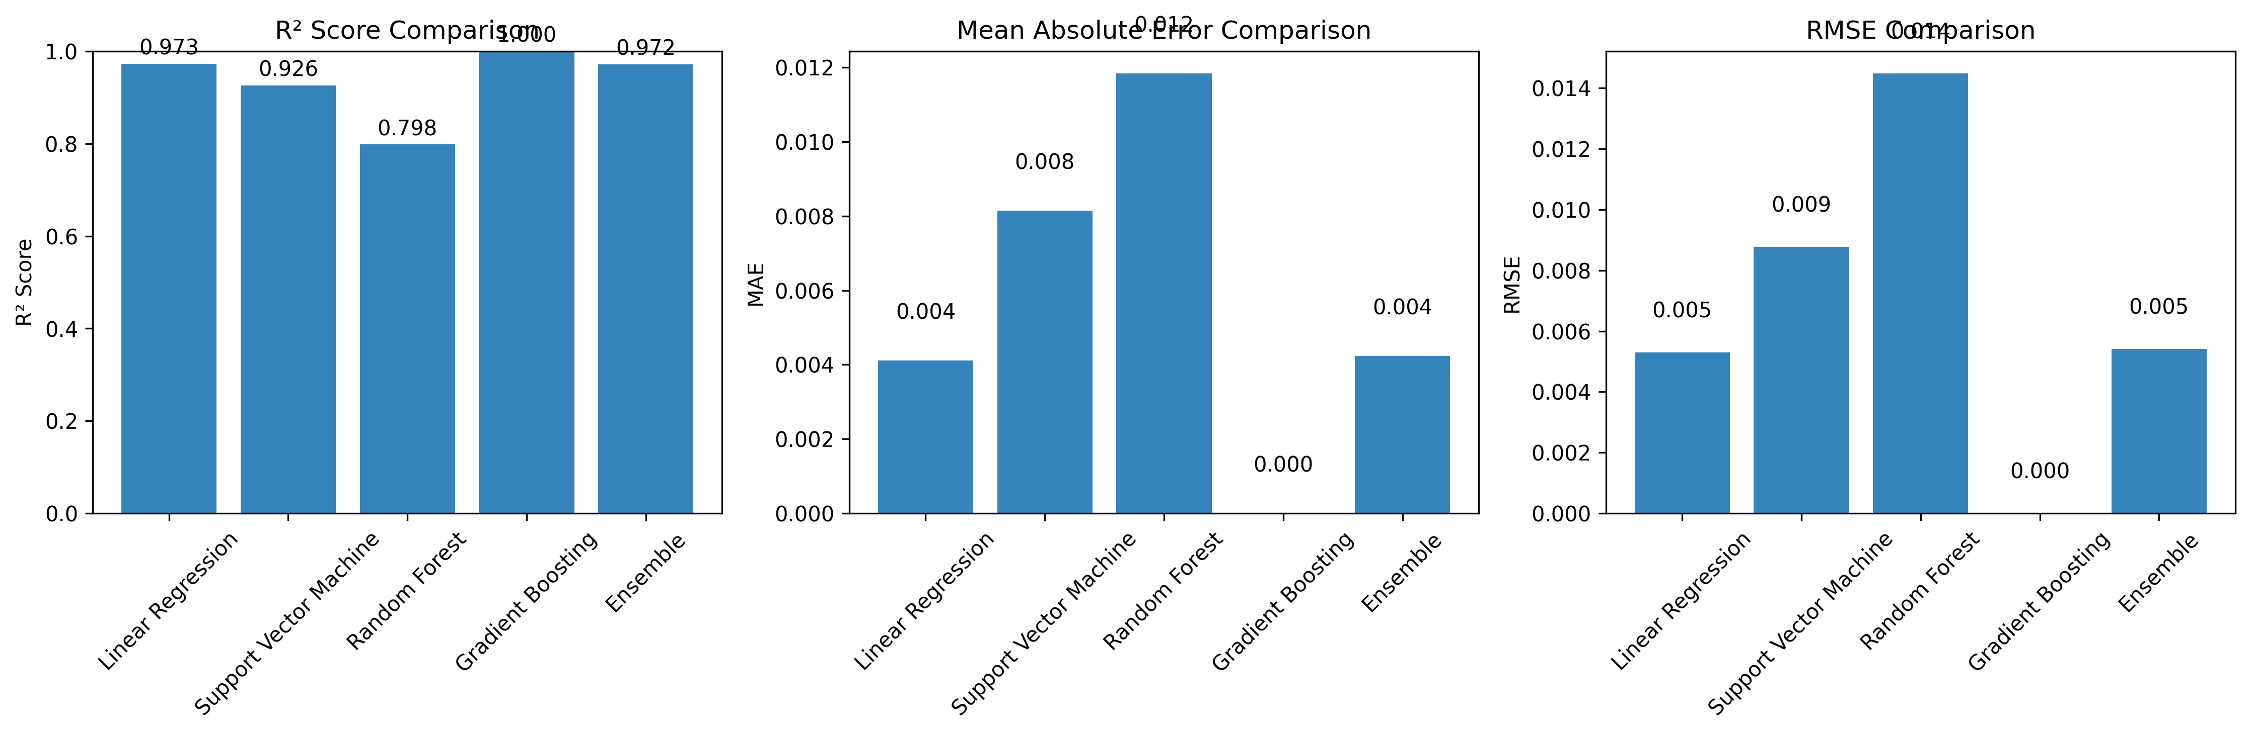

Detailed metrics table:

|  |  |  |  |  |
| --- | --- | --- | --- | --- |
| Model | R² | MAE | RMSE | MAPE (%) |
| Gradient Boosting | 1.000 | 0.000 | 0.000 | 0.0 |
| Linear Regression | 0.973 | 0.004 | 0.005 | 1.4 |
| Ensemble | 0.972 | 0.004 | 0.005 | 1.3 |
| Support Vector Machine | 0.926 | 0.008 | 0.009 | 2.6 |
| Random Forest | 0.798 | 0.012 | 0.014 | 3.7 |

## 5. Future Predictions (All Models)

Predictions comparison across all trained models (bar chart).

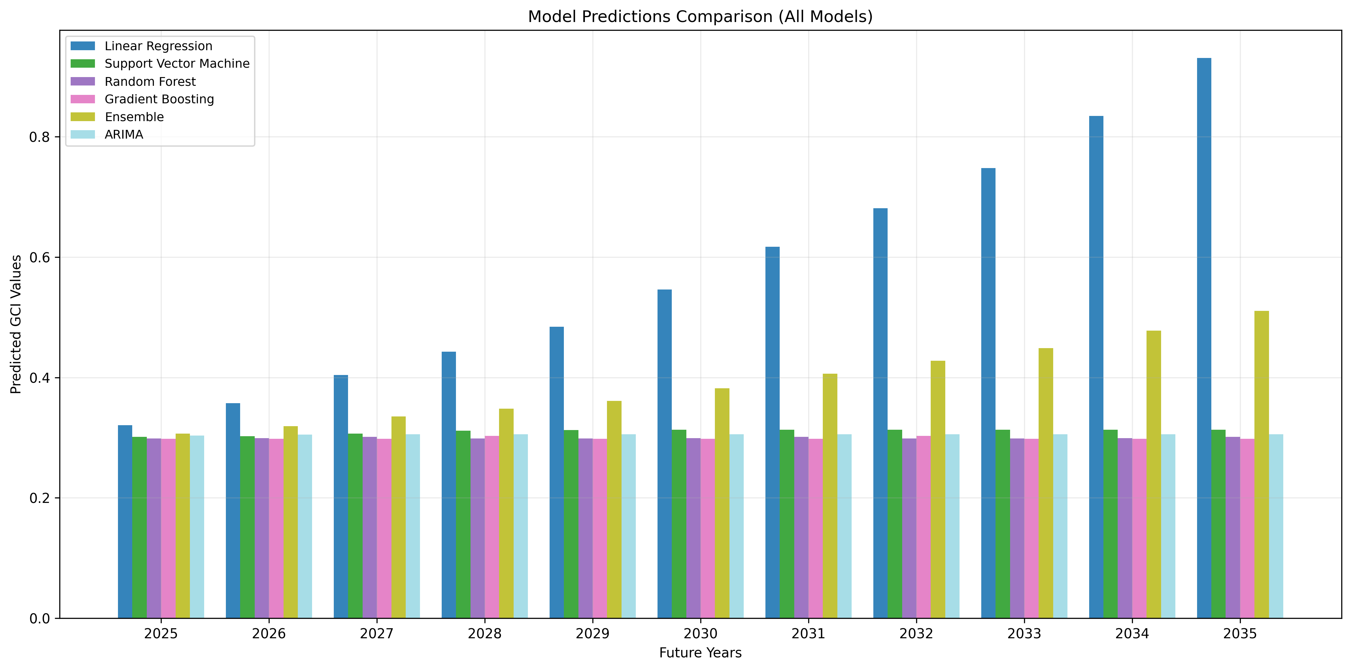

## 6. Combined Time Series: Historical + All Model Predictions

Comprehensive time series that overlays historical GCI and each model's predictions.

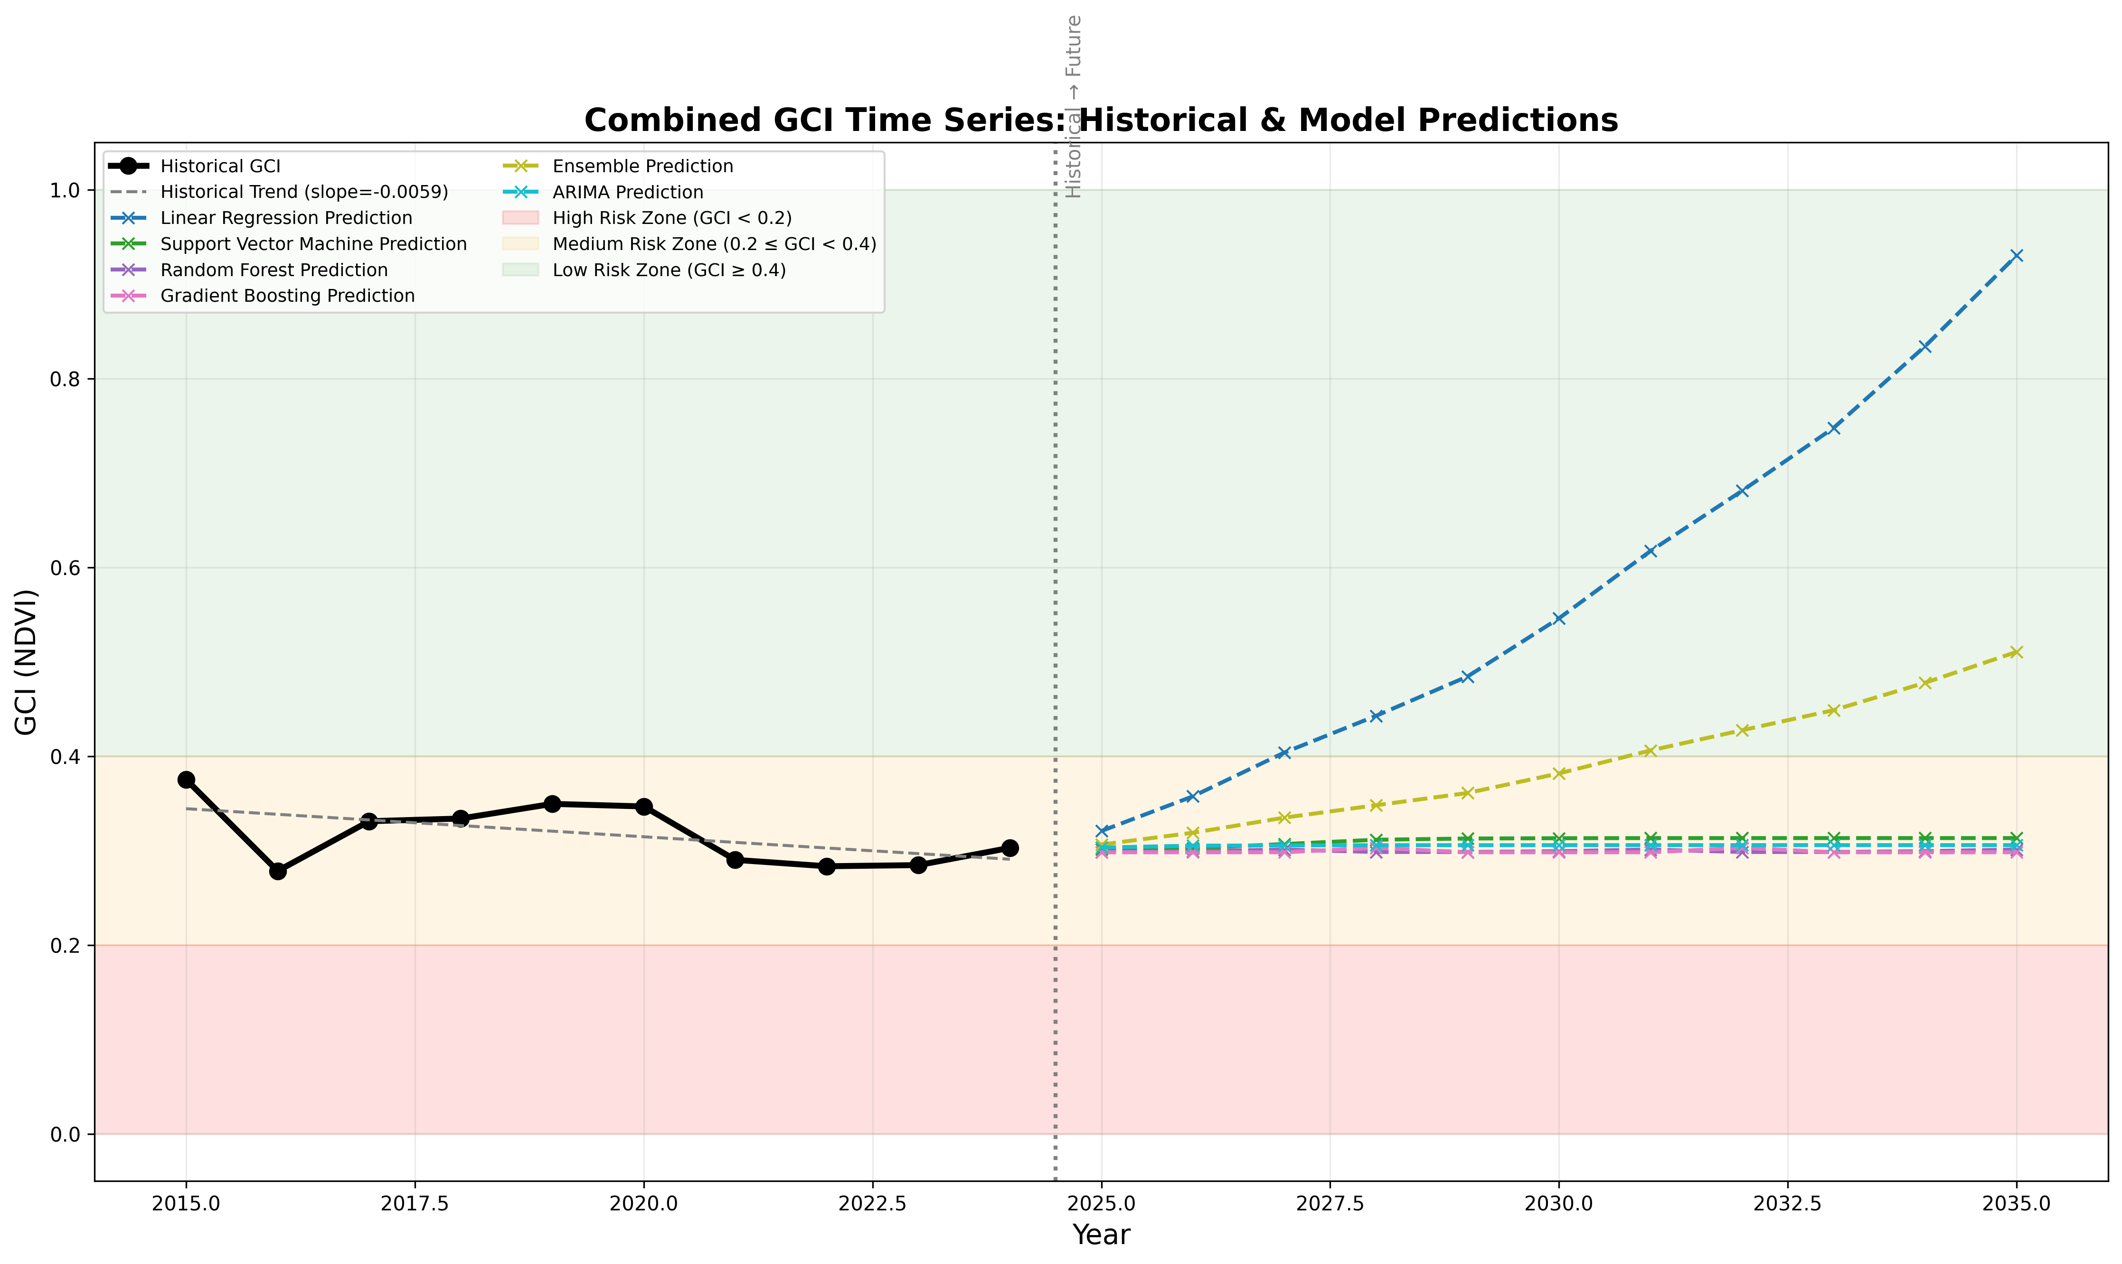

## 7. Predictions Table (per model)

### Linear Regression Predictions

|  |  |  |
| --- | --- | --- |
| Year | Predicted GCI | CI |
| 2025 | 0.3208 | N/A |
| 2026 | 0.3575 | N/A |
| 2027 | 0.4039 | N/A |
| 2028 | 0.4427 | N/A |
| 2029 | 0.4844 | N/A |
| 2030 | 0.5461 | N/A |
| 2031 | 0.6174 | N/A |
| 2032 | 0.6811 | N/A |
| 2033 | 0.7477 | N/A |
| 2034 | 0.8343 | N/A |
| 2035 | 0.9305 | N/A |

### Support Vector Machine Predictions

|  |  |  |
| --- | --- | --- |
| Year | Predicted GCI | CI |
| 2025 | 0.3012 | N/A |
| 2026 | 0.3026 | N/A |
| 2027 | 0.3070 | N/A |
| 2028 | 0.3115 | N/A |
| 2029 | 0.3128 | N/A |
| 2030 | 0.3131 | N/A |
| 2031 | 0.3133 | N/A |
| 2032 | 0.3133 | N/A |
| 2033 | 0.3133 | N/A |
| 2034 | 0.3133 | N/A |
| 2035 | 0.3133 | N/A |

### Random Forest Predictions

|  |  |  |
| --- | --- | --- |
| Year | Predicted GCI | CI |
| 2025 | 0.2986 | N/A |
| 2026 | 0.2994 | N/A |
| 2027 | 0.3011 | N/A |
| 2028 | 0.2986 | N/A |
| 2029 | 0.2986 | N/A |
| 2030 | 0.2994 | N/A |
| 2031 | 0.3011 | N/A |
| 2032 | 0.2986 | N/A |
| 2033 | 0.2986 | N/A |
| 2034 | 0.2994 | N/A |
| 2035 | 0.3011 | N/A |

### Gradient Boosting Predictions

|  |  |  |
| --- | --- | --- |
| Year | Predicted GCI | CI |
| 2025 | 0.2983 | N/A |
| 2026 | 0.2982 | N/A |
| 2027 | 0.2983 | N/A |
| 2028 | 0.3029 | N/A |
| 2029 | 0.2983 | N/A |
| 2030 | 0.2982 | N/A |
| 2031 | 0.2983 | N/A |
| 2032 | 0.3029 | N/A |
| 2033 | 0.2983 | N/A |
| 2034 | 0.2982 | N/A |
| 2035 | 0.2983 | N/A |

### Ensemble Predictions

|  |  |  |
| --- | --- | --- |
| Year | Predicted GCI | CI |
| 2025 | 0.3065 | N/A |
| 2026 | 0.3189 | N/A |
| 2027 | 0.3350 | N/A |
| 2028 | 0.3481 | N/A |
| 2029 | 0.3610 | N/A |
| 2030 | 0.3818 | N/A |
| 2031 | 0.4061 | N/A |
| 2032 | 0.4275 | N/A |
| 2033 | 0.4488 | N/A |
| 2034 | 0.4778 | N/A |
| 2035 | 0.5105 | N/A |

### ARIMA Predictions

|  |  |  |
| --- | --- | --- |
| Year | Predicted GCI | CI |
| 2025 | 0.3033 | N/A |
| 2026 | 0.3053 | N/A |
| 2027 | 0.3055 | N/A |
| 2028 | 0.3057 | N/A |
| 2029 | 0.3058 | N/A |
| 2030 | 0.3058 | N/A |
| 2031 | 0.3058 | N/A |
| 2032 | 0.3058 | N/A |
| 2033 | 0.3058 | N/A |
| 2034 | 0.3058 | N/A |
| 2035 | 0.3058 | N/A |

## 8. Model Validation and Tuning Assessment

|  |  |  |  |  |
| --- | --- | --- | --- | --- |
| Model | CV Score | Train Score | Status | Recommendations |
| Linear Regression | 0.000 ± 0.000 | 0.973 | Limited Data | Limited data - collect more historical points |
| Support Vector Machine | 0.000 ± 0.000 | 0.926 | Limited Data | Limited data - collect more historical points |
| Random Forest | 0.000 ± 0.000 | 0.798 | Limited Data | Limited data - collect more historical points |
| Gradient Boosting | 0.000 ± 0.000 | 1.000 | Limited Data | Limited data - collect more historical points |
| Ensemble | 0.000 ± 0.000 | 0.972 | Limited Data | Limited data - collect more historical points |

## 9. Recommendations

• Regular monitoring and model updates recommended

• Consider adaptive management & targeted field surveys to validate predictions