AIProject/ # Solution root
│
├── AIProject.sln # Solution file (opens all projects together)
│
├── BlazorApp/ # Blazor frontend project
├── Api/ # C# backend API project
├── Workers/ # Python workers (not a .NET project, but included)
├── Infrastructure/ # Setup scripts/config
├── Docs/ # Documentation
└── Tests/ # Unit & integration tests

AIProject/
│
├── BlazorApp/ # Blazor UI (Web Server or WASM)
│ ├── Pages/ # Razor pages (Upload, Status, Dashboard)
│ ├── Components/ # Reusable UI components
│ ├── Services/ # Frontend services (API calls, Blob client)
│ ├── Models/ # Shared models (FileMetadata, Domain, Status)
│ ├── Validators/ # File validation logic
│ ├── wwwroot/ # Static assets (CSS, JS, images)
│ ├── Program.cs # Entry point

│ └── appsettings.json # Config (Blob, RabbitMQ, API URLs)
│
├── Api/ # C# Backend API
│ ├── Controllers/ # UploadController, StatusController
│ ├── DTOs/ # Request/Response objects
│ ├── Services/ # BlobStorageService, RabbitMQPublisher
│ ├── Middleware/ # Error handling, logging
│ └── Startup.cs # API configuration
│

├── Workers/ # Python background workers
│ ├── hr_worker.py # HR domain processing
│ ├── qa_worker.py # QA domain processing
│ ├── dev_worker.py # Dev domain processing
│ ├── common/ # Shared utilities
│ │ ├── blob_client.py # Fetch files from Azurite
│ │ ├── text_extractor.py # PDF/DOCX/TXT parsing
│ │ ├── chunker.py # Text chunking logic
│ │ └── embeddings.py # Embedding generation
│ └── requirements.txt # Python dependencies
│
├── Infrastructure/ # System setup/config
│ ├── RabbitMQ/ # Exchange, queue setup scripts
│ ├── BlobStorage/ # Azurite setup/config
│ └── Logging/ # Centralized logging configs
│
├── Docs/ # Documentation
│ ├── architecture.md # System design overview
│ ├── api_contracts.md # API endpoints & payloads
│ └── workers_flow.md # Worker lifecycle & retry logic
│
└── Tests/ # Unit & integration tests
├── BlazorTests/ # UI & API tests
├── WorkerTests/ # Python worker tests
└── IntegrationTests/ # End-to-end pipeline tests

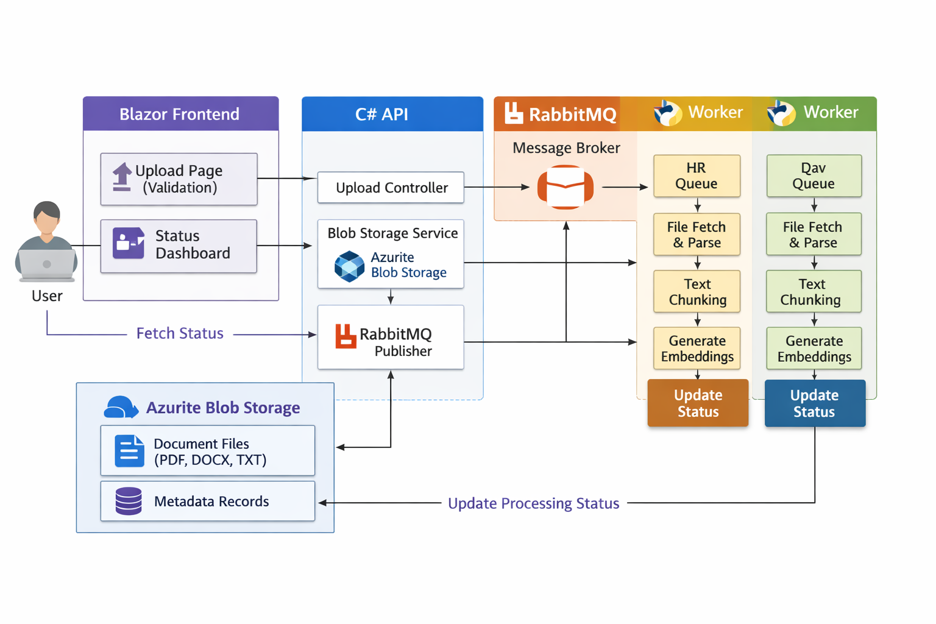
┌───────────────────────┐
│ Frontend UI │
│ (React / Angular) │
└──────────┬────────────┘
│ HTTP
▼
┌───────────────────────┐
│ C# API │
│ (Upload / Query) │
└───────┬─────┬─────────┘
│ │
Store File │ │ Send Message
│ ▼
│ ┌───────────────┐
│ │ RabbitMQ │
│ │ (Queue) │
│ └──────┬────────┘
│ │
▼ ▼
┌────────────────────┐ ┌────────────────────┐
│ Azurite Blob │ │ Background Worker │
│ (File Storage) │ │ (.NET Worker) │
└────────────────────┘ └─────────┬──────────┘
│
▼
┌────────────────────┐
│ Text Extraction │
└─────────┬──────────┘
│
▼
┌────────────────────┐
│ Chunking │
└─────────┬──────────┘
│
▼
┌────────────────────┐
│ Python AI Service │
│ (Embeddings) │
└─────────┬──────────┘
│
▼
┌────────────────────┐
│ Vector DB │
│ (FAISS / Chroma) │

2. DETAILED FLOW (STEP-BY-STEP WITH LOGIC)
[ USER UPLOAD ]
│
│ UploadController (C# API) │
│
✅ Step 1: Validate File
(type, size, format)
│
✅ Step 2: Store File
BlobService → Azurite
│
✅ Step 3: Send Message
RabbitMQService
│
🔁 ASYNC STARTS HERE
│
│ Background Worker (.NET) │
│
📥 Consume Message (Queue)
│
📄 Step 4: Download File
From Azurite
│
🧠 Step 5: Extract Text
(PDF / DOC / TXT)
│
✂️ Step 6: Chunking
(Split into small parts)
│
🤖 Step 7: Send to Python
(Embedding API)
│
🔢 Step 8: Generate Vectors
│
💾 Step 9: Store in Vector DB

Chat With Your Documents (Query Syste: POST /embed → Convert question to vector
POST /generate → Generate final answer
User Question
↓
C# API (QueryController)
↓
Convert Question → Embedding
↓
Search in Vector DB (Similarity)
↓
Top Relevant Chunks Retrieved
↓
Send to Python AI (LLM)
↓
Generate Answer
↓
Return Response to User

