<https://drive.google.com/drive/folders/1YG7QKvztaRNdmZ-n_NWh3UVTsO7mQd7p?usp=sharing>

Download in next 2 days 1811v Suit :

<https://drive.google.com/drive/folders/1sxXGzG6YvPN5O7rYYqO4TwBNtNse9tmB?usp=sharing>

<https://electronics.local:9002/yacceleratorstorefront/?site=electronics>

<https://apparel-uk.local:9002/yacceleratorstorefront/?site=apparel-uk>

<https://powertools.local:9002/yb2bacceleratorstorefront/?site=powertools>

Java 8 supports : 1811v

Java 11 supports: 2105v

Command to activate temporary licence:

>platform> license.bat -temp CPS_SQL

07/10/2021:

Examples for ecommerce sites :

- Marketplace Accelerator Commerce

Amazon

FLipkar

Myntra

- B2C Accelerator Commerce

Nike - Business to Customers COmmerce -B2C Accelerator

-Telico Accelerator Commerce

Mobile industry - Tellico Commerce

-Travel Accelerator

* Airlines
* Bus Booking

-Financial Accelerator Commerce

-Business to business model - b2b accelerator

Hybris started as a product based company in Germany in 2007

SAP acquired Hybris in 2013

2018 completed merged and rebranded as SAP commerce

We can also use this platform to build other kind of ecommerce platforms like grocery

Eg of Biryani recipe Rice

Biryani leaf

Masala

Vegetables

Oil Biryani

Websites running on Hybris:

Oakley

Shopper Stop

Ajio

Whirlpool

Energiser Battery b2b

Sharja Co operation

Apple

Wallmart

Other eCommerce platforms in market now:

Hybris - xxx licencing, support xxxxxx

Oracle ATG -

Salesforce commerce - b2c b2b

Meganto

Elastic path

Commerce tools

08/10/2021:

Detailed overview on Hybris architecture:

Facade design pattern

Uses Hsql store in the form of Models

>We use converters and populators to transform models to data objects

Product

Price

Stck

Image

Review

Product DTO

Price DTO

Stock

Select * from {product};

Modules vs Extensions:

Extinction and addon

Order module

Group of extension is called module

Extension > template for implementing any functionality

src> java

jsp> html jsp tag

Css > css

Local server setup with eclipse setup:

4.5

4.6

4.7

5.0

5.6

6.0

6.1

6.1.1

6.1.2

Hybris version :

1811

2005 Commerce Cloud

2105

2110

2202

Java 8

7zip

I5 / i7 > 16ram

Start server:

Platform > Setantenv.bat

Installer > install.bat -r b2b-acc -A <>

Platform > ant clean all

Hybrisserver.bat

Server started in xxxx mins

localhost:9001/hac

Initialize 30 -45mins

https://electronics.local:9002/yacceleratorstorefront/?site=electronics

Stop server : cntrl +c

Create extension

Create addon

Features in eCommerce:

Amazon

Flipkart

Ajio

Meeshow

PDP

Product Variant

Images

UX CX experience

PLP uses solr > PDP fetch from DB

Recommendations > MC

Image Search

Localisation

Pricing

Sellers

Stock

Restrictions

Guest checkout

Steps for any ammpication:

Database

MongoDB & mysql

Technology

Springboot controller /login , service, dqo

Frontend

Angular , jsp, tag

DAO vs DTO

Registration DB table,html,

Login java hml

My account java

Edit my details java hel

Java:

Collections

Exceptions

methods

Class

Oops

Spring:

MVC

Create beans

Bean scopes

Annotations

Xml creating bans

11/10/2021:

Local setup:

1.Open command prompt in platform folder

>platform>setantenv.bat

2.Navigate to the installer folder using install recipe using below command>cd..

E:\OOTB_1811\CXCOMM181100P_37-70004085\installer

>install.bat -r b2c_acc_plus -A local_property:initialpassword.admin=nimda

b2c_acc_plus

Recommended :b2c_b2b_acc_oms

Command for v2105:

install.bat -r cx setup -A initAdminPassword=password

3.Navigate to platform cd <folder name>

>platform> ant clean all

4. Hybrisserver.bat

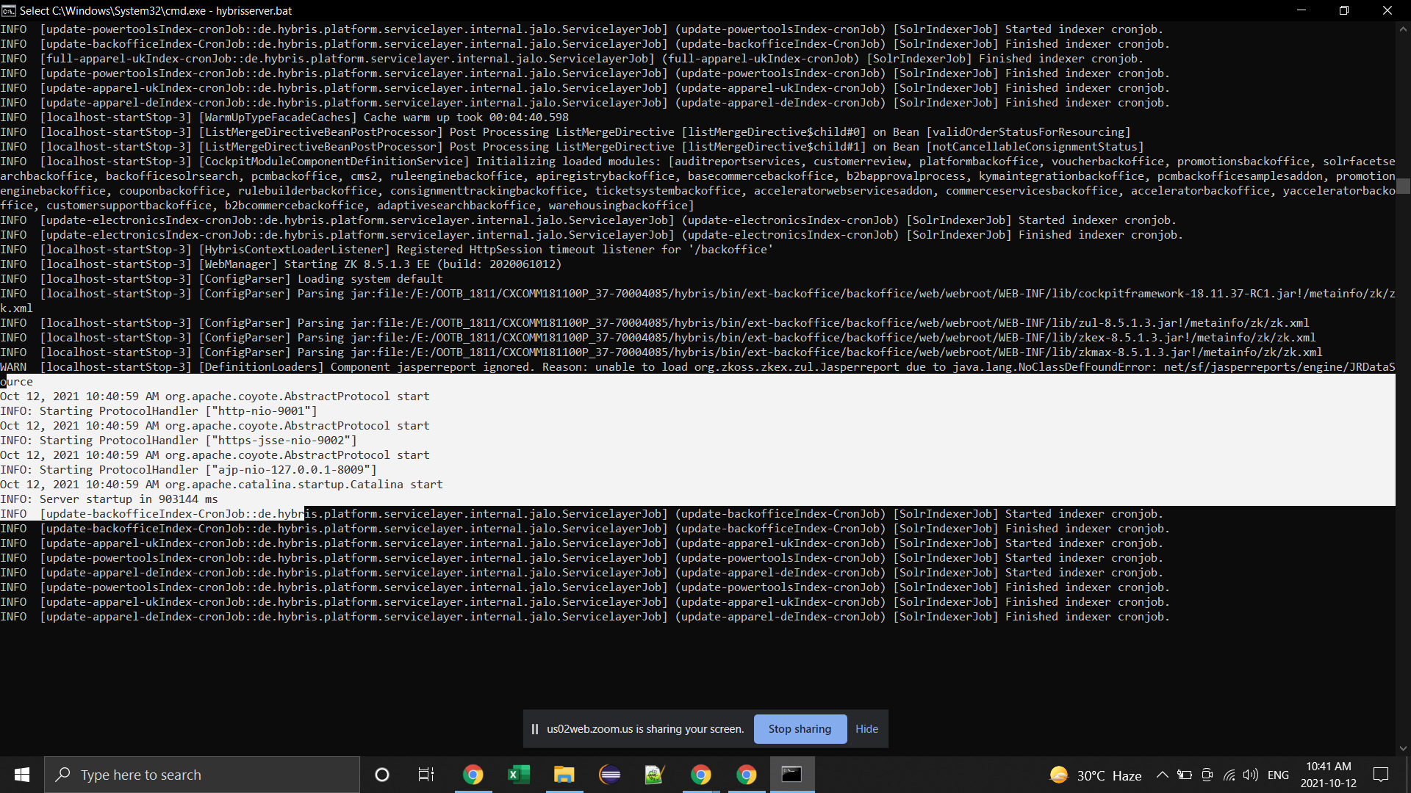

5.Once server is started started up open http://localhost:9001/hac

6.Login using admin / nimda

7. In Hac Under platform click on initialize and do initialisation

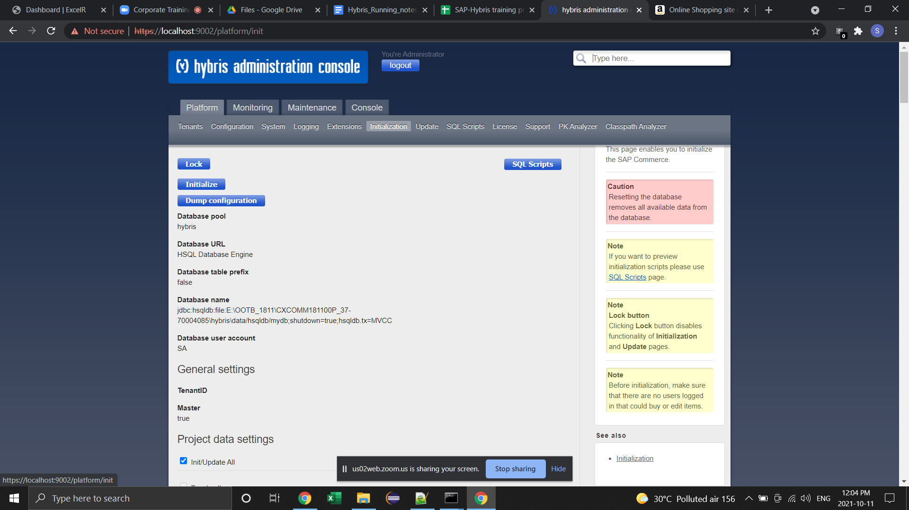

8. It will take an 30mins or an hour

Once you see it, continue… in your hac at the end, your local setup is done and you are good to go

Backoffice Url:

https://localhost:9002/backoffice

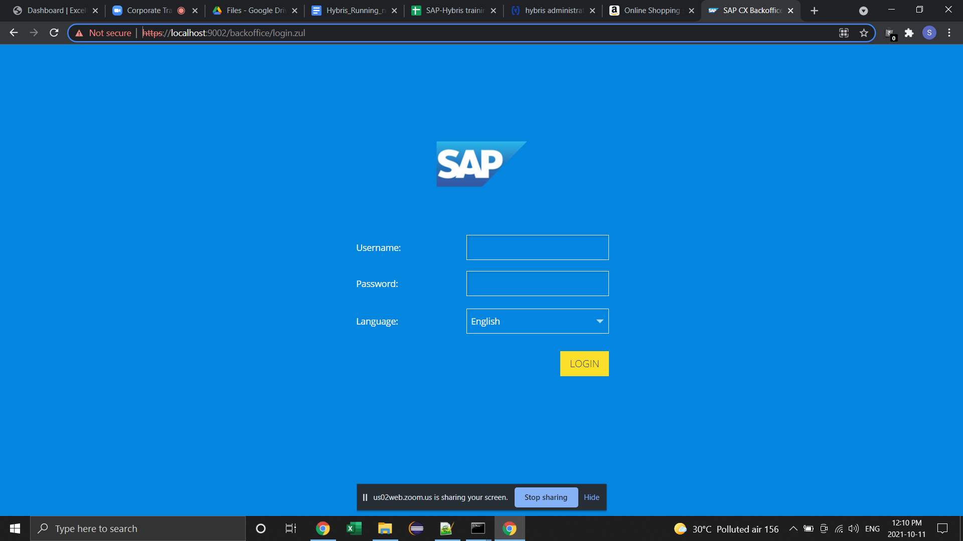

Use same password admin/ nimda

**Electronics storefront:**

**B2C: Nike**

<https://localhost:9002/yacceleratorstorefront/?site=electronics>

[://localhost:9002/yacceleratohttpsrstorefront/?site=apparel-uk](https://localhost:9002/yb2bacceleratorstorefront/?site=apparel-uk)

://localhost:9002/yacceleratorstorefront/?site=apparel-de

B2B : <https://localhost:9002/yb2bacceleratorstorefront/?site=powertools>

Add this after localhost in your **host** file: C:\Windows\System32\drivers\etc

apparel-uk.local apparel-de.local electronics.local powertools.local

Local Setup Eclipse: Done

Hac:

12/10/2021:

Pptx:

LinkedList sample = new Linke();

multiply( int a, int b){

Log.info(“Entered into multiply method”);

Int mul = a * b;

Log.info(“multiply done” +mul);

Log.info(“”);

}

***Reminder***** log4j vs logback

Kibana

Get to know what is logs

log4j

log level hierarchy

13/10/2021:

To show all the ant commands : ant -p

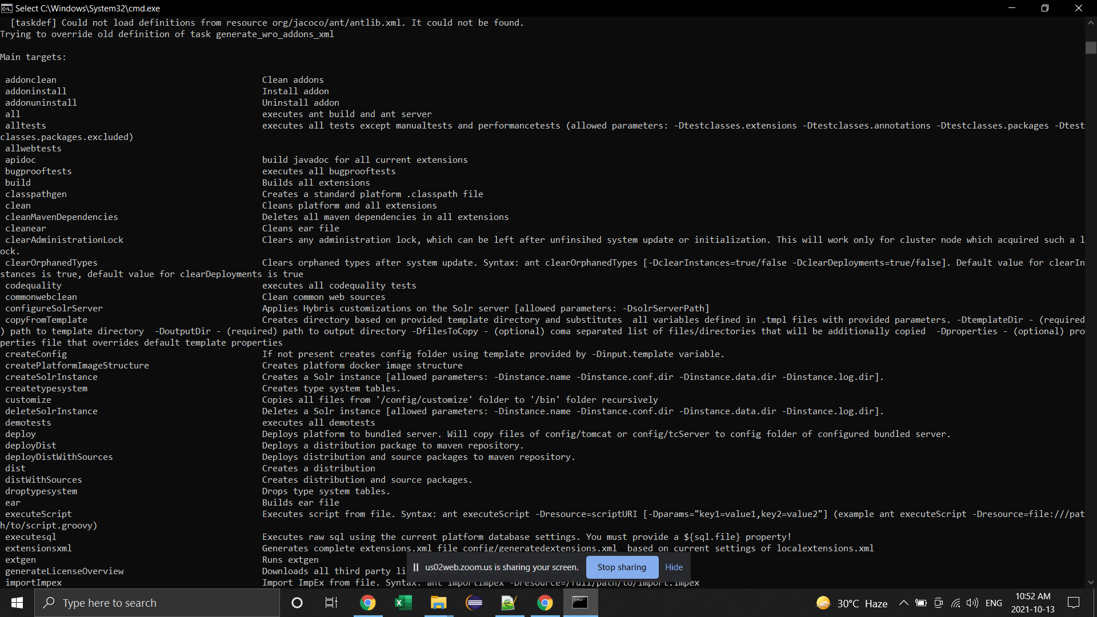

Backoffice Overview:

Earlier we used to have /hac

/Hmc

backoffice /Wcms : web content management system

/Product cockpit

/Customer support cockpit

Backoffice perspective :

Admin

Product

Integration

Search

Datahub / SCPI

CS agent

Warehouse

ERP

ECC

CRM

Marketing cloud

Sales

Payment

Cronjobs and its use cases

14/10/2021:

Warehouse

Id : name : last name : DOB

154646464 : Joy : joy : 12/12/2026

164664646:

15/10/2021:

CS perspective

16/10/2021:

17/10/2021:

18/10/2021:

Data Modeling

19/10/2021:

Data Modeling

20/10/2021:

Backoffice customisation

*backoffice*-config.xml - basic customisation like adding tables & columns in the navigation and editor area or search area

<editor-area>

<search>

Orchestration mode press f4 to open

Exit again press f4

Perspective :

Actions -

Localisation of tables & columns

type.CustomerFeedback.name = Customer Feedback

type.CustomerFeedback.description = Customer Feedback table

type.CustomerFeedback.customerDetails.name = Customer Details

type.CustomerFeedback.customerDetails.description = column for providing customer details

type.CustomerFeedback.media.name = Media

type.CustomerFeedback.media.description = media for customer details

Abc

164

NA

CustomerFeedback.hw

Customerfeedback.kw

Creating extension & addons with their use cases:

Antextgen - create only extension & addons

Ant modulegen - create Module

21/10/2121:

Addon vs extension differences:

Extgen template

Folder structure in extension addon storefront

22/10/21:

Local setup steps with custom modules for b2b and b2c:

Create 2 folders in your local and copy suit

Run b2b in one suit and b2c in other and follow the next steps as mentioned in doc

Follow the doc shared in drive space with few corrections as below.

Follow the below command on page 2 line 4:

ant modulegen -Dinput.module=accelerator -Dinput.name=training -Dinput.package=de.hybris.training -Dinput.template=develop

Remove the below extension from localextension.xml file:

yacceleratorcore

yacceleratorfacades

yacceleratorstorefront

yacceleratorinitialdata

yacceleratortest

yacceleratorcockpits

yacceleratorfulfilmentproces

25/10/21:

Catalog > Default Stage Online

Products Product

Content

sync gonna happen with cronjobs

syncCronjobs

menSpects

he

with

material

Youngspects

A-Stage B- Online

Name

Code

color

Name

Code

color

SyncCronjob

source

target

productSyncCronjob

contentSyncCronjob

syncCronjob extent cronjobs

source

target

categorysync

prodsync stage to none

apparal

electronct

syncjob(syncCronjob)

perform()

{

Sourec

target

}

electronct Catalog

electronct Catagories

electronct sub categories

electronct Produts

electronct Varient products

electronicsProdSyncjob

electronct content catalog-Stage

electronct content catalog-Onlie

Powertools Catalog

Powertools Catagories

Powertools sub categories

Powertools Produts

Powertools Varient products

SOLR creds: https://localhost:8983/

**solradmin**

**admin123**

26/10/21:

Media

Impex

27/10/21:

Media

Impex

28/10/21

Decorator?

29/10:

Solr

Boost

Adaptive search features

OMS - order management system

After Place order button

> fraud check

> authentication

>Authorisation

>Warehouse

> Consignment

> send email

>Set order status

Asynchronous

Process engine

Order Process

Refund Process

Cancel Process

Consignment process

Email

02/11/21:

OMS :

SOP -silent order payment

HOP - hosted order payment

Authentication

Authorisation

Capture

Return

Refund

Cancel

03/11:

Third party payment providers:

Adyan

Klarna

Paypal

2Checkout

Check consignment?

CS Perspective?

Warehouse perspective?

Backoffice solr issue? DO solr indexing for backkoffice

08/11/2021:

WCMS - Web Content Management System

SMARTEdit

Page template

Content slots

Components

INSERT_UPDATE PageTemplate;$contentCV[unique=true];uid[unique=true];name;frontendTemplateName;restrictedPageTypes(code);active[default=true]

INSERT_UPDATE ContentSlotName;name[unique=true];template(uid,$contentCV)[unique=true][default='ErrorPageTemplate'];validComponentTypes(code);compTypeGroup(code)

INSERT_UPDATE ContentSlotForTemplate;$contentCV[unique=true];uid[unique=true];position[unique=true];pageTemplate(uid,$contentCV)[unique=true][default='SearchResultsGridPageTemplate'];contentSlot(uid,$contentCV)[unique=true];allowOverwrite

Difference between ContentSlotName, ContentSlot, ContentSlotForTemplate and ContentSlotForPage:

* Content Slots hold WCMS Components
* Content Slot for Templates are default slots when not overridden at page level (i.e. top nav, header, footer)
* Content Slot for Page are slots assigned to an individual page instance and override the template level slot (i.e. homepage, sony brand landing page)
* Content Slot Name is a logical tagging for a content slot (aka Navigation Section, Top Merchandizing, Footer, Product Image Slot). To the Content Slot Name you can configure the types of components that will work in a slot.

ContentSlotName => Corresponding to the Position-Name in your Template and JSP (you can set ComponentType-Restrictions against these, e.g. Logo-Slot only allows SimpleBannerComponents)

ContentSlot => Components are placed in here (Links, Paragraphs)

ContentSlotForTemplate => ContentSlots that are globally mapped against a ContentSlotName/Template-Position are represented by this (e.g. Logo-Slot, which is the same for all Pages with the same Layout)

ContentSlotForPage => ContentSlots that have different content/components on each Page are represented by this

In the WCMS-Cockpit one can mage a ContentSlotForTemplate-Relation to a ContentSlotForPage-Relation by using the "Fist-Symbol".

References::

https://medium.com/@gokul.ch.pandey/sap-customer-experience-hybris-cms-page-template-pages-content-slot-component-impex-etc-73403bb50d44

2015 Installation issue workaround:

<https://answers.sap.com/questions/13497106/isuue-installing-sap-commerce-2105-with-windows.html?url_id=text-global-profile-inbox-qa-answer-published-to-question>

<https://answers.sap.com/questions/13510712/rush-cannot-run-correctly-after-sap-commerce-upgra.html>

OCC:

<https://localhost:9002/occ/v2/swagger-ui.html#/Users/createUser>

[https://medium.com/@manpreetsingh.16.11.87/sap-hybris-assisted-service-module-asm-b0a6c6d0f3c7](https://us02st1.zoom.us/web_client/rnqzmq/html/externalLinkPage.html?ref=https://medium.com/@manpreetsingh.16.11.87/sap-hybris-assisted-service-module-asm-b0a6c6d0f3c7)

Task for today

find asm component name and slot

Spartacus:

<https://sap.github.io/spartacus-docs/installing-sap-commerce-cloud-2105/>

Swagger:

[https://localhost:9002/occ/v2/swagger-ui.html#/](https://us02st1.zoom.us/web_client/rnqzmq/html/externalLinkPage.html?ref=https://localhost:9002/occ/v2/swagger-ui.html#/)

Different ways of data import:

Impex

Csv

Datahub

SCPI

Direct integration

SCPI:

Hybris

product

code

name

description

color

SCPI- iflows

MC

Sales

Service

ERP

CRM

......

field mappring

endpoints

credentials

Marketing LCoud

prodct

p_coe

p_name

p_desc

p_color

SAP Marketing Cloud trial version link:

<https://www.sap.com/cmp/td/sap-marketing-cloud-trial.html>

MC Trial version:

https://my300774.s4hana.ondemand.com/ui?sap-language=EN#Shell-home

[santhoshtraining123@mailinator.com](mailto:santhoshtraining123@mailinator.com)

Training123