QSPI Design Specification Document
Rev 1.0

Document Approval

Prepared by:

______________________ _______________

Reviewed by:

_______________________ ________________

Approved by:

_______________________ ________________

Change Log History

Revision No | Revision/  Submission Date | Revision  Description | Page No’s | Rationale for change | Change type (add / modify / delete)
1.0 |  | Initial release | All pages | -----------------

Contents
List of Figures 7
List of Tables 7
Preface 8
Purpose of the Document 8
Abbreviations Used 8
Pre-Requisites 8
Reference Documentation 8
1. Introduction to Quad-SPI Interface (QSPI) 9
1.1 Need for QSPI 9
1.2 Advantages of using QSPI 10
1.3 Function description and working of QSPI 10
1.4 Pins of QSPI 11
1.5 Features of QSPI 12
1.6 QSPI Interface Description 13
1.6.1 Instruction phase 13
1.6.2 Address phase 14
1.6.3 Alternate-bytes phase 15
1.6.4 Dummy cycles phase 16
1.6.5 Data phase 17
1.7 QSPI signal interface protocol modes 18
1.7.1 Single SPI mode 18
1.7.2 Dual SPI mode BK1_nCS 19
1.7.3 Quad SPI mode 20
1.7.4 SDR mode 20
1.7.5 DDR mode 21
1.7.6 Dual Flash Memory mode 21
1.8 QUADSPI Operating Modes 24
1.8.1 QUADSPI Indirect Mode 24
1.8.2 QUADSPI Status-flag polling mode 26
1.8.3 QUADSPI Memory-mapped mode 27
1.9 QUADSPI Special features 28
1.9.1 Send instruction only-once (SIOO)/Burst mode 28
1.9.2 Delayed data sampling 29
1.9.3 Timeout Counter 29
1.9.4 Additional Status bits 30
1.9.5 Busy bit and abort functionality 30
1.9.6 4-byte address mode / Extended address mode 31
1.10 QUADSPI Interrupts 32
1.11 DMA Usage 32
2 QUADSPI Registers 35
2.1 QUADSPI control register (QUADSPI_CR) 35
2.2 QUADSPI device configuration register (QUADSPI_DCR) 39
2.3 QUADSPI status register (QUADSPI_SR) 40
2.4 QUADSPI Flag clear register (QUADSPI_FCR) 42
2.5 QUADSPI Data Length register (QUADSPI_DLR) 43
2.6 QUADSPI Communication Configuration register (QUADSPI_CCR) 44
2.7 QUADSPI Address register (QUADSPI_AR) 47
2.8 QUADSPI Alternate Bytes register (QUADSPI_ABR) 47
2.9 QUADSPI Data register (QUADSPI_DR) 48
2.10 QUADSPI Polling Status Mask register (QUADSPI_PSMKR) 49
2.11 QUADSPI Polling Status Match register (QUADSPI_PSMAR) 49
2.12 QUADSPI Polling Interval register (QUADSPI_PIR) 50
2.13 QUADSPI Low Power Timeout register (QUADSPI_LPTR) 50
2.14 QUADSPI Register Map 51
3 Quad-SPI (QSPI) Functional Description 53
3.1 QSPI Protocol 53
3.2 Advanced eXtensible Interface Bus (AXI) Protocol 53
3.2.1 Advanced eXtensible Interface Bus (AXI) Protocol Specifications 54
3.3 QSPI Block Level Design 54
3.3.1 Clock and Reset Generator 55
3.3.2 Configuration Registers 55
3.3.3 FIFOs 56
3.3.4 QSPI Protocol Controller 58
3.3.5 QSPI Interrupt Controller 58
3.3.6 QSPI Register Module 58
3.3.7 QSPI Module 58
3.3.8 Implementation of state machine (FSM) 59
3.3.9 DC bus 62
3.3.10 QSPI Register definitions 64
4 Device Configuration and Results 65
4.1 Software and Steps 65
4.2 Results 72
4.2.1 SPI SDR 72
4.2.2 Dual SPI SDR 74
4.2.3 Quad SPI SDR 76
4.2.4 SPI DDR 78
4.2.5 Dual SPI DDR 80
4.2.6 Quad SPI DDR 82
4.2.7 Even Prescalar 84

List of Figures
Figure 1: QUADSPI block diagram when dual-flash mode is disabled. 10
Figure 2: QUADSPI block diagram when dual-flash mode is enabled. 11
Figure 3: QSPI working. (courtesy STMicroelectronics). 13
Figure 4: Hardware configuration: Single-SPI mode 19
Figure 5: Hardware configuration: dual-SPI mode 19
Figure 6: Hardware configuration: Quad-SPI mode 20
Figure 7: Read sequence in dual-Flash memory Quad I/O SDR mode 22
Figure 8: Dual-Flash memory hardware configurations 24
Figure 9: Executing non-sequential code from Quad-SPI 27
Figure 10: Executing non-sequential code from QUADSPI with SIOO enabled 28
Figure 11: Channel connections between the slave and the master interface 53
Figure 12: QUADSPI block diagram when dual-flash mode is disabled. 54
Figure 13: Implementation of State machine 61

List of Tables
Table 1: Pin description of QSPI 12
Table 2: Instruction phase configuration 14
Table 3: Address phase configuration 15
Table 4: alternate-byte phase configurations 16
Table 5: Data phase configuration versus Quad-SPI functional modes 17
Table 6: Dual-Flash memory hardware configurations 23
Table 7: Additional status bits 30
Table 8: BUSY bit reset in different Quad-SPI modes 30
Table 9: Address mode versus maximum addressable memory space 31
Table 10: QUADSPI interrupts summary 32
Table 11: DMA requests mapping and transfer directions versus STM32 series 33
Table 12: QUADSPI register map and reset values 52

Preface

Purpose of the Document
This document explains Design plan of Quad SPI controller.

Abbreviations Used
Term | Description
QSPI | QUAD SERIAL PERIPHERAL INTERFACE
AXI | ADVANCED EXTENSIBLE INTERFACE
FIFO | FIRST IN FIRST OUT
SDR | SINGLE DATA RATE
DDR | DOUBLE DATA RATE
CR | CONTROL REGISTER
DCR | DEVICE CONFIGURATION REGISTER
SR | STATUS REGISTER
FCR | FLAG CLEAR REGISTER
DLR | DATA LENGTH REGISTER
CCR | COMMUNICATION CONFIGURATION REGISTER
AR | ADDRESS REGISTER
ABR | ALTERNATE BYTES REGISTER
DR | DATA REGISTER
PSMKR | POLLING STATUS MASK REGISTER
PSMAR | POLLING STATUS MATCH REGISTER
PIR | POLLING INTERVAL REGISTER
LPTR | LOW POWER TIMEOUT REGISTER
TOF | TIME OUT FLAG
SMF | STATUS MATCH FLAG
FTF | FIFO THRESHOLD FLAG
TCF | TRANSFER COMPLETE FLAG
TEF | TRANSFER ERROR FLAG

Pre-Requisites
The following prerequisites are considered for design and description of the test cases:
Basic understanding of QSPI
Basic understanding of Verilog
Basic understanding of Bluespec System verilog
Basic understanding of AXI Protocol

Target Audience
This document is intended for design engineers and other technical personnel who want to understand the Design plan of QSPI Module.

Reference Documentation
- RM0394Reference manualSTM32L43xxx STM32L44xxx STM32L45xxx STM32L46xxxadvanced ARM®-based 32-bit MCUsApril 2017
- DocID027295 Rev 3 ➢ EXpanded Serial Peripheral Interface (xSPI) for Non Volatile Memory Devices, Version 1.0
- SERIAL FLASH MEMORY WITH 166/133MHZ MULTI I/O SPI &QUAD I/O QPI DTR INTERFACE : IS25LP256D - Rev A6 : 04/15/Digital_Trainees_Group2_-_2019
- JEDEC STANDARD Serial Flash Discoverable Parameters (SFDP) : JESD216D.01 : (Editorial Revision of JESD216D, August 2019)

1. Introduction to Quad-SPI Interface (QSPI)

Quad-SPI, also known as QSPI, is a peripheral that can be found in most modern microcontrollers. It has been specifically designed to communicate with flash memories. It is predominantly used in applications that involves a lot of memory-intensive data like multimedia and for which on-chip memory is not enough. It can be also used to store code externally and it has the ability to make the external memory behave as fast as the internal memory through special mechanisms.
The Quad-SPI is a serial interface that allows the communication on four data lines between the host and an external Quad-SPI memory. The QSPI supports the traditional SPI (serial peripheral interface) as well as the dual-SPI mode which allows to communicate on two lines. QSPI uses up to six lines in quad mode.
QSPI is faster than traditional SPI as Quad-SPI uses 4 data lines (I0, I1, I2, and I3) in contradiction to just 2 data lines (MOSI and MISO) on the traditional SPI.

Need for QSPI
Flash memory is cheap and durable which makes it an attractive option for embedded applications. But it is slow by nature and this creates a bottleneck and thus impacts the performance of embedded applications. Even though SPI is fast and can go up to 16MHz, the flash devices were not able to send out data at this rate through a single data line to make it work as fast as the on-chip memory. Engineers struggled adding more memory to their embedded devices.
Before QSPI, the solution was to use parallel memory where 8, 16 or 32 pins (depending on the address range) would be used to connect the external memory device with a microcontroller to achieve speed. But this approach had 2 major cons:
- It made the PCB design complicated.
- It also meant that all these pins are fixed to one particular chip and cannot be used anymore for literally anything else.
Due to these problems, engineers had to come up with a solution that would ease making flash faster. The solution proposed was to just modify the SPI protocols to use 2 more data lines and make all 4 data lines bidirectional and this was named QSPI.

Advantages of using QSPI
The advantages of QSPI mode include the following:
- Lower pin count as compared to parallel memories, which means more GPIO for other uses.
- Easier to design the PCB which is a direct consequence of lower pin count, which further leads to the lower overall cost of development.
- More compact design can be achieved as opposed to parallel memory options.
- Multiple devices can be linked to a single QSPI interface and the same data lines can be connected to multiple devices. To select a particular chip, the chip select pin can be used. This is an advantage since if we use a parallel memory solution we need a separate set of data lines for each chip we interface with.
- Approximately 4 times more throughput can be achieved as compared to SPI.
- It supports executing code in place through XIP, which can help increase the code memory and efficiency of complex systems.

Function description and working of QSPI
Unlike normal SPI which uses separate data lines for input and output (MISO and MOSI), QSPI interface configures the data lines on the fly so that they act as outputs if we need to send some information to the flash memory and they can act as inputs if we need to read some memory contents. It uses four data lines namely I0, I1, I2 and I3 which is as shown in the figure.
Figure 1: QUADSPI block diagram when dual-flash mode is disabled.
SPI Flash
CLK
BK1_IO0/SO
BK1_IO1/SI

BK1_IO2
%.B,2
BK1_IO3
%.B,2

CLK
Q0/SI

Q1/S0

Q2/WP
Pz
Q3/HOLD
ss
BK1_nCS
%.B,2

CS
AXI
Register / Control
Clock management
Mangement
,

FIFO
Shift Register
QUADSPI

Figure 2: QUADSPI block diagram when dual-flash mode is enabled.
Clock Management
Register / Control
FIFO
Shift
Register
AXI
QUADSPI
SPI Flash 1
CLK
Q0/SI
Q0/SO
Q2/WP
Q3/HOLD
CS
CLK
SPI Flash 2
CLK
Q0/SI
Qo/SO
Q2/WP
Q3/HOLD
CS
BK1_IO0/SO
BK1_IO1/SI
BK1_IO2
BK1_IO3
BK1_nCS
BK1_IO0/SO
BK1_IO0/SI
BK1_IO2
BK1_IO3
BK1_nCS

Pins of QSPI
Signal name | Signal type | Description
CLK | Digital output | Clock to FLASH 1 and FLASH 2
BK1_IO0/SO | Digital input/output | Bidirectional IO in dual/quad modes or serial output in single mode, for FLASH 1
BK1_IO1/SI | Digital input/output | Bidirectional IO in dual/quad modes or serial input in single mode, for FLASH 1
BK1_IO2 | Digital input/output | Bidirectional IO in quad mode, for FLASH 1
BK1_IO3 | Digital input/output | Bidirectional IO in quad mode, for FLASH 1
BK2_IO0/SO | Digital input/output | Bidirectional IO in dual/quad modes or serial output in single mode, for FLASH 2
BK2_IO1/SI | Digital input/output | Bidirectional IO in dual/quad modes or serial input in single mode, for FLASH 2
BK2_IO2 | Digital input/output | Bidirectional IO in quad mode, for FLASH 2
BK2_IO3 | Digital input/output | Bidirectional IO in quad mode, for FLASH 2
BK1_nCS | Digital output | Chip select (active low) for FLASH 1. Can also be used for FLASH 2 if QUADSPI is always used in dual-flash mode.
BK2_nCS | Digital output | Chip select (active low) for FLASH 2. Can also be used for FLASH 1 if QUADSPI is always used in dual-flash mode.
Table 1: Pin description of QSPI

Features of QSPI
Features of QSPI are as follows:
- There are three functional modes: indirect, status-polling, and memory-mapped.
- Dual-flash mode, where 8 bits can be sent/received simultaneously by accessing two Flash memories in parallel.
- SDR and DDR support.
- Fully programmable opcode for both indirect and memory mapped mode.
- Fully programmable frame format for both indirect and memory mapped mode.
- Integrated FIFO for reception and transmission.
- 8, 16, and 32-bit data accesses are allowed.
- DMA channel for indirect mode operations.
- Interrupt generation on FIFO threshold, timeout, operation complete, and access error.
- Indirect mode: all the operations are performed using the QUADSPI registers
- Status polling mode: the external Flash memory status register is periodically read and an interrupt can be generated in case of flag setting
- Memory-mapped mode: the external Flash memory is mapped to the microcontroller address space and is seen by the system as if it was an internal memory. Both throughput and capacity can be increased two-fold using dual-flash mode, where two QSPI Flash memories are accessed simultaneously.
Both throughput and capacity can be increased two-fold using dual-flash mode, where two Quad-SPI Flash memories are accessed simultaneously.

QSPI Interface Description
QSPI interface provides a fully programmable frame composed of five phases where each phase is fully configurable, allowing it to be configured separately in terms of length and number of lines. Five phase include: instruction, address, alternate byte, dummy, data. Any of these phases can be configured to be skipped, but at least one of the instruction, address, alternate byte, or data phase must be present. nCS falls before the start of each command and rises again after each command finishes.
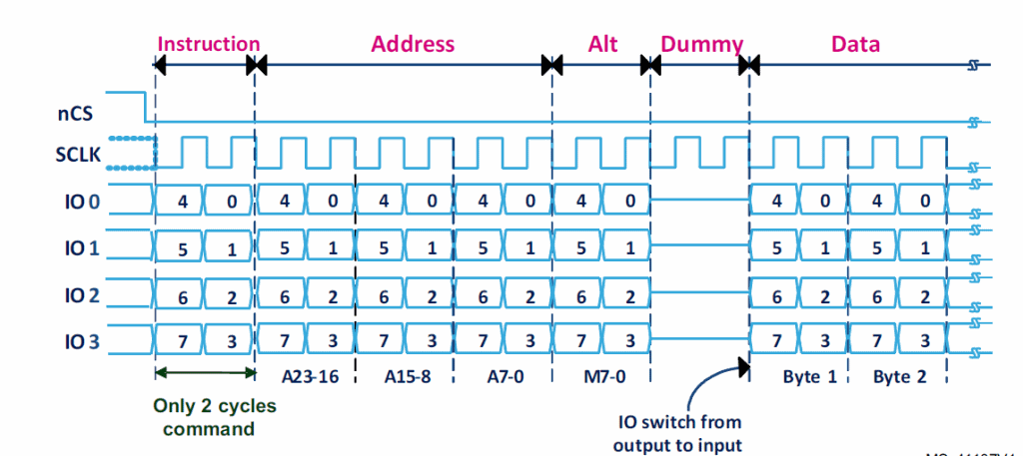
Figure 3: QSPI working. (courtesy STMicroelectronics).

The figure shows the typical stages of a QSPI exchange. First, the instruction is sent over the IO lines. Followed by the address and then comes the Alt field which can be implemented the way the manufacturer of the flash memory wants it to be. Then for a brief period, 2 clock cycles in the above figure, the transmission is paused to allow for changing the direction of the I/O line. Then the data is sent from the flash device to the microcontroller.
As seen in the figure, 4 bits are transferred every clock cycle. The bit order is IO0 sends bit0, IO1 sends bit1 and so on in the first clock cycle and bits 4, 5, 6, and 7 are sent out in the second clock cycle. Thus in just 2 clock cycles, the entire byte is transmitted.

Instruction phase
In this phase a command (8-bits instruction) is sent to the Flash memory, specifying the type of operation to be performed. This command is fully configurable allowing to send any value. The user can simply write the desired command to be sent in the INSTRUCTION field of the QUADSPI_CCR [7:0] register.

Register configurations |  | Indirect mode  Automatic-polling mode  Memory-mapped mode | Command Format
Instruction to be sent in QUADSPI_CCR [7:0] |  | INSTRUCTION [7: 0] | NA
Instruction phase QUADSPI_CCR [9:8] | No Instruction: skipped | IMODE [1:0] = 00 | The instruction phase is skipped
 | Instruction on 1 line: Single SPI mode | IMODE [1:0] = 01 | 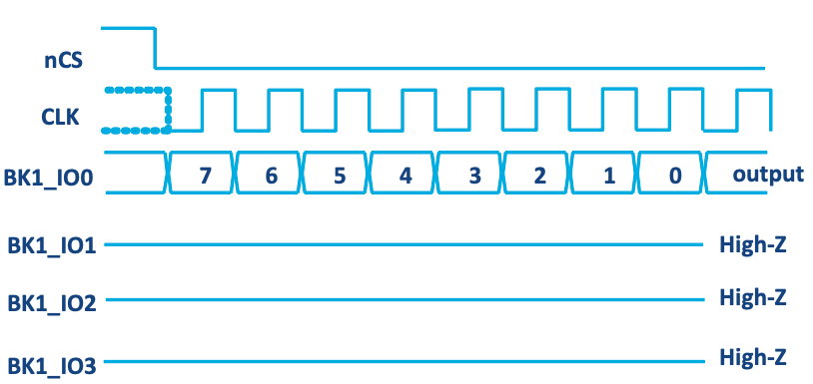
 | Instruction on 2 lines: Dual SPI mode | IMODE [1:0] = 10 | 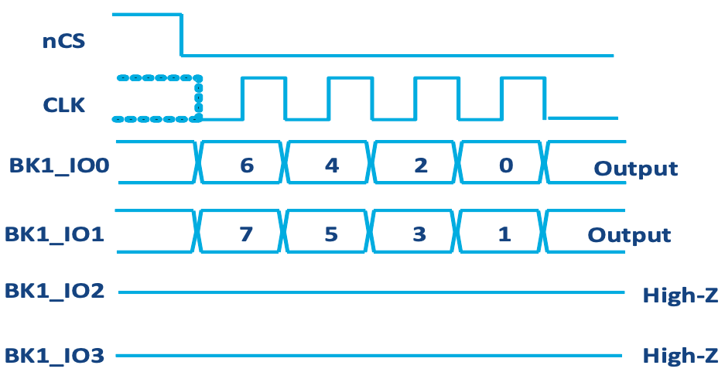
 | Instruction on 4 lines: Quad-SPI mode | MODE [1:0] = 11 | 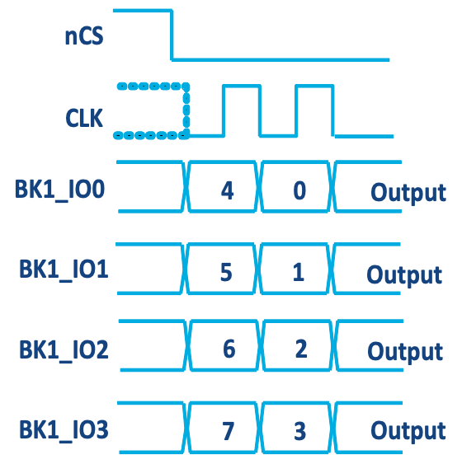
Table 2: Instruction phase configuration
Depending on the software and the hardware configurations, the instruction can be sent over one, two or four lines. In some use cases where only the address is sent, the instruction phase can be skipped. The table summarizes the different configurations for instruction phase.

Address phase
In this phase an address is sent to the Flash memory, specifying the address of the data to be read or written. The address phase is fully configurable allowing to send one, two, three or four bytes address. In Indirect mode and Automatic-polling mode, the user can simply write the desired address in the QUADSPI_AR register.
The table below summarizes different address phase configurations.
Register configurations |  | Indirect mode | Automatic-polling mode | Memory-mapped mode
Address to be sent QUADSPI_AR [31:0] |  | ADDRESS [31:0] |  | Address is given directly via the AHB from any master on the bus matrix like DMA
Address size QUADSPI_CCR [13:12] | 1-byte | ADSIZE [1:0] =00
 | 2-byte | ADSIZE [1:0] =01
 | 3-byte | ADSIZE [1:0] =10
 | 4-byte | ADSIZE [1:0] =11
Address phase QUADSPI_CCR [11:10] | No address: skipped | ADMODE [1:0] =00
 | Address on 1 line: Single SPI mode | ADMODE [1:0] =01
 | Address on 2 lines: Dual SPI mode | ADMODE [1:0] =10
 | Address on 4 lines: Quad SPI mode | ADMODE [1:0] =11
Table 3: Address phase configuration
Depending on the software and the hardware configurations, the address can be sent over one, two or four lines. In some use cases where the address is not needed such as in mass-erase operation, the address phase can be skipped

Alternate-bytes phase
This is an extra phase supported by the Quad-SPI interface offering more flexibility. It is generally used for controlling the mode of operation; for instance 1-byte can be sent continuously to keep the Quad-SPI device in an operating mode. This is supported for some memory manufacturers such as Spansion, Micron and Macronix where an alternate byte is sent continuously to keep the memory in execute-in-place mode.
The alternate-byte phase is fully configurable and permits to send one, two, three or four bytes depending on the ABRSIZE [1:0] file configuration. The user can simply write the desired alternate bytes in the QUADSPI_ABR register.
Depending on the software and the hardware configurations, the alternate byte can be sent over one, two or four lines. If not needed, the alternate-byte phase can be skipped.

Register configuration |  | Indirect mode | Automatic -polling mode | Memory-mapped mode
Alternate-byte to be sent QUADSPI_ABR |  | QUADSPI_ABR
Alternate-byte size QUADSPI_CCR [17:16] | 1-byte | ABSIZE [1:0] =00
 | 2-byte | ABSIZE [1:0] =01
 | 3-byte | ABSIZE [1:0] =10
 | 4-byte | ABSIZE [1:0] =11
Alternate-byte phase QUADSPI_CCR [15:14] | No alternate-byte: skipped | ABMODE [1:0] = 00
 | Alternate-byte on 1 line: single SPI mode | ABMODE [1:0] = 01
 | Alternate-byte on 2 lines: dual SPI mode | ABMODE [1:0] = 10
 | Alternate-byte on 4 lines: Quad SPI mode | ABMODE [1:0] = 11
The table summarizes different alternate-byte phase configurations.
Table 4: alternate-byte phase configurations

Alternate-byte phase: sending a nibble in Dual-SPI mode
In some cases only one nibble needs to be sent at alternate-byte phase during two clock cycles rather than a full byte during four clock cycles. For instance, when the Dual-SPI mode is used and only two cycles are used for the alternate-byte phase.
The Quad I/O mode can be activated only for alternate-byte phase in order to send an alternate byte where the nibble is sent over IO0 and IO1 while the other nibble have to be sent only to keep IO2 low and IO3 high during alternate-byte phase.

Dummy cycles phase
The dummy-cycle phase is needed in some cases when operating at high clock frequencies. This phase allows to ensure enough “turnaround” time for changing the data signals from output mode to input mode.
The dummy phase is enabled by setting the number of dummy cycles in the DCYC[4:0] field QUADSPI_CCR register. The number defined in DCYC[4:0] filed can reach 31 cycles and it does not depend on the used hardware configuration.

During this phase, if the QUADSPI hardware configuration is used and if communication phases are either in Quad-SPI or Dual-SPI modes, IO2 is forced to ‘0’ to disable the “write protect” function while IO3 is forced to ‘1’ to disable the “hold” function of the Quad-SPI memory. This is fully managed by hardware (QUADSPI peripheral) so nothing needs to be configured by the user.
During this phase, if the QUADSPI hardware configuration is used and if communication phases are either in Quad-SPI or Dual-SPI modes, IO2 is forced to ‘0’ to disable the “write protect” function while IO3 is forced to ‘1’ to disable the “hold” function of the Quad-SPI memory. This is fully managed by hardware (QUADSPI peripheral) so nothing needs to be configured by the user. The operating mode of the dummy-cycles phase is determined by DMODE.

Data phase
In this phase, the data is sent or received from or to the Quad-SPI memory. The data phase is fully configurable and permits to send, receive or both any number of bytes to or from the Quad-SPI memory device.
Register configuration |  | Indirect mode | Automatic-polling mode | Memory-mapped mode
Data | Read data | QUADSPI_DR |  | Data read is sent back directly over the AHB to any master on the bus matrix requesting for reading operation (Cortex®, DMA LTDC, DMA2D).
 | Write data | QUADSPI_DR |  | Not supported
Number of data to be sent/received | QUADSPI_DLR | 1-byte 0x00000000  to undefined ⁽¹⁾  0xFFFFFFFF | 1-byte 0x00000000  to  4-bytes 0x00000003 | QUADSPI_DLR has no meaning in this mode.  If DMA is used, number of data to be read is set only in DMA's DMA_SxNDTR register.
Data phase QUADSPI_CCR [15:14] | No Data: skipped | DMODE[1:0] = 00(2)
 | Data on 1 line: Single SPI mode | DMODE[1:0] = 01
 | Data on 2 lines: Dual SPI mode | DMODE[1:0] = 10
 | Data on 4 lines: Quad SPI mode | DMODE[1:0] = 11
Table 5: Data phase configuration versus Quad-SPI functional modes
In Indirect mode and in Automatic-polling mode, the number of bytes to be sent, received or both is specified in the QUADSPI_DLR register.
In Indirect-write mode the data to be sent to the Flash memory must be written to the QUADSPI_DR register, while in Indirect-read mode the data received from the Flash memory is obtained by reading from the QUADSPI_DR register.
In Memory-mapped mode, the data can only be read from the memory device but not written, then the data is accessed directly from the QUADSPI FIFO. All masters on the bus matrix can read data from the Quad-SPI memory device as if it was an internal memory.
Depending on the software and the hardware configurations, the data transfer can be done in one, two or four lines. In some use cases where data is not needed such as erasing operation, the data phase can be skipped.
The following table summarizes the data phase configuration in different functional modes.

QSPI signal interface protocol modes

Single SPI mode
This is the classic SPI where only four GPIOs are used and the data is sent on SO line and received on SI line.
In each phase which is configured in single mode:
- IO0 (SO) is in output mode
- IO1 (SI) is in input mode (high impedance)
- IO2 is in output mode and forced to ‘0’ to deactivate the “write protect” function
- IO3 is in output mode and forced to ‘1’ to deactivate the “hold” function
This is the case even for the dummy phase if DMODE = 01.
This is managed by the hardware (QUADSPI peripheral) during all communication phases. When not used, the nWP and nHOLD memory device pins have to be connected respectively to VDD and VSS while IO2 and IO3 pins could be used for other purposes.
In this mode, all phases as instruction, address, alternate-byte and data have to be configured in single-SPI mode by setting the IMODE/ADMODE/ABMODE/DMODE fields in QUADSPI_CCR to 01.

C
Figure 4: Hardware configuration: Single-SPI mode
CLK FLASH
Q0/SI
Q1/SI
Q2/nWP
Q3/nHOLD
nCS
CLK
BK1_IO0/SO
QUADSPI BK1_IO1/SI
BK1_IO2
BK1_IO3
BK1_ncs

BK1_IO0/SO

SI

Dual SPI mode BK1_nCS
In Dual-SPI mode the hardware configuration is similar to the one in single mode, but here two lines are used for data, it means that data is sent and received in two lines. As for Single-SPI mode, the IO2 and IO3 lines are optional, if not used the nWP and nHOLD device pins have to be connected respectively to VDD and VSS.
In this mode all the instruction, address, alternate-byte and data phases have to be configured in Dual-SPI mode by setting the IMODE/ADMODE/ABMODE/DMODE fields in QUADSPI_CCR to 10.
In each phase which is configured in dual mode:
- IO0/IO1 are at high impedance during the data phase for read operations, and outputs in all other cases.
- IO2 is in output mode and forced to ‘0’
- IO3 is in output mode and forced to ‘1’
In the dummy phase when DMODE = 01, IO0/IO1 are always high-impedance.

BK1_IO0/SO

Figure 5: Hardware configuration: dual-SPI mode
CLK FLASH
Q0/SI
Q1/SI
Q2/nWP
Q3/nHOLD
nCS
CLK
BK1_IO0/SO
QUADSPI BK1_IO1/SI
BK1_IO2
BK1_IO3
BK1_ncs

Quad SPI mode
In the Quad-SPI mode six pins are used: four pins for data and two pins for clock and chip select. In this hardware configuration it is possible to use either Single or Dual-SPI mode. In Quad-SPI mode the data is transferred, received or both over four lines.
In Quad-SPI mode, depending on the Quad-SPI memory brand, the user can choose to send each phase in single, dual or quad mode. Many memory manufacturers are supporting the following configurations where Command-Address-Data: 1-1-4; 1-4-4; 4-4-4.
In general, if the address is sent in four lines then the alternate-byte should be sent in four lines too. The different phases can each be configured separately to use quad SPI mode by setting the IMODE/ADMODE/ABMODE/DMODE fields of QUADSPI_CCR register to 11.
In each phase which is configured in quad mode, IO0/IO1/IO2/IO3 are all are at highimpedance (input) during the data phase for read operations, and outputs in all other cases.
In the dummy phase when DMODE = 11, IO0/IO1/IO2/IO3 are all high-impedance.
IO2 and IO3 are used only in Quad SPI mode. If none of the phases are configured to use Quad SPI mode, then the pins corresponding to IO2 and IO3 can be used for other functions even while QUADSPI is active.

Figure 6: Hardware configuration: Quad-SPI mode
CLK FLASH
Q0/SI
Q1/SI
Q2/nWP
Q3/nHOLD
nCS
CLK
BK1_IO0/SO
QUADSPI BK1_IO1/SI
BK1_IO2
BK1_IO3
BK1_ncs

SDR mode
By default, the DDRM bit (QUADSPI_CCR[31]) is 0 and the QUADSPI operates in single data rate (SDR) mode. In SDR mode, when the QUADSPI is driving the IO0/SO, IO1, IO2, IO3 signals, these signals transition only with the falling edge of CLK.
When receiving data in SDR mode, the QUADSPI assumes that the Flash memories also send the data using CLK’s falling edge. By default (when SSHIFT = 0), data sent on CLK falling edge and sampled on CLK rising edge.

DDR mode
When the DDRM bit (QUADSPI_CCR[31]) is set to 1, the QUADSPI operates in double data rate (DDR) mode.
In DDR mode, when the QUADSPI is driving the IO0/SO, IO1, IO2, IO3 signals in the address/alternate-byte/data phases, a bit is sent on each of the falling and rising edges of CLK.
The instruction phase is not affected by DDRM. The instruction is always sent using CLK’s falling edge.
When receiving data in DDR mode, the QUADSPI assumes that the Flash memories also send the data using both rising and falling CLK edges. When DDRM = 1, firmware must clear SSHIFT bit (bit 4 of QUADSPI_CR). Thus, the signals are sampled one half of a CLK cycle later (on the following, opposite edge).
When using DDR (dual data rate), also known as DTR (dual transfer rate) the user should consider the following:
- The communication start triggering and the configuration procedure are the same as in SDR.
- The command is sent every clock cycle like in SDR mode.
- The alternate, data and address phases are sent on both edges of the clock.
- The dummy cycles are counted every clock cycle like in SDR mode.

Dual Flash Memory mode
In Dual-Flash memory mode, the MCU communicates with two external memory devices at the same time. This mode is useful to double throughput and to double size while using only 10 GPIOs: eight for data, one chip select for both devices and one for CLK. A throughput of two bytes per cycle can be attained with dual-Flash memory in DDR Quad-SPI mode.
In this mode, only one chip-select could be used for both devices and then save one GPIO for other usages and either nCS_BK1 or nCS_BK2 can be connected to both devices. The clock has to be connected to both devices.
Different hardware configurations are allowed, offering a high flexibility to the user. Table illustrates all possible hardware configurations.
The Dual-memory mode allows doubling the throughput, as one byte can be sent or received at every cycle. This mode is very interesting when more performance is needed; not only throughput is doubled in Dual-Flash memory mode, but also the external memory size is doubled.
When using two external Quad-SPI memories the size to be configured in FSIZE[4:0] should reflect the total Flash memory capacity, which is double the size of one individual component.
To support dual die packages with two chip-selects and dual Quad-SPI devices, the FIFO size is always 32-bytes either in single Flash or Dual-Flash memory mode.
The following figure shows an example of a read sequence in Dual-Flash memory Quad I/O SDR mode.
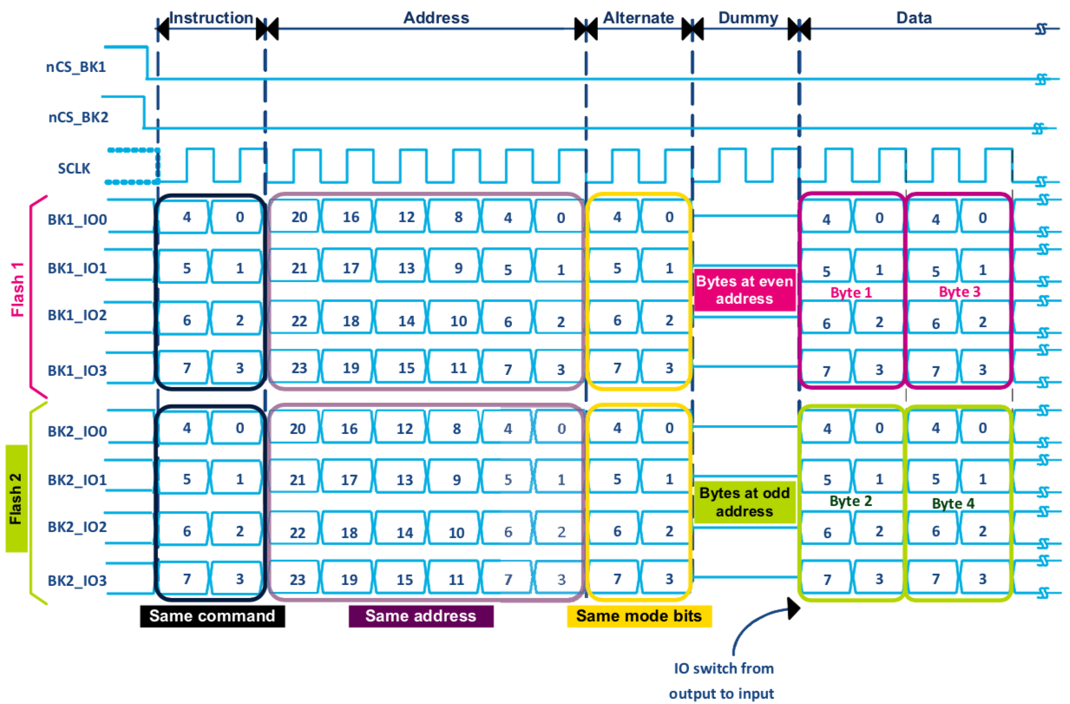
Figure 7: Read sequence in dual-Flash memory Quad I/O SDR mode

All the bytes at even addresses are stored in Flash 1 while all bytes at odd addresses are stored in Flash 2. As described in Figure 12, in dual-Flash mode the same command, address and alternate are sent to both Flash 1 and Flash 2. For example to read the first four bytes in dual-Flash memory-mapped mode from 0x90000 000 to 0x9000 0003 the following sequence is done by QUADSPI peripheral:
- The address 0x0000 0000 is sent to both Flashes and Byte 1 (at even address 0x9000 0000) is read from Flash 1 while Byte 2 (at odd address 0x9000 0001) is read from Flash 2.

- Then the address 0x0000 0001 is sent to both Flashes and Byte 3 (at even address 0x9000 0002) is read from Flash 1 while Byte 2 (at odd address 0x9000 0003) is read from Flash 2.

Used nCS | nCS configuration | Flash mode
2 nCS enabled | Both nCS_BK1 and nCS_BK2 not connected together | Single Flash DFM = 0(1) | FSEL = 0  Flash 1 enabled
FSEL = 1
Flash 2 enabled
Dual-Flash memory
DFM = 1
Table 6: Dual-Flash memory hardware configurations
Cautions:
- In Dual-Flash memory mode both device models must be identical, because in this mode the same commands and addresses are issued in parallel to both Flash memories; this permits to double the available Quad-SPI external Flash size. In the case that the two Flash-memory devices are different, the Dual-Flash mode must be disabled (DFM = 0) and each Flash memory could be used in standalone, allowing either Flash 1 or Flash 2 to be enabled using QUADSPI_CR[7] FSEL bit.
- For all hardware configurations listed in the table below, each memory device is configured in Quad-SPI mode. It is possible to connect each device in Single or Dual- SPI mode. If DFM = 1, both devices must be configured in the same way. This permits to double the available external data size and throughput.
- The Flash memory size, as specified in FSIZE[4:0] (QUADSPI_DCR[20:16]) should reflect the total Flash memory capacity, which is the double of the size of one individual component.

Figure 8: Dual-Flash memory hardware configurations
CLK FLASH 2
Q0/SI
Q1/SI
Q2/nWP
Q3/nHOLD
nCS
CLK FLASH 1
Q0/SI
Q1/SI
Q2/nWP
Q3/nHOLD
nCS
CLK
BK1_IO0/SO
BK1_IO1/SI
BK1_IO2
BK1_IO3
BK1_ncs

BK2_IO0/SO
BK2_IO1/SI
BK2_IO2
BK2_IO3
BK2_ncs

QUADSPI Operating Modes

QUADSPI Indirect Mode
The Indirect mode is used in below cases:
- For reading, writing or erasing operations
- If there is no need for AHB masters to access autonomously the Quad-SPI memory (available in Memory-mapped mode)
- For all the operations to be performed through the QUADSPI data registers using CPU or using DMA
- To configure the Quad-SPI Flash memory.
In Indirect mode, all operations are performed through the QUADSPI register where both read and write operations are available and managed by software. The Quad-SPI interface behaves like a classical SPI interface. The transferred data goes through the data register with FIFO. The data exchanges are driven by software or by DMA, using related interrupt flags in the QUADSPI status registers. The read and write operations are always performed in burst unless the amount of data is equal to one. The amount of data to be transferred is set in the QUADSPI_DLR register. In this mode it is possible to read or write data from or to external Flash memory with sizes up to 4 Gbytes. The Automatic-polling mode is available to generate an interrupt when the status-register inside the Flash memory is changing (useful for checking the end of the erase or the end of programming). In case of an erase or programming operation, the Indirect mode has to be used and all the operations have to be handled by software. In this case, it is recommended to use the Status-polling mode and then poll the status register inside the Flash memory to know when the programming or the erase operation is completed.
Triggering the start of a command
Essentially, a command starts as soon as firmware gives the last information that is necessary for this command. Depending on the QUADSPI configuration, there are three different ways to trigger the start of a command in indirect mode. The commands starts immediately after:
- Write is performed to INSTRUCTION[7:0] (QUADSPI_CCR), if no address is necessary (when ADMODE = 00) and if no data needs to be provided by the firmware (when FMODE = 01 or DMODE = 00)
- Write is performed to ADDRESS[31:0] (QUADSPI_AR), if an address is necessary (when ADMODE != 00) and if no data needs to be provided by the firmware (when FMODE = 01 or DMODE = 00)
- Write is performed to DATA[31:0] (QUADSPI_DR), if an address is necessary (when ADMODE != 00) and if data needs to be provided by the firmware (when FMODE = 00 and DMODE != 00)
Writes to the alternate byte register (QUADSPI_ABR) never trigger the communication start. If alternate bytes are required, they must be programmed before.
As soon as a command is started, the BUSY bit (bit 5 of QUADSPI_SR) is automatically set.
FIFO and data management
In indirect mode, data go through a 16-byte FIFO which is internal to the QUADSPI. FLEVEL[4:0] (QUADSPI_SR[12:8]) indicates how many bytes are currently being held in the FIFO.
In indirect write mode (FMODE = 00), firmware adds data to the FIFO when it writes QUADSPI_DR. Word writes add 4 bytes to the FIFO, halfword writes add 2 bytes, and byte writes add only 1 byte. If firmware adds too many bytes to the FIFO (more than is indicated by DL[31:0]), the extra bytes are flushed from the FIFO at the end of the write operation (when TCF is set).
Byte/halfword accesses to QUADSPI_DR must be done only to the least significant byte/halfword of the 32-bit register.
FTHRES[3:0] is used to define a FIFO threshold. When the threshold is reached, the FTF (FIFO threshold flag) is set. In indirect read mode, FTF is set when the number of valid bytes to be read from the FIFO is above the threshold. FTF is also set if there are data in the FIFO after the last byte is read from the Flash memory, regardless of the FTHRES setting. In indirect write mode, FTF is set when the number of empty bytes in the FIFO is above the threshold.
If FTIE = 1, there is an interrupt when FTF is set. If DMAEN = 1, a DMA transfer is initiated when FTF is set. FTF is cleared by HW as soon as the threshold condition is no longer true (after enough data has been transferred by the CPU or DMA).
In indirect read mode when the FIFO becomes full, the QUADSPI temporarily stops reading bytes from the Flash memory to avoid an overrun. Please note that the reading of the Flash memory does not restart until 4 bytes become vacant in the FIFO (when FLEVEL ≤ 11). Thus, when FTHRES ≥ 13, the application must take care to read enough bytes to assure that the QUADSPI starts retrieving data from the Flash memory again. Otherwise, the FTF flag stays at '0' as long as 11 < FLEVEL < FTHRES.

QUADSPI Status-flag polling mode
The Status-flag polling mode is used in below cases:
- To read Quad-SPI Flash memory status register
- To poll autonomously for the end of an operation: QUADSPI polls the status register inside the memory.
The interface can automatically poll a specified register inside the memory and relieve the CPU from this task (useful when polling end of programming flag for example). This is a mode to check for example when an erase operation is completed and to know that an interrupt could be generated. The Quad-SPI interface can also be configured to periodically read at a defined rate a register in the Quad-SPI Flash memory. The returned data can be masked to select the bits to be evaluated. The selected bits are compared bit per bit with their required values stored in the match register. The result comparison can be treated in two ways:
- AND’ed mode: if all the selected bits are matching, an interrupt is generated when it succeeds (stop on match flag).
- OR’ed mode: if one of the selected bits is matching, an interrupt is generated when it succeeds (stop on match flag) When a match occurs, the Quad-SPI interface can stop automatically. The READ STATUS REGISTER command is used by many memory manufacturers as Micron or Spansion to read continuously the status register.

QUADSPI Memory-mapped mode
The Memory-mapped mode is used in below cases:
- For reading operations
- To use external Quad-SPI Flash memory like an internal memory, so any AHB master can read data autonomously.
- For code execution from external Quad-SPI Flash memory.
In Memory-mapped mode the external memory is seen by the system as it was an internal memory. This mode allows all AHB masters to access the Quad-SPI memory as an internal memory. The CPU can execute code from the Quad-SPI memory as well. When Memory-mapped mode is used, a prefetching mechanism fully managed by the hardware permits the optimization of the read and the execution performances from the external Quad-SPI memory. Given that all the communication phases such as sending opcode or address are managed by the QUADSPI peripheral, a 32-bytes FIFO (16-bytes for STM32L4 Series) is used for prefetching; this optimized prefetch mechanism avoids software overhead. The programmed instructions and frame are sent automatically when an AHB master is accessing the memory-mapped space. Once the QUADSPI peripheral is configured, the Quad-SPI memory is accessed as soon as there is a read request on the AHB; this is done in the Quad-SPI memory mapped address range. This action is totally transparent for the user. An LTDC master for example can access autonomously to the external Flash memory where all the access operations are fully managed by the Quad-SPI interface. Meanwhile, the Cortex®-M CPU is executing code from the internal Flash memory. The Quad-SPI interface is able to manage up to 256 Mbytes memory starting from 0x9000 0000 to 0x9FFF FFFF in the Memory-mapped mode.
Execute in place (XIP)
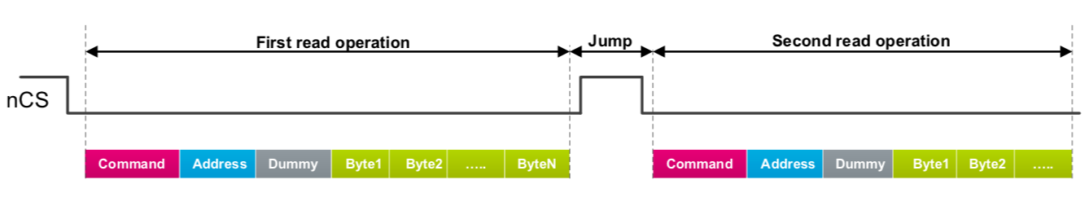
The prefetch buffer supports execution in place, therefore the code can be executed directly from the external Quad-SPI memory. The QUADSPI anticipates the next CPU access and loads in advance the byte at the following address. If the subsequent access is indeed made at a continuous address, the access is completed faster since the value is already prefetched.
Figure 9: Executing non-sequential code from Quad-SPI
Booting from Quad-SPI Flash memory
Boot from the Quad-SPI memory is not supported but the user can boot from the internal Flash memory and then configure the QUADSPI in Memory-mapped mode and then the execution starts from the Quad-SPI memory. For more details on how to execute from the external Quad-SPI memory. Reading the QUADSPI_DR in Memory-mapped mode has no meaning and returns 0.
Quad-SPI memory is accessible by Cortex®-M through system bus. QUADSPI is also accessible through the I-Code and the D-Code buses when a physical remap is enabled at address 0, which allows better execution performances.
When the QUADSPI is remapped at address 0x0000 0000, only 128 Mbytes are remapped. Even when aliased in the boot memory space, the Quad-SPI memory is still accessible at its original memory space.

QUADSPI Special features

Send instruction only-once (SIOO)/Burst mode
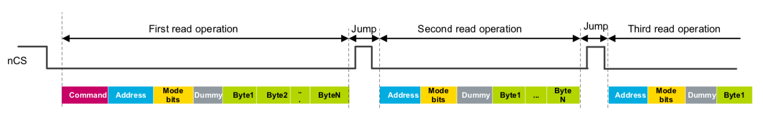
The SIOO feature is named as “continuous read mode”, “burst mode” or even as “performance enhanced mode”. This feature is available for all Quad-SPI modes: Indirect, Automatic-polling and Memory-mapped. It is recommended to use this feature in order to reduce command overhead and to boost the execution performances. When SIOO is enabled, the command is sent only once when starting the reading operation, then only the address is sent. The command is sent only at first when starting the read operation. If a new read operation occurs, only one address is sent; this action permits the reduction of up to eight cycles (in Single I/O mode) for the command. This is a very interesting feature to reduce access overhead to the Quad-SPI memory. Data are prefetched continuously while the FIFO is not full, when a discontinuous access is detected, the QUADSPI rises chip-select and starts a new read operation without sending the command but sending directly the new address.
Figure 10: Executing non-sequential code from QUADSPI with SIOO enabled

The SIOO feature is supported by many Quad-SPI memory manufacturers such as Micron, Spansion and Macronix, nevertheless before using it, the user has to check if the feature is supported by the used memory. To enable the SIOO mode, the user should:
- Configure the memory by entering the SIOO mode. Refer to relevant manufacturer’s datasheet for more details on how to enter this mode (make sure that the read command to be used does support this mode). Note that an alternate byte (mode Bits) needs to be sent in order to keep the device in this mode.
- Configure the QUADSPI peripheral by setting the SIOO bit in QUADSPI_CCR register.

Delayed data sampling
For read operations from the external memories, the delayed data sampling is useful when the signals are delayed due to constraints on the PCB layout optimizations; hence the optimization compensates this delay. The sampling clock can be shifted by an additional half cycle after data is driven by the Flash memory, this is done to guarantee that the data is ready at the sampling moment. This feature is not supported in DDR mode. To enable sampling shift, set the SSHIFT bit in QUADSPI_CR register. For write operations from the external memories in DDR mode, the output data can be shifted by one quarter of the QUADSPI output clock cycle in order to relax the hold constraints. To enable this output data delay, set the DHHC bit in QUADSPI_CR register.

Timeout Counter
The timeout counter can be used to reduce the Quad-SPI memory power-consumption by releasing the nCS and then putting the memory in a lower consumption state.
After each access in Memory-mapped mode, the QUADSPI prefetches the subsequent bytes and holds these bytes in the FIFO. When the FIFO is full, the communication clock is stopped but the nCS pin remains low to keep the Flash memory selected and not resend a complete command to read the next bytes when location is available in the FIFO.
To avoid any extra power-consumption in the external Flash memory, when the clock is stopped for a long time, the timeout counter can release the nCS pin; this action puts the external Flash memory in a lower-consumption state after a period of timeout elapsed without any access. Once FIFO becomes empty, the nCS is low and permits read operations.
To use the timeout counter the user should:
- Enable it by setting the TCEN bit in the QUADSPI_CR register.
- Program the timeout period TIMEOUT[15:0] in the QUADSPI_LPTR register.

Additional Status bits
QUADSPI_SR status register includes additional status bits, the table below summarizes the status flags.

Name | Size | Description
FLEVEL | 5 bits  (4 bits for STM32L4 Series) | Number of valid bytes being held in the FIFO (for indirect mode)
BUSY | 1 bit | This bit is set when an operation is ongoing. Clears automatically when operations are finished and FIFO is empty.
Table 7: Additional status bits

Busy bit and abort functionality
BUSY bit
The BUSY bit is used to indicate the state of the Quad-SPI interface, it is set in the QUADSPI_SR register when an operation is ongoing and it clears automatically when the operations are finished or aborted.
The following table summarizes different cases when the BUSY bit is reset in different QUADSPI operating modes:

Quad-SPI mode | BUSY bit reset
Indirect mode | – The QUADSPI has completed the requested command sequence and the FIFO is empty  – Due to an abort
Automatic-polling mode | – After the last periodic access is complete, due to a match whenAPMS =1 – Due to an abort
Memory-mapped mode | – On a timeout event – Due to an abort  – QUADSPI peripheral is disabled
Table 8: BUSY bit reset in different Quad-SPI modes

ABORT bit
When an application is running, any ongoing QUADSPI operation can be aborted by setting the ABORT bit in the QUADSPI_CR register. Once the abort is completed, the BUSY bit and the ABORT bit are automatically reset and the FIFO is flushed. If an abort occurs on an ongoing AXI/AHB burst operation, the QUADSPI allows the ongoing burst to complete properly before reseting the BUSY bit and the ABORT bit.

4-byte address mode / Extended address mode
This mode is named also by some brands “extended address mode”. In this mode a 4-byte address is sent; this action permits to address the Flash memories with sizes up to four Gbytes.
Before using the 4-byte mode, the user has to check if it is supported by the used device. To enable this mode, the user should:
- Configure the memory by entering the 4-byte mode.
- For Micron devices for example, the ENTER 4-BYTE ADDRESS MODE “B7h” command should be used, then the user should use dedicated 4-byte address commands for some operations, such as read, program or erase, from the device datasheet.
- For Micron devices, if a read operation is needed, the user should use 4-BYTE READ command “13h” instead of READ “03”
- Configure the QUADSPI peripheral in 32-bits address mode by setting ADSIZE[1:0] = 11 field in QUADSPI_CCR register.
Address length | QUADSPI_CCR ADSIZE [1:0] | QUADSPI_DCR [20:16] FSIZE [4:0] | Memory size 2[FSIZE+1]
8-Bits address | 00 | 00111 | Up to 256 bytes
16-Bits address | 01 | 01111 | Up to 64 Kbytes
24-Bits address | 10 | 10111 | Up to 16 Mbytes
32-Bits address | 11 | 11111 | Up to 4 Gbytes(1)
Table 9: Address mode versus maximum addressable memory space
Cautions
- In Indirect mode, if the address plus the data length exceeds the Flash memory size, TEF flag is set as soon as the access is triggered.
- In Memory-mapped mode, if an access is made to an address outside of the range defined by FSIZE but still within the 256 Mbytes range, then an AHB error is given. The effect of this error depends on the AHB master that attempted the access; if it is the Cortex® CPU, a hard fault interrupt is generated and if it is a DMA, a DMA transfer error is generated while the corresponding DMA channel is automatically disabled.

QUADSPI Interrupts
QUADSPI peripheral supports five different interrupts where each one is useful in a particular case. To be used, each interrupt has to be enabled by setting its corresponding enable bit and enabling the QUADSPI global interrupt on the NVIC side.
The table below summarizes all the supported interrupts.
Interrupt | Event Flag(1) | Enable  control bit(2) | Clear bits(3) | Description
Timeout | TOF | TOIE | CTOF | Timeout occurred
Status match | SMF | SMIE | CSMF | Matching of the masked received data with the match register (automatic-polling mode only)
FIFO threshold | FTF | FTIE | - | FIFO threshold reached (indirect mode)
Transfer complete | TCF | TCIE | CTCF | Indirect mode: the correct number of data set in the QUADSPI_DLR register has been transferred  All modes: the transfer has been aborted
Transfer error | TEF | TEIE | CTEF | Indirect mode: out-of-range address has been accessed
Table 10: QUADSPI interrupts summary

DMA Usage
DMA can be used to perform data transfers from or to the Quad-SPI external memory, this is possible when the Quad-SPI interface is configured either in Indirect read/write mode or in Memory-mapped mode. In Memory-mapped mode only-read from Quad-SPI memory is allowed.
DMA usage with QUADSPI in Indirect mode
In DMA mode, the DMA is the flow controller. When QUADSPI FIFO threshold is reached while DMAEN bit is set, DMA requests are generated from QUADSPI to the DMA.
The transfer is started when:
- The DMAEN bit is set and the QUADSPI and DMA are configured.
- The FTF flag is set when FIFO threshold is attained If DMAEN = 1 already, then the DMA controller must be disabled before changing the FTHRES/FMODE.
In indirect mode when configuring the DMA for data transfer from/to the QUADSPI, the QUADSPI should be considered as a peripheral:
- Memory to peripheral mode in case of writing data to the QUADSPI from the internal memory.
- Peripheral to memory mode in case of reading data from the QUADSPI to be transfered into the internal memory.Also the address of the QUADSPI should be written into the peripheral address register (DMA channel/stream x peripheral address). The table below summarizes the different DMA requests and transfer directions versus the STM32 series.
Product (1) | DMA1 | DMA2 | MDMA
STM32L4 Series | Request 5 Channel 5 | Request 3 Channel 7 | NA
STM32F4 Series | NA | Stream 7 Channel 3 | NA
STM32F7 Series | NA | Stream 7 Channel 3 | NA
STM32H7 Series | NA | NA | quadspi_ft_trg channel X[0..15]/Stream22
 | NA | NA | quadspi_tc_trg channel X[0..15]/Stream23
Table 11: DMA requests mapping and transfer directions versus STM32 series
DMA usage with QUADSPI in Memory-mapped mode
In Memory-mapped mode the QUADSPI allows the access to the external memory for read operation through the memory mapped address region (from 0x9000 0000 to 0x9FFF FFFF) and allows the external memory to be seen just like an internal memory.
In that case when configuring the DMA to transfer data from the QUADSPI memory-mapped region into an other internal memory, the QUADSPI memory-mapped region should be considered as a memory when configuring the DMA registers: Memory to memory mode in case of reading data from the QUADSPI memory mapped region to be transfered into the internal memory. Also the address of the QUADSPI should be written into the peripheral address register (DMA channel/stream x memory address).
In Memory-mapped mode the DMA is the flow controller since the QUADSPI does not generate DMA requests. In Memory-mapped mode either DMA1 or DMA2 can be used to transfer data from the external Quad-SPI memory to any other memory or peripheral. To perform a transfer using DMA from external Quad-SPI memory to any other memory or a peripheral, the user should configure the DMA by setting the source address (from 0x9000 0000), the destination address and the number of data to be transferred.
The DMAEN bit has no effect in Memory-mapped mode, the transfer is started as soon as the DMA is accessing the QUADSPI address range (from 0x9000 0000 to 0x9FFF FFFF). Once the DMA configured transfer is started by software, the DMA reads the data from the Quad-SPI memory exactly as an internal memory. The QUADSPI peripheral manages the communication with the external memory and puts the read data in the FIFO.
The number of data items to be transferred is managed by the DMA so the user should configure the number of data in the DMA’s register DMA_SxNDTR (or DMA_CNDTRx register for STM32L4x6xx). There is no need to configure the QUADSPI_DLR register as it has no effect in the Memory-mapped mode where the DMA is the flow controller.

QUADSPI Registers

QUADSPI control register (QUADSPI_CR)
Address offset: 0x0000
Reset value: 0x0000 0000
31 | 30 | 29 28 27 26 |  |  |  | 25 | 24 | 23 | 22 | 21 | 20 | 19 | 18 | 17 | 16
 |  | PRESCALER |  |  |  |  |  | PMM | APMS | Res. | TOIE | SMIE | FTIE | TCIE | TEIE
rw | rw | rw | rw | rw | rw | rw | rw | rw | rw |  | rw | rw | rw | rw | rw
15 | 14 | 13 12 11 10 |  |  |  | 9 | 8 | 7 | 6 | 5 | 4 | 3 | 2 | 1 | 0
Res. | Res. | Res. | Res. | FTHRES |  |  |  | FSEL | DFM | Res. | SSHIFT | TCEN | DMAEN | ABORT | EN
 |  |  |  | rw | rw | rw | rw | rw | rw |  | rw | rw | rw | rw | w1s
Bits [31:24] PRESCALER[7:0]: Clock prescaler
This field defines the scaler factor for generating CLK based on the AHB clock (value+1).
- 0: FCLK = FAHB, AHB clock used directly as QUADSPI CLK (prescaler bypassed)
- 1: FCLK = FAHB/2
- 2: FCLK = FAHB/3
- ….
- 255: FCLK = FAHB/256
For odd clock division factors, CLK’s duty cycle is not 50%. The clock signal remains low one cycle longer than it stays high. This field can be modified only when BUSY = 0.
Bit 23 PMM: Polling match mode
This bit indicates which method should be used for determining a “match” during automatic polling mode.
- 0: AND match mode. SMF is set if all the unmasked bits received from the Flash memory match the corresponding bits in the match register.
- 1: OR match mode. SMF is set if any one of the unmasked bits received from the Flash memory matches its corresponding bit in the match register. This bit can be modified only when BUSY = 0.
Bit 22 APMS:Automatic poll mode stop
This bit determines if automatic polling is stopped after a match.
- 0: Automatic polling mode is stopped only by abort or by disabling the QUADSPI.
- 1: Automatic polling mode stops as soon as there is a match. This bit can be modified only when BUSY = 0.
Bit 21 Reserved, must be kept at reset value.
Bit 20 TOIE: Time Out Interrupt Enable
This bit enables the TimeOut interrupt.
- 0: Interrupt disable
- 1: Interrupt enabled
Bit1 9 SMIE: Status match interrupt enable
This bit enables the status match interrupt.
- 0: Interrupt disable
- 1: Interrupt enabled
Bit 18 FTIE: FIFO threshold interrupt enable
This bit enables the FIFO threshold interrupt.
- 0: Interrupt disabled
- 1: Interrupt enabled
Bit 17 TCIE: Transfer complete interrupt enable
This bit enables the transfer complete interrupt.
- 0: Interrupt disabled
- 1: Interrupt enabled
Bit 16 TEIE:Transfer error interrupt enable
This bit enables the transfer error interrupt.
- 0: Interrupt disable
- 1: Interrupt enabled
Bits [15:12] Reserved, must be kept at reset value.
Bits [11:8] FTHRES[3:0] FIFO threshold level
Defines, in indirect mode, the threshold number of bytes in the FIFO that will cause the FIFO threshold flag (FTF, QUADSPI_SR[2]) to be set.
In indirect write mode (FMODE = 00):
- 0: FTF is set if there are 1 or more free bytes available to be written to in the FIFO
- 1: FTF is set if there are 2 or more free bytes available to be written to in the FIFO
- …
- 15: FTF is set if there are 16 free bytes available to be written to in the FIFO
In indirect read mode (FMODE = 01):
- 0: FTF is set if there are 1 or more valid bytes that can be read from the FIFO
- 1: FTF is set if there are 2 or more valid bytes that can be read from the FIFO
- …
- 15: FTF is set if there are 16 valid bytes that can be read from the FIFO
If DMAEN = 1, then the DMA controller for the corresponding channel must be disabled before changing the FTHRES value.
Bit 7 FSEL: Flash memory selection
This bit selects the Flash memory to be addressed in single flash mode (when DFM = 0).
- 0: FLASH 1 selected
- 1: FLASH 2 selected
This bit can be modified only when BUSY = 0.
This bit is ignored when DFM = 1.
Bit 6 DFM: Dual-flash mode
This bit activates dual-flash mode, where two external Flash memories are used simultaneously to double throughput and capacity.
- 0: Dual-flash mode disabled
- 1: Dual-flash mode enabled
This bit can be modified only when BUSY = 0.
Bit 5 Reserved, must be kept at reset value.
Bit 4 SSHIFT: Sample shift
By default, the QUADSPI samples data 1/2 of a CLK cycle after the data is driven by the Flash memory. This bit allows the data is to be sampled later in order to account for external signal delays.
- 0: No shift
- 1: 1/2 cycle shift
Firmware must assure that SSHIFT = 0 when in DDR mode (when DDRM = 1). This field can be modified only when BUSY = 0.
Bit 3 TCEN: Time out counter enable
This bit is valid only when memory-mapped mode (FMODE = 11) is selected. Activating this bit causes the chip select (nCS) to be released (and thus reduces consumption) if there has not been an access after a certain amount of time, where this time is defined by TIMEOUT[15:0] (QUADSPI_LPTR).
Enable the timeout counter.
By default, the QUADSPI never stops its prefetch operation, keeping the previous read operation active with nCS maintained low, even if no access to the Flash memory occurs for a long time. Since Flash memories tend to consume more when nCS is held low, the application might want to activate the timeout counter (TCEN = 1, bit 3 of QUADSPI_CR) so that nCS is released after a period of TIMEOUT[15:0]. (QUADSPI_LPTR) cycles have elapsed without an access since when the FIFO becomes full with prefetch data.
- 0: Timeout counter is disabled, and thus the chip select (nCS) remains active indefinitely after an access in memory-mapped mode.
- 1: Timeout counter is enabled, and thus the chip select is released in memory-mapped mode after TIMEOUT[15:0] cycles of Flash memory inactivity.
This bit can be modified only when BUSY = 0.
Bit 2 DMAEN: DMA enable
In indirect mode, DMA can be used to input or output data via the QUADSPI_DR register. DMA transfers are initiated when the FIFO threshold flag, FTF, is set.
- 0: DMA is disabled for indirect mode
- 1: DMA is enabled for indirect mode
Bit 1 ABORT: Abort request
This bit aborts the on-going command sequence. It is automatically reset once the abort is complete. This bit stops the current transfer.
In polling mode or memory-mapped mode, this bit also reset the APM bit or the DM bit.
- 0: No abort requested
- 1: Abort requested
Bit 0 EN: Enable
Enable the QUADSPI.
- 0: QUADSPI is disabled
- 1: QUADSPI is enabled

QUADSPI device configuration register (QUADSPI_DCR)
Address offset: 0x0004
Reset value: 0x0000 0000
Res. | Res. | Res. | Res. | Res. | Res. | Res. | Res. | Res. | Res. | Res. |  |  | FSIZE
 |  |  |  |  |  |  |  |  |  |  | rw | rw | rw | rw | rw
15 | 14 | 13 12 11 10 9 |  |  |  |  | 8 | 7 | 6 | 5 | 4 | 3 | 2 | 1 | 0
Res. | Res. | Res. | Res. | Res. | CSHT |  |  | Res. | Res. | Res. | Res. | Res. | Res. | Res. | CK-  MODE
 |  |  |  |  | rw | rw | rw |  |  |  |  |  |  |  | rw
Bits [31:21] Reserved, must be kept at reset value.
Bits [20:16] FSIZE[4:0]: Flash memory size
This field defines the size of external memory using the following formula:
Number of bytes in Flash memory = 2[FSIZE+1]
FSIZE+1 is effectively the number of address bits required to address the Flash memory. The Flash memory capacity can be up to 4GB (addressed using 32 bits) in indirect mode, but the addressable space in memory-mapped mode is limited to 256MB.
If DFM = 1, FSIZE indicates the total capacity of the two Flash memories together.
This field can be modified only when BUSY = 0.
Bits [15:11] Reserved, must be kept at reset value.
Bits [10:8] CSHT [2:0]: Chip select high time
CSHT+1 defines the minimum number of CLK cycles which the chip select (nCS) must remain high between commands issued to the Flash memory.
- 0: nCS stays high for at least 1 cycle between Flash memory commands
- 1: nCS stays high for at least 2 cycles between Flash memory commands
- ...
- 7: nCS stays high for at least 8 cycles between Flash memory commands.
- This field can be modified only when BUSY = 0.
Bits [7:1] Reserved, must be kept at reset value.
Bit 0 CKMODE: Mode0 / mode3
This bit indicates the level that CLK takes between commands (when nCS = 1).
- 0: CLK must stay low while nCS is high (chip select released). This is referred to as mode 0.
- 1: CLK must stay high while nCS is high (chip select released). This is referred to as mode 3.
This field can be modified only when BUSY = 0.

QUADSPI status register (QUADSPI_SR)
Address offset: 0x0008
Reset value: 0x0000 0000
31 | 30 | 29 28 27 26 25 |  |  |  |  | 24 | 23 | 22 | 21 | 20 | 19 | 18 | 17 | 16
Res. | Res. | Res. | Res. | Res. | Res. | Res. | Res. | Res. | Res. | Res. | Res. | Res. | Res. | Res. | Res.
15 | 14 | 13 12 11 10 9 |  |  |  |  | 8 | 7 | 6 | 5 | 4 | 3 | 2 | 1 | 0
Res. | Res. | Res. | FLEVEL[4:0] |  |  |  |  | Res. | Res. | BUSY | TOF | SMF | FTF | TCF | TEF
 |  |  | r | r | r | r | r |  |  | r | r | r | r | r | r

Bits 31:13 Reserved, must be kept at reset value.
Bits 12:8 FLEVEL [4:0]: FIFO level
This field gives the number of valid bytes which are being held in the FIFO. FLEVEL = 0 when the FIFO is empty, and 16 when it is full. In memory-mapped mode and in automatic status polling mode, FLEVEL is zero.
Bits 7:6 Reserved, must be kept at reset value.
Bit 5 BUSY: Busy
This bit is set when an operation is on going. This bit clears automatically when the operation with the Flash memory is finished and the FIFO is empty.
Bit 4 TOF: Timeout flag
This bit is set when timeout occurs. It is cleared by writing 1 to CTOF.
Bit 3 SMF Status match flag
This bit is set in automatic polling mode when the unmasked received data matches the corresponding bits in the match register (QUADSPI_PSMAR). It is cleared by writing 1 to CSMF.
Bit 2 FTF: FIFO threshold flag
In indirect mode, this bit is set when the FIFO threshold has been reached, or if there is any data left in the FIFO after reads from the Flash memory are complete. It is cleared automatically as soon as threshold condition is no longer true. In automatic polling mode this bit is set every time the status register is read, and the bit is cleared when the data register is read.
Bit 1 TCF: Transfer complete flag
This bit is set in indirect mode when the programmed number of data has been transferred or in any mode when the transfer has been aborted.It is cleared by writing 1 to CTCF.
Bit 0 TEF: Transfer error flag
This bit is set in indirect mode when an invalid address is being accessed in indirect mode. It is cleared by writing 1 to CTEF.

QUADSPI Flag clear register (QUADSPI_FCR)
Address offset: 0x000C
Reset value: 0x0000 0000

31 | 30 | 29 28 27 26 25 |  |  |  |  | 24 23 22 21 20 |  |  |  |  | 19 | 18 | 17 | 16
Res. | Res. | Res. | Res. | Res. | Res. | Res. | Res. | Res. | Res. | Res. | Res. | Res. | Res. | Res. | Res.
15 | 14 | 13 12 11 10 9 |  |  |  |  | 8 7 6 5 4 |  |  |  |  | 3 | 2 | 1 | 0
Res. | Res. | Res. | Res. | Res. | Res. | Res. | Res. | Res. | Res. | Res. | CTOF | CSMF | Res. | CTCF | CTEF
 |  |  |  |  |  |  |  |  |  |  | w1o | w1o |  | w1o | w1o

Bits 31: 4 Reserved, must be kept at reset value.
Bit 4 CTOF: Clear timeout flag
Writing 1 clears the TOF flag in the QUADSPI_SR register
Bit 3 CSMF: Clear status match flag
Writing 1 clears the SMF flag in the QUADSPI_SR register
Bit 2 Reserved, must be kept at reset value.
Bit 1 CTCF: Clear transfer complete flag
Writing 1 clears the TCF flag in the QUADSPI_SR register
Bit 0 CTEF: Clear transfer error flag
Writing 1 clears the TEF flag in the QUADSPI_SR register

QUADSPI Data Length register (QUADSPI_DLR)
Address offset: 0x0010
Reset value: 0x0000 0000
31 30 |  | 29 | 28 | 27 | 26 | 25 | 24 23 22 |  |  | 21 20 |  |  | 19 | 18 | 17 | 16
 |  |  |  |  |  |  | DL[31:16]
rw | rw | rw | rw | rw | rw | rw | rw | rw | rw | rw | rw |  | rw | rw | rw | rw
15 14 |  | 13 | 12 | 11 | 10 | 9 | 8 7 6 |  |  | 5 4 |  |  | 3 | 2 | 1 | 0
 |  |  |  |  |  |  | DL[15:0]
rw | rw | rw | rw | rw | rw | rw | rw | rw | rw | rw | rw |  | rw | rw | rw | rw
Bits [31:0] DL [31:0]: Datalength
Number of data to be retrieved (value+1) in indirect and status-polling modes. A value no greater than 3 (indicating 4 bytes) should be used for status-polling mode.
All 1s in indirect mode means undefined length, where QUADSPI will continue until the end of memory, as defined by FSIZE.
0x0000_0000: 1 byte is to be transferred
0x0000_0001: 2 bytes are to be transferred
0x0000_0002: 3 bytes are to be transferred
0x0000_0003: 4 bytes are to be transferred
...
0xFFFF_FFFD: 4,294,967,294 (4G-2) bytes are to be transferred
0xFFFF_FFFE: 4,294,967,295 (4G-1) bytes are to be transferred
0xFFFF_FFFF: undefined length -- all bytes until the end of Flash memory (as defined by FSIZE) are to be transferred. Continue reading indefinitely if FSIZE = 0x1F.
DL[0] is stuck at ‘1’ in dual-flash mode (DFM = 1) even when ‘0’ is written to this bit, thus assuring that each access transfers an even number of bytes.
This field has no effect when in memory-mapped mode (FMODE = 10).
This field can be written only when BUSY = 0.

QUADSPI Communication Configuration register (QUADSPI_CCR)
Address offset: 0x0014
Reset value: 0x0000 0000

31 30 |  | 29 28 |  | 27 26 |  | 25 24 |  | 23 | 22 | 21 | 20 19 |  |  | 18 | 17 16
DDRM | DHHC | Res. | SIOO | FMODE[1:0] |  | DMODE |  | Res. |  |  | DCYC[4:0] |  |  |  | ABSIZE
rw | rw |  | rw | rw | rw | rw | rw |  | rw | rw | rw | rw |  | rw | rw | rw
15 14 |  | 13 12 |  | 11 10 |  | 9 8 |  | 7 | 6 | 5 | 4 3 |  |  | 2 | 1 0
ABMODE |  | ADSIZE |  | ADMODE |  | IMODE |  |  |  |  | INSTRUCTION[7:0]
rw | rw | rw | rw | rw | rw | rw | rw | rw | rw | rw | rw | rw |  | rw | rw | rw

Bit 31 DDRM: Double data rate mode
This bit sets the DDR mode for the address, alternate byte and data phase:
- 0: DDR Mode disabled
- 1: DDR Mode enabled
This field can be written only when BUSY = 0.
Bit 30 DHHC: DDR hold
Delay the data output by 1/4 of the QUADSPI output clock cycle in DDR mode:
- 0: Delay the data output using analog delay
- 1: Delay the data output by 1/4 of a QUADSPI output clock cycle.
This feature is only active in DDR mode.
This field can be written only when BUSY = 0.
Bit 29 Reserved, must be kept at reset value.

Bit 28 SIOO: Send instruction only once mode
This bit has no effect when IMODE = 00.
- 0: Send instruction on every transaction
- 1: Send instruction only for the first command
This field can be written only when BUSY = 0.

Bits [27:26] FMODE[1:0]: Functional mode
This field defines the QUADSPI functional mode of operation.
- 00: Indirect write mode
- 01: Indirect read mode
- 10: Automatic polling mode
- 11: Memory-mapped mode
If DMAEN = 1 already, then the DMA controller for the corresponding channel must be disabled before changing the FMODE value.
This field can be written only when BUSY = 0.
Bits [25:24] DMODE[1:0]: Data mode
This field defines the data phase’s mode of operation:
- 00: No data
- 01: Data on a single line
- 10: Data on two lines
- 11: Data on four lines
This field also determines the dummy phase mode of operation.
This field can be written only when BUSY = 0.
Bit 23 Reserved, must be kept at reset value.
Bits [22:18] DCYC[4:0]: Number of dummy cycles
This field defines the duration of the dummy phase. In both SDR and DDR modes, it specifies a number of CLK cycles (0-31).
This field can be written only when BUSY = 0.
Bits [17:16] ABSIZE[1:0]: Alternate byte ssize
This bit defines alternate bytes size:
- 00: 8-bit alternate byte
- 01: 16-bit alternate bytes
- 10: 24-bit alternate bytes
- 11: 32-bit alternate bytes
This field can be written only when BUSY = 0.
Bits [15:14] ABMODE[1:0]: Alternate bytes mode
This field defines the alternate-bytes phase mode of operation:
- 00: No alternate bytes
- 01: Alternate bytes on a single line
- 10: Alternate bytes on two lines
- 11: Alternate bytes on four lines
This field can be written only when BUSY = 0.
Bits [13:12] ADSIZE [1:0]: Address size
This bit defines address size:
- 00: 8-bit address
- 01: 16-bit address
- 10: 24-bit address
- 11: 32-bit address
This field can be written only when BUSY = 0.
Bits [11:10] ADMODE[1:0]: Address mode
This field defines the address phase mode of operation:
- 00: No address
- 01: Address on a single line
- 10: Address on two lines
- 11: Address on four lines
This field can be written only when BUSY = 0.
Bits [9:8] IMODE[1:0]: Instruction mode
This field defines the instruction phase mode of operation:
- 00: No instruction
- 01: Instruction on a single line
- 10: Instruction on two lines
- 11: Instruction on four lines
This field can be written only when BUSY = 0.
Bits [7:0] INSTRUCTION [7:0]: Instruction
Instruction to be send to the external SPI device.
This field can be written only when BUSY = 0.

QUADSPI Address register (QUADSPI_AR)
Address offset: 0x0018
Reset value: 0x0000 0000

31 | 30 | 29 | 28 | 27 | 26 | 25 | 24 23 22 |  |  | 21 | 20 | 19 | 18 | 17 | 16
 |  |  |  |  |  |  | ADDRESS[31:16]
rw | rw | rw | rw | rw | rw | rw | rw | rw | rw | rw | rw | rw | rw | rw | rw
15 | 14 | 13 | 12 | 11 | 10 | 9 | 8 7 6 |  |  | 5 | 4 | 3 | 2 | 1 | 0
 |  |  |  |  |  |  | ADDRESS[15:0]
rw | rw | rw | rw | rw | rw | rw | rw | rw | rw | rw | rw | rw | rw | rw | rw

Bits [31:0] ADDRESS [31:0]: Address
Address to be send to the external Flash memory
Writes to this field are ignored when BUSY = 0 or when FMODE = 11 (memory-mapped mode).
In dual flash mode, ADDRESS[0] is automatically stuck to ‘0’ as the address should always be even

QUADSPI Alternate Bytes register (QUADSPI_ABR)
Address offset: 0x001C
Reset value: 0x0000 0000
31 | 30 | 29 | 28 | 27 | 26 | 25 | 24 23 22 |  |  | 21 20 19 |  |  | 18 | 17 | 16
 |  |  |  |  |  |  | ALTERNATE[31:16]
rw | rw | rw | rw | rw | rw | rw | rw | rw | rw | rw | rw | rw | rw | rw | rw
15 | 14 | 13 | 12 | 11 | 10 | 9 | 8 7 6 |  |  | 5 4 3 |  |  | 2 | 1 | 0
 |  |  |  |  |  |  | ALTERNATE[15:0]
rw | rw | rw | rw | rw | rw | rw | rw | rw | rw | rw | rw | rw | rw | rw | rw
Bits [31:0] ALTERNATE [31:0]: Alternate Bytes
Optional data to be send to the external SPI device right after the address.
This field can be written only when BUSY = 0.

QUADSPI Data register (QUADSPI_DR)
Address offset: 0x0020
Reset value: 0x0000 0000

 |  |  |  |  |  |  | DATA[31:16]
rw | rw | rw | rw | rw | rw | rw | rw | rw | rw | rw | rw | rw | rw | rw | rw
15 14 |  | 13 | 12 | 11 | 10 | 9 | 8 7 6 |  |  | 5 | 4 | 3 | 2 | 1 | 0
 |  |  |  |  |  |  | DATA[15:0]
rw | rw | rw | rw | rw | rw | rw | rw | rw | rw | rw | rw | rw | rw | rw | rw

Bits31:0 DATA[31:0]:Data
Data to be sent/received to/from the external SPI device.
In indirect write mode, data written to this register is stored on the FIFO before it is sent to the Flash memory during the data phase. If the FIFO is too full, a write operation is stalled until the FIFO has enough space to accept the amount of data being written.
In indirect read mode, reading this register gives (via the FIFO) the data which was received from the Flash memory. If the FIFO does not have as many bytes as requested by the read operation and if BUSY=1, the read operation is stalled until enough data is present or until the transfer is complete, whichever happens first.
In automatic polling mode, this register contains the last data read from the Flash memory (without masking).
Word, halfword, and byte accesses to this register are supported. In indirect write mode, a byte write adds 1 byte to the FIFO, a halfword write 2, and a word write 4. Similarly, in indirect read mode, a byte read removes 1 byte from the FIFO, a halfword read 2, and a word read 4. Accesses in indirect mode must be aligned to the bottom of this register: a byte read must read DATA[7:0] and a halfword read must read DATA[15:0].

QUADSPI Polling Status Mask register (QUADSPI_PSMKR)
Address offset: 0x0024
Reset value: 0x0000 0000
31 | 30 | 29 | 28 | 27 | 26 | 25 | 24 23 22 |  |  | 21 20 19 |  |  | 18 | 17 | 16
 |  |  |  |  |  |  | MASK[31:16]
rw | rw | rw | rw | rw | rw | rw | rw | rw | rw | rw | rw | rw | rw | rw | rw
15 | 14 | 13 | 12 | 11 | 10 | 9 | 8 7 6 |  |  | 5 4 3 |  |  | 2 | 1 | 0
 |  |  |  |  |  |  | MASK[15:0]
rw | rw | rw | rw | rw | rw | rw | rw | rw | rw | rw | rw | rw | rw | rw | rw

Bits [31:0] MASK [31:0]: Status mask
Mask to be applied to the status bytes received in polling mode.
For bit n:
- 0: Bit n of the data received in automatic polling mode is masked and its value is not considered in the matching logic
- 1: Bit n of the data received in automatic polling mode is unmasked and its value is considered in the matching logic
This field can be written only when BUSY = 0.

QUADSPI Polling Status Match register (QUADSPI_PSMAR)
Address offset: 0x0028
Reset value: 0x0000 0000
31 30 |  | 29 | 28 | 27 | 26 | 25 | 24 23 22 |  |  | 21 20 19 18 |  |  |  | 17 | 16
 |  |  |  |  |  |  | MATCH[31:16]
rw | rw | rw | rw | rw | rw | rw | rw | rw | rw | rw | rw | rw | rw | rw | rw
15 14 |  | 13 | 12 | 11 | 10 | 9 | 8 7 6 |  |  | 5 4 3 2 |  |  |  | 1 | 0
 |  |  |  |  |  |  | MATCH[15:0]
rw | rw | rw | rw | rw | rw | rw | rw | rw | rw | rw | rw | rw | rw | rw | rw
Bits [31:0] MATCH [31:0]: Status match
Value to be compared with the masked status register to get a match.
This field can be written only when BUSY = 0.

QUADSPI Polling Interval register (QUADSPI_PIR)
Address offset: 0x002C
Reset value: 0x0000 0000
31 | 30 | 29 28 27 26 25 |  |  |  |  | 24 23 22 |  |  | 21 | 20 | 19 | 18 | 17 | 16
Res. | Res. | Res. | Res. | Res. | Res. | Res. | Res. | Res. | Res. | Res. | Res. | Res. | Res. | Res. | Res.
15 | 14 | 13 12 11 10 9 |  |  |  |  | 8 7 6 |  |  | 5 | 4 | 3 | 2 | 1 | 0
 |  |  |  |  |  |  | INTERVAL[15:0]
rw | rw | rw | rw | rw | rw | rw | rw | rw | rw | rw | rw | rw | rw | rw | rw

Bits [31:16] Reserved, must be kept at reset value.
Bits [15:0] INTERVAL[15:0]: Polling interval
Number of CLK cycles between to read during automatic polling phases.
This field can be written only when BUSY = 0.

QUADSPI Low Power Timeout register (QUADSPI_LPTR)
Address offset: 0x0030
Reset value: 0x0000 0000
31 30 |  | 29 28 27 26 25 24 23 22 21 20 19 18 |  |  |  |  |  |  |  |  |  |  |  | 17 | 16
Res. | Res. | Res. | Res. | Res. | Res. | Res. | Res. | Res. | Res. | Res. | Res. | Res. | Res. | Res. | Res.
15 14 |  | 13 12 11 10 9 8 7 6 5 4 3 2 |  |  |  |  |  |  |  |  |  |  |  | 1 | 0
 |  | TIMEOUT[15:0]
rw | rw | rw | rw | rw | rw | rw | rw | rw | rw | rw | rw | rw | rw | rw | rw
Bits [31:16] Reserved, must be kept at reset value.
Bits [15:0] TIMEOUT [15:0]: Timeout period
After each access in memory-mapped mode, the QUADSPI prefetches the subsequent bytes and holds these bytes in the FIFO. This field indicates how many CLK cycles the QUADSPI waits after the FIFO becomes full until it raises nCS, putting the Flash memory in a lower-consumption state.
This field can be written only when BUSY = 0.

QUADSPI Register Map

Offset | Register | 31 | 30 | 29 | 28 | 27 | 26 | 25 | 24 | 23 | 22 | 21 | 20 | 19 | 18 | 17 | 16 | 15 | 14 | 13 | 12 | 11 | 10 | 9 | 8 | 7 | 6 | 5 | 4 | 3 | 2 | 1 | 0
0x0000 | QUADSPI_CR | PRESCALER[7:0] |  |  |  |  |  |  |  | PMM | APMS | Res. | TOIE | SMIE | FTIE | TCIE | TEIE | Res. | Res. | Res. | Res. | FTHRES  [3:0] |  |  |  | FSEL | DFM | Res. | SSHIFT | TCEN | DMAEN | ABORT | EN
 | Reset value | 0 | 0 | 0 | 0 | 0 | 0 | 0 | 0 | 0 | 0 |  | 0 | 0 | 0 | 0 | 0 |  |  |  |  | 0 | 0 | 0 | 0 | 0 | 0 |  | 0 | 0 | 0 | 0 | 0
0x0004 | QUADSPI_DCR | Res. | Res. | Res. | Res. | Res. | Res. | Res. | Res. | Res. | Res. | Res. | FSIZE[4:0] |  |  |  |  | Res. | Res. | Res. | Res. | Res. | CSHT |  |  | Res. | Res. | Res. | Res. | Res. | Res. | Res. | CKMODE
 | Reset value |  |  |  |  |  |  |  |  |  |  |  | 0 | 0 | 0 | 0 | 0 |  |  |  |  |  | 0 | 0 | 0 |  |  |  |  |  |  |  | 0
0x0008 | QUADSPI_SR | Res. | Res. | Res. | Res. | Res. | Res. | Res. | Res. | Res. | Res. | Res. | Res. | Res. | Res. | Res. | Res. | Res. | Res. | FLEVEL[5:0] |  |  |  |  |  | Res. | Res. | BUSY | TOF | SMF | FTF | TCF | TEF
 | Reset value |  |  |  |  |  |  |  |  |  |  |  |  |  |  |  |  |  |  | 0 | 0 | 0 | 0 | 0 | 0 |  |  | 0 | 0 | 0 | 0 | 0 | 0
0x000C | QUADSPI_FCR | Res. | Res. | Res. | Res. | Res. | Res. | Res. | Res. | Res. | Res. | Res. | Res. | Res. | Res. | Res. | Res. | Res. | Res. | Res. | Res. | Res. | Res. | Res. | Res. | Res. | Res. | Res. | CTOF | CSMF | Res. | CTCF | CTEF
 | Reset value |  |  |  |  |  |  |  |  |  |  |  |  |  |  |  |  |  |  |  |  |  |  |  |  |  |  |  | 0 | 0 |  | 0 | 0
0x0010 | QUADSPI_DLR | DL[31:0]
 | Reset value | 0 | 0 | 0 | 0 | 0 | 0 | 0 | 0 | 0 | 0 | 0 | 0 | 0 | 0 | 0 | 0 | 0 | 0 | 0 | 0 | 0 | 0 | 0 | 0 | 0 | 0 | 0 | 0 | 0 | 0 | 0 | 0
0x0014 | QUADSPI_CCR | DDRM | DHHC | Res. | SIOO | FMODE[1:0] |  | DMODE[1:0] |  | Res. | DCYC[4:0] |  |  |  |  | ABSIZE[1:0] |  | ABMODE[1:0] |  | ADSIZE[1:0] |  | ADMODE[1:0] |  | IMODE[1:0] |  | INSTRUCTION[7:0]
 | Reset value | 0 | 0 |  | 0 | 0 | 0 | 0 | 0 |  | 0 | 0 | 0 | 0 | 0 | 0 | 0 | 0 | 0 | 0 | 0 | 0 | 0 | 0 | 0 | 0 | 0 | 0 | 0 | 0 | 0 | 0 | 0
0x0018 | QUADSPI_AR | ADDRESS[31:0]
 | Reset value | 0 | 0 | 0 | 0 | 0 | 0 | 0 | 0 | 0 | 0 | 0 | 0 | 0 | 0 | 0 | 0 | 0 | 0 | 0 | 0 | 0 | 0 | 0 | 0 | 0 | 0 | 0 | 0 | 0 | 0 | 0 | 0
0x001C | QUADSPI_ABR | ALTERNATE[31:0]
 | Reset value | 0 | 0 | 0 | 0 | 0 | 0 | 0 | 0 | 0 | 0 | 0 | 0 | 0 | 0 | 0 | 0 | 0 | 0 | 0 | 0 | 0 | 0 | 0 | 0 | 0 | 0 | 0 | 0 | 0 | 0 | 0 | 0
0x0020 | QUADSPI_DR | DATA[31:0]
 | Reset value | 0 | 0 | 0 | 0 | 0 | 0 | 0 | 0 | 0 | 0 | 0 | 0 | 0 | 0 | 0 | 0 | 0 | 0 | 0 | 0 | 0 | 0 | 0 | 0 | 0 | 0 | 0 | 0 | 0 | 0 | 0 | 0
0x0024 | QUADSPI_ PSMKR | MASK[31:0]
 | Reset value | 0 | 0 | 0 | 0 | 0 | 0 | 0 | 0 | 0 | 0 | 0 | 0 | 0 | 0 | 0 | 0 | 0 | 0 | 0 | 0 | 0 | 0 | 0 | 0 | 0 | 0 | 0 | 0 | 0 | 0 | 0 | 0
0x0028 | QUADSPI_ PSMAR | MATCH[31:0]
 | Reset value | 0 | 0 | 0 | 0 | 0 | 0 | 0 | 0 | 0 | 0 | 0 | 0 | 0 | 0 | 0 | 0 | 0 | 0 | 0 | 0 | 0 | 0 | 0 | 0 | 0 | 0 | 0 | 0 | 0 | 0 | 0 | 0
0x002C | QUADSPI_PIR | Res. | Res. | Res. | Res. | Res. | Res. | Res. | Res. | Res. | Res. | Res. | Res. | Res. | Res. | Res. | Res. | INTERVAL[15:0]
 | Reset value |  |  |  |  |  |  |  |  |  |  |  |  |  |  |  |  | 0 | 0 | 0 | 0 | 0 | 0 | 0 | 0 | 0 | 0 | 0 | 0 | 0 | 0 | 0 | 0
0x0030 | QUADSPI_ LPTR | Res. | Res. | Res. | Res. | Res. | Res. | Res. | Res. | Res. | Res. | Res. | Res. | Res. | Res. | Res. | Res. | TIMEOUT[15:0]
 | Reset value |  |  |  |  |  |  |  |  |  |  |  |  |  |  |  |  | 0 | 0 | 0 | 0 | 0 | 0 | 0 | 0 | 0 | 0 | 0 | 0 | 0 | 0 | 0 | 0
Table 12: QUADSPI register map and reset values

Quad-SPI (QSPI) Functional Description

QSPI Protocol
The Quad Serial Peripheral Interface (QSPI) is a synchronous serial master-slave based interface mostly used for communication between the processor and external memories. The protocol allows connection of single memory or multiple memories in parallel. The in-terface uses only one master. The interface protocol features can vary between different manufactures.

Advanced eXtensible Interface Bus (AXI) Protocol
AXI or Advanced eXtensible Interface, and is part of the Arm Advanced Microcontroller Bus Architecture (AMBA) specification. It is especially prevalent in Xilinx’s Zynq devices, providing the interface between the processing system and programmable logic sections of the chip. The AXI4-Lite Interface Module provides the interface to the AXI4-Lite protocol and IPIC. The read and write transactions at the AXI4-Lite interface are translated into equivalent IP Interconnect (IPIC) transactions. This is the default combination for the core.
The protocol sets up the rules for how different modules on a chip communicate with each other, requiring a handshake-like procedure before all transmissions. Having a protocol such as this allows a true “system” rather than a “collection” of modules to be established as the protocol connects and provides an effective medium for transfer of data between the existing components on the chip.

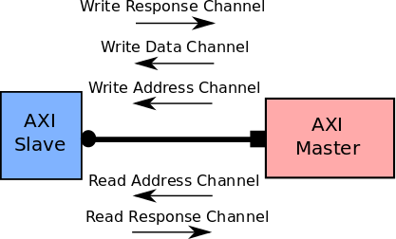

Figure 11: Channel connections between the slave and the master interface

Advanced eXtensible Interface Bus (AXI) Protocol Specifications
The specifications of the protocol are quite simple, and are summarized below:
- Before transmission of any control signal/address/data, both master and slave must extend their “hand” for a handshake via ready and valid signals.
- Separate phases exist for transmission of control signal/address and data.
- Separate channels exist for transmission of control signal/address and data.
- Burst type communication allows for continuous transfer of data.
The interface works by establishing communication between master and slave devices. Between these two devices exists five separate channels: Read Address, Write Address, Read Data, Write Data, and Write Response. Each channel has its own unique signals as well as similar signals existing among all five. The valid and ready signals exist for each channel as they allow for the handshake process to occur for each channel. For transmitting any signal (address/data/response/etc) the relevant channel source provides an active valid signal and the same channel’s destination must provide an active ready signal. After both signals are active, transmission may occur on that channel. As stated above, the transmission of control signals/address and data are done in separate phases, and therefore an address must always be transferred between devices before the handshake process can occur for the corresponding data transfer. In the case of writing information, the response channel is used at the completion of the data transfer.

QSPI Block Level Design
The Block diagram of the system is shown in Figure. The AXI is used to control conﬁguration registers and the RX FIFO in the memory-mapped mode. The conversion bridge is used between RX FIFO and PULP slave. Conﬁguration registers are used to store conﬁguration data for QSPI protocol. Two FIFOs are implemented to buffer RX/TX data from/to QSPI protocol. The QSPI protocol controller block is designed to operate the QSPI protocol. Each sub-block was designed to fulﬁll the selected protocol functions.
Figure 12: QUADSPI block diagram when dual-flash mode is disabled.
SPI Flash
CLK
BK1_IO0/SO
BK1_IO0/SI

BK1_IO2
%.B,2
BK1_IO3
%.B,2

CLK
Q0/SI

Q1/S0

Q2/WP
Pz
Q3/HOLD
ss
BK1_nCS
%.B,2

CS
AHB
Register / Control
Clock management
Mangement
,

FIFO
Shift Register
QUADSPI

Clock and Reset Generator

Clock Generator

The clock generator generates the QSPI protocol clock and a request for the system clock. The clock structure of the design is implemented as synchronous with only one input system clock. The design is intended for clock frequencies from 50 MHz up to 100 MHz. The prescaler is used to create the QSPI protocol clock with a lower frequency than the system clock.
The system clock request is generated by OR logical function between all sub-block requests. Thus, result request is active while at least one sub-block request is also active. The request is assumed glitch-free behavior for each sub-block.
The prescaler divides the system clock by 1/2/4/8 to generate the QSPI protocol clock. The value for a division is set in the conﬁguration registers block. The prescaler is inactive when the prescaler is set to 1. In this case the QSPI clock is implemented as a direct copy of the system clock gated by the OR gate. Otherwise, a 3-bit counter is used for dividing by 2/4/8. The counter counts up by one on each rising edge while it is active. Each divided clock signal is represented by one bit of the counter (/2 – ﬁrst bit LSB, /4 – second bit, /8 – third bit). Clock gating is used to disable the clock signal if it is not needed to lower power consumption.
Reset Generator
Reset generator handles the input global reset. The input global reset is asynchronous to the system clock, therefore synchronization is required. The Synchronization is done by two registers. The block is requests a clock when the reset is in an active state. Otherwise, internal clock gating is used to disable a clock signal if it is not needed. The block also generates reset for the QSPI protocol controller and both FIFOs from system reset and the QSPI enable signal to keep mentioned blocks in the reset state while the QSPI interface is disabled.

Configuration Registers
The Interrupt Controller Register Set Module consists of interrupt related registers, namely, the device global interrupt enable register (DGIER), IP interrupt enable register (IPIER), and IP interrupt status register (IPISR).
This block stores conﬁguration data for the QSPI protocol controller and allows read, enable, and clear interrupt and status ﬂag registers. The core of the block is formed by the tool generated register map with access through AXI. Each register is of size 32-bits. Registers are generated to support all conﬁgurations for QSPI features. The write-only register is implemented for the basic mode transaction request register. The register is cleared at the moment when the QSPI controller stops being busy. Interrupt and status registers are used to notify a user about the current state of the device. Status registers (QSPISTATUS) are read-only thus cannot be cleared or rewritten by the user. Interrupt registers are divided into interrupt write-only enable registers (QSPINTENA) and read-only interrupt status registers (QSPINTSTS). Interrupt status registers are cleared by writing one to the register. To write/read to/from TX/RX FIFO registers (QSPIW-DATA, QSPIRDATA) are implemented as write-only/read-only type registers and act only as a bridge between AXI and FIFOs.

FIFOs
When enabled by the parameter C_FIFO_DEPTH, the transmit FIFO and receive FIFO are implemented on both the transmit and receive paths. The width of the transmit FIFO and receive FIFO are the same and depend on the generic C_NUM_TRANSFER_BITS. When the FIFOs are enabled, their depth is variable at 0, 16 or 256 in Standard SPI mode. In Dual and Quad SPI modes, the FIFO depth is 16 or 256 locations (bytes).
The memory-mapped request is set high if the device is in memory-mapped mode, QSPI protocol controller is not in a busy state, and transaction on the AXI is active. The register is kept high while the QSPI interface is busy. It is reset if a transaction done signal from the QSPI interface is active. Bytes for the address phase need to be obtained. Thus ﬁrst address on the AXI bus is registered exactly before the transaction becomes active. The HREADY signal is set low if the Rx FIFO is empty. The PPI PULP and the PCI PULP read signals are multiplexed for RX FIFO according to set QSPI mode to ensure that both PULP slaves are able to read RX FIFO.
Tx and Rx FIFO
Both the FIFOs are used to buffer data between registers and QSPI interface. A generic variable sets the depth of FIFOs with supported widths, which equals 2n, where n is a natural number.. FIFO also supports watermark reach, empty, full status ﬂags and write/read operations in one clock cycle.
Write and read pointer counters are implemented to keep track of addresses for write and read operations. Each counter has a generic bit size, which equals to the size of the RAM address bus plus an additional bit. The write request is ﬁltered out if the request is active and FIFO is full. Otherwise, the write pointer is increased by one. The write pointer points to the position to which will be written during the next request. Write request also operates as enable signal for RAM. The data are written to the memory on a rising edge of the clock. Read request operates similarly as write with a difference that data are read and the read pointer points to the current read register. The data are read on a rising edge of the clock.
Empty and full conditions are determined by comparing write and read pointers with the use of an additional bit for both them. An empty condition is set when both pointers are equal. A full condition is also set when both pointers are equal except for an additional bit, which is not equal.

Watermark level is calculated from write and read pointer. The generic variable is implemented to distinguish between RX and TX FIFO. The watermark level for TX FIFO is set if the total number of words stored in the RAM is greater than the set watermark level. RX FIFO watermark is set if the total number of words stored in RAM is lesser then set watermark level.
Protocol wrapper around FIFOs is implemented to ﬁlter read and write requests from the QSPI protocol controller while a prescaler is used. Because one request from the QSPI protocol can last more than one clock cycle and will cause more than one read/write operation. The request is let through during the ﬁrst clock cycle and loaded to a register. The output of the register is compared with the current request value. The request is ﬁltered out if both compared values are set high.
MIMO Module
This package de_nes a Multiple-In Multiple-Out (MIMO), an enhanced FIFO that allows the designer to specify the number of objects enqueued and dequeued in one cycle. The MIMO interface is polymorphic and takes 4 parameters:
max_in, max_out, size, and t.
Where:
max_in is the maximum number of objects enqueued in one cycle and must be numeric. max_out is the maximum number of objects dequeued in one cycle and must be numeric. Size is the total size of internal storage and must be numeric.
t is the data type of the stored objects .

Here, in QSPI design the values of:
max_in = 4,
max_out = 4,
size = 16,
t = Bit#(8)
The MIMO interface provides the following methods:
interface MIMO#(numeric type max_in, numeric type max_out, numeric type size, type t); method Action enq(LUInt#(max_in) count, Vector#(max_in, t) data);
method Vector#(max_out, t) first;
method Action deq(LUInt#(max_out) count);
method Bool enqReady;
method Bool enqReadyN(LUInt#(max_in) count);
method Bool deqReady;
method Bool deqReadyN(LUInt#(max_out) count);
method LUInt#(size) count;
method Action clear;
endinterface

QSPI Protocol Controller
The protocol controller block is designed to control the QSPI protocol as a master device. Features of the protocol block are chosen to support the most functions of the current QSPI ﬂash memories. The block is decomposed into two separate sub-blocks. The FSM subb-lock controls the protocol, thus generates clock and control signals for transmitter sub-block and QSPI interface. The transmitter sub-block controls data path, therefore converts data between QSPI interface and internal FIFOs, and notiﬁes the FSM whether all data bytes were transmitted/received.

QSPI Interrupt Controller
The block is used to notify the processor unit that an interrupt in the system has occurred. The block controls the interrupt output signal. The design supports upto ﬁve different sources of interrupts – TX FIFO watermark level reached, RX FIFO watermark level reached, RX FIFO full, RX FIFO empty, TX FIFO full, TX FIFO empty, and QSPI transaction done. For each interrupt source, three signals are used – interrupt enable, interrupt set, and interrupt clear. The interrupt output signal is set if at least one set signal from all sources is active and its enable signal is active. Clear signals are used to set output register low. It is assumed that a clear input signal is active only if the corresponding interrupt is enabled and active. Interrupt is set high if clear and set signals became active in same clock cycle. Level based interrupts are set again after clear is low, but if the set value is still in an active state.

QSPI Register Module
The SPI Register Module includes all memory mapped registers. It interfaces the registers to AXI interface. It consists of Status Register, Control Register, N-bit Slave Select Register (N 32), and a pair of transmits and receive registers.

QSPI Module
The SPI module consists of a shift register, a parameterized baud rate generator (BRG), and a control unit. It provides the SPI interface, including the control logic and initialization logic. In Standard QSPI mode, this module is the center of the QSPI operation.

Implementation of state machine (FSM)
QUADSPI communicates with Flash through commands. Each command can be skipped in any of five stages: instruction, address, alternate byte, dummy and data. nCS drops before each instruction starts and rises again after each instruction is completed.
If the current state is idle (represented by register 7) and the flag instr_written is ‘1’ then we encounter a phase change from idle state to instruction state.
If the current state is idle (represented by register 7): if data_written is ‘1’ and ADMODE is not ‘0’ and DMODE is not ‘0’ and FMODE is ‘0’, then the phase changes to data wait phase (represented by register 5).
- Instruction phase
At this stage, an 8-bit instruction configured in the instruction field of the QUADSPI_CCR[7:0] register is sent to flash, specifying the type of operation to be performed.
If the current state is instruction phase (represented by register 0): if imode is ‘0’ or sioo is ‘1’ and instr_sent is ‘1’, then the phase changes to address phase.
- Address phase
In the address phase, 1-4 bytes are sent to flash indicating the operation address. The number of address bytes to be transmitted is configured in the ADSIZE [1:0] field of the QUADSPI_CCR[13:12] register. In indirect mode and auto polling mode, the address byte to be transmitted is specified in memory map mode in ADDRESS [31:0] of the QUADSPI_AR register, and the address is directly given by AHB (from Cortex ® or DMA). The address phase can transmit 1 bit at a time (via SO in single-line SPI mode), 2 bits (via IO0/IO1 in 2-wire SPI mode) or 4 bits (via IO0/IO1/IO2/IO3 in 4-wire SPI mode). This can be configured via the ADMODE[1:0] field in the QUADSPI_CCR[11:10] register.
If the current state is address phase (represented by register 1): if ADMODE is ‘0’ and addr_sent is ‘1’, then the phase changes to alternate byte phase.
- Alternate byte
In the alternate byte phase, 1-4 bytes are sent to flash, which is typically used to control the mode of operation. The number of alternate bytes to be transmitted is configured in the ABSIZE [1:0] field of the QUADSPI_CCR[17:16] register. The byte to be transmitted is specified in the QUADSPI_ABR register.
Alternate byte stage can transmit 1 bit at a time (via SO in single-line SPI mode), 2 bits (via IO0/IO1 in 2-wire SPI mode) or 4 bits (via IO0/IO1/IO2/ in 4-wire SPI mode) IO3). This can be configured via the ABMODE [1:0] field in the QUADSPI_CCR[15:14] register.
If the current state is alternate byte phase (represented by register 2): if ABMODE is ‘0’ and ab_sent is ‘1’, then the phase changes to dummy phase.
- Dummy cycle
During the empty instruction cycle phase, no data is sent or received for a given 1-31 period, in order to give Flash time to prepare for the data phase when a higher clock frequency is used. The number of cycles given during this phase is specified in the DCYC [4:0] field of the QUADSPI_CCR [22:18] register. In SDR and DDR modes, the duration is specified as a certain number of full clock cycles.
If the current state is dummy cycle phase (represented by register 3): if DCYC is ‘0’ or FMODE is not equal to ‘0’, then the phase changes to data read (represented by register 4).
If the current state is dummy cycle phase (represented by register 3): if DCYC is ‘0’ or FMODE is ‘0’, then the phase changes to data write (represented by register 6).
If the current state is dummy cycle phase (represented by register 3): if or FMODE is ‘2’ and pir_interval is ‘0’, then the phase changes to instruction phase (represented by register 0)
- Data phase
Data phase is divided into: data read, data wait and data write.
In the data phase, any number of bytes can be received or sent from Flash.

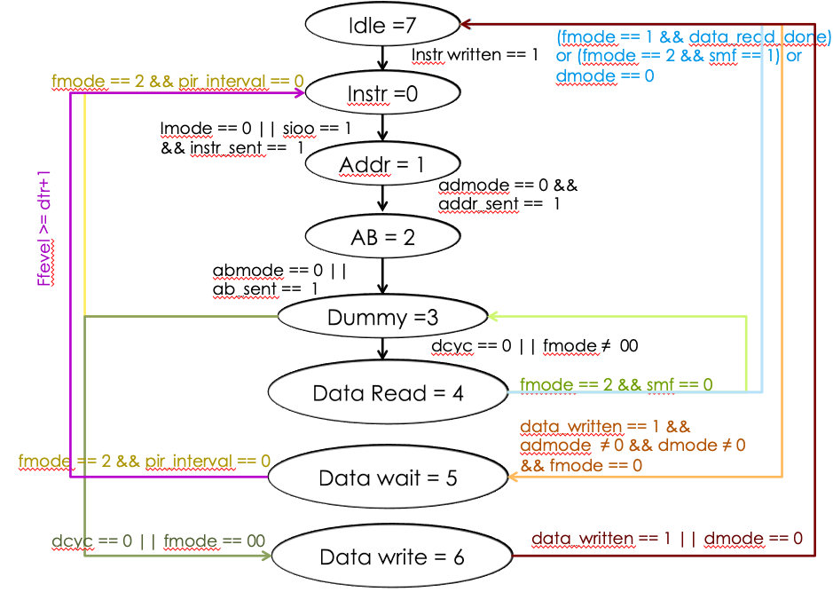
Figure 13: Implementation of State machine
In Indirect mode and Auto Poll mode, the number of bytes to be transmitted/received is specified in the QUADSPI_DLR register. In Indirect Write mode, data sent to Flash must be written to the QUADSPI_DR register. In Indirect Read mode, the data received from Flash is obtained by reading the QUADSPI_DR register. In memory-mapped mode, the read data is sent directly back to Cortex or DMA via bus. The data phase can transmit/receive 1 bit at a time (via SO in single-line SPI mode), 2 bits (via IO0/IO1 in 2-wire SPI mode) or 4 bits (via IO0/IO1/IO2/ in 4-wire SPI mode) IO3). This can be configured via the ABMODE [1:0] field in the QUADSPI_CCR [15:14] register. If DMODE = 00, the data phase is skipped and the command sequence is completed as soon as the nCS is pulled high. This configuration is only available in indirect write mode only.
If the current state is data read phase (represented by register 4): if FMODE is ‘2’ and SMF is ‘0’, then the phase changes to dummy cycle phase (represented by register 3).
If the current state is data read phase (represented by register 4): if (FMODE is ‘1’ and data_read_done) or (FMODE is ‘2’ and SMF is ‘1’) or DMODE is ‘0’, then the phase changes to idle phase (represented by register 7).
If the current state is data wait phase (represented by register 5): if FLVEL >= dtr +1, then the phase changes to instruction phase (represented by register 0).
If the current state is data read phase (represented by register 6): if data_written is ‘1’ or DMODE is ‘0’, then the phase changes idle phase (represented by register 7).

DC bus
The DCBUS module mkDCBMIMORW has two interfaces: 1. Interface is used by the Bus side 2. Device interface. The AXI/APB Bus side and the device interface being the MIMO Interface use the DCBus read/write interface.
Data path 1: From Processor to Flash memory through QSPI Controller
Processor will enqueue the data through the DCBus interface (Here either AXI-Lite/APB) into the MIMO. This data will be dequeued by the data_write_phase of the QSPI controller (using device side interface of mkDCBMIMORW module) and send it to Flash on SI line.
Data path 2: From Flash memory to Processor through QSPI Controller
Data_read_phase of QSPI controller will read data from Flash on SO line and enqueue this data into the MIMO (using device side interface of mkDCBMIMORW module). This data will be dequeued by the Processor through DCBus interface (Here either AXI-Lite/APB).
This library is a modified version of the CBus library provided by Bluespec. Following are its features:
1. The configuration registers can each be of any length (max of 4).
2. Ability to control the size of operation to be performed on each register using Access Size and mask.
3. Can connect to a bus of any size: 8, 16, 32 or 64 independent of the widths of the register.
4. Is provided with read-write, read-only, write-only and write-side effect register types.
Module collect
Variation to the 'Module' type of BSV 'Additional interfaces' is added to the existing design with separation of 'additional design details' from the 'main design details'. A module accumulating a collection must have the '[]' after the keyword 'module' - an instantiation of this module loses polymorphic capability and is constrained by 'inner module' For synthesis, accumulating collection should use 'exposeCollection' for top-level Module.
The three main operations on collection: add, expose & Mapping.
Takeaway: Operations of Module collects
Expose: The Expose type class converts a context to an interface for a synthesis boundary, converting it to a module type of Module. The Expose type class provides the modules unbury Context and unbury Context with Clocks.
Interfaces: The IWithCollection interface couples the normal module interface (the device interface) with the collection of collected items (the collection interface). This is the interface provided by the exposeCollection function. It separates the collection list and the device module interface, to allow the module to be synthesized.
DCR Addr: It is a structure type which consists of four fields:
Address, Min AccessSize, Max AccessSize and Mask value
Mask value is of type Bit. Syntax: Bit#(OS) Mask value;
OS indicates the number of bits for Maskvalue. The value of Maskvalue field indicates the access to the number of Bytes in the register.
For example, consider regB is an 8-bit register, with allowed = Sz1. Now this function is called when the index hits on regA. Within the 8 bytes allotted to regB, the read operation could be for any other byte. But we want to perform a read only if the request is at the lowest byte. We achieve this by having a 3-bit mask of 000 that is checked against the lower 3 bits of the address.
If the DATAWIDTH is 32, then the number of bits in the Mask value should be equal to 2. (i.e OS = 2. So that the combinations will define the access of particular Bytes.
Module primitives:
mkDCBRegRW: Regular Read-write register of DCBUS interface to the collection mkDCBRegRWCond: Read-Write Conditional registerDCBUS interface to the collection mkDCBRegCRRWCond: Conditional Read-write CR register DCBUS interface to the collection mkDCBRegWOCSe: Write Only Clear SideEffect register DCBUS interface to the collection mkDCBRegRWCondCCRe: Read Write Conditional -CCREffect register DCBUS interface to the collection
mkDCBRegRWCondSe: Conditional Read-write Side-effect register DCBUS interface to the collection
mkDCBRegRO: Read-Only register DCBUS interface to the collection
mkDCBRegWO: Write-Only register DCBUS interface to the collection
mkDCBRegROSe: ReadOnly-SideEffect register DCBUS interface to the collection mkDCBRegRWSe: Write-SideEffect register DCBUS interface to the collection mkDCBRWireW: Write only wire DCBUS interface to the collection
mkDCBBypassWireROSe: Read only Side effectbypass wire DCBUS interface to the collection mkDCBBypassWireRO: Read only bypass wire DCBUS interface to the collection

QSPI Register definitions
Structures have been defined for each register of QSPI. Each structure will consist of the fields of the respective register. The data type of each field is Bit and it will also indicate the number of bits the field mapped to.
CR register is a Conditional Read-write register which uses mkDCBRegCRRWCond module.
DCR is a read-write conditional register which uses mkDCBRegRWCond module.
SR is a read-only register, and uses mkDCBRegRO module.
FCR is a write-only clear side effect register which uses mkDCBRegWOCSe module.
CCR is a conditional read-write side effect register which uses mkDCBRegRWCondCCRe module.
DR is a read-write side effect register and uses mkDCBRegRWSe module.
AR is conditional read-write and write-side effect register and hence it uses mkDCBRegRWCondSe module.
DLR, ABR, PSMR, PSMA, PIR, LTPR are all read-write conditional registers which uses mkDCBRegRWCond module.

Device Configuration and Results

Software and Steps
Xilinx is the leading provider of All Programmable FPGAs, SoCs, MPSoCs, and 3D ICs. Xilinx uniquely enables applications that are both software defined and hardware optimized – powering industry advancements in Cloud Computing, SDN/NFV, Video/Vision, Industrial IoT, and 5G Wireless.
Vivado Design Suite is a software suite produced by Xilinx for synthesis and analysis of HDL designs, superseding Xilinx ISE with additional features for system on a chip development and high-level synthesis.
Steps:

1. Start the tool


2. Create a new project
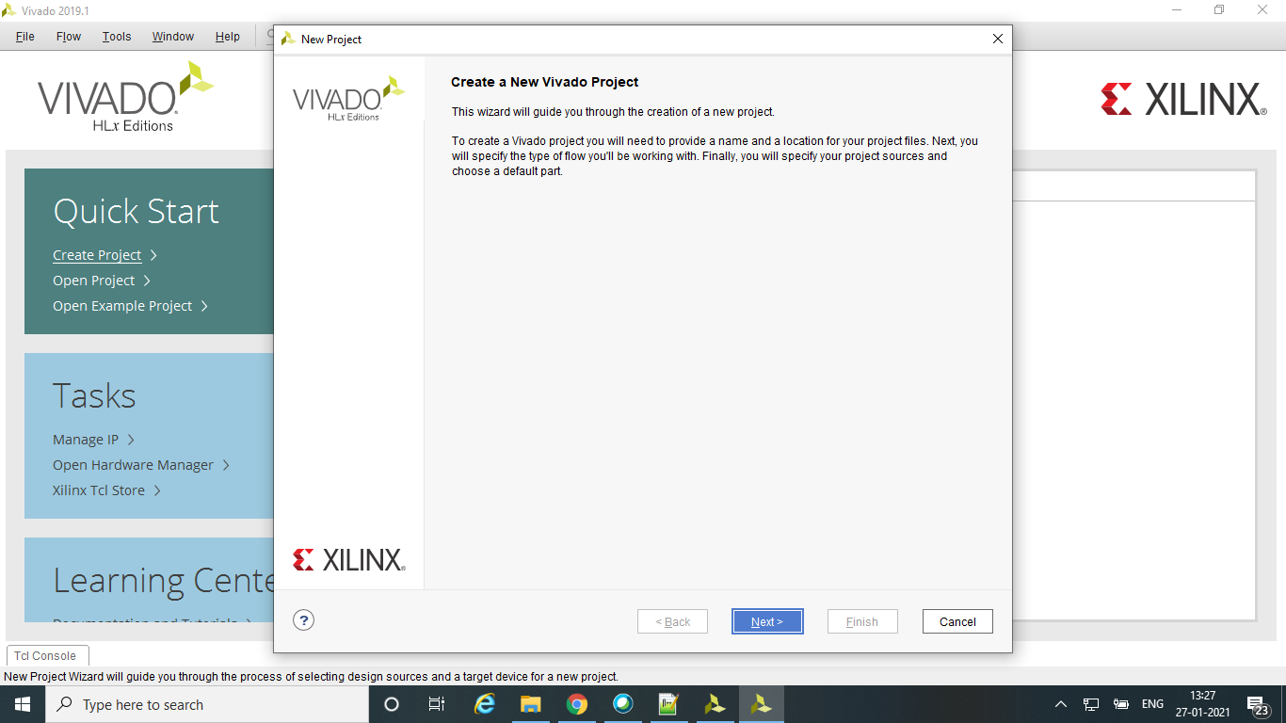

3. Create Project name
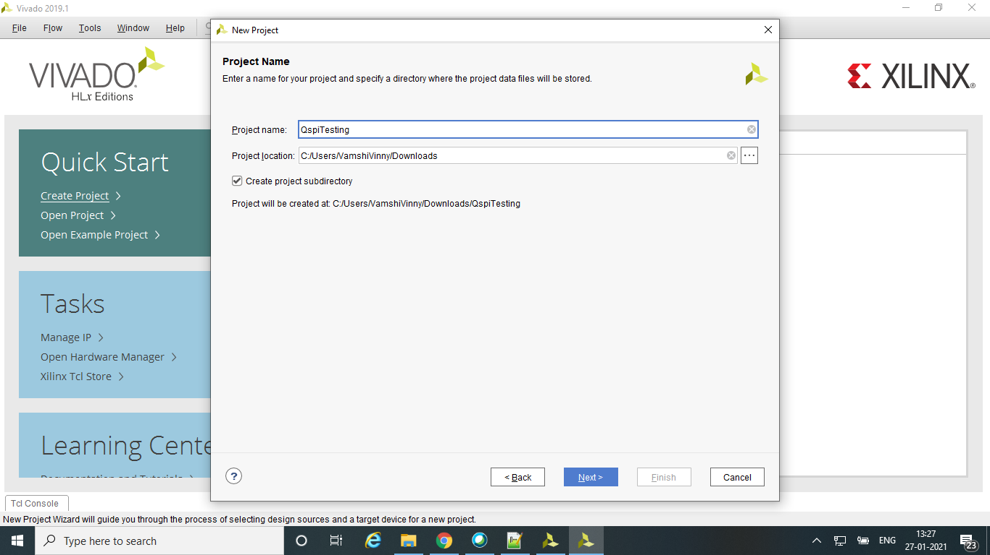

4. Select the project type
Here we select RTL project
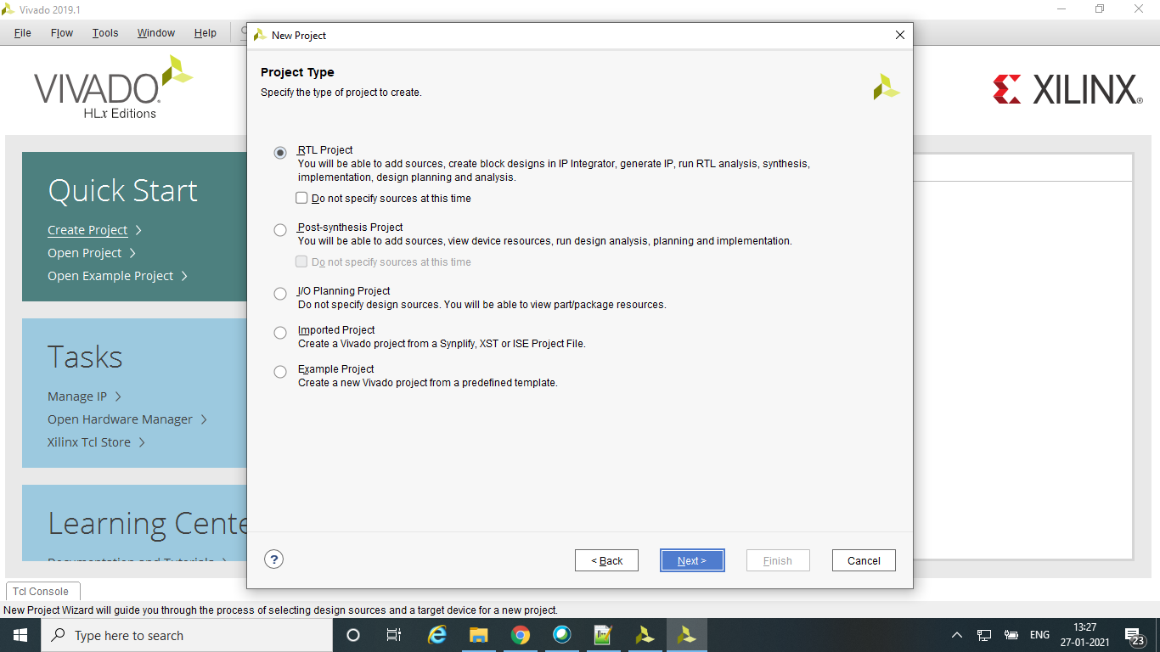

5. Add the required sources
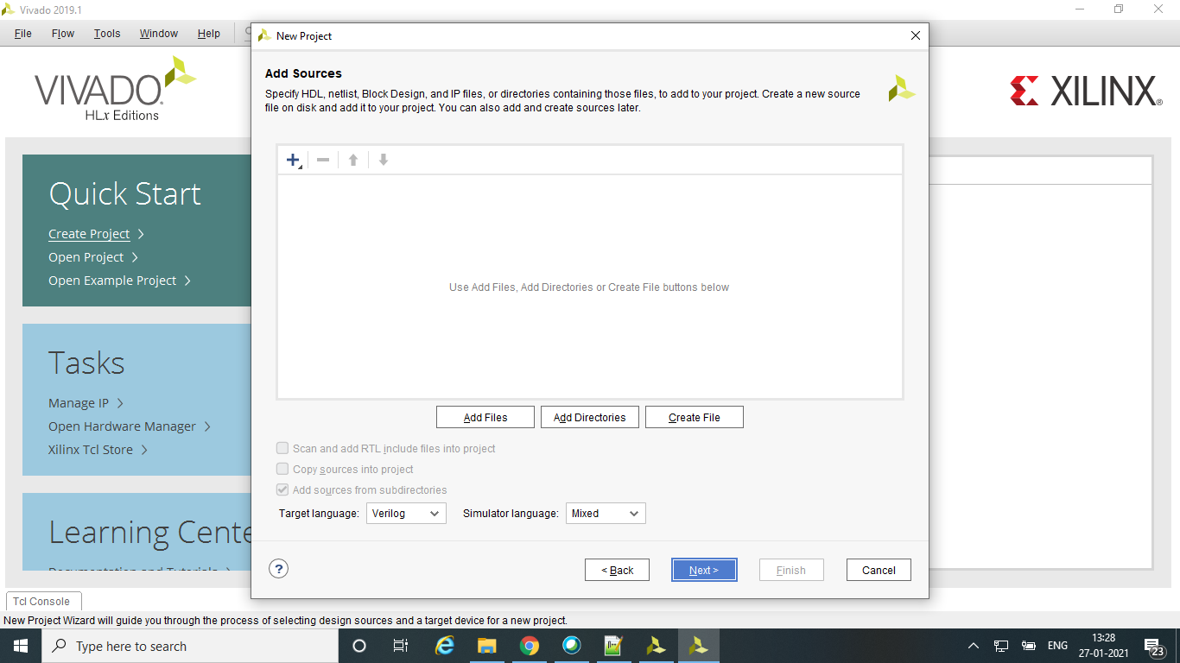

6. Set a board for the project
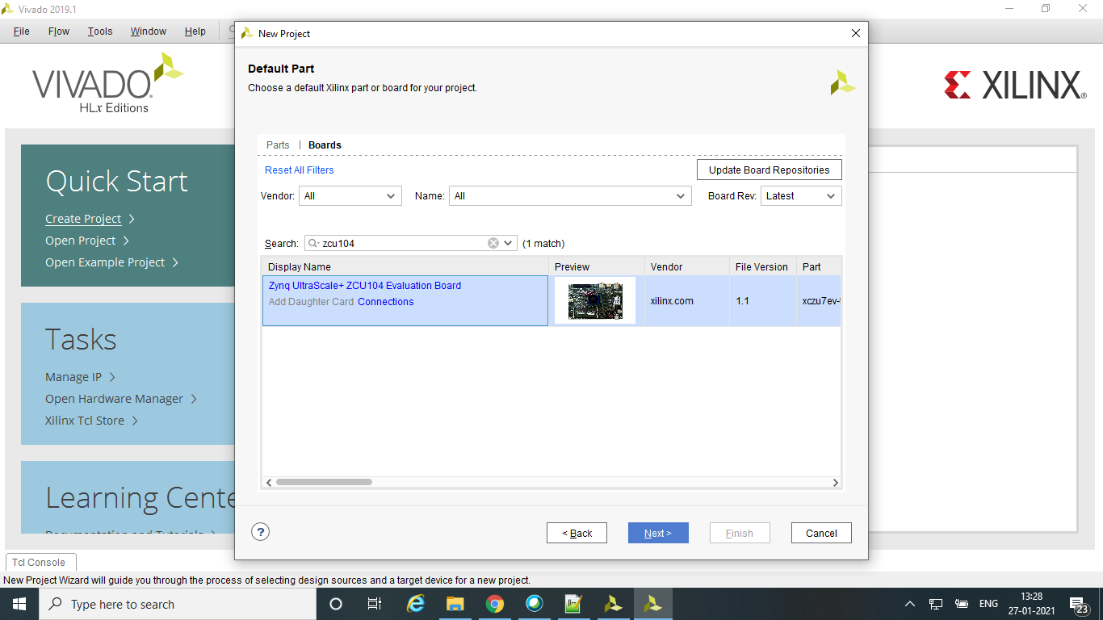

7. Gives the summary of the project created
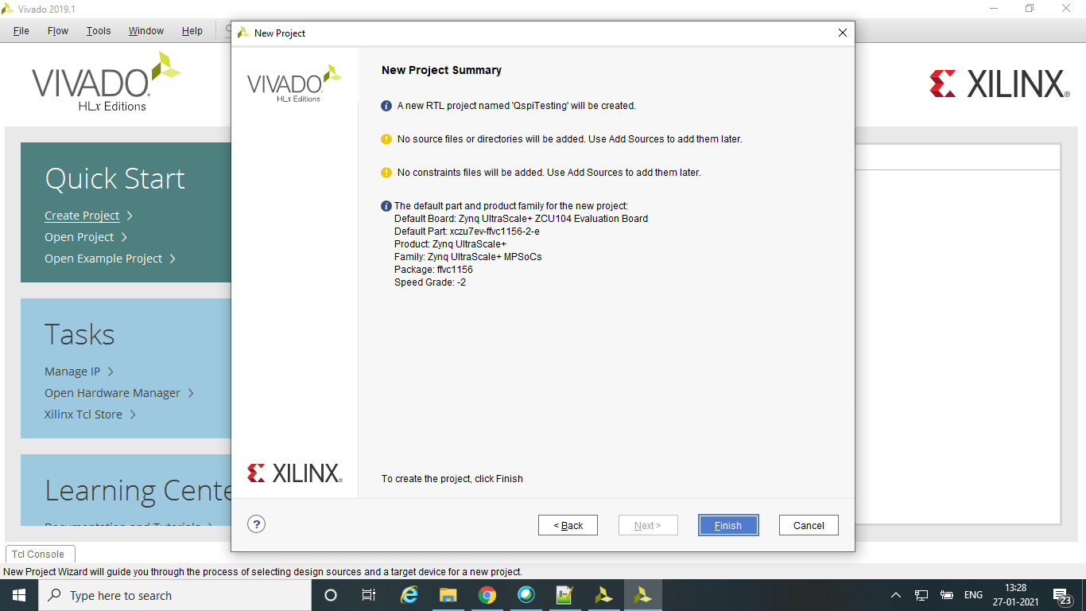

8. Project manager
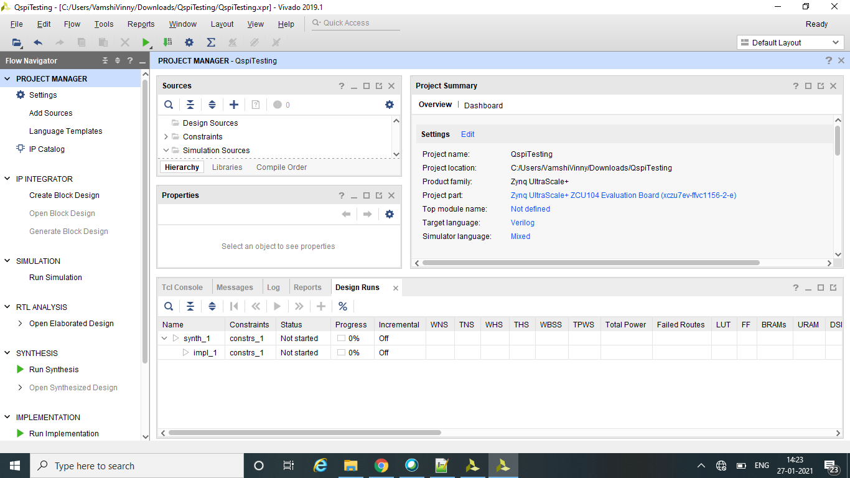

9. Specify and/or create source files to add to the project
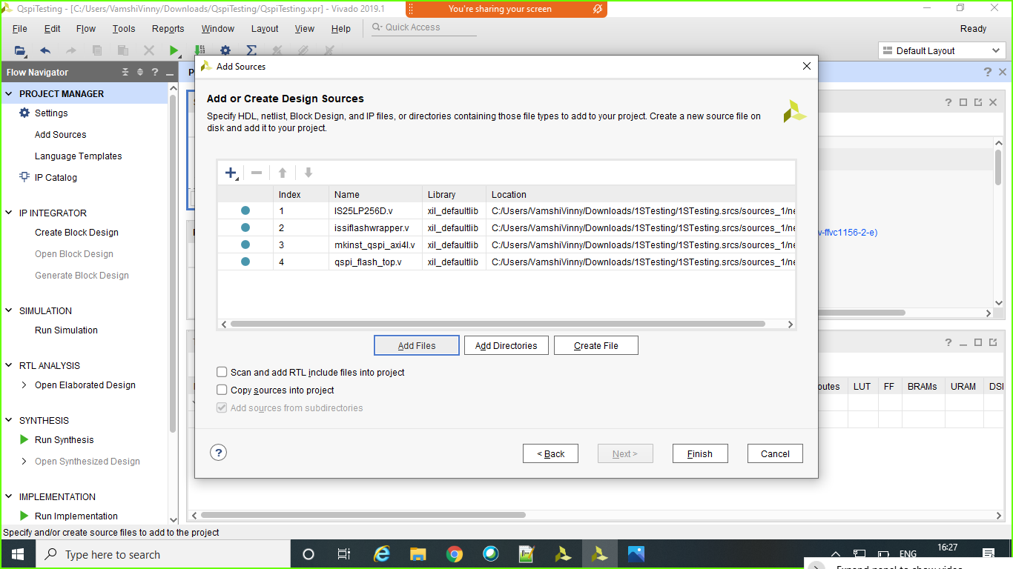

10. Add or create simulation sources
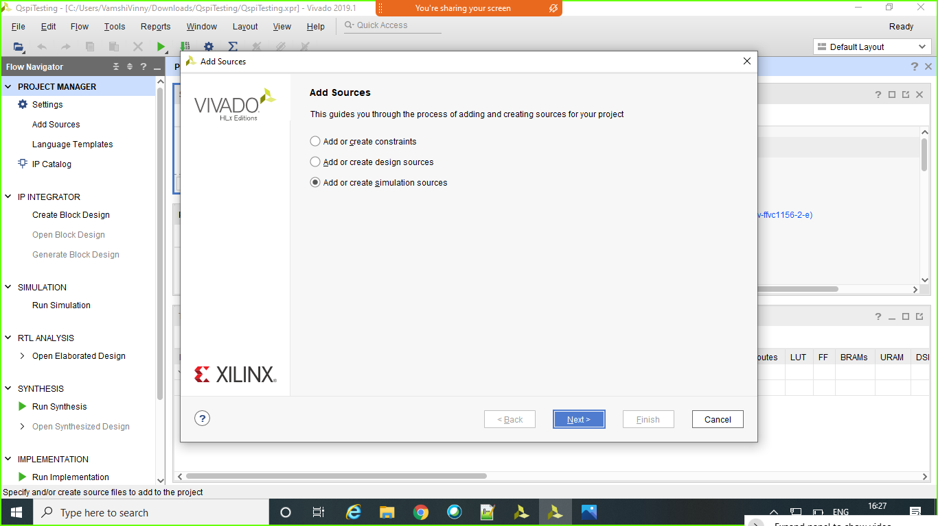

11. Create a source file on disk and add the project
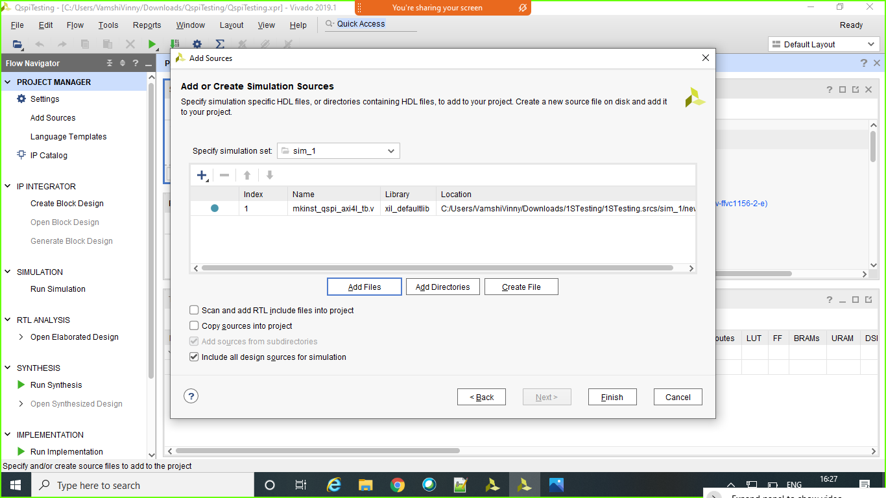

12. Testing
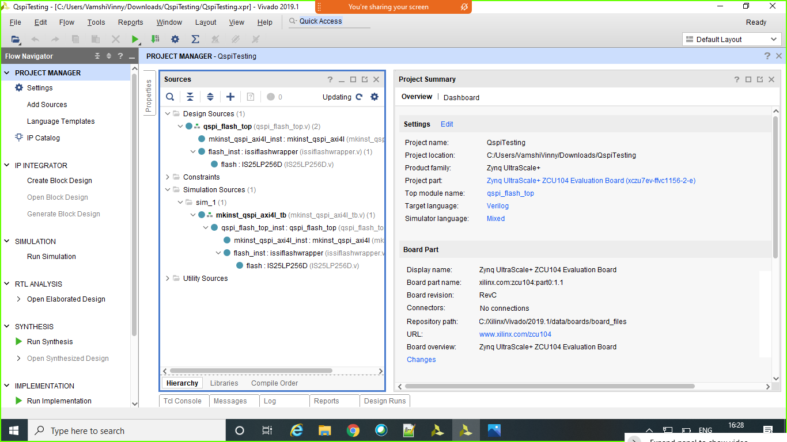

Results

SPI SDR
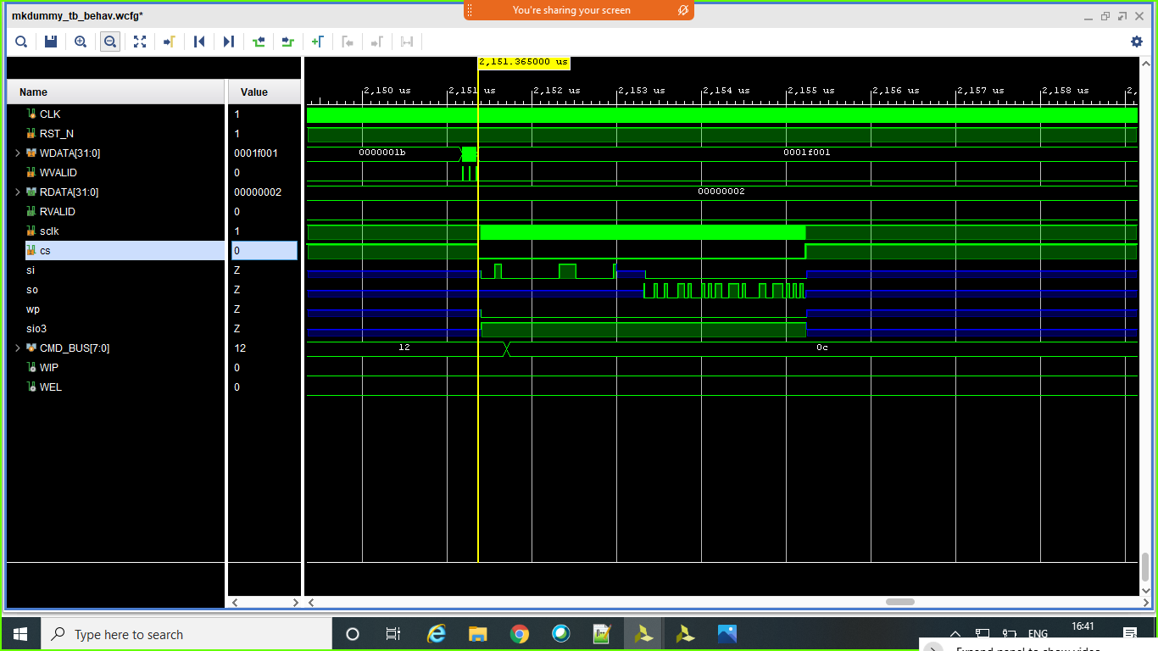
Configuration
- Initial configuration
32'h031f0f01 is the value configured into 32'h0 address(CR Register) and
This configuration will enable the QUADSPI and also sets the pre-scaler value.

32'h001b0001 is the value configured into 32'h4 address(DCR Register) and
This will configure the DCR register and its fields like ckmode and Fsize.

We wait for 1 millisecond to perform other operations as Flash takes 1ms to enable the Chip Enable.
- Sector Erase
32'h00003106 is the value configured into 32'h14(CCR Register) and this instruction is given to the flash before writing to the Flash (Write Latch Enable).

32'h0000001B is the value configured into 32'hC(FCR Register) to clear all the Flags.

32'h00003521 is the value configured into 32'h14(CCR Register) and 32'h21 instruction is for Sector erase operation in Flash and here the address and the instruction is configured on single line(SI).

32'h0001F001 is the address configured in 32'h18(Address Register).

- Write channel
32'h00003106 is the value configured into 32'h14(CCR Register) and this instruction is given to the flash before writing to the Flash (Write Latch Enable).

32'h0000001B is the value configured into 32'hC(FCR Register) to clear all the Flags.

32'h0000_0005 is the value configured into 32'h10(DLR Register) which specifies the number of bytes we want to write into Flash.

32'h01003512 is the value configured into 32'h14(CCR Register), here the 'h12 instruction is for page program(to perform write operation to the Flash).

32'h0001F001 is the address configured in 32'h18(Address Register).

32'h12345674 and 32'h112233AA are the eight bytes written into the 32'h20(DR Register).
Here based on strobe value(4'b0011) only the last two bytes of the second word will be considered as Valid.

- Read Channel
32'h0000_0005 is the value configured into 32'h10(DLR Register) which specifies the number of bytes we want to read from the Flash.

32'h0520350C is the value configured into the 32'h14(CCR Register) to send the instruction and address on a single line(SI) and also to read the data from flash on a single line(SO) with SDR clock.

32'h0001F001 is the address configured in 32'h18(Address Register).

Dual SPI SDR
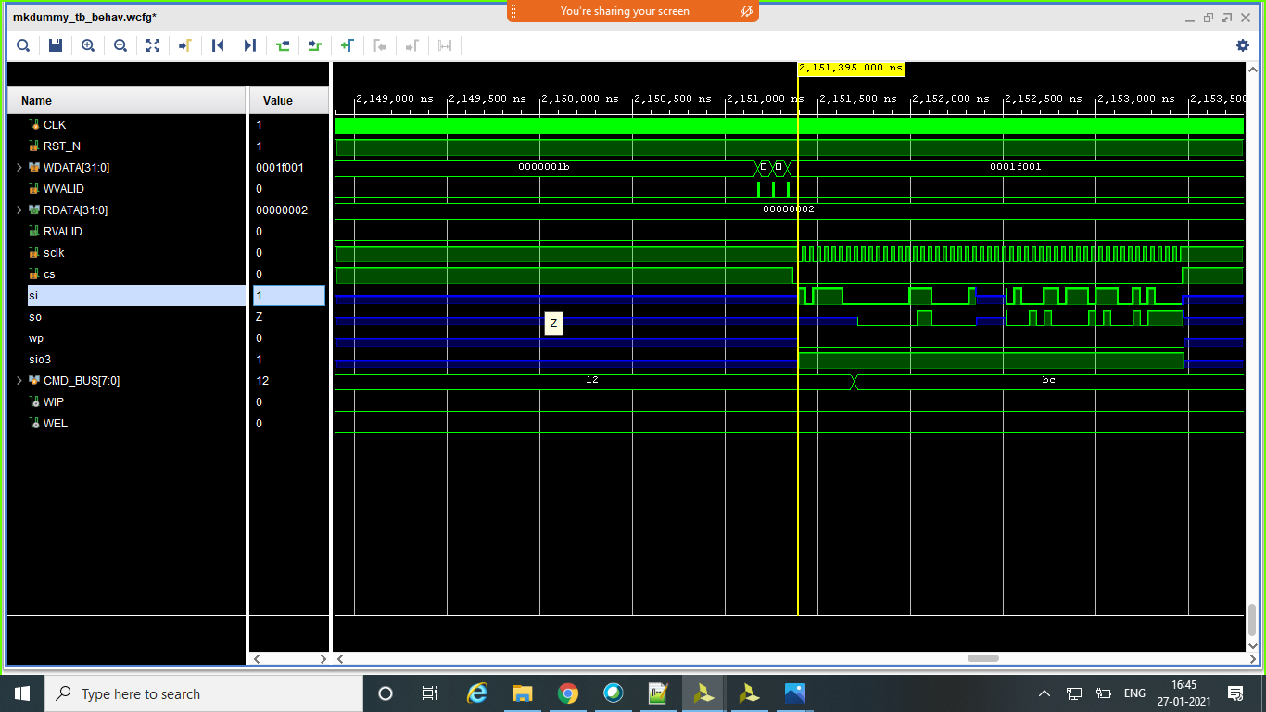
Configuration
- Initial configuration
32'h031f0f01 is the value configured into 32'h0 address(CR Register) and
This configuration will enable the QUADSPI and also sets the pre-scaler value.

32'h001b0001 is the value configured into 32'h4 address(DCR Register) and
This will configure the DCR register and its fields like ckmode and Fsize.

We wait for 1 millisecond to perform other operations as Flash takes 1ms to enable the Chip Enable.
- Sector Erase
32'h00003106 is the value configured into 32'h14(CCR Register) and this instruction is given to the flash before writing to the Flash (Write Latch Enable).

32'h0000001B is the value configured into 32'hC(FCR Register) to clear all the Flags.

32'h00003521 is the value configured into 32'h14(CCR Register) and 32'h21 instruction is for Sector erase operation in Flash and here the address and the instruction is configured on single line(SI).

32'h0001F001 is the address configured in 32'h18(Address Register).

- Write channel
32'h00003106 is the value configured into 32'h14(CCR Register) and this instruction is given to the flash before writing to the Flash (Write Latch Enable).

32'h0000001B is the value configured into 32'hC(FCR Register) to clear all the Flags.

32'h0000_0005 is the value configured into 32'h10(DLR Register) which specifies the number of bytes we want to write into Flash.

32'h01003512 is the value configured into 32'h14(CCR Register), here the 'h12 instruction is for page program(to perform write operation to the Flash).

32'h0001F001 is the address configured in 32'h18(Address Register).

32'h12345674 and 32'h112233AA are the eight bytes written into the 32'h20(DR Register).
Here based on strobe value(4'b0011) only the last two bytes of the second word will be considered as Valid.

- Read Channel
32'h0000_0005 is the value configured into 32'h10(DLR Register) which specifies the number of bytes we want to read from the Flash.

32' h061039BC is the value configured into the 32'h14(CCR Register) to send the instruction and address on two lines(SI & SO) and also to read the data from flash on dual line(SI & SO) with SDR clock.

32'h0001F001 is the address configured in 32'h18(Address Register).

Quad SPI SDR
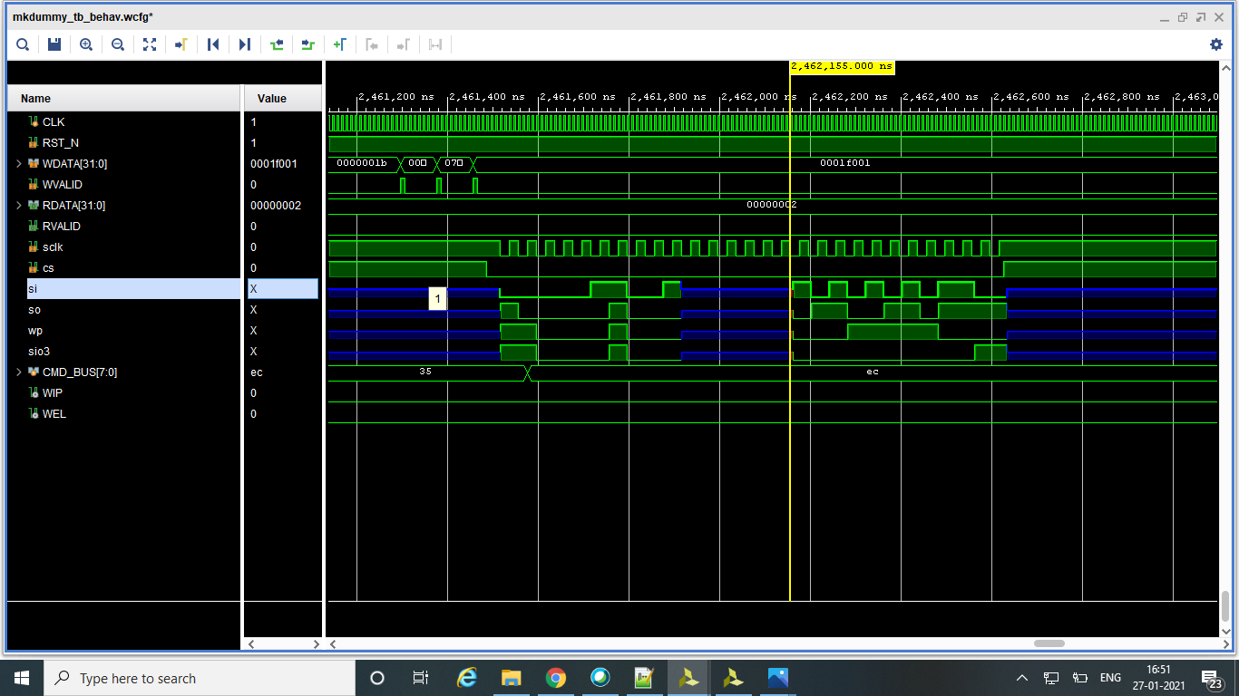
Configuration
- Initial configuration
32'h031f0f01 is the value configured into 32'h0 address(CR Register) and
This configuration will enable the QUADSPI and also sets the pre-scaler value.

32'h001b0001 is the value configured into 32'h4 address(DCR Register) and
This will configure the DCR register and its fields like ckmode and Fsize.

We wait for 1 millisecond to perform other operations as Flash takes 1ms to enable the Chip Enable.

- Sector Erase
32'h00003106 is the value configured into 32'h14(CCR Register) and this instruction is given to the flash before writing to the Flash (Write Latch Enable).

32'h0000001B is the value configured into 32'hC(FCR Register) to clear all the Flags.

32'h00003521 is the value configured into 32'h14(CCR Register) and 32'h21 instruction is for Sector erase operation in Flash and here the address and the instruction is configured on single line(SI).

32'h0001F001 is the address configured in 32'h18(Address Register).

- Write channel
32'h00003106 is the value configured into 32'h14(CCR Register) and this instruction is given to the flash before writing to the Flash (Write Latch Enable).

32'h0000001B is the value configured into 32'hC(FCR Register) to clear all the Flags.

32'h0000_0005 is the value configured into 32'h10(DLR Register) which specifies the number of bytes we want to write into Flash.

32'h01003512 is the value configured into 32'h14(CCR Register), here the 'h12 instruction is for page program(to perform write operation to the Flash).

32'h0001F001 is the address configured in 32'h18(Address Register).

32'h12345674 and 32'h112233AA are the eight bytes written into the 32'h20(DR Register).
Here based on strobe value(4'b0011) only the last two bytes of the second word will be considered as Valid.

- Read Channel
32’h00000135 is the valueconfigured into 32’h14(CCR Register) to enable the Quad bit in the Flash.

32'h0000001B is the value configured into 32'hC(FCR Register) to clear all the Flags.

32'h0000_0005 is the value configured into 32'h10(DLR Register) which specifies the number of bytes we want to read from the Flash.

32' h07183FEC is the value configured into the 32'h14(CCR Register) to send the instruction and address on four lines(SI, SO, SIO3,WP) and also to read the data from flash on four lines(SI, SO, SIO3,WP) with SDR clock.

32'h0001F001 is the address configured in 32'h18(Address Register).

SPI DDR
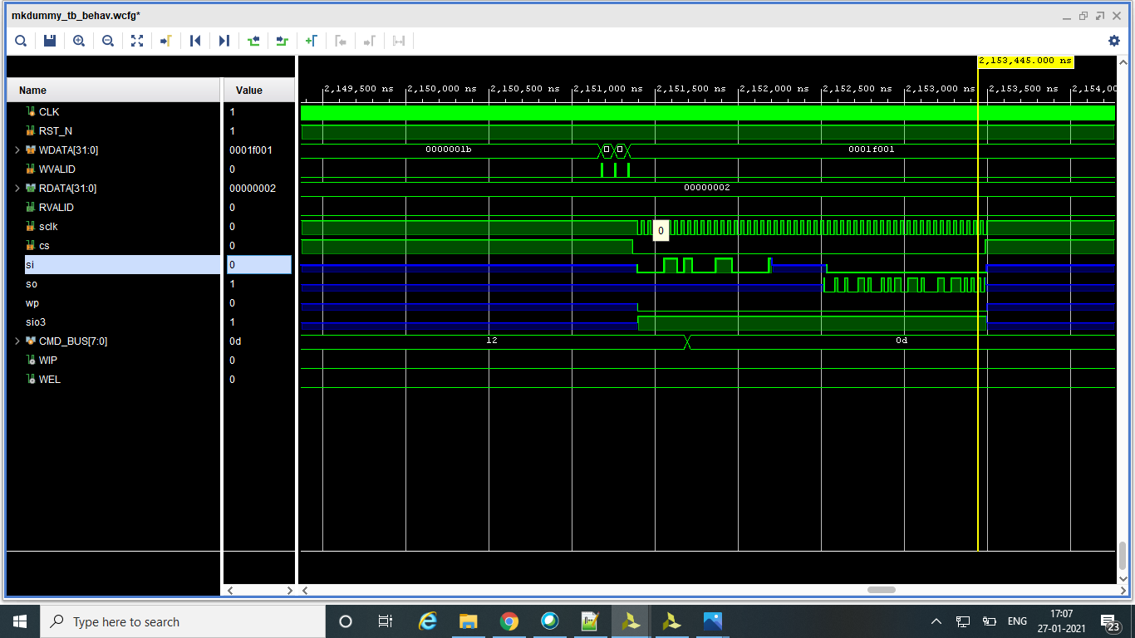

Configuration
- Initial configuration
32'h031f0f01 is the value configured into 32'h0 address(CR Register) and
This configuration will enable the QUADSPI and also sets the pre-scaler value.

32'h001b0001 is the value configured into 32'h4 address(DCR Register) and
This will configure the DCR register and its fields like ckmode and Fsize.

We wait for 1 millisecond to perform other operations as Flash takes 1ms to enable the Chip Enable.
- Sector Erase
32'h00003106 is the value configured into 32'h14(CCR Register) and this instruction is given to the flash before writing to the Flash (Write Latch Enable).

32'h0000001B is the value configured into 32'hC(FCR Register) to clear all the Flags.

32'h00003521 is the value configured into 32'h14(CCR Register) and 32'h21 instruction is for Sector erase operation in Flash and here the address and the instruction is configured on single line(SI).

32'h0001F001 is the address configured in 32'h18(Address Register).

- Write channel
32'h00003106 is the value configured into 32'h14(CCR Register) and this instruction is given to the flash before writing to the Flash (Write Latch Enable).

32'h0000001B is the value configured into 32'hC(FCR Register) to clear all the Flags.

32'h0000_0005 is the value configured into 32'h10(DLR Register) which specifies the number of bytes we want to write into Flash.

32'h01003512 is the value configured into 32'h14(CCR Register), here the 'h12 instruction is for page program(to perform write operation to the Flash).

32'h0001F001 is the address configured in 32'h18(Address Register).

32'h12345674 and 32'h112233AA are the eight bytes written into the 32'h20(DR Register).
Here based on strobe value(4'b0011) only the last two bytes of the second word will be considered as Valid.

- Read Channel
32'h0000_0005 is the value configured into 32'h10(DLR Register) which specifies the number of bytes we want to read from the Flash.

32'h8520350E is the value configured into the 32'h14(CCR Register) to send the instruction and address on a single line(SI) and also to read the data from flash on a single line(SO) with DDR clock.

32'h0001F001 is the address configured in 32'h18(Address Register).

Dual SPI DDR
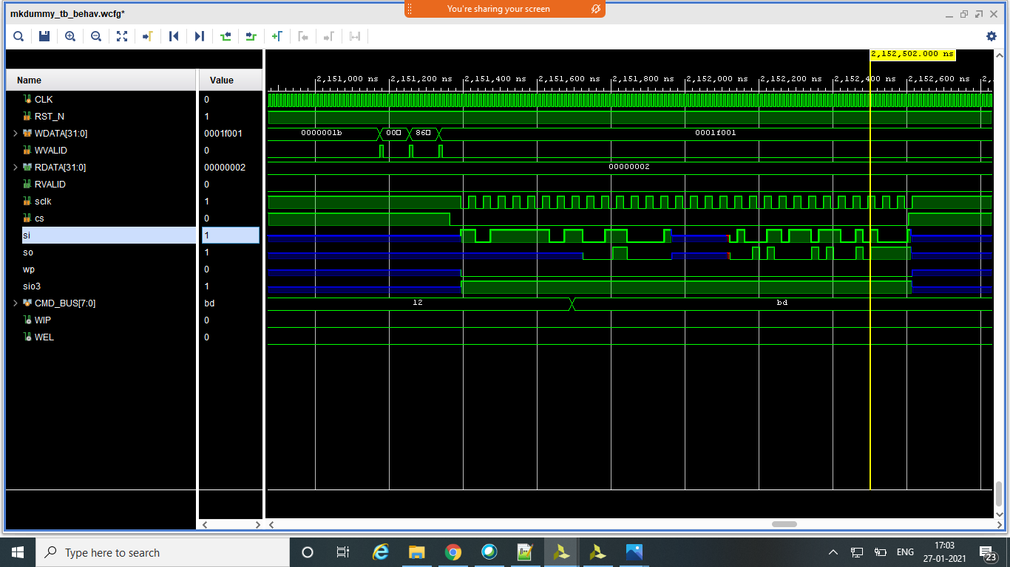
Configuration
- Initial configuration
32'h031f0f01 is the value configured into 32'h0 address(CR Register) and
This configuration will enable the QUADSPI and also sets the pre-scaler value.

32'h001b0001 is the value configured into 32'h4 address(DCR Register) and
This will configure the DCR register and its fields like ckmode and Fsize.

We wait for 1 millisecond to perform other operations as Flash takes 1ms to enable the Chip Enable.
- Sector Erase
32'h00003106 is the value configured into 32'h14(CCR Register) and this instruction is given to the flash before writing to the Flash (Write Latch Enable).

32'h0000001B is the value configured into 32'hC(FCR Register) to clear all the Flags.

32'h00003521 is the value configured into 32'h14(CCR Register) and 32'h21 instruction is for Sector erase operation in Flash and here the address and the instruction is configured on single line(SI).

32'h0001F001 is the address configured in 32'h18(Address Register).

- Write channel
32'h00003106 is the value configured into 32'h14(CCR Register) and this instruction is given to the flash before writing to the Flash (Write Latch Enable).

32'h0000001B is the value configured into 32'hC(FCR Register) to clear all the Flags.

32'h0000_0005 is the value configured into 32'h10(DLR Register) which specifies the number of bytes we want to write into Flash.

32'h01003512 is the value configured into 32'h14(CCR Register), here the 'h12 instruction is for page program(to perform write operation to the Flash).

32'h0001F001 is the address configured in 32'h18(Address Register).

32'h12345674 and 32'h112233AA are the eight bytes written into the 32'h20(DR Register).
Here based on strobe value(4'b0011) only the last two bytes of the second word will be considered as Valid.

- Read Channel
32'h0000_0005 is the value configured into 32'h10(DLR Register) which specifies the number of bytes we want to read from the Flash.

32' h861039BE is the value configured into the 32'h14(CCR Register) to send the instruction and address on two lines(SI & SO) and also to read the data from flash on dual line(SI & SO) with DDR clock.

32'h0001F001 is the address configured in 32'h18(Address Register).

Quad SPI DDR

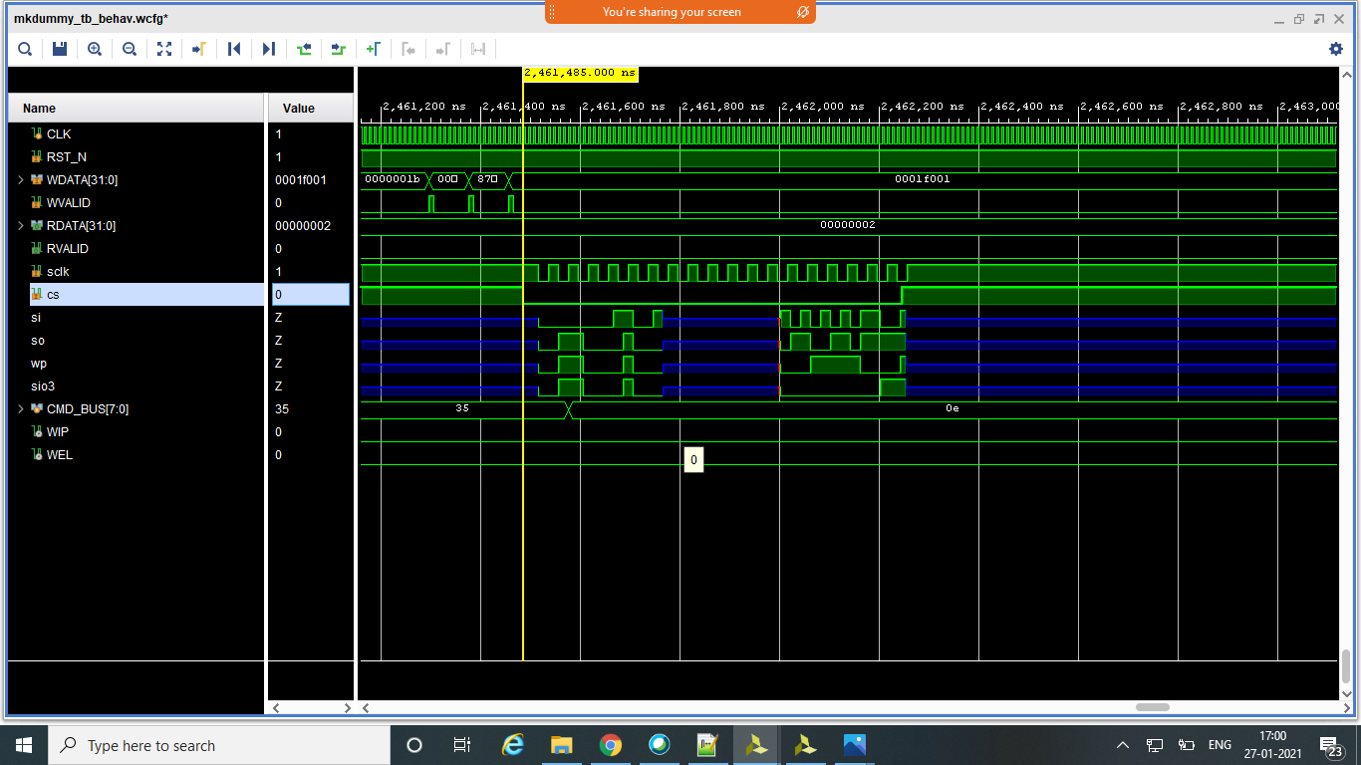
Configuration
- Initial configuration
32'h031f0f01 is the value configured into 32'h0 address (CR Register) and
This configuration will enable the QUADSPI and also sets the pre-scaler value.

32'h001b0001 is the value configured into 32'h4 address (DCR Register) and
This will configure the DCR register and its fields like ckmode and Fsize.

We wait for 1 millisecond to perform other operations as Flash takes 1ms to enable the Chip Enable.

- Sector Erase
32'h00003106 is the value configured into 32'h14(CCR Register) and this instruction is given to the flash before writing to the Flash (Write Latch Enable).

32'h0000001B is the value configured into 32'hC (FCR Register) to clear all the Flags.

32'h00003521 is the value configured into 32'h14(CCR Register) and 32'h21 instruction is for Sector erase operation in Flash and here the address and the instruction is configured on single line (SI).

32'h0001F001 is the address configured in 32'h18(Address Register).

- Write channel
32'h00003106 is the value configured into 32'h14(CCR Register) and this instruction is given to the flash before writing to the Flash (Write Latch Enable).

32'h0000001B is the value configured into 32'hC (FCR Register) to clear all the Flags.

32'h0000_0005 is the value configured into 32'h10(DLR Register) which specifies the number of bytes we want to write into Flash.

32'h01003512 is the value configured into 32'h14(CCR Register), here the 'h12 instruction is for page program (to perform write operation to the Flash).

32'h0001F001 is the address configured in 32'h18(Address Register).

32'h12345674 and 32'h112233AA are the eight bytes written into the 32'h20(DR Register).
Here based on strobe value(4'b0011) only the last two bytes of the second word will be considered as Valid.

- Read Channel
32’h00000135 is the valueconfigured into 32’h14(CCR Register) to enable the Quad bit in the Flash.
32'h0000001B is the value configured into 32'hC(FCR Register) to clear all the Flags.

32'h0000_0005 is the value configured into 32'h10(DLR Register) which specifies the number of bytes we want to read from the Flash.

32' h87183FEE is the value configured into the 32'h14(CCR Register) to send the instruction and address on four lines(SI, SO, SIO3,WP) and also to read the data from flash on four lines(SI, SO, SIO3,WP) with DDR clock.

32'h0001F001 is the address configured in 32'h18(Address Register).

Even Prescalar

SPI mode DDR even prescalar
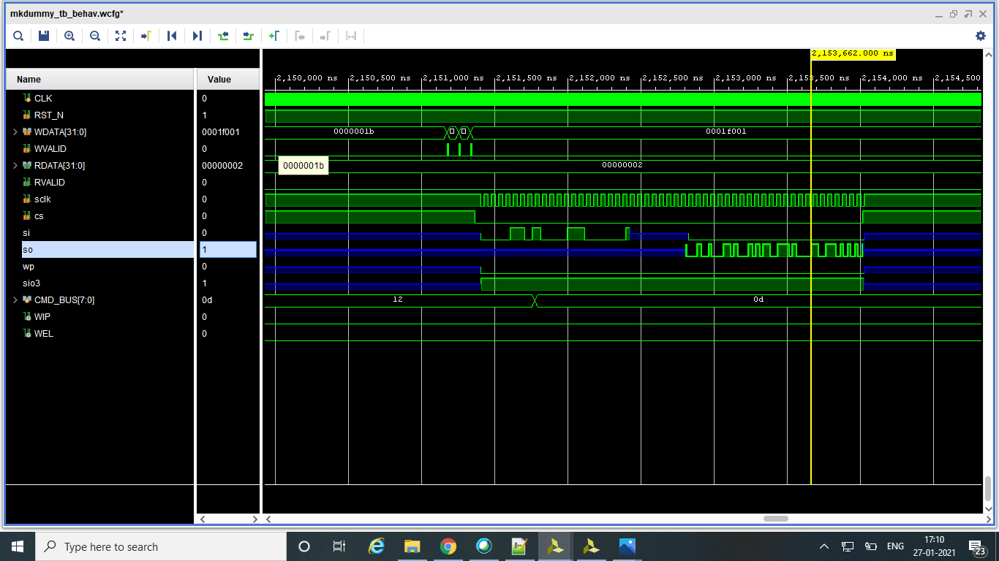
Configuration
- Initial configuration
32'h041f0f01 is the value configured into 32'h0 address(CR Register) and
This configuration will enable the QUADSPI and also sets the pre-scaler value(Here it is even Pre-scaler).

32'h001b0001 is the value configured into 32'h4 address(DCR Register) and
This will configure the DCR register and its fields like ckmode and Fsize.

We wait for 1 millisecond to perform other operations as Flash takes 1ms to enable the Chip Enable.
- Sector Erase
32'h00003106 is the value configured into 32'h14(CCR Register) and this instruction is given to the flash before writing to the Flash (Write Latch Enable).

32'h0000001B is the value configured into 32'hC(FCR Register) to clear all the Flags.

32'h00003521 is the value configured into 32'h14(CCR Register) and 32'h21 instruction is for Sector erase operation in Flash and here the address and the instruction is configured on single line(SI).

32'h0001F001 is the address configured in 32'h18(Address Register).

- Write channel
32'h00003106 is the value configured into 32'h14(CCR Register) and this instruction is given to the flash before writing to the Flash (Write Latch Enable).

32'h0000001B is the value configured into 32'hC(FCR Register) to clear all the Flags.

32'h0000_0005 is the value configured into 32'h10(DLR Register) which specifies the number of bytes we want to write into Flash.

32'h01003512 is the value configured into 32'h14(CCR Register), here the 'h12 instruction is for page program(to perform write operation to the Flash).

32'h0001F001 is the address configured in 32'h18(Address Register).

32'h12345674 and 32'h112233AA are the eight bytes written into the 32'h20(DR Register).
Here based on strobe value(4'b0011) only the last two bytes of the second word will be considered as Valid.

- Read Channel
32'h0000_0005 is the value configured into 32'h10(DLR Register) which specifies the number of bytes we want to read from the Flash.

32'h8520350E is the value configured into the 32'h14(CCR Register) to send the instruction and address on a single line(SI) and also to read the data from flash on a single line(SO) with DDR clock.

32'h0001F001 is the address configured in 32'h18(Address Register).

Quad SPI mode SDR even prescalar
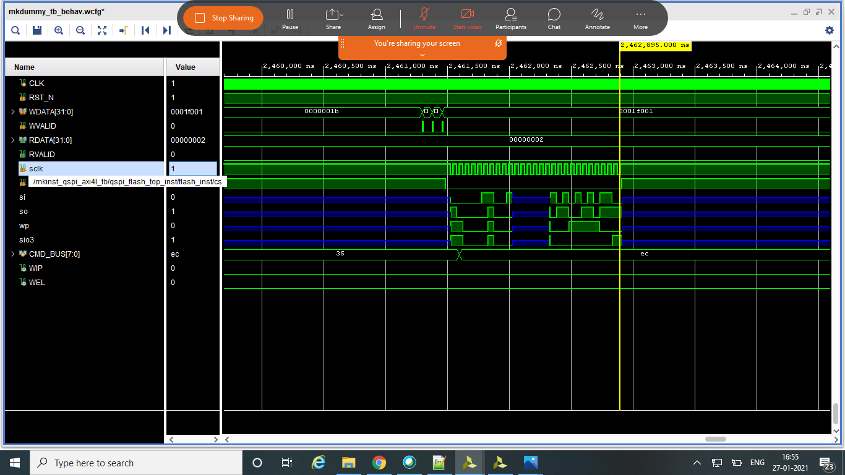

Configuration
- Initial configuration
32'h041f0f01 is the value configured into 32'h0 address(CR Register) and
This configuration will enable the QUADSPI and also sets the pre-scaler value(Here it is even Pre-scaler).

32'h001b0001 is the value configured into 32'h4 address(DCR Register) and
This will configure the DCR register and its fields like ckmode and Fsize.

We wait for 1 millisecond to perform other operations as Flash takes 1ms to enable the Chip Enable.

- Sector Erase
32'h00003106 is the value configured into 32'h14(CCR Register) and this instruction is given to the flash before writing to the Flash (Write Latch Enable).

32'h0000001B is the value configured into 32'hC(FCR Register) to clear all the Flags.

32'h00003521 is the value configured into 32'h14(CCR Register) and 32'h21 instruction is for Sector erase operation in Flash and here the address and the instruction is configured on single line(SI).

32'h0001F001 is the address configured in 32'h18(Address Register).

- Write channel
32'h00003106 is the value configured into 32'h14(CCR Register) and this instruction is given to the flash before writing to the Flash (Write Latch Enable).

32'h0000001B is the value configured into 32'hC(FCR Register) to clear all the Flags.

32'h0000_0005 is the value configured into 32'h10(DLR Register) which specifies the number of bytes we want to write into Flash.

32'h01003512 is the value configured into 32'h14(CCR Register), here the 'h12 instruction is for page program(to perform write operation to the Flash).

32'h0001F001 is the address configured in 32'h18(Address Register).

32'h12345674 and 32'h112233AA are the eight bytes written into the 32'h20(DR Register).
Here based on strobe value(4'b0011) only the last two bytes of the second word will be considered as Valid.

- Read Channel
32’h00000135 is the valueconfigured into 32’h14(CCR Register) to enable the Quad bit in the Flash.
32'h0000001B is the value configured into 32'hC(FCR Register) to clear all the Flags.

32'h0000_0005 is the value configured into 32'h10(DLR Register) which specifies the number of bytes we want to read from the Flash.

32' h07183FEC is the value configured into the 32'h14(CCR Register) to send the instruction and address on four lines(SI, SO, SIO3,WP) and also to read the data from flash on four lines(SI, SO, SIO3,WP) with SDR clock.

32'h0001F001 is the address configured in 32'h18(Address Register).

