Part-A
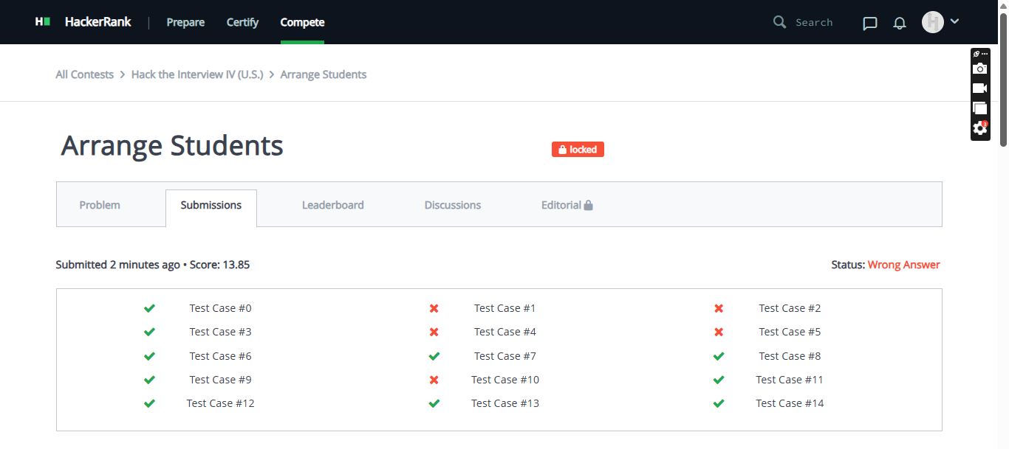
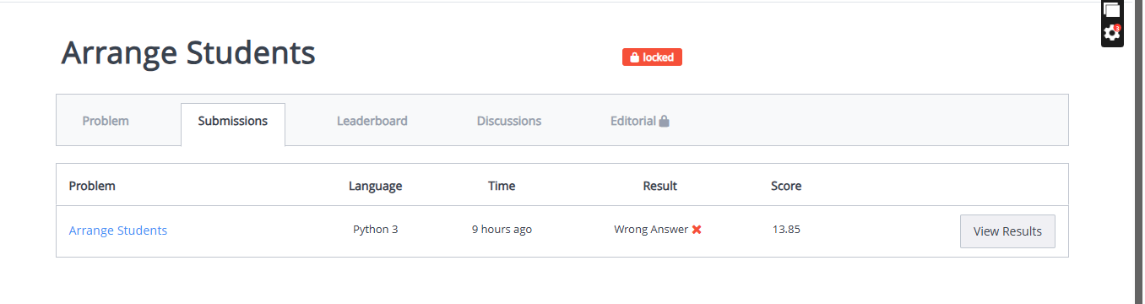
Submitted code:
import sys

def can_arrange(boys, girls, n):
boys.sort()
girls.sort()

# Pattern 1: B, G, B, G, ...
ok1 = True
for i in range(n):
if i == 0:
if boys[0] > girls[0]:
ok1 = False
else:
if boys[i] > girls[i]:
ok1 = False
# Also check that girls[i] >= boys[i-1] (so sequence is non-decreasing)
for i in range(1, n):
if girls[i] < boys[i-1]:
ok1 = False

# Pattern 2: G, B, G, B, ...
ok2 = True
for i in range(n):
if i == 0:
if girls[0] > boys[0]:
ok2 = False
else:
if girls[i] > boys[i]:
ok2 = False
for i in range(1, n):
if boys[i] < girls[i-1]:
ok2 = False

return ok1 or ok2

def main():
input = sys.stdin.read
data = input().split()
t = int(data[0])
idx = 1

results = []
for _ in range(t):
n = int(data[idx]); idx += 1
boys = list(map(int, data[idx:idx+n])); idx += n
girls = list(map(int, data[idx:idx+n])); idx += n

if can_arrange(boys, girls, n):
results.append("YES")
else:
results.append("NO")

print("\n".join(results))

if __name__ == "__main__":
main()
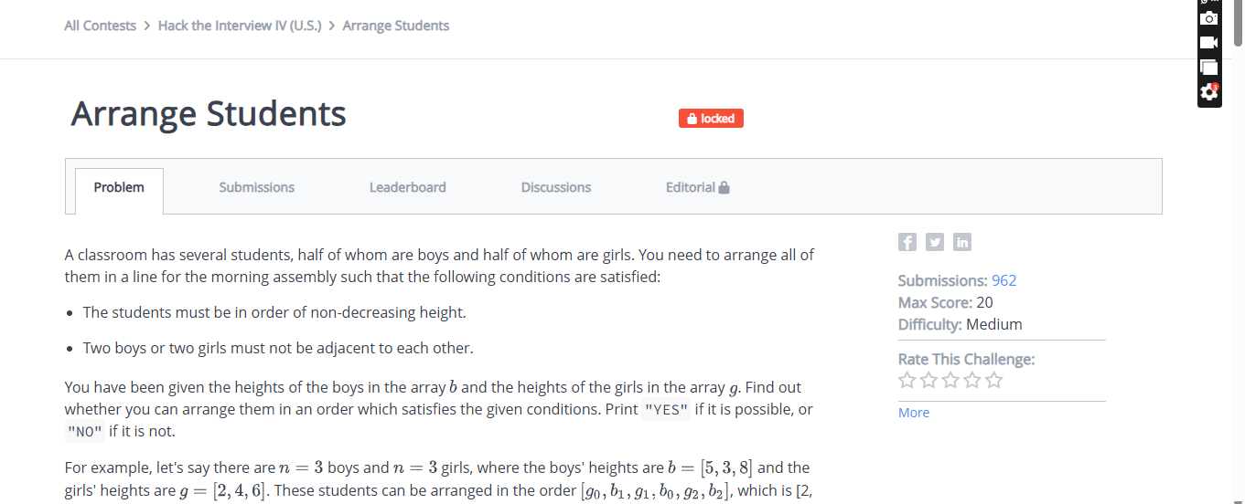
Part-b

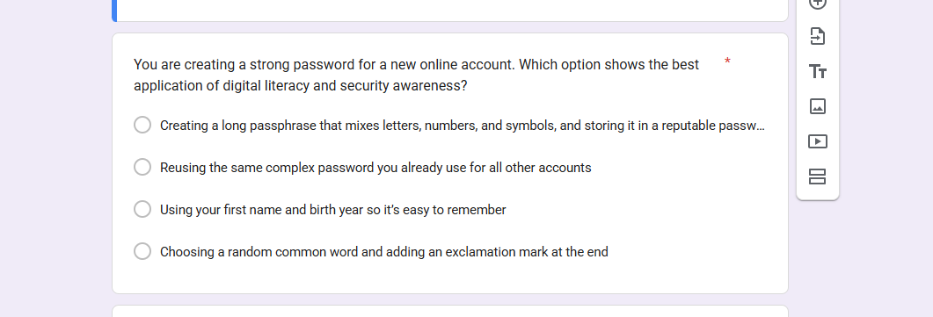


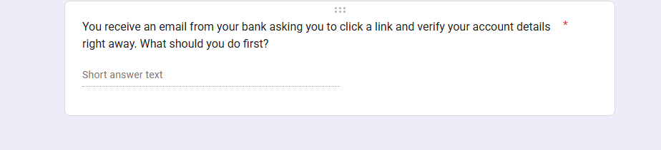
Responses:
