PROJECT REPORT

DIGITAL LITERACY

Name: Gowri Ramesh
Reg.no: 25BCY10100
Branch: CSE (B. Tech Cyber Security and Digital Forensics)
Year: 2025-26
Course Code: CSE0001
Date:

INTRODUCTION

In today’s rapidly evolving digital era, the ability to effectively navigate, evaluate, and create information using digital technologies has become an essential life skill. Digital literacy is no longer limited to basic computer knowledge; it extends to understanding online platforms, communicating professionally, maintaining a responsible digital presence, and ensuring personal safety in the virtual world. As students step into a highly interconnected academic and professional environment, developing strong digital literacy skills is crucial for both personal growth and career readiness.
This project is designed around the role of a Student Digital Ambassador, whose responsibility is to guide peers in adapting to the digital ecosystem efficiently and responsibly. Through this role-based scenario, the project provides a practical and hands-on approach to learning, encouraging the application of theoretical concepts into real-world digital practices. It emphasizes not only the usage of digital tools but also the importance of ethical behavior, online etiquette, and cybersecurity awareness.
The Digital Literacy Portfolio created as part of this project integrates multiple aspects of digital competence. It includes designing an awareness infographic, building a professional digital portfolio across relevant platforms, exploring coding and collaboration tools, understanding formal communication through email etiquette, and analyzing cybercrime scenarios with preventive strategies. Each task contributes to developing a holistic understanding of how digital tools can be used effectively in academic and professional contexts.
Furthermore, this project highlights the importance of creating a strong and responsible digital identity. With employers, educators, and organizations increasingly relying on online profiles and digital footprints, students must learn how to present themselves professionally and securely in the digital space. At the same time, awareness of potential online threats such as phishing, identity theft, and cyber fraud ensures that individuals can protect themselves and others.
Overall, this project serves as a foundation for building essential digital skills that will support students throughout their academic journey and beyond. It encourages critical thinking, creativity, responsible communication, and cybersecurity awareness, all of which are vital in becoming confident and competent participants in the digital world.

TASK-1
I created my presentation slide using Canva, a user-friendly digital design platform that helps in producing visually appealing content. While designing the slide on digital literacy, I explored several useful tools available in Canva. I used pre-designed templates to maintain a clean and professional layout. The text tool helped me organize headings and bullet points effectively, while the font combinations enhanced readability. I also incorporated icons and elements to visually represent ideas like safety, tools, and communication. The color palette feature allowed me to maintain consistency throughout the slide. Additionally, I used the alignment and spacing tools to ensure everything looked balanced and well-structured. Canva’s drag-and-drop interface made the entire process smooth and efficient. Overall, Canva enabled me to combine creativity with clarity, helping me design an informative and visually engaging slide on digital literacy.
This is how my final presentation has turned out:

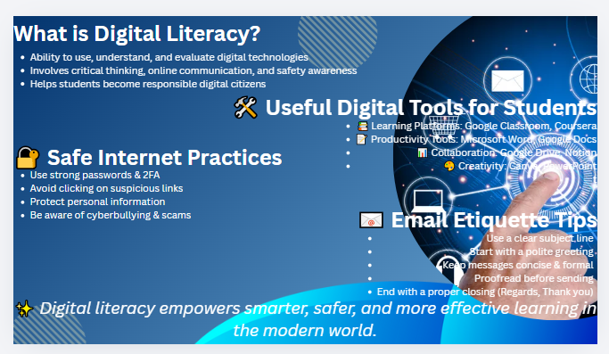

TASK-2
I chose to create accounts on LinkedIn, Kaggle, and GitHub to build a strong foundation in cybersecurity and data-related skills. LinkedIn is a professional networking platform where I can connect with cybersecurity experts, follow industry trends, and apply for internships or jobs over the next four years. Kaggle is a data-science and machine-learning hub where I can practice with real datasets, participate in security-related challenges (for example, attack detection or anomaly detection projects), and improve my analytical thinking. GitHub is a version-control and code-sharing platform where I plan to host cybersecurity projects such as scripts for vulnerability scanning, log analysis, or incident-classification models, and contribute to open-source security tools to gain real-world experience. Over the next four years, I will use LinkedIn to grow my professional network, Kaggle to sharpen my data and security modeling skills, and GitHub to build a visible, high-quality portfolio that demonstrates my cybersecurity expertise. Below given are my accounts that I’ve created:
For Kaggle:
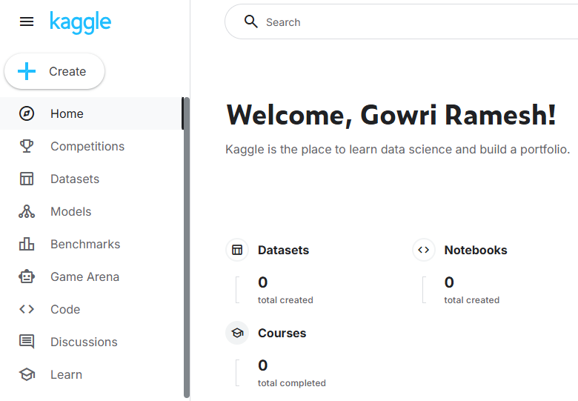
For LinkedIn:
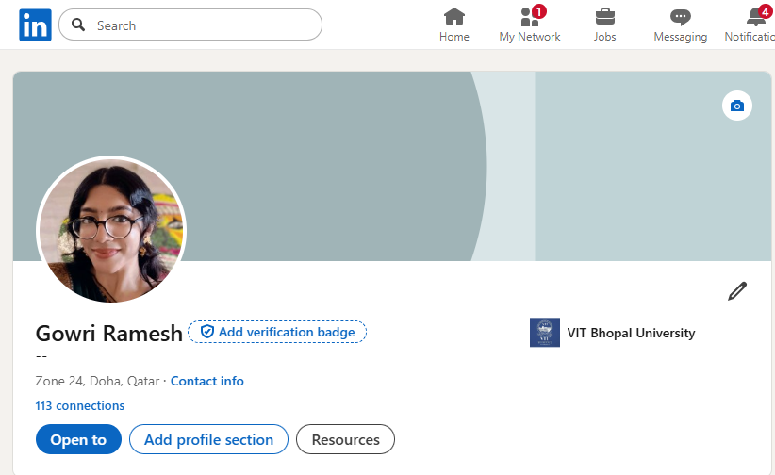

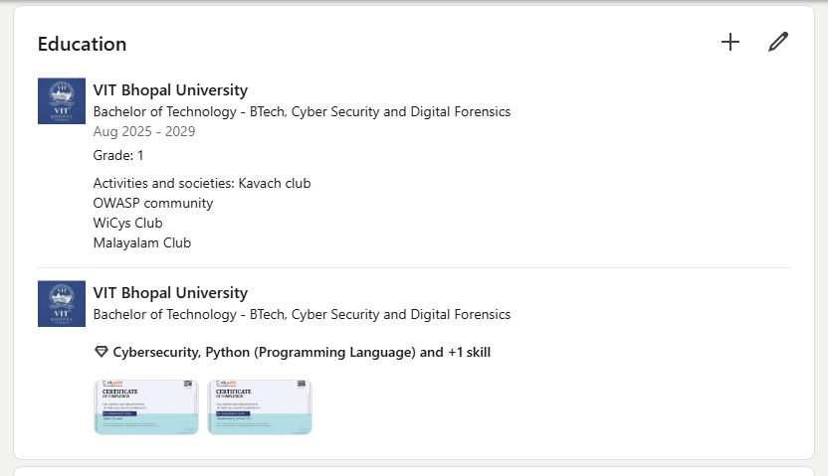
For GitHub:



TASK-3
Part a
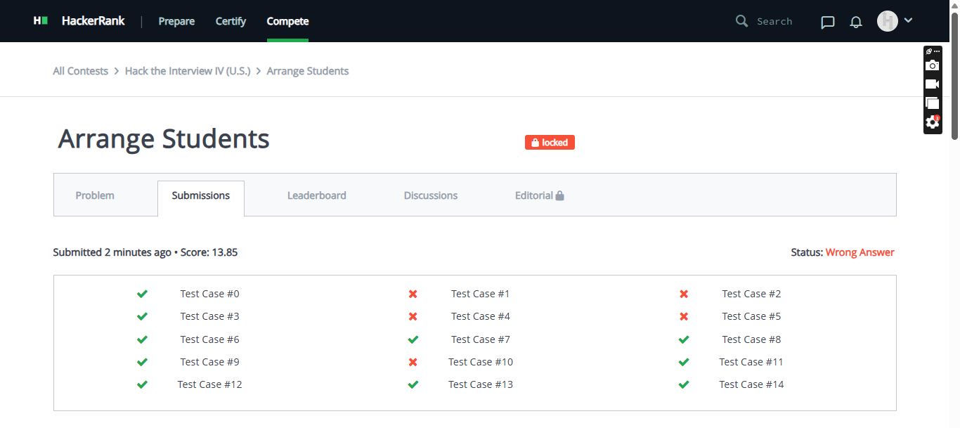
Part b

TASK-4
Part a
Email 1
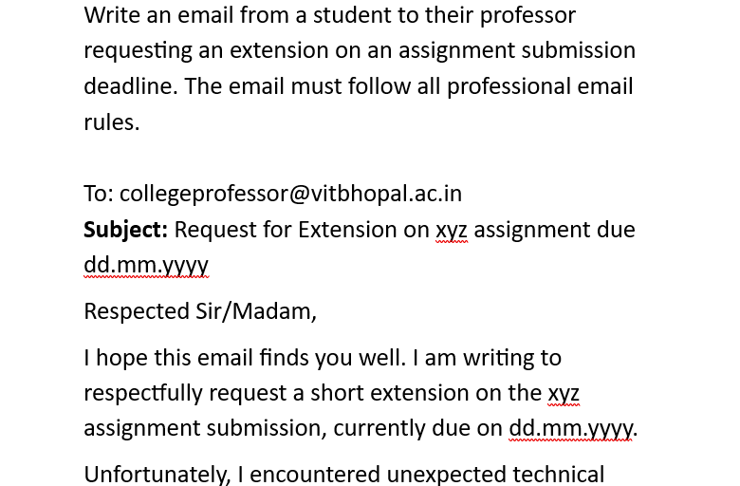
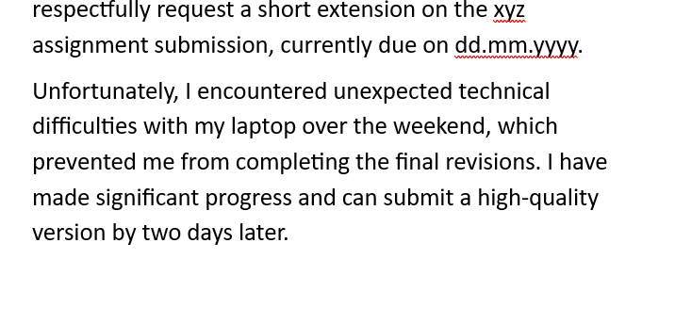
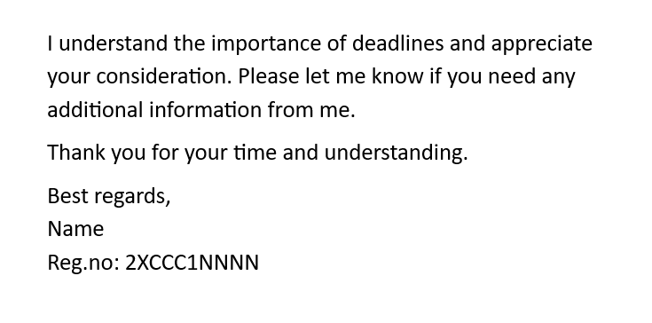
Part a
Email 2
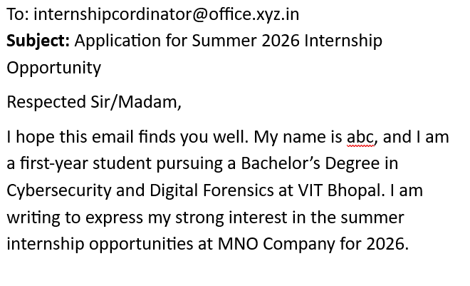
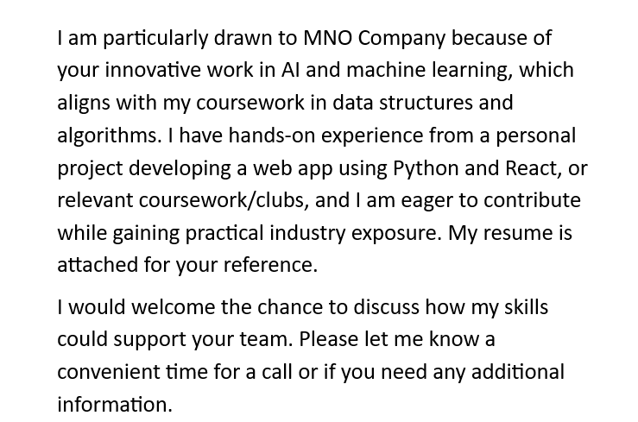
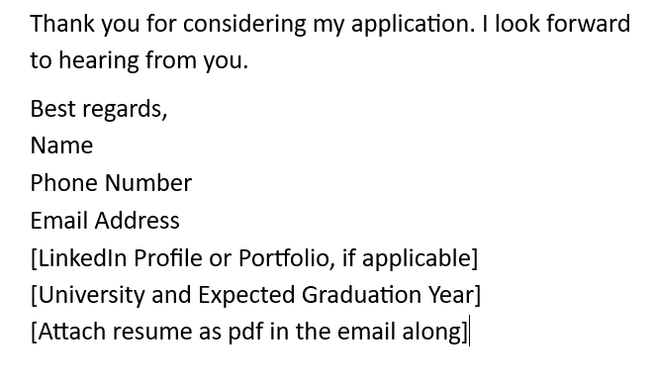
Part-b
The JP Morgan "London Whale" case of 2012 serves as a stark reminder of how poor digital information design can lead to catastrophe. Risk managers relied on convoluted Excel spreadsheets where critical data was buried under dense formatting and manual copy-paste errors. Because the digital communication lacked visual hierarchy and clear summaries, executives failed to see that the bank’s risk was being understated by billions. This technical and communicative breakdown ultimately resulted in a staggering $6.2 billion loss.
To prevent such a disaster, the team should have prioritized scannability by using executive summaries with bolded key metrics rather than raw data alone. Implementing a peer-review protocol for digital files would have ensured that the spreadsheets were interpretable by third parties. Finally, a brief contextual meeting could have bridged the gap between complex data and human understanding, ensuring the "bottom line" was never lost in the cells.

Task-5
Prevention Checklist
What surprised me most during my research was the sheer scale and speed of AI-driven social engineering. In 2026, cybercriminals are using "agentic AI" to launch highly personalized phishing attacks that no longer contain the classic "red flags" like typos or awkward phrasing. I was particularly shocked to learn that AI-generated lures have increased click-through rates by up to 54%, making "gut feelings" about suspicious emails far less reliable than they used to be.
As a result, the habit I am personally changing is my approach to multifactor authentication (MFA). While I previously used SMS-based codes, I’ve learned that "phishing-resistant" MFA—such as hardware security keys or authenticator apps—is now essential to block automated bot attacks. I am also adopting a "pause and verify" rule for any urgent request involving data or money, even if the voice or video looks and sounds exactly like someone I trust.

Conclusion
In conclusion, this Digital Literacy project has provided valuable insights into the importance of effectively using digital tools in today’s academic and professional environments. Through completing the various tasks, I developed a better understanding of creating a professional digital presence, communicating responsibly online, and ensuring safety while navigating the internet. The hands-on experience with platforms like GitHub, online collaboration tools, and design applications enhanced both my technical and practical skills. Additionally, learning about cybercrime and preventive measures has made me more aware and cautious as a digital user. Overall, this project has strengthened my confidence in using digital technologies and highlighted the importance of being a responsible and informed participant in the digital world.

References:
VITyarthi site:
https://vityarthi.b-cdn.net/VITyarthiProjects/CSE0001_Digital_Literacy_Project_Brief.docx.pdf
LinkedIn:
https://www.linkedin.com/in/gowri-ramesh-8824b7378/
GitHub:
gowriramesh61-svg · GitHub
Hacker Rank:
https://www.hackerrank.com/profile/gowri_25bcy10100

