**Domain**

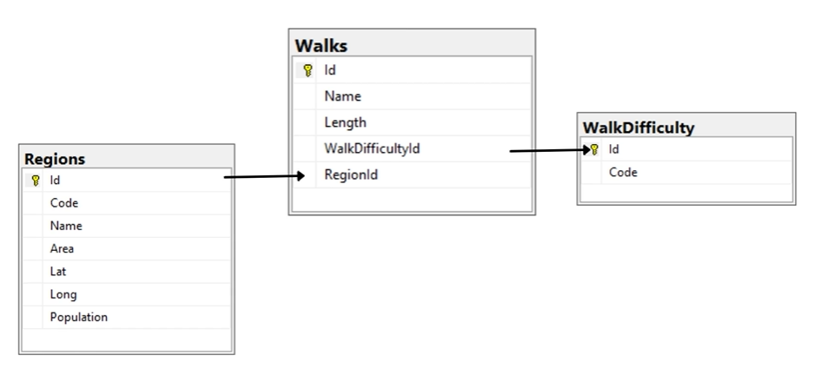

**Fluent Validation**

**NugetPackages**

FluentValidation

FluentValidation.DependencyInjectionExtensions

FluentValidation.AspNetCore

Add the builder service inside program.cs file



**JWT – JSON Web Token**

**NugetPackages**

Microsoft.AspNetCore.Authentication.JwtBearer

Microsoft.IdentityModel.Tokens

System.IdentityModel.Tokens.Jwt

Fetch the AppUrl from application properties.

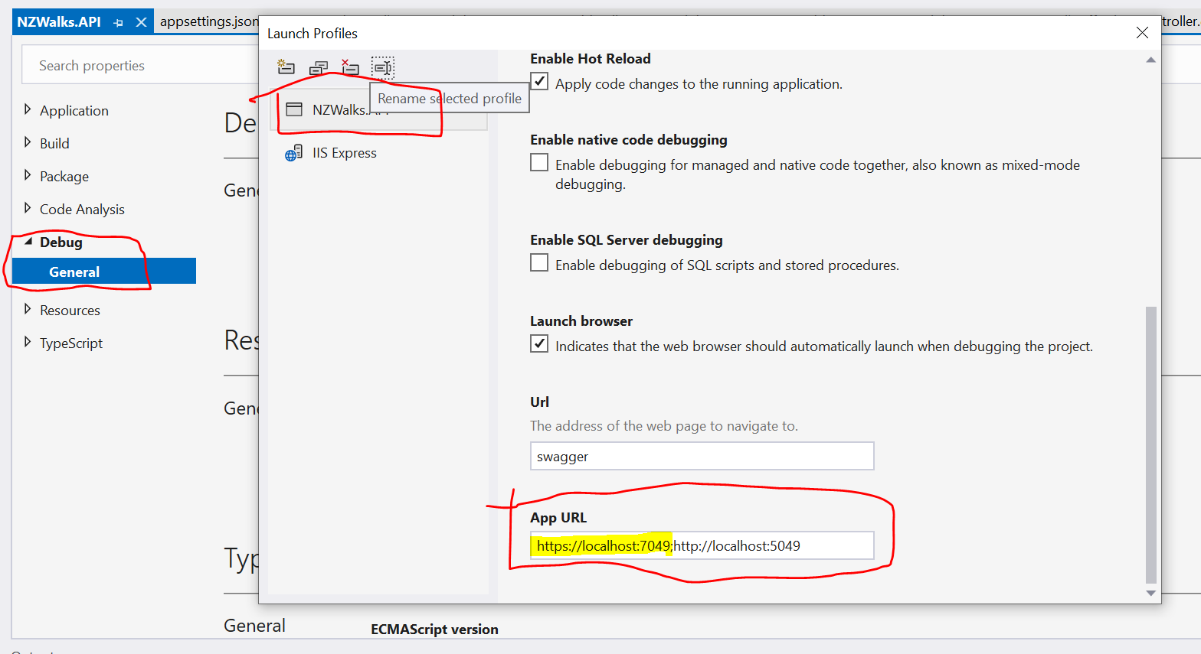

**Add the JWT inside Appsettings.Json**

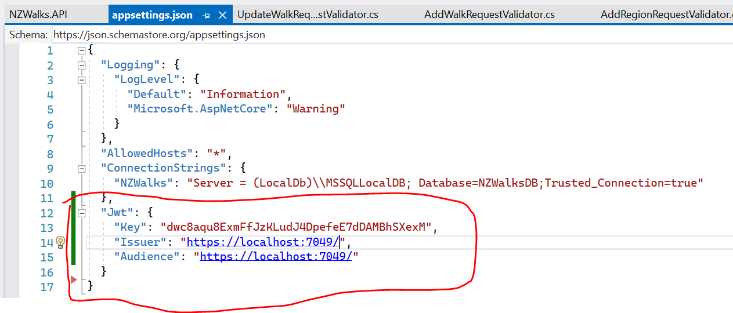

Here Key is a secured one which we are gonna pass with the client and validate. Both issuer and Audience are same in our case. Need to fetch the url from application properties(Mentioned in the previous image)

**Add the config and settings inside program.cs**

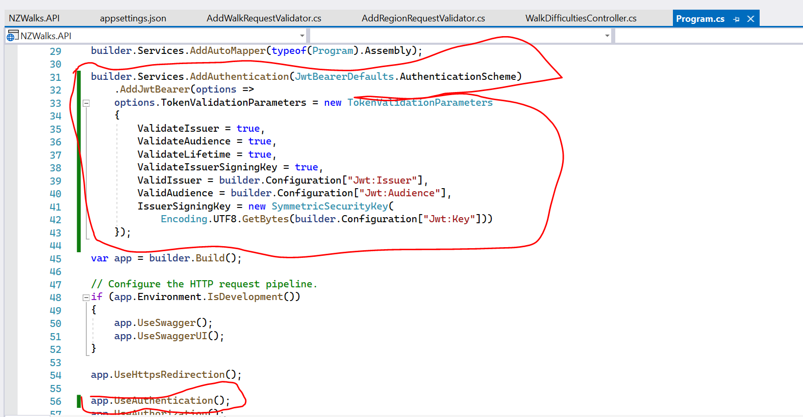

Create a user repository(Static one for hardcoding the user details)

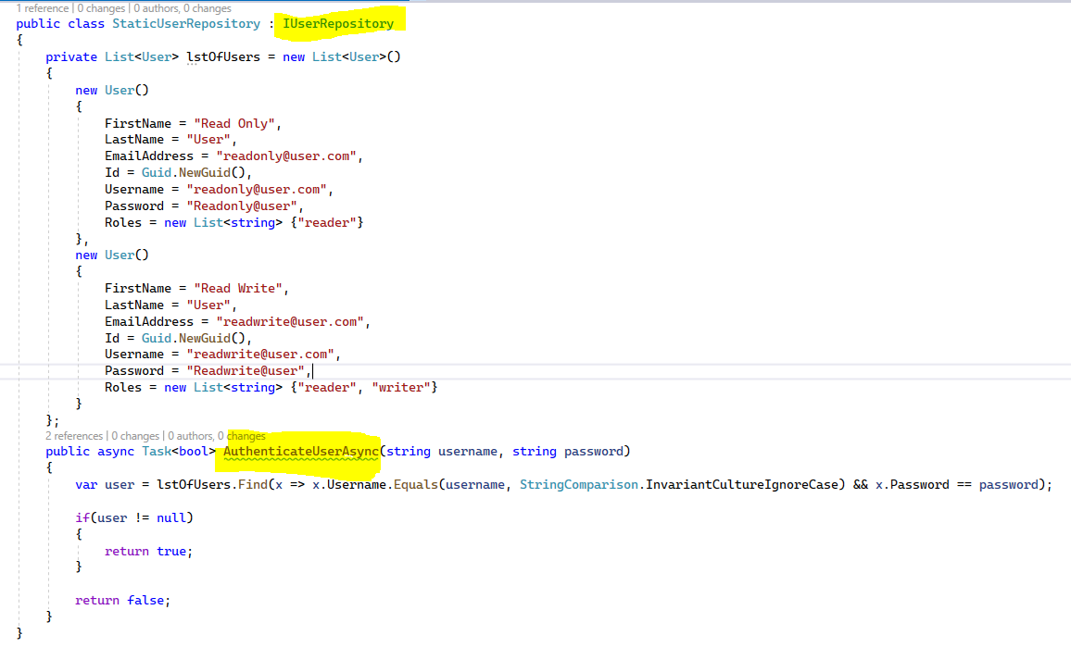

Refer Github and Udemy course video for full implementation.