**Steps for creating branch**

Login to BitBucket

Click on Bill_Prj

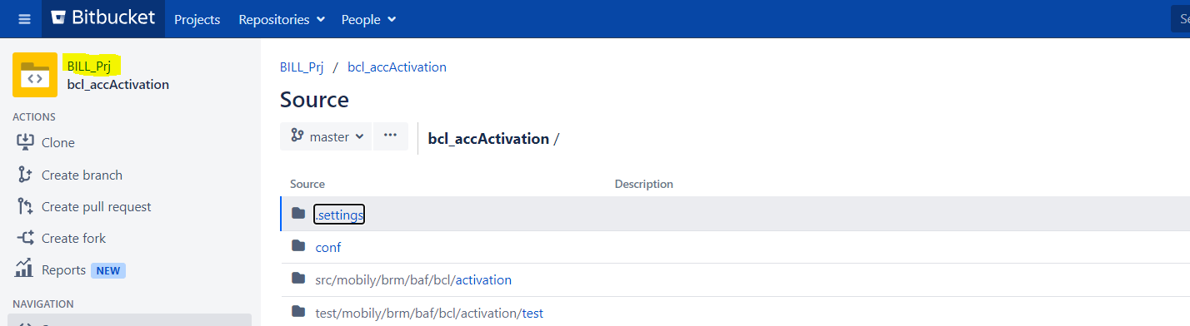

You will find all the repositories

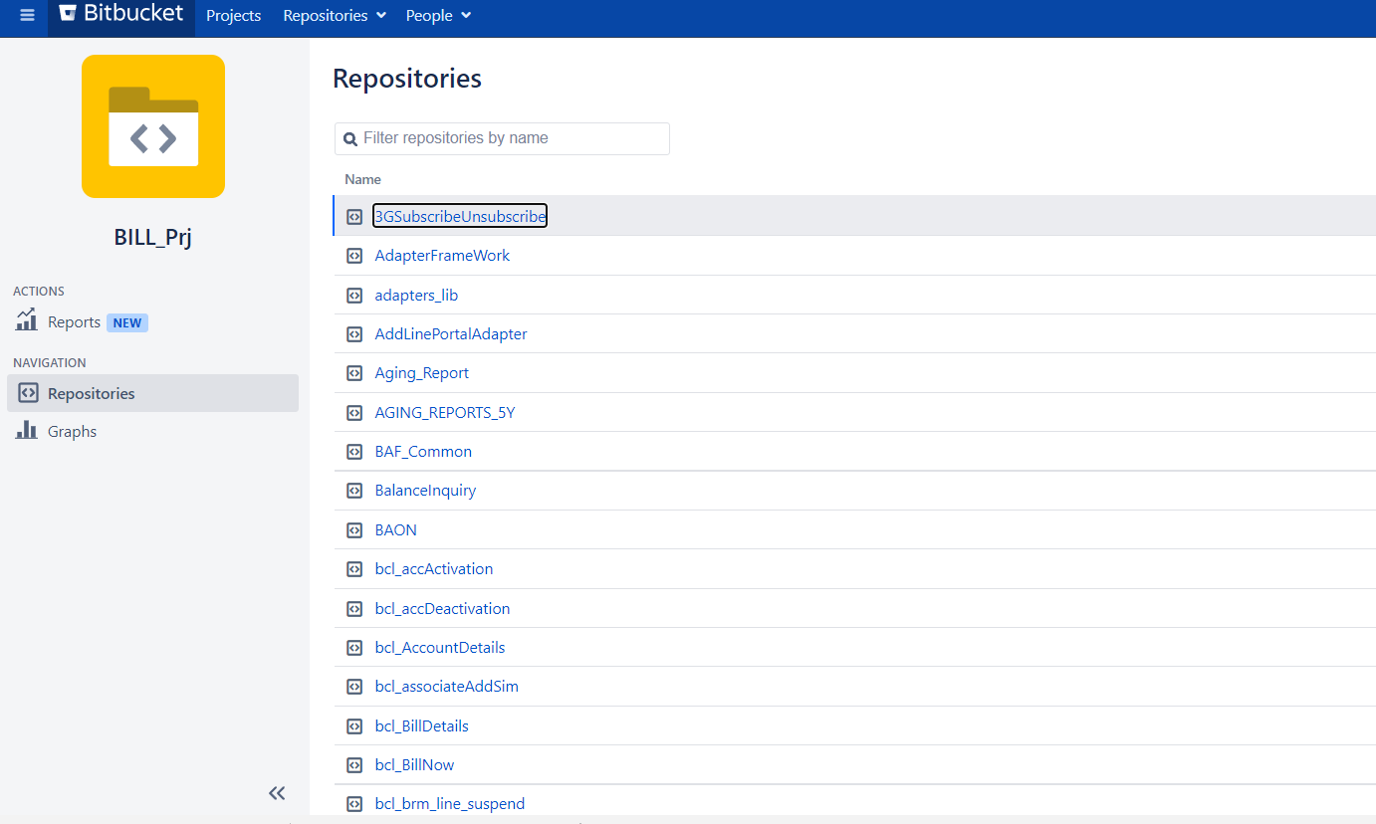

Click on repository for which you need to do changes

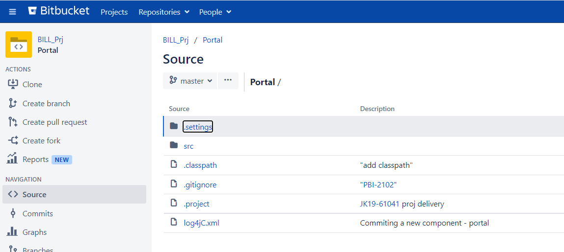

Create new branch by following below steps

Click on create branch

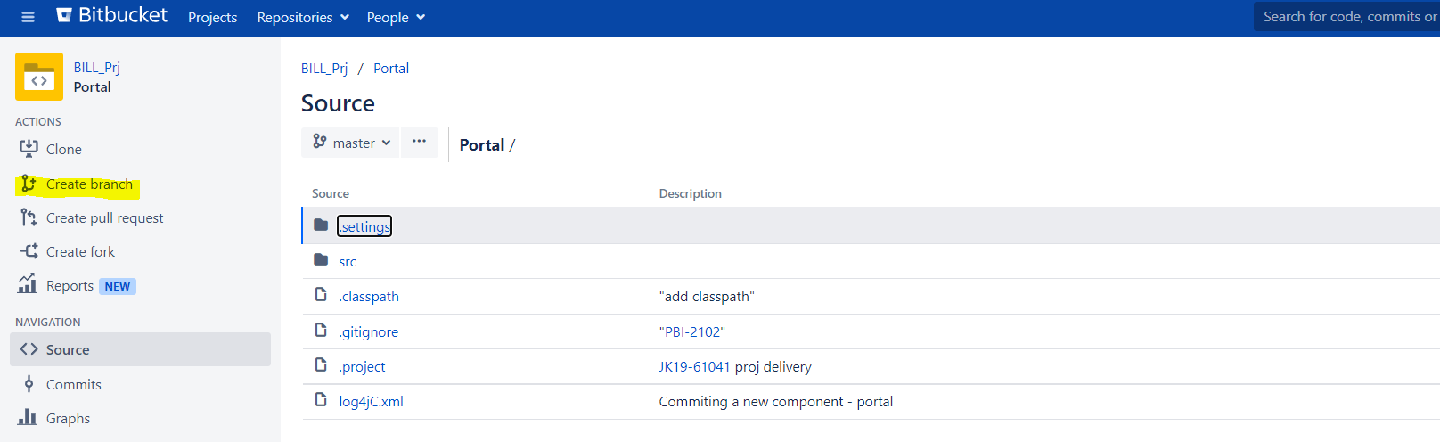

Select branch type to Release

Select branch from : sit/preprod/master

Give any branch name (eg: project name)

Click on create branch

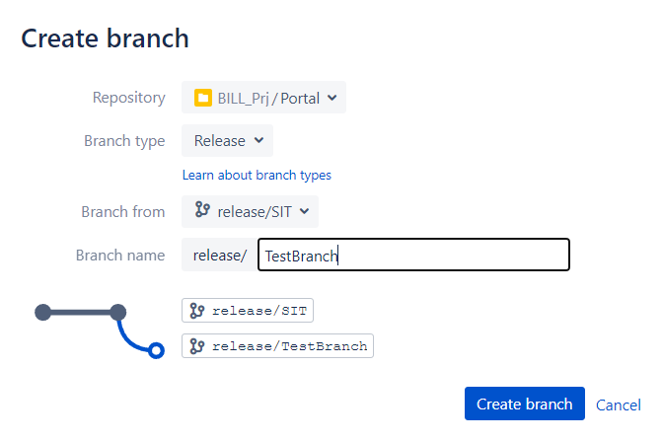

Once branch created follow below steps to clone repository

Click on Copy branch name and paste on below git command after -b

Click on clone and copy the url and paste on below git command

git clone -b release/test123 http://196.10.20.171:7990/scm/bil/portal.git

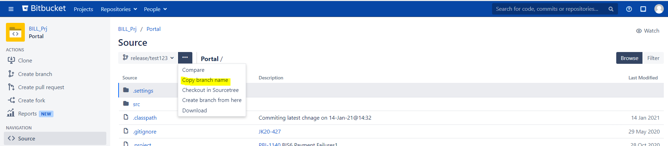

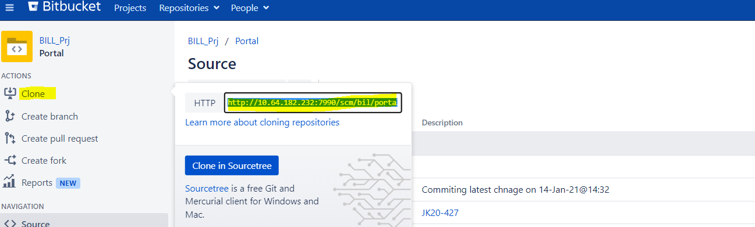

Create any project folder

Right click you will find Git Bash Here

Click on Git Bash Here

Black window will open

Copy and paste above git command which was having branch name and clone url

Then press enter from key bord

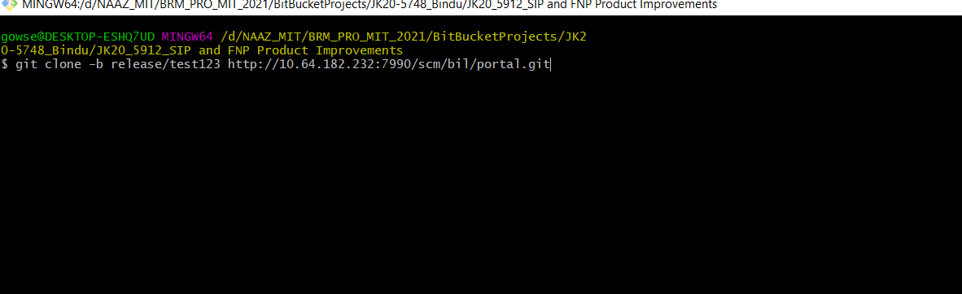

Project will download in your machine.

Import project in STS

Do the changes

**Steps for committing changes in Bitbucket**

Go to repository folder , Repository folder will looks like below , right click inside the folder you will find Git Bash here , click on Git Bash here black window will open then follow below steps

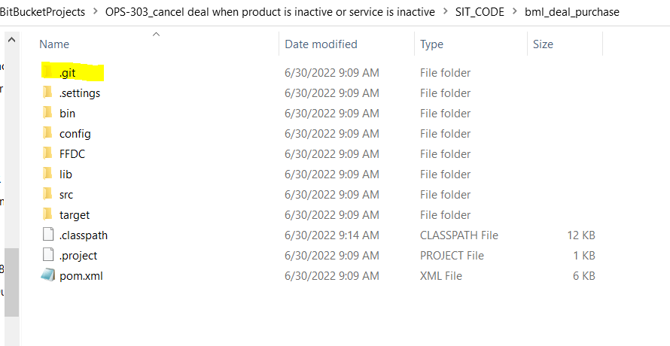

Below command to check which are the files modified

$ git status

Below command to add the files which we need to commit to bit bucket

$ git add src/mobily/brm/baf/common/headers/BAF_HEADERS.java

Below command to commit changes to bit bucket

$ git commit -m "JK19-50989_appleCarePlus"

Below command to push changes to your branch in Bitbucket

$ git push

Below command to merge the code

For sit stream

$ git pull origin release/SIT

For preprod steam

$ git pull origin release/PREPROD

For master stream

$ git pull origin master

Go to Bitbucket

Click on Create pull Request

Then select your branch name(where your changes are there) and to which branch you need to push the code (SIT/PREPROD/master)

NOTE: Perform this step carefully

Then click on continue

Then click on create

Once you click on create right side of the window you will find Merge button, click on merge button and then ok.

Changes will be committed globally

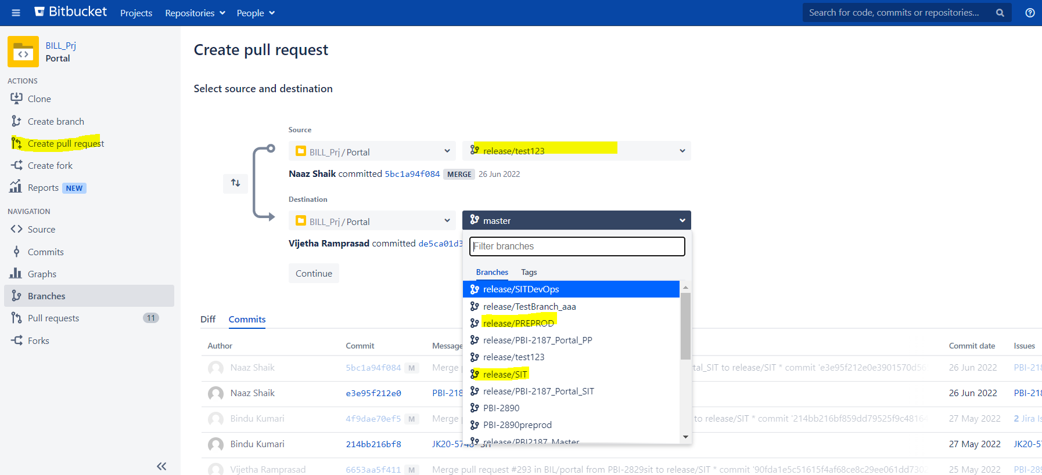

You can view your changes by clicking commits button

