## FULL STACK WEB APPLICATION DEVELOPMENT PROJECT REPORT

**CivicWatch**

## A project report submitted as part of Project-Based Learning

### Submitted By

**Name: Rollno:**

**Under the Guidance of [](https://tinyurl.com/4a87fdpn)**

**Dr. K. Jyothsna Devi** <https://tinyurl.com/4a87fdpn>

### Assistant Professor

**Department of Computer Science and Engineering**

### PRASAD V POTLURI SIDDHARTHA INSTITUTE OF TECHNOLOGY

(Permanently affiliated to JNTU: Kakinada, Approved by AICTE)

(An NBA & NAAC A+ accredited and ISO certified institution)

**Kanuru, Vijayawada - 520007**

**(2025-2026)**

**PRASAD V POTLURI**

# SIDDHARTHA INSTITUTE OF TECHNOLOGY

(Permanently affiliated to JNTU :: Kakinada, Approved by AICTE) (An NBA & NAAC A+ accredited and ISO certified institution) **Kanuru, Vijayawada – 520007**



# CERTIFICATE

This is to certify that the project report titled **“CivicWatch”** is the Bonafide

work of D. Gowtham (23501A0530), D. Gopi Kiran (24505A0505), A. Hemanth Kumar (23501A0503), and G. Praneeth Sai (23501A0540) as part of Project Based Learning for the Full Stack Development course in III B. Tech I Sem during the academic year 2025-2026.

### Signature of the Incharge Signature of the HOD

**Dr. K. Jyothsna Devi Dr. A. Jayalakshmi**

Asst. Professor, CSE Dept. Head, Department of CSE.

**INDEX**

|  |  |  |
| --- | --- | --- |
| **S.No** | **Content** | **Page No. (s)** |
| 1 | Abstract |  |
| 1 | SDG addressed report |  |
| 3 | Introduction |  |
| 4 | Objectives and Scope of the Project |  |
| 5 | Software used |  |
| 6 | Backend |  |
| 7 | Web Pages |  |
| 8 | Sample Code |  |
| 9 | Result/Output Screen shots |  |
| 10 | Conclusion |  |
| 11 | Reference URLs |  |

**Abstract**

CivicWatch represents a paradigm shift in civic engagement and urban governance, serving as a comprehensive digital platform that revolutionizes how communities interact with local government authorities. This innovative system addresses the critical gap in citizen-government communication by providing a sophisticated, user-centric solution for reporting, tracking, and resolving civic issues across diverse urban environments. The platform operates on a dual-interface architecture, seamlessly integrating citizen-facing and administrative functionalities where citizens access an intuitive web portal for effortless issue submission with multimedia documentation, geolocation services, and real-time status tracking, while government administrators utilize a powerful dashboard with advanced filtering, analytics, and workflow management tools to efficiently process, prioritize, and resolve community concerns.

Built upon a robust full-stack JavaScript foundation, CivicWatch leverages React.js 18.2.0 for dynamic frontend interactions, Node.js with Express.js for scalable backend operations, and MongoDB for flexible data management. The system implements enterprise-grade security through JWT-based authentication, bcrypt password encryption, and comprehensive input validation protocols, ensuring optimal performance across desktop, tablet, and mobile devices. The platform features multi-modal issue reporting with text descriptions, high-resolution images, priority classifications, and precise location data, supported by an intelligent categorization system that organizes issues into predefined categories including Infrastructure, Public Safety, Environmental, Utilities, and Other classifications.

Real-time status tracking keeps citizens informed throughout the resolution lifecycle while interactive mapping provides visual representation of community issues with color-coded priority indicators, supported by streamlined administrative workflows and comprehensive analytics dashboards. CivicWatch transcends traditional complaint management systems by incorporating modern web technologies, user experience design principles, and data-driven governance approaches that facilitate evidence-based decision making through comprehensive analytics, promote community engagement through transparent processes, and enhance government accountability through detailed audit trails and performance metrics.

The platform exemplifies modern software engineering principles through component-based React.js architecture with hooks for state management, TailwindCSS utility-first styling for rapid UI development, and Express.js middleware patterns for modular request processing. MongoDB's document-based storage is optimized for civic data patterns with strategic indexing, while Recharts visualization library provides actionable insights into community trends and service delivery performance.

**SDG ADDRESSED REPORT**

Sustainable Development Goals (SDGs) are a set of global objectives established by the United Nations to address critical issues affecting humanity and the planet. Among the 17 SDGs, SDG 11: Sustainable Cities and Communities focuses on making cities and human settlements inclusive, safe, resilient, and sustainable. Urban governance systems worldwide face significant challenges, including inadequate citizen engagement mechanisms, inefficient issue resolution processes, delayed responses to community problems, and limited transparency in government operations, particularly in rapidly growing urban areas.

Digital transformation of civic engagement services through web-based solutions can play a critical role in overcoming these challenges. The CivicWatch Community Issue Reporting System developed using the MERN stack (MongoDB, Express.js, React.js, Node.js) directly contributes to achieving SDG 11 by enhancing municipal operational efficiency, reducing administrative burdens, improving citizen accessibility, and promoting the delivery of timely and quality public services. By automating civic processes such as issue reporting, status tracking, administrative workflows, and analytics generation, the system ensures accurate and streamlined service delivery.

**Alignment with SDG 11 Goals**

The CivicWatch system contributes to SDG 11 in multiple ways:

1. **Improving Access to Quality Public Services:**

The system ensures that citizens can access municipal services more efficiently through online issue reporting, digital status tracking, and real-time notifications. This reduces response times, ensures timely resolution, and improves citizen satisfaction with government services.

2. **Enhancing Municipal Operational Efficiency:**

Government agencies face significant administrative challenges due to manual record-keeping and paperwork. By automating these processes, CivicWatch reduces errors, ensures consistent data management, and allows municipal staff to focus more on issue resolution and community service.

3. **Ensuring Data Accuracy and Security:**

Sensitive civic data is securely stored using MongoDB, while authentication and encryption mechanisms (JWT and bcrypt) ensure confidentiality. Accurate digital records support better decision-making, resource allocation, and long-term urban planning initiatives.

4. **Promoting Proactive Governance:**

With structured records and analytics capabilities, the system enables predictive maintenance, trend analysis, and proactive issue prevention, thereby encouraging preventive governance practices and reducing the risk of community problems escalating due to neglect or delay.

5. **Reducing Inequalities in Public Service Access:**

By providing an online, role-based system accessible to citizens and staff remotely, CivicWatch contributes to reducing disparities in public service availability, particularly in regions where government offices are overburdened or underserved.

**Implementation and Impact**

The CivicWatch implementation demonstrates the practical integration of technology with urban governance goals:

• **Citizen Module:** Citizens can register online, report issues with multimedia documentation, and track resolution progress. This facilitates continuous engagement and reduces unnecessary visits to government offices.

• **Administrative Module:** Government officials can review issue details, update status information, and manage workflows efficiently. Real-time access to data enables informed decision-making and resource allocation.

• **Analytics Module:** Municipal administrators can oversee operations, generate performance reports, manage departmental assignments, and monitor overall civic service delivery.

**Impact on SDG 11:**

• **Timely Response:** Citizens receive faster acknowledgment and resolution of civic issues, improving community satisfaction and urban livability.

• **Reduced Errors:** Automated record management minimizes human errors in issue tracking and administrative processes.

• **Increased Productivity:** Staff can focus more on issue resolution rather than administrative tasks, improving overall municipal performance.

• **Data-Driven Urban Planning:** Structured digital records support evidence-based policy making, urban planning, and long-term community development.

**Future Contributions Towards SDG 11**

The CivicWatch system establishes a foundation for sustainable and innovative urban governance. Future expansions may include:

1. **Smart City Integration:** Connecting with IoT sensors and smart infrastructure to provide real-time monitoring of urban conditions and automated issue detection.

2. **AI-Assisted Issue Classification:** Using data analytics and machine learning to automatically categorize issues, predict resolution times, and optimize resource allocation.

3. **Community Engagement Platform:** Expanding to include public forums, participatory budgeting, and collaborative urban planning features.

4. **Environmental Monitoring Integration:** Real-time tracking of air quality, noise levels, and environmental hazards with automated alerts and response protocols.

By continuously leveraging technology and expanding digital governance capabilities, CivicWatch can significantly contribute to achieving the broader targets of SDG 11, ensuring inclusive, safe, resilient, and sustainable cities and communities globally.

**Introduction**

**Global Urban Challenges:**

Urban communities worldwide face an unprecedented array of challenges in the 21st century, with over 68% of the global population expected to live in cities by 2050. These rapidly growing urban centers struggle with aging infrastructure, increasing population density, environmental degradation, and the complex task of delivering quality public services to diverse communities. Traditional civic engagement mechanisms, developed for smaller, less complex societies, have proven inadequate for addressing the scale and complexity of modern urban governance challenges.

**The Digital Divide in Civic Engagement:**

Conventional methods of reporting civic issues—phone calls, physical visits to government offices, paper-based complaint systems—create significant barriers to citizen participation. These outdated processes often involve bureaucratic complexity through multi-step procedures requiring citizens to navigate complex administrative hierarchies, while limited accessibility creates physical and temporal constraints that exclude working families, elderly citizens, and individuals with disabilities. Information asymmetry prevents citizens from having visibility into issue status, resolution timelines, and government response protocols, compounded by resource inefficiency from manual processing systems that waste both citizen time and government resources. Additionally, accountability gaps exist due to the absence of transparent tracking mechanisms that enable performance evaluation.

**The CivicWatch Revolution:**

CivicWatch emerges as a transformative solution that leverages cutting-edge web technologies to reimagine the relationship between citizens and government. This comprehensive platform represents more than a simple digitization of existing processes—it fundamentally restructures civic engagement to be more inclusive, efficient, and transparent.

**Comprehensive Problem Analysis:**

Communication inefficiencies arise when traditional systems create information silos between departments, forcing citizens to contact multiple agencies for single issues while lack of standardized communication protocols leads to inconsistent responses. Language barriers and accessibility issues exclude marginalized communities, compounded by the absence of centralized knowledge bases for common issues and solutions. Transparency deficits prevent citizens from tracking the progress of their submitted issues while government decision-making processes remain opaque, with no public visibility into resource allocation and priority setting, absence of performance metrics and accountability measures and limited feedback mechanisms for service quality assessment.

Response time delays occur due to manual routing and assignment processes that slow initial response, while lack of priority classification leads to inefficient resource allocation and inter-departmental coordination challenges cause unnecessary delays. The absence of automated escalation procedures for urgent issues and lack of predictive analytics to anticipate and prevent problems further compound these delays. Citizen engagement barriers include complex reporting procedures that discourage participation, limited awareness of available government services and resources, absence of incentive structures to encourage community involvement, lack of feedback loops that demonstrate citizen impact, and digital literacy gaps that exclude certain demographic groups.

Data-driven governance gaps manifest through lack of comprehensive data collection and analysis capabilities, absence of integration between different government information systems, and lack of predictive modeling for proactive governance. Limited performance measurement and continuous improvement processes, combined with absence of evidence-based policy development frameworks, prevent municipalities from leveraging data for better decision-making and service delivery optimization.

**Innovative Solution Framework:**

CivicWatch addresses these multifaceted challenges through an integrated technology platform that:

CivicWatch democratizes access through mobile-responsive design that ensures accessibility across all devices, while intuitive user interfaces reduce barriers to participation and multi-language support accommodates diverse communities. Offline capability enables reporting in areas with limited connectivity, complemented by integration with social media platforms that expands reach and engagement across different demographic groups.

The platform enhances transparency by providing real-time status tracking that offers continuous visibility into issue resolution, while public dashboards display community-wide statistics and trends. Automated notifications keep citizens informed throughout the process, supported by open data APIs that enable third-party applications and civic innovation, with performance metrics creating accountability for government agencies.

Efficiency optimization occurs through automated routing and assignment based on issue type and location, while priority classification algorithms ensure urgent issues receive immediate attention. Integration with existing government systems eliminates duplicate data entry, workflow automation reduces manual processing time and errors, and resource optimization through data-driven allocation strategies maximizes municipal effectiveness.

Data-driven governance capabilities include comprehensive analytics that provide insights into community needs and trends, predictive modeling that enables proactive issue prevention, and performance dashboards that support evidence-based decision making. Integration capabilities allow connection with smart city infrastructure while machine learning algorithms improve system efficiency over time.

**Strategic Vision:**

CivicWatch serves as more than a technological solution—it represents a fundamental shift toward participatory governance and smart city development. The platform creates a foundation for collaborative governance where citizens become active partners in community development, while evidence-based policy development utilizes data-driven insights to inform strategic planning and resource allocation. Continuous improvement occurs through feedback loops that enable iterative enhancement of public services, supported by an innovation ecosystem where open architecture facilitates third-party development and civic technology innovation. The platform also promotes sustainable development through efficient resource utilization and comprehensive environmental monitoring capabilities.

This comprehensive approach positions CivicWatch as a catalyst for urban transformation, demonstrating how technology can bridge the gap between citizens and government while promoting transparency, accountability, and collaborative community improvement. The platform's modular architecture and scalable design ensure adaptability to diverse urban contexts while maintaining consistency in core functionality and user experience.

**Objectives and Scope**

**Primary Objectives:**

The project aims to streamline civic issue reporting by developing an intuitive interface for citizens to report various civic issues, implementing image upload functionality for visual documentation, and enabling location-based issue reporting with map integration. Administrative efficiency enhancement involves creating a centralized dashboard for issue management, implementing automated issue categorization and assignment, and providing real-time status tracking and updates throughout the resolution process.

Transparency and accountability promotion includes offering public visibility into issue resolution processes, generating analytical reports for performance monitoring, and maintaining comprehensive audit trails for all activities. Citizen engagement improvement focuses on providing personalized dashboards for issue tracking, implementing notification systems for status updates, and enabling feedback mechanisms for service quality assessment that foster continuous improvement in municipal services.

**Project Scope:**

The project scope includes comprehensive features such as user registration and authentication system that ensures secure access, issue submission with multimedia support for detailed documentation, and administrative dashboard with filtering and search capabilities for efficient management. Real-time status updates and notifications keep all stakeholders informed, while analytics and reporting functionality provides insights for decision-making. Mobile-responsive design ensures cross-device compatibility, role-based access control differentiates between citizens and administrators, and data visualization capabilities present trends and insights in accessible formats.

**Future Enhancements:**

**Phase 1: Core Platform Extensions (0-6 months)**

- **Native Mobile Application**: iOS and Android apps with offline capability and push notifications

- **Advanced GIS Integratio**: Google Maps API, OpenStreetMap, and custom mapping solutions

- **Enhanced Notification System**: SMS, email, and in-app notifications with user preference controls

- **Multi-language Support**: Internationalization framework supporting 10+ languages

- **API Gateway**: RESTful and GraphQL APIs for third-party integrations

**Phase 2: Intelligence and Automation (6-12 months)**

- **AI-Powered Categorization**: Machine learning algorithms for automatic issue classification

- **Predictive Analytics**: Trend analysis and proactive issue identification

- **Chatbot Integration**: AI-powered customer service for common inquiries

- **Advanced Search**: Elasticsearch integration for complex query capabilities

- **Workflow Automation**: Business process automation for routine administrative tasks

**Phase 3: Smart City Integration (12-18 months)**

- **IoT Sensor Integration**: Real-time data from environmental and infrastructure sensors

- **Government Database Integration**: Seamless connection with existing municipal systems

- **Blockchain Implementation**: Immutable audit trails and transparent governance records

- **Advanced Analytics Platform**: Business intelligence dashboard with custom reporting

- **Citizen Engagement Portal**: Community forums, voting systems, and collaborative planning tools

**Phase 4: Advanced Governance Features (18-24 months)**

- **Augmented Reality**: AR-based issue reporting and visualization

- **Voice Recognition**: Voice-to-text reporting and accessibility features

- **Social Media Integration**: Automated monitoring and response to social media reports

- **Performance Benchmarking**: Comparative analysis with other municipalities

- **Citizen Satisfaction Surveys**: Automated feedback collection and analysis systems

The technical scope encompasses web-based application architecture that ensures accessibility across platforms, RESTful API design that follows industry standards for interoperability, and database design and optimization for efficient data management. Security implementation with JWT authentication protects user data and system integrity, while responsive UI/UX design provides optimal user experience across devices. Performance optimization and scalability considerations ensure the system can handle growing user bases and expanding functionality requirements.

**Software Used**

**Frontend Technologies:**

- **React.js 18.2.0** - Primary JavaScript library for building user interfaces

- **React Router 6.8.0** - Declarative routing in React applications

- **TailwindCSS 3.2.0** - Utility-first CSS framework for styling

- **Lucide React 0.263.1** - Icon library for modern web applications

- **Recharts 2.5.0**- Composable charting library for React-based data visualization

**Backend Technologies:**

- **Node.js 18.x** - JavaScript runtime environment

- **Express.js 4.18.0** - Web application framework for Node.js

- **MongoDB 6.0** - NoSQL document database

- **Mongoose 7.0.0** - MongoDB object modeling for Node.js

- **JWT (jsonwebtoken 9.0.0)** - JSON Web Token implementation for authentication

- **bcrypt 5.1.0** - Password hashing

- **Multer 1.4.5** - Middleware for handling multipart/form-data including file uploads

**Development Tools:**

- **Visual Studio Code** - Integrated development environment

- **Postman** - API development and testing

- **MongoDB Compass** - GUI for MongoDB database management

- **Git** - Version control

- **npm** - Package manager for Node.js

**Additional Libraries:**

- **cors 2.8.5** - Cross-Origin Resource Sharing middleware

- **dotenv 16.0.0** - Environment variable management

- **nodemon 2.0.20** - Development server with auto-restart capabilities

- **concurrently 7.6.0** - Running multiple commands simultaneously

**Database Implementation:**

- **MongoDB Atlas** - Cloud-hosted MongoDB service

- **Collections:** Users, Reports, Categories, Admins, and Comments

**Deployment and Hosting:**

- **Frontend Hosting:** Netlify

- **Backend Deployment:** Render

- **Database Services:** MongoDB Atlas

**Backend**

**Architecture Overview:**

The backend follows a RESTful API architecture built with Node.js and Express.js, implementing the MVC (Model-View-Controller) pattern for organized code structure.

**Database Schema:**

**User Model:**

{

  name: String (required),

  email: String (required, unique),

  password: String (required, hashed),

  phone: String,

  address: String,

  role: String (default: 'user'),

  createdAt: Date,

  updatedAt: Date

}

**Report Model:**

{

  title: String (required),

  description: String (required),

  category: ObjectId (ref: Category),

  location: String,

  priority: String (Low/Medium/High),

  status: String (Pending/In Progress/Resolved),

  images: [String],

  userId: ObjectId (ref: User),

  assignedTo: String,

  createdAt: Date,

  updatedAt: Date

}

**Category Model:**

{

  name: String (required, unique),

  description: String,

  createdAt: Date

}

**Admin Model:**

{

  username: String (required, unique),

  email: String (required, unique),

  password: String (required, hashed),

  role: String (default: 'admin'),

  isActive: Boolean (default: true),

  createdAt: Date

}

**Comment Model:**

{

  reportId: ObjectId (ref: Report),

  userId: ObjectId (ref: User),

  content: String (required),

  createdAt: Date

}

The API endpoints include authentication routes such as POST `/api/auth/register` for user registration, POST `/api/auth/login` for user login, GET `/api/auth/profile` for retrieving user profiles, and PUT `/api/auth/profile` for updating user profile information. Report routes encompass GET `/api/reports` for retrieving all reports with filtering capabilities, POST `/api/reports` for creating new reports, GET `/api/reports/:id` for accessing specific reports, PUT `/api/reports/:id` for updating reports, DELETE `/api/reports/:id` for removing reports, and GET `/api/reports/user/:userId` for retrieving user-specific reports.

Admin routes include POST `/api/admin/login` for admin authentication, GET `/api/admin/dashboard` for dashboard statistics, PUT `/api/admin/reports/:id/status` for updating report status, and GET `/api/admin/analytics` for analytics data. Category routes comprise GET `/api/categories` for retrieving all categories and POST `/api/categories` for creating new categories (admin only access).

Middleware implementation includes authentication middleware for JWT token verification, authorization middleware for role-based access control, file upload middleware using Multer configuration for image uploads, error handling middleware for centralized error management, and CORS middleware for cross-origin request handling. Security features encompass password hashing using bcrypt, JWT token-based authentication, comprehensive input validation and sanitization, rate limiting for API endpoints, and secure HTTP headers implementation to protect against common vulnerabilities.

**Webpages**:

**Citizen Interface:**

- **Home Page (`/`)** - Interactive map with reported issues and quick access to report submission

- **Login/Register (`/login`, `/register`)** - User authentication and registration forms

- **Report Form (`/report`)** - Issue submission with category selection, location, and image upload

- **My Reports (`/my-reports`)** - Personal dashboard with status tracking and filtering

- **Profile (`/profile`)** - User profile management and settings

**Administrative Interface:**

- **Admin Login (`/admin/login`)** - Secure administrator authentication

- **Admin Dashboard (`/admin/dashboard`)** - Overview statistics and key performance metrics

- **Admin Reports (`/admin/reports`)** - Report management with filtering and status updates

- **Admin Analytics (`/admin/analytics`)** - Data visualization and trend analysis

**Design Features:**

- Mobile-responsive design with touch-friendly interfaces

- Adaptive layouts for all device types

- Intuitive navigation and user experience

**Sample Code:**

**Frontend - Authentication Context:**

// context/AuthContext.jsx

const AuthContext = createContext();

export const AuthProvider = ({ children }) => {

  const [user, setUser] = useState(null);

  const [token, setToken] = useState(localStorage.getItem('token'));

  const login = async (email, password) => {

    const response = await fetch('/api/auth/login', {

      method: 'POST',

      headers: { 'Content-Type': 'application/json' },

      body: JSON.stringify({ email, password })

    });

    const data = await response.json();

    if (response.ok) {

      setToken(data.token);

      setUser(data.user);

      localStorage.setItem('token', data.token);

    }

  };

  return (

    <AuthContext.Provider value={{ user, token, login }}>

      {children}

    </AuthContext.Provider>

  );

};

**Backend - Report Controller:**

// controllers/reportController.js

const getAllReports = async (req, res) => {

  try {

    const { status, category, page = 1, limit = 10 } = req.query;

    const filter = {};

    if (status) filter.status = status;

    if (category) filter.category = category;

    const reports = await Report.find(filter)

      .populate('category userId')

      .sort({ createdAt: -1 })

      .limit(limit * 1)

      .skip((page - 1) * limit);

    res.json({ success: true, reports });

  } catch (error) {

    res.status(500).json({ success: false, message: error.message });

  }

};

const createReport = async (req, res) => {

  try {

    const { title, description, category, location } = req.body;

    const report = new Report({

      title, description, category, location,

      userId: req.user.id, status: 'Pending'

    });

    await report.save();

    res.status(201).json({ success: true, report });

  } catch (error) {

    res.status(400).json({ success: false, message: error.message });

  }

};

**Database Models:**

// models/report.js

const reportSchema = new mongoose.Schema({

  title: { type: String, required: true, maxlength: 100 },

  description: { type: String, required: true, maxlength: 1000 },

  category: { type: mongoose.Schema.Types.ObjectId, ref: 'Category', required: true },

  location: { type: String, required: true },

  priority: { type: String, enum: ['Low', 'Medium', 'High'], default: 'Medium' },

  status: { type: String, enum: ['Pending', 'In Progress', 'Resolved'], default: 'Pending' },

  images: [{ type: String }],

  userId: { type: mongoose.Schema.Types.ObjectId, ref: 'User', required: true }

}, { timestamps: true });

reportSchema.index({ status: 1, createdAt: -1 });

reportSchema.index({ userId: 1, createdAt: -1 });

module.exports = mongoose.model('Report', reportSchema)

**Result / Output Screenshots:**

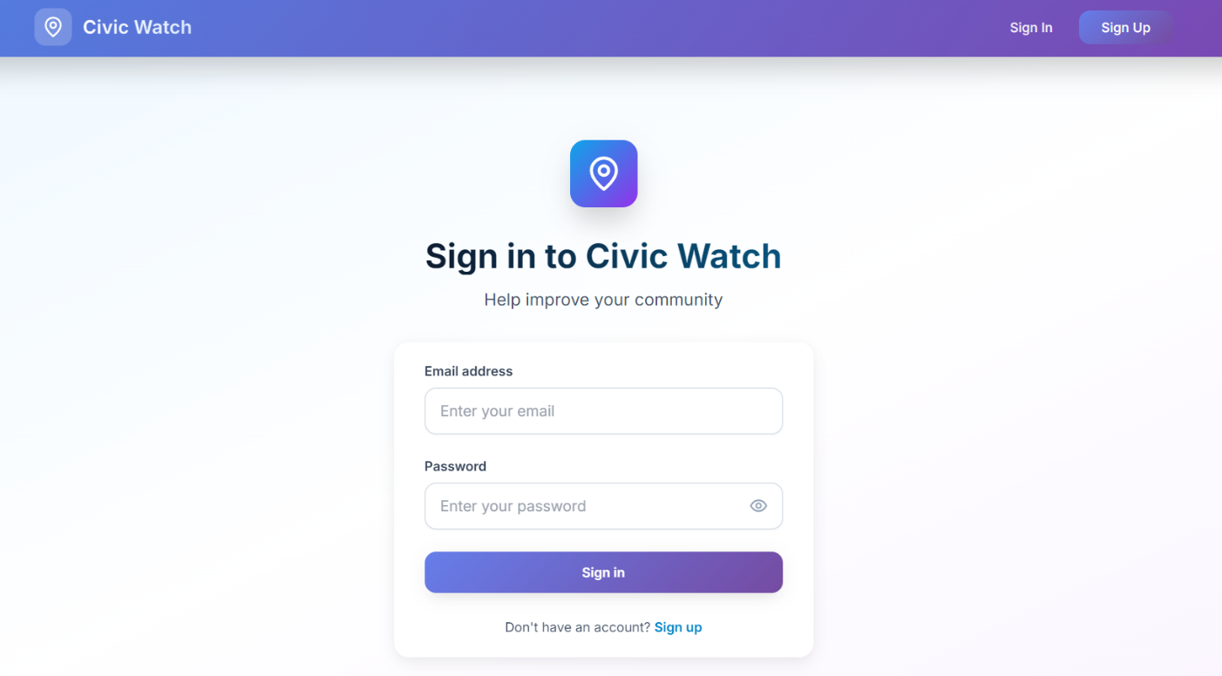

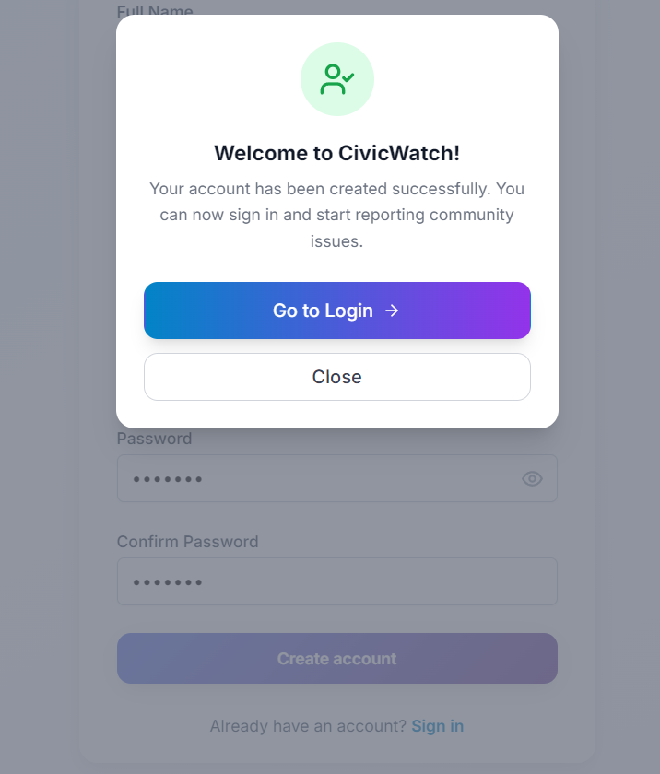

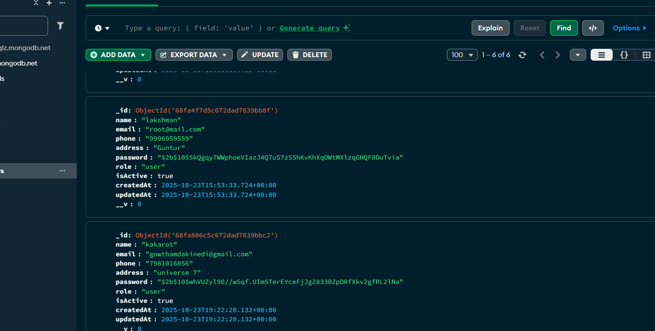

**User:**

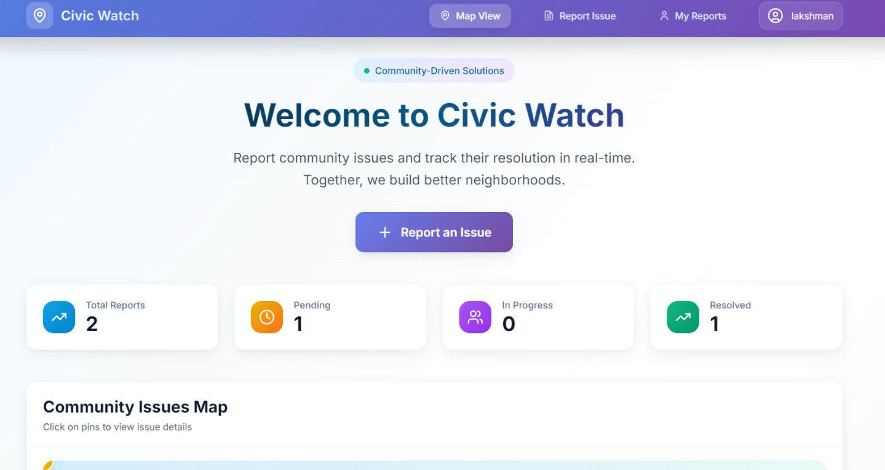

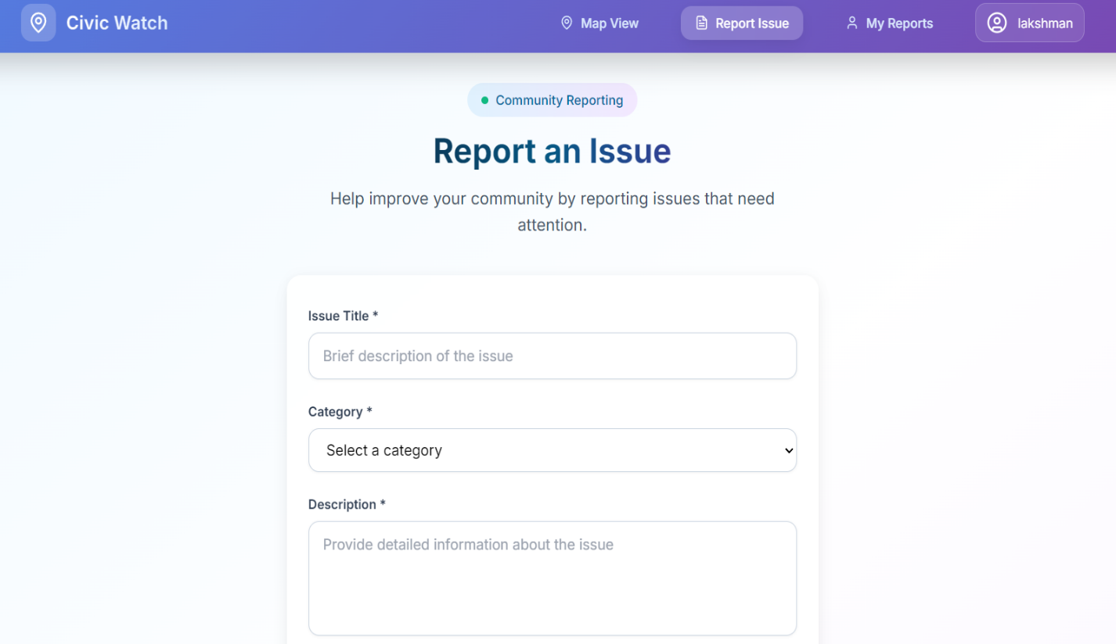

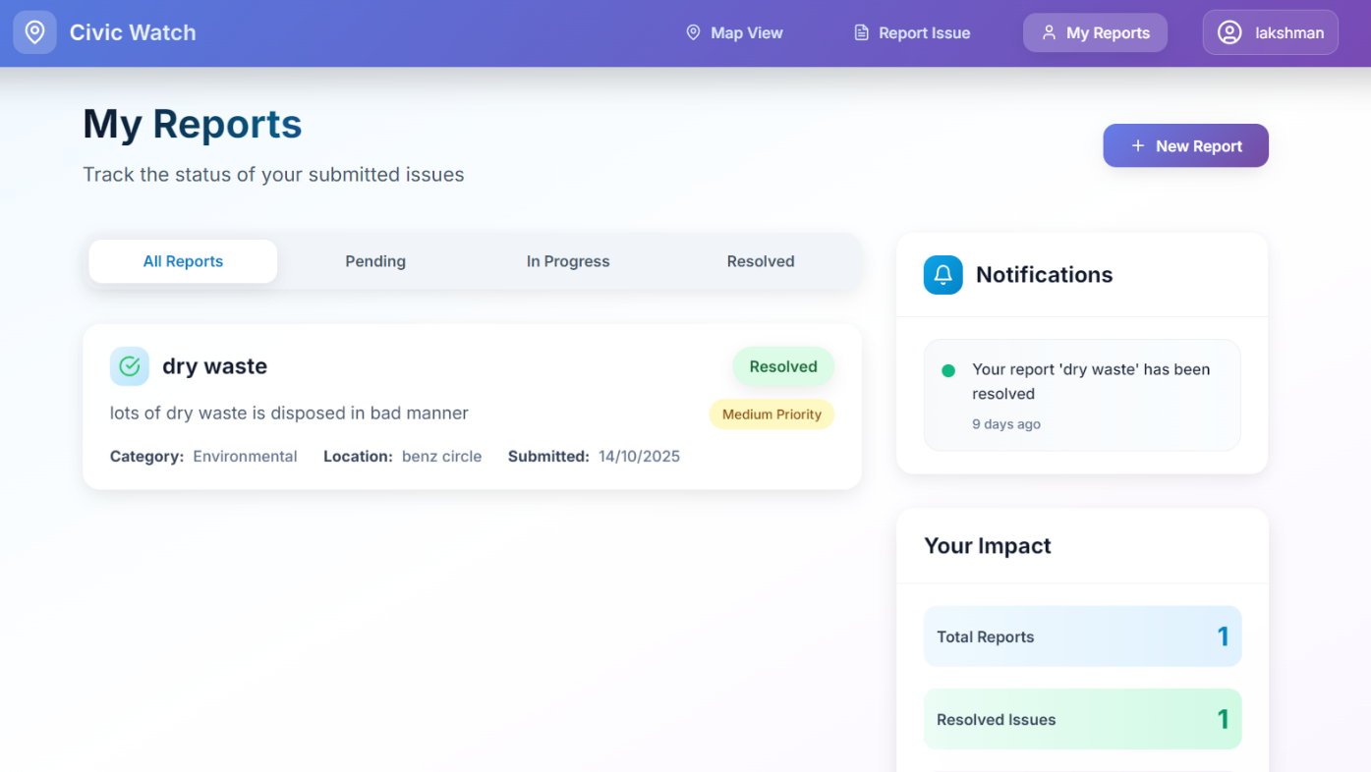

**Admin:**

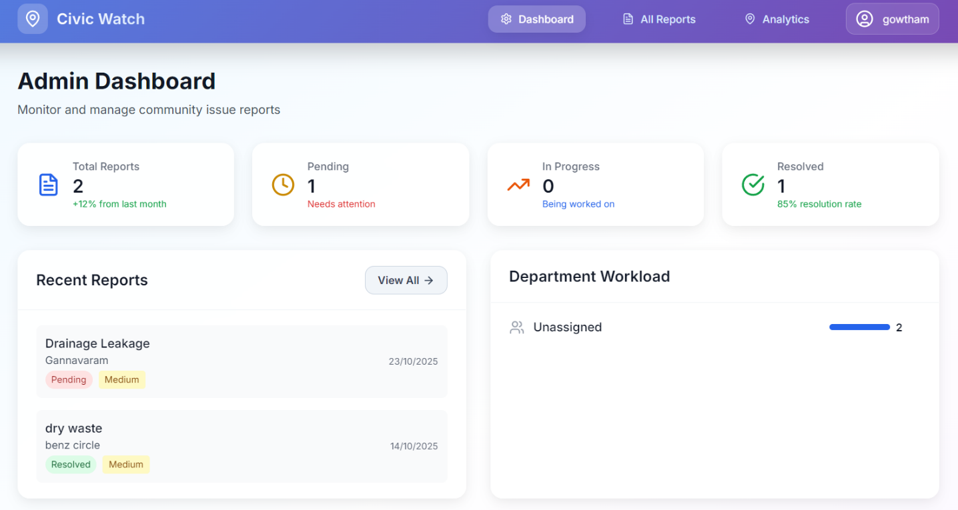

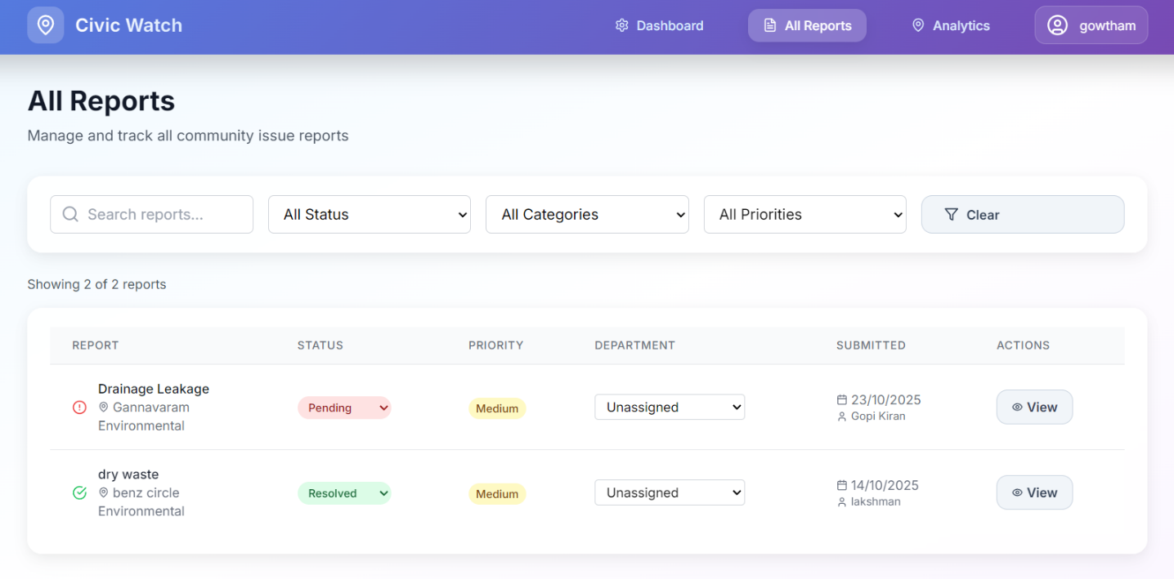

**Conclusion**

The CivicWatch project successfully demonstrates a comprehensive community issue reporting system that bridges the gap between citizens and government through modern web technologies.

**Key Achievements:**

- **Technical Implementation** : Full-stack MERN application with secure authentication, file uploads, and responsive design

- **User Experience** : Intuitive interface for citizens and powerful administrative tools for government officials

- **Social Impact** : Enhanced civic engagement, transparency, and accountability in municipal governance

- **Learning Outcomes** : Gained expertise in modern web development, security practices, and database design

**Future Enhancements:**

- Integration with mapping services and mobile applications

- AI-powered categorization and predictive analytics

- Smart city infrastructure connectivity

**SDG Contribution:**

CivicWatch directly supports UN SDG 11 (Sustainable Cities and Communities) and SDG 16 (Peace, Justice and Strong Institutions) by promoting responsive, inclusive, and effective governance through digital transformation.

The project demonstrates how technology can create positive social impact while addressing real-world urban governance challenges.

**Refernces**

**Core Technologies:**

- React.js : <https://react.dev/learn>

- Node.js : <https://nodejs.org/en/docs/>

- Express.js : <https://expressjs.com/>

- MongoDB : <https://docs.mongodb.com/>

- TailwindCSS : <https://tailwindcss.com/docs>

**Authentication & Security:**

- JWT : <https://jwt.io/introduction/>

- bcrypt : <https://www.npmjs.com/package/bcrypt>

**Deployment:**

- Netlify : <https://docs.netlify.com/>

- Render : <https://render.com/docs/>

- MongoDB Atlas : <https://docs.atlas.mongodb.com/>

**Github:**

**-** <https://github.com/gowtham-178/CivicWatch>

- <https://github.com/gopikiran22001/CivicWatch>