**Smart Public restroom Phase-2: Design Innovation**

**Introduction**

The Innovation steps are which we transform our design thinking ideas into a tangible IoT-based flood management solution. The document outlines the comprehensive steps that will be taken to put our design concept of Smart Public Restroom

**Step 1: Refine Problem Definition**

**Review Problem Statement**: Traditional public restrooms face challenges related to cleanliness, accessibility, and resource management. Users often encounter inconvenience in locating available restrooms, uncertain about their condition and supplies. Maintenance staff struggle to efficiently manage cleaning schedules and supplies. This project aims to address these issues by developing a Smart Public Restroom IoT System with a mobile app to enhance user experience, improve hygiene, streamline maintenance, and promote sustainable practices

**Gather Additional Insights:** Consult with stakeholders and target communities to gather more information’s.

**Step 2: Technical Requirements**

**Sensor Selection:** Determine the types of sensors required for data collection (e.g., Smell Sensor, Turbidity Sensor etc.).

**Data Storage:** Decide on the data storage solutions (local or cloud-based databases) and data management tools.

**Communication Protocols:** Choose the appropriate communication protocols for data transmission (e.g., LoRa, NB-IoT, or cellular networks)

**Data Analysis Tools:** Identify the data analysis tools and algorithms to be used for deriving actionable insight

**Step 3: Hardware and Software Developments**

**Hardware Development:**

* Identify IoT hardware components (sensors, microcontrollers, communication modules)

Create a detailed hardware architecture diagram.

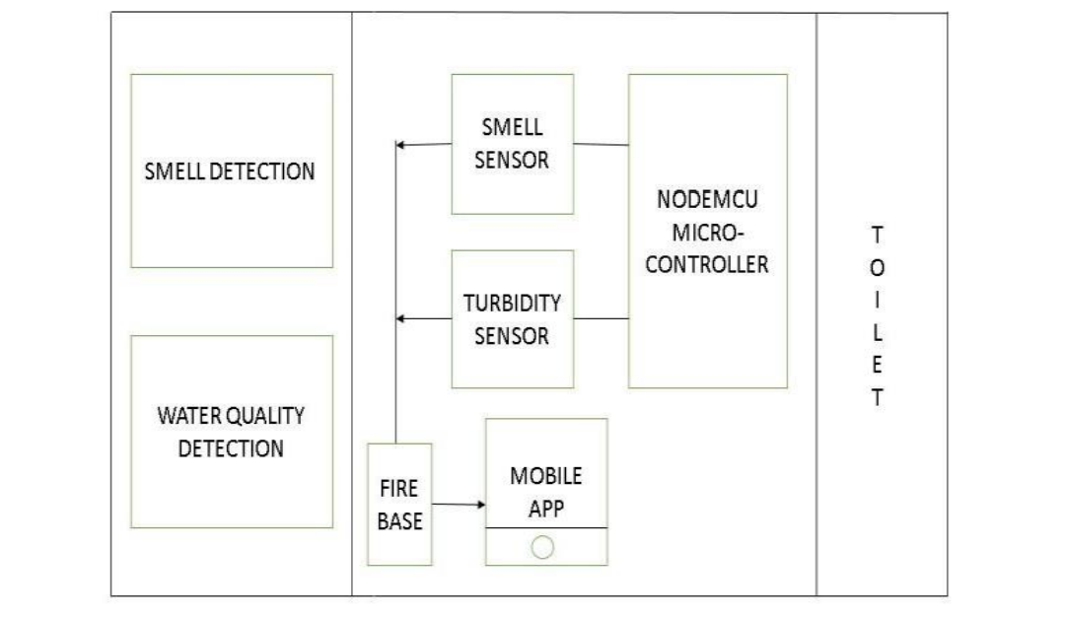

* + Source the required hardware components.
  + Assemble and test the hardware components

**Software Development:**

* + Develop firmware for microcontrollers to collect and transmit data.
  + Develop server-side software for data reception, storage, and analysis.
  + Create a user interface (UI) for data visualization and user interaction.
  + Ensure data security and privacy measures are implemented.

**Step 4: Design Prototype**

**Create Prototypes**:

* + Build a prototype system with a limited set of sensors.

**LIST OF SENSORS USED IN THIS PROJECT**

**TURBIDITY SENSOR**

A turbidity sensor is a sensor which is mainly used to measure scattered light suspended by solids in water. As the number of total suspended solids in the water source is increased, the turbidity level of water is increased accordingly. Turbidity sensors can be used in the determination of water quality of small as well as large water bodies.

**MQ3 GAS SENSOR**

MQ3 gas sensor is an alcohol gas sensor which can detect the presence of gases which contain alcohol traces in them. It is made out of tin in the form of stannic oxide. It can detect alcohol, ethanol and smoke.

**NODEMCU WI-FI MODULE**

NodeMCU is a development kit that aids in making an IoT project. This module runs on ESP8266 Wi-Fi system on a chip. It is a microcontroller unit which includes a built in WiFi module.

* Test the prototype in controlled environments
  + Refine the hardware and software-based on initial testing

**Step 5: Prototype Testing**

* Install prototypes in Smart public restroom.
* Monitor and collect real-time data over an extended period.
* Address technical issues and refine the system based on field testing result.

**Step 6: Problems solved Using these Sensors**

* **Using a smell sensor** in a restroom can ban effective way to detect and address odour issues. These sensors can trigger ventilation systems, air fresheners, or alerts to maintenance staff when unpleasant odours are detected. It's a practical solution for maintaining a more pleasant restroom environment

.

* **Using a turbidity sensor** in a restroom can help address problems related to water quality and cleanliness. These sensors measure the cloudiness or turbidity of water, and in a restroom setting, they can be used in urinals, toilets, or sinks to monitor water quality. This can help in maintaining water cleanliness, detecting issues like blockages or contaminants, and ensuring a hygienic restroom environment
* **Using an MQ-3 gas sensor** in a restroom can help address specific issues related to alcohol vapor. Here are a few problems that can be solved by using an MQ-3 gas sensor in a restroom:

1. Monitoring Public Restrooms: MQ-3 sensors can be used to monitor public restrooms for alcohol consumption, especially in locations where it's prohibited, such as schools or workplaces.

2. Preventing Vandalism: Restrooms in public spaces are sometimes subject to vandalism or misuse. An MQ-3 sensor can help detect alcohol use or abuse and trigger alerts to prevent further issues.

3. Ensuring Safety: In some settings, ensuring the safety of restroom users is critical. The sensor can help identify potential intoxication or unsafe behavior.

4. Compliance with Policies: If a facility has a no-alcohol policy, the MQ-3 sensor can help enforce compliance by detecting alcohol use.

* It's important to note that the **MQ-3 sensor** is specifically designed for alcohol detection and may not be suitable for addressing other restroom-related problems. The use of such sensors should also consider privacy and legal implications, as well as the specific needs of the facility.
* Using a NodeMCU Wi-Fi module in a smart public restroom can help solve various problems and improve restroom functionality. Here are some issues that can be addressed:

1. **Real-time Monitoring**:NodeMCU can be used to monitor the restroom's occupancy status, cleanliness, and supply levels (toilet paper, soap, paper towels). This data can be used to ensure timely maintenance and refilling.

2. **Energy Efficiency**: It can control lighting and ventilation systems based on occupancy, saving energy when the restroom is unoccupied.

3. **Maintenance Alerts**: NodeMCU can detect issues such as water leaks, malfunctioning fixtures, or even excessive odors, and send alerts to maintenance staff for quick response.

4.**Security**: It can help ensure the safety and security of users by providing real-time monitoring and alerts in case of any suspicious activities or emergencies.

5.**User Experience**: By offering features like touchless operation of fixtures, providing Wi-Fi access, and interactive displays, NodeMCU can enhance the overall user experience in the restroom.

6.**Resource Management**: It can help optimize resource consumption, such as water usage in toilets and sinks, by offering automated control based on usage patterns.

Using NodeMCU and IoT technology in a smart public restroom can lead to increased efficiency, improved user experience, and better maintenance, making it a valuable addition to public facilities.

**Step 7: User Feedback**

Engage with stakeholders and user groups for feedback.

* Identify areas for improvement and additional features.
* Iteratively refine the system based on feedback.

**Step 8: Sustainability and Community Engagement**

**Community Involvement**:

* + Implement community engagement programs, educational initiatives, and awareness campaigns.
  + Enable community members to access and interpret real-time data.
  + Promote sustainable practices based on i.

**Step 9: Regulatory Compliance**

* **Ensure Regulatory Compliance**:
  + Implement features to facilitate compliance reporting.
  + Collaborate with regulatory bodies to ensure data accuracy and alignment with regulations.

**Step 10: Documentation and Reporting**

* **Document the Entire Process**:
  + Create detailed documentation for hardware and software components.
  + Prepare reports on field testing, user feedback, and data analysis.
  + Share findings and progress with stakeholders and project sponsors.

The Innovation phase is a crucial step in turning our design thinking concept into a practical solution for IoT-based Smart Public Restroom.