Design of CrankShaFt FOR Tractor

Final Year Project Report

Group:09 | Batch: 2012-2013
Shahrukh Ahmed Khan | AU-12021
Sajjad Hussain Soomro | AU-12027
Muhammad Awais Raza | AU-12036

Internal Advisor: | Mr. Assad Anis  Assistant Professor  Department of Automotive Engineering
Co-Advisor:
External Advisor:

Reference#: XX/20XX


Department of AUTOMOTIVE Engineering

NED University of Engineering and Technology

Certificate

It is to certify that the following students have completed their project “Design of Crankshaft for Tractor” satisfactorily.

Group: 09 | Batch: 2012-2013
Name |  | Seat No.
Shahrukh Ahmed Khan |  | AU-12021
Sajjad Hussain Soomroo |  | AU-12027
Muhammad Awais Raza |  | AU-12036

Internal Advisor  Mr. Assad Anis  Assistant Professor  Department of Automotive Engineering  NED University of Engg. & Tech. | Co-Advisor  .
Projects’ Coordinator  Mr. Assad Anis  Department of Automotive Engineering  NED University of Engg. & Tech. | External Advisor

Department of AUTOMOTIVE Engineering

NED University of Engineering and TechnologY

Dedication

(optional)

Acknowledgements

We would like to express our deepest appreciation to all those who provided us the possibility to complete this project. A special gratitude wee give to our final year project advisor, Mr. Assad Anis, whose contribution in stimulating suggestions and encouragement, helped me to coordinate our project.

Abstract

The crankshaft is an important part of IC engine that converts the reciprocating motion of the piston into rotary motion through the connecting rod. A crankshaft should have sufficient strength to withstand the bending and twisting moments to which it is subjected. This project describes the stress distribution of a crankshaft for a (4-stroke, diesel engine) tractor by manual calculations for different subjected loads and moments by considering different operating conditions such as maximum bending moment condition (without twisting moment) and combined twisting and bending moment condition (where torsion is maximum). Followed by the CAD modeling using the dimensions obtained from hand calculations. Finally, model was analyzed by using commercial Finite Element Analysis (FEA) software ANSYS™ .The stress analysis results are significant to improve the component design at the early developing stage. Harmonic analysis was used to determine the steady state response to sinusoidal (harmonic) loads of known frequency. Modal analysis was carried out to determine the natural frequencies of the crankshaft and the mode shapes were examined.

Table of Contents

1. Litreature Review 1
1.1 Introduction 1
1.2 Function of Crankshaft in IC Engine 2
1.3 Materials and Manufacturing Processes………………………………….2
1.3.1 Forging process and the Influencing Parameters…………………...2
1.3.1.1 Lubrication…………………………………………….4
1.3.1.2 Shape complexity in forging…………………………..4
1.3.1.3 Heat Treatment………………………………………...4
1.3.1.4 Straightening and coining……………………..……….5
1.3.2 Casting Process and the Influencing Parameters………………………5
1.3.2.1 Green Sand…………………………………………….6
1.3.2.2 Dry sand molds………………………………………...6
1.3.2.3 Skin Drying……………………………………………6
1.3.3 Comparison of Forging and Casting Processes…………………….….7
1.4 Market survey……………………………………………………….…7

2. Preliminary Design………………………………………..……….……………9
2.1 Service Loads and Failures Experienced by Crankshaft 9
2.2 Design Procedure for Crankshaft........................................................…...9
2.3 Design of center crankshaft…………...………………………………….9

2.3.1 When the crank is at Top Dead Centre (TDC)……………………….10
2.3.1.1 Design of crankpin…………………………………...11

2.3.1.2 Design of left hand crank.............................................11

2.3.1.3 Design of right hand crankweb………………………12
2.3.1.4 Design of Shaft under Flywheel……………………...12
2.3.2 When the crank is at an angle of Max Twisting Moment……………12
2.3.2.1 Design of Crankpin…………………………………..13
2.3.2.2 Design of Shaft under Flywheel……………..………13
2.3.2.3 Design of Shaft at the juncutre………………………13
2.3.2.4 Design of right hand crank web………………...……14
2.3.2.5 Design of left hand crank web………………………..14
2.3.2.6 Design of Crankshaft bearings……………………….15
2.3.3 Results………………………………………………………………..15
3. Modeling and Optimization……………..………………….……………...16
3.1 CAD Model…………………………………………………………..16
3.2 Optimization………………………………………………………….18
3.2.1 Definition…………………………………………………….18
3.2.2 Procedure……………………………………………………..18
3.2.3 Finite Element Analysis (FEA)………………………..….….18
3.2.4 Static Analysis………………………………………………..20
3.2.4.1 Maximum bending moment analysis………………...20
3.2.4.1.1 Pre-Processor Phase………………………….20
3.2.4.1.2 Solution Phase……………………….……….20
3.2.4.1.3 Post Processor……………………..…………21
3.2.4.2 Pure Torsion Analysis…………………………….….23
3.2.4.2.1 Pre-Processor Phase………………………….23
3.2.4.2.2 Solution Phase……………………….……….23
3.2.4.2.3 Post Processor……………………..…………24
3.2.4.3 Combine Bending and Twisting Analysis…………...26
3.2.4.1.1 Pre-Processor Phase………………………….26
3.2.4.1.2 Solution Phase……………………….……….26
3.2.4.1.3 Post Processor……………………..…………26
3.2.4.4 Results……………………………………………….28
3.2.4.5 Factor of Safety………………………………………28
3.2.4.6 Option # 1 (Select Other Material)…………………..28 3.2.4.6.1 Results………………………………..31
3.2.4.6.2 Factor of Safety………………………31
3.2.4.7 Option # 2 (Reduce Dimensions)…………………….31
3.2.4.7.1 Results………………………………..34
3.2.4.7.2 Factor of Safety………………………34
3.2.5 Dynamic Analysis……………………………………………34
3.2.5.1 Harmonic Analysis…………………………………...34 3.2.5.1.1 Results………………………………..35
3.2.5.2 Modal Analysis………………………………………36
3.2.5.2.1 Procedure…………………………………….36
3.2.5.2.2 Results……………………………………….39

- Conclusion
- References
- Appendix

List of Figures

Figure 1: A cup of tea 1
Figure 2: asdad 2

List of TABLES

Table 1-1: Prices. 8
Table 1-2: Specifications..............................................................................................8
Table 3-1: Nodal Frequencies....................................................................................39

CHAPTER#1

LITERATURE REVIEW

Introduction
Notwithstanding the combustion engine is a consolidated mechanical system due to its continuous developments during the decades, its components are still subject of research in terms of strength to mass ratio enhancement, acoustic, dynamic and vibration behavior, stress and fatigue assessment. The mechanical components that have a great impact on the reliability and performances of the engine are the transmission gears, the crankshaft, and the connecting rod with its piston pin. Such components may lead to engine failure in case of low reliability.
Crankshaft is a large component with a complex geometry in the engine, which converts the reciprocating displacement of the piston to a rotary motion with a four link mechanism. Depending upon position of crank, may be divided into two types:
- side crank or over hung
- centre crank
We will focus on the design of centre crank.
Depending on the number of cranks may be divided into two types:
- Single throw
- Multi throw
Since the crankshaft experiences a large number of load cycles during its service life, fatigue performance and durability of this component has to be considered in the design process. Design developments have always been an important issue in the crankshaft production industry, in order to manufacture a less expensive component with the minimum weight possible and proper fatigue strength and other functional requirements. These improvements result in lighter and smaller engines with better fuel efficiency and higher power output.

Functions of crankshaft in IC Engine
The crankshaft, connecting rod, and piston constitute a four bar slider-crank Mechanism, which converts the sliding motion of the piston (slider in the mechanism) to a rotary motion. Since the rotation output is more practical and applicable for input to other devices, the concept design of an engine is that the output would be rotation. In addition, the linear displacement of an engine is not smooth, as the displacement is caused by the combustion of gas in the combustion chamber. Therefore, the displacement has sudden shocks and using this input for another device may cause damage to it. The concept of using crankshaft is to change these sudden displacements to a smooth rotary output, which is the input to many devices such as generators, pumps, and compressors. It should also be mentioned that the use of a flywheel helps in smoothing the shocks

Materials and Manufacturing Processes
The material of crankshaft should be tough and fatigue resistant. Generally carbon steel, special steel and special cast iron are used. In industrial engines, commonly made from carbon steel such as 40C8, 55C8 and 60C4 etc.
In transport engines, manganese steel such as 20Mn2, 27Mn2 and 37Mn2
Manufacturing of crankshaft is done by two methods:
- Forging
- Sand Casting

Forging process and the Influencing Parameters
Forging is the term for shaping metal by plastic deformation. Cold forging is done at low temperatures, while conventional hot forging is done at high temperatures, which makes metal easier to shape. Cold forgings are various forging processes conducted at near ambient temperatures, such as bending, cold drawing, cold heading, coining, and extrusion to produce metal components to close tolerances and net shape. Warm forging is a modification of the cold forging process where the work piece is heated to a temperature significantly below the typical hot forging temperature, ranging from 500º C to 750º C.
Compared with cold forging, warm forging has the potential advantages of reduced tooling loads, reduced press loads, increased steel ductility, and elimination of need to anneal 10 prior to forging, and favorable as-forged properties that can eliminate heat treatment.
The use of the lower temperatures in cold and warm forging processes provides the advantages of reducing and even substantially eliminating the harmful scale or oxide growth on the component as well as enabling the component to be produced to a high dimensional accuracy (Koike and Matsui, 2001). Despite these advantages, cold and warm forging processes have the limitations of close tolerance and net shape of the final component with the work piece. Hot forging is the plastic deformation of metal at a temperature and strain rate such that recrystallization occurs simultaneously with deformation, thus avoiding strain hardening
Since crankshafts have complex geometries, warm and cold forging of the component is not possible. Therefore, crankshafts are manufactured using the hot forging process. In impression (or closed die) hot forging two or more dies are moved toward each other to form a metal billet, at a suitable temperature, in a shape determined by the die impressions. These processes are capable of producing components of high quality at moderate cost. Forgings offer a high strength to weight ratio, toughness, and resistance to impact and fatigue, which are important factors in crankshaft performance. In closed die forging, a material must satisfy two basic requirements: (a) The material strength (or flow stress) must be low so that die pressures can be kept within the capabilities of practical die materials and constructions, and (b) The capability of the material to deform without failure (forge ability) must be sufficient to allow the desired amount of deformation.
By convention, impression and closed die forging are considered to be hot working operations. In most practical hot forging operations, the temperature of the work-piece material is higher than that of the dies. The metal flow and die filling are largely determined by (a) the forging material’s resistance to flow and ability to flow, i.e. its flow stress and forge ability, (b) the friction and cooling effects at the material interface and (c) the complexity of the forging shape. A multi-cylinder crankshaft is considered to have a complex geometry, which necessitates proper work piece and die design according to material forge ability and friction to have the desired geometry

Lubrication
In hot forging, in addition to lubrication effects, the effects of die chilling or heat transfer from the host material to the colder dies must be considered. Therefore, values of the friction factor, or coefficient of friction, obtained under certain forging conditions may not be applicable under other conditions. For example, for a given lubricant, friction data obtained in hydraulic press forging cannot be useful in mechanical press or hammer forging, even if the die and billet temperatures are comparable

Shape complexity in forging
The main objective of forging process design is to ensure adequate flow of the metal in the dies so that the desired finish part geometry can be obtained without any external or internal defects. Metal flow is greatly influenced by part or dies geometry.
Often, several operations are needed to achieve gradual flow of the metal from an initially simple shape (cylinder or round cornered square billet) into the more complex shape of the final forging. Schematic initial work piece and lower forging die for a four cylinder crankshaft. The as-forged crankshaft with flashes is shown in. As could be seen, the geometry complexity requires extensive analysis on the forging piece and die, in order to have proper material flow to fill all cavities in the die. Improper work piece design will result in a deficient geometry.

Heat treatment
All hot forged parts receive a certain amount of heat treatment in the process of being forged and, thereafter, may be used without additional heat treatment. For maximum usefulness, however, many forgings are heat treated one or more times before being put into service. For instance, bearing sections and fillet areas on crankshafts are heat treated in order to improve fatigue and wear properties of the material at these certain locations.
Usually forgings are heat treated before and after their machining. The purpose of the initial treatment is to secure uniform structure of the metal and contribute to ease of machining of the forged part. The final treatment makes it possible to use the finished forgings for the service intended. For example, forged tools must be hard and tough, consequently, they must receive final hardening and tempering treatments
Today, micro alloy steels are widely used for manufacturing forged steel crankshafts. The micro alloyed steel can effectively eliminate the need for additional heat-treating, reducing the cost of forgings by 5% to 10% to the final cost

Straightening and coining
When the flash is trimmed from the drop forging, the shape may become distorted, which common in forged crankshafts because of geometry section changes and non-uniform is cooling during forging process. Correction of this condition may be necessary. Correction to a certain degree may be accomplished by hammering the distorted forging in a special re-striking die. The correction is made while the forging cools. Other re-striking operations, called coining, are conducted on powerful and accurate presses after the forgings have cooled to room temperature. The forgings are brought to the correct size and shape in these presses, and final machining operations ordinarily performed are either entirely or partially eliminated. Micro alloy steels provide more consistent mechanical properties, improved steelmaking and metal forming processes such as rolling, and reduced surface flaws with less distortion than heat-treated forged steel. This reduces the need for straightening in the forging process and increases the machinability of the forged steel.

Casting Process and the Influencing Parameters
Casting is a manufacturing process by which a molten material such as metal or plastic is introduced into a mold, allowed to solidify within the mold, and then ejected or broken out to make a fabricated part. Casting is used for making parts of complex shape, such as crankshafts, that would be difficult or uneconomical to make by other methods (such as machining from solid material). Sand-mold casting is adaptable to a very wide range of alloys, shapes, sizes, and production quantities. Hollow shapes can be produced in these castings through the use of cores. Sand-mold casting is by far the most common casting process used in the industry; some estimates are that as many as 90% of industrial castings use the sand-mold casting process.

Green sand
Green sand refers to the fact that water is added to activate the clay binder. Green sand-mold casting involves mixing sand with a suitable clay binder (usually a bentonite clay) and other additives, and packing the sand mixture tightly around a pattern that is constructed from the part design, but the pattern is not an exact replica of the part since various dimensional allowances must be made to accommodate certain physical effects. For most metals and most sizes and shapes of casting, green sand molding is the most economical of all the molding processes. The moisture present in green sand produces steam when contacted by hot metal. Inability of the steam and other gases to escape causes problems with some casting designs, and blowhole damage results. The dimensional accuracy of green sand casting is limited. Even with small castings, it is seldom that dimensions can be held closer than ±0.5 millimeter.

Dry sand molds
Dry sand molding is a sand casting process using a mold made of greensand which is dried in an oven to remove the moisture and increase its strength. The absence of moisture eliminates the formation of water vapor and reduces the type of casting defects that are due to gas formation. The cost of heat, the time required for drying the mold, and the difficulty of handling heavy molds without damage make the process expensive compared to green sand molding, and it is used mostly when steam formation from the moisture present would be a serious problem.

Skin drying
Most of the benefits of dry sand molds can be obtained by skin drying molds to depths from a fraction of an inch to an inch. With the mold open, the inside surfaces are subjected to heat from torches, radiant lamps, hot dry air, or electric heating elements to form a dry insulting skin around the mold cavity. Skin-dried molds can be stored only for short periods of time before pouring, since the water in the main body of the mold will redistribute itself and re-moisturize the inside skin.

Comparison of Forging and Casting Processes
To some extent, forging and casting are competitive, even where different materials are involved with each process. As a general rule, the tooling investment is higher for forging than casting. Thus, the use of forging tends to be restricted to applications in which the higher material properties of steel compare to cast iron or the higher properties of wrought steel compared to cast steel can be made use of in the design. Because forgings compete best in high strength applications, most producers take particular care in raw material selection and inspection. In many cases, either forging or castings may have adequate properties, and one process has no universal economic advantage over the other.
Some characteristics of castings as compared to forgings are as follows:
- Castings cannot obtain the strengthening effects of hot and cold working. Forging surpasses casting in predictable strength properties, producing assured superior strength consistently.
- A casting has neither grain flow nor directional strength and the process cannot prevent formation of certain metallurgical defects. Pre-working forge stock produces a grain flow oriented in directions requiring maximum strength. Dendritic structures, alloy segregations and like imperfections are refined in forging.
- Casting defects occur in a variety of forms. Because hot working refines grain pattern and imparts high strength, ductility and resistance properties, forged products are more reliable. And they are manufactured without the added costs for tighter process controls and inspection that are required for casting.
- Castings require close control of melting and cooling processes because alloy segregation may occur. This results in non-uniform heat-treatment response that can affect straightness of finished parts. Forgings respond more predictably to heat treatment and offer better dimensional stability.
- Some castings, such as special performance castings, require expensive materials and process controls, and longer lead times. Open-die and ring rolling are examples of forging processes that adapt to various productions run lengths and enable shortened lead times. In spite of the aforementioned advantages of forgings over castings, castings may be an economical alternative, depending on part functionality requirements, production volume, and other considerations.

Market Survey
We have survey the local and international market where we found different tractor models of Millat Tractors Ltd. and selected few of them i.e. Massey Ferguson 240,350,260,360. (MF-240,350,260,360).
Locally crankshafts are manufactured by sand casting in Sargodha (Pakistan).
Crankshafts that are manufactured locally do not have proper standards neither for material nor for design calculations.
In international market crankshafts have been manufactured through forging process.
Table 1-1 prices
No of cylinders | Price (Rs.)
No of cylinders | Local | International
3 | 6,800 | 25,000
4 | 8,000 | 35,000

Applications
Tractor type: Diesel
Make: Millat Tractors Ltd.
Model: MF - 240, MF - 360, MF - 350, MF - 260

Specifications
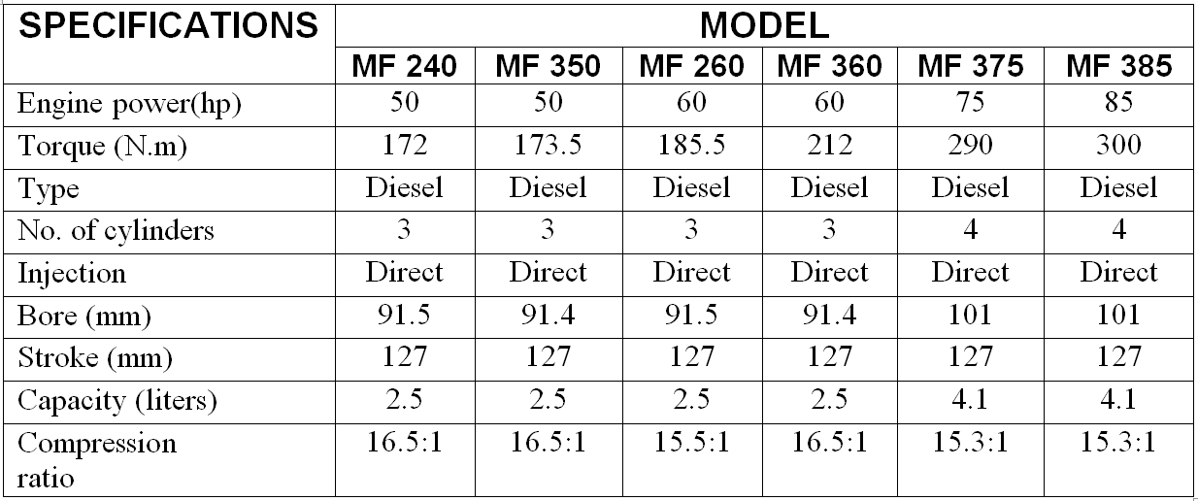
Table 1-2 specifications

CHAPTER#2

Preliminary Design

Service Loads and Failures Experienced by Crankshaft
Crankshaft experiences large forces from gas combustion. This force is applied to the top of the piston and since the connecting rod connects the piston to the crankshaft; the force will be transmitted to the crankshaft. The magnitude of the force depends on many factors which consist of crank radius, connecting rod dimensions, and weight of the connecting rod, piston, piston rings, and pin. Combustion and inertia forces acting on the crankshaft cause two types of loading on the crankshaft structure torsional load and bending load.
One of the most common crankshaft failures is fatigue at the fillet areas due to bending load caused by the combustion in the combustion chamber. Due to the crankshaft geometry and engine mechanism, the crankshaft fillet experiences a large stress range during its service life.
The stress induced in the crank shaft is mainly due to the combined bending moment and the twisting moment. The bending stresses are due to the cylinder gas pressure, bending stresses caused are due to bending moment and the shear stresses caused due to twisting moment.

Design Procedure for Crankshaft
The following procedure is adopted for designing a crankshaft.
1. First of all, find the magnitude of the various loads on the crankshaft.
2. Determine the distances between the supports and their position with respect to the loads.
3. For the sake of simplicity and also for safety, the shaft is considered to be supported at the centers of the bearings and all the forces and reactions to be acting at these points. The distances between the supports depend on the length of the bearings, which in turn depend on the diameter of the shaft because of the allowable bearing pressures.
4. The thickness of the cheeks or web is assumed to be from 0.22D to 0.32D, where D is the cylinder bore in mm.
5. Now calculate the distances between the supports
6. Assuming the allowable bending and shear stresses, determine the main dimensions of the crankshaft.

Design of center crankshaft
we shall design the centre crankshaft by considering the two crank positions, i.e. when the crank is at Top Dead Centre (TDC) where the crankshaft is subjected to maximum bending moment and when the crank is at the angle at which the twisting moment is maximum.
These two cases will be discussed in detail.

When the crank is at Top Dead Centre (TDC):
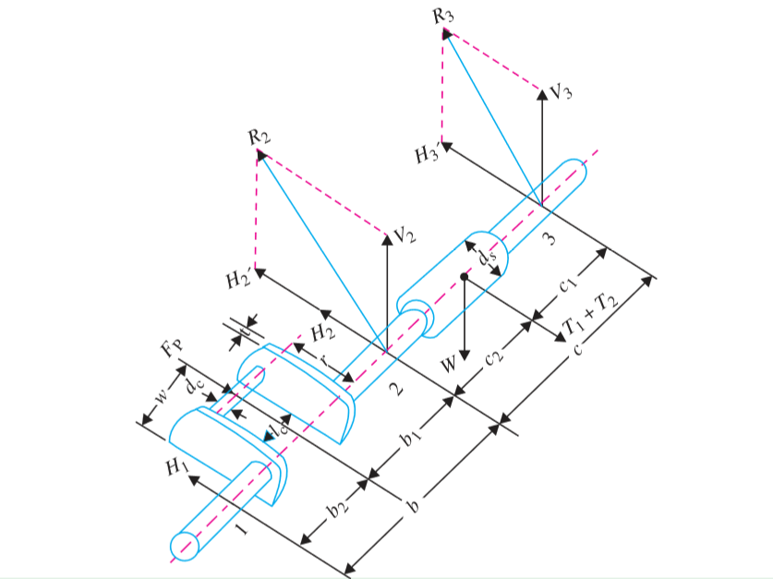
At this position of crank, the maximum gas pressure on the piston will transmit maximum force on the crankpin in the plane of the crank causing only bending of the shaft. The crankpin as well as ends of the crankshaft will be only subjected to bending moment. Thus, when the crank is at the dead centre, the bending moment on the shaft is maximum and the twisting moment is zero.
Figure 2-1 crank at TDC
Consider a single throw three bearing crankshaft as shown in Figure 2-1.
Let D = piston diameter or cylinder bore in mm
= 91.5 mm
P = maximum intensity of the pressure in the piston in N/mm2
= 50 N/mm2
W = weight of the flywheel acting downwards in N = 250 N and
T1 + T2 = resultant belt tension or pull acting horizontally in N.
T1 = 1827 N
T2 = 710.9102 N
The thrust in the connecting rod will be equal to the gas load on the piston (Fp)
Fp = 32.87 kN
Due to this piston gas load (Fp) acting horizontally, there will be two horizontal reactions H1 and H2 at bearings 1 and 2 respectively.
H1 = 16.435kN
H2 = 16.435kN
Due to weight of the flywheel acting downwards, there will be two vertical reactions V2 and V3 at bearings 2 and 3 respectively.
V2 = 125N
V3 = 125N
Now due to the resultant belt tension (T1 + T2) acting horizontally, there will be two horizontal reactions H’2 and H’3 at bearings 2 and 3 respectively.
H’2 = 1269 N
H’3 = 1269 N
The resultant force at bearing 2 is
R2 = 17708 N
The resultant force at bearing 3 is
R3 = 1275.1 N
Now the various parts of the centre crankshaft are designed for bending only

Design of crankpin
let d_{c} = diameter of crankpin in mm
l_{c} = length of crankpin in mm
σ_{b} = Allowable bending stress for crankpin in MPa
Bending moment at crank pin
Mc = 1504200 N.mm
Diameter of crank pin is find out
dc = 33.7089 mm
length of crankpin is determined
lc = 77.4082 mm

Design of left hand crank
let d_{c} = diameter of crankpin in mm
l_{c} = length of crankpin in mm
σ_{b} = Allowable bending stress for crankpin in MPa
Bending moment at crank pin
Mc = 1504200 N.mm
Diameter of crank pin is find out
dc = 33.7089 mm
length of crankpin is determined
lc = 77.4082 mm

Design of right hand crank web
The dimensions of the right hand crank web (i.e. thickness and width) are made equal to left hand crank web from balancing point of view.

Design of shaft under flywheel
Bending moment due to the weight of flywheel, M_{w} = 11438 N.mm
Bending moment due to belt tension, M_{T} = 116110 N.mm
Resultant bending moment, M_{s} = 116670 N.mm
Diameter of shaft is determined to be d_{s} = 14.376 mm

WHEN THE CRANK IS AT AN ANGLE OF MAX TWISTING MOMENT
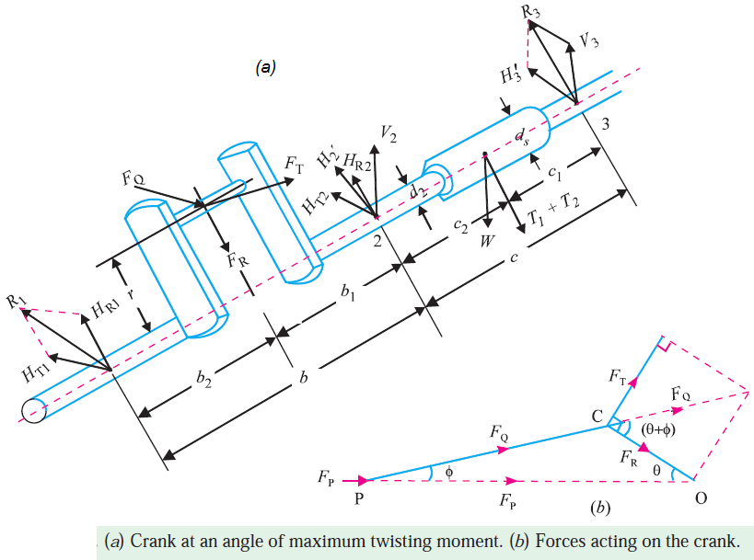
The twisting moment on the crankshaft will be maximum when the tangential force on the crank is maximum (F_{T}). The maximum value of tangential force lies when the crank is at angle of 25 to 30 degree from the dead center for a constant volume combustion engines (i.e. petrol engines) and 30 to 40 degree for constant pressure combustion engine (i.e. diesel engines).
figure 2-2 crank at max twist
Consider the position of the crank at an angle of maximum twisting moment as shown in Figure 2-2. If P' is the intensity of the pressure on the piston at this instant, then the piston gas load at this position of the crank.
F_{p} = 13.15kN
And thrust on the connecting rod, F_{Q} = 13327 N
The thrust in the connecting rod (F_{Q}) may be divided into two components, one perpendicular to the crank and the other along the crank. The component of (F_{Q}) perpendicular to the crank is the tangential force (F_{T}) and the component of (F_{Q}) along the crank is the radial force (F_{R}) which produces thrust on the crankshaft bearings. From figure we find that
F_{T} = 9310.3 N
F_{R} = 9528.8 N
Due to the tangential force, there will be two reactions at bearing 1 and 2, these are
H_{T1} = 4655.1 N
H_{T2} = 4655.1 N
Due to the radial force, there will be two reactions at bearing 1 and 2, these are
H_{R1} = 4764.4 N
H_{R2} = 4764.4 N
The reactions at bearings 2 and 3 due to flywheel weight and tension will be same as above.
Now the various parts of the center crankshaft are designed

Design of crankpin
Bending moment at the centre of the crank pin, M_{c} = 435940 N.mm
Twisting moment at crankpin, T_{c} = 295600 N.mm
Diameter of crank pin is calculated as
d_{c} = 29.9351 mm
length of the crank pin is calculated as
l_{c} = 34.866 mm

Design of shaft under the fly wheel
Bending moment on the shaft, M_{S} = 116670 N.mm
Twisting moment on the shaft, T_{S} = 591200 N.mm
Therefore equivalent moment on the shaft, T_{e} = 602600 N.mm
Diameter of shaft is determined to be d_{s} = 31.3089 mm

Design of shaft at the juncture
Bending moment at the juncture of the right hand crank arm, M_{S1} = 426180N.mm
Twisting moment at the juncture of the right hand crank arm, T_{S1} = 591200 N.m
Equivalent Twisting moment at the juncture of the right hand crank arm, T_{e} = 145760 N.mm
Diameter of the shaft at the juncture of the right hand crank arm is determined to be d_{S1} = 42.0278 mm

Design of the right hand crank web
The right hand crank web is subjected to the following stresses:
- Bending stresses in two planes normal to each other, due to the radial and tangential components of F_{Q}.
- Direct compressive stress due to F_{R} , and
- Torsional stresses.
The bending moment due to the radial component of F_{Q} is
M_{R} = 304929.7 N.mm
Bending stress in radial direction, σ_{bR} = 89.19 MPa
The bending moment due to the tangential component of F_{Q} is
M_{T} = 395558.34 N.mm
Bending stress in tangential direction, σ_{bT} = 115.7 MPa
The direct compressive stress, σ_{d} = 4.765 MPa
The maximum compressive stress will occur at the upper left corner of the cross section of the crank
Therefore σ_{c} = 209.655MPa
Now the twisting moment on the arm is
T =344818.8 N.m
Polar section modulus = z = 4558.5 mm³
Therefore the maximum or total combined stress is determined as
(σ_{c})_{max} = 216.3 MPa
Since σ_{allow} > (σ_{c})_{max}
Therefore design is safe

Design of left hand crank web
Since the left hand crank web is stressed to the extent as the right hand crank web, therefore, the dimensions for the left hand crank web may be made same as for right hand crank web.

Design of crankshaft bearings
The bearing 2 is the most heavily loaded and should be checked for the safe bearing pressure.
We know that the total reaction at the bearing 2,
R₂ = 17833 N
Length of the bearing 2 is calculated out as
l_{B} = 33.6755 mm
See Appendix B for calculations

Results
Diameter of crankpin = d_{C} = 33.7 mm ᴝ 34 mm
Length of crankpin = l_{C} = 34.866 mm ᴝ 35 mm
Diameter of shaft = d_{S} = 42.0278 mm ᴝ 42 mm
Length of bearing = l_{B} = 33.675 mm ᴝ 33.7 mm
Web thickness = t = 20.13 mm
Web width = w = 50.6225 mm

CHAPTER#3

MODELING & OPTIMIZATON

CAD Model
After the design calculations cad model of crankshaft is prepared using the design calculations on Pro-E. The most important significance of Pro-E is that it has a totally different interface. The significance of Pro-E over other existing drafting tools come from its capability of being parametric, feature based solid modeling software. The parametric capability of Pro-E enables the designers to change certain parameters and dimensions in the feature they are designing. We are designing the crankshaft for 3- cylinder engine (which is frequently used in tractors) so the CAD model should be made for 3- cylinder, but here we will analyze only single crank due to symmetry (i.e. all the dimensions, boundary conditions, loadings, support distances, material are same). there is no need to analyze the whole crankshaft. Therefore the CAD model of the single crank is shown in figure 3-1.

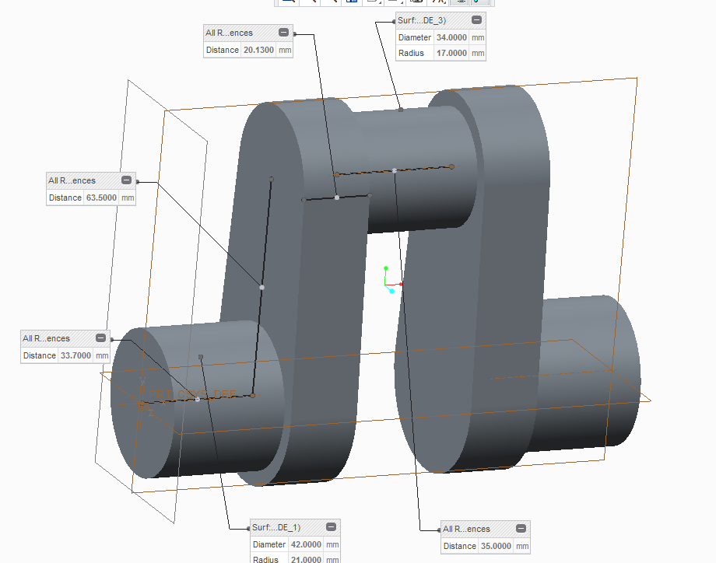
Figure 3-3 CAD

OPTIMIZATION

DEFINITION
an act, process, or methodology of making something (as a design, system, or decision) as fully perfect, functional, or effective as possible. The optimization stage of the engineering design process is a systematic process using design constraints and criteria to allow the designer to locate the optimal solution. The purpose of optimization is to achieve the “best” design relative to a set of prioritized criteria or constraints. The goal of optimization is to reduce product development costs and improve quality. FEA helps solve design challenges without complex manual iterations or prototyping.

PROCEDURE
After the completion of CAD model, we will analyze the model by using Finite Element Analysis (FEA). there are many tools/softwares for FEA. Here we will use ANSYS for Finite Element Analysis to analyze our model. following analysis's will be done:
1. Static analysis
- Maximum bending moment Analysis
- Pure Torsion Analysis
- Combined Bending and Twisting Analysis
2. Dynamic analysis
- Harmonic Analysis
- Modal Analysis
before doing analysis, we first introduce FEA.

FINITE ELEMENT ANALYSIS (FEA) :
Finite element analysis (FEA) is a computerized method for predicting how a product reacts to real-world forces, vibration, heat, fluid flow, and other physical effects. Finite element analysis shows whether a product will break, wear out, or work the way it was designed. It is called analysis, but in the product development process, it is used to predict what is going to happen when the product is used.
FEA works by breaking down a real object into a large number (thousands to hundreds of thousands) of finite elements, such as little cubes. Mathematical equations help predict the behavior of each element. A computer then adds up all the individual behaviors to predict the behavior of the actual object.
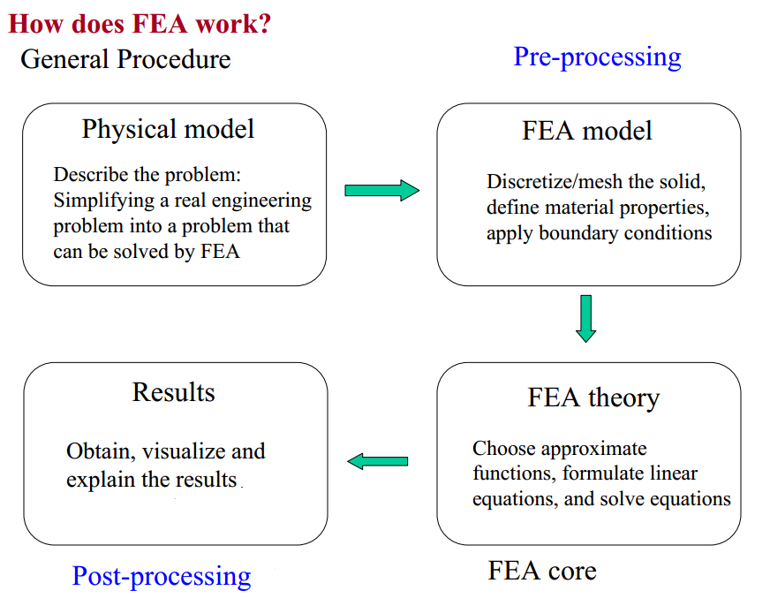
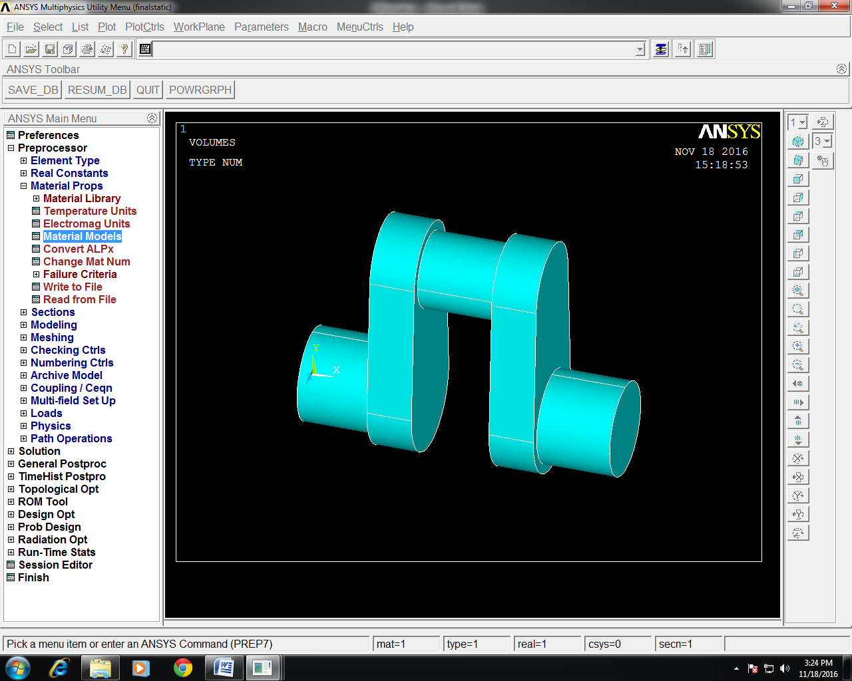
First of all, the CAD model is prepared as shown above and it is converted in "iges" format in order to import it on ANSYS. The model is imported in ANSYS workspace. The model will look like this as shown in figure 3-2
Figure 3-4 import CAD

STATIC ANALYSIS

Maximum Bending Moment Analysis
The given below procedure is followed :

PREPROCESSOR PHASE
- In preferences > check on structural
- In preprocessor > Element type > Solid > brick8node 45 > SOLID 45
- preprocessor > Material properties > Material Models > structural > linear > elastic > isotropic, a window will appear, put the values of Young's Modulus which is 200 GPa (for chromoly steel) and Poisson's ratio = 0.3
- Preprocessor > Meshing > Mesh > Volumes > Free and select the model. After meshing the model will look like this:
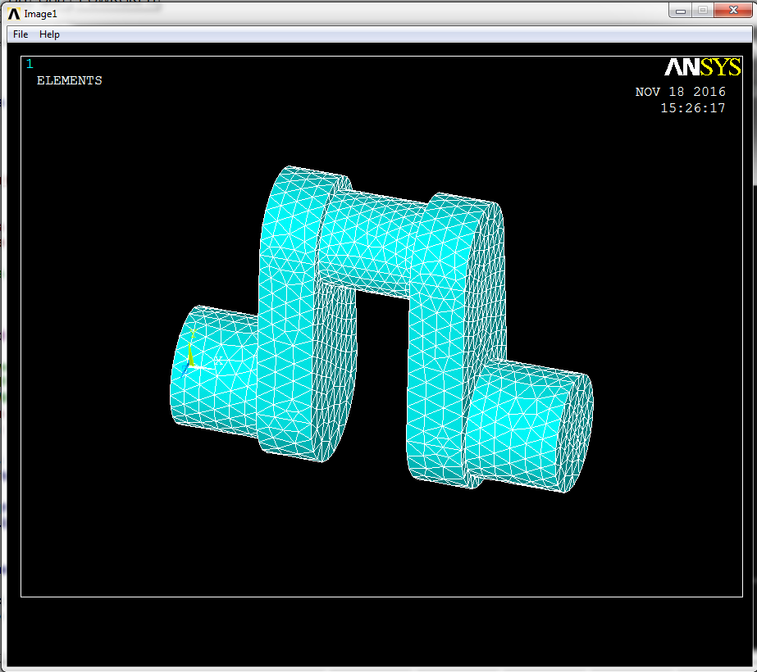
Figure 3-5 Meshed model

SOLUTION PHASE
- In Solution > Analysis type > New analysis . A window will appear select "STATIC".
Now the boundary conditions and forces (i.e. piston gas load in this case) are defined.
here the crank is fixed at its both bearings (static condition), so we constrained the both ends to all DOF.
- Solution > Loads > Define loads > Structural > displacement > on areas and select the area of both ends. A window will appear, from there select "ALLDOF".
At this condition (i.e. Top Dead Center(TDC)) the maximum gas pressure exist which is transferred to the crankpin through the connecting rod which is usually around 5 MPa for tractors.
- Solution > Loads > Define loads > Structural > Pressure > On area. Select the upper area of the crankpin. put the value of pressure i.e. 5 (MPa) in the dialog box.
- Now it is solved
- Solution > Solve > Current LS.
following window will appear:


POST PROCESSOR:
After solving the results can be observed by the following procedure:
- In General post processor > Plot results > Contour Plot > Nodal solution.
- A window will appear from which, select DOF solution > Displacement vector sum to observe the deflection at each point and maximum deflection. the model will look like this as shown in figure 3-4.

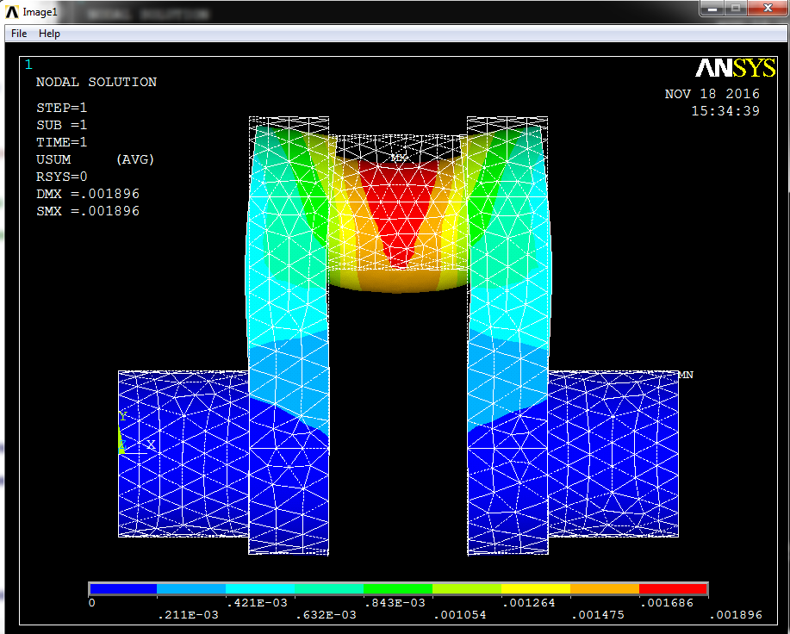
Figure 3-6 max bending deflection

- As it is clear from the above image the maximum deflection can occur on the top of the crankpin because at Top Dead Center, piston gas load is directly acted on the top of the crank shaft. The value for maximum deflection is 0.001896 mm which is negligible.
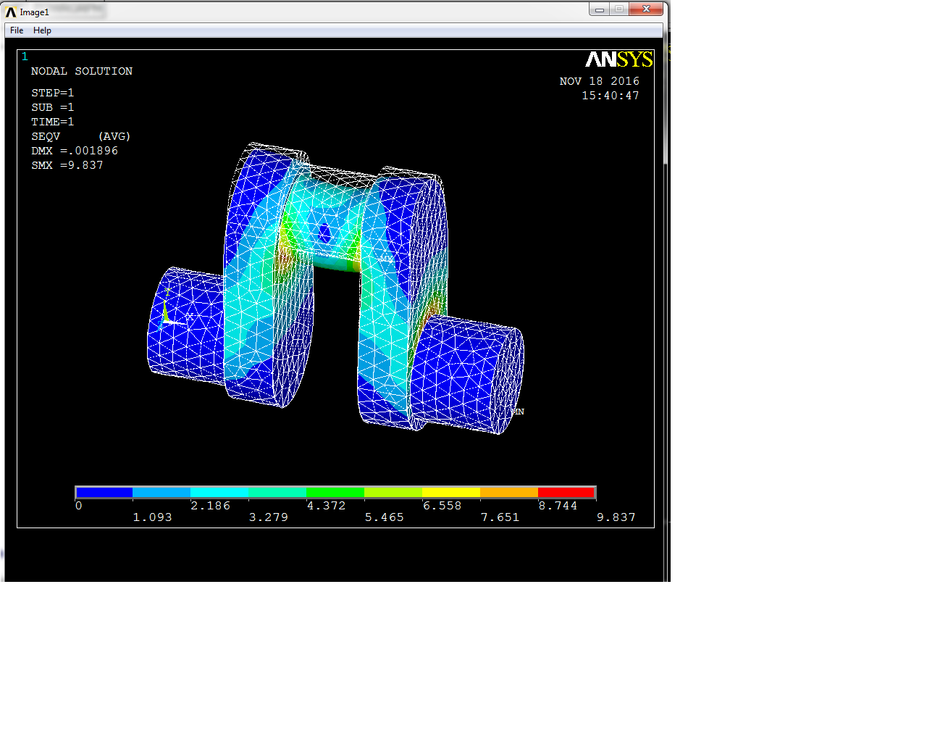
- For stress distribution and maximum stress, in Nodal solution > Stress > Von Misses stress₍₁₎ . The following figure shows the stress distribution and maximum stress:

Figure 3-7 max bending Von mises

- The maximum bending stress occurs at edges of the crankpin & web and main journal & web and the value of maximum bending stress is 9.837 MPa.
(1. Von Misses stress is widely used by designers to check whether their design will withstand a given load condition. Von Misses stress is considered to be a safe haven for design engineers. Using this information an engineer can say his design will fail, if the maximum value of Von Misses stress induced in the material is more than strength of the material.)

Pure Torsion Analysis

. PREPROCESSOR PHASE
The pre processor phase for torsion analysis is exactly same as described above in bending case.

SOLUTION PHASE
- In Solution > Analysis type > New analysis . A window will appear select "STATIC".
Now the boundary conditions and forces are defined.
here the crank is fixed at its both bearings (static condition), so we constrained the both ends to all DOF.
- Solution > Loads > Define loads > Structural > displacement > on areas and select the area of both ends. A window will appear, from there select "ALLDOF".
- Solution > Loads > Define loads > Structural > Force/Moment > On Nodes
- Select nodes and apply the force/no. of node, which is calculated from engine torque as:
F = T/ radius of crank pin
F = 173500N.mm/17mm = 10205.88 N
we have selected 7 nodes so F = 10205.88/7 N
After applying loads and boundary conditions model will look like this as shown in figure 3-6.

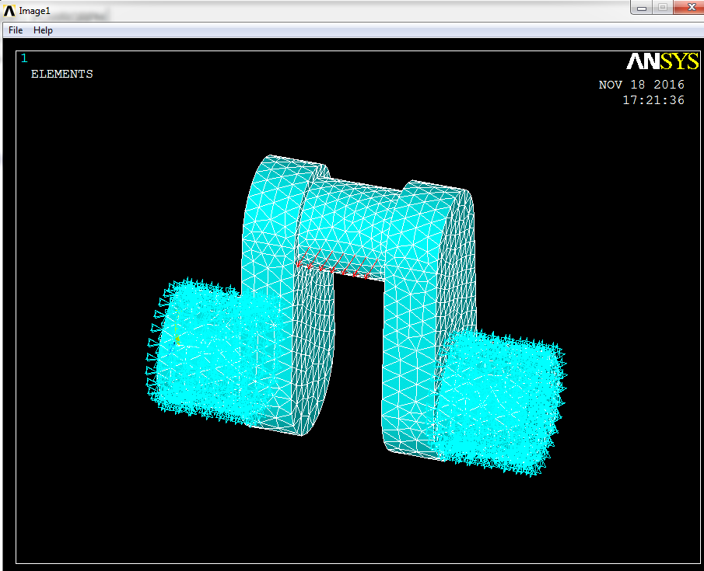

Figure 3-8 torsion contrained

- Now it is solved
- Solution > Solve > Current LS.
following window will appear:

POST PROCESSOR:
After solving the results can be observed by the following procedure:
- In General post processor > Plot results > Contour Plot > Nodal solution.
- A window will appear from which, select DOF solution > Displacement vector sum to observe the deflection at each point and maximum deflection. the model will look like this as shown in figure 3-7.
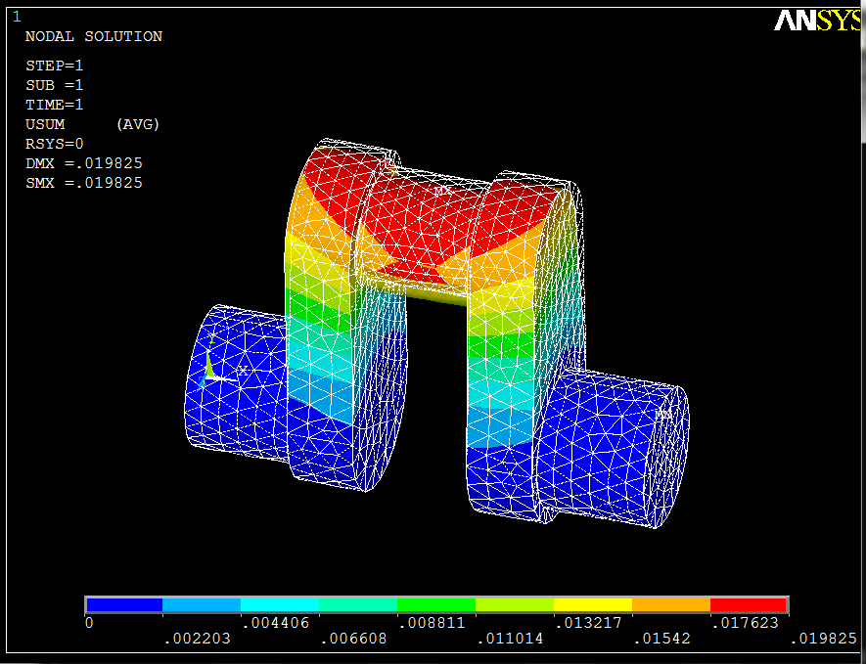
Figure 3-9 torsion max deflection
The value for maximum deflection is 0.019825 mm.
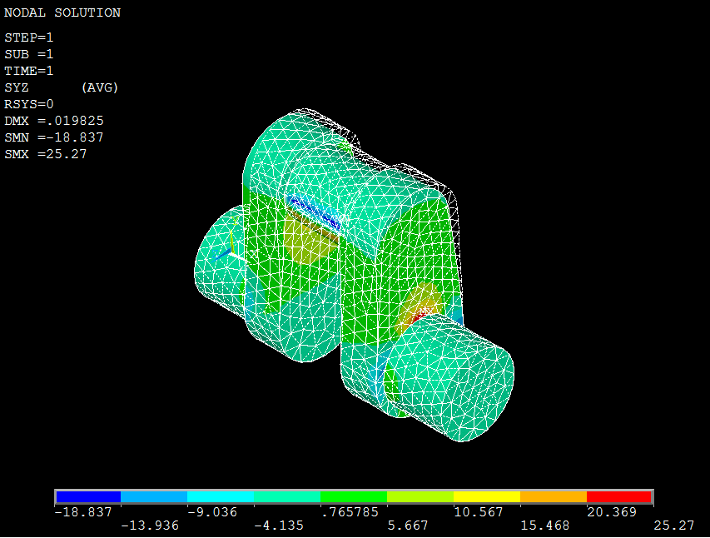
- For shear stress distribution and maximum shear stress, in Nodal solution > Stress > YZ shear stress. The following figure shows the shear stress distribution and maximum shear stress:

Figure 3-10
torsion shear sr
The maximum shear stress is YZ shear stress which is 25.27 MPa

Combined Bending and Twisting Analysis
In actual practice, pure torsion does not exist. some amount of bending moment also occurs at the point of maximum twisting moment. In this case both cases which are described above (i.e. bending moment and torsion case) are combined.

PREPROCESSOR PHASE
The pre processor phase for combined bending and twisting analysis is exactly same as described above in bending case.

SOLUTION PHASE
- In Solution > Analysis type > New analysis . A window will appear select "STATIC".
- Now the boundary conditions and forces are defined.
- here the crank is fixed at its both bearings (static condition), so we constrained the both ends to all DOF.
- forces of both cases are combined together.
- then it is solved.

POST PROCESSOR
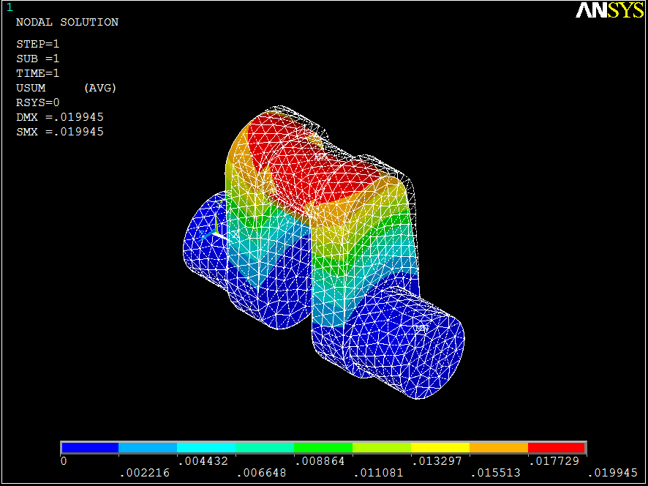
Following the same procedure to get maximum deflection, max normal and shear stresses.
Figure 3-11 combined deflection

The maximum deflection is 0.019945 mm

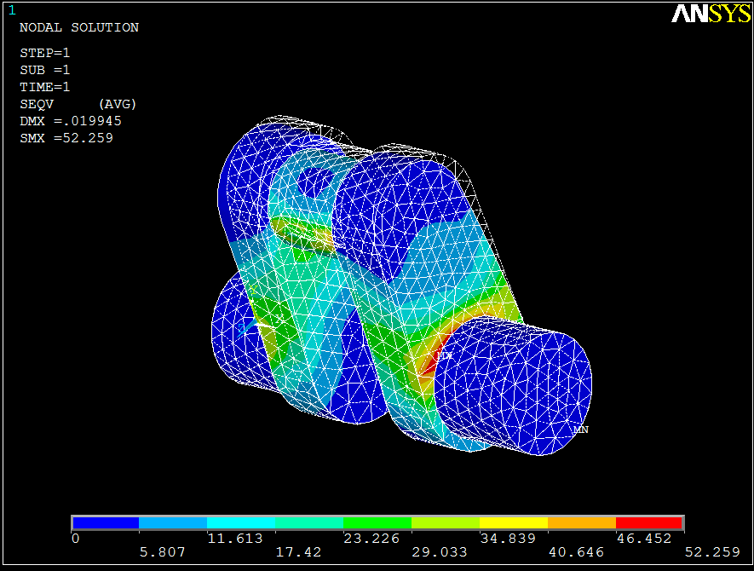
Figure 3-12 combined von mises

The maximum normal stress is 52.259 MPa
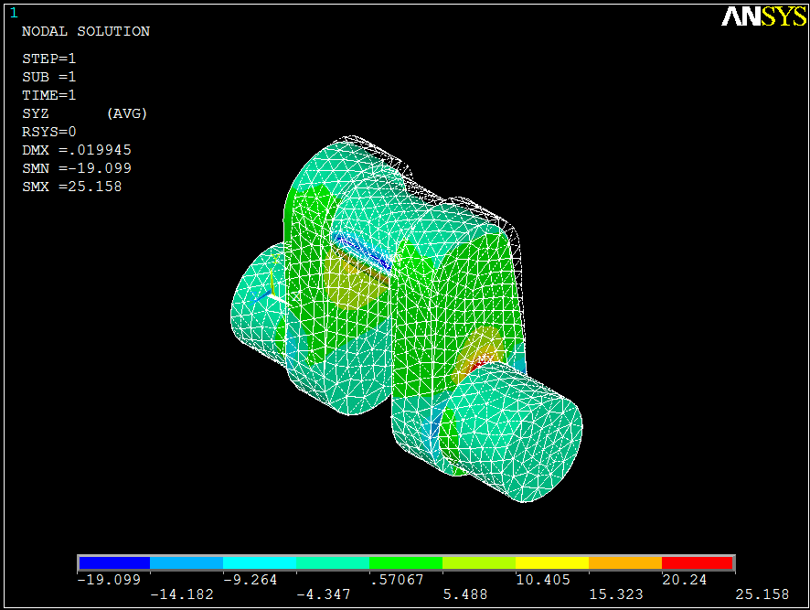

Figure 3-13 combined max shear stress

The maximum shear stress is 25.158 MPa

RESULTS
maximum deflection = 0.019945 mm (combined bending and twisting)
maximum normal stress = 52.259 MPa (combined bending and twisting)
maximum shear stress = 25.27 MPa (twisting only)

FACTOR OF SAFETY
F.O.S = allowable bending stress/max bending stress
F.O.S = 400/52.59
F.O.S = 7.6
Factor of safety is very large so this is over designed. For crankshaft, the recommended factor of safety is 3 to 4.
We have two options, 1st option is to select another material having comparatively low strength than chromoly steel with same dimensions. By doing so, we can reduce the overall cost of the crankshaft. Another option is that we have to reduce the dimensions to get the factor of safety 3 to 4. This will reduce the material cost and also the weight of crankshaft will also reduce, ultimately the life of crankshaft and durability is increased. In fact, this is called optimization.

OPTION # 1 SELECT ANOTHER MATERIAL:
We have selected nickel chrome having following properties :
allowable bending stress = 150MPa
allowable shear stress = 80 MPa
Young's Modulus = 220 MPa
Poisson's ratio = 0.315
following the same procedure as above and finding out the maximum deflection, max normal and shear stress for all the cases i.e. Maximum bending, maximum twisting and combined bending and twisting.

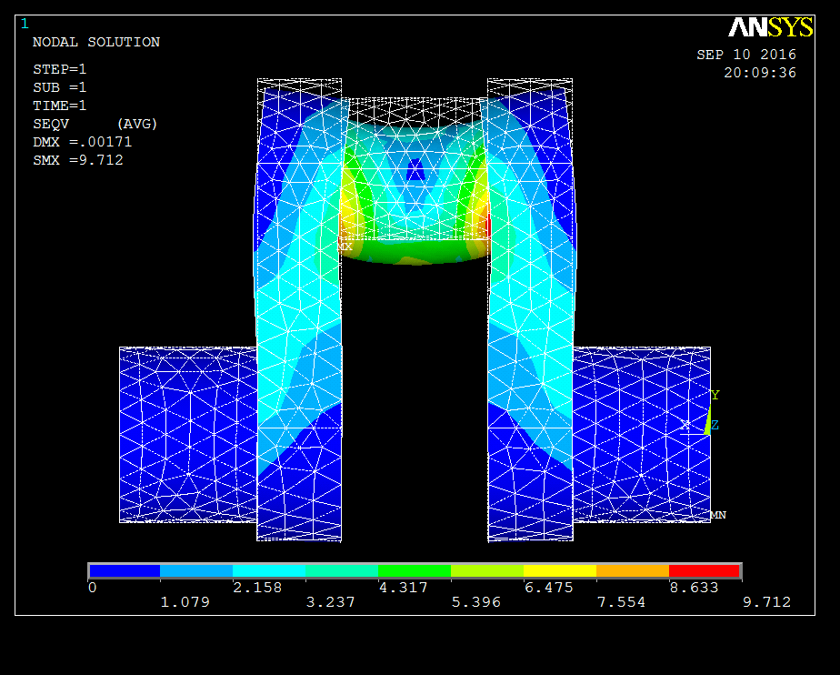

Figure 3-14 max bendin von mises chrome nickel

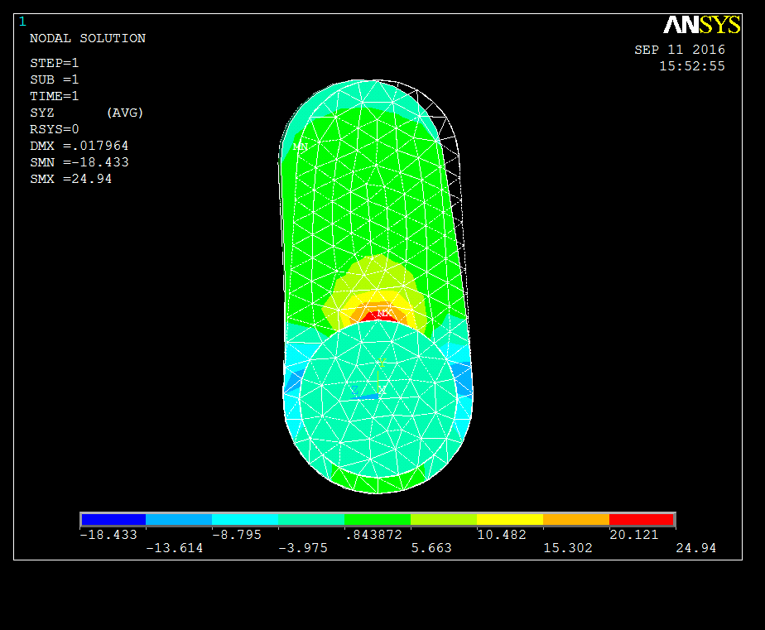
Figure 3-15 max twist chrome nickel

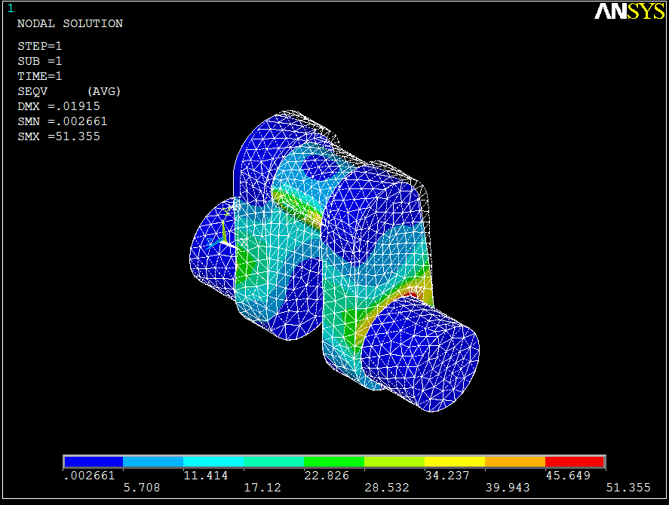
Figure 3-16 combined von mises chrome nickel

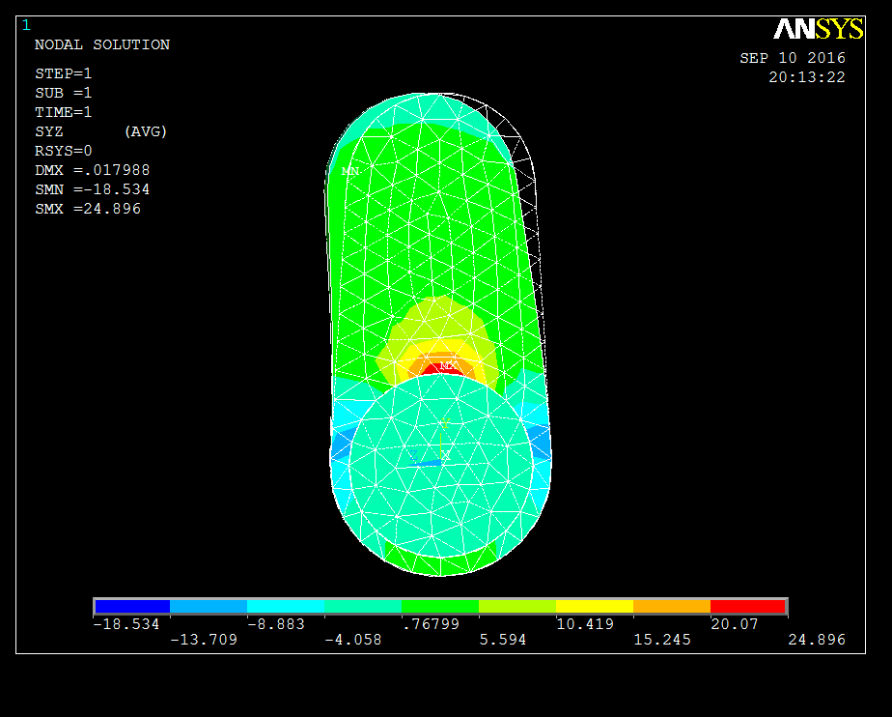
Figure 3-17 combined max shear stress chrome nickel

RESULTS:
maximum deflection = 0.019155 mm (combined bending and twisting)
maximum normal stress = 51.355 MPa (combined bending and twisting)
maximum shear stress = 24.94 MPa (twisting only)

FACTOR OF SAFETY:
F.O.S = allowable bending stress/max bending stress
F.O.S = 150/51.355
F.O.S ᴝ 3
The design is acceptable for chrome nickel.

OPTION # 2 REDUCE DIMENSIONS:
Reducing the dimensions of original cad model keeping the same material i.e. chromoly steel. So we have to prepare another CAD model. Following dimensions are used to make another CAD model:
diameter of crankpin = d_{C} = 27 mm
diameter of crankshaft = d_{S} = 33 mm
thickness of the web = t = 18 mm
width of the web = w = 43.1 mm
length of crankpin = l_{C} = 35 mm
length of the bearing = l_{B} = 33.7 mm

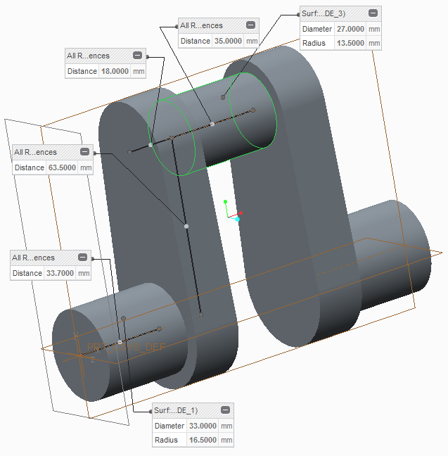
Figure 3-18 optimized CAD
- Now, save the model in "iges" format.
- import this model in ANSYS
- now, following the same procedure as above. Maximum deflection, maximum normal stress and max shear stress are observed in all maximum bending, torsion and combined bending.
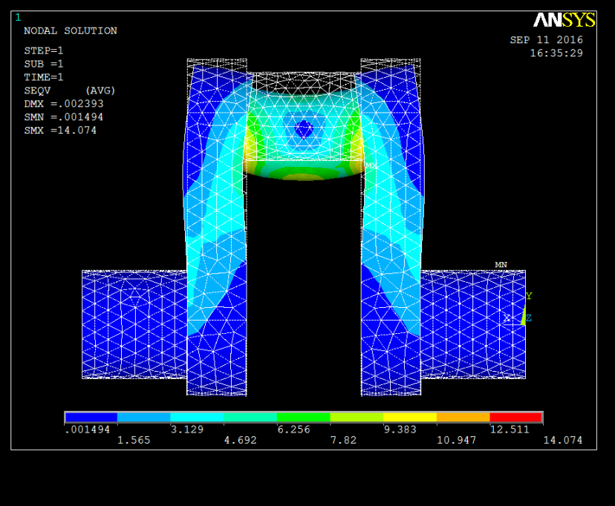
Figure 3-19 opt max bending
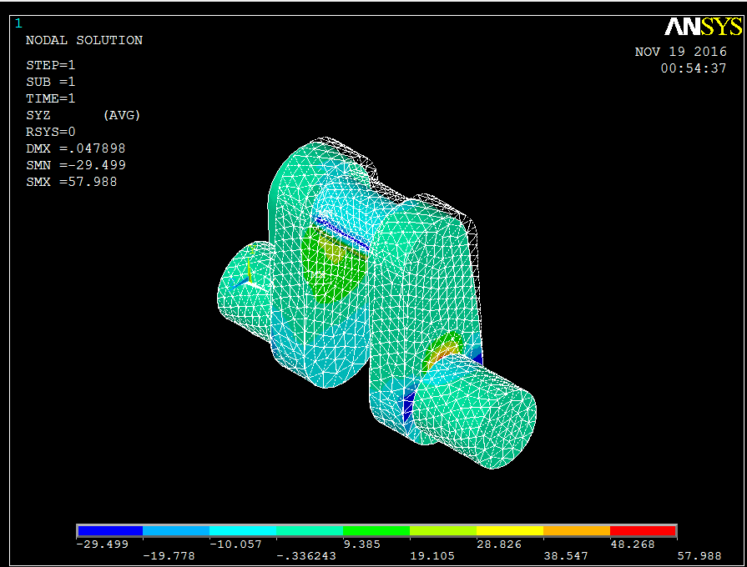
Figure 3-20 opt max twist

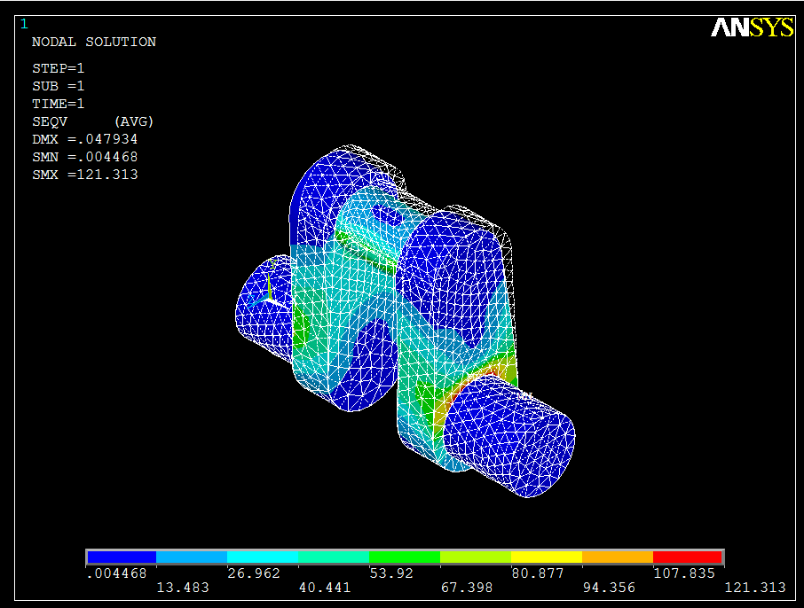
Figure 3-21 opt combined deflction & von mises

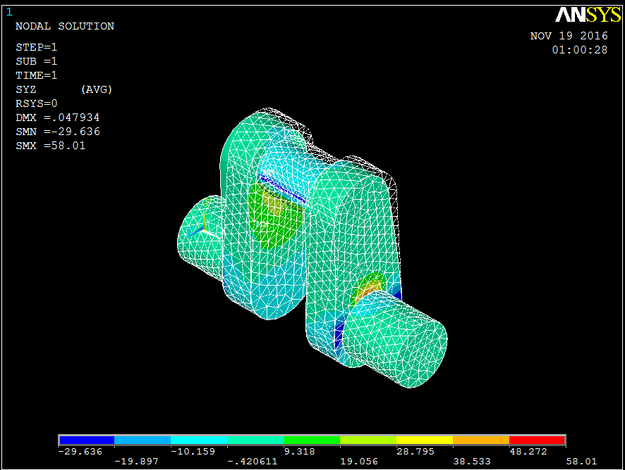
Figure 3-22 opt combined max shear

RESULTS:
maximum deflection = 0.047934 mm (combined bending and twisting)
maximum normal stress = 121.33 MPa (combined bending and twisting)
maximum shear stress = 58.01 MPa (combined bending and twisting)

FACTOR OF SAFETY:
F.O.S = allowable bending stress/max bending stress
F.O.S = 400/121.33
F.O.S ᴝ 3.3
The design is under safe limits and is acceptable.

DYNAMIC ANALYSIS

Harmonic analysis
crankshaft is investigated under the dynamic force of piston transferred to crankshaft through connecting rod and gudgeon pin. The results will be shown in the term of graphs between the amplitude and the frequency of the various quantities like displacement and stress levels using finite element method in ANSYS APDL.
Harmonic response of the crankshaft for the excitation in the range of 0-1000Hz will be analyzed. Variation of stress and displacement amplitude (frequency response) with respect to frequency will be plotted graphically.
the procedure for harmonic analysis is described below:
- first of all, import the model in ANSYS in "iges" format.
- In preprocessor > Element type > Solid > brick8node 45 > SOLID 45
- preprocessor > Material properties > Material Models > structural > linear > elastic > isotropic, a window will appear, put the values of Young's Modulus which is 200 GPa (for chromoly steel) and Poisson's ratio = 0.3. Also put the density = 7.85 e -6 kg/mm³
- Preprocessor > Meshing > Mesh > Volumes > Free and select the model.
- In Solution > Analysis type > New analysis . A window will appear select "HARMONIC".
Now the boundary conditions and forces (i.e. piston gas load in this case) are defined. Here the crank is fixed at its both bearings (static condition), so we constrained the both ends to all DOF.
- Solution > Load step options > frequency and step options and put the range of the frequency and click on stepped.
- After solving, the graph can be plotted as Time history postprocessor > variable viewer.

RESULTS:
The results represent the various contours under the applied load of the pressure for the harmonic analysis. The range of frequency starts from 0Hz and lasts to 1000 Hz figures the maximum deformation of 7.3e-004 mm at a frequency of 520 Hz at zero degree phase angle. Amplitude and the frequency diagram depict the various peak points of amplitude at different frequency points. The magnitude of amplitude of harmonic vibrations goes on changing at small intervals of frequency. The amplitude hikes at 500 Hz and 800 Hz becomes lowers at 700 Hz.

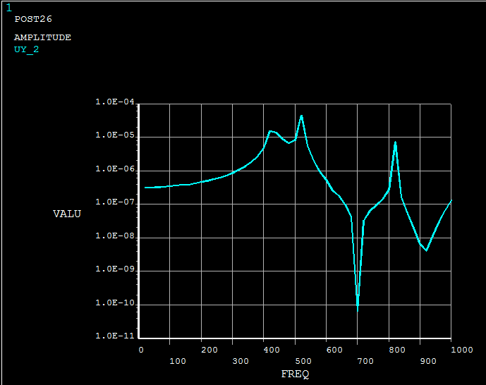
Figure 3-23 amplitude VS frequency

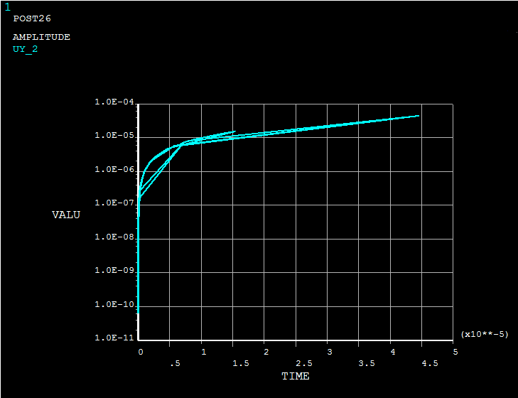
Figure 3-24 Amplitude Vs Time

Modal analysis

Modal analysis is the study of the dynamic properties of structures under vibrational excitation. Modal analysis is the field of measuring and analyzing the dynamic response of structures and or fluids during excitation. Modal analysis is the study of the dynamic properties of structures under vibrational excitation. Modal analysis is the field of measuring and analyzing the dynamic response of structures and or fluids during excitation. The main purpose of modal analysis is the design of crankshaft is required to make noise and vibration as light as possible. In order to successfully control the noise and vibration, the vibration of crankshaft which can cause vibration and noise of the engine, and some even can destroy crankshaft bearing and crankshaft itself must be estimated and analyzed.

PROCEDURE
- first of all import the model in ANSYS in "iges" format.
- Same method is followed as in Harmonic analysis for Pre processor phase.
- In Solution Phase go to solution > Analysis type > New analysis and select "Modal".
- Now define Master degrees of freedom in Solution > Master DOF > program selected and put Master degrees of freedom = 1.
- Now constrain the both ends as we have done in previous analysis's.
- Solution > Loads > Define loads > Structural > displacement > on areas and select the area of both ends. A window will appear, from there select "ALLDOF".
- Now solve > current LS
- The different mode shapes are observed in post processor phase.
- figures below represent the different mode shapes with maximum deflection on different frequencies:
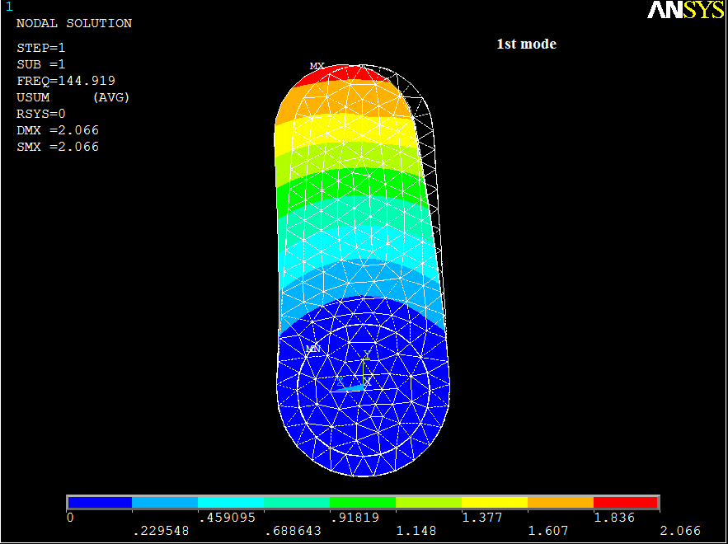
Figure 3-25 1st mode

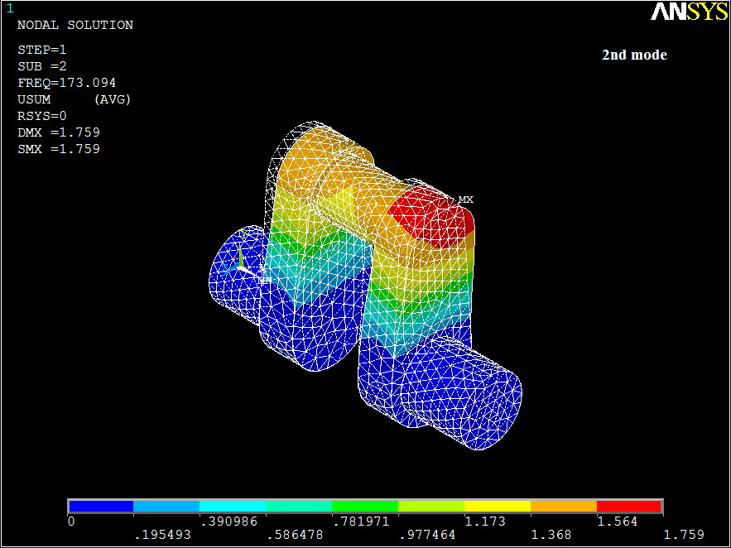
Figure 3-26 2nd mode

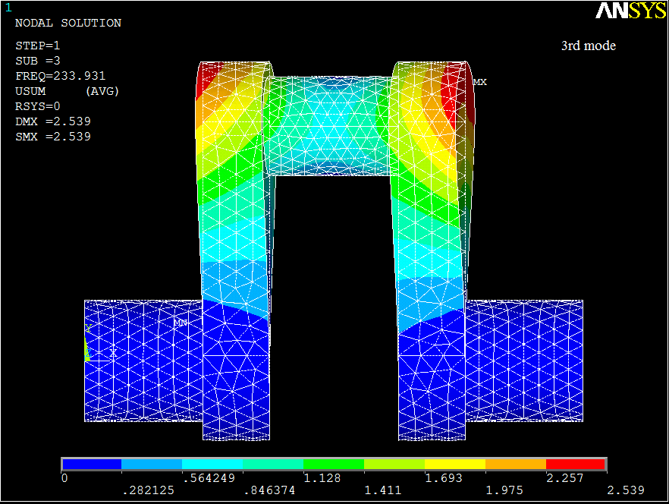
`1
Figure 3-27 3rd mode

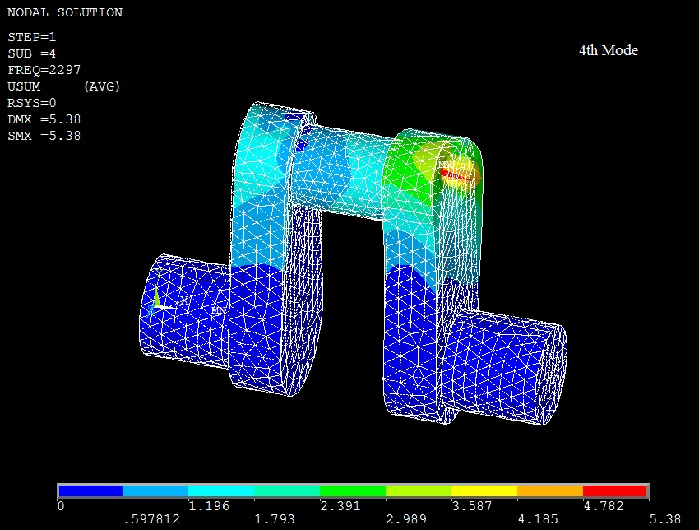
Figure 3-28 4th mode

Table 3-3 Modal frequencies
Mode | Deformation (mm) | Frequency (Hz)
1st | 2.066 | 144.919
2nd | 1.759 | 173.094
3rd | 2.539 | 233.931
4th | 5.38 | 2297

Results
Thus, it can be concluded that modal analysis gives the relation of frequency and the vibration characteristics of the crankshaft. The results of modal analysis are extremely important as the resonance frequency or the frequency at which the effects of vibration are maximum is provided. The modal analysis also provides the starting point for harmonic and transient dynamic analysis where, the details of these mode shapes with their frequencies are useful.

CHAPTER#4

Drafting & Layout

Introduction
Drafting is the act and discipline of composing drawings that visually communicate how something functions or is constructed. Technical drawing is essential for communicating ideas in industry and engineering. Technical drawings tells about many information hidden in an object or part that is to be created. Some of them are as follows.
Drawings convey the following critical information:

Information in an Engineering Drawing

Geometry
shape of the object; represented as views; how the object will look when it is viewed from various angles, such as front, top, side, etc.

Dimensions
size of the object is captured in accepted units.

Tolerances
The allowable variations for each dimension.

Material
represents what the item is made of.

Finish
specifies the surface quality of the item, functional or cosmetic. For example, a mass-marketed product usually requires a much higher surface quality than, say, a component that goes inside industrial machinery.

Lines
A variety of line styles graphically represent physical objects. Types of lines include the following:

Visible Lines
Are continuous lines used to depict edges directly visible from a particular angle.

Hidden Lines
Are short-dashed lines that may be used to represent edges that are not directly visible.

Center Lines
Are alternately long- and short-dashed lines that may be used to represent the axes of circular features.

Cutting plane lines
Are thin, medium-dashed lines, or thick alternately long- and double short-dashed that may be used to define sections for section views.

Section lines
Are thin lines in a pattern (pattern determined by the material being "cut" or "sectioned") used to indicate surfaces in section views resulting from "cutting." Section lines are commonly referred to as "cross-hatching."

Views
An Engineering Drawing also shows multiple views and projection. Because a single view is not sufficient to show all necessary features, and several views are used. Types of views include the following:

Orthographic projection
The orthographic projection shows the object as it looks from the front, right, left, top, bottom, or back, and are typically positioned relative to each other according to the rules of either first-angle or third-angle projection

Auxiliary projection
An auxiliary view is an orthographic view that is projected into any plane other than one of the six principal views. These views are typically used when an object contains some sort of inclined plane. Using the auxiliary view allows for that inclined plane (and any other significant features) to be projected in their true size and shape.

Isometric projection
The isometric projection shows the object from angles in which the scales along each axis of the object are equal.

Section view
Projected views (either Auxiliary or Orthographic) which show a cross section of the source object along the specified cut plane. These views are commonly used to show internal features with more clarity than may be available using regular projections or hidden lines.
Figure 4-1 shows the Working Drawing of crankshaft.

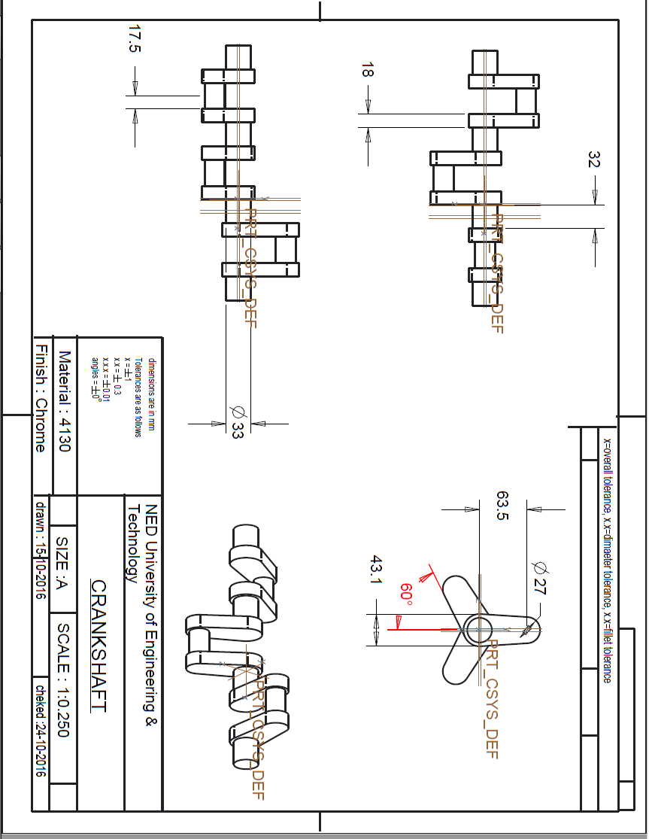
Figure 4-29 working drawing
Conclusion

The following conclusions can be drawn from the analysis conducted in this project:

Dynamic loading analysis of the crankshaft results in more realistic stresses whereas static analysis provides overestimated results. Accurate stresses are critical input to fatigue analysis and optimization of the crankshaft. There are two different load sources in an engine; inertia and combustion. These two load source cause both bending and torsional load on the crankshaft. The maximum load occurs at the Top Dead Center (TDC). At this angle only bending load is applied to the crankshaft. Considering torsional load in the overall dynamic loading conditions has no effect on von Mises stress at the critically stressed location. The effect of torsion on the stress range is also relatively small at other locations undergoing torsional load. Therefore, the crankshaft analysis could be simplified to applying only bending load. Superposition of FEM analysis results from two perpendicular loads is an efficient and simple method of achieving stresses for different loading conditions according to forces applied to the crankshaft from the dynamic analysis. Critical (i.e. failure) locations on the crankshaft geometry are all located on the fillet areas because of high stress gradients in these locations, which result in high stress concentration factors. Geometry optimization resulted in approximately 30% weight reduction of the crankshaft, which was achieved by changing the dimensions and geometry of the crank webs while maintaining dynamic balance of the crankshaft. This stage of optimization did not require any changes in the engine block or connecting rod. Using the nickel chromium instead of chromoly steel, there is a significant in overall cost of the crankshaft and another advantage is that we don't need to change the dimensions which save the cost of making a new die.

References

- R.S Khurmi (2005). “Machine Design” (J.K Gupta). RAM NAGAR, NEW DELHI-110 055
- Joseph Edward Shigley. (2011). “Mechanical Engineering Design” (Richard G. Bodynas and J. Keith Nisbett.).
- K.Pandiyan, Dr. Ashesh Tiwari (2015). “Crankshaft Design Methodology for Diesel Engines”, International Journal of Innovative Research in Science, Engineering and Technology, Vol. 04, issue 8.
- Germanischer Lloyd SE (2012), “Calculation of Crankshafts for Internal Combustion Engines”, VIGL, part 4.

- Dr. C. M. Ramesha, Abhijith K G, Abhinav Singh, Abhishek Raj, Chetan S Naik (2015). “Modal analysis and harmonic response analysis of a crankshaft”, vol. 5, issue 6.
- http://tractors.wikia.com/wiki/Massey_Ferguson
- http://www.ijraset.com/fileserve.php?FID=3290
- http://www.Onallcylinders.com

Appendix
(section for appendix material)

