**Global Journal of Engineering Science and Researches**

**DESIGN AND ANALYSIS OF CRANKSHAFT FOR FOUR CYLINDER DEISEL ENGINE**

**Shubham Singhmar*1, Sahil2, Shubham Gupta3, Ankesh Sharma4**

*1,2Student, Department of mechanical engineering, Chandigarh university , India

3Student, Department of mechanical engineering, Chandigarh Polytechnic college , India

4Student, Department of mechanical engineering, Govt. Engg. College Kotla (Jeori), Himachal Pardesh , India

**ABSTRACT**

Crankshaft is one of the critical components for the effective and precise working of the internal combustion engine. In this paper a dynamic simulation is conducted on a crankshaft from a single cylinder 4- stroke diesel engine. A three-dimension model of diesel engine crankshaft is created using CATIA software. Finite element analysis (FEA) is performed to obtain the variation of stress magnitude at critical locations of crankshaft. Simulation inputs are taken from the engine specification chart. The dynamic analysis is done using FEA Software ANSYS which resulted in the load spectrum applied to crank pin bearing. This load is applied to the FE model in ANSYS, and boundary conditions are applied according to the engine mounting conditions. After Static Structure Analysis Modal analysis performed upto 8 mode shape. The finite element analysis (FEM) software ANSYS is used to analyse the stress status and vibration modal for the distortion behaviour of the crank shaft. Since the crankshaft experiences a large number of load cycles during its service life, fatigue performance and durability of this component has to be considered in the design process.

***Keywords****:* *Diesel engine; Crank shaft Catia; Ansys; finite element analysis; stress analysis*

1. **INTRODUCTION**

Crankshaft (i.e. a shaft with a crank) is a central component of any internal combustion engine and is used to convert reciprocating motion of the piston into rotatory motion or vice versa.

The obvious source of forces applied to a crankshaft is the product of combustion chamber pressure acting on the top of the piston. High-performance, contemporary high performance Compression-Ignition (CI) engines can see combustion pressures in excess of 200 bar (2900 psi) which will produce a force of 80 KN acting on a small 4.00 inch diameter piston. Rotation of crankshaft is 705 RPM. This kind of huge force exerted onto a crankshaft rod journal which produces substantial bending and torsional moments and the resulting tensile, compressive and shear stresses.

In an internal combustion engine, two load sources apply force on the crankshaft. The load applied by combustion in the combustion chamber to the piston is transmitted to the crankpin bearing by a four bar slider-crank mechanism. This is the main source of loading in the engine. The other load source is due to dynamic nature of the mechanism. Since the engine operates at high speeds, the centrifugal forces are present at different rotating components such as connecting rods. These load sources apply both torsional and bending load on the crankshaft.

1. **DESIGN INPUT PARAMETERS**

In the present simulation, a 4-stike diesel engine crankshaft is analyzed. The crankshaft has four crankthrows, three rod journals and two main journals. The mainly dimensional parameters of the crankshaft are mentioned below in Table 1.

|  |  |
| --- | --- |
| **Structure parameters** | **Values** |
| Crankshaft length (mm) | 514 |
| Crankshaft height (mm) | 140 |
| Crank radius (mm | 67.5 |
| Main journal diameter (mm) | 58 |
| rod journal (mm) | 58 |
| Crankpin axial length (mm) | 31 |
| Main journal axial length (mm) | 15 |
| Crank cheek thickness (mm) | 19 |

**Table 1: Crankshaft main dimensions**

1. **METHODOLOGY**

**3.1 Procedure of static Analysis**

**1. Geometry**

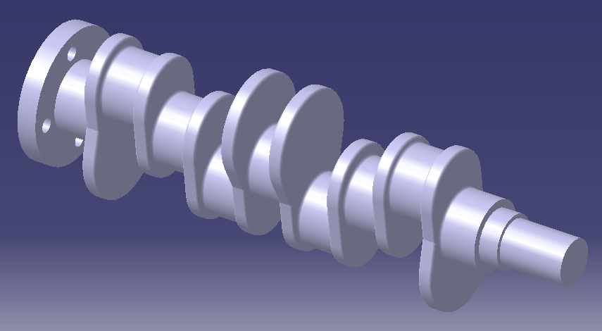

**Fig:1 Crankshaft Geometry in Catia**

**2. Material Properties – 42CrMn**

The material used here for the analysis of crankshaft is steel alloy 42CrMn and the physical parameters are listed below in the table.

|  |  |
| --- | --- |
| **Physical parameters** | **Values** |
| Tensile Ultimate strength (MPa) | 1080 |
| Yield strength (MPa) | 930 |
| Modulus of Elasticity (GPa) | 210 |
| Poisson ratio | 0.3 |
| Density (g/cm3) | 7.9 |
| Elongation (%) | 12 |
| Reduction of cross sectional area (%) | 5 |
| Rigidity (HB) | 217 |

**Table 2: Material properties of 42CrMn**

**3. Meshing**

The meshing detail of crankshaft is shown in table:

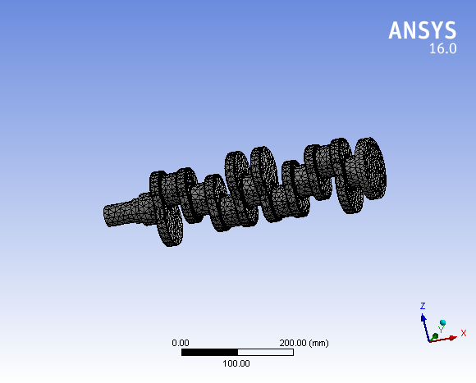

**Fig: 2 Meshing**

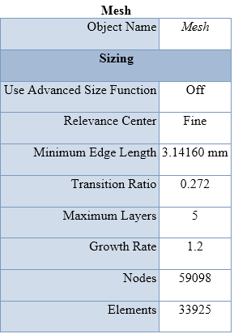

**Table: 3 Mesh Detail**

**4. Boundary Condition**

Define boundary condition for Analysis Boundary conditions play an important role in finite element calculation here; I have taken both remote displacements for bearing supports are fixed (Fig:3).

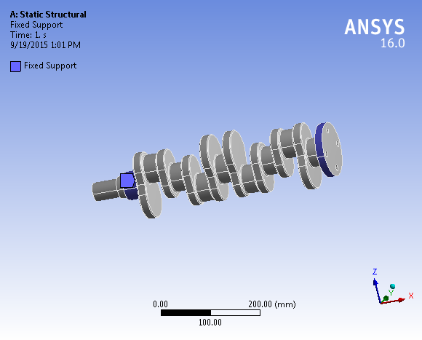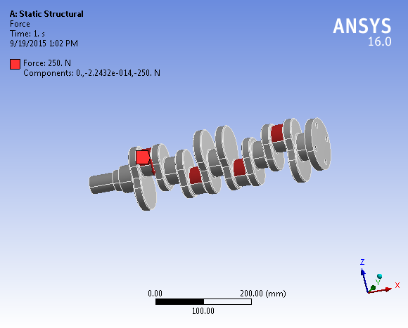

**Fig: 3 Fig: 4**

**5. Run the Analysis**

6. RESULT OF STATIC STRUCTURE

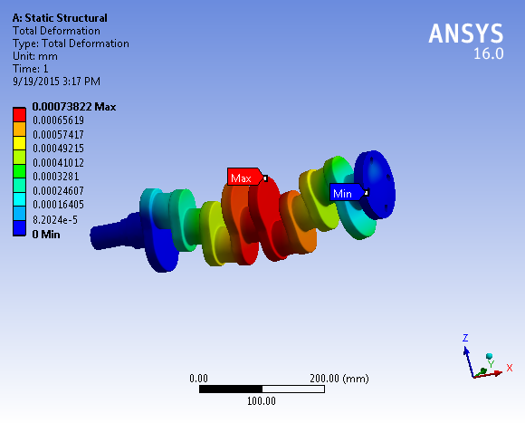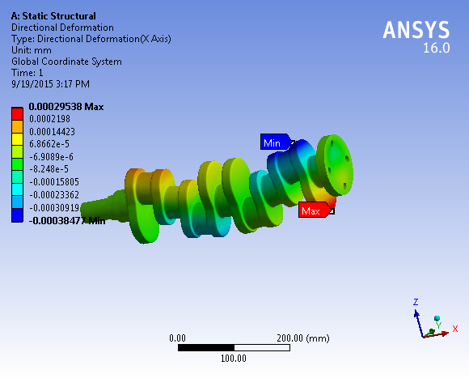

**Fig:5 Total Deformation Fig:6 Directional Deformation**

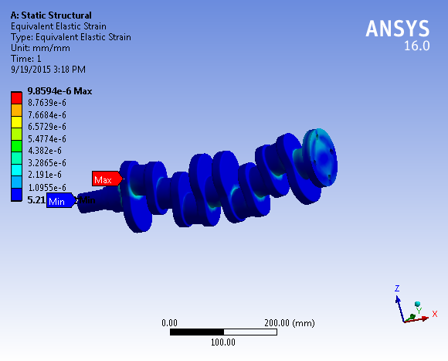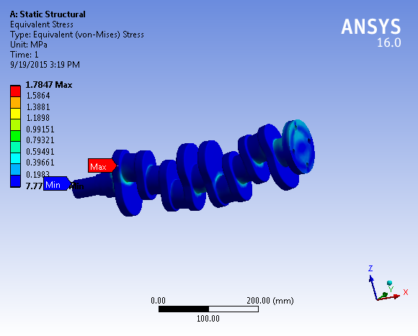

**Fig: 7 Equivalent Elastic Strain Fig: 8 Equivalent Stress**

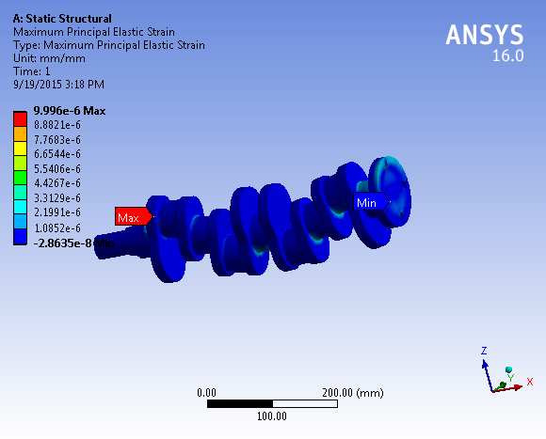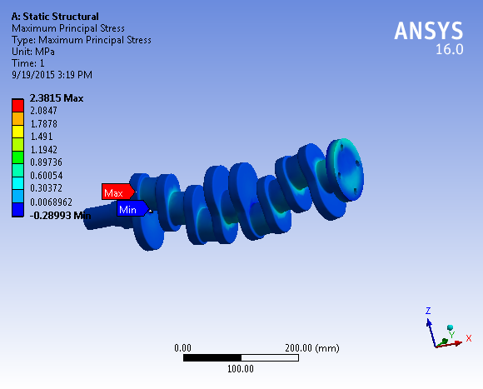

**Fig: 9 Maximum Principal Elastic Strain Fig: 10 Maximum Principal Stress**

**7 Modal Analysis Result**

The vibration characteristic of crankshaft was obtained with modal analysis.The former six vibration modal diagrams of crankshaft are shown in Fig. 11-18

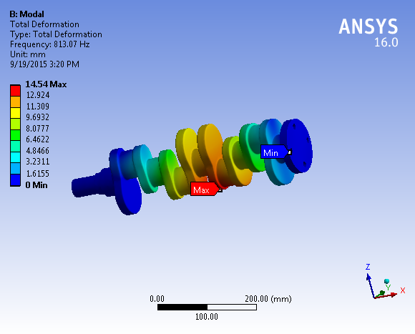

**Fig: (11) 1 vibration modal of crankshaft**

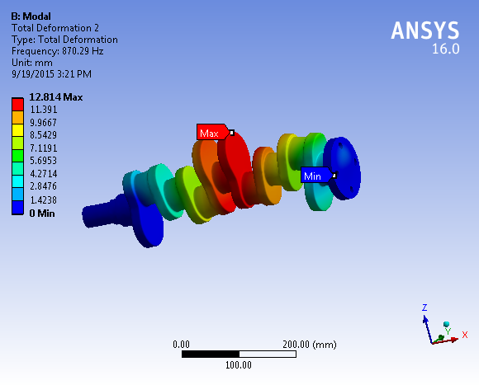

**Fig: (12) 2 vibration modal of crankshaft**

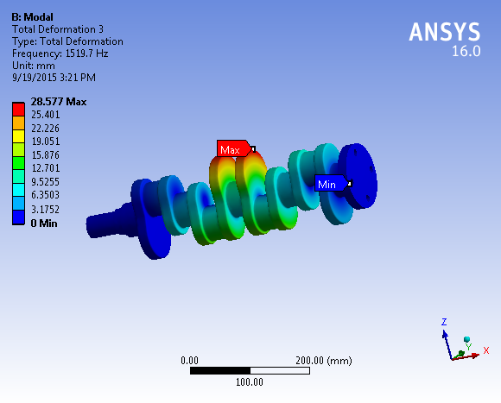

**Fig: (13) 3 vibration modal of crankshaft**

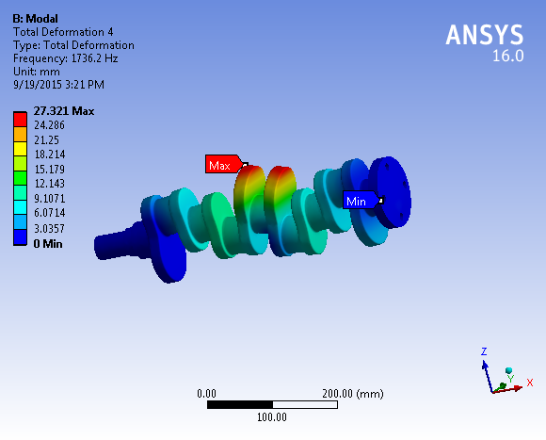

**Fig: (14) 4 vibration modal of crankshaft**

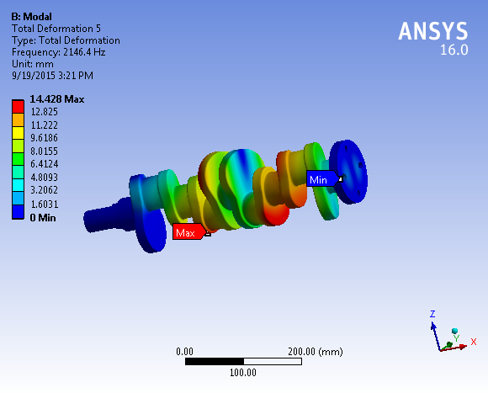

**Fig: (15) 5 vibration mode of crankshaft**

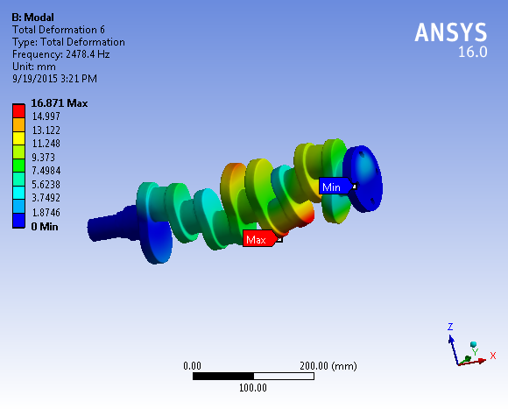

**Fig: (16) 6 vibration mode of crankshaft**

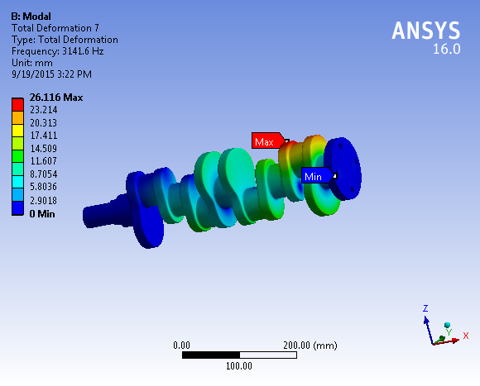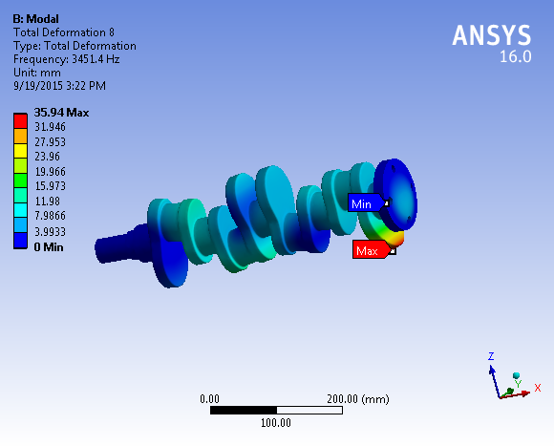

**Fig: (17) 7 vibration mode of crankshaft Fig: (18) 8 vibration mode of crankshaft**

1. **CONCLUSIONS**

In this paper, the crankshaft model was created by Catia software. Then, the model created by Catia was imported to ANSYS software.

|  |  |  |  |
| --- | --- | --- | --- |
| Sr no | Types of Stress(MPa) | Theortical | Fea Analysis |
| 1 | Von- Mises Stress | 1.5624 | 1.7847 |
| 2 | Max Principal Stress | 2.1064 | 2.3815 |
| 3 | Min Principal Stress | 0.6984 | 0.70231 |

Above Results Shows that FEA Results Conformal matches with the theoretical calculation so we can say that FEA is a good tool to reduce time consuming theoretical Work. The crankshaft deformation was mainly bending deformation under the lower frequency. And the maximum deformation was located at the link between main bearing journal and crankpin and crank cheeks. So this area prones to appear the bending fatigue crack. Base on the results, we can forecast the possibility of mutual interference between the crankshaft and other parts. The resonance vibration of system can be avoided effectively by appropriate structure design

**References**

1. *Jaimin Brahmbhatt Design And Analysis Of Crankshaft For Single Cylinder 4-Stroke Deisel Engine, International Journal of Advanced Engineering Research and Studies- E-ISSN2249– 8974*
2. *Yu Ding and Xiaobo Li.,2011, “ Crankshaft Strength Analysis of a Diesel Engine Using Finite Element Method,” Asia-Pacific Power and Energy Engineering Conference*
3. *Jian Meng., Yongqi Liu., Ruixiang Liu.,2011,“Finite Element Analysis of 4-Cylinder Diesel Crankshaft, ” I.J. Image, Graphics and Signal Processing, 5, 22-29*
4. *Yu Gongzh.i, Yu Hongliang., Duan Shulin., 2011, “Crankshaft Dynamic Strength Analysis for Marine Diesel Engine,” Third International Conference on Measuring Technology and Mechatronics Automation.*
5. *Gu Yingkui, Zhou Zhibo.,2011,“Strength Analysis of Diesel Engine Crankshaft Based on PRO/E and ANSYS,” Third International Conference on Measuring Technolog and Mechatronics Automation*
6. *O. kamura H, “A dynamic stiffnessmat rix approach to the analysis of three dimensional vibrations of automobile engine crankshaft,” Part 1-Background and application to free vibrations. Proceeding of Vehicle Noise, ASME, 1990, 9 (2) , pp. 899-908.*
7. *J. Sun, C..L. Gui, and x. Li, “A Review of Crankshaft Strength Analysis for Internal Combustion Engines,” Transactions of Csice, 20(2), pp, 179-184,2002.*
8. *Z. Mourelatos, “An analytical investigation of the crankshaft flywheel bending vibrations for a V6 engine,” SAE Paper 951276, 1995.*