**Lead businesses from the comfort of your couch: Metaverse**



**Metaverse**, the thought isn’t new. From being described in a novel “Snow Crash” In 1992 to being the most spoken subject in today’s world, it is something worth your attention.

The metaverse is the combination of three-dimensional network of **virtual worlds** and it is digitally interactive, now how do you ‘live’ in these worlds or access these virtual worlds and seem cool? Just own a few virtual reality gadgets like headsets, smart glasses, PC’s and you are good to go.

Joining or experiencing metaverse can be done by using: For example, ‘decentraland’ is a virtual world based on a crypto currency where you can explore, play and interact, buy digital assets (NFT’s) etc.

We can say that metaverse has gone far. Musicians and producers, entertainment industries, sports industry are developing virtual stadiums and hosting shows, events etc. When it comes to [metaverse in gaming](https://www.papersdrop.com/srivastavapriyanshu1605/metaverse-in-gaming/d32c7d85-3222-4d58-aa41-271c22c576b0), metaverse and gaming go hand in hand, connecting players regardless of their location and helping them interact in a virtual world will impact and change the gaming industry to an extent.



Now how can this widely spoken realm help or change businesses and improve it:

There are people who are involved in gaming in the virtual world, **interacting** etc. But this new virtual immersive platform which embodies augmented reality and virtual reality connecting people from all over the world virtually help **businesses grow** too. Popular brands use it in a wise way like, especially Meta (Previously Facebook), Nike after the acquisition of RTFKT which designs digital assets, virtual sneaker designs, collectibles and more became a popular brand featuring in the metaverse.

Nike then collaborated with a popular game Roblox which uses metaverse widely, selling in-game virtual goods, all these do nothing but promote Nike.

Louis Vuitton was clever enough in combining fashion and gaming industry, developed and hosted their own game to celebrate their 200th anniversary which includes many purchasable NFT’s. This **strategic** move helped Louis Vuitton in many ways.

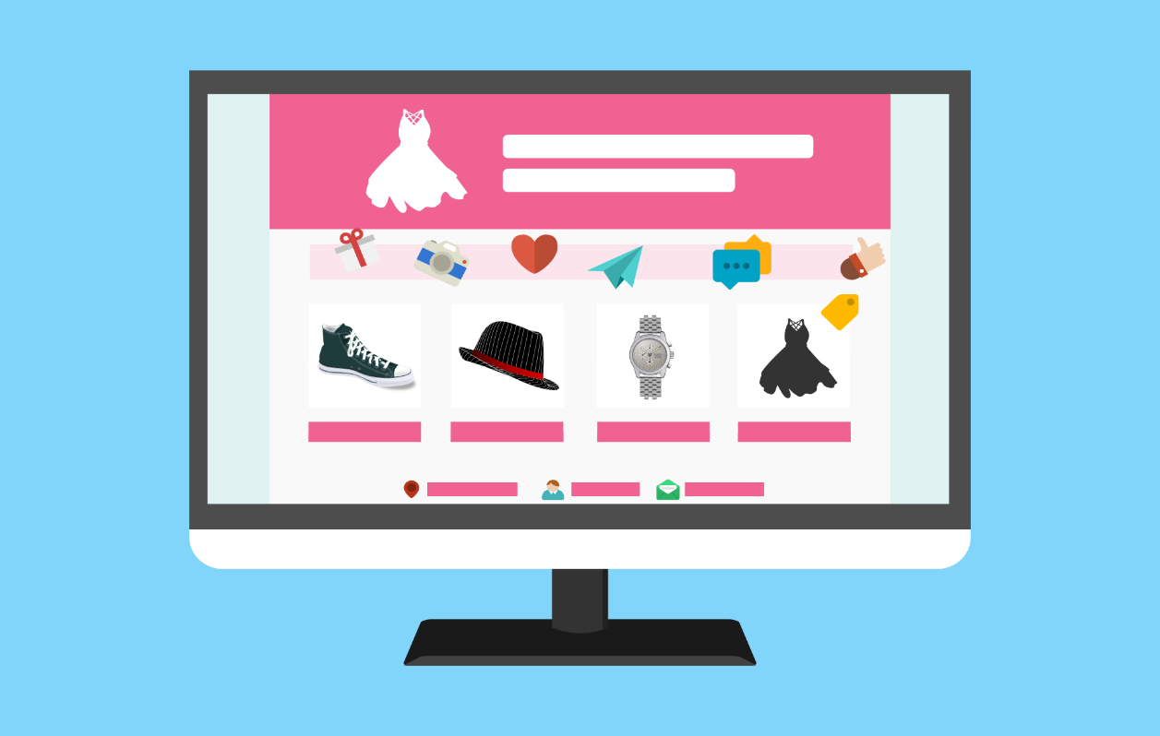

Many more popular brands like Disney, Coca-Cola, Hyundai, apple adapted the ways of metaverse and evolved further.

Business in metaverse is an assured reality to you if you know your niche – From selecting the metaverse platform, creating the meta space, building an interaction panel, creating an interoperability digital structure to knowing who is going to use your services or products, what features they might expect, a proper model for business, marketing, security, digital strategies, virtual interaction with the consumers and stakeholders etc. Enhancing all these will surely be a bang for your buck and help your business grow simultaneously in the metaverse.