**CUSTOMER CHURN PREDICTION**

**DEVELOPMENT PART 1**

|  |  |
| --- | --- |
| **Date** | **20-10-2023** |
| **Team ID** | **3923** |
| **Project Name** | **Customer Churn Prediction** |

**Table of Contents**

|  |  |
| --- | --- |
| 1 | Introduction |
| 2 | Problem Statement |
| 3 | Steps involved in model evaluation |
| 3.1 | Data collection |
| 3.2 | Load the dataset |
| 3.3 | Data preprocessing |
| 3.4 | Data visualisation using Cognos |
| 4 | Conclusion |

**1. Introduction**

The primary goal of this document is to provide an in-depth analysis of the design and innovation strategies required for developing a Customer Churn Prediction model. Predicting customer churn is pivotal for businesses aiming to not only retain their customers but also sustain profitability. This project is specifically dedicated to harnessing inventive techniques and methodologies to significantly enhance the accuracy and overall effectiveness of churn prediction, ensuring that businesses can proactively address potential customer attrition and tailor retention strategies for maximum impact.

**2. Problem Statement**

Customer churn is a significant challenge for businesses across various industries. The central problem of this project is to build a model that accurately predicts customer churn and identifies the key factors influencing customer retention.

**3. Steps involved in model evaluation**

**3.1. Data collection:**

The data collection begins by defining the project's objectives and understanding the problem domain. Next, data sources are identified, which could range from databases and APIs to surveys or sensors. The actual gathering process involves extracting or obtaining the data from these identified sources.This stage involves defining project objectives, identifying relevant data sources, gathering data, preprocessing (handling missing values, outliers, etc.), cleaning, validating, exploring, and visualizing the data.

**3.2. Load the dataset.**

Import the necessary dependencies and load the dataset.

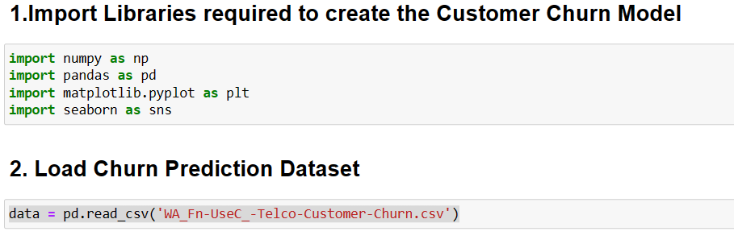

**3.3. Explore the dataset using jupyter notebook.**

**Step 1:**

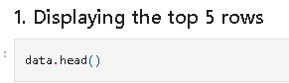

**Step 2:**

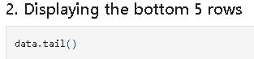

**Step 3:**

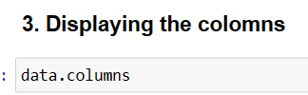

**Step 4:**

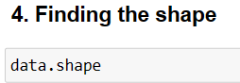

**Step 5:**

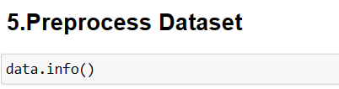

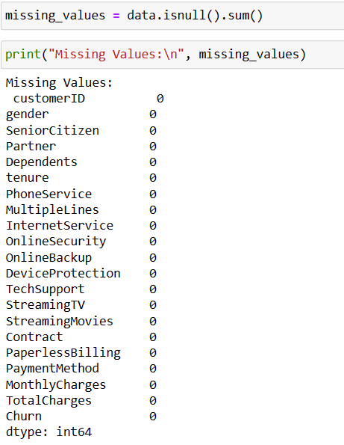

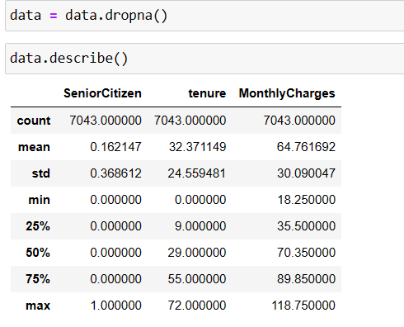

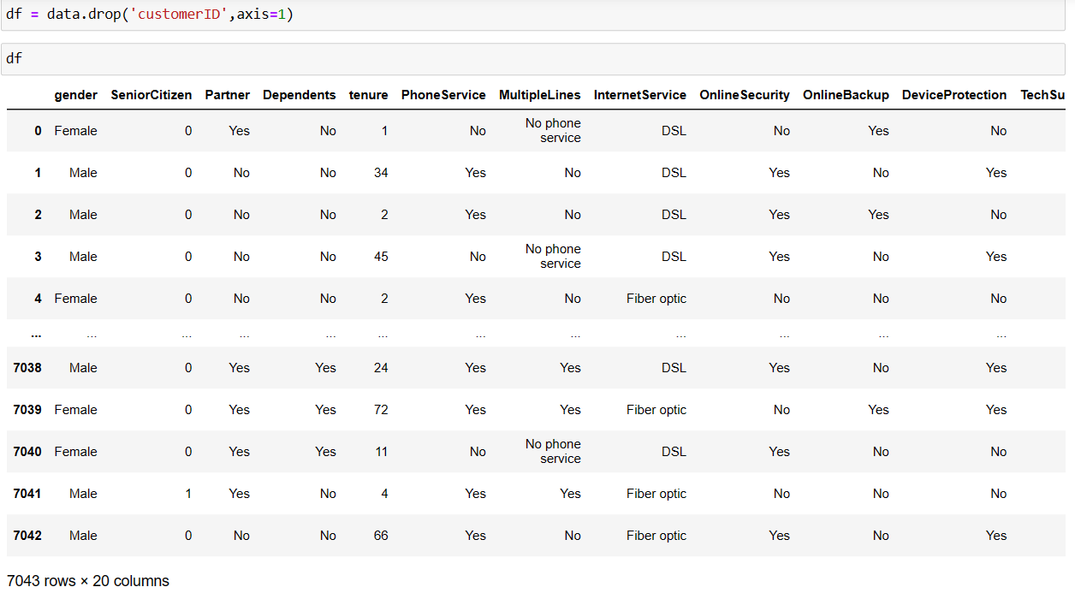

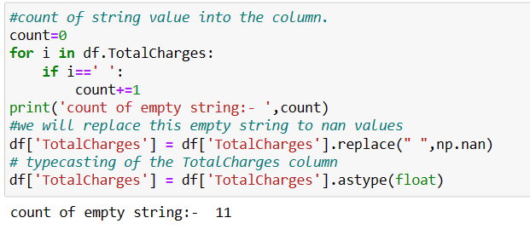

**Step 6:**

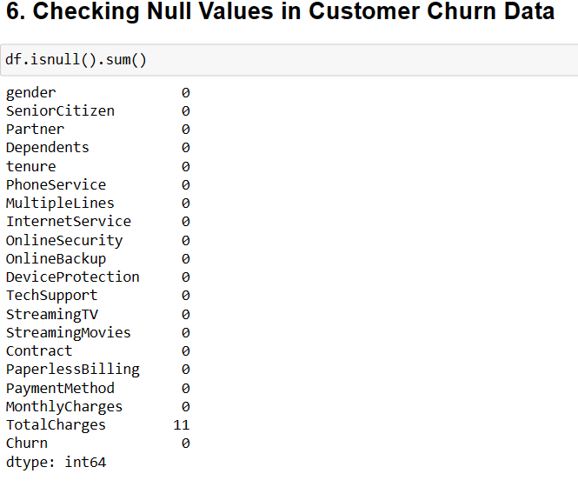

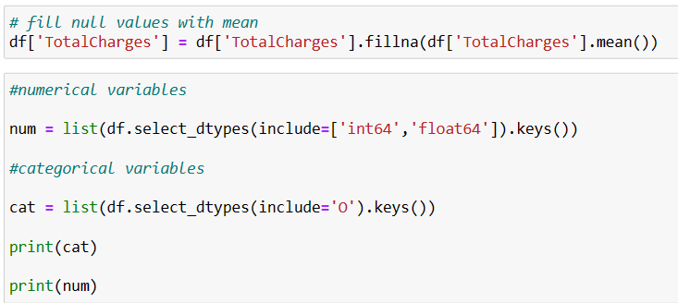

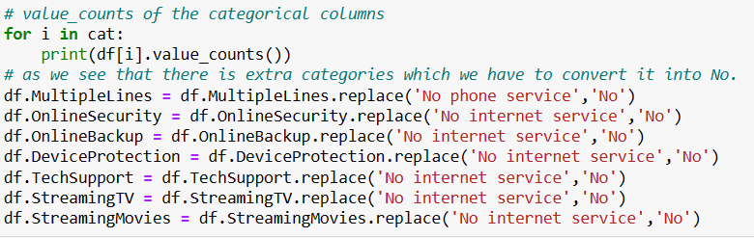

**Step 7:**

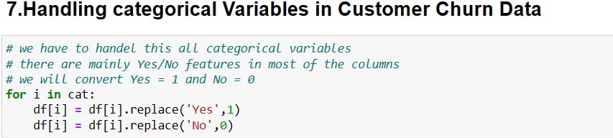

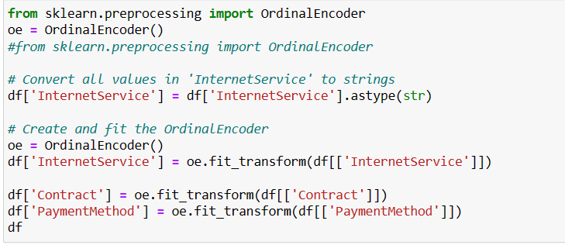

**3.4 Visualisation using Cognos:**

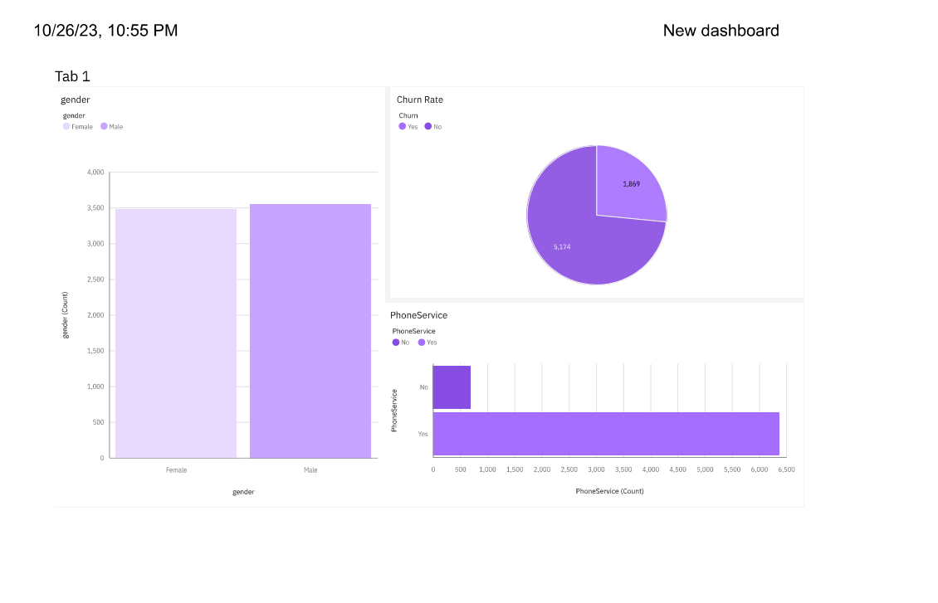

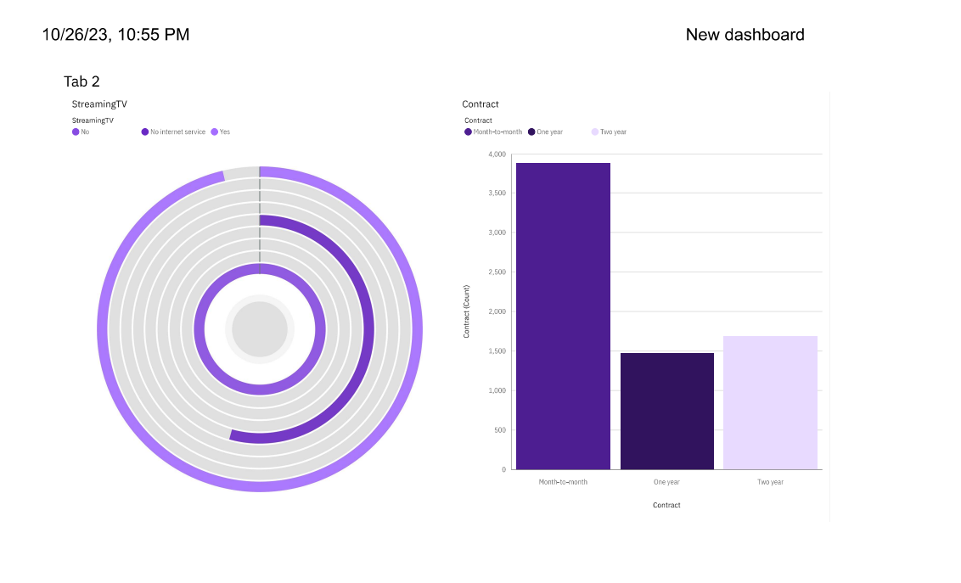

**4. Conclusion**

In conclusion, the analysis elucidates distinct patterns in the prediction of customer churn. By monitoring ongoing fluctuations, it becomes apparent whether churn rates are increasing or decreasing. These insights are invaluable for making well-informed decisions and implementing effective strategies to reduce customer attrition, ultimately bolstering business performance. The amalgamation of advanced analytics techniques and data visualization within the framework of the 'Customer Churn Prediction' project enhances our grasp of customer retention dynamics, facilitating the development of strategies to mitigate attrition and optimize business outcomes.