Schematic:
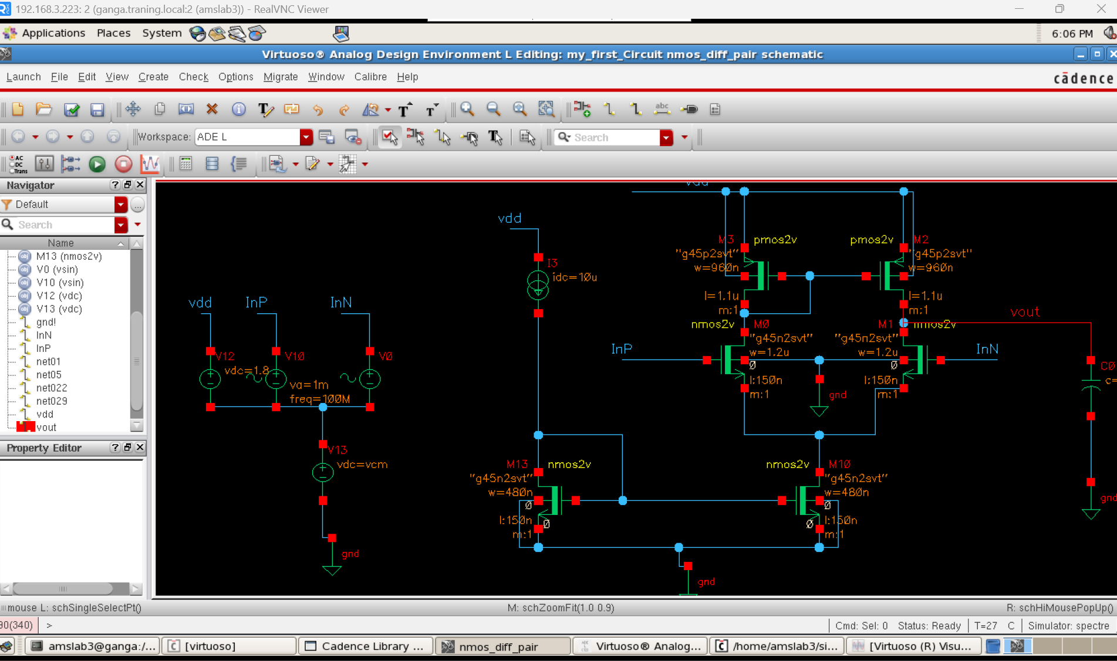

AC Responds: Gain
Input + : AC magnitude 1V, Amplitude 1mv
Input - : AC magnitude 1v (180 phase shift), Amplitude 1mv
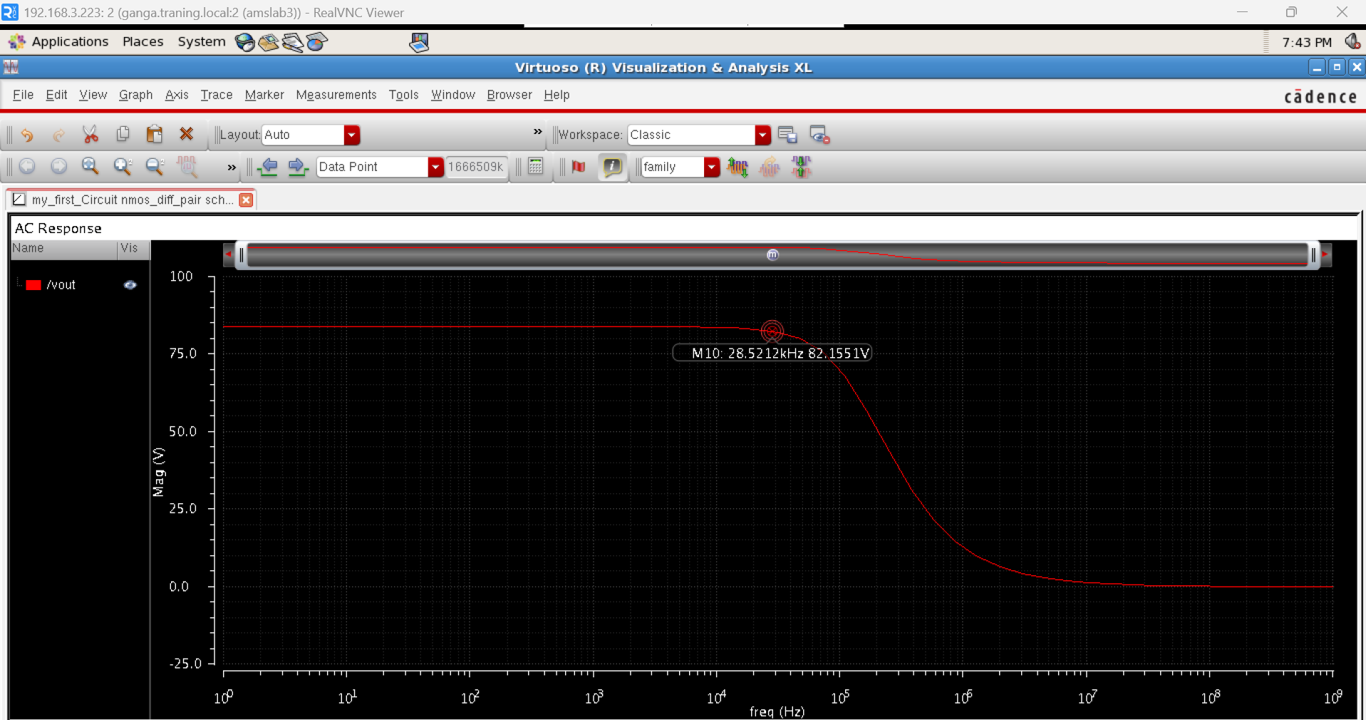
Gain = V_{OUT} / (V_{INP} - V_{inN} )

Gain in dB:
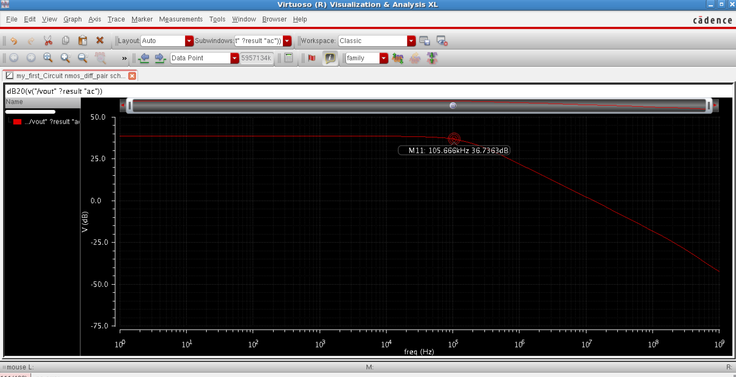

Bandwidth:
- Low-frequency gain ALF≈38.45 dBALF≈38.45 dB.
- −3 dB level =38.45−3=35.45 dB=38.45−3=35.45 dB.
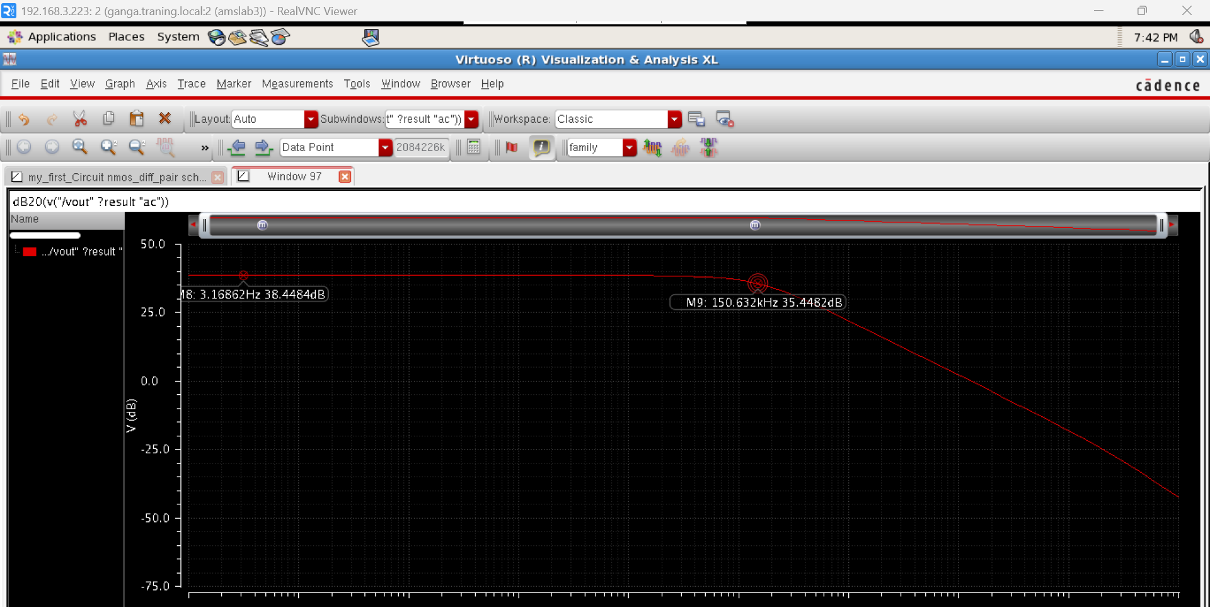

Trans Analysis: at 1mv AC amplitude
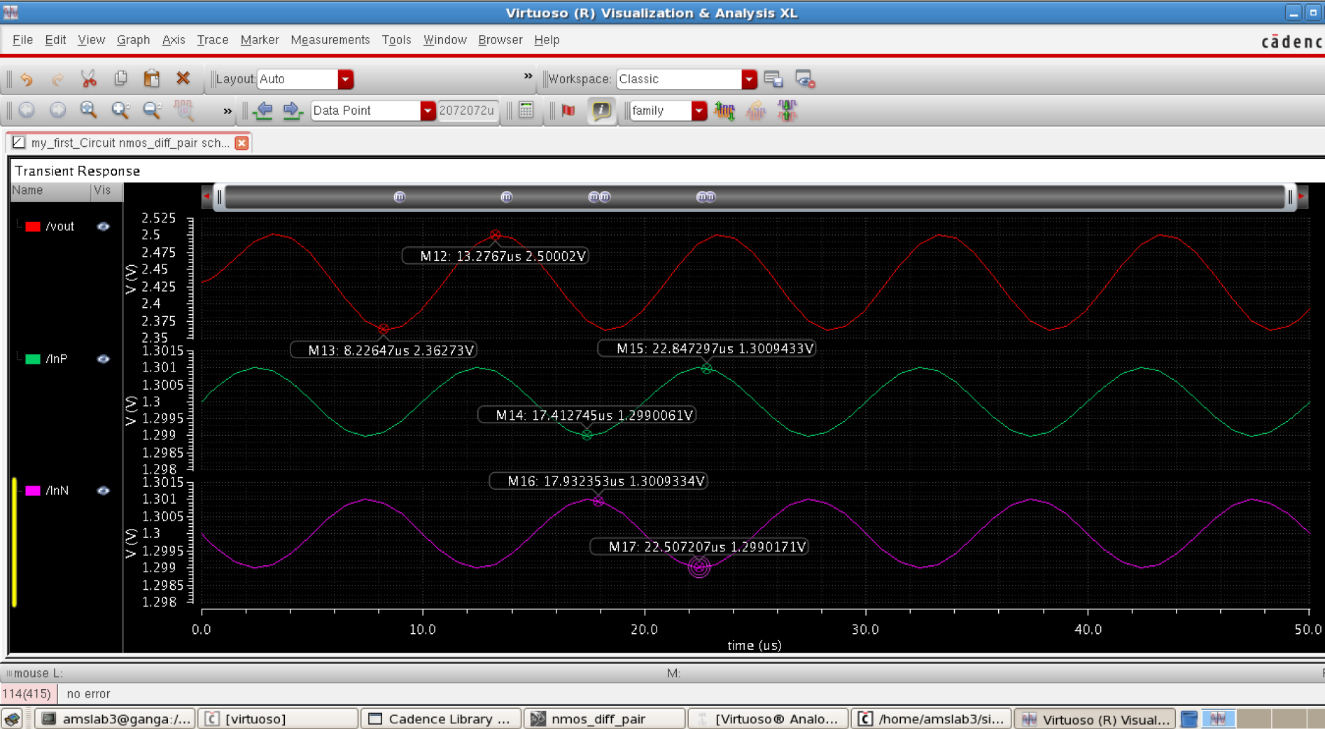
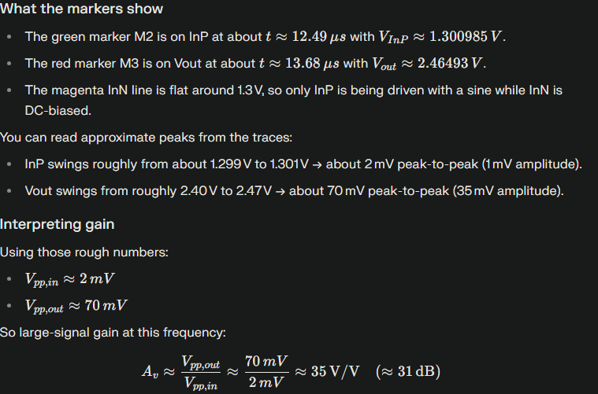
which matches well with my AC gain of about 32 dB. The waveforms look sinusoidal with no clipping, so the amplifier is operating linearly for this input amplitude at this frequency.

