Alzheimer Brain Tumour Detection using VGG16 & 19 Algorithms

In this project as per your request we are using DICOM normal and brain tumour dataset to train VGG16 and VGG19 algorithms and then evaluating each algorithm performance in terms of accuracy, precision, recall, FSCORE and Confusion Matrix. To train both algorithms we are using below dataset

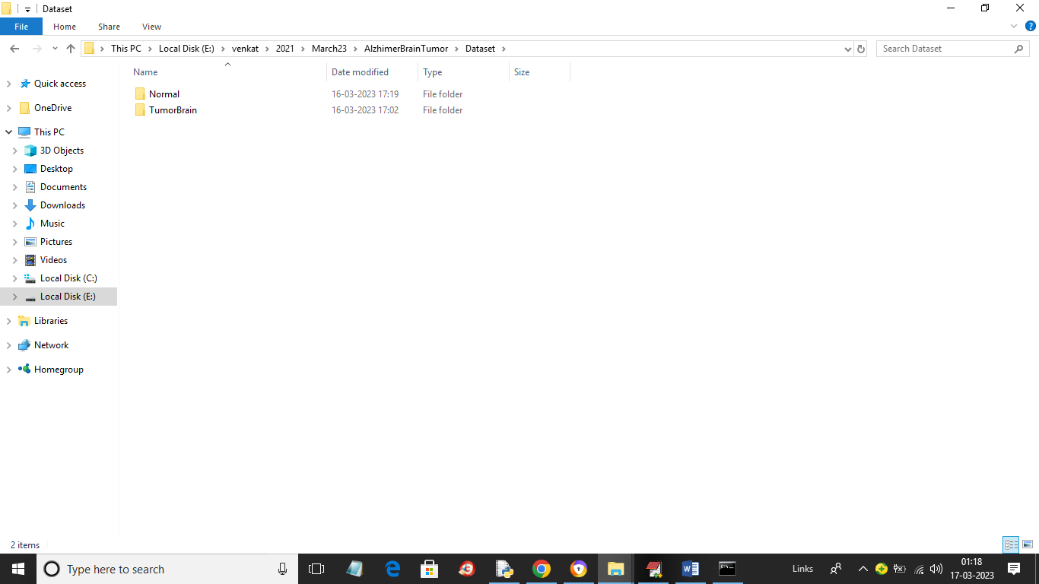

In above screen we have two folders and just go inside any folder to view DICOM files like below screen.

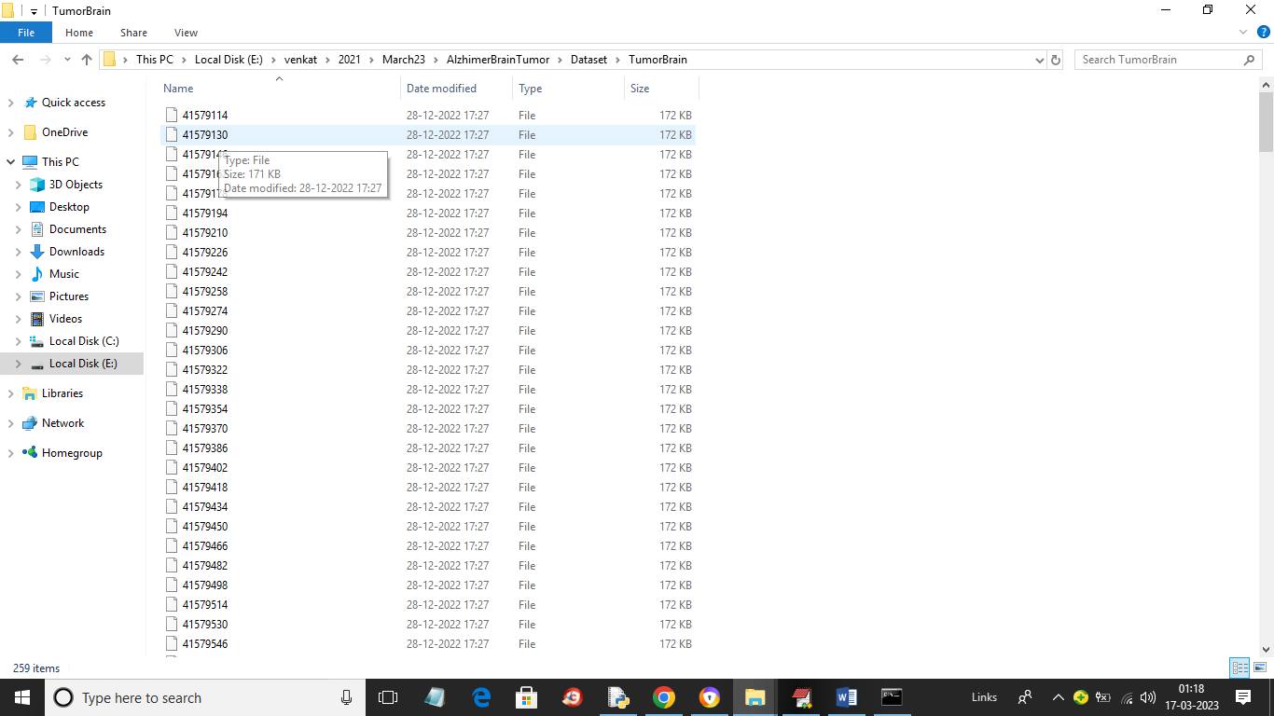

So to train both VGG16 and 19 we are using above dataset files

To implement this project we have designed following modules

1. Upload Dicom Alzheimer Brain Dataset: using this module we will upload dataset to application and then print type of classes found in dataset
2. Preprocess Dataset: using this module we will read each DICOM image and then extract brain image and then normalize, shuffle and split dataset into train and test where application using 80% dataset for training and 20% for testing
3. Train VGG16 Algorithm: using this module we will input 80% training data to VGG16 to train a model and this model will be applied on test data to calculate prediction accuracy
4. Train VGG19 Algorithm: using this module we will input 80% training data to VGG19 to train a model and this model will be applied on test data to calculate prediction accuracy
5. Comparison Graph: using this module we will plot accuracy graph between both algorithms
6. Tumour Detection: using this module we will upload test DICOM data to application to extract brain images and then predict weather image is normal or contains Brain Alzheimer tumour.

SCREEN SHOTS

To run project double click on ‘run.bat’ file to get below screen

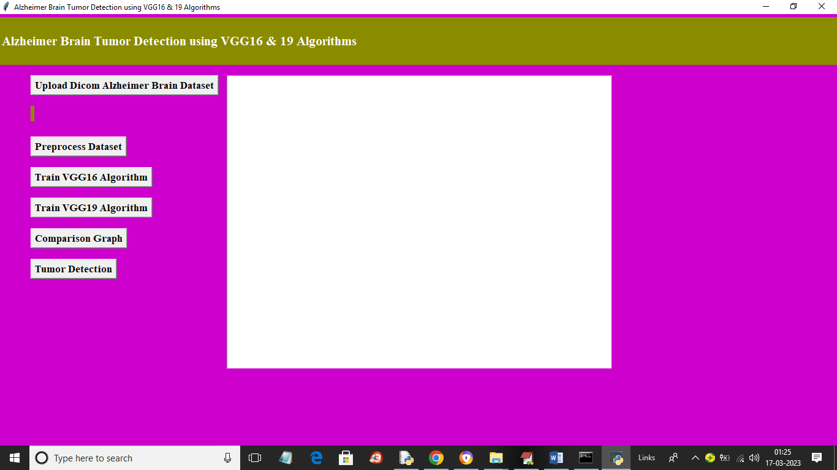

In above screen click on ‘Upload Dicom Alzheimer Brain Dataset’ button to upload dataset and get below output

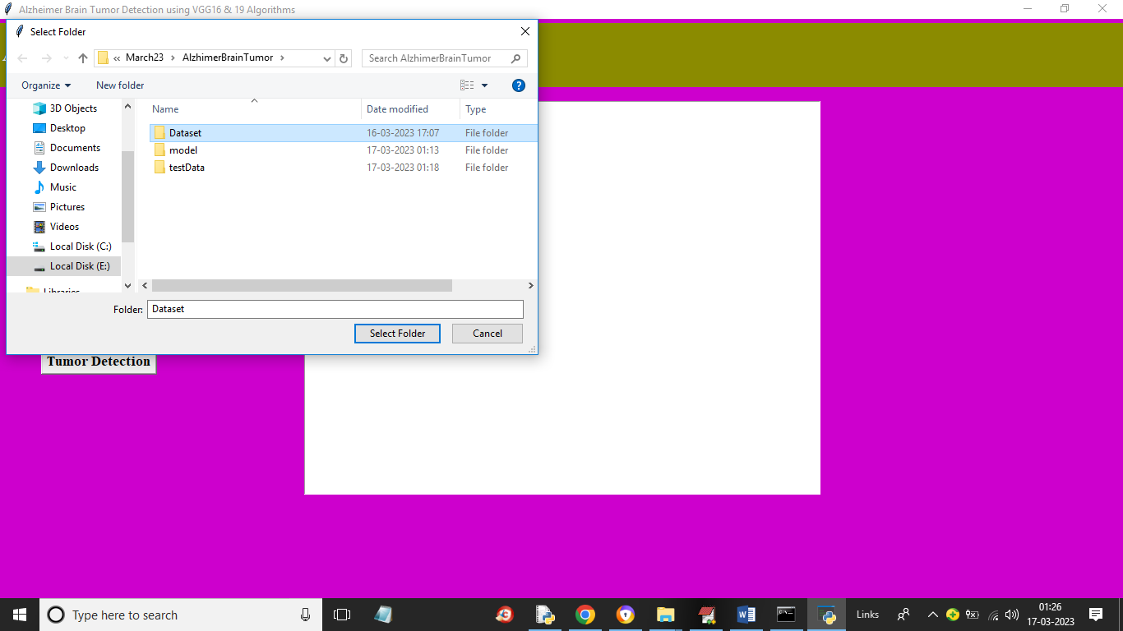

In above screen selecting and uploading entire DICOM dataset folder and then click on ‘Select Folder’ button to load dataset and get below output

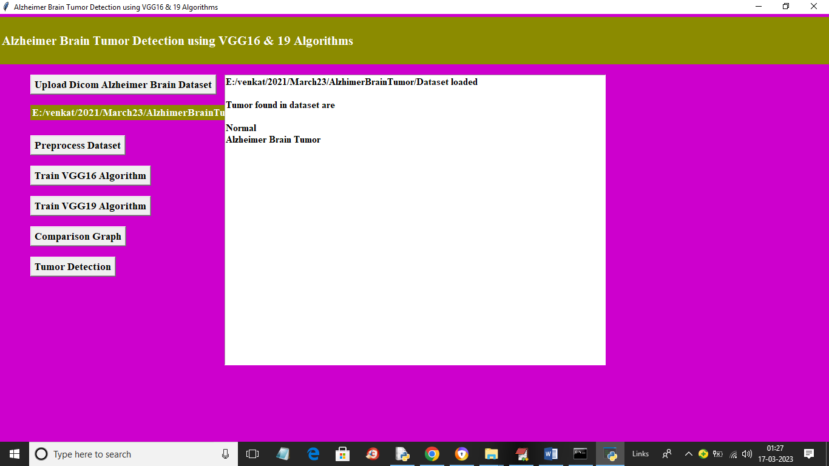

In above screen dataset loaded and we can see types of labels found in dataset as ‘Normal or Alzheimer Tumour’ and now click on ‘Preprocess Dataset’ button to process images and get below output

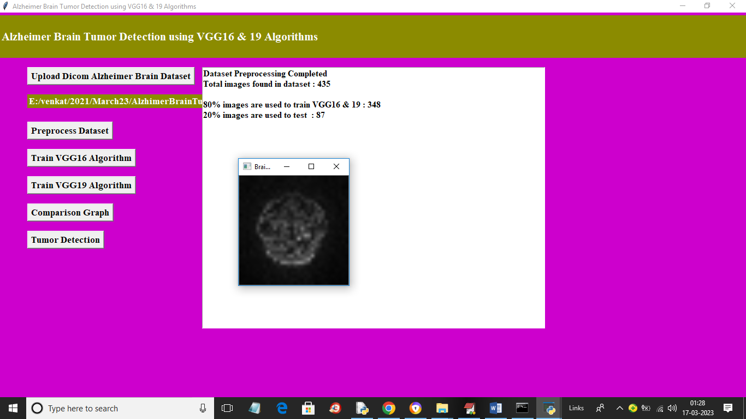

In above screen we can see dataset contains 435 images and then application using 80% (348) images for training and 20% (87) images for testing. Now close above graph and then click on ‘TrainVGG16 Algorithm’ button to train VGG16 and get below output

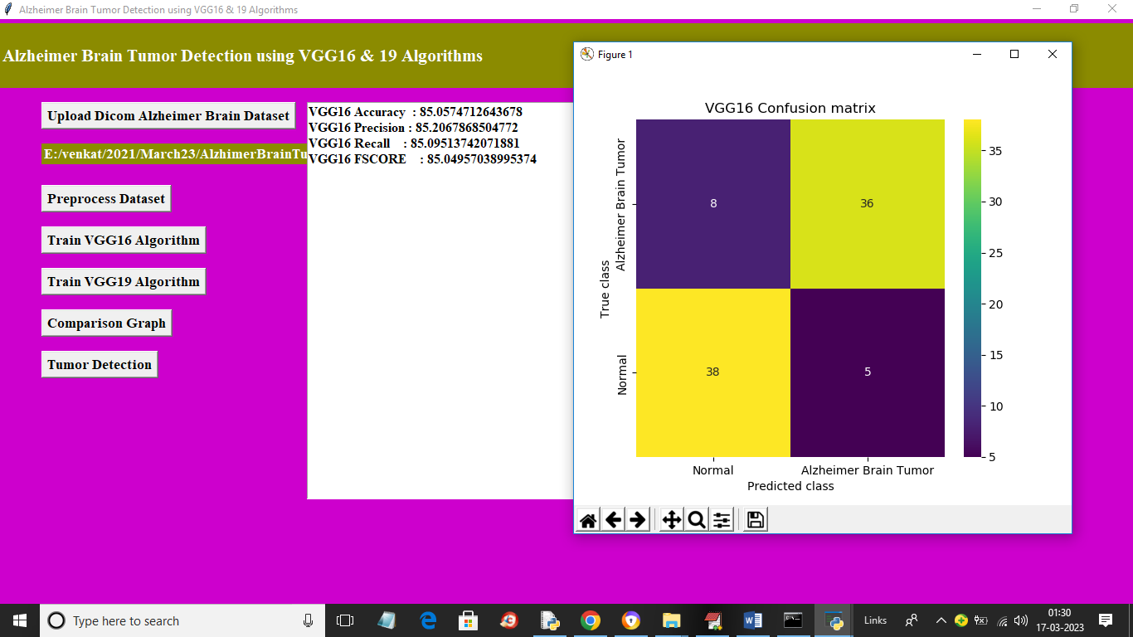

In above screen with VGG16 we got 85% accuracy and we can see other metrics also and in confusion matrix graph x-axis represents Predicted Labels and y-axis represents True Labels and yellow boxes contains correct prediction count and blue boxes contains incorrect prediction count which are very few. Now close above graph and then click on ‘Train VGG19 Algorithm’ button to train VGG19 and get below output

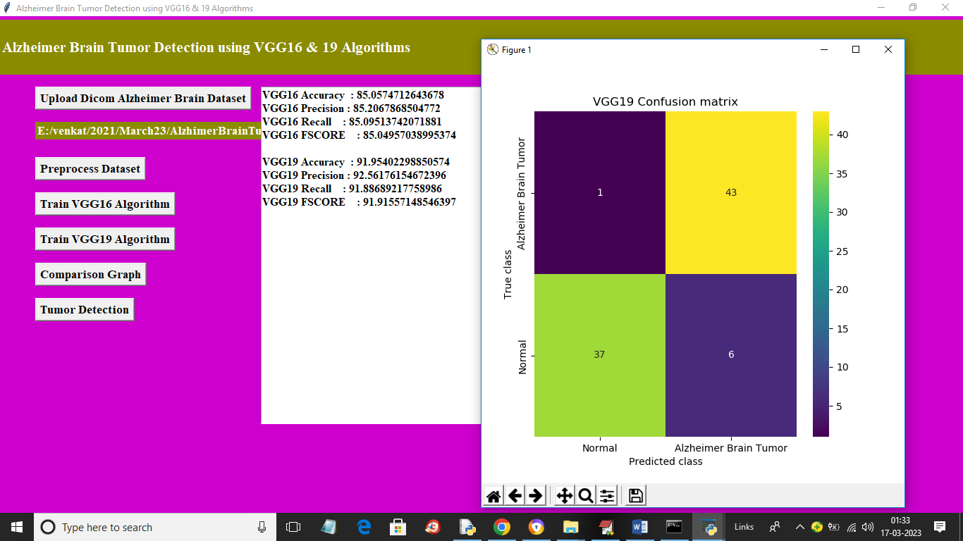

In above screen with VGG19 we got 91% accuracy and now close above graph and then click on ‘Comparison Graph’ button to get below graph

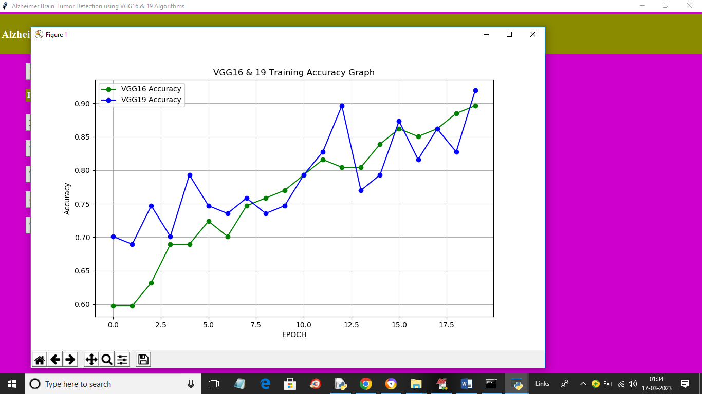

In above graph x-axis represents Training epochs of VGG16 and 19 and y-axis represents accuracy and green line represents VGG16 accuracy and blue line represents VGG19 accuracy and we can see with each increasing epoch accuracy got increase for both models but VGG19 got high accuracy. Now close above graph and then click on ‘Tumour Detection’ button to upload test DOCOM file and get below output

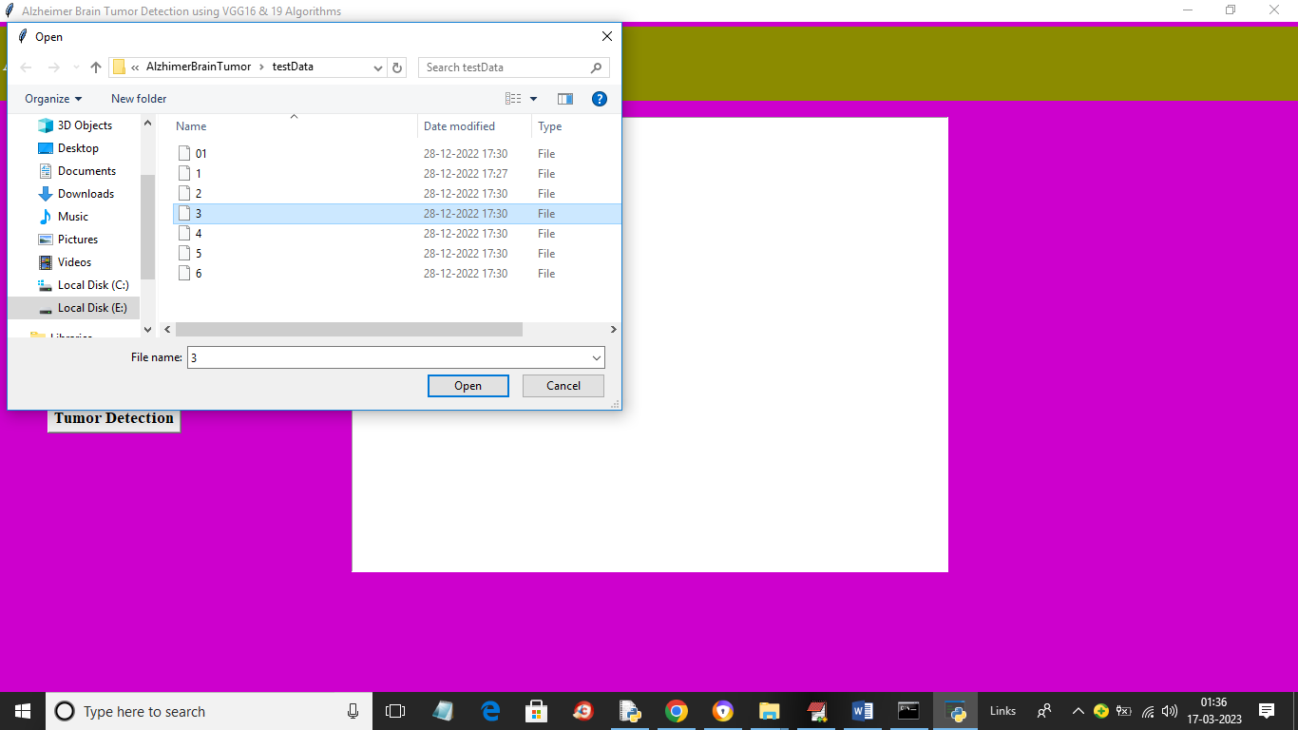

In above screen selecting and uploading ‘3’ DICOM file and then click on ‘Open’ button to get below output

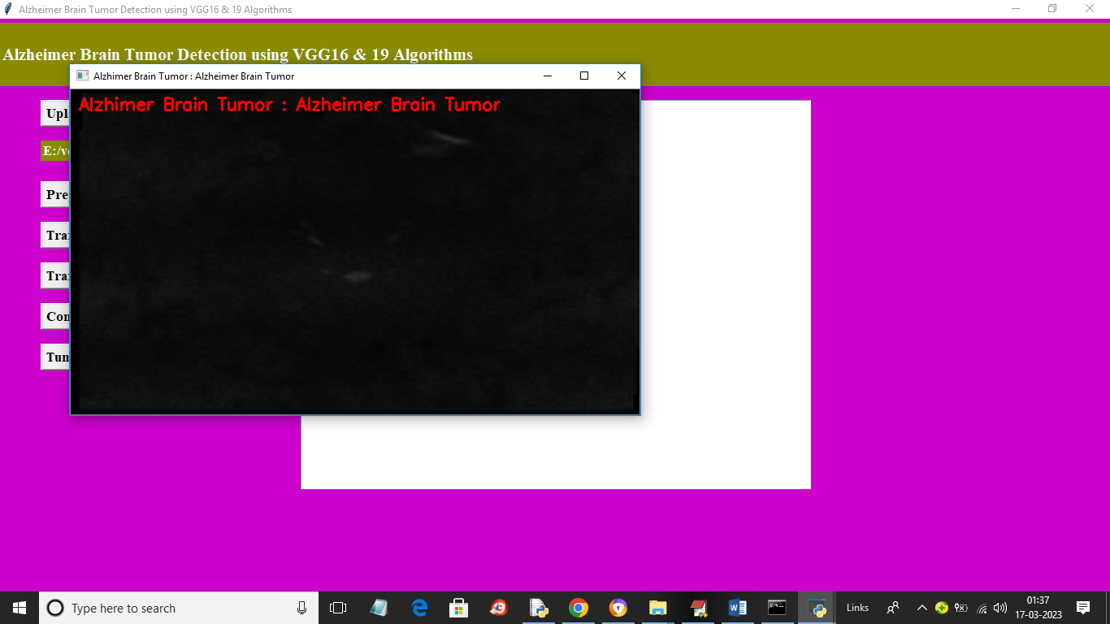

From above DICOM file Tumour detected and similarly you can upload and test other images

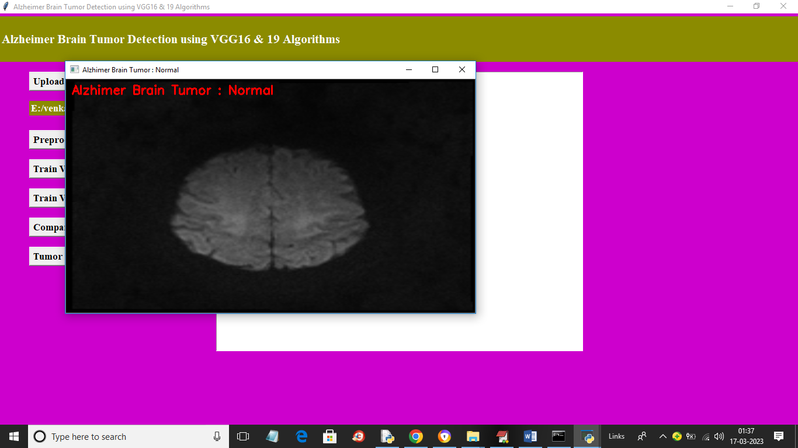

In above screen for another image we got output as ‘Normal’

