**AWS CHALLENGES**

1. Launch one **EC2 instance** using **Amazon Linux 2.**

Step 1: create an instance with **c7i-flex.large** so that we can run all services at same time.

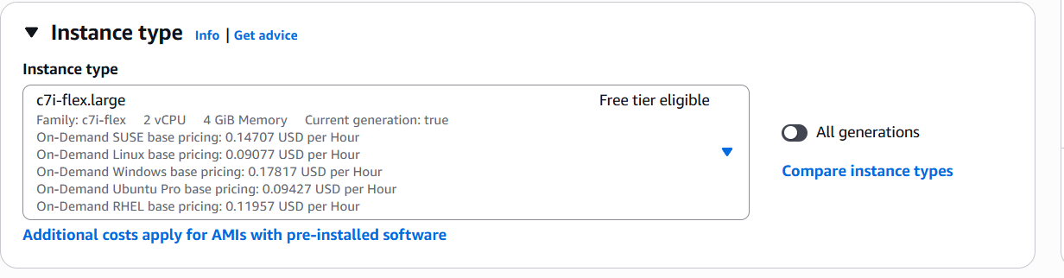

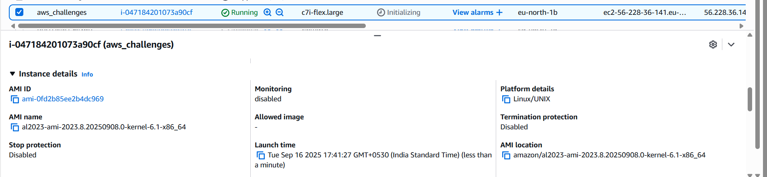

Step 2: Add three different ports in **inbound rules**

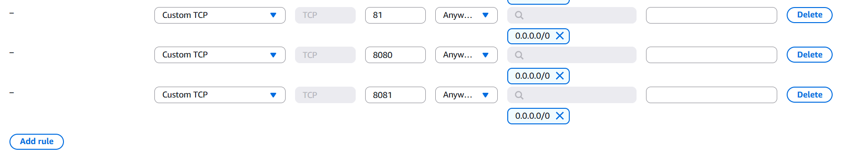

1. Install **Docker.**

Step 1: connect to EC2 using **ssh -i security_key.pem ec2-user@public_ip**

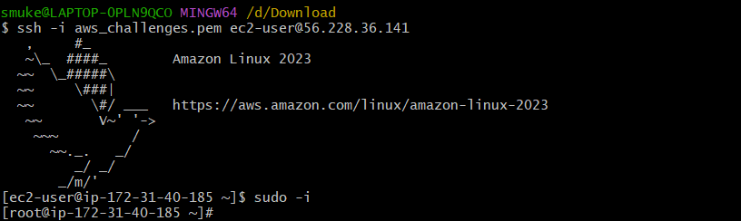

Step 2: Run following commands to install **Docker.**

* **sudo yum update -y**
* **sudo yum install docker -y**
* **sudo systemctl start docker**
* **sudo systemctl enable docker**
* **sudo systemctl status docker**
* **docker info**

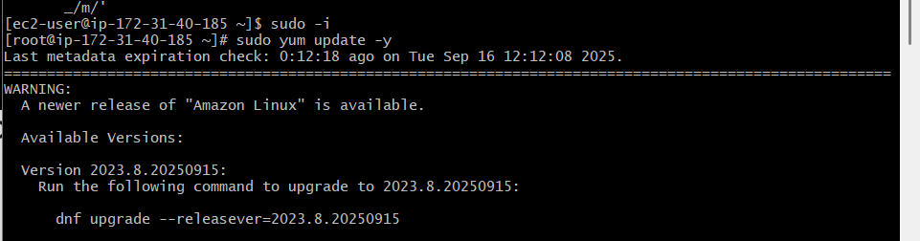

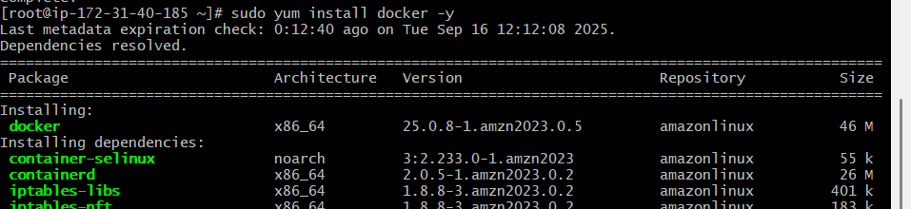

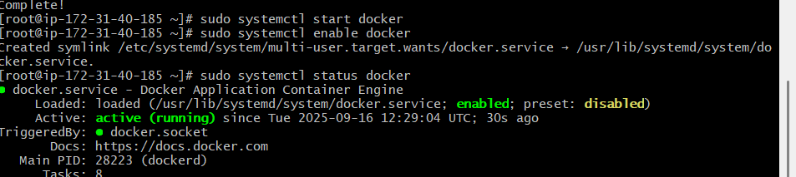

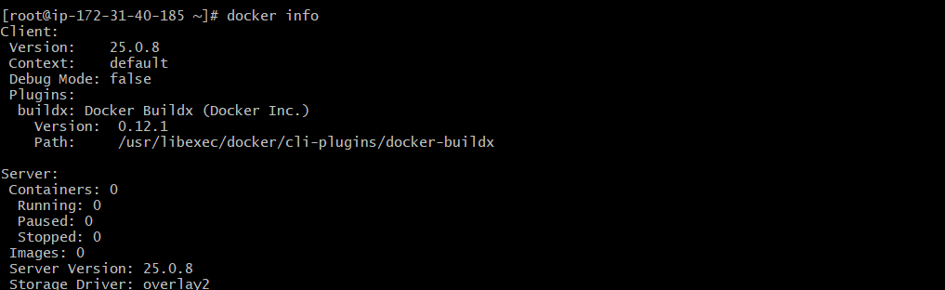

1. Install HTTPD (Apache)  
   Step 1: Run following commands to install and run HTTPD.

* **Sudo yum install httpd -y**
* **Sudo systemctl start httpd**
* **Sudo systemctl enable httpd**
* **Sudo systemctl status httpd**

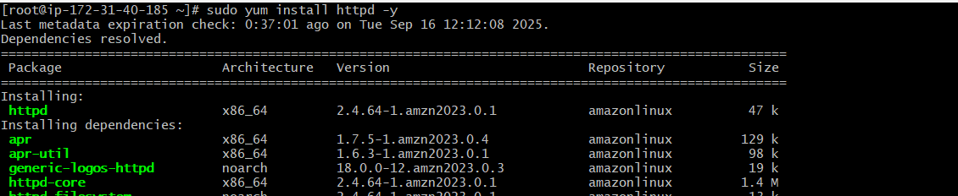

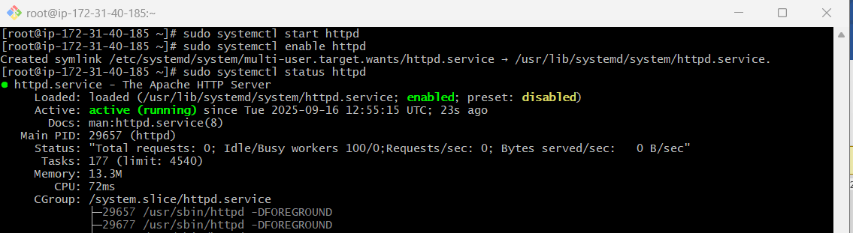

Step 2: Run **public_ip:80** in browser.

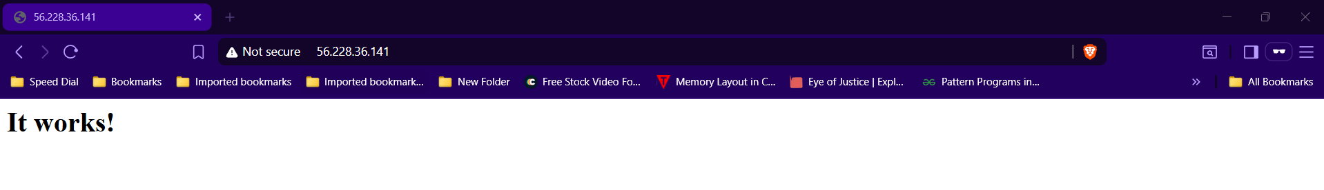

1. Install NGINX

Step 1: Run **Sudo yum install nginx -y** to install and run NGINX.

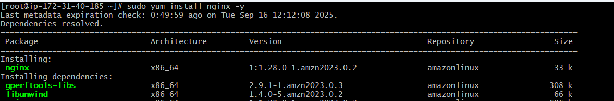



Step 2: open nginx.conf file in **etc/nginx/nginx.conf** and change port to **81**

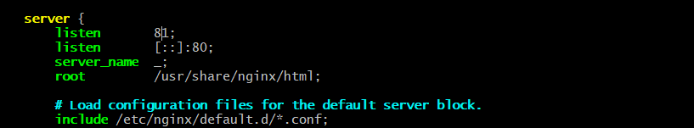

Step 3: Run **systemctl start nginx** and **systemctl enable nginx** to start NGINX

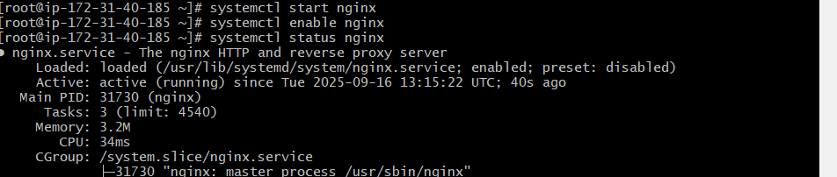

Step 4: Run **public_ip:81** in browser.

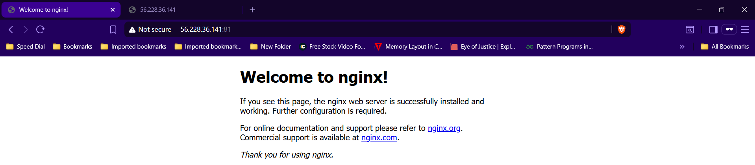

1. Install Apache Tomcat.

Step 1: Move to **opt/** directory and run following commands to install Apache Tomcat.

* **sudo yum install java**
* **sudo wget https://dlcdn.apache.org/tomcat/tomcat-11/v11.0.11/bin/apache-tomcat-11.0.11.tar.gz**
* **sudo tar -xvzf apache-tomcat-11.0.11.tar.gz**

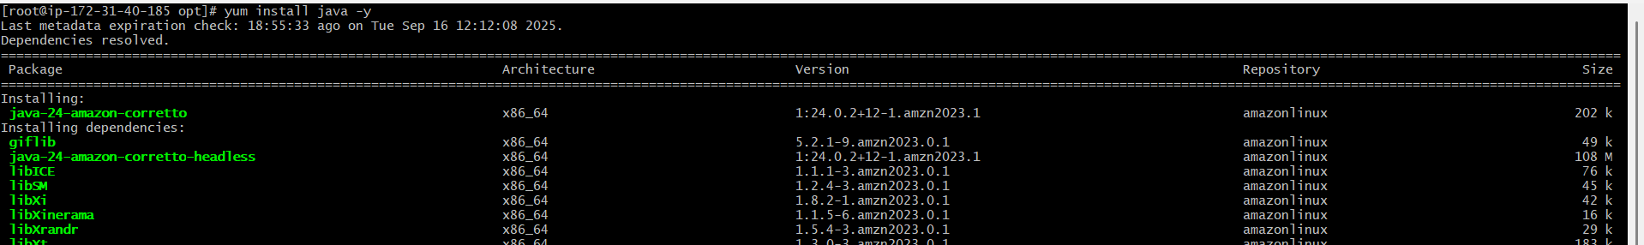

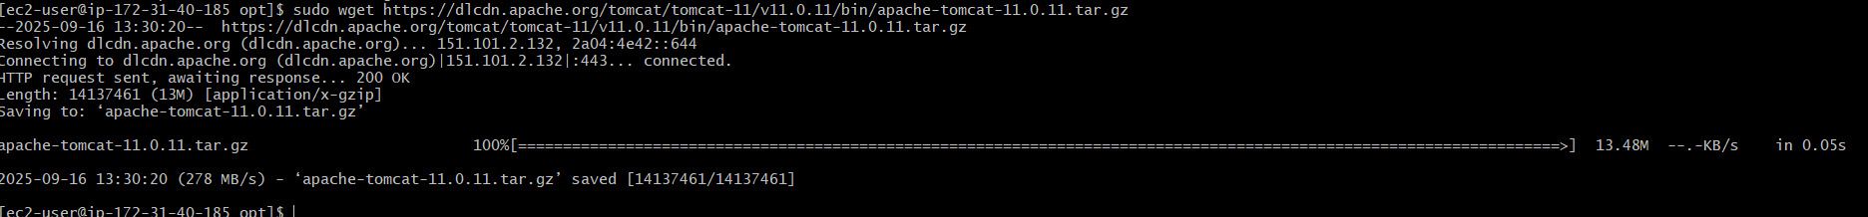

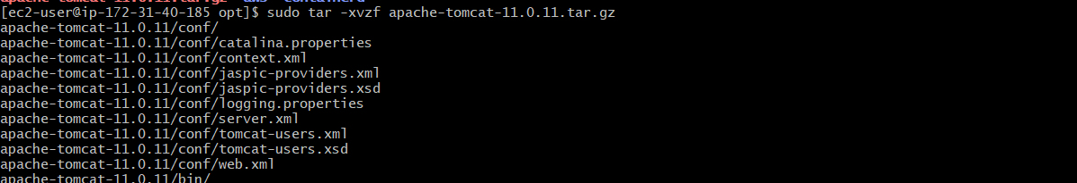

Step 2: change the port number to **8081** in **server.xml** file.

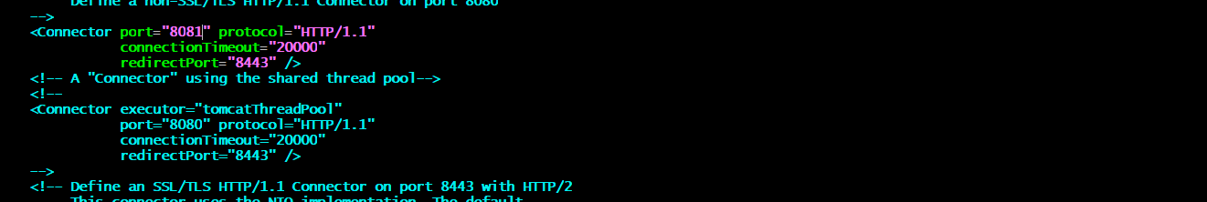

Step 3: Now goto **bin/** directory and run **./startup.sh** to run Apache Tomcat.

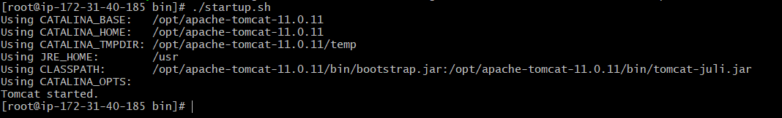

Step 4: Run **public_ip:8081** in browser.

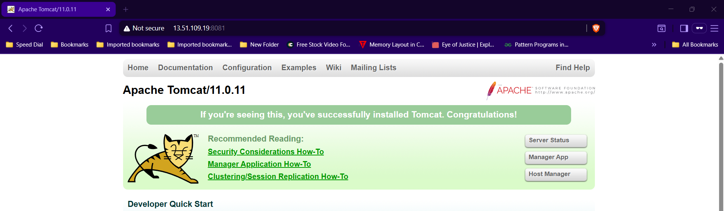

1. Install Jenkins

Step 1: Run following commands to install **Jenkins.**

* **Sudo yum update**
* **sudo wget -O /etc/yum.repos.d/jenkins.repo \** [**https://pkg.jenkins.io/redhat/jenkins.rep**](https://pkg.jenkins.io/redhat/jenkins.rep)
* **sudo rpm --import https://pkg.jenkins.io/redhat/jenkins.io-2023.key**
* **sudo yum upgrade**
* **sudo yum install Jenkins**
* **sudo systemctl enable Jenkins**
* **sudo systemctl start Jenkins**
* **sudo systemctl status Jenkins**

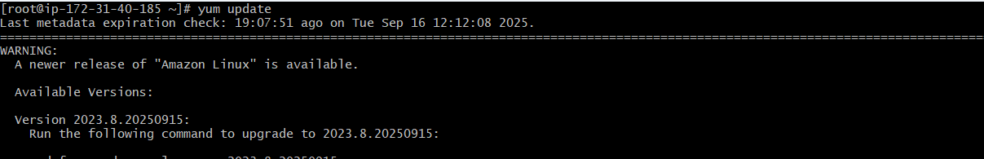

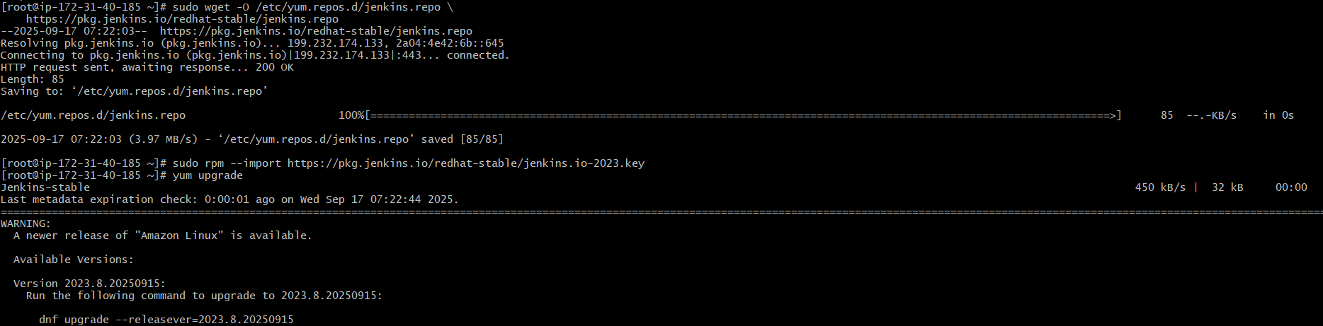

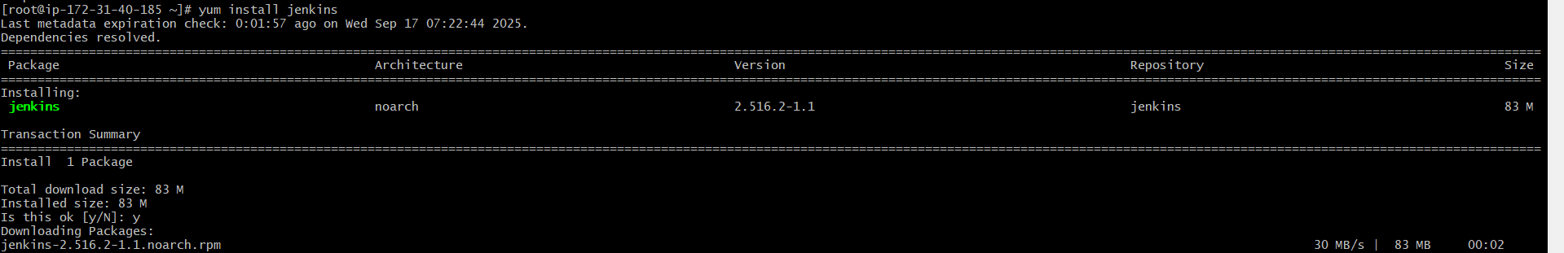

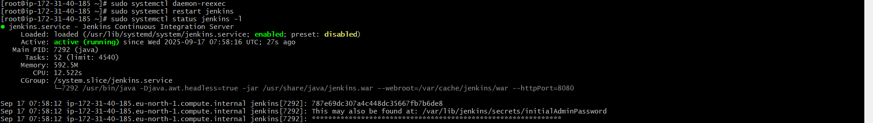

Step 2: Run **public_ip:8080** in your browser and copy the path and give **cat path** to get password, copy that password and use it in login page.

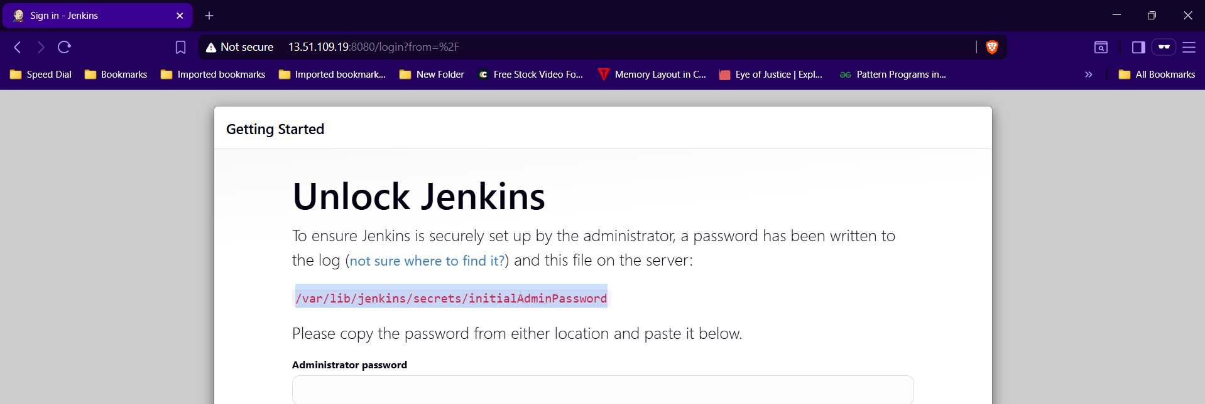

  
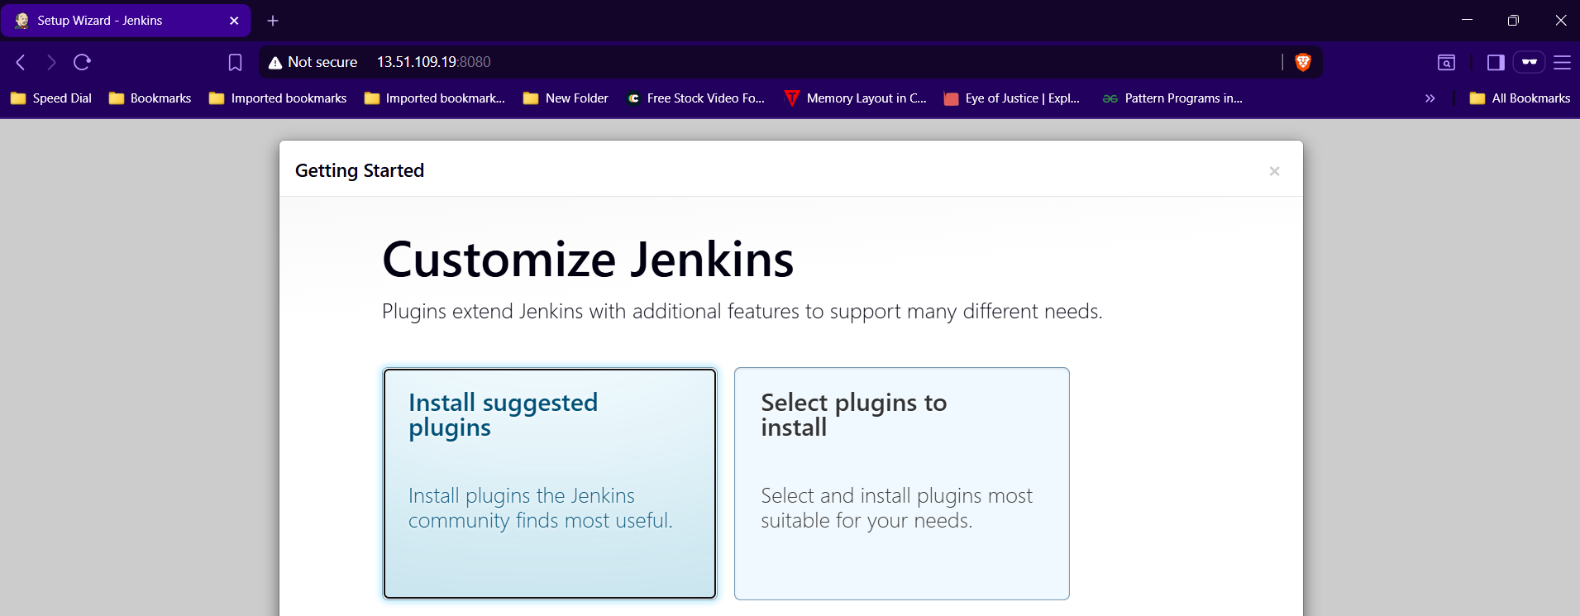

Step 3: click **install suggested plugins.**

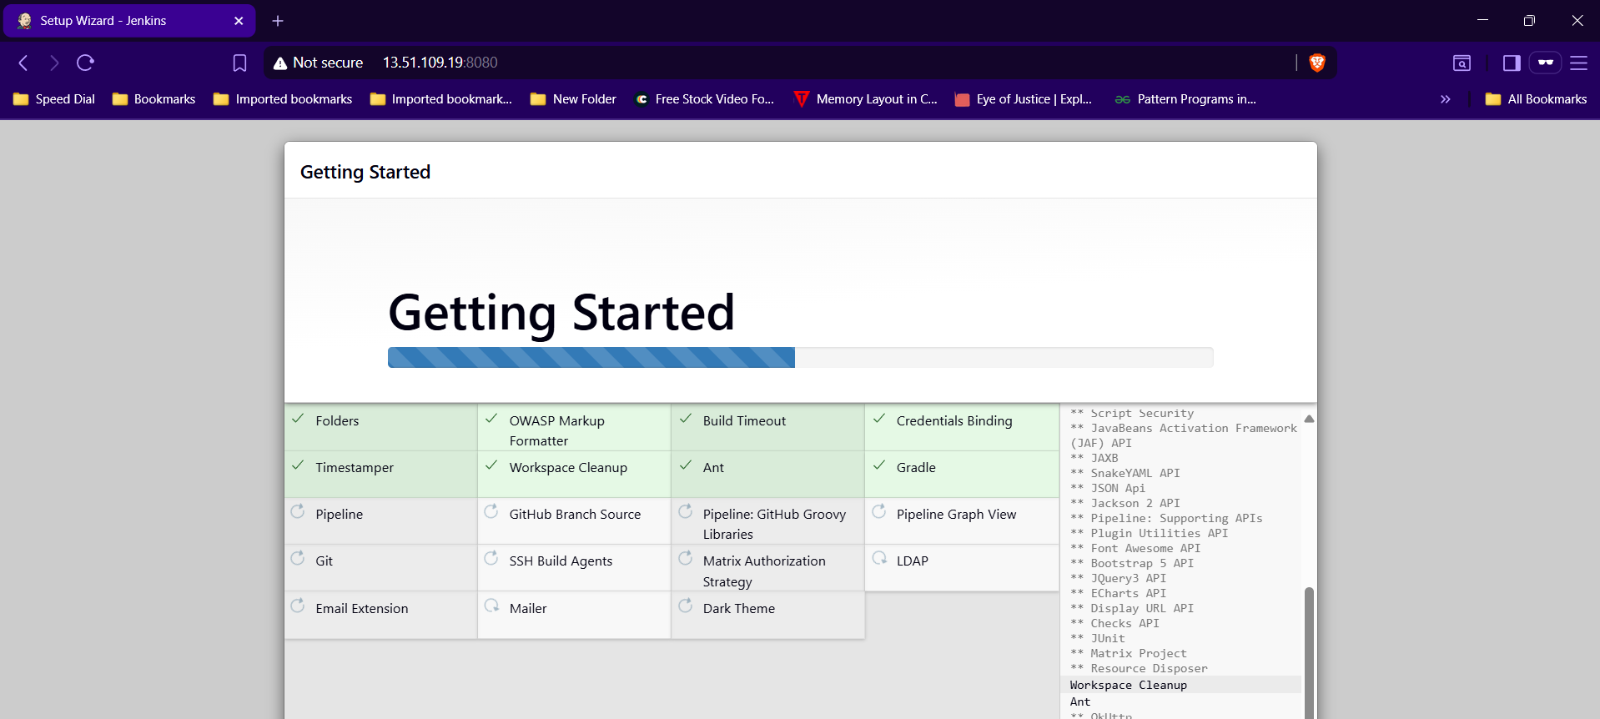

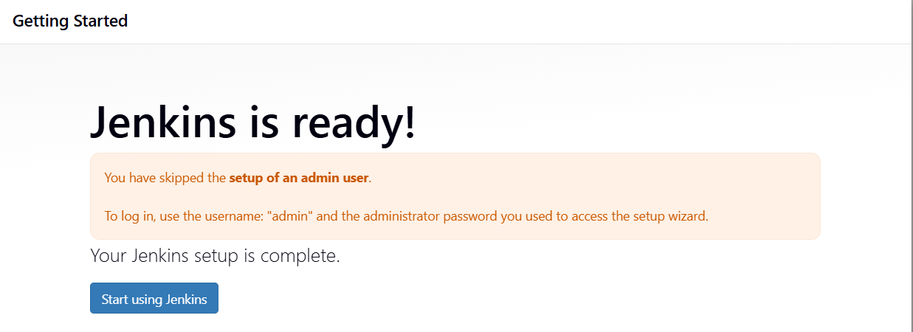

Step 4: Select start using Jenkins.

