1. Create a GitHub account

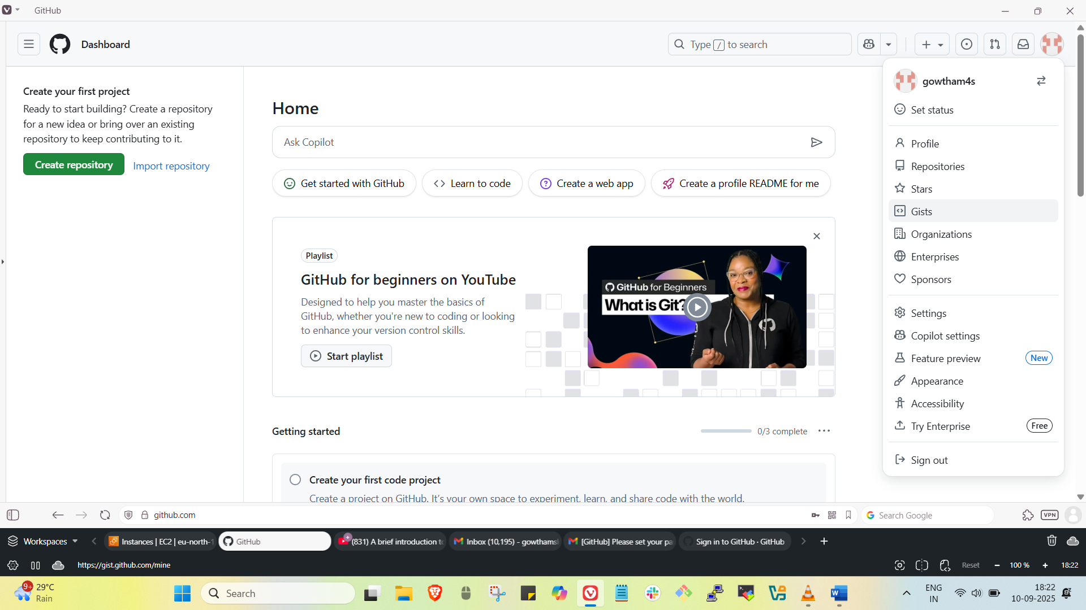

1. Set up MFA(Multi-Factor Authentication) for GitHub account using mobile app

Go to Settings 🡪 Password and Authentication 🡪 Enable 2-factor Authentication 🡪 scan qr code from your Authenticator app 🡪Enter 6 digit code

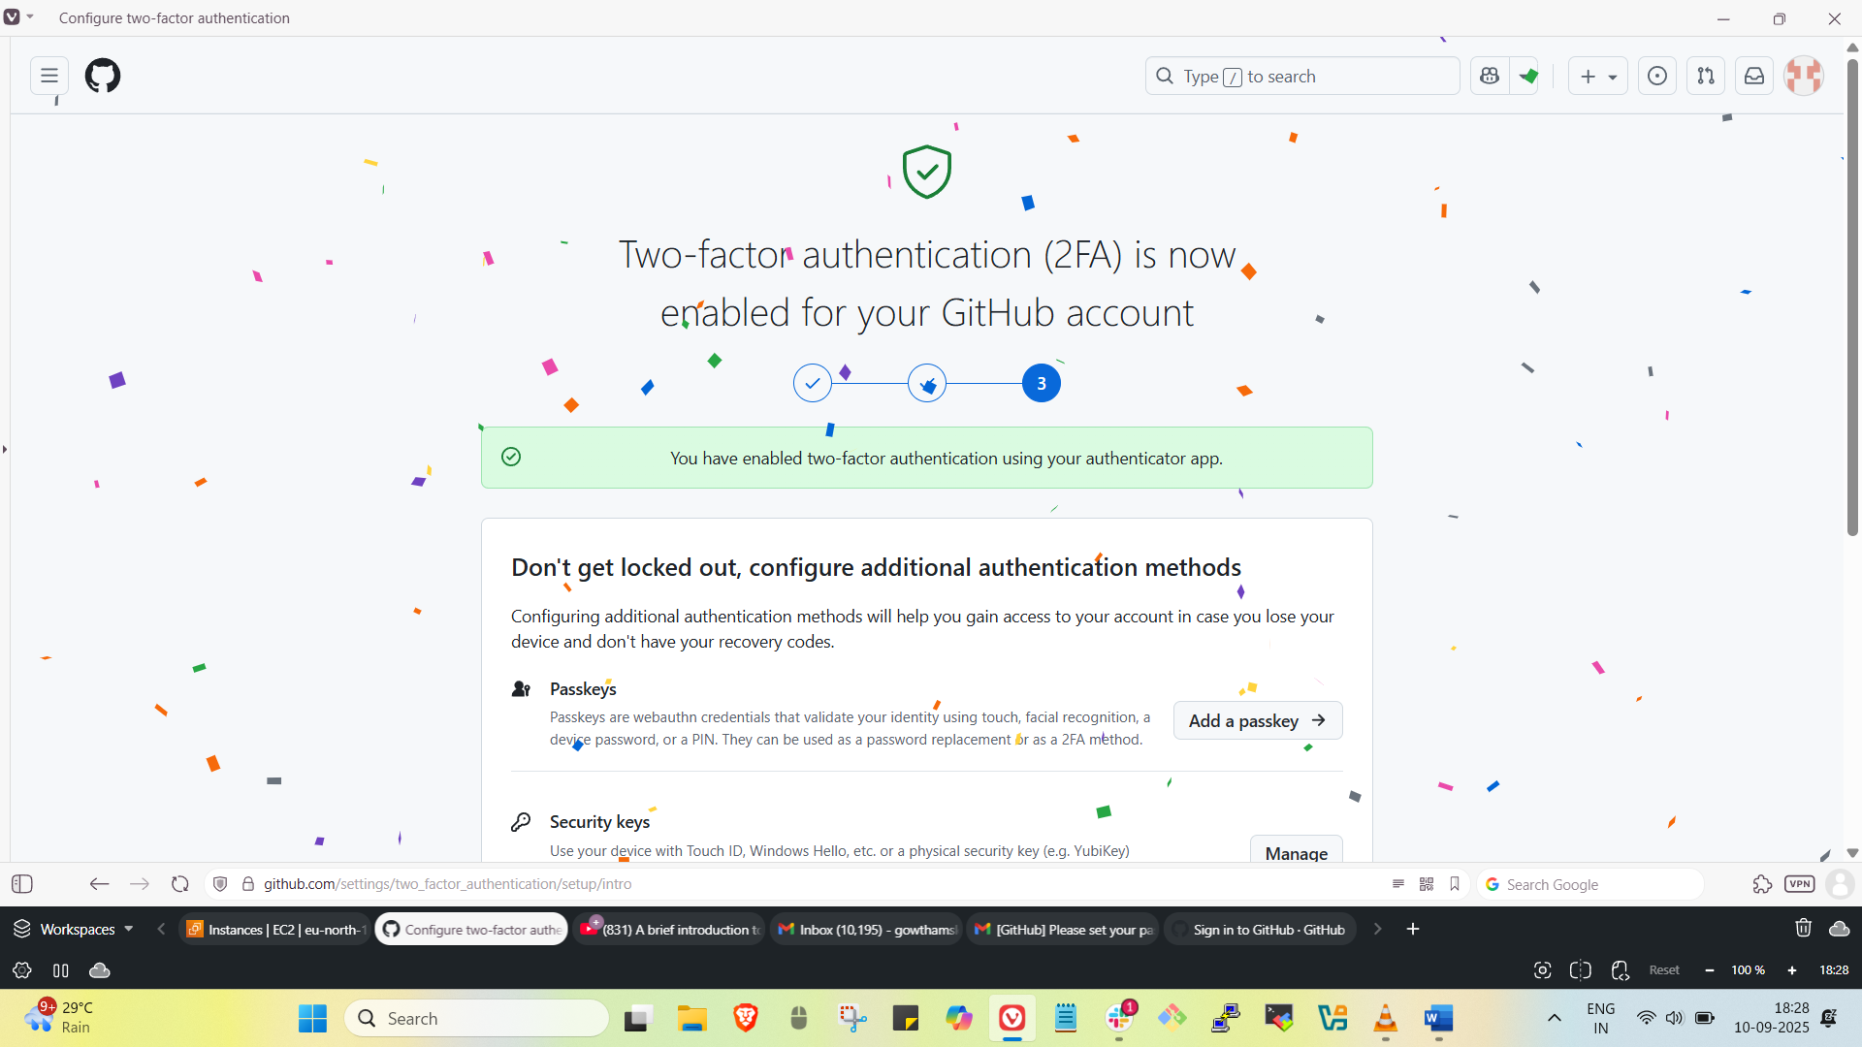

1. Execute all commands shown in the video.

**git --version**

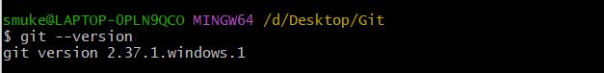

**git init -**  To initialize git



**git status –** To track the changes in particular repository

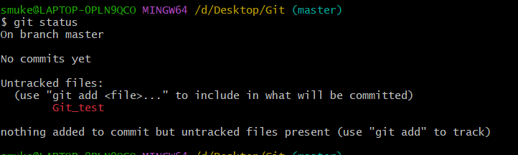

**git config --global user.name "username" -** To add username



**git config --global user.email "username@mail.com" -**  To add usermail



**git config --list –** it shows configuration details

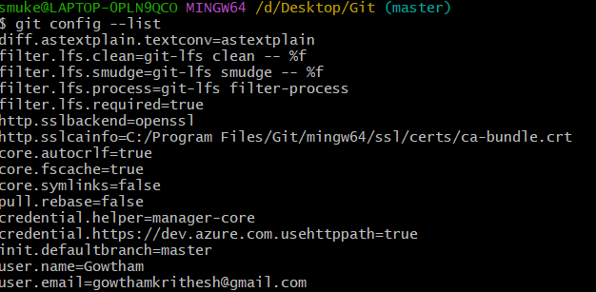

**git add filename –** It adds file from untracking area to tracking area

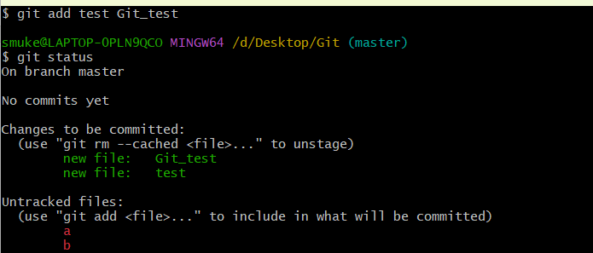

**git add . –** It adds all files from untracking area to tracking area

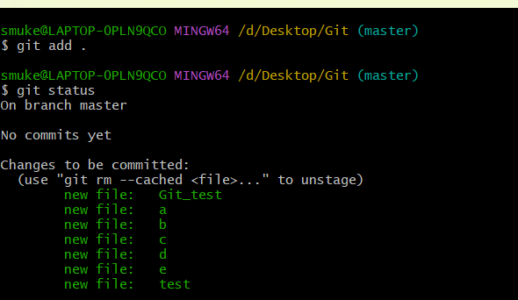

**git commit -m “message” -** It will store a copy of changes with commit id

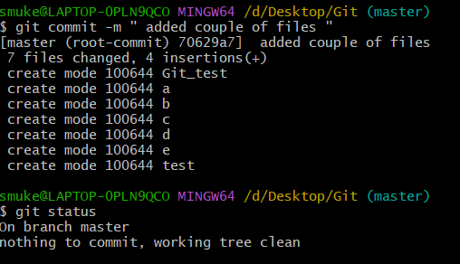

**git log -**  It will show the previous commit/changes that have made

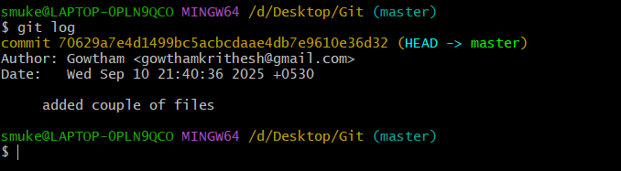

**git remote add origin SSH-GitHub-URL -**  It will add GitHub repo



**git remote -v -**  It shows list of GitHub repo that have added before

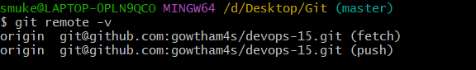

**git push -u origin master / git push -**  It will push changes to GitHub repo

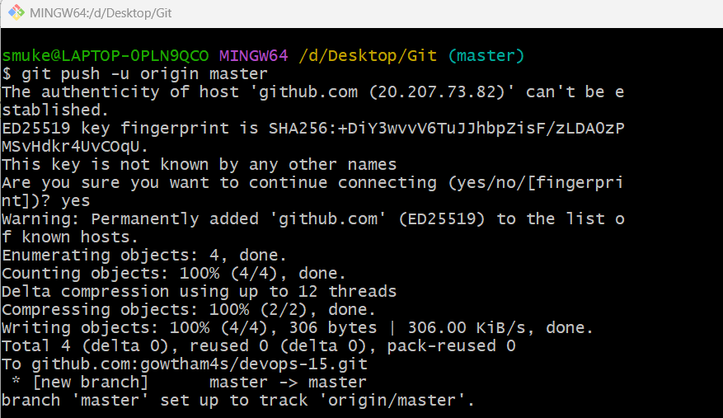

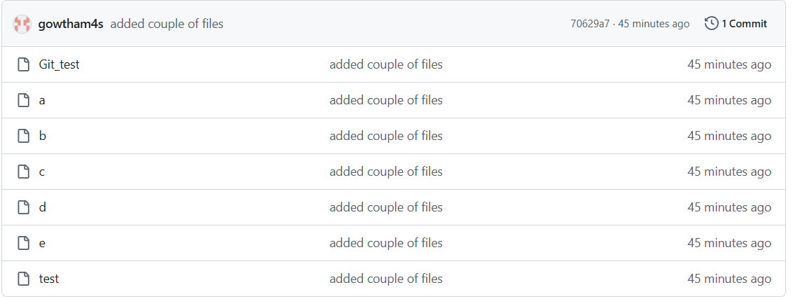

**git pull -**  It’ll pull changes from GitHub repo to our Git repo

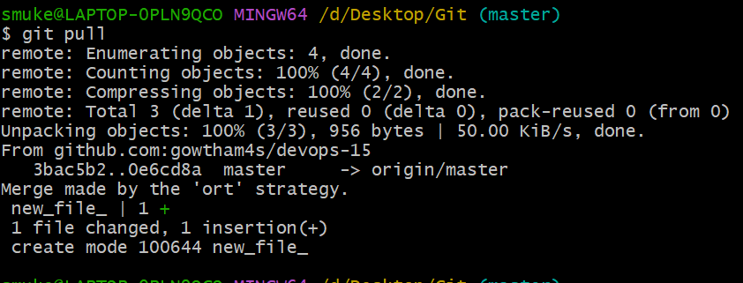

**git clone github-repo-URL –** It’ll download all data from GitHub

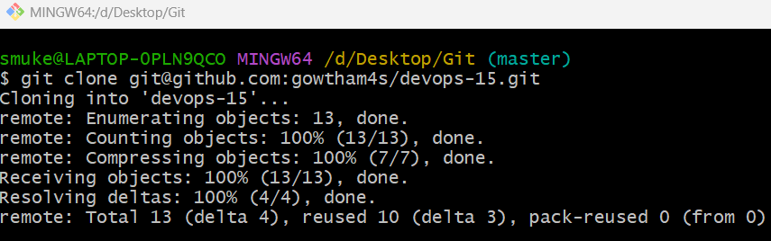

**git revert <commit_id> -**  It’ll try to go to previous commit

